Visualisation of IoT Data
Smart and Connected Devices I (ACCA5005)
May 13, 2019
Matthew Lewington
BSc Software engineering
UWTSD School of Applied Computing
Contents
1. Introduction 1
2. Site Design and Implementation 1
2.1 Login 1
2.1.1 Login Security 3
2.2 index.php 4
2.3 loaddata.php 5
3. Searches 7
4. Graphs 8
4.1 Graph Selection 13
5. Conclusion 13
6. References 13

1. Introduction
This document has been produced to provide an insight into the decisions made on production of the website for visualisation of data provided by the sensors.

2. Site Design and Implementation
The website produced for the task is a simple layout, with basic navigation allowing the user to visit the home page, or to logout of their session (if logged in) [Figure 2-1]. This is a separate php file (top.php) that is included in the main files (along with a bottom.php for the footer).


Figure 2-1 – Simple navigation bar

2.1 Login
Upon visiting any of the pages of the website, if the user is not logged in it will prompt them to go to the login screen [Figure 2-2] and enter their credentials, again with the login.php being a separate page that is included. This was done to save users going from page to page as originally it re-directed them to a login page, but now it is incorporated.

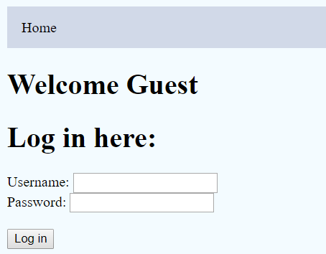
Figure 2-2 – Login prompt

If the user doesn’t enter either the username or password or enters the wrong credentials it will alert them and prompt for credentials again [Figure 2-3, Figure 2-4].

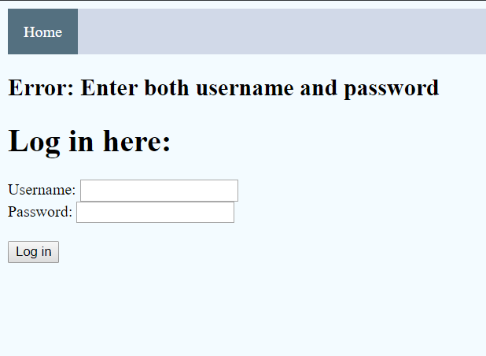
Figure 2-3 – Missing credentials

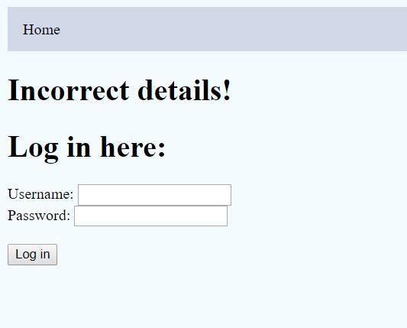
Figure 2-4 – Incorrect credentials

2.1.1 Login Security
For the login information, prepared statements were used [Figure 2-5] to help combat SQL injection as when utilised in a study, up to 94% of injection attacks were mitigated [1]. This adds to the security of the database and can prevent unauthorised access to the website and data alike.

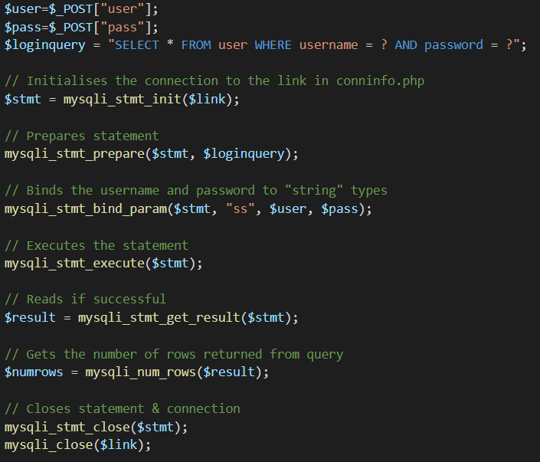
Figure 2-5 – Prepared statement for login

To access any pages that may contain information, the php session [2] is checked to see if the username is set [Figure 2-6]. If it is not, the user is prompted to login. This provides a layer of security that can help with unauthorised access to data.

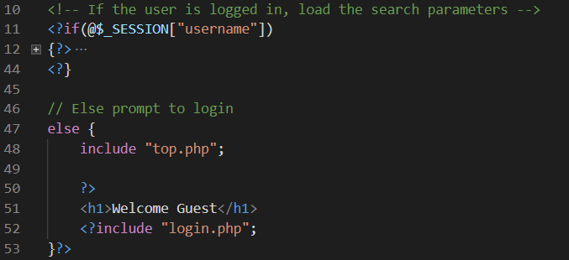
Figure 2-6 – Checking if the PHP session includes the username

2.2 index.php
The index page [Figure 2-7] contains an image that selects all of the data and displays a button to implement the loading in of data from the supplied data files, a CanvasJS [3] graph and the search.php is included for the user to implement a query for the graphs.
The search parameters are passed via POST to the php page that contains the queries, graphs and raw data. The POST method is slightly more secure than the GET method [4] as it doesn’t store parameters in the server logs or browser history, unlike with GET which stores parameters in the URL which could be vulnerable to a direct object reference attack [5].

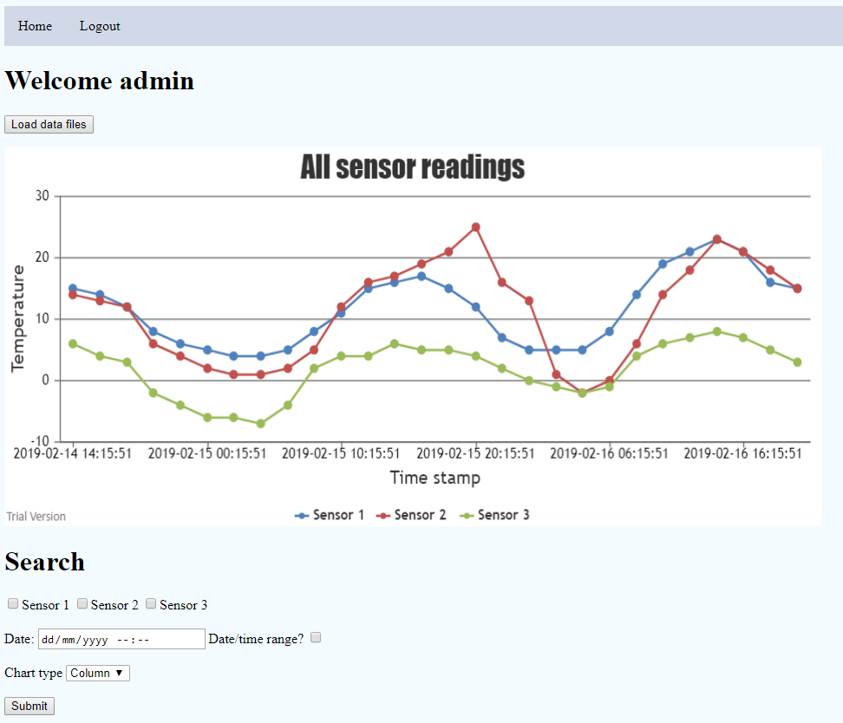
Figure 2-7 index.php full page

2.3 loaddata.php
The loaddata.php file was added to allow the user to import data into the database. It loops for the maximum number of sensors [Figure 2-8], opens the correctly formatted filename and checks if the filesize is greater than 0. If there is, it will “explode” (separate) the file based on the carriage return character (so each line), then enter another loop to read each character of the line.

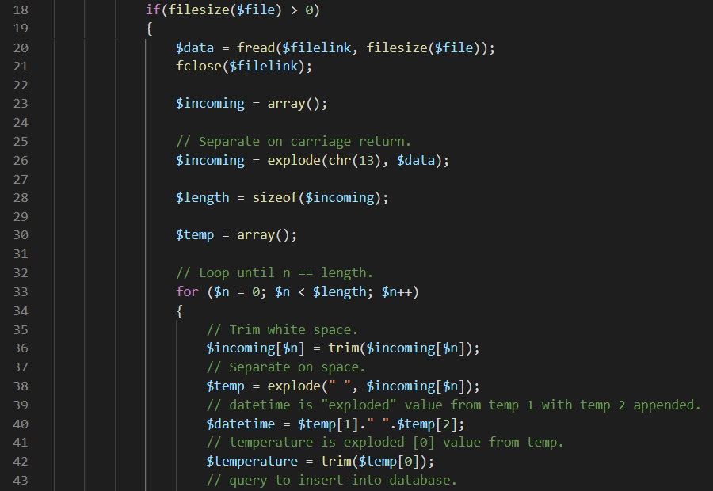
Figure 2-8 – File reading (exploding data)

This then further explodes on a blank space and separated into the temperature and the datetime. The datetime could be stored as separate date and time values, however to save space in the database it was stored as one type.
Once all values are read from the files, a query is initiated [Figure 2-9] to insert the records into the database.
Figure 2-9 – File reading (query)

When the query is complete, the file is opened again but in write mode which deletes everything from the file [Figure 2-10]. This is done to ensure no duplicate readings are added to the database.

Figure 2-10 – File reading (writing to file)

Output is then displayed to the user on whether the files have copied successfully [Figures 2-11 – Figures 2-13].

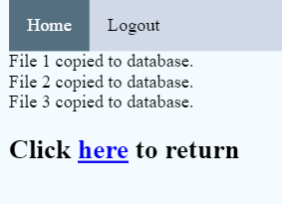
Figure 2-11 – Files being successfully copied

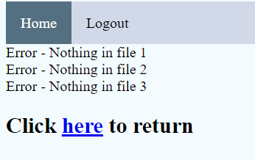
Figure 2-12 – No updated files, so it doesn’t copy to the database

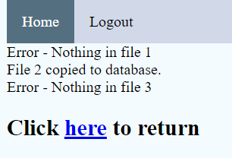
Figure 2-13 – File 2 has been updated, so this copies to the database

3. Searches
The user has the option to select which sensor(s) to display data from, the date/time, whether they want to specify a date/time range (if so, further search parameters will appear including the average, minimum and maximum values for the range), and the chart type to be displayed [Figure 3-1 & Figure 3-2].

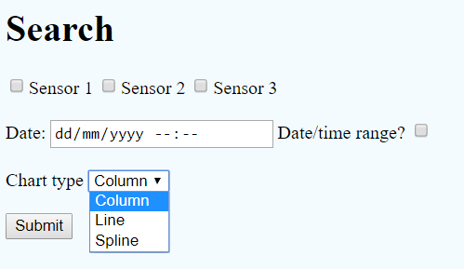
Figure 3-1 – Search parameters single datetime

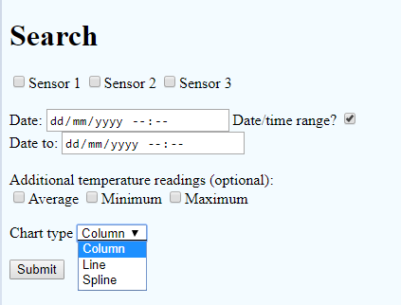
Figure 3-2 – Search parameters datetime range

4. Graphs
Once search parameters are entered [Figure 4-1] and passed to the searchdate.php file and the query [Figure 4-2] is then created.

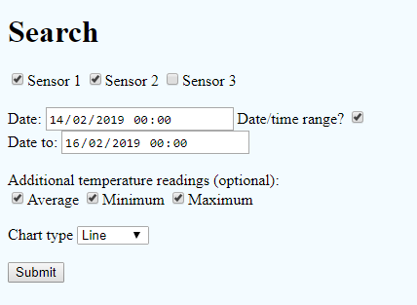
Figure 4-1 – Test parameters

Figure 4-2 – Search query

Depending on which sensor is selected (set), a sensorArray variable is created ready [Figure 4-3] to store the results from the search query.

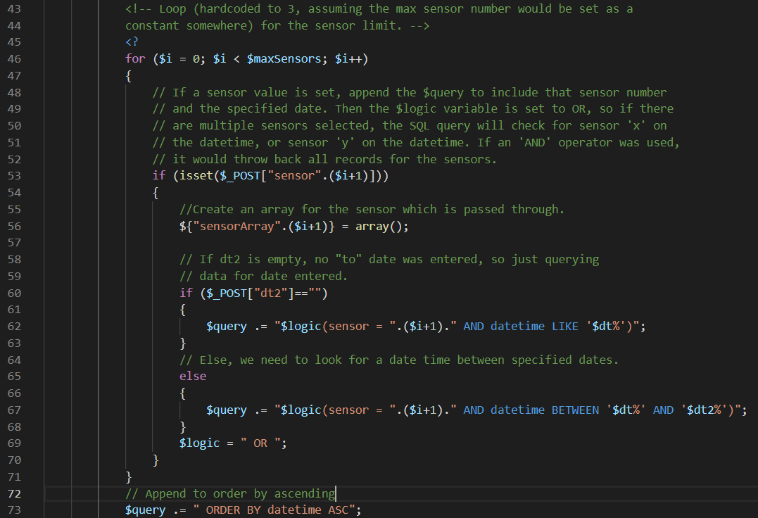
Figure 4-3 – Entering loop and creating sensorArrays

The query variable is then appended with the user search parameters. If the $dt2 variable is empty, the user has selected a specific time. If the $dt2 variable contains a value, the user has selected a datetime range, so the query is updated to include BETWEEN two dates [Figure 4-4].
This then changes the $logic variable to “OR” in case the user has selected multiple sensors. One last addition to the query is to order it by the datetime, so it is ordered from oldest to newest.
Figure 4-4 – Appending query

Once the query is ready, it is then executed and if there is information returned, it is pushed into an array containing the x and y labels for the graph display [Figure 4-5].

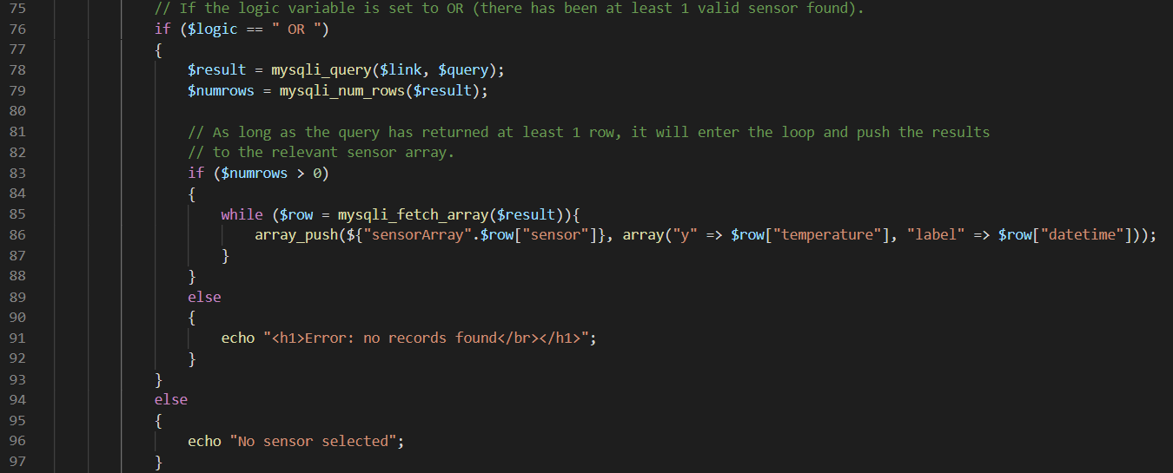
Figure 4-5 – Pushing results to array

The sensor array is then encoded [6] into a JSON representation of the value and the CanvasJS script renders the graph [Figure 4-6].

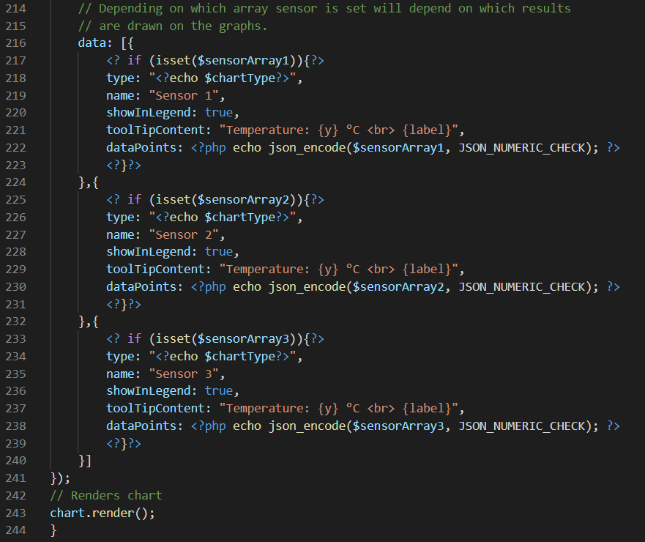
Figure 4-6 – CanvasJS dataPoints

The graph is then produced [Figure 4-7 & Figure 4-9] based on the parameters from the POST data and the user also has the option to view the raw data [Figure 4-8 & Figure 4-10] which includes the optional parameters (average, minimum, maximum values).

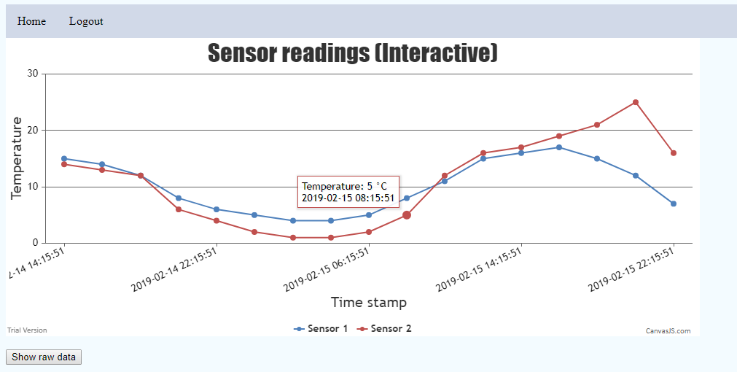
Figure 4-7 – Generated graph with above parameters from figure 4-1

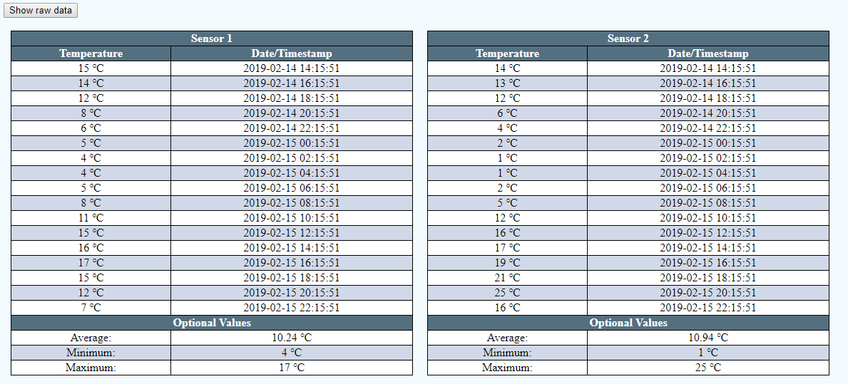
Figure 4-8 – Raw data with above parameters from figure 4-1

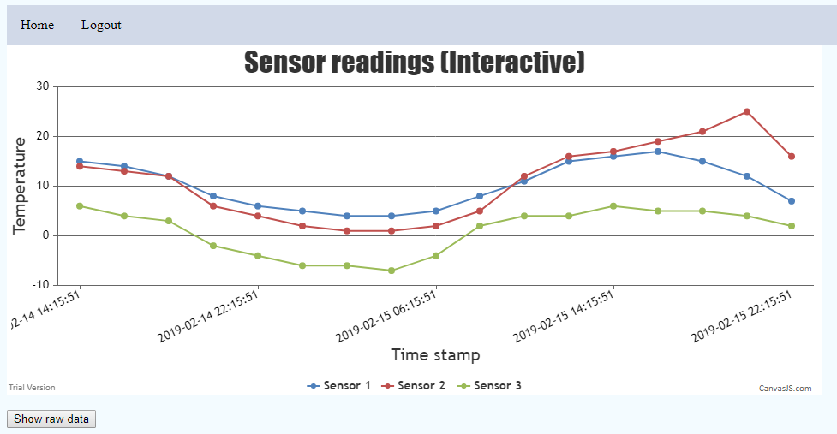
Figure 4-9 – Generated graph with additional parameters from above

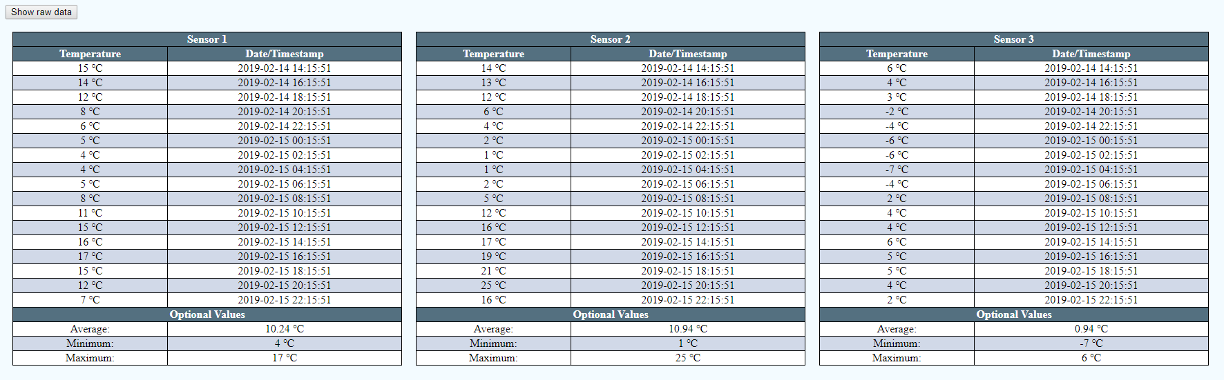
Figure 4-10 – Raw data with above additional parameters from above

4.1 Graph Selection
CanvasJS was used as it provides the user with some interactive capability to enhance user experience. There were also some difficulties in getting the ‘x’ axis labels with the provided phpMyAdmin library to display the datetime.

5. Conclusion
A simple website has been created to allow for importation of data from files that are produced from sensors or a similar module. Basic security has been implemented to show an understanding of potential vulnerabilities and mitigation, and a range of PHP coding techniques have been highlighted to show work. The website is clear, simple to use, and is able to provide relevant information and interactive graphs based on user input.
Going forward, using existing knowledge and furthering knowledge on PHP and web technologies, it would be possible to develop an enhanced application with more usability, a better layout and also to make it more secure.

6. References
[1] S. Thomas, “On automated prepared statement generation to remove SQL injection vulnerabilities,” Inf. Softw. Technol., vol. 51, no. 3, pp. 589–599, 2009.
[2] “PHP 5 Sessions.” [Online]. Available: https://www.w3schools.com/php/php_sessions.asp. [Accessed: 07-May-2019].
[3] “Beautiful HTML5 JavaScript Charts | CanvasJS.” [Online]. Available: https://canvasjs.com/. [Accessed: 07-May-2019].
[4] “HTTP Methods GET vs POST.” [Online]. Available: https://www.w3schools.com/tags/ref_httpmethods.asp. [Accessed: 07-May-2019].
[5] J. Brodkin, “The top 10 reasons Web sites get hacked,” Netw. World, vol. 24, no. 39, p. 1–17,20, 2007.
[6] “PHP: json_encode - Manual.” [Online]. Available: https://www.php.net/manual/en/function.json-encode.php. [Accessed: 07-May-2019].

