

Cover Page

Student Name- Daljeet Matharu
Student Number- 2433456
Module Code- BMHP5014
Module - Change makers: Creativity and Value Creation
Assignment - Component 1: Online Portfolio of Set Exercises

Task 1 concept map
Create a concept map that outlines the relationship between creativity, value creation, and health and social care improvement. Within the concept map explain how these concepts interact in a health and social care context (250 words)

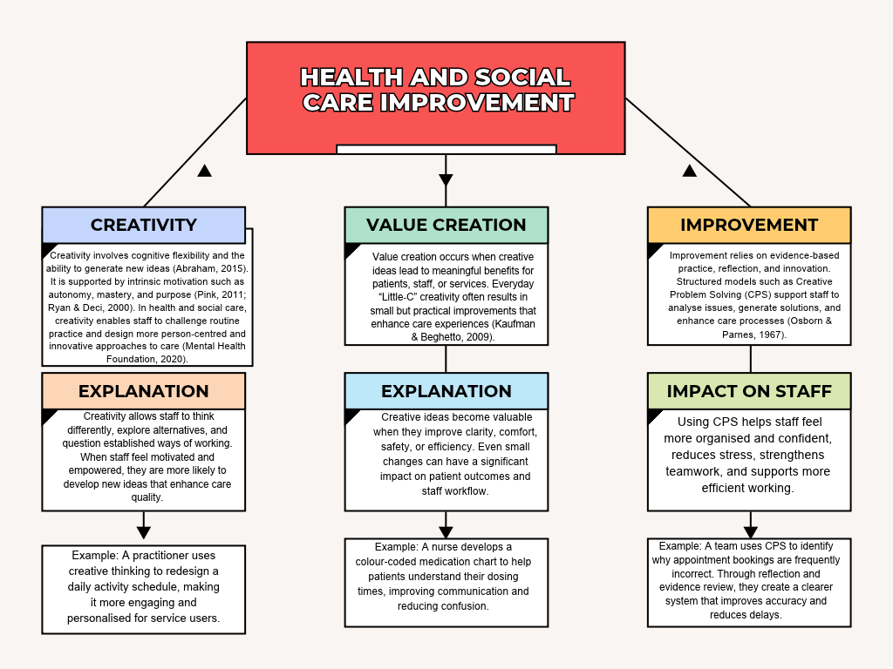

Overall, creativity generates ideas, value creation turns those ideas into practical benefits, and improvement processes embed them into everyday practice. Together, these concepts drive better outcomes for patients and more effective, empowered practice for staff.

Task 2 - Self-Reflection of Group Activity
Complete a self-Reflection on the Convergent/Divergent paperclip thinking class activity using a reflective model (250 words, 1 source)
The following reflection will utilise the ERA Model of Reflection on the Paperclip Activity (Eraut, 1994).
Experience
In class our group was asked to generate as many uses as possible for a paperclip within ten minutes. This task encouraged rapid idea generation and collaborative creativity. The process relied heavily on divergent thinking, which involves producing multiple, varied ideas without immediate judgement (Guilford, 1967: Runco, 2014). Each group member contributed differently, offering practical, creative, and unconventional suggestions. I actively participated by sharing ideas and expanding on others’ contributions, which helped sustain the flow of thinking. We later used convergent thinking to refine, organise, and select the most practical ideas, allowing the group to move from broad creativity to focused decision-making (Cropley, 2006).
Reflection
Reflecting on the activity, I realised how group interaction influences creative problem-solving. Divergent thinking allowed us to explore a wide range of possibilities, while convergent thinking helped us organise, refine, and evaluate the ideas more logically (Cropley, 2006: Sawyer, 2012). I noticed that I naturally adopted a facilitative role, helping the group stay focused and encouraging quieter members to contribute. The activity demonstrated how suspending judgement can enhance creativity and how communication supports idea expansion. This mirrors teamwork in health and social care, where diverse perspectives and collaborative thinking improve decision-making (Thompson, 2018).
Action
From this experience, I plan to apply both divergent and convergent thinking in future group tasks. I will encourage open brainstorming before narrowing ideas down, ensuring all contributions are valued, reflecting evidence that divergent thinking supports idea generation while convergent thinking strengthens decision-making (Guilford, 1967: Cropley, 2006). This balanced approach can strengthen problem solving and innovation in care settings, as creative collaboration enhances effective practice (Sawyer, 2012: Thompson, 2018). I also aim to continue developing my facilitation skills by promoting inclusive communication and supporting collaborative creativity (Runco, 2014).

Task 3 - Case Study of a UK innovation

Write a concise case study analysis of an innovative project or initiative within the NHS or UK social care. Focus on how creativity was used to drive change and the value it created for patients or service users (400 words, 2 sources).
Case Study 1: “NHS at Home” - Remote Monitoring to Reduce Hospital Admissions (Imperial College Healthcare NHS Trust, 2024).
Creativity and Innovation in NHS Remote Monitoring
Creativity was central to the development of the NHS remote-monitoring initiative, enabling healthcare teams to redesign traditional post-hospital care and respond to rising readmissions. The programme emerged from growing evidence that technology-enabled pathways can improve recovery and reduce avoidable admissions (Imperial College Healthcare NHS Trust, 2024). Creative thinking encouraged clinicians, digital health specialists, and system leaders to explore new technological possibilities, reimagine service delivery, and collaborate across disciplines to create safer, more personalised care (Care Quality Commission, 2021).
One of the most significant creative approaches involved integrating digital tools and wearable devices into everyday clinical practice. For example, cardiac patients were provided with wearable ECG patches that transmitted real-time heart-rhythm data directly to clinicians, allowing early identification of deterioration without requiring hospital attendance (Imperial College Healthcare NHS Trust, 2024). This shift from reactive, appointment-based care to proactive, continuous monitoring reflected national calls for innovative, safe, and efficient digital pathways (Care Quality Commission, 2021).
Creativity also drove the adoption of artificial intelligence (AI) to support clinical decision-making. AI systems analysed large volumes of patient data, identifying subtle changes that might indicate early deterioration. Bajwa et al. (2021) emphasise that AI enhances diagnostic accuracy and enables more personalised care. A practical example includes AI-generated alerts that notified clinicians when a patient’s oxygen saturation dropped below their personalised baseline, prompting timely intervention and preventing emergency readmissions. Additional evidence shows AI can support cancer prognosis and treatment planning, demonstrating its wider potential across healthcare (Zhang, Shi and Wang, 2023).
Collaborative creativity was equally important. Clinicians worked with digital health teams to design user-friendly platforms that patients could navigate independently. A simplified mobile app was co-developed with older adults to ensure accessibility for people with limited digital literacy, enabling them to upload symptoms, vital signs, and medication updates with confidence (MIND, 2021). Creative design also supported patients with cognitive impairments by reducing anxiety associated with repeated hospital visits and improving transitions between home and clinical environments (Alzheimer’s Society, 2019: NHS England, 2019).
Finally, creativity extended to system-level innovation. Leaders explored new governance models, digital-safety principles, and patient-centred approaches to ensure technology was adopted responsibly (Vats, 2024). These creative strategies collectively transformed remote monitoring from a small-scale digital trial into a robust, person-centred model of care that improved outcomes, enhanced autonomy, and strengthened NHS efficiency (Care Quality Commission, 2021).
Remote monitoring showed how creative digital innovation can enhance safety, empower patients, reduce admissions, and transform NHS care into a more proactive system.

Task 4 - Research Task
Identify a current issue in health and social care (e.g. e.g., mental health stigma, access to care for vulnerable populations). Find two pieces of academic research (journal articles) that explain the reason for this problem. Paraphrase the findings of each article (300 words, 2 sources).
Current Issue: Mental Health Stigma
Mental health stigma remains a major barrier to accessing care, achieving recovery, and maintaining social inclusion for people with mental illness. One key reason for this problem is the persistence of negative attitudes and discriminatory behaviours within society (Clement et al. 2022).
A systematic scoping review by Kagstrom et al. (2025) highlights that stigma operates through multiple pathways, including harmful stereotypes, social exclusion, and reduced opportunities for employment, education, and healthcare. Their review of 448 studies found that stigma contributes to poorer health outcomes, lower service use, and significant psychosocial and economic disadvantages. Although public awareness campaigns have increased understanding of mental illness, the review notes that negative attitudes remain deeply embedded, particularly in contexts where mental illness is associated with danger, unpredictability, or personal weakness. The authors argue that stigma persists partly because interventions often fail to distinguish between negative attitudes (stigma) and discriminatory behaviours, meaning efforts to reduce stigma do not always translate into improved access to care or reduced inequality.
A second piece of research by Kummetat et al. (2026) explains that mental health stigma is strongly influenced by societal values and belief systems. Their scoping review synthesised quantitative evidence showing that cultural norms, moral beliefs, and value-based judgements shape how individuals perceive mental illness. For example, in societies where self-reliance and emotional control are highly valued, mental illness may be viewed as a personal failure rather than a health condition, reinforcing stigma and discouraging help-seeking. The authors found that stigma is more prevalent in communities where mental illness is linked to moral weakness, lack of discipline, or social burden. These value-driven beliefs contribute to persistent stigma even when clinical knowledge improves, demonstrating that education alone is insufficient without addressing underlying cultural attitudes.
Mental health stigma continues to persist because negative attitudes, cultural beliefs, and value-based judgements remain deeply embedded across societies. Addressing these underlying factors is essential for improving access to care and reducing inequality for people with mental illness.

Task 5 – Podcast

Record a two-minute Podcast introducing your idea for component 2 using https://www.rev.com/onlinevoicerecorder The MP3 audio must be downloaded and embedded as a file (see guidance video on how to do this here:

https://www.rev.com/content/curve/img/icons/studio-icons/audio.svg

Task 6 - NHS Leadership Framework Analysis
Write a short summary (200 words) explaining the key components of the NHS Leadership Framework. Then, choose one component and describe (150 words) how a leader might use it to encourage creativity and improve care in the NHS (2 sources).
Summary of the NHS Leadership Framework
The NHS Leadership Framework outlines the behaviours, values and competencies required for effective leadership across all levels of health and social care. It emphasises leadership as a shared responsibility, encouraging staff to contribute to improvement regardless of job title. The framework is built around several core components: Inspiring shared purpose, Leading with care, Evaluating information, Connecting our service, Sharing the vision, Engaging the team, and Holding to account. Together, these elements promote compassionate, ethical and evidence-based leadership that supports high-quality care (NHS Leadership Academy, 2013).
A key feature of the framework is its focus on creating environments where staff feel motivated, supported and able to contribute ideas. This aligns with research showing that transformational leadership improves staff engagement, communication and retention (Tian et al. 2020).
The framework also highlights the importance of modelling positive behaviours, encouraging collaboration and using data to inform decisions. Ethical leadership is central, particularly in health settings where trust and transparency influence staff wellbeing and patient outcomes (Franczukowska et al. 2021).
Overall, the NHS Leadership Framework provides a structured approach to developing leaders who can drive innovation, maintain high standards and respond effectively to the complex challenges within modern healthcare.
How one component encourages creativity: “Engaging the Team”
The component Engaging the Team is crucial for fostering creativity and improving care within the NHS. Leaders who actively engage their teams create psychological safety, allowing staff to share ideas without fear of criticism (NHS England, 2022).This is essential for creativity, as innovative thinking often emerges from open discussion, experimentation and collaborative problem-solving. Transformational leadership research shows that when leaders communicate effectively and encourage participation, staff are more likely to contribute new ideas and feel committed to organisational goals (Tian et al. 2020).
By engaging the team, leaders can facilitate regular reflective discussions, encourage cross-disciplinary collaboration and recognise creative contributions. Ethical leadership also plays a role, as fairness and transparency strengthen trust and motivate staff to take initiative (Franczukowska et al. 2021). In practice, an NHS leader might use this component by involving staff in redesigning care pathways, co-creating solutions to service pressures, or trialling new digital tools. This approach enhances creativity and leads to more responsive, person-centred care.

Task 7 - Self-Reflection Journal Entry
Write a short journal entry about what you learned in this module. Focus on how your understanding of creativity and value creation withing H&SC has changed and how it has informed your professional practice (200 words).
Journal Entry - Creativity and Value Creation in Health & Social Care
This module has significantly deepened my understanding of creativity and value creation within Health and Social Care. I previously saw creativity as something abstract, but I now recognise it as a practical and essential skill for developing innovative, aspiring and progressive solutions. Learning about creative thinking processes has helped me understand how ideas are generated, shaped and applied within real work-based contexts. This directly supports the development of an enterprising mindset, as highlighted in the module outcomes, and has shown me how creativity contributes to the common good by improving experiences and outcomes for individuals and communities (Puente-Díaz and Cavazos-Arroyo, 2021).
I have also gained a clearer understanding of value creation, particularly how creative ideas only become meaningful when they lead to positive change. This includes enhancing service quality, improving efficiency, or supporting person-centred care (NICE, 2021).
Creativity in Health and Social Care involves generating flexible, person-centred ideas that improve practice. I learned that creativity is not only about new concepts but also adapting existing approaches to meet individual needs. Understanding this has helped me appreciate how everyday “little-c” creativity can enhance care quality and problem-solving (Kaufman & Beghetto, 2009). This insight now shapes how I approach challenges in my role.

Reference List
Abraham, A. (2015) Creativity and the brain. Frontiers in Human Neuroscience, 9, pp. 1-3.
Alzheimer’s Society (2019) Difficulty with Deciding to Move Mum with Dementia into a Care Home. Available at: https://www.alzheimers.org.uk/blog/difficulty-deciding-move-mum-dementia-care-home (Accessed: 20 September 2026).
Bajwa, J. Munir, U. Nori, A. and Williams, B. (2021) ‘Artificial Intelligence in healthcare: Transforming the Practice of Medicine’, Future Healthcare Journal, 8(2), pp.188-194. Available at: https://doi.org/10.7861/fhj.2021-0095. (Accessed: 20 September 2026).
Care Quality Commission (2021) Enabling Innovation and Adoption in Health and Social Care: Developing a Shared View. Available at: https://www.cqc.org.uk/sites/default/files/20210208_InnovationPrinciples_report.pdf (Accessed: 20 September 2026).
Clement, S. Schauman, O. Graham, T. and Evans-Lacko, S. (2022) ‘Impact of mental health-related stigma on help-seeking: Systematic review update’, Psychological Medicine, 52(4), pp. 654-667.
Cropley, A. (2006) ‘Creativity in education and learning: A guide for teachers and educators’, Creativity Research Journal, 18(3), pp. 391-404.
Eraut, M. (1994) Developing professional knowledge and competence. London: Falmer Press
Franczukowska, A.A. Krczal, E. Knapp, C. and Baumgartner, M. (2021) ‘Examining ethical leadership in health care organizations and its impacts on employee work attitudes: an empirical analysis from Austria’. Leadership in Health Services, 34(3), pp. 322-338. Available at: https://www.emerald.com/insight/content/doi/10.1108/LHS-06-2020-0034/full/pdf (Accessed: 4 September 2026).
Guilford, J.P. (1967) The Nature of Human Intelligence. New York: McGraw-Hill.
Imperial College Healthcare NHS Trust (2024) Remote Monitoring of Heart Attack Patients Significantly Reduced Hospital Readmissions. Available at: https://www.imperial.nhs.uk/about-us/news/remote-monitoring-of-heart-attack-patients-significantly-reduced-hospital-readmissions (Accessed: 20 September 2026).
Kagstrom, A. Thornicroft, G. Henderson, C. and Clement, S. (2025) ‘Stigma and discrimination in mental health: A systematic scoping review’, The Lancet Psychiatry, 12(3), pp. 215-230.
Kaufman, J.C. and Beghetto, R.A. (2009) ‘Beyond big and little: The four c model of creativity’, Review of General Psychology, 13(1), pp. 1-12.
Kummetat, M. Schomerus, G. Muehlan, H. and Speerforck, S. (2026) ‘Values and mental health stigma: A scoping review of quantitative evidence’, Social Psychiatry and Psychiatric Epidemiology, 61(2), pp. 145-160.
Mental Health Foundation (2020) Creative and innovative practice in health and social care. London: Mental Health Foundation. Available at: https://www.mentalhealth.org.uk/explore-mental-health/publications/creative-and-innovative-practice-health-and-social-care (mentalhealth.org.uk in Bing) (Accessed: 10 October 2026).
MIND (2021) The Importance of Choice in Remote Mental Health Services: Trying to Connect. Available at: https://www.mind.org.uk/media/8575/mind-20582-trying-to-connect-report-aw2-welsh-recommendations-lr.pdf (Accessed: 20 September 2026).
NHS England (2019) Dementia-friendly Health and Social Care Environments. Available at: https://www.england.nhs.uk/wp-content/uploads/2021/05/HBN_08-02-1.pdf (Accessed: 20 September 2026).
NHS England (2022) Safety culture: learning from best practice. Available at: https://www.england.nhs.uk/aac/wp-content/uploads/2022/11/B1760-safety-culture-learning-from-best-practice.pdf (Accessed: 4 October 2026).
NHS Leadership Academy (2013) The Healthcare Leadership Model. Leeds: NHS Leadership Academy. Available at: https://www.leadershipacademy.nhs.uk/resources/healthcare-leadership-model (Accessed: 14 October 2026).
NICE (2021) Person-centred care. National Institute for Health and Care Excellence. Available at: https://www.nice.org.uk/about/what-we-do/our-programmes/nice-guidance/person-centred-care (nice.org.uk in Bing) (Accessed: 10 October 2026).
Osborn, A.F. and Parnes, S.J. (1967) Creative problem solving: The basic course. New York: Scribner.
Pink, D.H. (2011) Drive: The surprising truth about what motivates us. New York: Riverhead Books.
Puente-Díaz, R. and Cavazos-Arroyo, J. (2021) ‘The role of creativity in well-being: A systematic review’, Thinking Skills and Creativity, 39, pp. 1-10.
Rhodes, M. (1961) ‘An analysis of creativity’, Phi Delta Kappan, 42(7), pp. 305-310.
Runco, M.A. (2014) Creativity: Theories and Themes - Research, Development, and Practice. 2nd edn. London: Academic Press.
Ryan, R.M. and Deci, E.L. (2000) ‘Intrinsic and extrinsic motivations: Classic definitions and new directions’, Contemporary Educational Psychology, 25(1), pp. 54-67. Available at: https://doi.org/10.1006/ceps.1999.1020 (Accessed: 10 October 2026).
Sawyer, R.K. (2012) Explaining Creativity: The Science of Human Innovation. 2nd edn. Oxford: Oxford University Press.
Thompson, N. (2018) People Skills. 4th edn. London: Red Globe Press.
Tian, H. Iqbal, S. Akhtar, S. Qalati, S.A. Anwar, F. and Khan, M.A.S. (2020) ‘The Impact of Transformational Leadership on Employee Retention: Mediation and Moderation Through Organizational Citizenship Behavior and Communication’. Frontiers in Psychology, 11, Article 314. Available at: https://www.frontiersin.org/articles/10.3389/fpsyg.2020.00314/full (Accessed: 4 September 2026).

Vats, K. (2024) ‘Navigating the Digital Landscape: Embracing Innovation, Addressing Challenges, and Prioritizing Patient-Centric Care’, Cureus, 16(4). Available at: https://doi.org/10.7759/cureus.58352.( Accessed: 20 September 2026).
Zhang, B. Shi, H. and Wang, H. (2023) ‘Machine Learning and AI in Cancer Prognosis, Prediction, and Treatment Selection: a Critical Approach’, Journal of Multidisciplinary Healthcare, 16, pp.1779-1791. Available at : https://doi.org/10.2147/jmdh.s410301 (Accessed 20 September 2026).

