University of Wales Trinity Saint David
Institute of Science and Art



Application of Computer Aided Engineering Processes
(ACHA6010)

Stephen White
2003889
11/12/2022
Contents
1. Introduction 1
2. Literature Review 3
2.1. Finite Element Analysis 3
2.2. Validation 3
2.3. Mesh 3
2.4. Boundary Conditions 4
2.5. Topology Studies 4
3. Validation Studies 5
3.1. Methodology 5
3.2. Bimetallic Strip 6
3.3. Cantilever Uniform Load 9
4. Modelling and Assembly 13
4.1. Model 13
4.2. Boundary Conditions 14
4.3. Testing Methodology 16
5. Results 19
5.1. Total Deformation 19
5.2. Temperature 20
5.3. Equivalent Stress 22
5.4. Equivalent Elastic Strain 23
5.5. Total Heat Flux 24
5.6. Mass 25
5.7. Results Analysis 25
6. Conclusion 26
7. References 27
8. Appendix 28

Introduction
Since their inception, Computer Aided Design (CAD) and Computer Aided Engineering (CAE) have rapidly become a major part of the engineering and design process. There exist lots of different software packages able to conduct a wide range of studies capable of outputting values that would take up a considerable amount of development time and money to obtain through physical testing. Additionally, the use of iterative design has vastly sped up the component optimisation process, again decreasing time that would be spend physically testing components to the point of failure.

Literature Review

Finite Element Analysis
Finite Element Analysis (FEA) is used to create and analyse components and systems without physically making the component (Macdonald, 2011). Studies can be run, which work by using a multitude of simultaneous equations appropriate to the study to output values, such as stress and strain, which would be time consuming to do by hand and only increases as component complexity increases (Macdonald, 2011). Different study types exist and must be appropriately selected depending on their relevancy to the results required and the components intended use. Using FEA also saves physically creating components, testing them to the point of failure and using the results to create a new and improved design until the optimal design is reached, greatly reducing cost and development time (Macdonald, 2011).

Validation
To ensure that the results outputted by the solver are accurate to how the component would behave in the real world, validation studies are used (McCaslin, 2021). These are set models that can be created and tested, with set values that should be outputted by the solver (McCaslin, 2021). A variety exist and different ones can be utilised for different scenarios where appropriate. For example, a thermal study would be irrelevant if there are no thermal influences acting on the component in its real-world application.

Mesh
To effectively produce results, the problem must first be discretised into individual components (Macdonald, 2011). This is the purpose of the mesh, allowing the component to be broken down for a more accurate analysis.
Mesh sizing affects solver accuracy; a finer mesh usually produces more accurate results, however results in a substantially longer computational time. This issue can be solved however by only using finer meshes on more complicated geometry areas rather than the whole component (Macdonald, 2011). Areas that could require a finer mesh include component interfaces, thickness changes, fillets and holes (Macdonald, 2011).

Boundary Conditions
Boundary conditions serve as the constrains applied to a model (Macdonald, 2011). They are used as a point where the model of the system is no longer modelled (Cyprien, 2016). Generally, modelling additional components to allow for testing of an assembly where possible, rather than testing only one component, yields more accurate results and is therefore encouraged (Macdonald, 2011).
Boundary conditions also serve as the loadings that the component is subject to. (Macdonald, 2011). The loadings must also be accurately selected, otherwise the solver will give erroneous results that are not accurate to what the component will see in service. This could result in the component being unsafe for its intended use.

Topology Studies
Topology studies automatically remove material where the FE solvers deems it unnecessary, without negatively affecting the components existing stress characteristics. Appropriate loadings must be applied, as otherwise the solver could remove too much material than would be needed, which could result in the component failing when in use.
FE solvers can create components that would be difficult or impossible to manufacture using conventional manufacturing methods, reducing any cost savings that could be made (Dassault Systems, 2022). Due to this, the results output from topology optimisation studies are best used to influence future designs rather than be used unchanged from the study.
Topology studies can however remove material that would be necessary for the component to be mounted, i.e., removing bolt holes and threads (Macdonald, 2011). This can be solved by specifying non-designable regions in the solver, meaning it will not alter these areas.

Validation Studies

Methodology
To confirm that the results output by the solver are accurate, a series of appropriate validation studies should be run first. Validation studies were used from Dlubal, which give examples components and loadings to replicate in ANSYS Mechanical, along with the expected output values.
To assess how mesh element size impacts result accuracy and computing time, studies were run where element size was changed from coarse to fine meshes.
The components needed for each study were created and assembled in Solidworks 2022, saved as a .STEP file and exported to ANSYS Mechanical 19.2.
- Create the component/assembley in Solidworks as per the measurements in the validation study
- Save it as a .STEP file
- Create the required materials using the “Engineering Data” block
- Insert a “Static Structural” block and attach it to the “Engineering Data” block
- Import the component/assembly to the “Geometry” section
- Create a mesh for the component
- Open the “Setup” section and apply the relevant loadings
- In the “Solution” section, select the results that the study requires
- Compare to the validation study results
- Repeat steps 6 through 10, changing the mesh element size each time

Bimetallic Strip
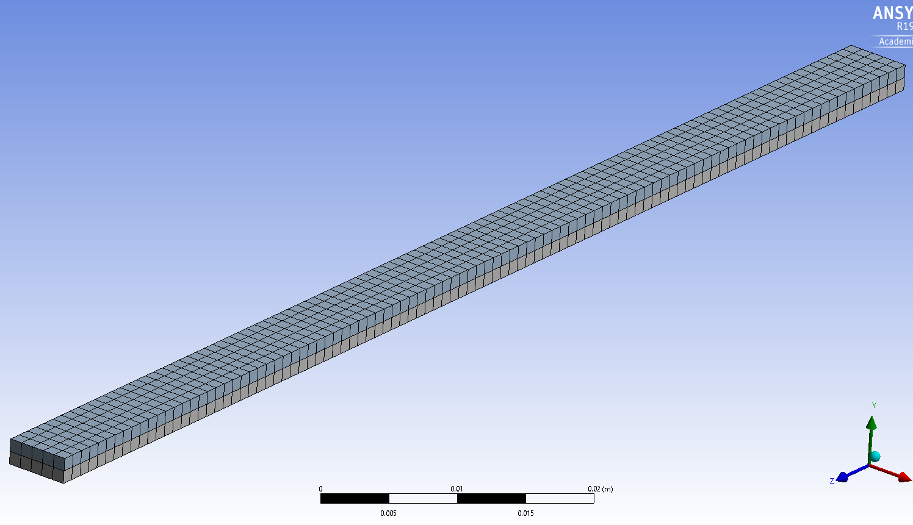
To assess the thermal study accuracy, the Dlubal validation study shown in Appendix 1 and Appendix 2 was used. This was chosen as thermal loadings will be applied to the piston in the form of heat flux on the piston crown and valve cut faces, along with convections on the inner and outer piston surfaces, therefore accuracy from the thermal studies is vital.
Figure 1: Bimetallic Strip assembly used for the validation study, 1mm Element Size. The fixed faces are circled in red

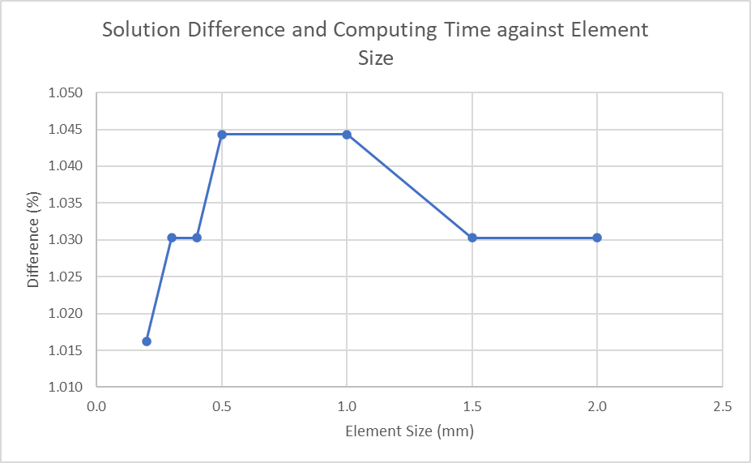
Graph 1: Solution Difference against Element Size, Bimetallic Strip
Graph 1 shows that the difference between the analytical and solver solutions for this validation study, showing that a mesh element size that too fine or too coarse can have an impact on accuracy. However, this difference is small, with the delta between the maximum and minimum difference being 0.03%. This shows that for this validation study, mesh element sizing has minimal impact to solver accuracy

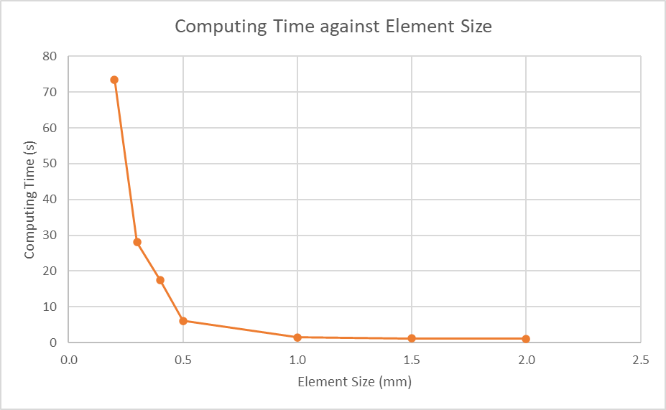
Graph 2: Computing Time against Element Size, Bimetallic Strip
Graph 2 shows that the larger the element size, the faster the computing time. This shows that using a finer element size results in a much longer computing time, allowing for less studies to be run within the same timeframe.

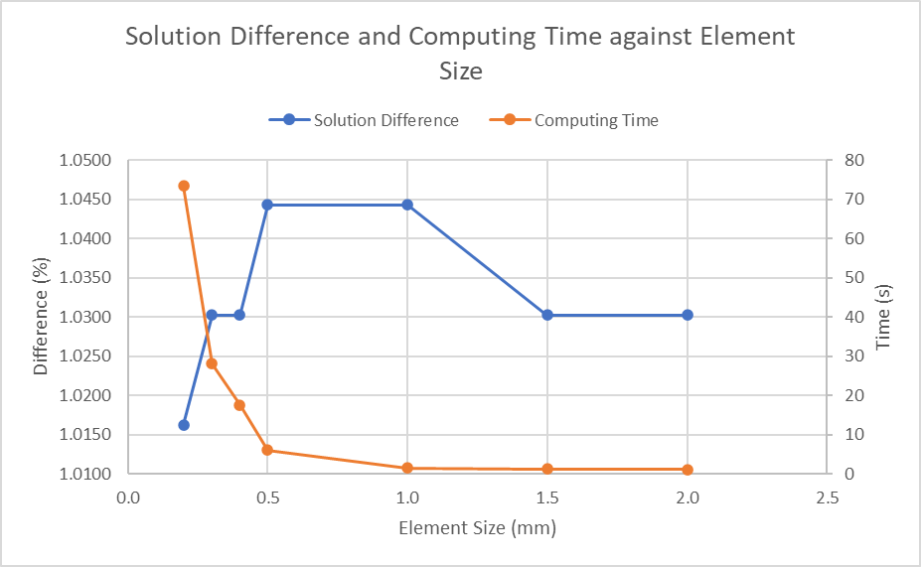
Graph 3: Solution Difference and Computing Time against Element Size, Bimetallic Strip
Graph 3 shows a comparison between the solution difference and computing time. It shows that result accuracy is affected very minimally by mesh element size, however computing time is affected by it, with smaller element sizes resulting in less studies able to be run in the same timeframe, with not enough of a solution accuracy difference to warrant a much longer solving time

Cantilever Uniform Load
To assess the solver accuracy when dealing with calculations involving a uniform load, the Dlubal validation study shown in Appendix 3 and Appendix 4 was used. This is relevant to the study as the piston will be subject to a uniform pressure loading on the crown and valve cut faces, therefore it is necessary to ensure its accuracy.


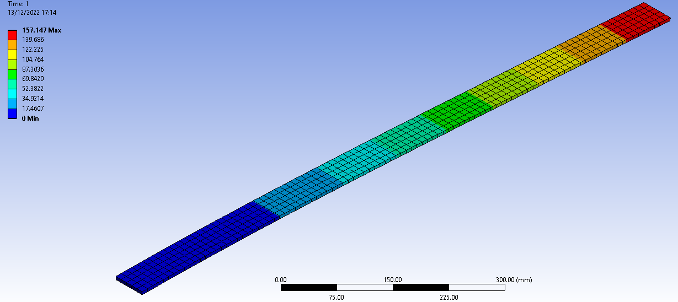
Figure 2: Cantilever uniform load validation study, 10mm element size. The fixed face is circled in red
Figure 2 shows the cantilever uniform load validation study, showing that maximum deflection is at the unfixed end. This is to be expected as it is the furthest away from the fixed point.

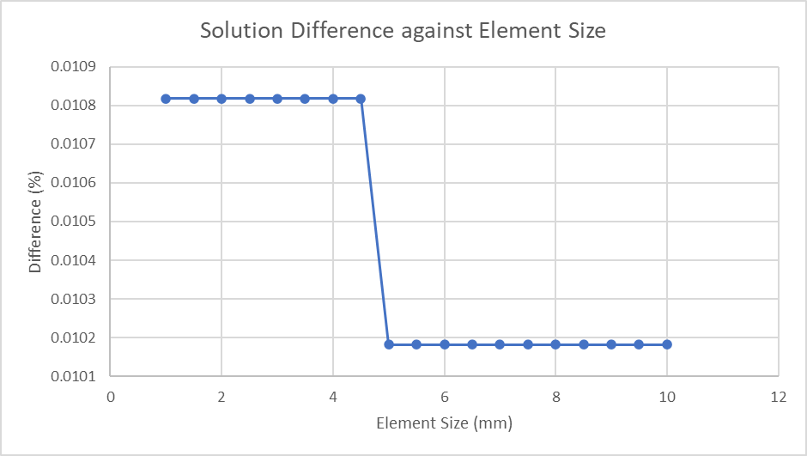
Graph 4: Solution Difference against Element Size, Cantilever Uniform Load
Graph 4 shows that for this case, solution accuracy is very minimally affected by mesh size with the largest difference being 0.0006%. This percentage difference is practically negligeable, showing that for this study, element size does not affect solution accuracy in a noticeable manner. This could be because the component is a simplistic structure
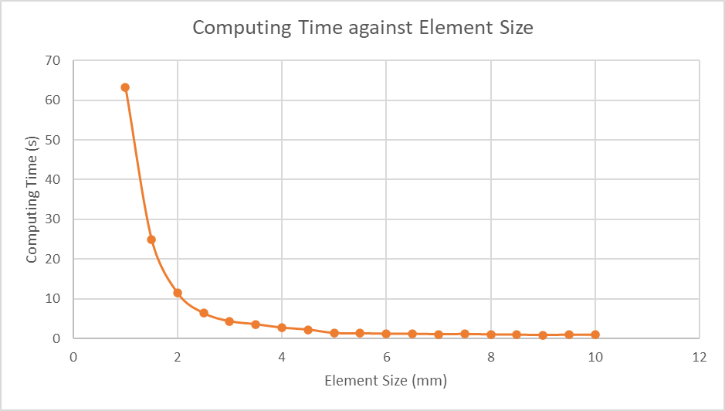
Graph 5: Computing Time against Element Size, Cantilever Uniform Load
Graph 5 shows that unlike percentage difference between the analytical and solver solutions, the computing time is greatly affected by element size. It shows that the smaller the element size, the longer it takes to compute. This is to be expected as a smaller element size will result in the component having more elements, which would take longer to compute.
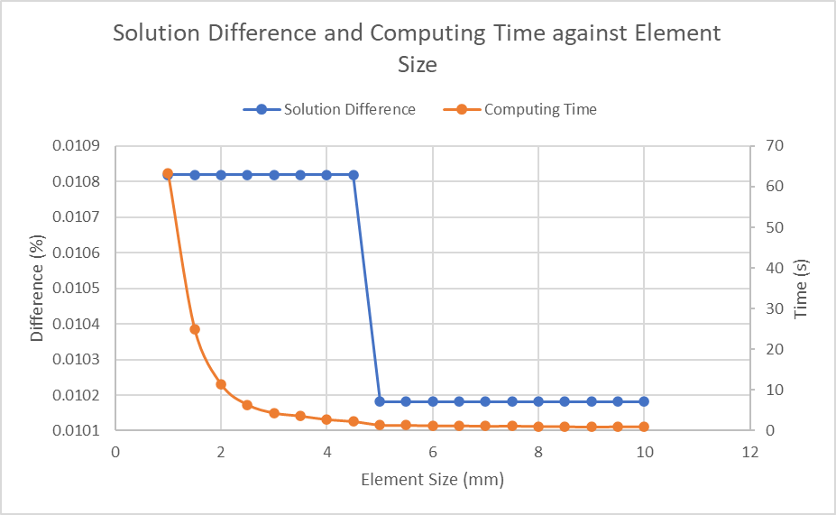
Graph 6: Solution Difference and Computing Time against Element Size, Cantilever Uniform Load
Graph 6 shows a similar pattern to Graph 3, showing that result accuracy is affected very minimally by mesh element size, however computing time is affected by it. The percentage difference between analytical and solver solution for this study is much smaller than the study run for the bimetallic strip, showing that the solvers outputs for this study are very accurate. Again, the computational time increases with a smaller element size, with not enough of a solution accuracy difference to justify a longer solving time.

Modelling and Assembly

Model
To assess the capability of ANSYS Mechanical when modelling components that move, have thermal influences and can deform, a simple model of an engine was used. This model only made use of one piston, gudgeon pin and connecting rod, connected to a crankshaft. The assembly is shown below:
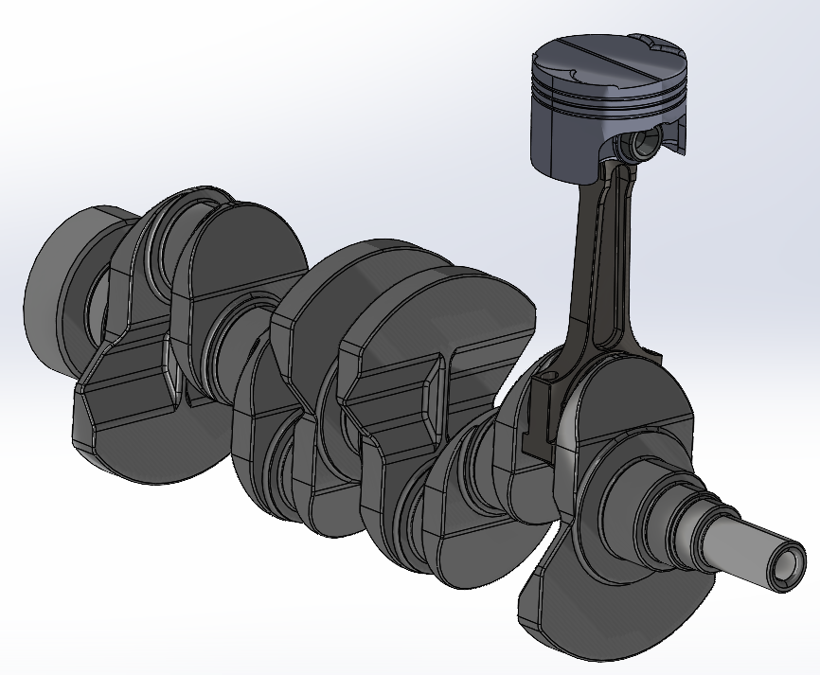
Figure 3: Engine Assembly (Noble, 2022)
The part to be assessed is the piston. This is an area where weight can be saved by changing the material to another type, along with having other beneficial characteristics. The base piston is made from 6061-T6 grade aluminium (Noble, 2022). This piston will be tested, along with 2 different grades of aluminium commonly used to make pistons for high performance engines, 2168-T6 and 4032-T6. This will allow for a comparison between the different grades. The material properties and the elements present in each alloy are shown in Table 1 and Table 2 respectively:
Table 1: Material Properties of the Selected Aluminium Grades
Table 2: Alloy element breakdown of the Selected Aluminium Grades

Boundary Conditions
To test the piston effectively, each study will be subject to the same boundary conditions.
The rotational velocity at the crankshaft was set to 6500RPM. This value was chosen as it is representative of an inline 4 engines redline, making sure the piston is suitable for extreme operating conditions. Additionally, 2168-T6 and 4032-T6 are both grades of aluminium which are commonly used in high performance engines, therefore it is to be expected that the pistons would be subject to high RPM loads.
Boundary conditions will also be created from the joint probe on the piston to gudgeon pin connection, which will log the forces and moments the piston is subject to. An example of this is shown below in Figure 4:

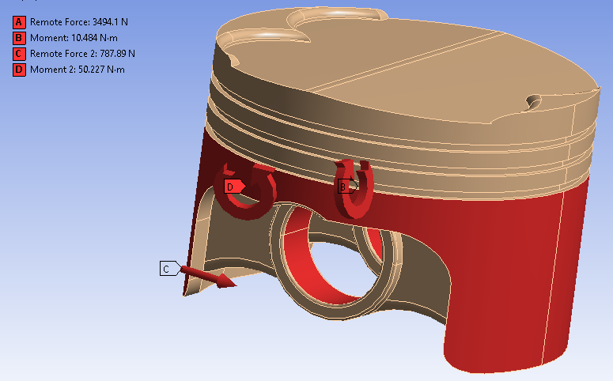
Figure 4: Imported loads from the Rigid Dynamics solver, 6061-T6
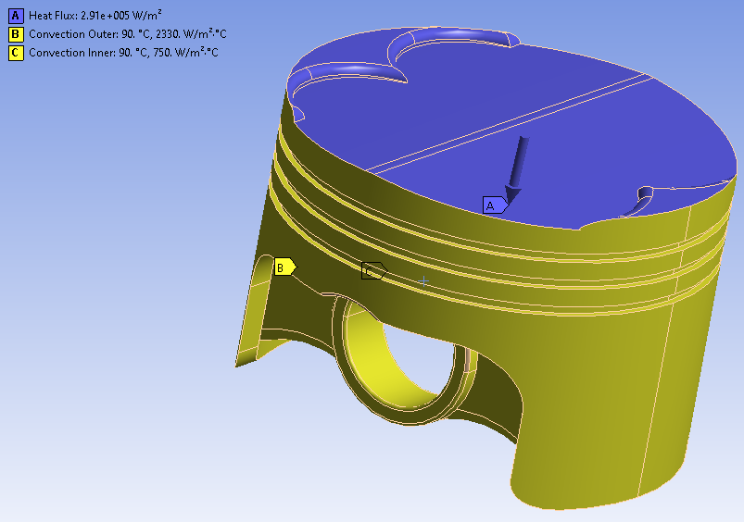
To model the thermal influences effectively, values used in a paper on the study of a piston using ANSYS Mechanical by Cioat et. Al. will be used. These values are shown in the table below, along with showing them applied to the part in Figure 5.
Figure 5: Thermal loadings applied to the piston
Table 3: Thermal loadings to be applied to the piston (Cioat, 2017)

Testing Methodology
To effectively test the piston, the following methodology was used:
- Create the component in Solidworks 2022, using the geometry measurements provided in the validation study documents
- Save the part/assembly as a .STEP file
- In ANSYS Workbench, insert an “Engineering Data” system block, then create the material(s) needed for the study using the toolbox
- Insert a “Rigid Dynamics” system block and connect the “Engineering Data” block to the “Engineering Data” section of the “Rigid Dynamics” system,
- Right click on the “Geometry” section on the “Static Structural” block, then import the .STEP file
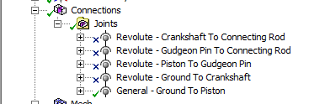
- Once the assembly has been imported, create the connections necessary for accurately modelling the system, shown in the figure below:
Figure 6: Connections applied to the engine assembly
- Apply the desired material to the piston
- Apply a rotational velocity to crankshaft to ground joint model the crankshaft spinning at that speed.
- Apply a joint probe to the piston to gudgeon pin joint to record the force between the two contact points. This records the force acting between the gudgeon pin and the piston contact point
- Run the solver
- Find the maximum value for the force, then export the result as a .txt file
- Add a “Static Structural” block to the system, connecting it to the “Engineering Data”, “Geometry” and “Model” sections of the “Rigid Dynamics” solver
- Open the “Model” section of the “Static Structural” solver, right click on the piston part and select “Suppress All Other Bodies”
- Insert the Motion Loads file from the “Rigid Dynamics” study to apply the forces from that study to the piston.
- Apply a pressure to the piston crown and valve cut faces
- Close the Mechanical viewer
- Insert a “Steady State Thermal” study, attaching it to the “Model,” “Geometry” and “Engineering Data” sections of the “Rigid Dynamics” study
- Apply the heat flux to the piston crown and valve cut faces, convection to the outer faces and convection to the inner faces
- Run the solver
- Close the Mechanical viewer
- Insert a “Static Structural” study, attaching it to the “Model,” “Geometry” and “Engineering Data” sections of the “Rigid Dynamics” study
- Connect the “Solution” section from the “Steady State Thermal” study to the “Setup” section of the “Static Structural” study
- Open the Setup section of the “Static Structural” study
- Set the piston “Stiffness Behaviour” to “Flexible”
- In the “Solution” section of the “Static Structural” study, insert “Total Deformation,” “Equivalent Elastic Strain” and “Equivalent Stress”
- In the “Solution” section of the “Steady State Thermal” study, insert “Temperature” and “Total Heat Flux”
- Run the solver
- Repeat steps 5 through 29 until all materials are tested. The final Workbench layout us shown below:
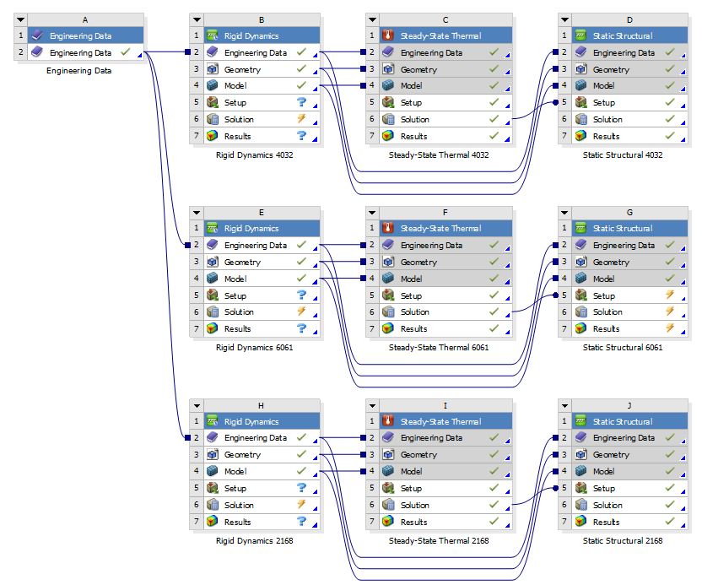
Figure 7: Final workbench layout for testing the 3 different aluminium grades

Results

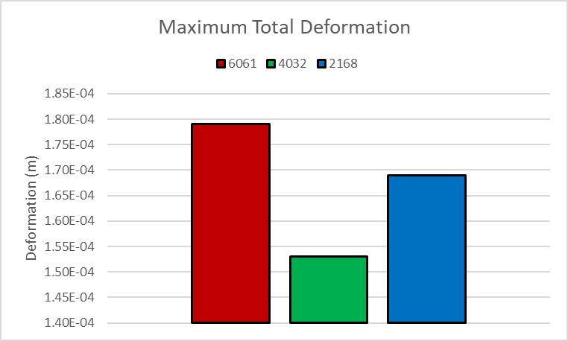
Total Deformation
Graph 7: Maximum Total Deformation
Graph 7 shows that 6061-T6 shows the highest maximum deformation, with 4032-T6 showing the least. This is to be expected, as the 4032-T6 alloy’s higher silicon content reduces its expansion rate, thus resulting in it deforming less than 2168-T6 and 6061-T6 when subjected to the same boundary conditions (JE Pistons, 2019).
4032-T6 has the lowest thermal expansion coefficient, meaning that the thermal influences have less impact on its deformation, again validating this study as it shows that it deforms the least. Lower deformation values means that a 4032-T6 piston can be machined using tighter production tolerances, due to it expanding less with temperature increases (JE Pistons, 2019).

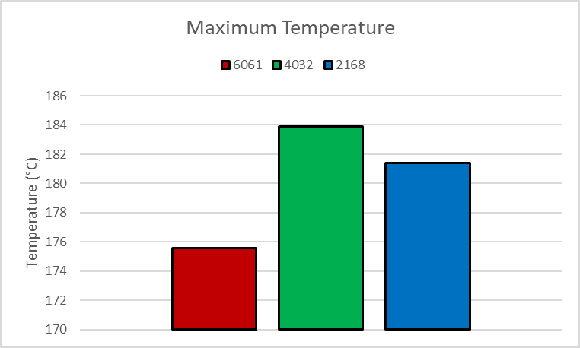
Temperature
Graph 8: Maximum Temperature
Graph 8 shows that at the maximum temperature of 4032-T6 is higher than for the other two aluminium grades. This makes sense as 4032-T6 has the lowest thermal conductivity value, meaning that it takes longer to dissipate the same amount of heat when compared to the other two aluminium grades, therefore holding in more thermal energy in comparison (Bird, Stewart and Lightfoot, 2006). This is also the reason why 6061-T6 has the lowest maximum temperature, as it has the highest thermal conductivity value, meaning it can dissipate the thermal energy faster (Bird, Stewart and Lightfoot, 2006).
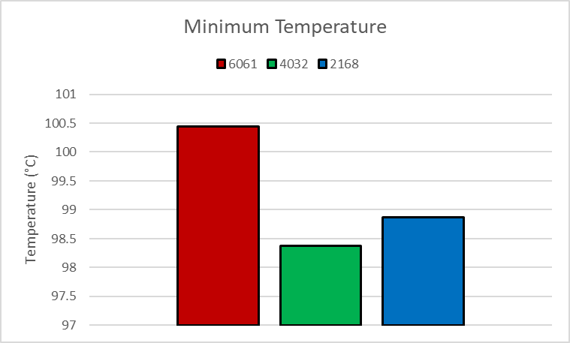
Graph 9 shows that minimum temperature is lowest for the 4032-T6 alloy and highest for the 6061-T6 alloy, the opposite of the trend shown in Graph 8. This makes sense as materials with lower thermal conductivity values do not transfer thermal energy as effectively as materials with higher thermal conductivity values, thus resulting in a larger temperature difference through the component (Bird, Stewart and Lightfoot, 2006). The opposite is true for the 6061-T6 alloy, as its higher thermal conductivity value results in it transferring thermal energy through its structure more effectively, resulting in a lower temperature difference. (Bird, Stewart and Lightfoot, 2006).
Graph 9: Minimum temperature

Equivalent Stress
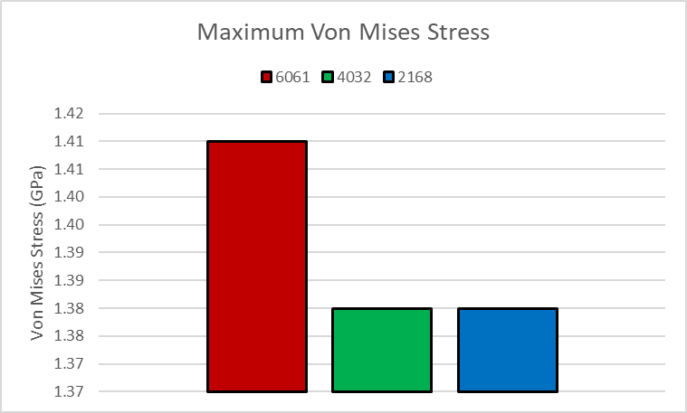
Graph 10: Maximum Von Mises Stress
Graph 10 shows that 6061-T6 has the highest Von Mises Stress of the 3 aluminium grades, with 4032-T6 and 2168-T6 having the same value. This shows that 6061-T6 is less resistant to stress, however it is not enough that the piston would experience plastic deformation, which would permanently deform it.

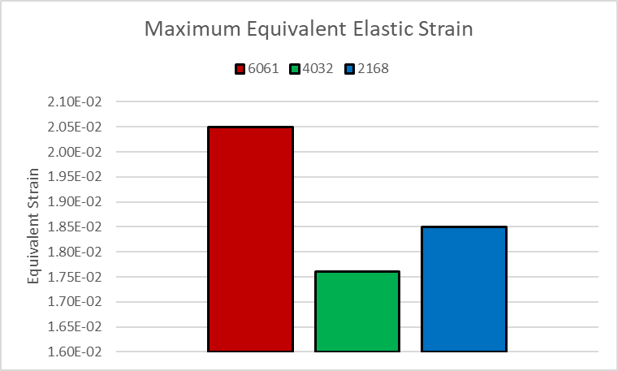
Equivalent Elastic Strain
Graph 11: Maximum Equivalent Elastic Strain
Graph 11 shows that the maximum equivalent elastic strain is highest for 6061-T6 and lowest for 4032-T6. The trend shown is the same as shown in Graph 7, which makes sense as strain is equal to the difference in component length divided by the original length. Again, this shows that 4032-T6 expands the least, which is to be expected due to its high silicon content (JE Pistons, 2019).

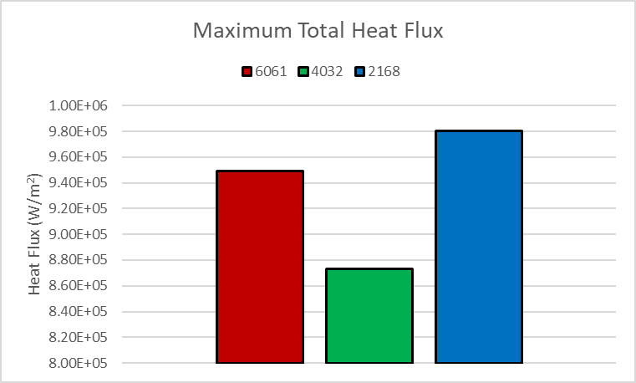
Total Heat Flux
Graph 12: Maximum Total Heat Flux
Graph 12 shows that 2168-T6 experiences the largest maximum total heat flux and that 4032-T6 experiences the least total heat flux. As heat flux represents the flow of heat through the component, it shows that heat flows through the 2168-T6 piston the easiest, whilst flowing through the 4032-T6 piston the least. This is similar to the results shown in Graph 9 and is to be expected.

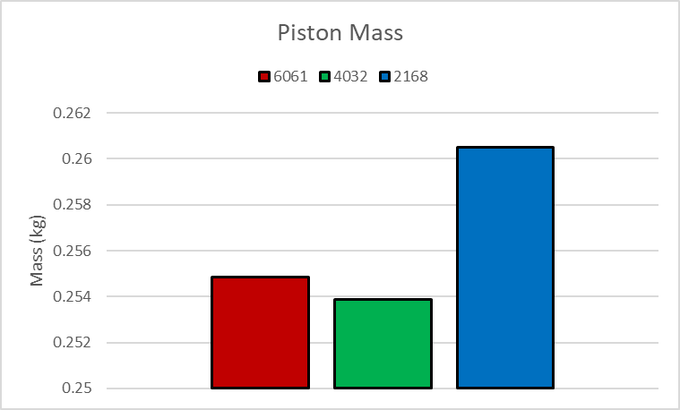
Mass
Graph13: Piston mass
Graph 13 shows that the piston mass is the lowest for the 4032-T6 allow, and highest for the 2168-T6 alloy. Referring to Table 1, this makes sense as 4032-T6 has the lowest density, therefore the pistons mass should be lowest when using 4032-T6. A lower mass results in a lower inertia value, in turn resulting in allowing this engine to rev faster when fitted with 4032-T6 pistons when compared to the other two graded

Results Analysis
Looking at the results shown throughout Section 5, it is clear to see that each aluminium grade has desirable properties. However, 4032-T6 will be used as the piston material moving forward. When factoring in the three missing pistons, changing from 6061-T6 to 4032-T6 results in a mass reduction of 0.0038kg. Albeit small, the mass reduction will result in the engine revving faster.
As mentioned in Section 5.1., the lower maximum deformation of the piston made from 4032-T6 allows for tighter machining tolerances to be run, which is advantageous as the component can be made closer to the size it will be when in service at the set thermal boundary conditions.

Conclusion
When given accurate boundary conditions to work with, ANSYS Workbench can be a powerful analysis tool, allowing for multiple studies to be run in a fraction of the time that running the same study physically would require. Additionally, multiple studies can be run, with the results from one being used in another to influence its output, furthering the result accuracy.
The validation studies show that ANSYS Mechanical was very accurate to the expected analytical result, in turn showing that the output parts can be expected to operate as expected when put into service. The studies also showed that mesh element size does affect solver accuracy, however this difference was very minimal. Additionally, they show that finer element sizing results in much longer computing times. Combine this with the minimal effect on accuracy, finer element sizes may not be worth the added computing time.
The results shown in Section 5 highlight the differences between the three aluminium grades, each showing how they differ from each other when subject to the same crankshaft rotational velocity and thermal boundary conditions. Additionally, it shows solver accuracy when handling components made from materials with different properties, as the expected differences were present in the output results. This again validates the outputs from ANSYS Mechanical.
To further improve mass reduction and take full advantage of 4032-T6s properties, topology studies should be run, which will allow the solver to reduce mass where it deems it unnecessary. The output designs can be used to influence future designs through an iterative process, thus reducing mass even further whilst maintaining the majority of its existing desirable characteristics.

References
Macdonald, B. (2011). Practical Stress Analysis with Finite Elements. 2nd edn. Dublin: Glasnevin Publishing
Dassault Systems (2022). Topology Study. Accessible at: (Accessed 31st October 2022).
Cyprien (2016). The role of boundary conditions. Available at:(Accessed 2nd November 2022).
McCaslin, S (2021). Validation and Verification in Finite Element Analysis (FEA). Accessible at: https://control.com/technical-articles/validation-and-verification-in-finite-element-analysis-fea/ (Accessed 12th November 2022).
Dlubal (2018). 0078 – Bimetallic Strip. Accessible at: https://www.dlubal.com/-/media/B437DA0115FB496C9C7BA58F08960A5E.ashx (Accessed 13th December 2022).
Dlubal (2016). 0016 – Elastic Bending - Continuous Load. Accessible at: https://www.dlubal.com/-/media/769CFB1370D742D9BEE0D37876B3E637.ashx (Accessed 13th December 2022).
AZO Materials (2012a). Aluminium/Aluminum 4032 Alloy (UNS A94032). Accessible at: https://www.azom.com/article.aspx?ArticleID=6622 (Accessed 15th December 2022).
AZO Materials (2012b). Aluminium / Aluminum 2618 Alloy (UNS A92618). Accessible at: https://www.azom.com/article.aspx?ArticleID=6617 (Accessed 15th December 2022).
Aerospace Specification Metals Inc. (2016). Aluminum 6061-T6. Accessible at: https://asm.matweb.com/search/SpecificMaterial.asp?bassnum=ma6061t6 (Accessed 15th December 2022)
JE Pistons (2019). Piston Faceoff: 2618 vs. 4032 Aluminum Alloys. Accessible at: https://www.enginebuildermag.com/2019/08/piston-faceoff-2618-vs-4032-aluminum-alloys/ (Accessed 15th December 2022)
Bird, R., Stewart, W., and Lightfoot, E. Transport Phenomena. Hoboken: John Wiley & Sons
Noble, A (2022). Engine Assembly and Components
Cioat et. Al. (2017). Mechanical and thermal analysis of the internal combustion engine piston using Ansys. Accessible at: https://iopscience.iop.org/article/10.1088/1757-899X/163/1/012043/pdf (Accessed 15th December 2022)

Appendix
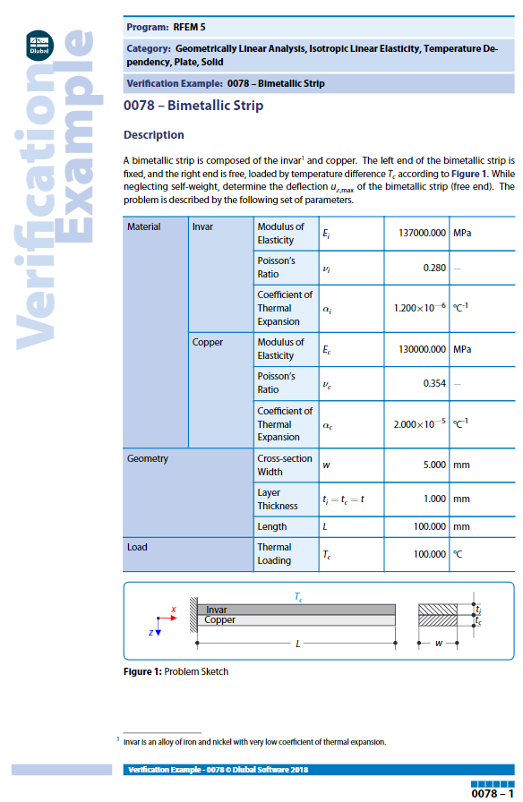
Appendix 1:Page 1 of the Dlubal bimetallic strip validation study (Dlubal, 2018)

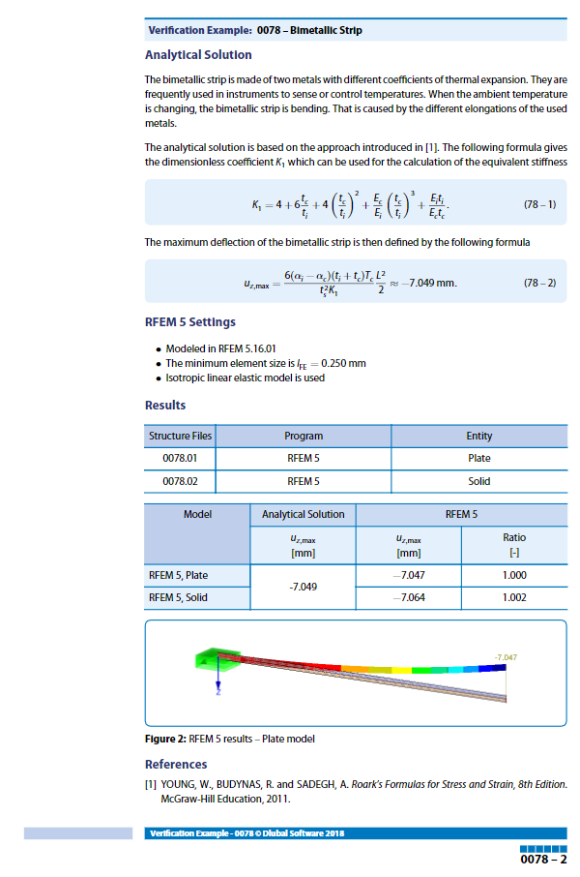
Appendix 2: Page 2 of the Dlubal bimetallic strip validation study (Dlubal, 2018)

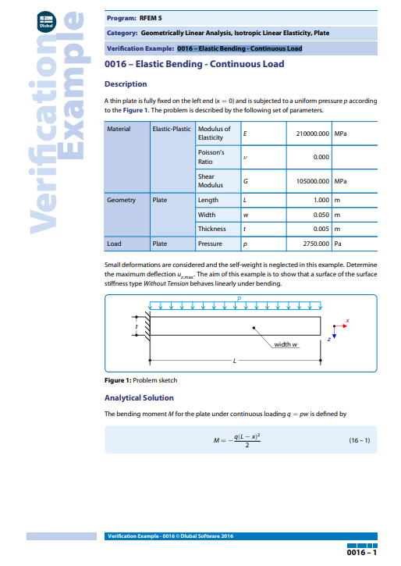
Appendix 3: Page 1 of the Dlubal elastic bending – continuous load validation study (Dlubal, 2016)

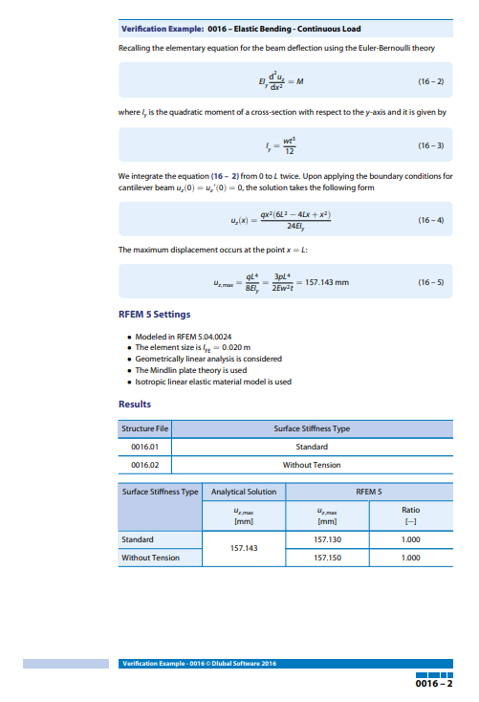
Appendix 4: Page 2 of the Dlubal elastic bending – continuous load validation study (Dlubal, 2016)

