
UNIVERSITY OF WALES TRINITY & SAINT DAVID
MODULE CODE: ACCA6026
rajeev nath
Andrey Atanasov
2324732
2324732@student.uwtsd.ac.uk
data warehousing AND DATA mining

BSC applied computing

Contents
INTRODUCTION 2
TASK 1 2
1.1: OLTP vs Data Warehousing 2
1.2: Data Warehouse Architecture & ETL 2
1.3: Data Marts for Management Decision-Making 4
1.4: OLTP Normalisation vs Data Warehouse Dimensional Modelling 4
TASK 2 6
2.1: Source Identification 6
2.2: Star Schema Design 6
2.3: Data Marts Schema 8
2.4: ETL Plan 8
2.5: Data Quality & Governance 9
CONCLUSION 9
REFERENCES 10

INTRODUCTION
This report has been prepared as an external data warehousing consultant's response to a request from NHS England's Chief Executive and senior leadership team. NHS England oversees a large and complex healthcare system, and while individual systems such as Electronic Patient Records (EPR), Patient Administration Systems (PAS) and workforce platforms operate effectively at a local level, a fragmented data landscape currently prevents a consolidated, near real-time view of performance across regions and care pathways.
Task 1 introduces the case for a data warehouse to the Board in non-technical terms: how it differs from the OLTP systems NHS England already uses, how its architecture and ETL process integrate existing data sources without disrupting daily operations, how tailored data marts can serve the CEO, Finance Director and Medical Director, and how dimensional modelling differs from the normalised structures the IT Director is familiar with.
Task 2 builds on this approval in principle to produce a concrete design: the internal and external sources that will feed the warehouse, a star schema and supporting schemas for NHS activity data, the data marts that support departmental decision-making, a simplified ETL plan, and the data quality and governance considerations that must be addressed throughout.

TASK 1

1.1: OLTP vs Data Warehousing
NHS England already relies on Online Transaction Processing (OLTP) systems, Electronic Patient Records (EPR), Patient Administration Systems (PAS) and workforce platforms, to record day-to-day operations such as admissions, shift patterns and bed status. These systems are read-write, updated continuously as events happen, and optimised for fast, high-volume transactions that answer operational who and what questions. They are not built, however, to answer the strategic why, what-if and what-next questions senior leadership needs to plan capacity, manage budgets and respond to demographic pressures [1].
A data warehouse closes this gap. It is a subject-oriented, integrated, time-variant and non-volatile collection of data built specifically to support decision-making [2]. Rather than replacing EPR, PAS or workforce systems, it draws data from them, alongside clinical and financial systems, into one consolidated, read-only repository spanning every region and care pathway [3]. Because it is refreshed on a planned cycle rather than continuously, it does not interfere with the live systems clinicians and administrators depend on daily. The benefit is already proven within the NHS: Midlands and Lancashire Commissioning Support Unit built a data warehouse for financial reporting and halved the time taken to produce financial planning templates, freeing finance staff for higher-value analysis [4].
An equivalent capability for NHS England would give the Board a single, near real-time view of patient flow, bed utilisation, workforce capacity and cost per treatment across the whole organisation, insight no individual OLTP system can provide alone.

1.2: Data Warehouse Architecture & ETL
Figure 1 illustrates how a data warehouse for NHS England would be structured. The architecture has three layers: source systems, a staging area where data is extracted, transformed and loaded (ETL), and the data warehouse itself, from which role-specific data marts are drawn [2].
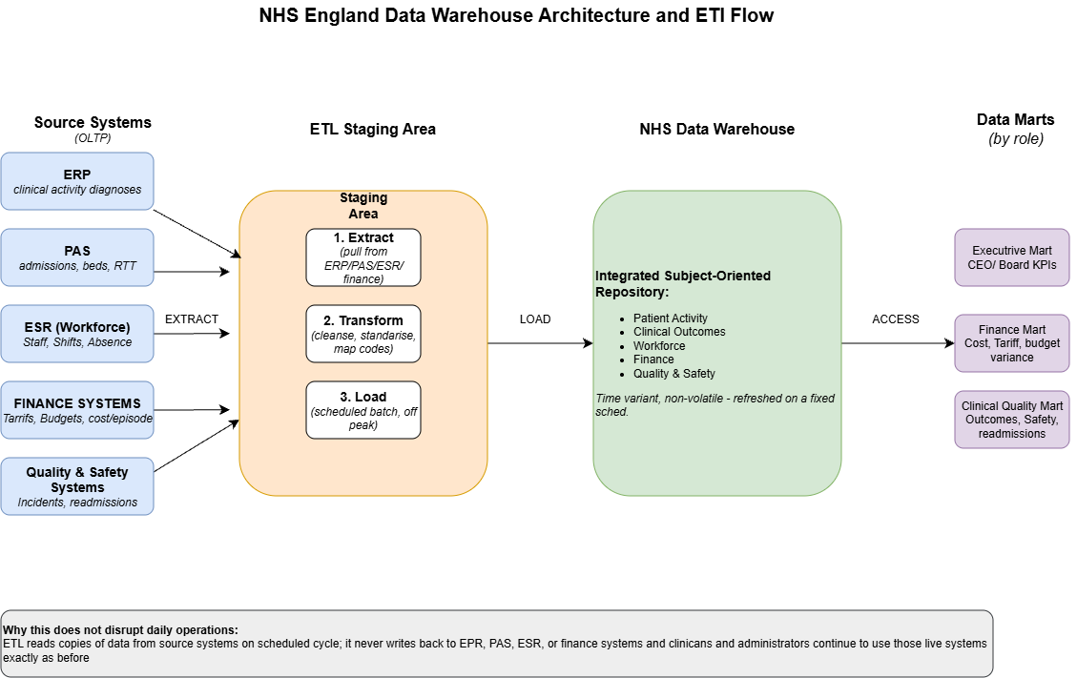
Figure 1. NHS England data warehouse architecture and ETL flow, adapted from the three-layer architecture in [2], the ETL patterns in [5], and the NHS Federated Data Platform [6].
Source systems remain exactly as they are today: EPR and PAS supply patient, admission and clinical activity data; the Electronic Staff Record (ESR) supplies workforce data such as shifts and sickness absence; finance systems supply tariffs, budgets and cost-per-episode figures; and quality and safety systems supply incident and readmission data [5].
None of these systems is replaced or modified, the warehouse simply reads from them.
The ETL process moves data through three steps. Extraction pulls copies of records from each source system on a scheduled basis, typically overnight when clinical and administrative use is lowest. Because different systems may record the same patient under different local identifiers, transformation resolves these to the patient's NHS number, giving a single consistent view of each individual across acute, community and mental health records. Transformation also cleanses the extracted data, resolves inconsistencies such as differing coding standards across trusts, and maps clinical codes, for example ICD-10 diagnoses, to a common format [5]. Loading then writes the cleaned, standardised data into the warehouse, which is refreshed on this fixed cycle rather than continuously [2].
This design is why the warehouse will not disrupt daily healthcare operations.
ETL extracts are read-only: they copy data out of EPR, PAS, ESR and the finance systems but never write back into them, so clinicians, administrators and finance staff continue using those systems exactly as before, unaffected by the warehouse's schedule.
NHS England has already validated this approach at national scale through the Federated Data Platform, which connects operational data from hospitals, community providers and specialist centres into a single environment without altering the underlying source systems [6].
Once loaded, the warehouse becomes a single, subject-oriented store of patient activity, workforce, finance and quality data spanning every region. From this central repository, the CEO, Finance Director and Medical Director can each be served a tailored data mart, discussed further in Section 1.3, without needing to query the underlying operational systems directly.

1.3: Data Marts for Management Decision-Making
Rather than forcing the CEO, Finance Director and Medical Director to query the warehouse directly, each should be served a data mart: a smaller, subject-specific extract built for their particular decisions. Evidence from the healthcare literature shows that dashboards tailored to a specific role, rather than one generic report, measurably improve the speed and quality of decision-making [7].
Each mart draws from the same underlying warehouse but is shaped around a different audience:
The Executive Mart, for the CEO and Board, aggregates data to a high, cross-organisational level: overall referral-to-treatment (RTT) compliance, bed occupancy, elective waiting list size and total cost per patient episode, trended monthly across every region. Its purpose is strategic oversight rather than operational detail, so it deliberately hides ward- or service-level granularity that would only distract from board-level decisions.
The Finance Mart, for the Finance Director, goes deeper into cost and budget data: tariff income against actual treatment cost, budget variance by directorate and region, and workforce-related costs such as agency staff spend and overtime drawn from ESR. This level of detail supports monthly reconciliation and forecasting work that the Executive Mart is not built for.
The Clinical Quality Mart, for the Medical Director, is built around outcomes and safety rather than cost: readmission rates, mortality indicators, patient safety incidents and RTT breaches broken down by specialty and treatment centre, supporting clinical governance and service improvement decisions.
Although these three marts hold different measures, they must stay consistent with one another. This is achieved through conformed dimensions, shared reference tables for time, region and service line, managed once and reused across every mart [8].
Because all three are dependent marts drawn from one integrated warehouse rather than independently built silos, NHS England avoids the fragmented, inconsistent reporting it experiences today across separate trust systems. The CEO can therefore see a KPI dip in the Executive Mart and drill into the Finance or Clinical Quality Mart for the same period and region without reconciling conflicting figures. NHS England's Federated Data Platform already applies this principle nationally, offering distinct analytical products for priority areas such as elective recovery and population health management from a shared data foundation [6].

1.4: OLTP Normalisation vs Data Warehouse Dimensional Modelling
NHS operational systems such as PAS store data in normalised form, following the OLTP design principle established by Inmon: entities such as patient, admission, treatment and ward are split into separate, related tables to eliminate redundancy and protect transactional integrity [3]. This structure is efficient for recording one admission or one procedure at a time, but answering a broad question, for example total treatment cost by specialty across the year, requires joining many tables together, which is slow and hard for non-technical staff to follow [9].
A data warehouse instead uses dimensional modelling, arranged as a star schema: a central fact table holding measurable events and numeric measures, surrounded by denormalised dimension tables describing the context of each event [10].
Figure 2 shows a star schema for NHS patient activity. The fact table, FactPatientActivity, holds foreign keys to DimPatient, DimTreatment, DimLocation and DimDate, together with measures such as cost and length of stay. Because each dimension is a single flattened table, a query such as total cost of cardiology treatments in the Northwest last quarter needs only one join per dimension, rather than the many joins a normalised OLTP schema would require [1].
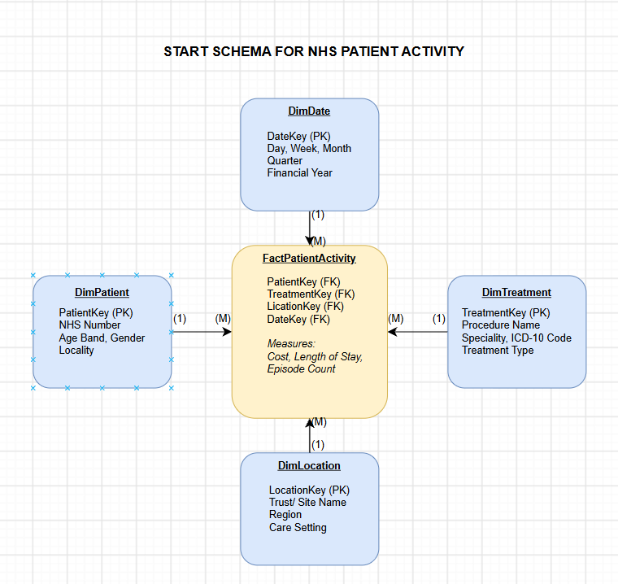
Figure 2. Star schema for NHS patient activity, adapted from the healthcare star schema in [1] and Kimball dimensional modelling principles [10].
For the IT Director, the practical difference is this: normalisation protects the systems that capture care as it happens; dimensional modelling makes the same data fast and simple to analyse afterwards. NHS England needs both, operating side by side, not one replacing the other.

TASK 2

2.1: Source Identification
NHS England's data warehouse draws on both internal and external sources. Internally, each trust's Electronic Patient Record (EPR) and Patient Administration System (PAS) supply patient, admission and clinical activity data [11]; the Electronic Staff Record (ESR) supplies workforce data [12]; and local finance and quality and safety systems supply cost and incident data. Externally, referrals originate in GP and primary care systems, while Integrated Care Systems and partner Trusts contribute activity data for patients treated across organisational boundaries. NHS England's own Federated Data Platform already aggregates operational data nationally from hospitals, community providers and specialist centres, showing that cross-organisational source integration is achievable at scale [6].
Together, these internal and external systems form the source layer feeding the warehouse shown in Figure 1.

2.2: Star Schema Design
A single star schema cannot serve every part of NHS England: patient care, staffing and executive reporting each happen at a different grain and pace. Kimball's enterprise bus architecture, already introduced in Section 1.3 for the data marts, solves this by building several business-process-specific star schemas that share a common set of conformed dimensions [8].
Figure 3 sets out the resulting bus matrix for three core NHS processes, patient activity, workforce activity and monthly performance reporting, showing which dimensions each fact table draws on.
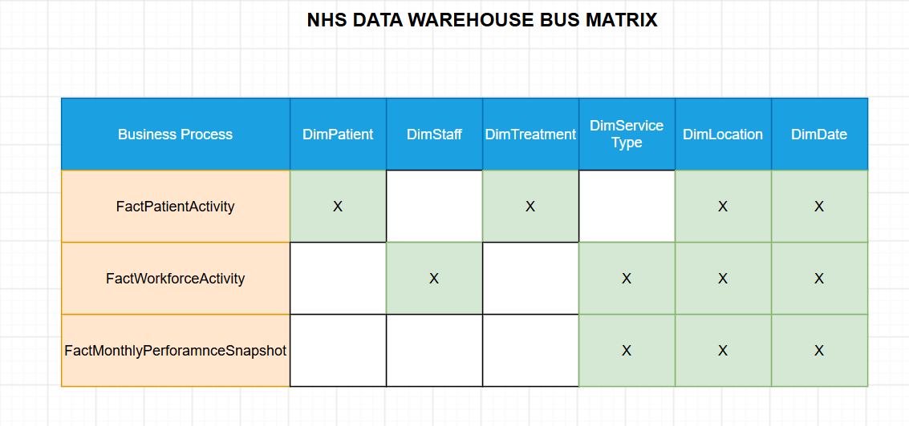
Figure 3. Data warehouse bus matrix showing conformed dimensions shared across NHS business processes, based on the Kimball bus architecture [8].
Two dimensions in the matrix hold master data.
DimPatient, introduced in Figure 2, is joined here by DimStaff, which holds each employee's staff ID, role, banding and home directorate.
Both are slowly changing dimensions: a patient's address or a staff member's role may change over time, but historical activity must still be reportable against the values that applied when the activity occurred.
This is typically handled by preserving the old row and inserting a new one when an attribute changes, so trend analysis is not distorted by later updates. Because both dimensions are conformed, they are built once and reused unchanged by every fact table that needs them.
A third dimension, DimServiceType, holds metadata rather than master data: it classifies activity by service line, for example Acute Care, Community Services, Mental Health, Specialist and Tertiary Care, or Public Health and Prevention, mirroring the service categories in the case study. This lets every fact table be sliced consistently by service type, regardless of which system originally recorded the data.
Two transaction-grain fact tables sit alongside FactPatientActivity from Figure 2.
FactWorkforceActivity records each shift against DimStaff, DimLocation, DimDate and DimServiceType, with measures for hours worked, overtime hours, agency cost and sickness days, directly supporting the workforce capacity and agency spend questions raised in the case study.
Aggregate data is handled differently. Rather than storing one row per transaction, FactMonthlyPerformanceSnapshot stores one row per month, per location, per service type, a periodic snapshot fact table, shown in Figure 4.
Its measures are pre-calculated monthly indicators: average length of stay, bed occupancy rate, RTT compliance percentage, cost per episode and readmission rate. Because these figures are aggregated during ETL rather than computed on demand, the Executive, Finance and Clinical Quality Marts from Section 1.3 can retrieve board-level KPIs instantly, without scanning millions of individual patient or workforce records. As DimLocation, DimDate and DimServiceType are conformed across all three fact tables, a manager can still drill from a monthly KPI down into the underlying patient or workforce transactions when an anomaly needs investigating.
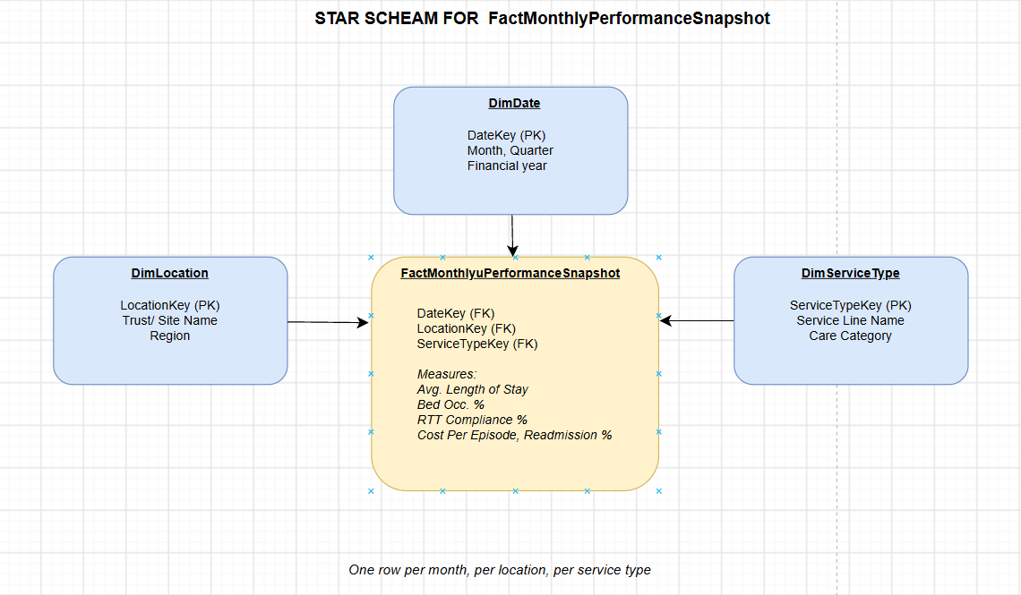
Figure 4. Periodic snapshot star schema supplying pre-aggregated monthly KPIs to the Executive, Finance and Clinical Quality marts.

Together, the master data dimensions (DimPatient, DimStaff), the metadata dimension (DimServiceType) and the aggregate fact table (FactMonthlyPerformanceSnapshot) give NHS England one coherent design rather than three disconnected schemas, satisfying the case study's need for both transactional detail and instant executive-level reporting from the same warehouse.

2.3: Data Marts Schema
Building on the marts identified in Section 1.3, this section specifies the underlying schema each draws on. The Finance Mart is built from FactMonthlyPerformanceSnapshot, filtered to cost, tariff and budget-variance measures, joined to DimLocation, DimServiceType and DimDate; because these figures are pre-aggregated monthly, Finance can reconcile budgets without querying patient-level detail.
The Operations Mart serves day-to-day site and service managers rather than the Board, so it queries FactPatientActivity and FactWorkforceActivity directly at their native daily grain, joined to DimLocation, DimDate and DimServiceType, to monitor bed occupancy, referral-to-treatment waiting times and staffing levels as they change day to day, detail the monthly snapshot deliberately hides.
The Clinical Quality Mart, supporting the Medical Director introduced in Section 1.3, extends FactPatientActivity with quality-specific measures, readmissions, patient safety incidents and mortality indicators, joined to DimPatient, DimTreatment, DimServiceType and DimDate, so clinical governance teams can drill from a service-line trend down to the individual treatment episodes behind it.
All three marts reuse the same conformed DimLocation, DimDate and DimServiceType dimensions from the bus matrix in Figure 3 [8], so a figure appearing in one mart, for instance monthly cost per episode in Finance, can always be traced to the same underlying region, period and service line in Operations or Clinical Quality, avoiding the inconsistent reporting NHS England experiences today across separate trust systems.

2.4: ETL Plan
Figure 5 sets out a simplified ETL plan for the core warehouse tables, extending the extract, transform and load sequence introduced in Section 1.2 to show where each table's data originates and what transformation it needs before loading.
Target Table | Source System(s) | Key Transformation(s)
DimPatient | EPR, PAS | Deduplicate via NHS number; apply slowly changing dimension logic for address/GP changes
DimStaff | ESR | Deduplicate via staff ID; apply slowly changing dimension logic for role/banding changes
DimServiceType | National service classification reference | Standardise service line naming across trusts
DimLocation | PAS, trust site registers | Standardise trust/site names; map to region
DimDate | Generated calendar | Generate day/week/month/quarter/financial year attributes
FactPatientActivity | EPR, PAS | Cleanse duplicate records; map clinical codes (e.g. ICD-10) to a common format
FactWorkforceActivity | ESR | Standardise shift/absence codes; calculate overtime hours
FactMonthlyPerformanceSnapshot | FactPatientActivity, FactWorkforceActivity, finance systems | Aggregate to month/location/service-type grain; calculate KPIs (occupancy %, RTT %, cost per episode)
Figure 5. Simplified ETL plan: source system and key transformation for each warehouse table.

2.5: Data Quality & Governance
Data quality and governance must be addressed throughout ETL and ongoing operations. Accuracy and consistency are enforced during transformation: patient and staff records are deduplicated and clinical codes standardised before loading [5]. Privacy and regulatory compliance follow the Caldicott Principles and UK GDPR, limiting use of identifiable data to justified purposes [13], [14].
Access control restricts each data mart to authorised roles under NHS England's information governance policy, so the CEO, Finance Director and Medical Director see only data relevant to their responsibilities [15].

CONCLUSION
NHS England already collects the operational, clinical, workforce and financial data needed to manage performance nationally; what it lacks is a single, integrated view of it. This report has shown that a data warehouse, built alongside rather than instead of existing EPR, PAS and workforce systems, can provide that view without disrupting the daily operations clinicians and administrators rely on.
Task 1 established the principle: a subject-oriented, integrated repository, populated through a scheduled, read-only ETL process, and made accessible to different stakeholders through tailored, consistent data marts. Task 2 turned this principle into a design NHS England could begin building: a bus matrix of conformed dimensions spanning patient activity, workforce activity and monthly performance reporting; a simplified ETL plan identifying where each table's data originates and how it must be cleansed, standardised or aggregated; and governance controls, aligned with the Caldicott Principles and UK GDPR, for using this data responsibly.
The NHS Midlands and Lancashire case study demonstrates that these benefits are achievable in practice, not just in theory. A similar phased approach, starting with a single high-value area such as financial or elective-recovery reporting before extending to the full set of data marts described here, would let NHS England build confidence in the warehouse quickly while managing implementation risk, supporting the Board's goals of improved patient care, operational efficiency and long-term sustainability.

REFERENCES
[1] O. E. Sheta and A. Nour Eldeen, "The technology of using a data warehouse to support decision-making in health care," International Journal of Database Management Systems, vol. 5, no. 3, pp. 75–86, Jun. 2013. [Online]. Available: https://arxiv.org/pdf/1307.3061. [Accessed July 10, 2026].
[2] O. E. Sheta and A. Nour Eldeen, "Evaluating a healthcare data warehouse for cancer diseases," International Journal of Computer Science and Information Technology & Security (IJCSITS), vol. 3, no. 3, pp. 237–241, Jun. 2013. [Online]. Available: https://arxiv.org/pdf/1307.3448. [Accessed July 10, 2026].
[3] L. Yessad and A. Labiod, "Comparative study of data warehouses modeling approaches: Inmon, Kimball and Data Vault," in Proc. 2016 Int. Conf. System Reliability and Science (ICSRS), Paris, France, Nov. 2016, pp. 95–99, doi: 10.1109/ICSRS.2016.7815845. [Online]. Available: https://www.researchgate.net/publication/312486486_Comparative_study_of_data_warehouses_modeling_approaches_Inmon_Kimball_and_Data_Vault. [Accessed July 12, 2026].
[4] NHS Midlands and Lancashire, "Data warehouse cuts financial reporting time in half," case study, NHS Midlands and Lancashire CSU. [Online]. Available: https://www.midlandsandlancashirecsu.nhs.uk/case-studies/data-warehouse-cuts-financial-reporting-time-in-half/. [Accessed July 13, 2026].
[5] K. Y. Cheng, S. Pazmino, and B. Schreiweis, "ETL processes for integrating healthcare data – tools and architecture patterns," Studies in Health Technology and Informatics, vol. 297, pp. 175–178, Nov. 2022, doi: 10.3233/SHTI220974. [Online]. Available: https://ebooks.iospress.nl/doi/10.3233/SHTI220974. [Accessed July 14, 2026].
[6] NHS England, "Federated Data Platform," NHS England Digital, 2025. [Online]. Available: https://digital.nhs.uk/services/federated-data-platform. [Accessed July 15, 2026].
[7] A. Iftikhar, R. Bond, V. E. McGilligan, A. McShane, S. J. Leslie, K. Rjoob, C. Knoery, and A. Peace, "Role of dashboards in improving decision making in healthcare: review of the literature," in Proc. 31st Eur. Conf. Cognitive Ergonomics (ECCE 2019), Belfast, UK, 2019, pp. 215–219, doi: 10.1145/3335082.3335109. [Online]. Available: https://dl.acm.org/doi/10.1145/3335082.3335109. [Accessed July 17, 2026].
[8] Kimball Group, "Enterprise data warehouse bus architecture," Kimball Dimensional Modeling Techniques. [Online]. Available: https://www.kimballgroup.com/data-warehouse-business-intelligence-resources/kimball-techniques/kimball-data-warehouse-bus-architecture/. [Accessed July 18, 2026].
[9] S. Rangarajan, "Data warehouse design – Inmon versus Kimball," TDAN.com / Dataversity, Sep. 1, 2016. [Online]. Available: https://www.dataversity.net/articles/data-warehouse-design-inmon-versus-kimball/. [Accessed July 19, 2026].
[10] Kimball Group, "Star schemas and OLAP cubes," Kimball Dimensional Modeling Techniques. [Online]. Available: https://www.kimballgroup.com/data-warehouse-business-intelligence-resources/kimball-techniques/dimensional-modeling-techniques/star-schema-olap-cube/. [Accessed July 20, 2026].
[11] NHS England Digital, "Building healthcare software – acute, community and mental health care," NHS England Digital. [Online]. Available: https://digital.nhs.uk/developer/guides-and-documentation/building-healthcare-software/acute-community-and-mental-health-care. [Accessed July 22, 2026].
[12] NHS Business Services Authority, "Electronic Staff Record (ESR) workforce services," NHSBSA. [Online]. Available: https://www.nhsbsa.nhs.uk/electronic-staff-record-esr-workforce-services. [Accessed July 23, 2026].
[13] National Data Guardian for Health and Social Care, "The Caldicott Principles," GOV.UK, Dec. 2020. [Online]. Available: https://assets.publishing.service.gov.uk/government/uploads/system/uploads/attachment_data/file/942217/Eight_Caldicott_Principles_08.12.20.pdf. [Accessed July 24, 2026].
[14] U.K. Government, Data Protection Act 2018, c. 12, London, U.K.: The Stationery Office, 2018. [Online]. Available: https://www.legislation.gov.uk/ukpga/2018/12/contents. [Accessed July 28, 2026].
[15] NHS England, "Information governance and data protection," NHS England, 2024. [Online]. Available: https://www.england.nhs.uk/long-read/information-governance-and-data-protection/. [Accessed July 25, 2026].

