School of International Hotel Management
BA International Hotel Management

Personal Resourcing and Development M5X01921
Module tutor: Dr Jahanzeeb Qurashi
Student number 1905565
Student: Livia Zmuncila

Jumerah Beach Hotel in Dubai
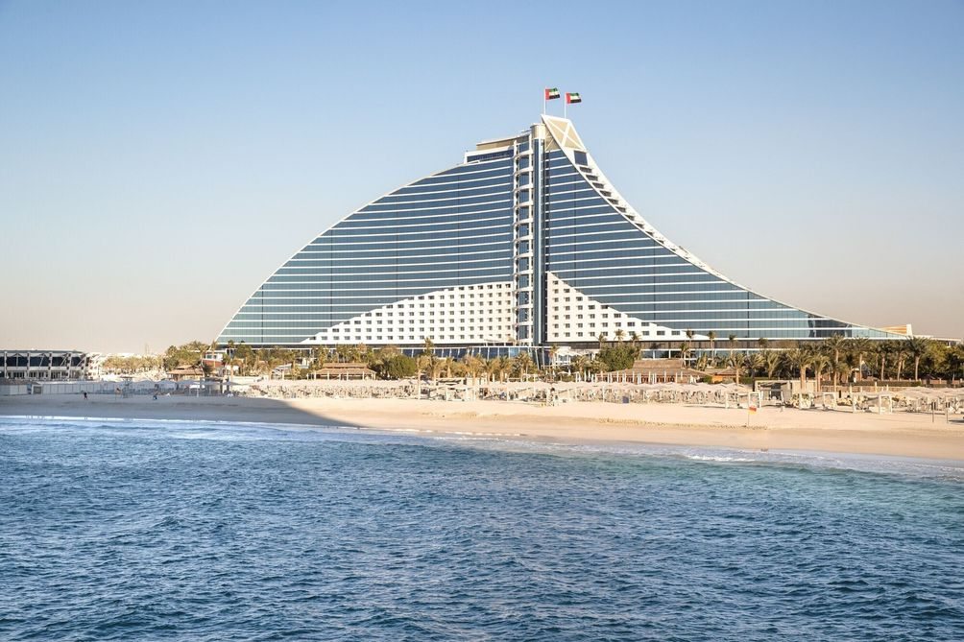

Introduction
The purpose of this work is to demonstrate the understanding of external and internal factors and their influence on performance management, recruitment, selection and identification of the most effective management methods of Human Resources that help to maintain competitive position of the successful hotel business in the hospitality industry.
The starting point of the assignment is the analyses that examined the Jumeirah Beach Hotel’s product in Dubai. It was launched only in 1997 and has got successful in delivering of its product. The keys of its competitive advantages associated:
First, based on its leading principals and standards of its brand, that promotes innovation, integrity, teamwork, core competences, and constant development. It gets 5star rating base on 5 criteria such as Services, Cleanliness, Location, Services and pricing.
Second, customers are of the first priority experience exceeding of their expectations. The hotel is premium family hotel for customers of all ages. Even for children they have wide range of facilities such as: child-friendly restaurants with menus for them especially, playgrounds, kids clubs, and babysitting services.
Third, IBH in Dubai is a role model as a culture of excellence in everything it performs. The evidence of this value we find in customers comments. They offer 9 premium types of rooms starting from Deluxe Room and finishing with President Suite.
More than that, the hotel has the best price guarantee for guests who book directly through their website where customers have the opportunity to save up to 70% and customers are provided convenience to book room and taking sales off to save their money. It shows that the Hotel staff really cares about its customers, as in their statement says, “open minded, challenging, conventional thinking improving their processes and implementing new ideas” (Jumeirah webside).
Its room rate is in America dollars and is from 422 and up. But it is distinguished as 12-th of 452 hotels in Dubai (Trip advisors). Compare room prices of 19 hotels in Dubai that are: 571 and up, 608 and up, 312 and up or 422 and up, we may say that our Hotel achieves luxury, excellent services, and competitive advantage by pricing.
PESTLE Analysis
Systematized, PESTLE analyses are an important and useful management tool. It brings immense contribution to success of a business as it gives the real picture of what is happening around it (Dwyer & Tanner, 2002). The analyses of Dubai is very important in understanding the dynamic and changing external factors, that cannot be control but can influence the operating organization and could determine the place in the market (Jonson, et al., 2013).There are 6 important factors will be investigated:
Political stability of United Arab Emirates, relations with India, China, Sandi Arabia, the USA and many others counties are considered favorable for the hotel business as people feel protected traveling to it. Foreign policy has been based on principals that have tended to avoid any political conflicts in the region (Hellyer, 2001). Political sanctions were applied for all countries.
If to speak about economic factors we can conclude that, the country is prosperous economically and there are appropriate factors to a hotel business. First of all, UAE one of the richest countries in the world, everything starting from the very small details and finishing with decorations in streets and buildings look very expensive. Hotel buildings compete with each other in their architectural beauty, shape and height to make an unforgettable impression on tourists. And because of this facts, every person in the world dreams, even once in his life, to visit this place for to enjoy the breathtaking views of the country. More than that, it is rich in natural resources like gold, petroleum, gas, and diamonds (OEC, 2019) Tourists enjoy purchasing of gold items in local shops. And there are no VET taxes for gold jewelry in comparison with the other countries. The other valid fact is, that people could enjoy a decent standard of tax-free living in Dubai, as neither physical individuals no business establishments should pay any taxes on income or wealth that is perfect for a hotel business and people working there as well (Iberglobal, 2019).
Considering social factors, we can say that tourism business flourishes in counties where people feel social safeness. Emirates is one of these safety places, where locals cohesive, respect and preserve their traditions and customs, practice their Islam religious, value family ties, mutual respect and care, have traditional dress code for men and women and at the same time, they prepared liberal, modern, and entertaining conditions for the tourists in frame of following Islamic law. Native population is just 20% of all people from UAE, but the rest are immigrants, who work in Emirates. The staff of the hotel prepared for their guests the guide of do’s and don’ts in Dubai for tourists. For example, the offensive and insulting behavior or even gestures are the reason to stay in jail. Speaking about COVID-19 we experience now social distancing.
There are 1,137,347 people live in Dubai (Worldometers, 2020) and 86% of the population is urban. Govers and Go (2009, p74) emphasize that Dubai is very powerful brand on the International stage according to expansion, communicating local cultures through global tourism, creature, large-scale projects and usable civic initiatives in collaboration with value premium that a company generates from a product.
Dubai income tax at zero attracts global professionals and is one of the pros of living in Dubai. (Worldometers, 2020), the Hotel occupancy rate was 86%, the highest ever. There were 544 operating hotels and 100,744 hotel rooms. Occupancy rates in Dubai hotels decreased by 0,5% between January and October 2019 in comparison to the rate of 74% in the same period in 2018. The statistic shows that the quantity of 5star hotels in the emirate of Dubai from 2015 to 2018 amounted to 113, showing an increase, in comparison to 91 in 2015 (Statista, 2019).
Technological factors are the next element to discuss. The Emiratis are widely used public network as for advertising purposes, receive online bookings to the hotels, introduce all information of the purchasing in the restaurant, how many people stay in the hotel, what rooms are available and etc. The government of the country financially supported space science and life science as well and it influences the hotel business enormous, as it important for operating the business and as the main feature of the hotel. In the period of COVID-19 people apply to technology tools for help with such things as: applications for work in completed online, receive our salaries, give presents, order prescriptions for medicines from JP are ordered online; do online shopping, pay our bills, study, write our assignments and upload them, get and sent emails, book hotels to stay on holidays, look for entertaining, starting with watching news, films, communicate with friends and family members and many other important things
Legal factors are the last element to discuss in the PESTLE analyses. Due to the limited purpose the work offers basic discussion on the legal environment of the Emirates country. It is a Federal Constitutional Monarchy. Its Labor law applies to all staff and employees regardless of their nationalities. An adult worker should be engaged in working process maximum 8 hours a day and 48 hours a week. But because of challenges in the Hospitality Industry, it can a little vary in the dependence of the type of business. It is one of the safest countries in the world with low crime rates. It is the contribution that shows that rules and regulations are work very strictly in all parts of the country.

Environmental factors are one of the most important and because the Emirate developed rapidly in a short period of time, the country now experiencing effects of it in: polluted environment, During with the situation with COVID-19 the Beach Hotel in Dubai reduced staffing to 20%.(Government, 2019).
EFFECTIVE RECRUITMENT AND SELECTION PROCESS
HRM is the term that unites labor relations, organizational behaviour and personnel management. It has a market driving approach where needs of business determine the manner in which employees are treated. More than that, HRM is the means by which organization can obtain competitive advantage (Heery and Noon, 2001).
This is a method of ensuring internal fit and coordination of approaches to people management with areas of organization.
It is a method of Hospitality areas offer extremely attractive working conditions for low-paid labor force with poor status and lack of competence and experience (Alison D. 2020). Many authors recognize the difficulties of activating in service society that were described as large quantity of low-skill, low-pay jobs and less high-skills and well-paid jobs that have a very small quantity of jobs between these two abstract opposites (MacDonald and Sirrianny. 1996). That is why hospitality industry struggles recruiting professionals who were trained to offer high quality service, as the truth, that from the quality of product depends on competitiveness, desired result, and profitability as a whole. Without a doubt, hospitality industry depends upon Human Resource Management’s strategies on the nature of recruitment (D Annunzio-Green, 2002, Lucas, 2004).
Hospitality Recruitment is responsible for hiring the special person for the hospitality sector. Well-known fact, that HR experienced new changes and now ready to meet new challenges that should be overcome, like (Chand S. 2019):
- Finding the right person. According to new research, performed by Caterer it is in 34 times more difficult to perform in comparison with the previous year. As people first estimated that the Hotel Industry is looking for 993,000 staff by 2020, and should be ready to replace 870,000 the existing staff.
- Engage the right person, because it doesn’t have many advantages and people are not in hurry to apply for the position. May be the solution for this try to found more encouraging methods.
- The turnover rate is extremely high. It is 2 to 3 times the rate of all other Industries (U S. Bureau of Labor Statistics).
The Recruitment Hospitality professionals should:
- Use more modern approaches and indicate in more details everything, connected with the position.
- Utilize more professional tactics for to be sure that the right candidate is hiring.
- Make the test for interview oriented on the Hospitality Industry as much as possible and you can find the right type of personality. Because sometimes small details can add a lot of value.
- Add presentation of employer brand in the application form, as it is very important for recruitment purposes.
- Write detailed employee value’ proposition, where should be included the company’ culture, potential personal development, benefits, everything that offer the company.
- Write the advertisement for the position, but speaking most off all about benefits that it could bring to applicant.
- Make the application form as simple as possible, because not all people are used with technology. And difficult forms make people boring.
- Encourage to apply people who have worked in the Industry more than 30 years, as they have experience that they can pass to young staff members, they are great communicators and they are ready to work part time as well (Willie, 2008).
Culture, Diversity and Equality
The main factor that affects culture in the negative way are being a stress factor for the rest of the people or the ignoring attitude in the working place. People of different cultures will behave differently in the same situation as they have different values, attitudes and believe. For example, in Dubai tourists receive the guide of do and don’ts for not to get in trouble, because of the lack of knowledge of Islamic lows that should be respected (UAE, 2019).
It is especially important to recognize the difference of cultural norms, customs, values and behavior from one society to another most of all for developing appropriate behavior within the whole society.
It is important for the hospitality manager to create pleasant work environment where equal opportunity will be for every employer, without discrimination of any kind, as stress-free work place for women, ethnic minorities or people with disabilities (Franklin & Wellbeing, 2019).
Performance Management in hotel industry
Performance management is ongoing monitoring and reporting of organizational accomplishments, particularly accomplishments towards pre-established goals (Andersen, Hendrickson and Aarseth, 2006, p.63). The examination of relationship between Human Resource management and performance demonstrate that they are dependent upon the business strategy of the hotel and the HRM contributes to competitive success of the organization.
Conclusion The report has proved clear understanding of the external factors and their influences, great understanding of the recruitment and selection process as well as their importance. Moreover, the report briefly discussed the performance management as it is playing an important role in the hotel and especially in the one chosen for this report it is doubly important because it is a very popular hotel, located in a place full of tourists all the time.

References


