
Improving CIP Efficiency to Reduce Downtime & Improve Quality
ACMA5005

March 31, 2023
University of Wales Trinity Saint David

BEng Mechanical and Manufacturing Engineering
Six Sigma Green Belt
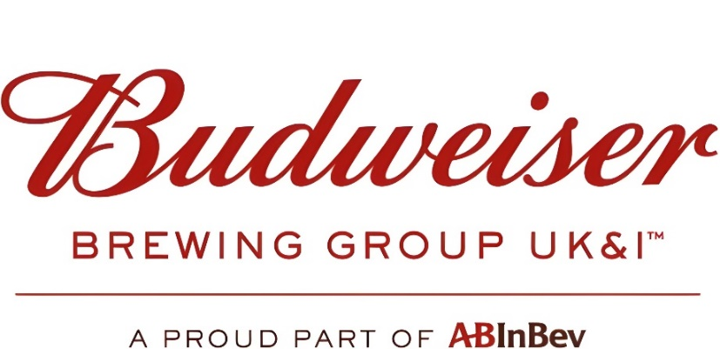

Report submitted by Benjamin James

Table of Contents

Title Page 1
Table of Contents 2
Introduction 3
Define 4
Problem Statement 4
PDCA to DMAIC Roadmap 4
Process Mapping 5
Critical to Quality 6
Project Scope 6
Project Charter 7
Gantt Chart 8
Measure 9
Identify Measurement Variation 9
Determine Data type 10
Develop Data Collection Plan 11
Data Collection 11
Qualitative Data 18
FMEA 19
Analyse 20
Process Analysis Methods 20
Review Analysis Methods 21
Graphical Analysis Tools 21
Improve 24
Generate Improvements 24
Generate Improvement Alternatives 24
Improve FMEA Phase 24
Pilot Proposals 26
Validate Improvements 27
Cost/Benefit Analysis 33
Control 34
References 35
Appendices 36

Introduction

As explained in the Brewing Green British Beer & Pub Association's Case study (2021): Budweiser Brewing Group UK & Ireland is a proud part of AB InBev, the world's largest brewer, employing around 170,000 people worldwide and over 1,400 people in the UK. We are a proud British brewer with a strong presence in the UK. In addition to our head office in London, our breweries are located in Samlesbury in Ribble Valley, established in 1972 and will be celebrating 50 years next year, and our Magor brewery in South Wales was established in 1979. Our other breweries in Camden Town and Enfield are craft brewing innovators.
In the UK, we produce global and internationally recognised brands, including Budweiser, Stella Artois, Bass, Boddingtons, Corona and Becks and No and Low Alcohol Beers such as Budweiser Zero, Stella Artois Alcohol-Free, Becks Blue and Bud Light and Franziskaner Alkoholfrei.
Clean-In-Place (CIP) is an essential aspect of the manufacturing industry, particularly in the food and beverage industry. At Budweiser Brewing Group, the CIP process for the fillers on the bottling lines is crucial in ensuring the quality and safety of the beer produced. The filler fills the beer into bottles, and any issues with the CIP process can lead to contamination, which can be harmful to both the product and the consumer.There are two types of CIP’s we do on our Fillers:
- Medium CIP – Using Caustic (This will be referred to in the report as “Medium CIP”). A Medium CIP is done between product changes and if the line is down for for in excess of 24 hours. This is an Alkaline Clean.

- Long CIP – Using Caustic & Acid (This will be referred to in the report as “Long CIP”). A Long CIP is done once per month to prevent microbial resistance to the Caustic and is an Acid Clean.
The purpose of this report is to outline the steps that can be taken to improve the CIP process for the filler on the bottling line at Budweiser Brewing Group. The report will highlight the current challenges faced in the CIP process, including the impact of inefficiencies on production, quality, and safety. Furthermore, the report will provide recommendations for improving the CIP process to ensure that the filler operates at optimal efficiency, producing high-quality beer that is safe for consumption.
The CIP process is critical to ensuring the quality and safety of the bottled products. However, the current CIP process is causing excessive downtime and is not as efficient as it could be. By improving the CIP process, we can reduce downtime and improve the quality of the cleaning process, resulting in cost savings and improved customer satisfaction.

Define

Problem Statement
On the CIP (Clean-In-Place) process for the Fillers on the Bottling lines it was discovered that operators are aborting CIP cycles prematurely, resulting in caustic and acid going to drain unused. This leads to several issues, including increased costs associated with wasted water and chemicals, reduced efficiency in cleaning the Filler, and potential environmental impacts from the disposal of unused cleaning chemicals.
The premature abortion of CIP cycles may be caused by a number of factors, such as unclear or inadequate training of operators, lack of proper equipment and tools to monitor and control the CIP process, or issues with the CIP system itself. This problem not only wastes valuable resources but also increases the risk of contamination on the bottling lines, which can impact product quality and safety. Currently we are experiencing 1/3 of CIP’s being aborted over a period of 7 months with an average of 8 CIP’s being done per month. That being Caustic CIP’s with Acid CIP’s being done once per month.
Furthermore, the disposal of unused caustic and acid can cause harm to the environment and create safety risks for employees. The disposal of hazardous chemicals must be carefully managed to avoid contamination of water sources and comply with regulatory requirements. The on-site water treatment plant is not built to have excessive Caustic or Acid put to drain at one time and causes an imbalance to the pH scale.
In order to address this problem, it is essential to understand the root causes of the premature abortion of CIP cycles and develop a comprehensive solution. A more effective CIP process can help to reduce waste, increase efficiency, and ensure compliance with environmental and safety regulations, while also maintaining high levels of product quality and safety.

PDCA to DMAIC Roadmap
PDCA | Methodology | DMAIC
Plan | Identify the priorities | Define
Plan | Define Goals | Define
Plan | Measure the Process | Measure
Plan | Measure variation | Measure
Plan | Define the process characteristics | Measure
Plan | Identify potential causes | Analyze
Plan | Quantify causes | Analyze
Plan | Select and test solutions | Improve
Do | Implement best solution | Improve
Check | Verify and check that solution is working | Control
Act | Take action to ensure solution remains intact | Control
Process Mapping
The following Process Map is the current CIP Procedure and indictes the steps taken from start to finish:
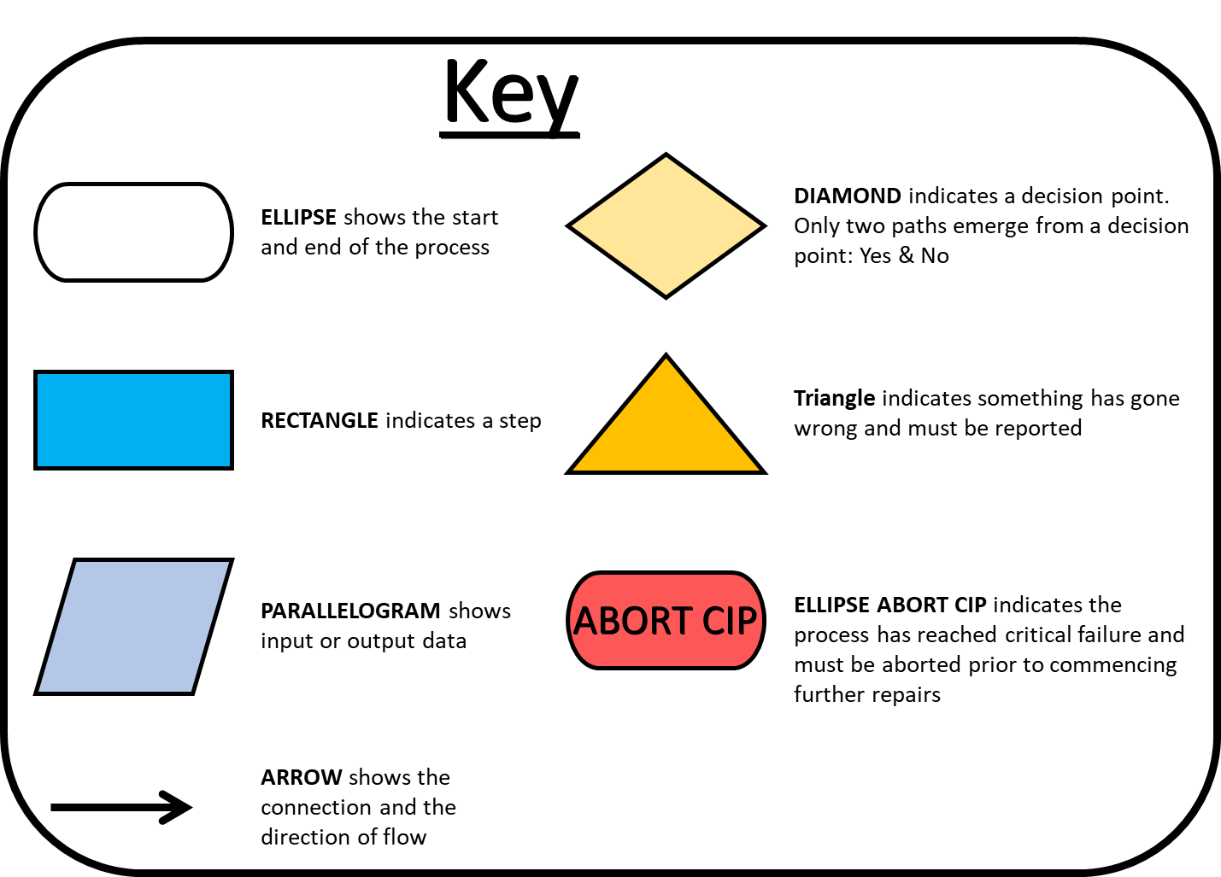
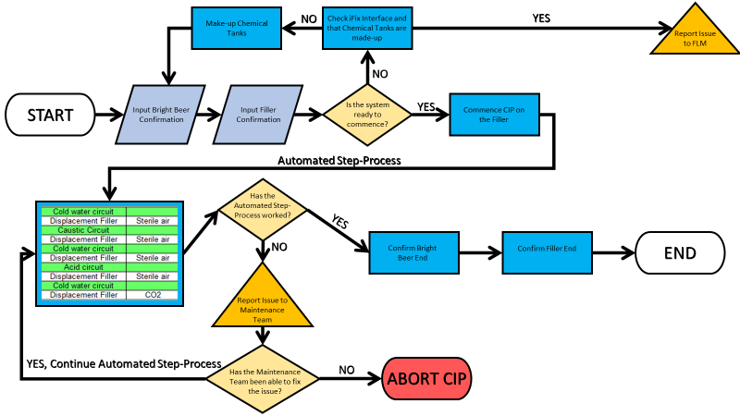

Critical to Quality
CIP, or Clean-In-Place, is a crucial process in the brewing industry that ensures product quality and maintains hygienic conditions in the production process. Its main purpose is to clean and sanitize processing equipment and pipelines without disassembly, reducing downtime and minimizing contamination risk.
There are several reasons why CIP is critical to quality on a bottling line's Filler:
- Contamination Prevention: CIP removes residual product and microbial populations that can cause spoilage, off-flavors, and potential health hazards, preventing contamination.

- Consistency: Consistent CIP procedures ensure that equipment is cleaned and sanitized to the same standards, providing a stable platform for the bottling process.

- Efficiency: CIP can reduce downtime and increase productivity by minimizing the need for manual cleaning, reducing the risk of human error, and allowing rapid equipment turnover between production runs.

- Regulatory Compliance: CIP is crucial in complying with food safety regulations and industry standards, including Good Manufacturing Practices (GMPs) and Hazard Analysis and Critical Control Points (HACCP).
If the CIP process is not followed correctly, it is likely to result in consumer complaints regarding poor quality and taste of the beer. While these complaints are available internally, they may not be distributed due to confidential information.
Project Scope
The goal of this project is to enhance the efficiency of the CIP process on the bottling line by minimizing downtime and improving the quality of the cleaning process. The project will encompass the entire CIP process, from preparation to completion, for all bottling line machines.
The following are the deliverables of the project:
- Establish a baseline measurement of current CIP process efficiency and downtime.
- Examine the existing CIP process to identify areas of inefficiency and downtime.
- Determine the root causes of inefficiency and downtime utilizing data analysis and statistical tools.
- Create and execute strategies to reduce inefficiency and downtime.
- Establish new metrics for CIP process efficiency and downtime and track progress towards them.
- Offer training and standard operating procedures (SOPs) for the enhanced CIP process to ensure long-term success.
Project Timeline:
Phase 1 - Define (3 weeks): Develop project charter, identify stakeholders, and develop a high-level process map.
Phase 2 - Measure (12 weeks): Collect data on current CIP process efficiency and downtime, and establish baseline metrics.
Phase 3 - Analyze (8 weeks): Analyze data and identify root causes of inefficiency and downtime.
Phase 4 - Improve (8 weeks): Develop and implement solutions to reduce inefficiency and downtime.
Phase 5 - Control (10 weeks): Establish new CIP process efficiency and downtime metrics and measure progress against them. Develop SOPs and provide training to ensure sustainability.
Project Charter
Gantt Chart

Measure

Identify Measurement Variation
The Measurement variation is in the form of attribute data for the Filler CIP’s will be split into four sections, within each of those sections will follow two separate types of CIP’s:
- MAB1 – KHS Filler
- Caustic CIP
- Acid CIP
- MAB2 – KHS Filler
- Caustic CIP
- Acid CIP
- MAB3 – Krones Filler
- Caustic CIP
- Acid CIP
- MAB4 – Krones Filler
- Caustic CIP
- Acid CIP
For Reader:
Example – MAB1
MA – Magor (Location)
B – Bottling (Department)
1 – (Line Identification Number)

Each Bottling Line’s CIP will vary in length and time. The parameters however, will be the same for the individual Manufacturer (KHS & Krones).

MAB1, MAB2 & MAB3 all use Chemical from the Bottling Bright Beer (Chemical and Beer Location) room. MAB1 and MAB2 use Virgin (Freshly Made) Caustic. MAB3 however, uses Reclaimed Caustic which has been used by MAB1 & MAB2. This is due to MAB1 & MAB2 having been Flash Pasteurisation Lines in the past (Now use Tunnel Pasteurisation).

MAB4 on the other hand uses Chemical from Kegging Bright Beer and uses both Virgin and Reclaimed depending on the number of times the Caustic has been used.

Variation on the fillers will be across four shifts with at minimum 2 filler operators per line. Each individual may have a different way of working and timings, mindset can be dependant on the individual.

The measurement for the CIP’s is provided through our PA-Web system which is used as a tool to summarise the data required for processes. This is an accurate measurement system and is directly linked to the Filler’s HMI and PLC system.

Determine Data Type
The data to be collected will be Discrete, Continuous, Nominal and Attribute Data. Discrete data being wether or not a CIP has been successful and continuous data being the time taken to complete a CIP. Here is an example of a Completed and a Failed CIP Attribute Data collection from PA Web:
Completed CIP
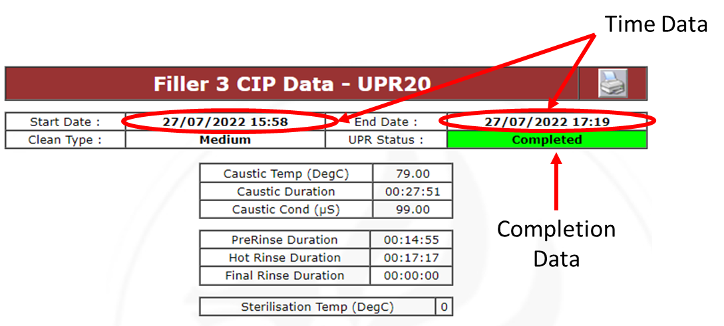

Failed/Aborted CIP
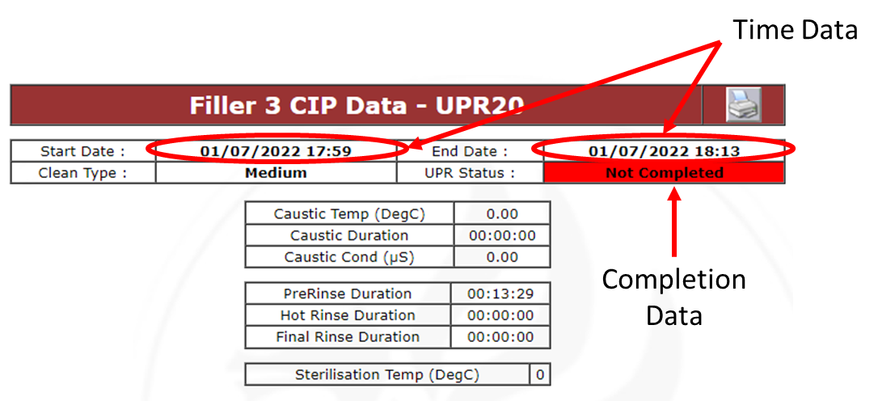
Additional Data will include Qualitative Data. Observations of what we see or encounter. Interviews with the operators to understand any issues they may have. Focus groups to generate discussions amongst a groups of people. Secondary Research with existing data such as the iFix system which is a software-based control system architecture which uses networked data to provide Technicians and Operators with a graphical user interface that allows them to monitor equipment and machinery and issue process commands and settings. The benefit of iFix is that it has automated what was before a manual process.

Develop Data Collection Plan

Data Collection
One of the very first pieces of data gathered was in the form of an audit where we could identify exactly what was going wrong on the worst performing line at the time. CIP audits done by Benjamin James and Julie Leonard.
Audit – Appendices 1
MAB1 – Medium CIP Data
Here you can see the efficiency data based on an expected CIP time of 100 Minutes. An average has been taken for the month. All aborted CIP’s highlighted in red have been classified as being 0% efficient as they have not completed the process.
An important thing to note about MAB1 is it had Sterile Filter skids added to its plant in order to accommodate for Camden Beer which at the time was an unpasteurised product. Sterile Filter skids were later removed in January 2023 and Camden beer is now being pasteurised.
Here you can see the data for how many Medium CIP’s were done each month and the number of minutes each one took. Those highlighted in red are aborted CIP’s. There are 91 minutes between the best CIP and the worst which has gone through.

MAB1 – Long CIP Data
As you can see, the Long CIP on MAB1 did not have any aborted CIP’s.
However, the efficiency of the CIP was still inconsistent. What is happening for the CIP to take 24 minutes longer on these occasions?

MAB2 – Medium CIP Data
MAB2 has a pretty good efficiency rate in comparison to many of the other lines. It is also notable that MAB2 has a high level of knowledgeable operators.
MAB2 has a 90% Efficiency score overall with only one abort in June.

MAB2 – Long CIP Data
MAB2 Long CIP was not performed in July, this is very concerning to the quality of the product and the potential impact it could have.
The efficiency overall not including July would have provided a very good Efficiency % but it is critical to quality that CIP’s are done on time.

MAB3 – Medium CIP Data
MAB3 had a number of aborts. The key data to look into starts from May when the conductivity issues began. The conductivity probe was reading incorrectly and instead of calibrating it again they bypassed it through the HMI and PID Controller to “Manually Input Values”. Fortunately there are two other conductivity probes however the way in which this was dealt with is completely unnaceptable
After the 4th CIP in May until August this issue persisted until it was forcibly made to be calibrated by Quality and process Automation.

MAB3 – Long CIP Data
The Long CIP was missed in April and then the conductivity issues began in May. No long CIP was carried out until August. This is a critical issue to Quality and unacceptable from the Bottling Department.

MAB4 – Medium CIP Data
MAB4 CIP was started and aborted numerous times in February. Fortunately many of these would not have been able to commence any sequences however it is concerning that it has been started and prematurely aborted by the operator. A severe lack of understanding of the process is seen here and a lack of proper training. That aside there was some software issues alongside this. However, the software issues were related to the blowdown at the end of the CIP where the system is finally pushed with gas to ensure all liquids have been removed from the pipework.

MAB4 – Long CIP Data
MAB4 Data again not proving very good for the Long CIP with an average efficiency of 58%. If that equated to 32% of the product going to waste the problem would be all the way up the ladder. Unfortunately CIP’s are a largely misunderstood process between managers and operators thus resulting in a lack of care and attention.

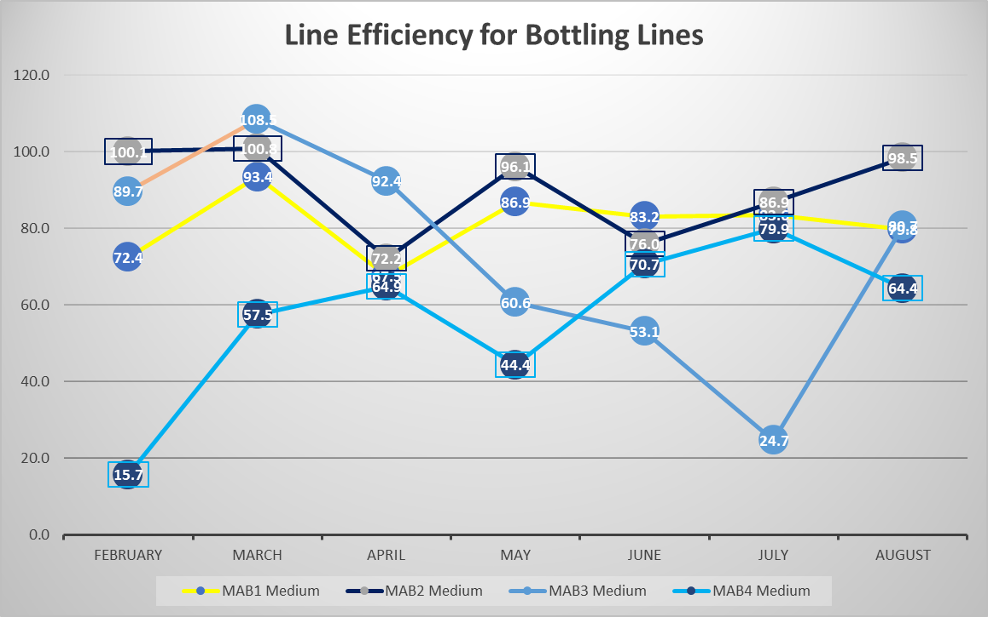
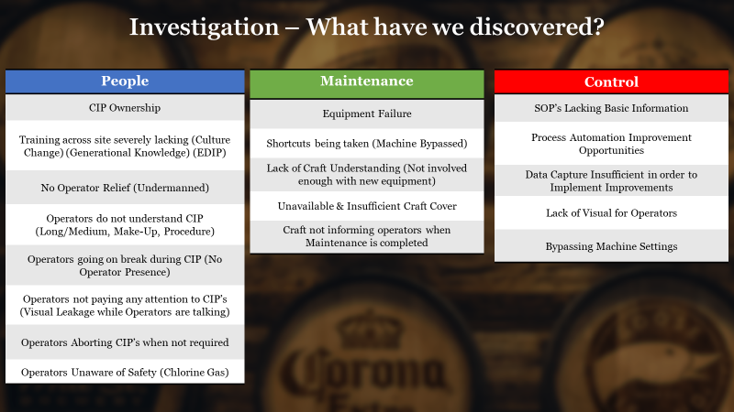
Qualitative Data

Operator/Craft Understanding and knowledge. We have noticed a considerable gap in operator knowledge and in some instances craft as well. Example: Conductivity Probe. Pre-checks and communication not being carried out prior to starting (Canning to Filtration communication, Bottling not making tanks up, Canning not doing pre-checks)

Operator Training – Operators have a misunderstanding of what they are doing on CIP’s, when questioned regarding CIP’s we find they are unable to give us answers. Some unable to provide SOP location. What would they do if they were unsure about something? Do you think they would be able to find the SOP or would they do something they should not?

Operational Relief – Through my qualitative research I found operators saw CIP’s as opportunities for breaks. If there is no secondary cover available for that operator the CIP can fail 5 minutes after they go on break and be waiting an hour to start back up. This extends CIP times from 1 hour and 20 minutes to over 3 hours in some instances (Have to address errors as well).

SOP’s Incomplete – We have found some of the SOP’s to be somewhat lacking in the information required. MAB3 and MAB4 are essentially copied even though many elements are not exactly the same.

Lack of Data Capture – When a CIP fails there is no real capture of data for that failure, there may be some notes written in the shift handover log but there is no official document which the operators can provide a detailed explanation of the errors.

FMEA

Analyse

Process Analysis Methods
There are five main ways in which a Six Sigma Green Belt Project may be Analysed. The goal is to be able to analyse the data in order to identify root causes of a problem or process inefficiency. The process Analysis methods are used to identify areas which can be improved and potential improvement opportunities. Here are five ways in which the data can be analysed:
Value Stream Mapping (VSM): A VSM is a tool used in order to identify the process steps and activities which are value adding and non-value adding. By evaluating current processes the project team is capable of identifying innefieciencies which may be causing errors or delays and potential bottlenecks which slow down the production rate.
Root Cause Analysis (RCA): RCA is a tool used identify underlying causes of inneficiencies and defects within a process. Techniques such as Ishikawa Diagrams and 5 Whys can be used to identify the root cause of a problem and create solutions which will address the issues.
Process Flowcharting: A Process Flowchart is a visual representation tool of a process or workflow. It provides the activities and steps involved in a process in order which they occur. The flowchart uses standardized symbols to represent different types of activities, decision points, inputs and outputs, and the flow of materials or information between process steps.
Lean Manufacturing: Lean Manufacturing involves using techniques such as Value Stream Analysis (VSA) and 5S to identify areas for improvement and reduce waste in a process. By using VSA, the project team can analyze the value-added and non-value-added activities in the process and develop solutions to eliminate waste. 5S, on the other hand, can be employed to improve the organization and cleanliness of the work area, thereby reducing wasted time and motion.
Six Sigma: Six Sigma techniques such as hypothesis testing and regression analysis can be used to identify the factors that are contributing to process variation and defects. The project team can then prioritize these factors based on their impact on the process and identify potential solutions to reduce or eliminate them.

Review Analysis Methods
Root Cause Analysis (RCA) is a methodical approach to identifying the underlying causes of problems and defects in a process, and developing solutions to eliminate those causes. It involves using tools such as Fishbone diagrams, 5 Whys, and Fault Tree Analysis to analyze process failures and identify the root cause of defects or other problems. Lean Manufacturing, on the other hand, is a philosophy and set of principles that aims to eliminate waste in a process by identifying value-added steps and eliminating non-value-added steps. Tools used in Lean Manufacturing include Value Stream Mapping (VSM), 5S, and Kaizen events, which can help improve process efficiency and reduce cycle times.
Six Sigma is a structured approach to process improvement that uses statistical tools and techniques to identify and eliminate defects in a process. It involves using DMAIC (Define, Measure, Analyze, Improve, Control) methodology and techniques such as hypothesis testing and regression analysis to reduce process variability and improve process performance. Process Flowcharting and Value Stream Mapping (VSM) are visual tools that can be used to document and analyze a process. Process Flowcharting creates a visual representation of the process steps and the flow of materials or information between them, while VSM focuses on the value stream, including the steps that add value to the product or service and those that do not. Both tools can help identify areas for improvement in a process.
In the context of the CIP Project, Root Cause Analysis (RCA) and Six Sigma are the most appropriate tools to use, as they can be applied to a wide range of processes and specific goals of the project. While Lean Manufacturing principles and Process Flowcharting and Value Stream Mapping are also useful, RCA and Six Sigma are more focused on identifying the underlying causes of a problem or defect, and reducing process variability and improving process performance.

Graphical Analysis Tools
Six Sigma DMAIC:
Some of the many tools used in Six Sigma will be represented in this report.
Root Cause Analysis:
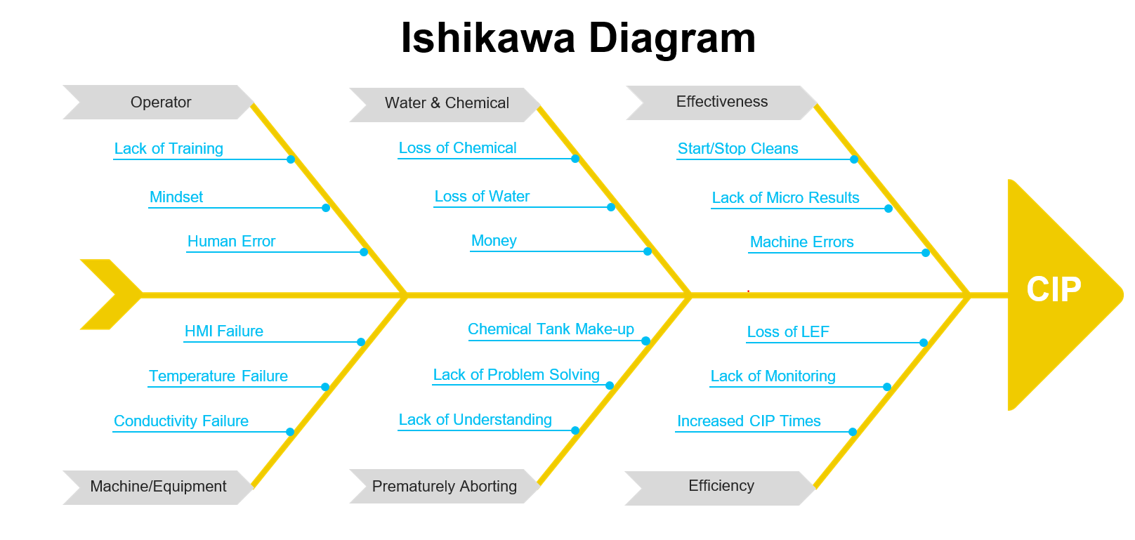
The Ishikawa Diagram found below is to help with brainstorming and identifies potential Cause and Affect’s of the process as a whole:
Two 5 Why’s were done for personal recording. Additional official 5 Why’s and done will be provided in the indices.
5 Why’s – Appendices 2

5 Why – Personal Use 1

A 5 Why was conducted after an error had occurred, a Corrective Action plan was summarised at the end to provide steps going forward. The main points in which we want to take out of this information are the incorrect and insufficient of training, SOP procedure outdated and unsuitable for use. From this 5 Why a Qualitative data research was done and found my operators had not actually read SOP’s and were in fact relying on word of mouth and personal notes to run the machines.

5 Why – Personal Use 2
A 5 Why analysis was conducted following an error, and a corrective action plan was developed to identify steps for moving forward. The main takeaway from this analysis is that the Brewing Maintenance Manager and their team need to increase their inspections of valves in the area to ensure that the plant is not being restricted by any other potential faults, as the UV rays may cause the plastic airline pipe to become brittle and break.

Improve

Generate Improvements
- Training – Classroom training will be supplemented with hands-on training and virtual reality simulations to ensure operators are up-to-date on the latest information. Following classroom training, operators will complete an immediate test, and additional 1-1 training will be provided as needed based on individual scores.

- SOPs – Each SOP will be tailored to the specific line it is on, and all CIP logs will be included as an official document. If operators do not complete the CIP log when an error occurs, they will be responsible. After updating the SOPs, operators will be required to read and sign them.

- Acadia – A quick link to the Acadia training platform will be added to all computers, and the platform will be made more user-friendly. Additionally, training sessions focused on navigating the platform will be provided, and a mobile app version will be created.

- Equipment monitoring – Predictive maintenance will be implemented to monitor equipment failures. Data from CIP logs will be used to track equipment failures, and if a correlation is found, the issue will be investigated to optimize the plant.

- Qualitative data – In addition to current qualitative data collection methods, surveys and customer feedback will be used to gather insights for improving product quality and customer satisfaction.

Generate Improvement Alternatives
Currently, the timing of CIP's is inconsistent across the bottling department. Despite having a maintenance day for each line every week, CIP's are still being carried out at different times, which makes it difficult to monitor and support the process. To address this, we suggest implementing an 8-hour MTE Day where CIP's should be done within this time period. During the CIP, a sign-off sheet should be used every 10 minutes to show progress steps and help operators learn.
The benefits of having CIP's done during MTE Days are numerous. We will have access to process automation, CIP experts, and additional management, who can provide support and ensure that the CIP is done correctly. This change is simple and will not affect the line's performance, and maintenance can still be carried out at the same time. There are no significant risks associated with this change, as it is just making the CIP available to be monitored and supported by more people.
However, the bottling department may have their own schedule and may not agree that CIP's need to be done during a specific time. To address this, we will need to communicate the benefits of this change to the department and get their buy-in. Ultimately, doing CIP's during MTE Days will lead to a more consistent and efficient process, which will benefit everyone involved.
Improve FMEA Phase

Pilot Proposals
From the FMEA shown on the previous page a number of actions have been completed as part of process improvements. Due to the vast amount of changes/improvements made One will be selected as part of improvement carried out. Training will be the example provided.
For Training we conducted a classroom session with operators and began with an initial test of their current knowledge.
CIP Test Sheet - Appendices 3
CIP Test Sheet Answers – Appendices 4
This test was then marked and the resulting mark is to be used as an indication of the operators which will require a more advanced One-to-One session.
Picture taken during the Classroom training session for B-Shift, there were only three operators available for this session however we did have a D-Shift attendance of 13 people:
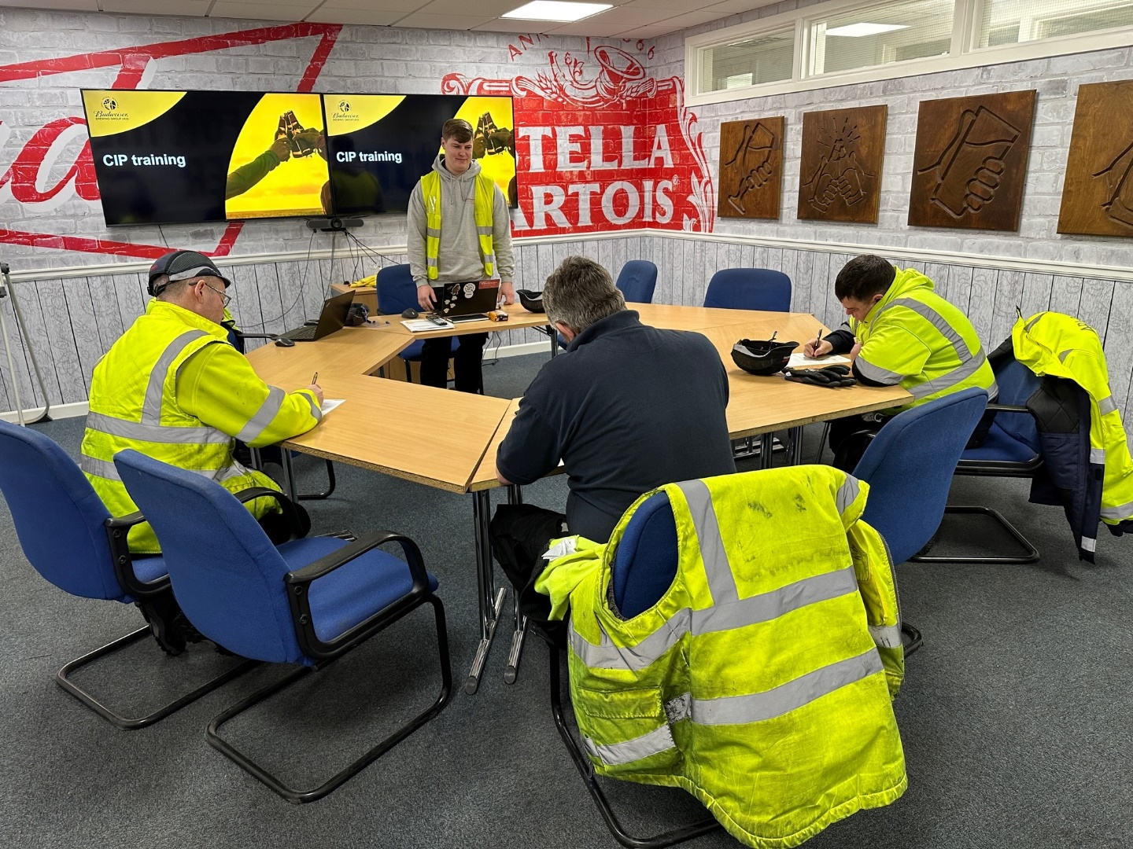
Following the completion of the test, the papers were returned and we went through the answers. Instead of me giving the operators the answers I wanted them to shout out, if they were incorrect I would correct them and explain the answer. After the answers the One-to-One follow-up was explained to the operators. After this, Julie Leonard our CIP expert took the operators for a tour of the plant to show them where our chemicals and CIP sets are aswell as where the Beer comes from. This is crucial training to the operators as it’s important they understand the processes and the supplies involved.
SOP’s Created by Benjamin James – Appendices 5

Validate Improvements
Have they actually made an improvement?
The following Data is taken from the time after the project started and is as follows:
MAB1 – Medium CIP Data
MAB1 Medium CIP received a 9.7% Efficiency Increase.

MAB1 – Long CIP Data
Unfortunately we saw a decrease in our efficiency for MAB1 Long CIP, resulting in a Decrease in Efficiency by 25.9%. This is due to there being a low amount of data to select from and the removal of the Sterile Filter Skids for Camden Beer causing issues. Additionally there was no Long CIP performed in February due to a shutdown.
MAB2 – Medium CIP Data
For MAB2 we gained a 5% Efficiency Increase.

MAB2 – Long CIP Data
MAB2 Long received a 2.7% Efficiency Increase.

MAB3 – Medium CIP Data
MAB3 Medium CIP received a 4.3% Efficiency Increase.

MAB3 – Long CIP Data
MAB3 Long CIP received a 24.1% Efficiency Increase.

MAB4 – Medium CIP Data
MAB4 Medium CIP received a 7.8% Efficiency Increase.

MAB4 – Long CIP Data
MAB4 Long CIP reieved a 32% Efficiency Increase.

To Summarise all the data, these are the Percentage increases/decreases of each line:
Data of before and after improvement as a percentage and Graph comparison of Medium CIP’s:

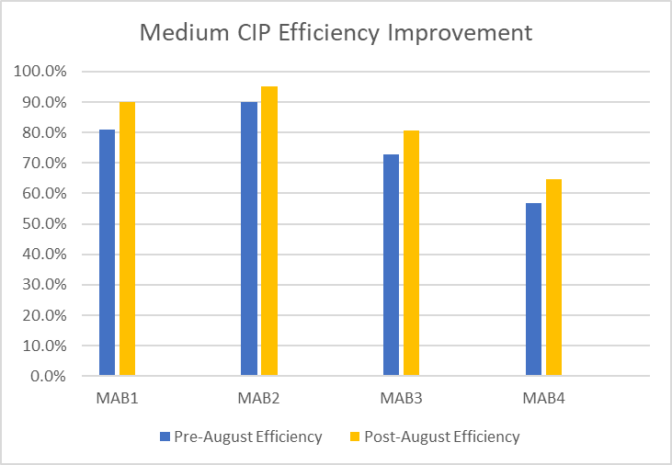
Data of before and after improvement as a percentage and Graph comparison of Long CIP’s:

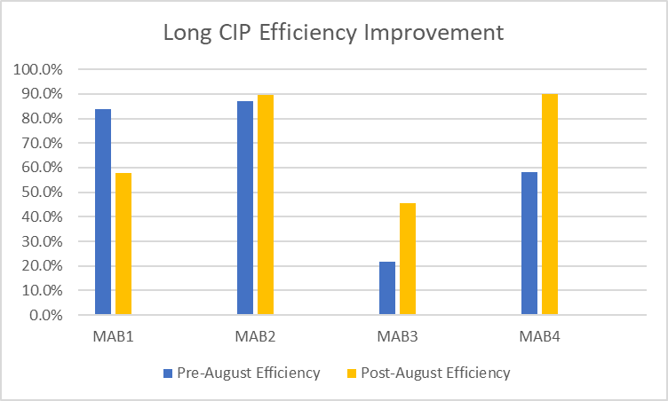

Cost/Benefit Analysis
Sometimes the cost is high and the benefit low so not worth the cost
Here is the Requirements for our current CIP’s and what is required to make up a Vessel for both Caustic and Acid:
The cost of our water types used in the process:
The costings of making up a Caustic Tank:
The costings of making up an Acid Tank:
The cost to run a Medium CIP is £649.92 in water and chemicals while a Long CIP will use both of these resulting in a cost of £807.31.
Pre-August Data
There were 38 prematurely aborted CIP’s in the 7 months shown in the data for Medium CIP’s resulting in an estimated loss £24,696.96. While for a Long CIP an estimated loss of £8,880.41 during the 7 Months with 11 prematurely aborted CIP’s.
That’s a total of £33,577.37 quite literally thrown down the drain.
Post-August Data
There were 17 prematurely aborted CIP’s in the 7 months shown in the data for Medium CIP’s resulting in an estimated loss £11,048.64. While for a Long CIP an estimated loss of £9,687.72during the 7 Months with 12 prematurely aborted CIP’s.
That’s a total of £20,736.36 loss. This is an improvement seen essentially pre-training and thus resulted in a potential saving of £12,841.01.

Control

In order to control the process after the improvements have ben implemented it is important that we maintain a standard. Currently this project is ongoing with training and CIP’s so for the purpose of this control section we will make the assumption that we have finished Classroom Training and One-to-One training with operators
Improving the Clean-In-Place (CIP) process is essential for achieving increased efficiency, reduced downtime, and improved product quality. However, controlling the process is just as important to ensure that the desired outcomes are achieved.
Several measures can be put in place to control the CIP process. One crucial measure is establishing Standard Operating Procedures (SOPs) that detail the steps involved in cleaning, chemicals used, cleaning solution concentration and temperature, and contact time. Personnel responsible for the CIP process should be trained on the SOPs to ensure compliance, and an SOP Operator Check should confirm that operators are following procedures.
Monitoring and recording the CIP process is essential to ensure that it is being carried out according to the SOPs. This can be achieved through sensors that measure cleaning solution concentration and temperature, flow rate, and pressure. Any deviation from the set parameters should be investigated and corrected promptly.
Validation is also critical to controlling the CIP process. Validation ensures that the CIP process can consistently achieve desired outcomes. Conducting tests on the equipment before and after the CIP process can validate its effectiveness. Periodic validation should be carried out to ensure the CIP process remains effective.
Preventive maintenance is another measure that should be put in place to control the CIP process. Regular maintenance ensures equipment functions correctly and reduces the risk of breakdowns. Malfunctioning equipment should be repaired or replaced promptly to avoid compromising the CIP process.
Quality control measures should also be implemented to ensure the CIP process achieves desired quality standards. Testing the product after the CIP process can validate whether it meets required quality specifications. Any deviation from set quality standards should be investigated, and corrective action taken.
Training and communication are crucial in controlling the CIP process. Personnel responsible for the CIP process should be trained on SOPs, monitoring, validation, preventive maintenance, and quality control measures. Communication should be clear and timely to address issues promptly. New operators going on the filler to be put on the CIP Training course immediately.
In conclusion, implementing the measures discussed can help to control the CIP process effectively, improve efficiency, reduce downtime, and improve product quality. Ensuring the CIP process is controlled can achieve the desired outcomes of improvements made. Following this we would evaluate if the control measures were effective or not and suggest improvements to better control the process.

References

AB InBev CSRWire (2010) CSRWire - Anheuser-Busch InBev Announces Global Environmental Goals

AB InBev UK Limited (2022) Our company | Budweiser Brewing Group

AB InBev Workplace Communication (2022)

Bhote, K. R. (2002). The Ultimate Six Sigma: Beyond quality excellence to total business excellence. AMACOM.

Bhunia, A. K., Johnson, M. C., & Kim, M. S. (2019). Foodborne Microbial Pathogens: Mechanisms and Pathogenesis. Springer.

Brewing Green (2021) Budweiser Brewing Group UK&I

Dedhia, N.S., (2005). Six sigma basics. Total Quality Management & Business Excellence, 16(5), pp.567-574.

Gangidi, P., (2018). A systematic approach to root cause analysis using 3× 5 why’s technique. International Journal of Lean Six Sigma, 10(1), pp.295-310.

Guo, M., Hu, H., Zhu, Y., & Li, J. (2019). Improving the reliability of clean-in-place control systems in food and beverage industries. Journal of Food Engineering, 253, 50-60.

Harry, M. J., & Schroeder, R. (2000). Six Sigma: The breakthrough management strategy revolutionizing the world's top corporations. Currency.

Hines, P. and Rich, N., (1997). The seven value stream mapping tools. International journal of operations & production management, 17(1), pp.46-64.

Karan, V., Khan, Z. and Sharifi, M., (2003). Process Flowcharting: A Skill That Adds Value. Review of Business Information Systems (RBIS), 7(1), pp.89-102.

Karuppusami, G. and Gandhinathan, R., (2006). Pareto analysis of critical success factors of total quality management: A literature review and analysis. The TQM magazine.

Liliana, L., (2016), November. A new model of Ishikawa diagram for quality assessment. In IOP Conference Series: Materials Science and Engineering (Vol. 161, No. 1, p. 012099). IOP Publishing.

Pande, P. S., Neuman, R. P., & Cavanagh, R. R. (2000). The Six Sigma way: How GE, Motorola, and other top companies are honing their performance. McGraw-Hill Education.

Pyzdek, T., & Keller, P. A. (2014). The six sigma handbook (4th ed.). McGraw-Hill Education.

Rooney, J.J. and Heuvel, L.N.V., (2004). Root cause analysis for beginners. Quality progress, 37(7), pp.45-56.

Wilson, L., (2015). How to implement lean manufacturing. McGraw-Hill Education.

Yemmireddy, V. K., & Pandit, A. B. (2020).

Appendices

I am unsure if these will work, they contain information which cannot be copied in easily. If they do not work and you wish to see them please contact: 2110766@student.uwtsd.ac.uk and I will provide them immediately for your perusal.

Appendices 1 – Audit

Appendices 2 – 5 Why’s

Appendices 3 – CIP Test Sheet

Appendices 4 – CIP Test Sheet Answers

Appendices 5 – MAB2 & MAB4 SOP’s

