ACDA5001 Electrical Engineering

Assignment
Joseph Samuel Roan

2411525

05/01/2026

Table of Contents

1. Abstract 6
2. Introduction 7
2.1 What is an AC Circuit? 7
2.2 What is am RLC Circuit? 7
2.3 What is Power Factor? 7
2.4 What is Resonance? 7
2.5 What is Maximum Power transfer? 7
2.5.1 AC Circuits 7
2.5.2 DC Circuits 7
2.6 What is Power Factor Correction? 8
3. Method 9
3.1 RL Circuit 9
3.2 RLC Circuit 10
3.2.1 Calculations for the Capacitor: 11
3.3 Power 16
3.3.1 Apparent Power 16
3.3.2 Reactive Power 16
3.3.3 Active Power 16
3.4 Power Factor 16
3.5 Phase Angle 18
3.6 What happens to energy stored in Capacitor and Inductor as the Power Factor Reaches 1? 20
4. Results 21
4.1 Phasor Diagrams and Results 21
4.1.1 Resonance 21
4.1.2 25 Hz Below Resonance 22
4.1.3 25 Hz Above Resonance 25
4.1.4 50 Hz 27

5. Discussion 29
5.1 How the PFC relates to Resonance of the Circuit 29
5.2 How the PFC relates to Achieving Maximum Power Transfer 30
5.3 How the PFC relates to Energy Efficiency 30
5.4 Why is Electricity Three-Phase within Developed Countries? 30
5.5 Why do systems generally not go beyond 3 phases? 30
5.6 Significance of PF and PFC in Electrical Engineering Systems 31
6. Conclusion 32
7. References 33

List of Figures
Figure 1 - RL Circuit Design 9
Figure 2 - RL Circuit Graph 9
Figure 3 – RLC Circuit Design 10
Figure 4 – RLC Circuit Graph 10
Figure 5 - Phasor Diagram 12
Figure 6 - Triangle OAC 13
Figure 7 - Triangle OAB 14
Figure 8 - Graph of Power Factor in relation to Capacitor Value 17
Figure 9 - Graph of Phase Angle in Relation to Capacitor Value 19
Figure 10 - 25 Hz Below Resonance Phasor Diagram 22
Figure 11 - 25Hz Above Resonance Phasor Diagram 25
Figure 12 - Phasor Diagram For 50Hz 27
Figure 13 - Resonance in PFC [21] 29

Table 1 - PFC 18

Equation 1 - Vrms 11
Equation 2 - Irms 11
Equation 3 - ∅1 Calculation 11
Equation 4 - Power Factor 11
Equation 5 - Cos ∅2 Calculation 11
Equation 6 - ∅2 Calculation 11
Equation 7 - Cos ∅1 13
Equation 8 -OA 13
Equation 9 - Sin ∅1 13
Equation 10 - Ac 13
Equation 11 - ∅1 14
Equation 12 - OB 14
Equation 13 - Sin ∅2 14
Equation 14 - AB 14
Equation 15 - BC 15
Equation 16 - Xc 15
Equation 17 - Xc 15
Equation 18 - Formulae for Capacitor 15
Equation 19 - Capacitor 15
Equation 20 - Apparent Power 16
Equation 21 - Reactive Power 16
Equation 22 - Active Power 16
Equation 23 - Formulae for Fr 18
Equation 24 - Calculation for Fr 18
Equation 25 - Xl Calculation 18
Equation 26 - ∅LR Formulae 18
Equation 27 - ∅LR Calculation 18
Equation 28 - Equation for Fr 21
Equation 29 - Fr 21
Equation 30 - Frequency 22
Equation 31 – Xc Calculation 22
Equation 32 – Xl Calculation 22
Equation 33 - Formulae For ZLR 22
Equation 34 – ZLR Calculation 23
Equation 35 - ILR Formulae 23
Equation 36 – VLR Calculation 23
Equation 37 – ILR Calculation 23
Equation 38 - Ic Calculation 23
Equation 39 - ∅LR Calculation 23
Equation 40 - ∅ Formulae 23
Equation 41 - ∅ Calculation 23
Equation 42 - ILR Sin ∅LR Calculation 24
Equation 43 - I Calculation 24
Equation 44 - Frequency 25
Equation 45 - Xc Calculation 25
Equation 46 - Xl Calculation 25
Equation 47 - ZLR 25
Equation 48 – ILR Calculation 26
Equation 49 – Ic Calculation 26
Equation 50 - ∅LR Calculation 26
Equation 51 - ∅ Calculation 26
Equation 52 - ILR Sin ∅LR Calculation 26
Equation 53 – I Calculation 26
Equation 54 - Xc Calculation 27
Equation 55 - Xl Calculation 27
Equation 56 - ZLR Calculation 27
Equation 57 - ILR Calculation 27
Equation 58 - Ic Calculation 28
Equation 59 - ∅LR Calculation 28
Equation 60 - ∅ Calculation 28
Equation 61 - ILR Sin ∅LR Calculation 28
Equation 62 - I Calculation 28

Abstract
Throughout this experiment, the author has created a RL and an RLC Circuit, calculated the capacitor to create the RLC Circuit, given graphs of this too. Additionally, the author has calculated voltages at different at resonance and at different frequencies relating to resonance, while also creating phasor diagrams too. The results outputted, in reference to PFC, determine that when the capacitor value increases, so does the Power Factor, however the phase angle will decrease, this is also true in vice-versa.

Introduction

What is an AC Circuit?
‘AC’ Stands for Alternating Current [1], which is described a circuit, which can be single or three phase, with the produced voltages being at 120° [2]. They are made up of windings, which can be Star or Delta [2]. These can be used in various applications, for example Power Generation, Power Distribution, Motors, Heating and Lighting.

What is am RLC Circuit?
An RLC Circuit is a circuit containing a Resistor (Described as ‘R’), an Inductor (Described as ‘L’) and a Capacitor (described as ‘C’) [3]. They are generally used in Filters, Voltage Stabilization and Medical Application.

What is Power Factor?
Power Factor (PF), refers to the measurement of the effectiveness of electrical power being converted into output that is used within an electrical system [4]. It is the Ratio of Real Power to apparent power, which indicates the efficiency of power usage within an electrical system [4]. The highest value of PF is 1 [5], this means maximum efficiency, therefore the larger the PF is, the higher the efficiency. A method of increasing this in an electrical circuit is PFC, See section 2.6 below, for an explanation.

What is Resonance?
Resonance or Resonance Frequency is the maximum amplitude response [6]. It occurs when a force is applied periodically at the natural frequency of the system, this results in larger amplitudes in comparison to other frequencies, therefore being the maximum amplitude response [7].

What is Maximum Power transfer?
Maximum Power Transfer differs in AC and DC Circuits, they are explained below in sections 2.5.1 & 2.5.2.

AC Circuits
In AC Circuits it’s when the maximum power is transferred to the load, when its impedance is equal to the complex conjugate [8].

DC Circuits
Additionally, within DC Circuits it’s when the maximum power transferred to the load, when the loads resistance equals the internal resistance of the source [9].

What is Power Factor Correction?
The purpose of Power Factor Correction (PFC) is to bring the Power Factor to close to ‘Unity’ as possible [10]. PFC is a method that will increase the efficiency of electrical power [4], a PFC Circuit will shape the current input, so that it will be in phase with the line voltage and reduce the apparent power used [11]. Moreover this uses capacitors to reduce reactive power, as it will reduce current and improve its efficiency [12].

Method

RL Circuit
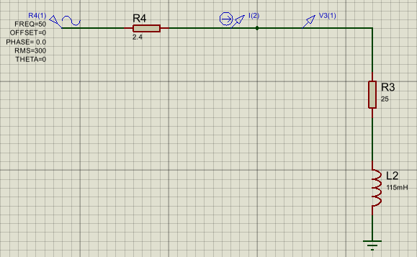
This circuit was created by the author, the values for the components were derived from their student number (2411525). This is shown below in Figure 1. The Graph of results for this is shown below in Figure 2.
Figure 1 - RL Circuit Design

Figure 2 - RL Circuit Graph

RLC Circuit
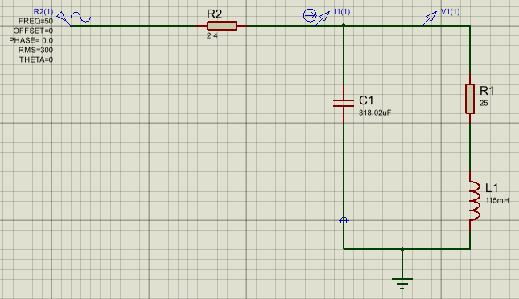
This Circuit was designed by the author, the only difference between this and the RL Circuit created above in section 3.1, was the Capacitor. The value for this was calculated by the author, see Equation 19 below. The Circuit Design is shown below in Figure 3 and the Graph is shown below in Figure 4. The Calculations for the Capacitor is shown below in Section 3.2.1.
Figure 3 – RLC Circuit Design

Figure 4 – RLC Circuit Graph

Calculations for the Capacitor:

Equation 1 - Vrms
$$Vrms=\frac{Vm}{√2}=\frac{424}{√2}=6.56A$$

Equation 2 - Irms
$$Irms=\frac{Im}{√2}=\frac{9.28}{√2}=299.81$$

Equation 3 - ∅1 Calculation
$$∅_{1}=\frac{2.94×{10}^{-3} }{20×{10}^{-3}}$$

Equation 4 - Power Factor
$Power Factor=Cos∅_{1}=Cos (52.92)=0.60$

The P.F. needed is 0.95, therefore:

Equation 5 - Cos ∅2 Calculation
$$Cos ∅_{2}=0.95$$

Equation 6 - ∅2 Calculation
$∅_{2}={Cos}^{-1}(0.95)$ = 18.2°

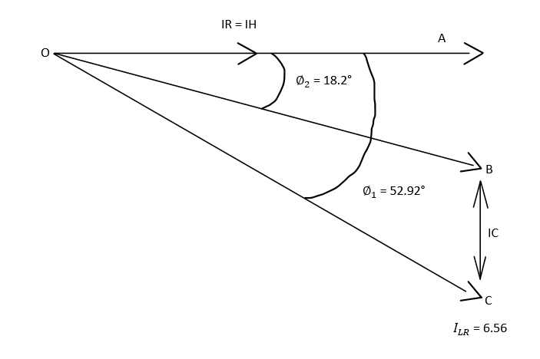

Figure 5 - Phasor Diagram

In Triangle AOC:
Equation 7 - Cos ∅1
$$Cos ∅_{1}=\frac{OA}{OC}$$

Equation 8 -OA
$$OA=6.56×Cos \left(52.92\right)=IR=3.96A$$

Equation 9 - Sin ∅1
$$Sin ∅_{1}=\frac{Ac}{I_{LR}}$$

Equation 10 - Ac
$$Ac=6.56 ×Sin \left(52.92\right)=Ic=5.23A$$

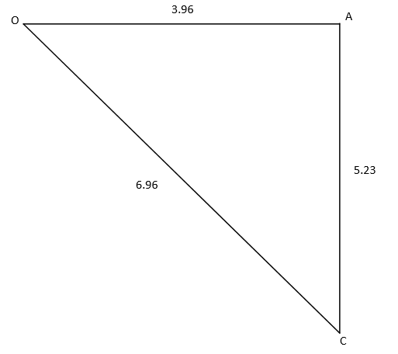

Figure 6 - Triangle OAC

In Triangle AOB:

Equation 11 - ∅1
$$Cos ∅_{2}=\frac{OA}{OB}$$

Equation 12 - OB
$$OB=I=\frac{3.96}{Cos (18.2)}=4.17A$$

Equation 13 - Sin ∅2
$$Sin ∅_{2}=\frac{AB}{OB}$$

Equation 14 - AB
$$AB=Sin \left(18.2\right)×4.17=1.30$$

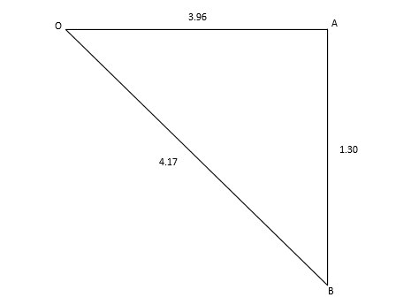
Figure 7 - Triangle OAB

Equation 15 - BC
$$BC=AC-AB$$

Equation 16 - Xc
$$Xc=\frac{299.81}{3.93}=76.29Ω$$

Equation 17 - Xc
$$Xc=\frac{1}{2πFC}$$

Equation 18 - Formulae for Capacitor
$$C=\frac{1}{2πFX_{C}}$$

Equation 19 - Capacitor
$C=\frac{1}{2π \left(6.56\right)(76.29)}=318.02$µF

Power

Apparent Power
Waldo V. Lyon, an expert and author in electrical engineering [13], describes Apparent Power as “The Greatest” power that can be taken by a load, that has the same RMS line Currents and Voltages [14]. The authors calculations for Apparent Power are shown below in equation 20.
Equation 20 - Apparent Power
$$S=VI=\left(299.81\right)×\left(6.56\right)=1966.75$$

Reactive Power
Reactive power is described as the “product of the voltage and current”, whilst being measured at the same point in the circuit, this is calculated using the sin function [15]. The authors calculations for Reactive Power are shown below in equation 21.
Equation 21 - Reactive Power
$$Q=299.81×\left(6.56\right)×Sin \left(52.92\right)=1569.07$$

Active Power
Similar to Reactive power, Apparent power refers to the “product of the voltage and current”, whilst being measured at the same point in the circuit, however this is calculated using the cos function [15]. The authors calculations for Active Power are shown below in equation 22.
Equation 22 - Active Power
$$P=VI Cos ∅ =299.81×\left(6.56\right)×Cos \left(52.92\right)=1185.81$$

Power Factor
The Equation the author used to Calculate the Power Factor is shown above in equation 4. With the calculations of the Power Factor, the author created a graph of Power Factor in relation to the value of the capacitor. This is shown below in Figure 8. The Table of the results are also shown in table 1, below.

Figure 8 - Graph of Power Factor in relation to Capacitor Value

Phase Angle
Phase Angle is a measurement of angle between resistance and ratio of reactance with the same frequency [16]. The method in which the author calculated this, is shown below in Equations 23 to 27, this method is repeated from 5uF to 35uF. With the results of the Phase angle, the author created a table and a graph of Phase angle in relation to the capacitor value. These are shown below in Table 1 and Figure 9.

Equation 23 - Formulae for Fr
$$Fr=\frac{1}{2π} \sqrt{\frac{1}{Lc}-\frac{R^{2}}{L^{2}}}$$
Equation 24 - Calculation for Fr
$Fr=\frac{1}{2π} \sqrt{\frac{1}{\left(115×{10}^{-3}\right) \left(5×{10}^{-6}\right)}-\frac{{25}^{2}}{{(115 ×{10}^{-3})}^{2}}}=$207.02

Equation 25 - Xl Calculation
$$Xl=\left(2π\right)×\left(207.02\right)×\left(115×{10}^{-3}\right)=149.59 Ω$$

Equation 26 - ∅LR Formulae
$$∅_{LR}={Tan}^{-1} \left(\frac{X_{L} }{R}\right)$$
Equation 27 - ∅LR Calculation
$$∅_{LR}={Tan}^{-1} \left(\frac{149.59 }{25}\right)=80.51°$$

Table 1 - PFC
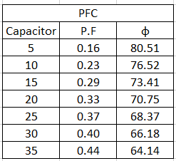

Figure 9 - Graph of Phase Angle in Relation to Capacitor Value

What happens to energy stored in Capacitor and Inductor as the Power Factor Reaches 1?
When Power Factor reaches 1, the power is at maximum efficiency, as only the useful power is being used (without any waste) [17]. This Happens due to the active power and reactive power being equal [18]. In regards to energy stored in a Inductor, when the Power Factor reaches 1, the current is in phase with the voltage, resulting in only the useful power being used [19]. This means that it’s at maximum efficiency and also has no reactive power within the circuit [19]. In regards to energy stored in a Capacitor, when the Power Factor reaches 1, it will result in the circuit being fully resistive, this is because it will consume all the power from the source, however will not consume any reactive power [20].

Results

4.1 Phasor Diagrams and Results
The Phasor Diagrams showing the component voltages and current that were calculated for the RLC Circuit, see section 3.2. are shown below. Additionally the Results of the calculations are shown below:

Resonance
The definition of resonance is outlined in the author above in section 2.4. The authors calculations for resonance are shown below:

Equation 28 - Equation for Fr
$$Fr=\frac{1}{2π} \sqrt{\frac{1}{\left(115×{10}^{-3}\right) \left(318.02×{10}^{-6}\right)}-\frac{{25}^{2}}{{(115 ×{10}^{-3})}^{2}}}$$

Equation 29 - Fr
$$Fr=34.59$$

25 Hz Below Resonance
For the Phasor diagram refer to Figure 9 below. The authors calculations for 25 Hz below resonance is shown below:

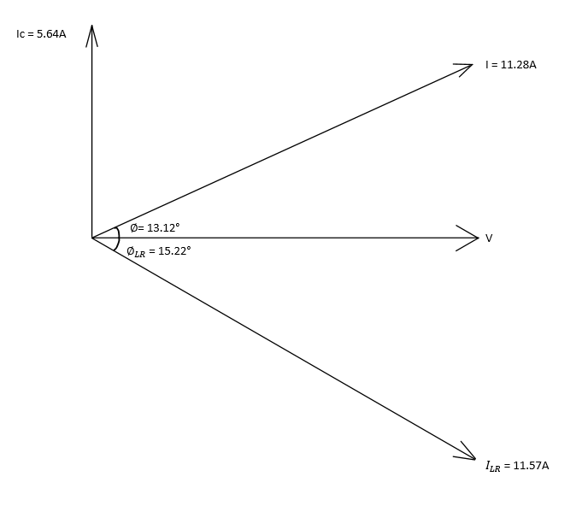

Figure 10 - 25 Hz Below Resonance Phasor Diagram

Equation 30 - Frequency
$$34.59-25=9.41Hz$$

Equation 31 – Xc Calculation
$$Xc=\frac{1}{2π \left(9.41\right)(318.02×{10}^{-6})}=53.18 Ω$$

Equation 32 – Xl Calculation
$$Xl=\left(2π\right)×\left(9.41\right)×\left(115×{10}^{-3}\right)=6.80 Ω$$

Equation 33 - Formulae For ZLR
$$Z_{LR}= \sqrt{R^{2}+X_{L}^{2}}$$

Equation 34 – ZLR Calculation
$$Z_{LR}= \sqrt{{25}^{2}+{6.80}^{2} }=25.91Ω$$

Equation 35 - ILR Formulae
$$I_{LR}=\frac{V_{LR}}{Z_{LR}}$$

Equation 36 – VLR Calculation
$$V_{LR}=\frac{424}{\sqrt{2}}=299.81V$$

Equation 37 – ILR Calculation
$$I_{LR}=\frac{299.81}{25.91}=11.57A$$

Equation 38 - Ic Calculation
$$I_{C}=\frac{V_{C}}{X_{C}}=\frac{299.81}{53.18}=5.64A$$

Equation 39 - ∅LR Calculation
$$∅_{LR}={Tan}^{-1} \left(\frac{6.80 }{25}\right)=15.22°$$

Equation 40 - ∅ Formulae
$$∅={Tan}^{-1} \left(\frac{I_{LR} Sin ∅_{LR}\sim I_{C} }{I_{LR} Cos ∅_{LR}}\right)$$

Equation 41 - ∅ Calculation
$$∅={Tan}^{-1} \left(\frac{11.57 (Sin 15.22)\sim 5.64}{11.57 Cos 15.22}\right)=13.12° [Leading]$$

Equation 42 - ILR Sin ∅LR Calculation
$$I_{LR} Sin ∅_{LR}=11.57 Sin 15.22=3.04A$$

$${I_{C}>I}_{LR} Sin ∅_{LR}$$

Equation 43 - I Calculation
$$I= \sqrt{{\left({I_{LR} Cos∅}_{LR}\right)}^{2}+ {\left({I_{LR} Sin∅}_{LR}\sim I_{C}\right)}^{2}}=11.28A [Leading]$$

25 Hz Above Resonance
For the Phasor diagram refer to Figure 10 below. Additionally, the authors calculations for 25 Hz below resonance is shown below:

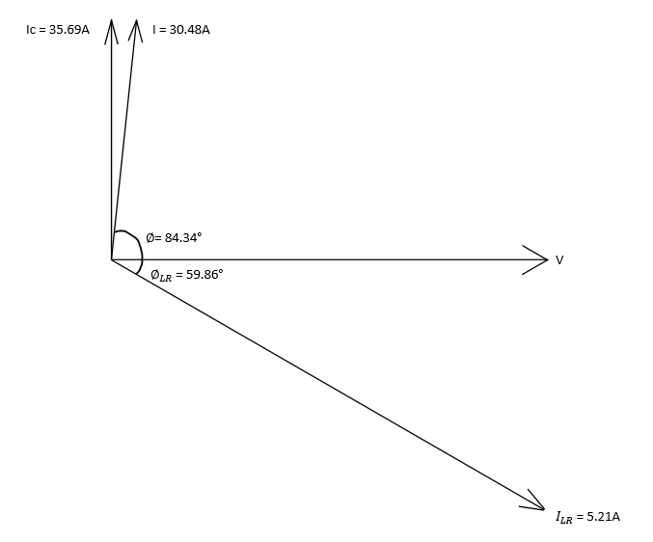
Figure 11 - 25Hz Above Resonance Phasor Diagram

Equation 44 - Frequency
$$34.59+25=59.59Hz$$

Equation 45 - Xc Calculation
$$Xc=\frac{1}{2π \left(59.59\right)(318.02×{10}^{-6})}=8.40 Ω$$

Equation 46 - Xl Calculation
$$Xl=\left(2π\right)×\left(59.59\right)×\left(115×{10}^{-3}\right)=43.06 Ω$$

Equation 47 - ZLR
$$Z_{LR}= \sqrt{{25}^{2}+{43.06}^{2} }=49.80Ω$$

Equation 48 – ILR Calculation
$$I_{LR}=\frac{299.81}{49.80}=6.02A$$

Equation 49 – Ic Calculation
$$I_{C}=\frac{V_{C}}{X_{C}}=\frac{299.81}{8.40}=35.69A$$

Equation 50 - ∅LR Calculation
$$∅_{LR}={Tan}^{-1} \left(\frac{43.06 }{25}\right)=59.86°$$

Equation 51 - ∅ Calculation
$$∅={Tan}^{-1} \left(\frac{6.02 (Sin 59.86)\sim 35.69 }{6.02 Cos 59.86}\right)=84.34° [Leading]$$

Equation 52 - ILR Sin ∅LR Calculation
$$I_{LR} Sin ∅_{LR}=6.02 Sin 59.86=5.21A$$

$${I_{C}>I}_{LR} Sin ∅_{LR}$$

Equation 53 – I Calculation
$$I= \sqrt{{\left({I_{LR} Cos∅}_{LR}\right)}^{2}+ {\left({I_{LR} Sin∅}_{LR}\sim I_{C}\right)}^{2}}=30.48A$$

50 Hz
For the Phasor diagram refer to Figure 11 below. The authors calculations for 50 Hz is shown below:

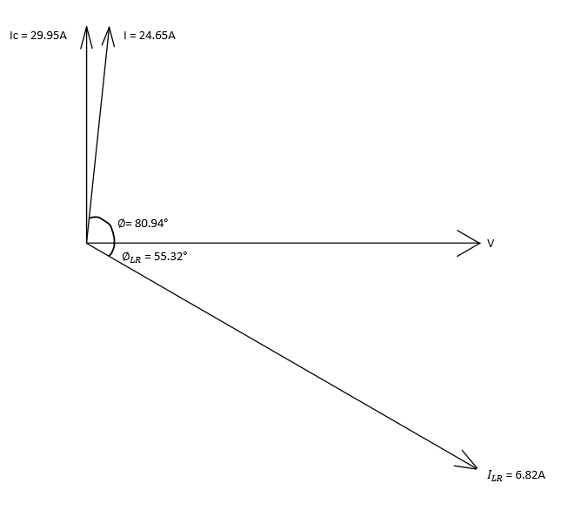

Figure 12 - Phasor Diagram For 50Hz

Equation 54 - Xc Calculation
$$Xc=\frac{1}{2π \left(50\right)(318.02×{10}^{-6})}=10.01Ω$$

Equation 55 - Xl Calculation
$$Xl=\left(2π\right)×\left(50\right)×\left(115×{10}^{-3}\right)=36.13 Ω$$

Equation 56 - ZLR Calculation
$$Z_{LR}= \sqrt{{25}^{2}+{36.13}^{2} }=43.94Ω$$

Equation 57 - ILR Calculation
$$I_{LR}=\frac{299.81}{43.94}=6.82A$$

Equation 58 - Ic Calculation
$$I_{C}=\frac{V_{C}}{X_{C}}=\frac{299.81}{10.01}=29.95A$$

Equation 59 - ∅LR Calculation
$$∅_{LR}={Tan}^{-1} \left(\frac{36.13 }{25}\right)=55.32°$$

Equation 60 - ∅ Calculation
$$∅={Tan}^{-1} \left(\frac{6.82 (Sin 55.32)\sim 29.95 }{6.82 Cos 55.32}\right)=80.94° [Leading]$$

Equation 61 - ILR Sin ∅LR Calculation
$$I_{LR} Sin ∅_{LR}=6.82 Sin 55.32=5.61A$$

$${I_{C}>I}_{LR} Sin ∅_{LR}$$

Equation 62 - I Calculation
$$I= \sqrt{{\left({I_{LR} Cos∅}_{LR}\right)}^{2}+ {\left({I_{LR} Sin∅}_{LR}\sim I_{C}\right)}^{2}}=24.65A$$

Discussion
The author has calculated a capacitor value to correct the power factor to $≥0.95$, see section 3.2.1. Below the author has described how this relates to:

How the PFC relates to Resonance of the Circuit
Refer to section 2.6 for a description of PFC, also, refer to section 2.4 for a description of resonance. However, in regards to how PFC relates to resonance of the circuit, if the PFC is installed in a system with non-linear loads, the capacitors can cause harmonic resonance [21]. This occurs when the system inductance and the capacitance that has been added creates a circuit, which causes the flow of harmonic currents [22]. This will result in high voltage and current at the resonant frequency, which could overload the capacitors and lead to a failure [22]. The self-healing process of PFC capacitors can change the capacitance, creating a damaged resonant frequency [22]. A graph showing Resonance in PFC is shown below in Figure 13.

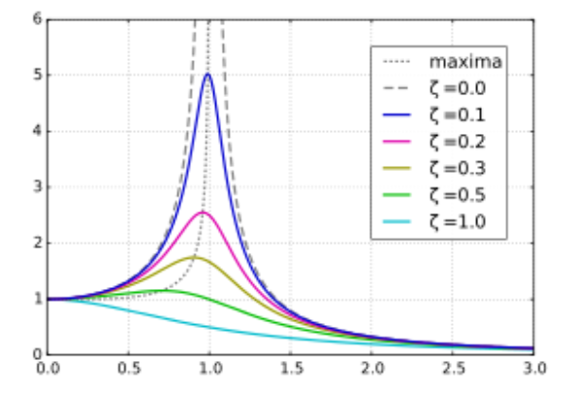
Figure 13 - Resonance in PFC [22]

How the PFC relates to Achieving Maximum Power Transfer
Refer to section 2.6 for a description of PFC and refer to section 2.5 for a description of Maximum Power Transfer. In regards to how PFC relates to achieving maximum power transfer, its important that the power factor be as close to unity as possible [23]. This is because, when the power factor is less than 1, the current and voltage are not in phase [10], as a result less of the supplied power is being used efficiently and potentially disruptions to the device can occur [23], which can have negative effects from a business’s commercial aspect, as it can lead to increased operational costs, due to utility charges and distribution losses [24]. However if the PFC is utilised, the efficiency will be improved, due to lower distribution losses, as this will lower energy consumption also prolonging equipment’s lifespan [24], which will mitigate this risk.

How the PFC relates to Energy Efficiency
Refer to section 2.6 for a description of PFC, Energy Efficiency is providing a service with the same or better quality, while using less energy [25]. Energy Efficiency is imperative in today’s society and on any business [26] [27]. Some Society benefits include, reduce climate change for later generations, Economic growth, provide Jobs, Affordability and Public Health [28]. For Businesses, some benefits include, Cost savings, Economic growth and following Government Legislations [29] [30]. Regarding how PFC relates to energy efficiency, PFC is tremendously important in improving energy efficiency as when PFC is applied, it will create a high Power Factor, a high power factor, as explained in section 2.6, it will increase energy efficiency, this is as it reduces energy losses [31]. Additionally, if there is a high Power Factor, it can increase the efficiency of electrical appliances, make them more reliable for use in the future [32], making them more sustainable and energy efficient.

Why is Electricity Three-Phase within Developed Countries?
Electricity in the United Kingdom and throughout the developed world, is transmitted on a three-phase basis, it’s the method used by the national grid [33]. This because, its more efficient than single phase in regards to power, as they can produce more power with less current [34]. Additionally, they are proficient at power distribution, as they can distribute power over long distances without the need for additional transformers [35].

Why do systems generally not go beyond 3 phases?
However, as useful as a 3 -Phase system is, a system using more than 3 phases are not used for several reasons, for instance the cost effectiveness, as it would require a greater number of electrical components, which would come to a much larger cost [36]. Additionally, there would be limited gain as 6 & 12-Phase Systems do exist in rare cases, for example very high voltages. For normal voltages, they would not be suitable for power transmission [37], however they have an issue with dynamic overvoltage’s [37].

Significance of PF and PFC in Electrical Engineering Systems
For an description of PF refer to section 2.3. For a description of PFC refer to section 2.6. Electrical Engineering systems refers to an electrical system that manage and distribute electrical power [38]. Electrical systems engineering covers the design, manufacture and maintenance of electrical systems [39]. These are used in many different industries, for example; construction, aviation, domestic, aerospace, motorsport, and many more [40]. The significance of PF in relation to Electrical Engineering Systems, is that it is very critical, as it indicates the efficiency of electrical power usage, as detailed in section 2.3. Additionally, PF is the relationship between active and apparent power and is essential for optimising the efficiency of electrical systems and it can prevent issues in the systems, for example, energy losses and conductor overheating [41]. The results of these can lead to equipment failure and higher utility charges [41], which for a business are risks they would like to mitigate, as a result the PF plays a significant role in electrical systems. The significance of PFC in relation to Electrical Engineering Systems, is that it is very important, as PFC is the method used to increase the power factor, to make it as close to 1 as possible, as detailed in section 2.6. PFC is significant in relation to Electrical systems as, if the PF is increased due to the PFC, this means the issues highlighted in regards to a lower PF (energy losses and overheating), wont occur and would be a method of eliminating/mitigating these risks.

Conclusion
From the experiment, it has been determined that, when the capacitor value increases, so does the Power Factor, however the phase angle will decrease, this is also true in vice-versa, this is in relation to PFC. Additionally, with a higher frequency, this will create a higher Power Factor value. Additionally, the author has created a RLC Circuit, via PFC, using the value calculated for the capacitor to do this. Using this value the author calculated the component voltages and current for the RLC Circuit, using phasor diagrams to demonstrate the values. Additionally, explaining the relation between PFC and different subjects within electrical engineering. While also describing PF and PFC and explaining its significance to electrical engineering systems.

References

[1] | J. C. Rawlins, “Preface,” in Basic AC Circuits, Second Edition, Newnes, 2000, p. VIII.
[2] | K. P. Wong, “Direct Current and Alternanting Current Systems,” in Electrical Engineering - Volume I, Singapore, EOLSS Publications, 2009, p. 108.
[3] | I. Torriente-García, F. M. Muñoz-Pérez, J. C. Castro-Palacio and J. S. Monsoriu, “The internal resistance of a non-ideal inductor in an RLC series circuit at resonance,” Physics Education, vol. 59, no. 4, 2024.
[4] | C. M. Coman, A. Florescu and C. D. Oancea, “Improving the Efficiency and Sustainability of Power Systems Using Distributed Power Factor Correction Methods,” 2020.
[5] | RapidTables, “Power Factor,” RapidTables, [Online]. Available: https://www.rapidtables.com/electric/Power_Factor.html. [Accessed 4 January 2026].
[6] | M. R. Stoker, “Principles of pressure transducers, resonance, damping and frequency response,” Anaesthesia & Intensive Care Medicine, vol. 5, no. 11, pp. 371-375, 2004.
[7] | M. Gilbert, “Principles of pressure transducers, resonance, damping and frequency response,” Anaesthesia & Intensive Care Medicine, vol. 13, no. 1, pp. 1-6, 2012.
[8] | S. Roberts, “Conjugate-Image Impedances,” Proceedings of the IRE, vol. 34, no. 4, pp. 198-204, 1946.
[9] | M. Pinuela, D. C. Yates, S. Lucyszyn and P. D. Mitcheson, “Maximizing DC-to-Load Efficiency for Inductive Power Transfer,” IEEE Transactions on Power Electronics, vol. 28, no. 5, pp. 2437 - 2447, 2012.
[10] | J. Ware, “Power Factor Correction,” IET, 2006.
[11] | B. McDonald and B. Lough, “Power Factor Correction (PFC) Circuit Basics,” in Texas instruments power supply design seminar, Texas , 2020.
[12] | Nokian Capacitors, “Power Factor Correction,” Tampere, Nokian Capacitors, 2002, p. 3.
[13] | W. V. Lyon, Problems in electrical engineering, New York: McGraw, 1908.
[14] | S. Pajic and A. E. Emanuel, “Modern apparent power definitions: theoretical versus practical Approach-the general case,” IEEE Transactions on Power Delivery, vol. 21, no. 4, pp. 1787 - 1792, 2006.
[15] | R. Fetea and A. Petroianu, “Reactive Power: A Strange Concept?,” in Second European Conference on Physics Teaching In Engineering Education, Cape Town, 2000.
[16] | S. Kumar, A. Dutt, S. Hemraj, S. Bhat and B. Manipadybhim, “Phase Angle Measurement in Healthy Human Subjects through Bio-Impedance Analysis,” Iran J Basic Med Sci, vol. 15, no. 6, p. 1180–1184, 2012.
[17] | J. W. Kolar, F. Krismer, Y. Lobsiger, J. Muhlethaler, T. Nussbaumer and J. Minibock, “Extreme efficiency power electronics,” in 2012 7th International Conference on Integrated Power Electronics Systems (CIPS), Nuremberg, 2012.
[18] | A. Emanuel, “On the definition of Power factor and apparent power in unbalanced polyphase circuits with sinusoidal voltage and currents,” IEEE Transactions on Power Delivery, vol. 8, no. 3, pp. 841 - 852, 1993.
[19] | A. Bhatia, “Power Factor in Electrical Energy,” CEDengineering.com, [Online]. Available: https://www.cedengineering.com/userfiles/E04-014%20-%20Power%20Factor%20in%20Electrical%20Energy%20Management%20-%20US.pdf. [Accessed 23 December 2025].
[20] | “Power Factor Correction,” Electronics Tutorials, [Online]. Available: https://www.electronics-tutorials.ws/accircuits/power-factor-correction.html. [Accessed 23 December 2025].
[21] | Y. C. Arif, L. P. S. Raharja and S. Auladah, “Design and Implementation of Hybrid Filter for Harmonic Reduction and Damped Resonances in Non-Linear Loads,” IOP Conference Series: Materials Science and Engineering, vol. 1096, no. 1, 2021.
[22] | Fuseco, “Why is Resonance a Problem in Power Factor Correction?,” Fuseco, [Online]. Available: https://www.fuseco.com.au/articles/why-is-resonance-a-problem-in-power-factor-correction. [Accessed 31 December 2025].
[23] | CUI INC, “Power Factor and Power Factor Correction,” Belfuse, [Online]. Available: https://www.belfuse.com/media/documents/whitepapers/power-factor-and-power-factor-correction.pdf. [Accessed 1 January 2026].
[24] | S. Velickovic, “Ultimate Guide To Power Factor Correction,” 29 April 2025. [Online]. Available: https://infinitemathworld.com/ultimate-guide-to-power-factor-correction/. [Accessed 1 January 2026].
[25] | Stanford University, “Energy Efficiency,” Stanford University, [Online]. Available: https://understand-energy.stanford.edu/energy-resources/renewable-energy/energy-efficiency. [Accessed 3 January 2026].
[26] | M. Yang and X. Yu, Energy efficiency: Benefits for environment and society, Springer, 2015.
[27] | C. Russell, “Multiple Benefits of Business-Sector Energy Efficiency: A Survey of Existing and Potential Measures,” American Council for an Energy-Efficient Economy , 2015.
[28] | European Union, “The many benefits of energy efficiency,” European Union, [Online]. Available: https://build-up.ec.europa.eu/en/resources-and-tools/publications/many-benefits-energy-efficiency-report-IEA. [Accessed 3 January 2026].
[29] | F. Godemel, “Why Energy Efficiency Is A Strategic Imperative For Modern Businesses,” Forbes Business Development Council, 2025.
[30] | Energy 2 Businesses, “UK Energy Regulations for Businesses: A Comprehensive Guide,” Energy 2 Businesses, [Online]. Available: https://www.e2b.uk/uk-energy-regulations-businesses-guide/. [Accessed 3 January 2026].
[31] | Turn2Engineering, “Power System Efficiency,” Turn2Engineering, [Online]. Available: https://turn2engineering.com/electrical-engineering/power-systems-engineering/power-system-efficiency. [Accessed 3 January 2026].
[32] | M. Howard, “Understanding The Importance Of PFC In Energy Efficiency,” 2025.
[33] | A. Snow, “The first National Grid,” Engineering Science and Education Journal, vol. 2, no. 5, 1993.
[34] | E. C. d. Santos, C. B. Jacobina, E. R. Cabral da Silva and N. Rocha, “Single-Phase to Three-Phase Power Converters: State of the Art,” Transactions on Power Electronics, vol. 27, no. 5, pp. 2437 - 2452, 2012.
[35] | S. Chimklai and J. R. Marti, “Simplified three-phase transformer model for electromagnetic transient studies,” IEEE Transactions on Power Delivery, vol. 10, no. 3, pp. 1316 - 1325, 1995.
[36] | J. Laghari, H. B. Mokhlid, A. H. Abu Bakar and H. Mohamad, “A comprehensive overview of new designs in the hydraulic, electrical equipments and controllers of mini hydro power plants making it cost effective technology,” Renewable and Sustainable Energy Reviews, vol. 20, pp. 279-293, 2013.
[37] | J. R. Stewart and D. D. Wilson, “High Phase Order Transmission--A Feasibility Analysis Part II--Overvoltages and Insulation Requirements,” IEEE Transactions on Power Apparatus and Systems, Vols. PAS-97, no. 6, pp. 2308-317, 1978.
[38] | S. W. Blume, Electric power system basics for the nonelectrical professional, 3rd Edition, IEEE Press Series on Power and Energy Systems, 2025.
[39] | Workbred, “Electrical Systems Engineer: Key Skills, Qualifications and Career Path,” Workbred, [Online]. Available: https://workbred.co.uk/career/electrical-systems-engineer. [Accessed 3 January 2026].
[40] | R. Milsom, “What jobs can you do with an electrical engineering degree?,” Careers Advice and Planning, 2025.
[41] | G. E. Portal, “Power Factor: Concept, Importance, and Impacts,” Global Energy Portal, [Online]. Available: https://globalenergyportal.com/power-factor-concept-importance-and-impacts-2/. [Accessed 4 January 2026].

