
University of Wales Trinity Saint David London

Module Title: Problem Solving and Decision Making
Module No: BMSW4004_LON
Lecturer: Balendran Kandasamy
Student Name: Maria Sabrina Belcianu
Student Number: 1914905

Table of Contents
1.Introduction 3
2.The workplace Problem 3
3. Analysing information 4
3.1. SWOT Analysis 4
3.2 PESTEL 5
3.3 Fishbone Diagram 6
4.Range of alternative solutions 7
5.Evaluation of Alternative solutions 7
6.Solution implementation 8
7.Communication plan to stakeholder 9
8.Monitoring and Reviewing techniques 10
9.Conclusion 11
References 12
Appendices 14

1.Introduction
In a simple way problem solving refers to finding a solution for a situation, so when it comes to management this skill is highly required. In an organisation the situation changes very frequently, and the managers have to find out what caused the problem and need to respond and come with an effective solution (Proctor, 2018).
In this report the workplace problem of McDonalds Islington is going to be discussed where the employees are dissatisfied with the workplace. The problem identified will be analysed, a range of alternative solutions will be offered and based on the evaluation of this solutions the best possible solutions will be presented to the stakeholders. In class exercises are attached at the end of the report as an appendix.

2.The workplace Problem
The workforce in UK is facing problems because of dissatisfaction arises among employees and thus resulting in frequent workplace turnover also the economy of UK is facing pressure because of employee unsatisfaction these circumstances arising inefficiency among the workforces (Angrave and Charlwood,2015).
Crew members, who are working on night shift in Islington McDonalds, are facing several problems. Here five W’s technique will be used to analyse the problems of McDonald’s Islington Store. The Five W’s is one of the basic information gathering techniques through five questions to find a solution to a problem (Hohman et al., 2018).
Who is involved?
Crew members and managers of Islington McDonalds are involved in this case where the crew members are suffering the most.
What happened?
The crew members from the night shift have longer shifts because the schedule does not follow the projection, so they are constantly understaffed this leads to them feeling overworked. And there is also a lack of effective communication and training so new workers tend to leave after their first-month job, also the experienced crew are frequently calling sick. On the other hand, customers are complaining about long service time because employees cannot cope with the customer flow.
When did it take place?
It has been noticing in recent times in the night shift and the main problem is that the management department is not responding to this overall situation.
Where did it take place?
It is happening in the night shift.
Why did it happen?
The assistant managers of Islington store cannot provide effective scheduling system. Night shift is always understaffed so crew members are unhappy with their working environment because they have to work more than the employees of day shift as a result, they cannot provide their best service to the customers.

3. Analysing information

3.1. SWOT Analysis
SWOT analysis is one of the popular models to analyse a company internally and externally that comprise of four segments: strength, weakness, opportunities and threats (Phadermrod and Crowder,2019). Swot analysis of McDonald’s Islington was created, and the following segments identified:
Strengths: The main strength of McDonalds is its goodwill in the market. Apart from that they have flexible shifts, and they provide free meal at work.
Weakness: Sells at night shift are lower than expected due to mismanagement.
Opportunities: Surveys say that the workforce of the UK is dissatisfied with their working environment (Mourshed,Patel and Suder,2014). So, McDonalds has the opportunity to make their environment attractive to its employees. If the satisfaction among the employees increases the efficiency of their work increases as a result probability of the company increases.
Threats: If they cannot improve the situation the competitors will get the upper hand and the market share will decrease.

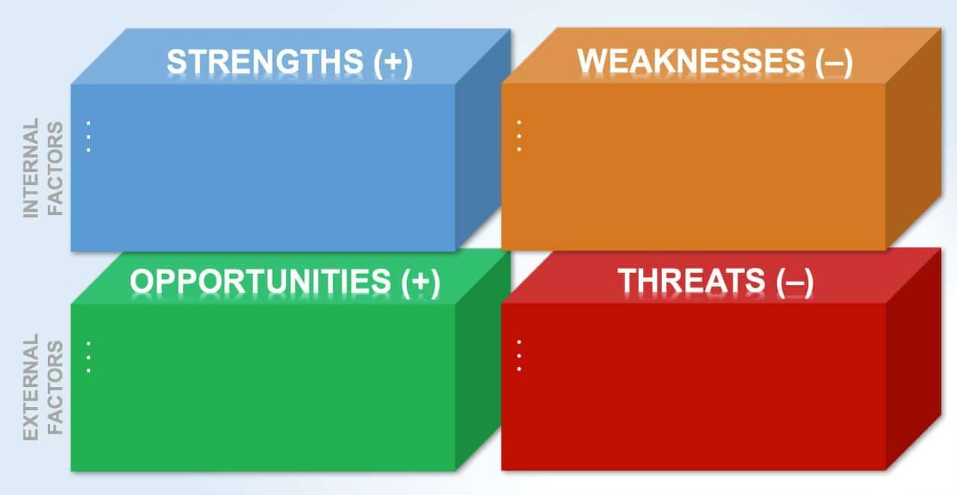
Figure 1: SWOT Analysis (Mourshed,Patel and Suder, 2014)

3.2 PESTEL
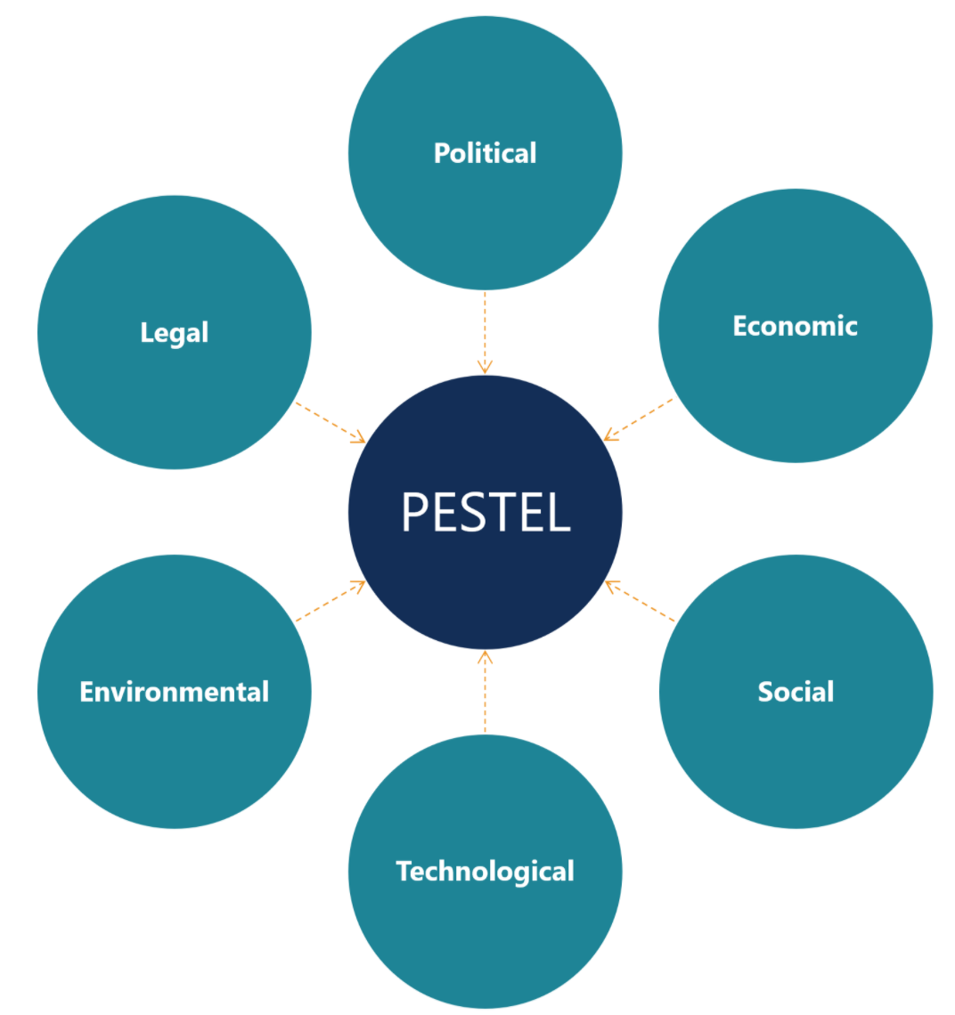
Figure 2: PESTEL Analysis (Teece,2018)
To analyse problems of business organisation considering the environmental factors is very important and PESTEL analysis is one of the best ways to analyse business environment (Ortega et al., 2019). PESTEL analysis of McDonalds is described below:
Political: A business must comply with the policy of the government. For example, Due to BREXIT lot of staffs from Islington store left the job.
Economical: Economical condition of UK puts an impact on McDonalds business policy. During the lockdown working hours of the store was reduced significantly.
Socio-Culture: An organisation must be dynamic with the changing taste and choices of customers (Pan,Chen and Zhan,2019). McDonalds has started McCafé to get the pulse of changing taste of customers. McDonalds staff has employee discounts to give greater benefit to their friends and family.
Technological: Technological advancement in business always brings dynamism in the business (Teece,2018). McDonalds has always provided upgraded technology to safeguard staffs and customers.
Environmental: McDonalds always encourage their staff to be concerned with environmental issues.
Legal: Regulatory issues may change with government decisions. During the lockdown McDonalds payed 80% of the salary to comply with government law.

3.3 Fishbone Diagram
Fishbone diagram is also known as cause-and-effect diagram that is conducted to visualize the causes of a problem so that root causes can be easily found (Desai et al.,2015). Fishbone analysis of McDonald’s is done below:
Crew members are dissatisfied
Management is poor

Night shift is longer than day shift
Lack of communication

No feedback is provided
Not properly trained

Improving workplace environment
No proper scheduling
Unethical mangers

Customers not getting best service
Newcomers are dominated
Management team is not properly trained
Employees are not treated properly

Employees cannot provide their best.
Conflict among employees

Staffs are leaving
or call sick
Complaint from customers

Figure 3: Fishbone Diagram (Letaifa, 2015)

4.Range of alternative solutions
The best possible solutions for McDonald’s might be as below:
Solution 1: McDonald’s should increase the numbers of staff in the overnight shift according with the sale that are projected, this will reduce the pressure that employees are feeling because they are understaffed, and they can focus more on the customer experience.
Solution 2: They need to train employees because training increases the efficiency of the employees and provides sustainable working environment.
Solution 3: They should take proper steps to increase the employee relationship through arranging different kinds of sessions. They can arrange different kinds of events that can break the ice among them. A good teamwork of employees can provide defined output to an organisation.

5.Evaluation of Alternative solutions
PMI is a decision-making, brainstorming and critical thinking tool that help to analyse an idea or concept or a solution from different dimensions (Cottrell, 2011). We can analyse the solutions for McDonald’s through using the PMI.
Plus | Minus | Interesting
- There will exist satisfaction among the workforce when they will feel that they are in friendly environment. (+7)  - More duties for the night shift workers will be justified. (+6)  - Mangers can make more effective management policy. (+6)  - The workforce will be more efficient. (+5)  - Conflict among the employees will be reduced. (+5)  - Frequent employee turnover will be stopped. (+6) | - It will cut cost for the company. (-6)  - Some of the workforce may be unhappy with the decisions. (-3)  - Arranging proper training is also a challenging task. (-4)  - This problem prevails all over the country, so it is challenging to sort out. (-6) | - This will be a role model for the other organisations so this can cut good concerns from the people as well as government. (+6)
+33 | -19 | +6

This analysis is based on the evaluation of the alternative solutions where the plus got more weights than minus. So according to PMI analysis the solutions are appropriate for McDonalds. The first solution will solve the customer complains that the organisation has at the time as well will reduce the pressure that overnight employees are feeling. The second solution will increase the expertise of the managers and employees, but it is to consider that arranging training programs will create expense to the organisation. The third solution can create a friendly working environment among the employees that also create some expense to the organisation. Here the first and third are the best option to choose if we compare the case scenario. The scenario says that most of the employees are facing too much pressure at work and they are not finding a friendly environment in the workplace. The alluded two solutions are the best option the deal with the situations.

6.Solution implementation
To implement the solutions properly there need to develop a SMART plan. The SMART plan indicates to the plan that is specific, measurable, achievable, relevant and time framed (Letaifa,2015). A SMART implementation for the solutions is explained below:

SMAT steps | Action required
What to accomplish? | Reduce the overall pressure and unsatisfaction employees are feeling on the night shift as well reduce the number of complains that the company is receiving from customers.
What logical steps to take? | The number of the employees in night shift will be increase according with the projections. And one or two interacting events should be organised in a month. In these events, the top authorities should join.
How to know whether the goals are accomplished or not? | As the number of staff will be increased and other motivational tools increased there can be expected to increase efficiency among the employees that may result to 20 percent increase in the profitability and 14 percent increase in the customers.
Who will take responsibility? | To implement these actions within the timeframe there need to take proper steps from the top decision makers. They should hire some experts to guide them properly.
What time is required to have results? | The result of these actions should be visible within three months. For this the top authority of McDonalds have to be concerned most.

Top authorities of McDonalds, Islington has to implement the plan step by step along with hiring expertise. As mangers from McDonald’s are included in the process the top authority has to take lead here. As the situation is prevailing in the whole UK the top tire should be in field to take their company out of this situation.

7.Communication plan to stakeholder
Communication plan is a technique to making plan for an issue providing information to the stakeholders (Butt,Naatanoja and Savolainen,2016). Communication plan for the stakeholders is shown through template below:

STAKEHOLDER | POWER/ INTEREST | KEY INTERST & ISSUES | COMMUN-ICATION  VEHICLE | FREQUEN-CY | COMMENTS
Area Manger | Top authority | They will decide what will be executed in the whole project. | Meeting  Email | Monthly | Formulate plan for the project; Allocate budget and time for the project
Store manager | Chief of executives | He will distribute the responsibility to the managers and will give required guideline. | Meeting and Email | Weekly | Will make execution plan; assign a person to execute the project.
Shift Managers | Head of the project | They will take all the responsibilities to execute plan and get the project plan done. | Meeting, Email and Phone Call | Daily | Will make execution plan in field level; keep day to day communication with the executive manager.

8.Monitoring and Reviewing techniques
There are a range of existing monitoring and reviewing techniques. Some of the most common and effective monitoring techniques are described to successfully implementing the solutions:
Observation: observation is the best way to monitoring the performance of a project or even performance of anything. For this manger have to keep close eye on the activities of the project also the manger has to have proper knowledge about the project task (Lyons et al.,2014).
Comparing performance and output: At the planning level there set an estimated performance and output level. The manger can find out the deviation from the standard. The deviation will tell how good or bad is the performance is going on.
Taking & surveying: Taking with the employees and getting data from them is another effective way to review performance.
Benchmarking is one of the popular techniques in monitoring. So, the manager can benchmark with other units to review the performance.
Employee meeting can be a good technique to review this plan for Islington McDonalds.
Keeping records and finding errors from the records is another effective way to review and monitor.

9.Conclusion
The problem identified at McDonalds by using the techniques described in the report can be sorted out with the given solutions. This report included the analysis of the information, a range and evaluation of alternative solutions, solution implementation and stakeholder’s communication plan. The top authority should take into consideration the problem in a short time to respond properly. As the same kind of problems is prevailing in UK the company should be more concern about the situation and should implement the solutions as early, they can.

References
Angrave, D. and Charlwood, A., 2015. What is the relationship between long working hours, over-employment, under-employment and the subjective well-being of workers? Longitudinal evidence from the UK. Human Relations, 68(9), pp.1491-1515.
Butt, A., Naaranoja, M. and Savolainen, J., 2016. Project change stakeholder communication. International Journal of Project Management, 34(8), pp.1579-1595.
Cottrell, S. (2011) Critical thinking skills: Developing effective analysis and argument (Palgrave study skills). 2nd edn. Basingstoke: Palgrave Macmillan.
Desai, K.J., Desai, M.S. and Ojode, L., 2015. Supply chain risk management framework: a fishbone analysis approach. SAM Advanced Management Journal, 80(3), p.34.
Letaifa, S.B., 2015. How to strategize smart cities: Revealing the SMART model. Journal of business research, 68(7), pp.1414-1419.
Lyons, E.J., Lewis, Z.H., Mayrsohn, B.G. and Rowland, J.L., 2014. Behavior change techniques implemented in electronic lifestyle activity monitors: a systematic content analysis. Journal of medical Internet research, 16(8), p.e192.
Mourshed, M., Patel, J. and Suder, K., 2014. Education to employment: Getting Europe’s youth into work. McKinsey & Company.
Ortega, R.G., Rodríguez, M.D.O., Vázquez, M.L., Ricardo, J.E., Figueiredo, J.A.S. and Smarandache, F., 2019. Pestel analysis based on neutrosophic cognitive maps and neutrosophic numbers for the sinos river basin management. Infinite Study.
Pan, W., Chen, L. and Zhan, W., 2019. PESTEL analysis of construction productivity enhancement strategies: A case study of three economies. Journal of Management in Engineering, 35(1), p.05018013.
Phadermrod, B., Crowder, R.M. and Wills, G.B., 2019. Importance-performance analysis based SWOT analysis. International Journal of Information Management, 44, pp.194-203.
Proctor, T., 2018. Creative problem solving for managers: developing skills for decision making and innovation. Routledge.
Teece, D.J., 2018. Business models and dynamic capabilities. Long range planning, 51(1), pp.40-49

Appendices

In class exercise from 07/10/20: Philipps case study
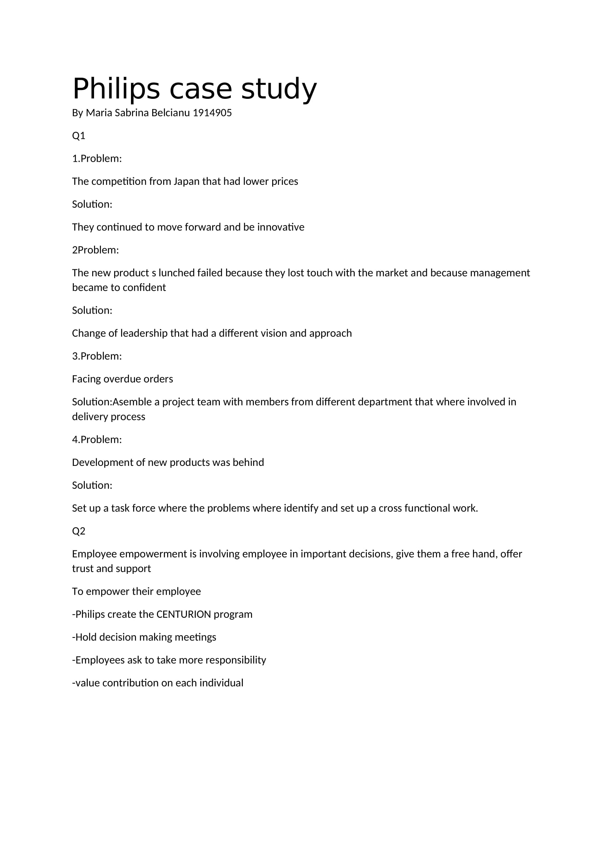

In class exercise from 21/10/20: Problem solving and decision making using the 7 steps
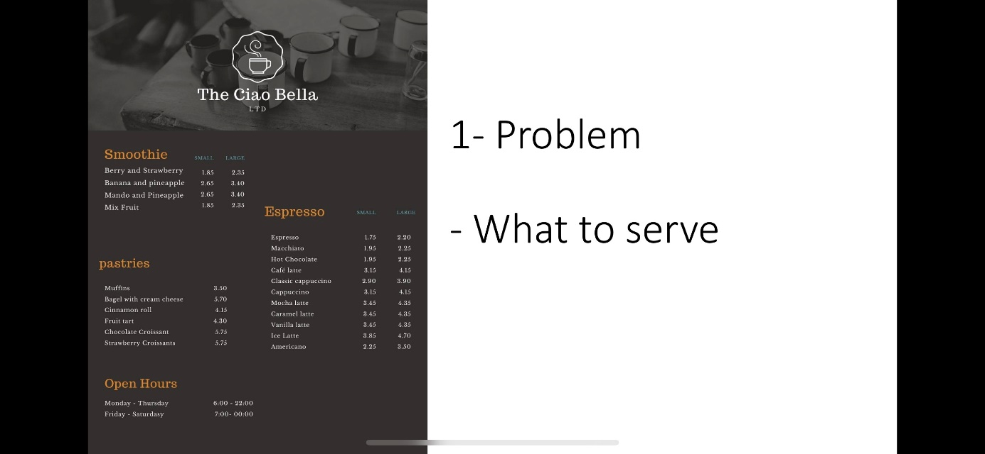
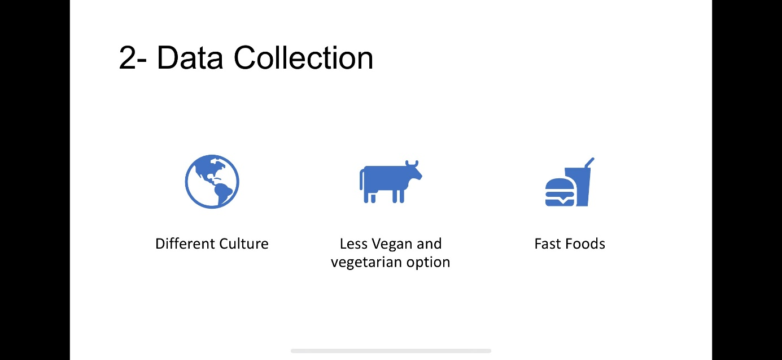
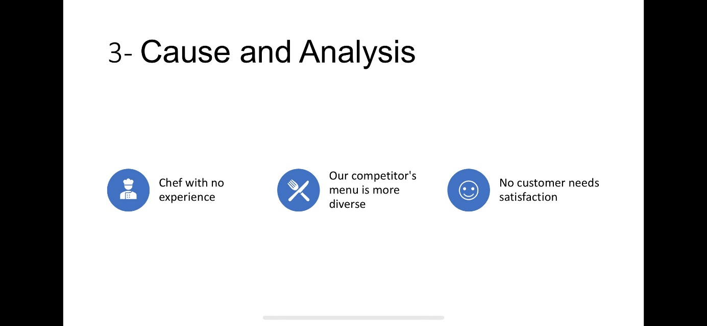
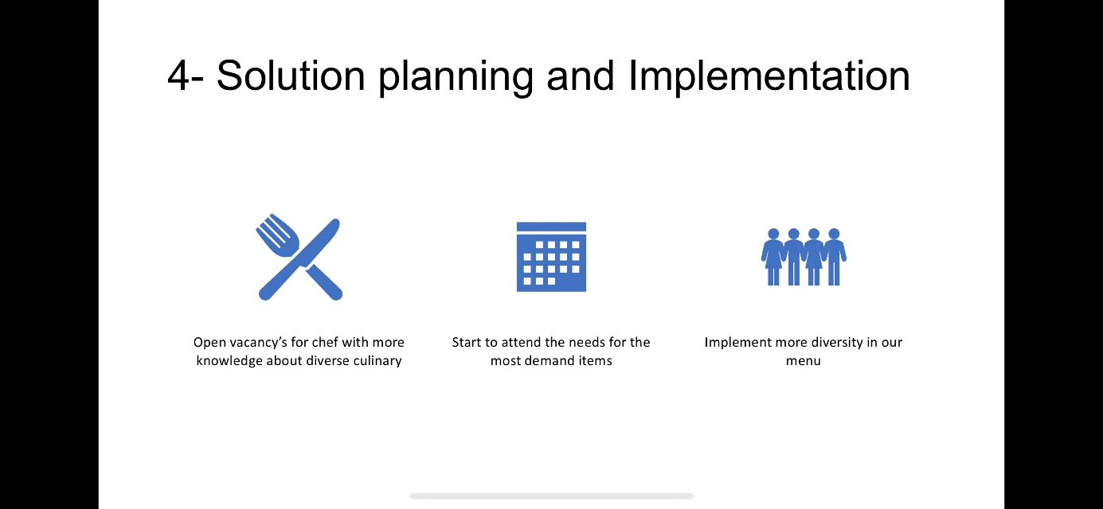
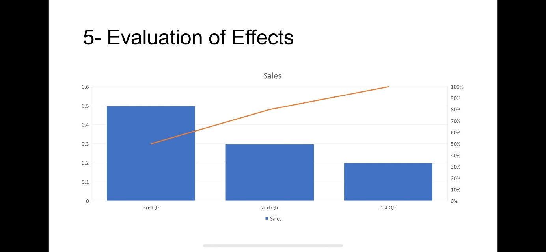
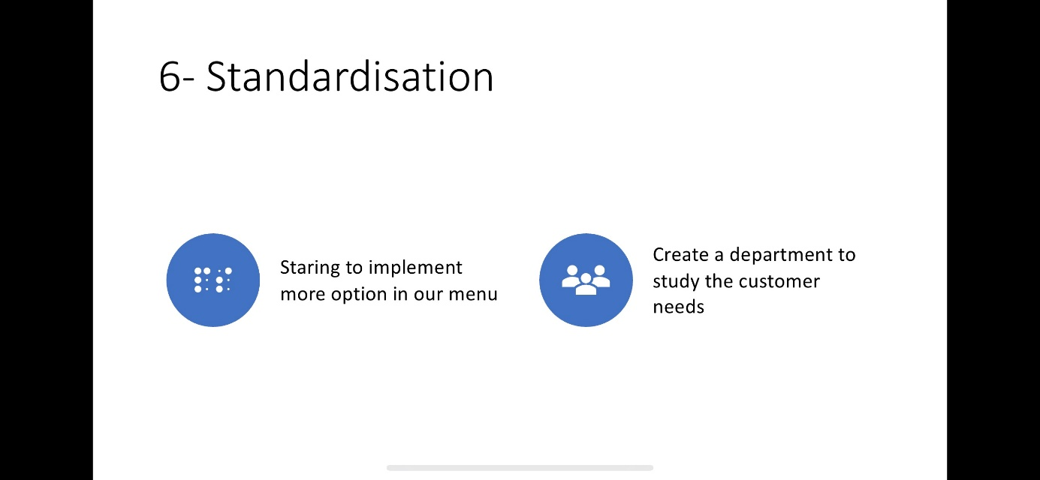
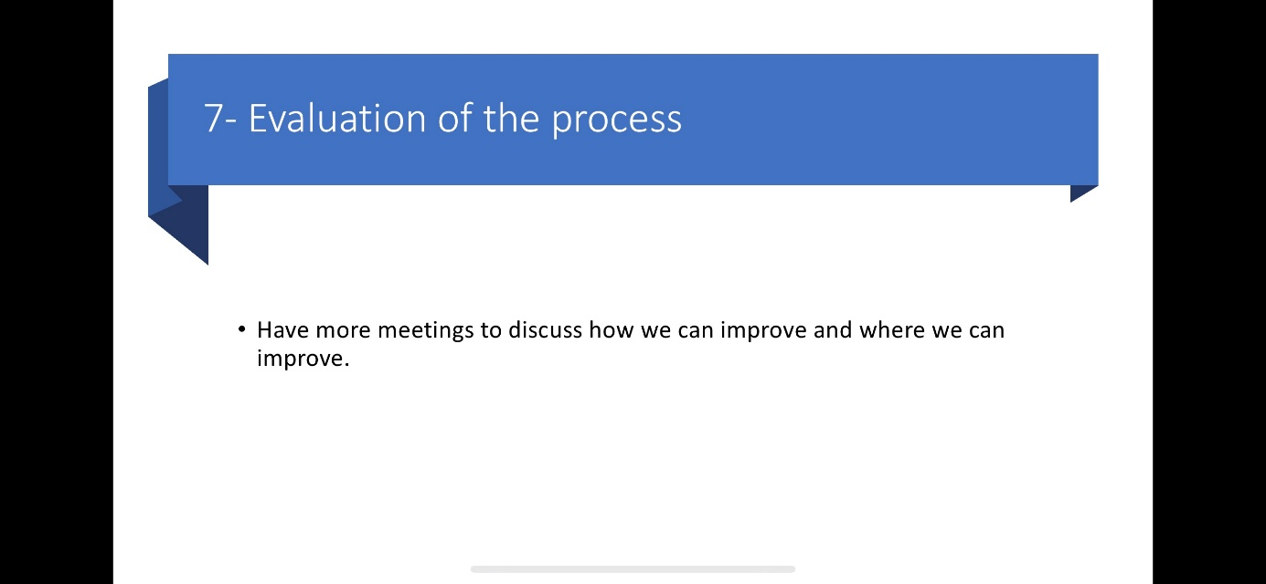

In class exercise from 04/11/20: Fishbone analyse


