Exhibition and Evaluation

For the task we were given the title The Narcissism Epidemic in which we had to create and organise an exhibition which opens on the 25th of October at 5pm. I chose to base my project around self-portraits which i did two shoots that i had to choose from. Both shoots inspired by Narcissism had a different feel and inspired by various artists. The first shoot I did was based on Cindy Sherman’s ‘Early Transformations’ which i discovered after watching her documentary. The work instantly spoke to me and I felt a connection with the ways we both works. I took a series of images where i changed my makeup, hair and clothes that were shot in an almost theatrical way and very over exaggerated, maybe so much that it was more like I was trying to be someone else rather than basing it on Narcissism in Me. To me, this shoot was successful with how the final products looked but it was time to try something different and be more myself.

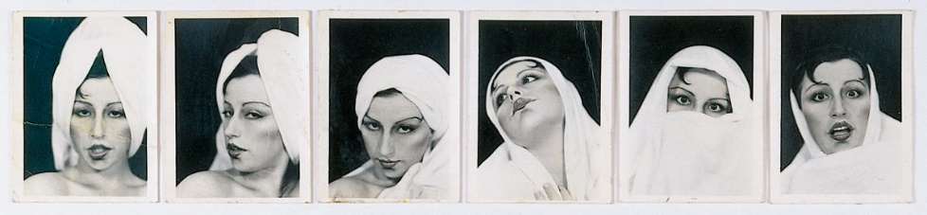Cindy Sherman – Early Transformations

When trying to feel inspired for another shoot I came across Claude Cahun, French surrealist Photographer whose strong profile and their way of being true to themselves made me want to try a shoot a little more traditional. Stripped back to my true self with minimal colours and editing the shoot was done by a neutral coloured wall with just me, the camera and a friend. We shot a series of images some which were almost trying too hard to be like a studio shoot, we then relaxed into it and started experimenting with some things disturbing the camera, inspired by a shoot i saw in W Magazine by Laurence Ellis, firstly using a plastic bag to distort some of the images, then we used the metal frame of some glasses that gave a light leak effect. Ellis used coloured cellophane which created a soft and dreamy effect to his portraits which was what i wanted to translate into my images. We found these images to be the most so i decided to use one of them in the exhibition. I think that the space i was given to put my work on the wall worked well alongside everyone else’s work.
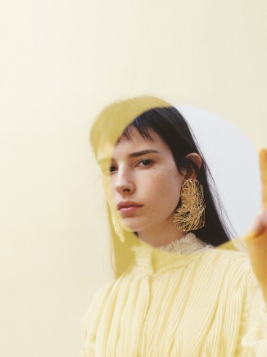Laurence Ellis – W Magazine
As we had to work as a group we each needed jobs to get the exhibition complete. On a Facebook group chat there was a Poll made so we could all vote fairly for jobs we wanted to do, I chose the role of organising the bar for opening night which I collected £3 off each student to be able to have a good amount of drinks. I also decided to make cocktails instead of the usual wine so there was more variety. The £3 off everyone worked out a £60 total which was the perfect amount to have a well-run bar. I think that everyone involved with making the exhibition come to life worked hard at the jobs allocated, most people in the group helped with putting their own work on the walls.

