
LEVEL 7 ASSESSMENT SPECIFICATION
Developing a Sustainable Brand Extension Strategy for IKEA: The IKEA Circular Living Initiative

Student Name: Harsh Dipak Kundaliya

Student ID: 2535226

Module Name: Marketing Management

Module code: LCMB7024

Lecturer’s Name: Sinan He

Words Count: 2582

Term 1

Table of Contents
Element 1: Sustainable Brand Extension Poster 3
Element 2: STDP Analysis 4
2.1 Market Segmentation 4
2.2 Target Market 6
2.3 Differentiation Strategy 6
2.4 Positioning Strategy 7
Element 3: Marketing Mix (4Ps) 7
3.1 Product 8
3.2 Price 8
3.3 Place 9
3.4 Promotion 10
Element 4: Reflection 11
4.1 Description 12
4.2 Feelings 12
4.3 Evaluation 12
4.4 Analysis 12
4.5 Conclusion 13
4.6 Action Plan 13
References 14
Appendixes 17

Element 1: Sustainable Brand Extension Poster
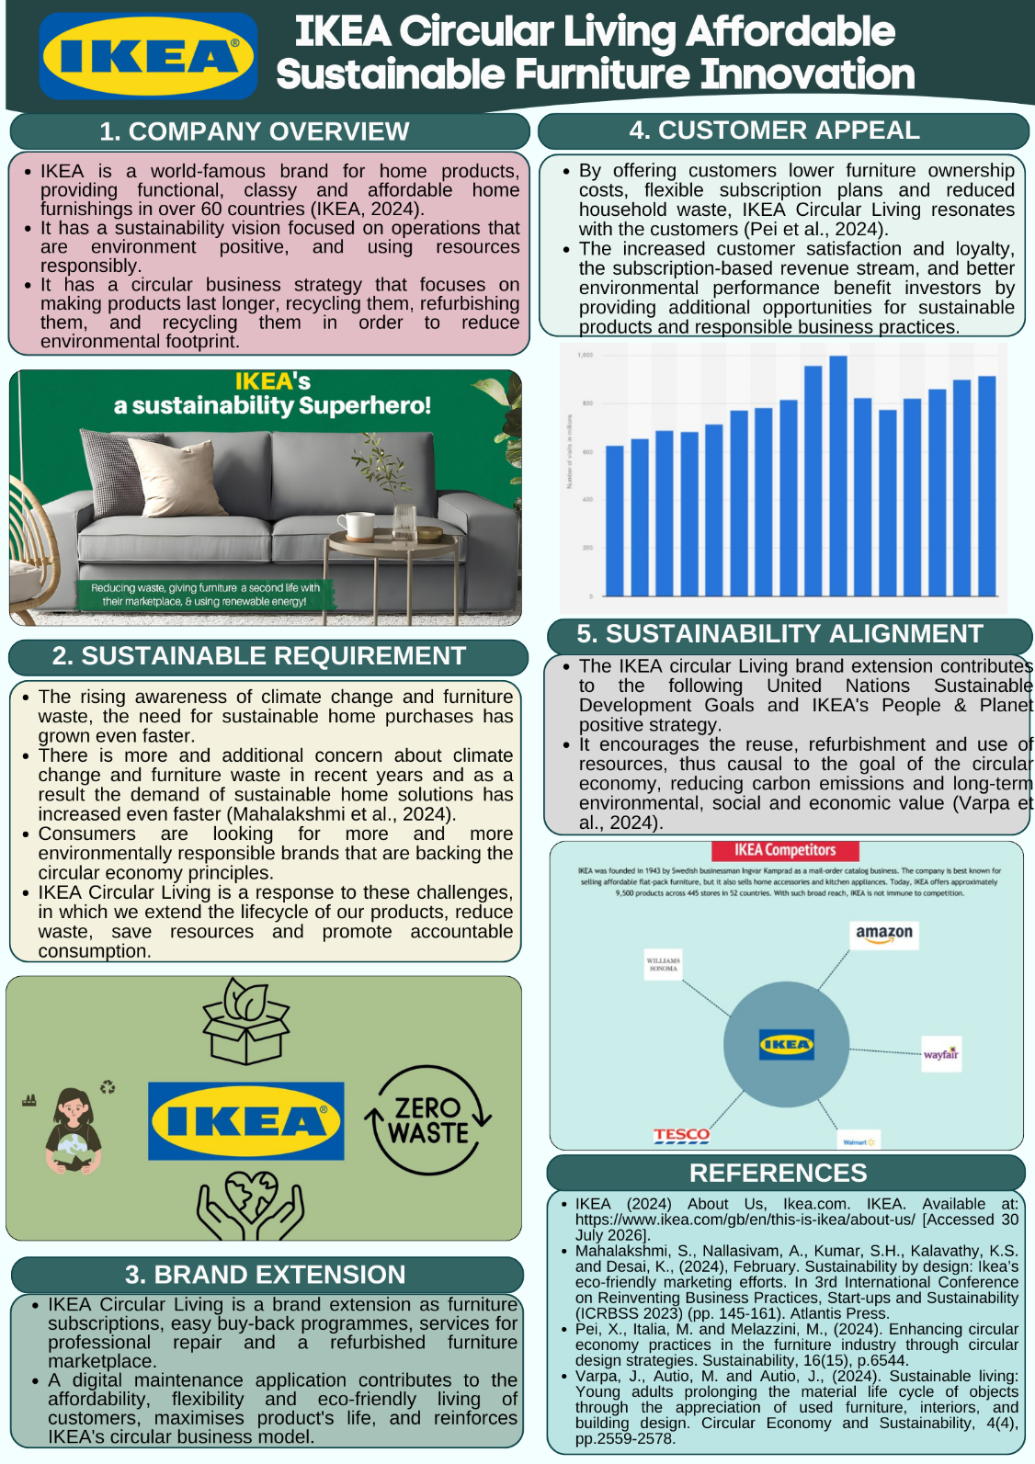

Element 2: STDP Analysis
The STDP framework for the creation of a Sustainable Brand of IKEA Circular Living- Identifying the sustainable consuming customers finished a sustainable-oriented approach, focusing on target on the affordable & value oriented Urban customers who values circular approaches and distinguished with furniture subscription & refurbishment and positioning in the marketplace as innovative, affordable & sustainable furniture solutions refer in figure 1.
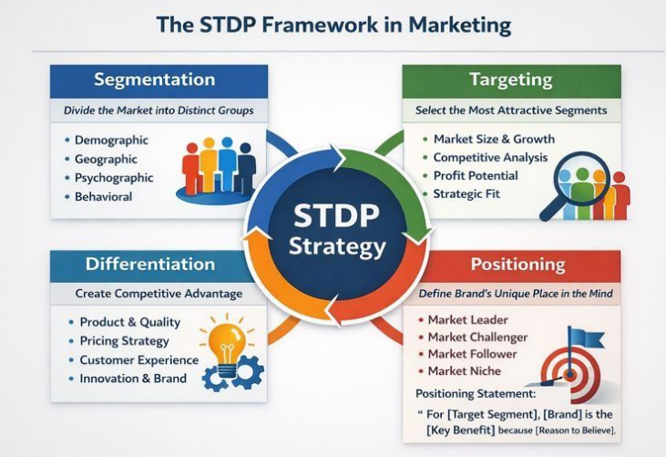
Figure 1: STDP framework
(Source: Linkedin.com, 2026)

2.1 Market Segmentation
Geographic Segmentation: The IKEA Circular Living marketing strategy is mainly aimed at customers who live in urban cities in Europe, UK, North America and Asia-Pacific, an area where the desire of the people to live in an apartment and to care about the environment is rapidly growing (Andersson, 2022) [refer in figure 2]. There is a high demand in these marketplaces for sustainable, space-efficient and affordable furniture solutions. IKEA can provide the subscription, refurbishment and buy-back facility and assist local circular economy efforts, whilst at the same time making efficient use of local, densely populated areas to minimise carbon emissions from transport.
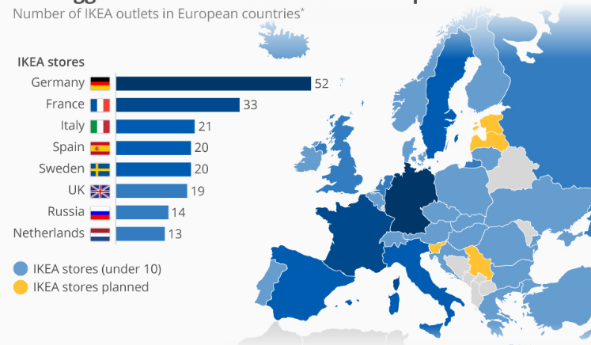
Figure 2: Global Distribution of IKEA Stores (Map)
(Source: Moebus, 2024)
Demographic Segmentation: The extension is aimed at young people aged 20-45, people with a middle income, young adults, students and small families – mostly Millennials and Generation Z. The collections are looking for home furnishings that are affordable, fashionable and flexible to adapt to lifestyles that change (Attah et al., 2023). Their financial and sustainability expectations are met with a furniture access service, a repair service and IKEA refitted furniture, thus turning sustainable living into an economically appealing choice.
Psychographic Segmentation: IKEA Circular Living targets consumers who are mindful of sustainability, technology, minimalism, and convenience, and are eco-conscious and aware of sustainability (Bäckman and Engdahl, 2022). These customers are more concerned with being environmentally responsible, choosing affordable quality, and living in a circular way, rather than owning more. The brand extension strengthens their lifestyle with a recipe to reduce waste and keep products relevant to their customers' lives
Behavioral Segmentation: The extension is aimed at shoppers who tend to buy from IKEA often, buy on-line, and would like the furniture to be affordable, replaceable, and would like flexible options of ownership. These buyers are on the move and value enabling, affordable products (Bhatta, 2024). IKEA Circular Living also helps to build a loyal customer base thanks to its subscription model, buy-back programme, repair service and refurbished furniture, which can enable repeat sales and support sustainable ingesting while increasing the life cycles of products.

2.2 Target Market
IKEA Circular Living's main target group is young urban professionals between 20-45 years old, who are looking for affordable, flexible and sustainable solutions to their furniture needs that are appropriate for the modern lifestyle and small living space. These customers are connected in the digital world, often shop online and rise convenience, quality and products that are environmentally friendly. A secondary market comprises students, young families, remotely located workers, and apartment renters in need of flexible furniture with none of the financial responsibility of owning (Börjesson and Jobrant, 2024). The things they buy are influenced by being affordable, functional, and being able to promotion furniture in case one's lifestyle changes. They also want brands to show their strong sustainability efforts which involve waste-reduction, reuse of products, and carbon emission reduction activities (Himmelmann, 2024). Being able to access IKEA Circular Living with subscription services, buy-back programmes, repair solutions and refurbished furniture on an integrated digital platform, meets these expectations, strengthening the relationship by the customer and contributing to the circular economy principles, while fostering responsible consumption among different segments of customers.

2.3 Differentiation Strategy
IKEA Circular Living's USP is that it offers affordable furniture that is paired with innovative circular economy services that prolong the life of the product and minimize environmental impact. IKEA also has combined furniture subscription programmes, furniture refurbishment, professional repairs and easy buy-back programmes, which is different from other furniture companies like Wayfair, Habitat, John Lewis and numerous local furniture stores (Mahalakshmi et al., 2024). The services are sponsored by a smart digital platform that allows customers to manage their subscriptions, schedule maintenance and repair services, access maintenance advice and efficiently return products. The circular business model promotes re-use, refurbishment and responsible ingesting over more frequent replacement.

2.4 Positioning Strategy
IKEA Circular Living A eco-friendlier furniture experience of trendy, stylish and sustainable furniture at reasonable prices that, the buying, refurbishing, repairing and returning options can be achieved, without affecting that convenience, style and economy; customers can turn their home into a additional environment-friendly space (Yani et al., 2025). Positioning statement; the positioning has of being a revolutionary local living with furniture solution to all green aware persons that seek value and flexibility. On a positioning perceptual map IKEA circular living stands strong in the market place in contradiction of traditional home furnishing retailers & furniture retail companies, sitting among high sustainability & low cost (Yani et al., 2025). By focusing on right fit, digitally enabled connections and circularity principles, it offers meaningful customer benefits and repeats IKEA’s position as an innovative player, and as leading the way in life at home and working sensibly with resources.
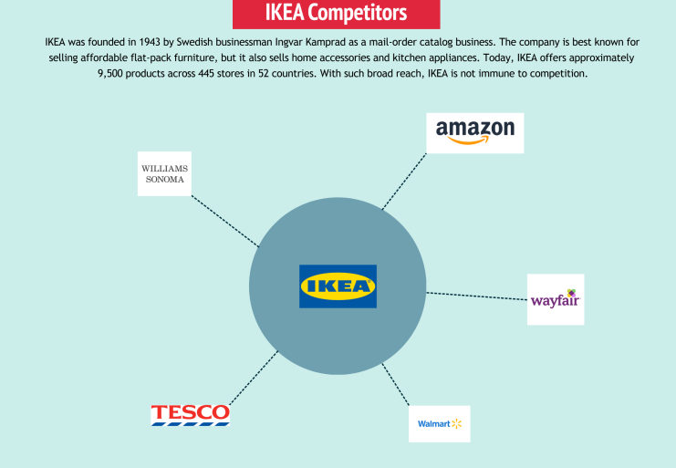
Figure 3: Competitors Map
(Source: Cuofano, 2024)

Element 3: Marketing Mix (4Ps)
The 4Ps can be used to help attain the sustainable brand extension of IKEA Circular Living, which adds value to the customers and contributes to the competitive advantage.

3.1 Product
The core product at IKEA Circular Living is the subscription furniture service, bringing high-quality living room furnishing to your fingertips without the capital outlay of ownership. This model is ideal for a city resident, student, rental apartment inhabitant and any type of user whose lifestyle means they may well move frequently. According to Weje (2024) found that product offering the product offering in the modular range comprises a range of reconfigurable living spaces, second-hand Furniture Suites with professional repair, an outstanding refurbishment program and convenient buy-back program that offers for an extended life cycle. This leads to minimal waste and cost-effective furniture solutions for the customer.
The value augmentation will enable customer to get better delight experience, through a mobile app where customer can subscribe, subscribe agenda for home delivery, schedule a paid professional installing service for the product and then set up for professional guidance with automatic care (Ateeq et al., 2025). IKEA reports that their product lifespan was increased because they implemented buy-back programs and circulated more than 40 million spare parts globally, with approximately 10 million Ikea products buybacks occurring (IKEA, 2025). IKEA Sustainability Report highlights that product life was extended by the purchase back of approx 10 million Ikea products finished their buy-back initiatives and over 40m spare parts provided worldwide (IKEA, 2026).

3.2 Price
The pricing policy of IKEA Circular Living is a mixture of subscription pricing, value pricing, penetration pricing, and flexible pricing to make it affordable for customers and increase customer retention. According to Aro (2024) found that Subscription furniture makes sustainable furniture more attainable by offering customers a chance to bear premium furniture in small steps, rather than a single, large acquisition. Value based pricing considers the extra value of product refurbishment, maintenance services and product upgrading whereas penetration-based pricing uses it as a tool to get people to try a subscription when they are environmentally conscious (Carmona et al., 2026). Flexible payment options are various subscription levels, premium packages with better services, student discounts and loyalty cards for multiple purchases and product returns. The company's worldwide strategy of selling affordable products backs this pricing strategy, and IKEA says that retail sales, which account for its annual sales of more than €27.34 billion in 2022, are well received by consumers and have a proven ability to sell (Cuofano, 2024). Subscription models also make repeat sales and revenue, and foster customer lifetime value by ongoing engagement. Loyalty schemes and incentives for customers to return pre-loved furniture for re-use and re-purposing help to achieve the goals of the circular economy.
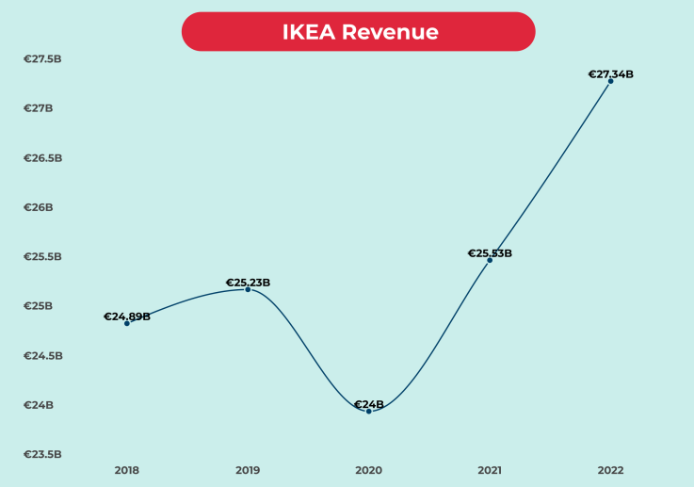
Figure 4: IKEA global economic
(Source: Cuofano, 2024)

3.3 Place
The distribution strategy for IKEA Circular Living is based on an integrated omnichannel retail strategy, with the aim of getting the customer to easily find sustainable service of furniture via different channels (Sarin et al., 2026). These are IKEA's physical locations, official website, mobile app, Click and Collect services and group points in the urban centers. The furniture can be digitally subscribed and bought, the repair services be arranged, buy-backs be booked and refurbished furniture bought, all on digital platforms or in retail. Reverse logistics is a key component in the system and is used to change returned furniture to a specific refurbishment centre for re-use and/or inspection and refurbishment, thereby minimizing waste and prolonging product life. Efficient transport routes and local completion centres add to the reduction of carbon emissions and operational costs in delivery optimisation. IKEA has over 470 stores around the world, which offers an extensive distribution network able to further support circular business activities across the international markets (Statista, 2025).
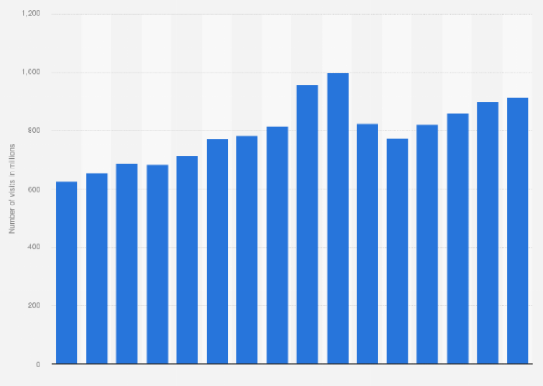
Figure 5: Number of visits to IKEA stores worldwide
(Source: Statista, 2025)

3.4 Promotion
IKEA Circular Living This model utilizes a marketing communications framework surrounding IMC in an endeavor to increase brand recognition among customers with regard to sustainable living and also ensure brand equity. Specifically, in the domain of digital marketing there are absorbed Instagram campaigns, TikTok and YouTube, Facebook, and influencer partnerships centered on offering furniture via subscription, furniture refurbishing, and the benefits the circular economy affords (Kohli, 2025). It’s a platform for younger customers who are keen on the best in organic products. In-store sustainability information presentations are among the store’s conservative marketing techniques; community activities, green advocacy efforts customers ways that the furniture is able to be reinstated or repurposed. Buy backs, referral programs, rewards as well as store loyalty plans have been designed to encourage stores to buy a lot (Alzoubi et al., 2023). The public relations work comprises cooperation with environmental organizations, environmental communication campaigns as well as CSR (Corporate Social Responsibility) initiatives that demonstrate obligation to IKEA's sustainability journey. IKEA invests substantially in sustainability communication that strengthens the company's work within the People and Planet Positive Strategy, while also linking the company and its creativities to its customers and stakeholders.

Element 4: Reflection
I used Gibbs' Reflective Cycle to evaluate my experience of developing the IKEA Circular Living brand extension. Reflection helped me to assess my learning, identify strengths, notice difficulties and plan for future professional learning.

Figure 6: Gibbs' Reflective Cycle
(Source: Self-Created)

4.1 Description
IKEA Circular Living is a sustainable new branch of this iconic Swedish retailer focusing on furniture subscriptions, refurbished furniture, repairs, and buyback options. This brand extension project was researched by examining business sustainability reports, academic journals on circular economies and pertinent customer behaviour studies and analysis (Rodrigo, 2023). I have made this in the form of a poster to clearly and attractively put over my ideas in a brief way. I feel this way I have been able to tie up what I learned with a practical situation which could benefit a business in order for growth.

4.2 Feelings
At first, I was sure about the choice of IKEA because of their reputable sustainability image, but I wasn't sure about the design of a brand extension. It was difficult to find a balance between creativity and evidence from theoretical research. As my research continued, I gained confidence to apply the marketing and sustainability concepts. The process of making the poster enhanced my communication skills and also aided me to present complex ideas in a simple, organized and visually appealing way.

4.3 Evaluation
The project is contributing to my learning about sustainable marketing, brand development, and strategic decision making. The application of theoretical models has helped me in improving my analytical and research skills in the context of IKEA (Longani and Sharma, 2024). But it took a long time to evaluate market tendencies and consumer needs to choose the most appropriate brand extension. It was difficult to manage my time, especially when reading academic literature and arranging the collection, but it helped me to plan and prioritise and enhance my academic performance.

4.4 Analysis
STDP framework and the marketing mix was useful in understanding the impact of segmentation, positioning, pricing, distribution and promotion on sustainable brand success. Theories of branding and customer behaviour were used to justify the decisions made during the project. This case study on IKEA's sustainability strategy highlighted how IKEA's circular economy programmes add value to the customer and the company. This experience enabled me to combine theory and practical skills in marketing solutions for real business problems.

4.5 Conclusion
During the course of this job, it has certainly given me confidence in coming up with marketing plans which are sustainable and has helped me revise my brand delay plan knowledge. I have learned that the real trick to give effective marketing solutions lies in managing to fuse strategy, creativity and thoughtful into one. Looking back at my performance, it does complete my realization of that I am doing pretty good on me as a separate but do still have weaknesses to polish up as an aspiring marketing expert. Over all this gave an additional value to my professional knowledge, which has made me ready for a future plan professional for using sustainable marketing practice.

4.6 Action Plan
For success plans I will work more on my performance skills and will be looking for comments to raise more assurance throughout the interaction. Also, I will more dive into the peer-reviewed studies to increase my academic language as well as serious analytical thinking. I will be enrolled for more professional sequences too in order to last learning about digital marketing and the current changes in sustainability. Time management and project planning can help me to perform the tasks by higher quality while having greater effectiveness.

References
Poster References
IKEA (2024) About Us, Ikea.com. IKEA. Available at: https://www.ikea.com/gb/en/this-is-ikea/about-us/ [Accessed 30 July 2026].
Mahalakshmi, S., Nallasivam, A., Kumar, S.H., Kalavathy, K.S. and Desai, K., (2024), February. Sustainability by design: Ikea’s eco-friendly marketing efforts. In 3rd International Conference on Reinventing Business Practices, Start-ups and Sustainability (ICRBSS 2023) (pp. 145-161). Atlantis Press.
Pei, X., Italia, M. and Melazzini, M., (2024). Enhancing circular economy practices in the furniture industry through circular design strategies. Sustainability, 16(15), p.6544.
Varpa, J., Autio, M. and Autio, J., (2024). Sustainable living: Young adults prolonging the material life cycle of objects through the appreciation of used furniture, interiors, and building design. Circular Economy and Sustainability, 4(4), pp.2559-2578.
Report references
Alzoubi, A., Al-Talib, M. and Al Saad, W.K., (2023), March. Sustainability as a competitive advantage: IKEA as a case study. In 13th International Conference on Industrial Engineering and Operations Management (IEOM).
Andersson, J., (2022). Theory of Change as a Strategic Tool for Sustainability Within IKEA1. HOW TO CHANGE THE WORLD? AN ANTHOLOGY ON THEORIES OF CHANGE, p.224.
Aro, O.E., (2024). Circular Economy in Supply Chain Management: Leveraging Technology for Sustainability. International Journal of Research Publication and Reviews, 5(10), pp.4057-4074.
Ateeq, K., Agarwal, S., Jawabr, A., Oswal, N. and Alami, R., (2025). Strategic integration of sustainable development goals in international business: A framework for competitive advantage.
Attah, R.U., Ogunsola, O.Y. and Garba, B.M.P., (2023). Advances in sustainable business strategies: Energy efficiency, digital innovation, and net-zero corporate transformation. Iconic Research and Engineering Journals, 6(7), pp.450-469.
Bäckman, M. and Engdahl, A., (2022). Integration of Planning Functions to Improve Operational Supply Chain Planning-A case study of the facilitators and obstacles at IKEA.
Bhatta, S., (2024). The effect of mobile augmented reality apps on customer experience: The IKEA case.
Börjesson, A. and Jobrant, D., (2024). Exploring Behavior-Driven Development at IKEA Using Design Research. LU-CS-EX.
Carmona Marques, P., Reis, J. and Silva, W.D.O., (2026). Integrating circular economy and lean management: A strategic framework for sustainable business transformation. Corporate Social Responsibility and Environmental Management.
Cuofano, G. (2024). IKEA Business Model. [online] FourWeekMBA. Available at: https://fourweekmba.com/ikea-business-model/.[Accessed 30 July 2026].
Cuofano, G. (2024). IKEA Competitors. [online] FourWeekMBA. Available at: https://fourweekmba.com/ikea-competitors/.[Accessed 30 July 2026].
Himmelmann, N., (2024). Creative Storytelling in IKEA Advertising: Furnishing Narratives: A Multimodal Discourse Analysis of Creative Storytelling Techniques in IKEA Advertising.
IKEA (2024) About Us, Ikea.com. IKEA. Available at: https://www.ikea.com/gb/en/this-is-ikea/about-us/ [Accessed 30 July 2026].
IKEA (2025) Financial reports, www.inter.ikea.com. Available at: https://www.inter.ikea.com/en/performance/download-financial-reports [Accessed 30 July 2026].
IKEA (2025) Sustainability at IKEA, Ikea.com. Available at: https://www.ikea.com/gb/en/this-is-ikea/sustainable-everyday/ [Accessed 30 July 2026].
IKEA (2026). How We Work – IKEA Global. [online] IKEA. Available at: https://www.ikea.com/global/en/our-business/how-we-work/ [Accessed 30 July 2026].
Kohli, N., 2025. Sustainable business practices in IKEA: a study on consumers perceptions.
Kral, V., (2023). Transforming Phase of Circular Business Model Innovation in IKEA: A Case Study from Circular Business Ecosystem Perspective.
Linkedin.com. (2026). LinkedIn. [online] Available at: https://www.linkedin.com/posts/aydin-ahrabi_stdp-segmentation-targeting-activity-7412383487904862208-zt0t [Accessed 30 July 2026].
Longani, K.D. and Sharma, P., (2024). The green movement of sustainability: A case of IKEA in India. Perspektif Komunikasi: Jurnal Ilmu Komunikasi Politik Dan Komunikasi Bisnis, 8(2), pp.241-250.
Mahalakshmi, S., Nallasivam, A., Kumar, H., Kautish, S. and Madan, S., (2024). From Assembly to Reassembly: Ikea's Circular Design for a Sustainable Future. In Utilizing Technology for Sustainable Resource Management Solutions (pp. 261-280). IGI Global.
Moebus, F. (2024). Infographic: The Biggest IKEA Store Networks in Europe. [online] Statista Infographics. Available at: https://www.statista.com/chart/9561/the-biggest-ikea-store-networks-in-europe/.[Accessed 30 July 2026].
Perciun, R., Şavga, L. and Iordachi, V., (2023). Circular economy in practice: key actors in sustainable transformation. In Creşterea economică în condiţiile globalizării (pp. 31-45).
Rodrigo, I.C., (2023). Firm Resources and Capabilities and Their Impact on Sustainability: The Case of IKEA.
Sarin, P.Y., Sidhad, R. and Sarin, A.B., (2026). From Linear Consumption to Circular Value Creation: Advancing Sustainability Through Circular Economy Practices. International Journal of Economic Practices and Theories, 2026, pp.3548-3565.
Statista. (2025). Ikea: Number of store visits globally 2010-2025. [online] Available at: https://www.statista.com/statistics/241828/number-of-visits-to-ikea-stores-worldwide/?srsltid=AfmBOoo1HQzHmZyJiuVB9dARLY6TnQI-tbBKtPNAWpBH12LVBw7M0q8g[Accessed 30 July 2026].
Cuofano, G. (2022). What is the SFA matrix? SFA matrix in a nutshell. [online] FourWeekMBA. Available at: https://fourweekmba.com/sfa-matrix/ [Accessed 30 July 2026].
Weje, I.V., (2024). The Implication of Innovation on Consumer Buying Behavior in Relation to COVID-19: A Case Study of IKEA in Ireland.
Yani, M.F., Muhdiantini, C., Firdaus, F.A. and Muhammad, H.A., (2025). IKEA: Enhancing Customer Experience through Digital Transformation. JIPI (Jurnal Ilmiah Penelitian dan Pembelajaran Informatika), 10(2), pp.1771-1779.

Appendixes
Appendix A: IKEA Company Overview
Item | Description
Company Name | IKEA
Industry | Home Furnishing and Furniture Retail
Founded | 1943
Founder | Ingvar Kamprad
Headquarters | Delft, Netherlands
Global Presence | Over 60 markets
Business Model | Affordable flat-pack furniture and home accessories
Sustainability Vision | Climate-positive and circular business by 2030

Appendix B: Proposed Brand Extension Summary
Brand Extension Element | Application to IKEA Circular Living
Brand Name | IKEA Circular Living
Core Service | Furniture Subscription
Additional Services | Repair, Refurbishment, Buy-back
Digital Innovation | Mobile Application
Sustainability Focus | Circular Economy
Customer Benefit | Affordable and Flexible Furniture Access

Appendix C: STDP Summary
Element | Application to IKEA Circular Living
Geographic | Urban cities across Europe, UK, North America, Asia-Pacific
Demographic | Age 20–45, Millennials, Gen Z, Young Families
Psychographic | Sustainability-focused, Minimalist, Eco-conscious
Behavioural | Frequent IKEA Buyers, Online Users, Flexible Ownership
Target Market | Young Urban Professionals
Differentiation | Subscription, Repairs, Refurbishment, Buy-back
Positioning | Affordable Sustainable Circular Furniture

Appendix D: Competitor Comparison
Criteria | IKEA Circular Living | Wayfair | John Lewis | Habitat
Furniture Subscription | ✓ | ✗ | ✗ | ✗
Buy-back Service | ✓ | ✗ | Limited | ✗
Repair Service | ✓ | Limited | Limited | Limited
Refurbished Furniture | ✓ | ✗ | Limited | ✗
Circular Economy Focus | High | Low | Medium | Medium
Digital Platform | Advanced | Advanced | Advanced | Moderate
Appendix E: Marketing Mix (4Ps) Summary
Marketing Mix | Application
Product | Subscription, Refurbished Furniture, Repairs
Price | Monthly Plans, Student Discounts, Loyalty Rewards
Place | IKEA Stores, Website, Mobile App, Click & Collect
Promotion | Social Media, Influencers, CSR Campaigns, Buy-back Rewards

Appendix F: Sustainability Benefits
Area | Expected Benefit
Carbon Emissions | Reduced through furniture reuse
Waste Reduction | Extended product lifecycle
Resource Efficiency | Increased refurbishment and recycling
Customer Value | Lower ownership costs
Business Growth | Higher customer retention
Brand Reputation | Stronger sustainability image

Appendix G: Implementation Timeline
Phase | Duration | Key Activities
Phase 1 | Months 1–3 | Market Research and Service Design
Phase 2 | Months 4–6 | Mobile App Development
Phase 3 | Months 7–9 | Pilot Launch in Selected Cities
Phase 4 | Months 10–12 | Marketing Campaign and Customer Feedback
Phase 5 | Year 2 | International Expansion

