Module title: Population Health and Digital Health Promotion
Student name : Ashvinbhai Raymalbhai Chaudhary
Student number:2408901
Module code: LCHS7009
Lecturer name: Dr Opeyemi Odejimi, Dr Raheela Shaikh

Assignment title: Component 1 , 2 Blogs
References: Harvard
Table of Contents

Blog 1: Critical discussion of Quit Smoking applications for promoting smoking cessation 3
Health issue 3
Digital technology in health promotion and addressing issues 3
Success 5
Advantages and disadvantages 5
Blog 2: Critical discussion of the effectiveness of the Healthy Habits AI Coach in promoting a healthy lifestyle to reduce the obesity burden 6
Health issue 6
Designed digital technology 6
Utilisation in health promotion 7
Critical discussion of the impacts (disadvantages and advantages) 7
References 8

Blog 1: Critical discussion of Quit Smoking applications for promoting smoking cessation

Health issue
Our concern here is smoking. The World Health Organization (WHO) says that tobacco smoking kills half of the users who do not quit. Globally, 7 million smokers die from smoking habits, and 1.6 million smokers are killed by passive smoking (World Health Organization, 2025). Similar to the global trend, in the UK, in 2025, 1in 9 working-age adults cannot work because of smoking-related illness or disability (Jackson et al., 2025). All these adversities indicate a need to promote smoking cessation.

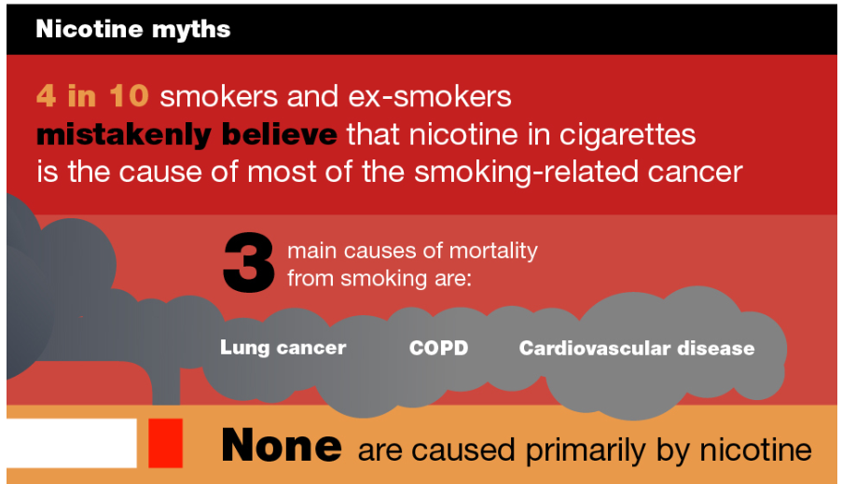
Figure 1: Health impact of smoking
(Source: Public Health England, 2019)

Digital technology in health promotion and addressing issues
Quit smoking application is an assistive technology to promote smoking cessation. Quit smoking application creates a customised quitting plan for each individual through beating cravings and triggering distraction activities, tracking smoking-free streaks to guide a smoke-free habit (Better Health, n.d.).
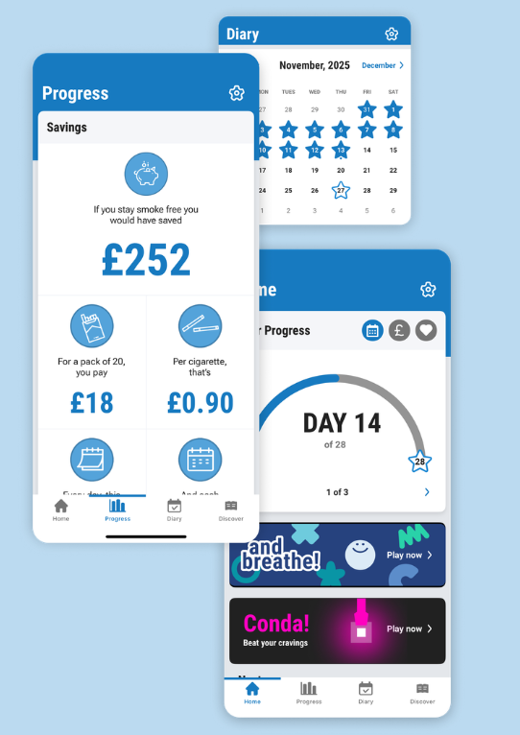
Figure 2: Quit smoking app tracking progress
(Source: Better Health, n.d.)
The quit smoking app is such a digital technology that motivates us to quit smoking. According to Cobos-Campos et al. (2020), they have indicated that quit smoking applications promote smoking cessation through providing personalised motivation. It is dedicated to individual-level health promotion.

Success
Research on the effectiveness of app-based smoking indicated that the smoking risk ratio after utilising the app was 0.901 (Cobos-Campos et al., 2020). A near-significant impact of a quit smoking app on reducing smoking habits can be concluded, but it needs more research.

Advantages and disadvantages
The main advantage of a quit smoking application is that the quitting plan is personalised (Better Health, n.d.). Therefore, any individual, based on their own decision-making autonomy, decides to be part of the promotional initiative. Contrastingly, the disadvantage or the shortfall of the quit smoking application is that only a few clinical trials have been conducted, so the effectiveness cannot be significantly understood (Cobos-Campos et al., 2020). I think conducting more clinical trials on the effectiveness of a quit smoking application based on the usage and progress data will help to implement this promotional initiative on a larger scale in future.

Blog 2: Critical discussion of the effectiveness of the Healthy Habits AI Coach in promoting a healthy lifestyle to reduce the obesity burden

Health issue
We are concerned about fitness and weight gain. Obesity is slowly becoming a health burden. 890 million people are living with obesity, and 35 million children under the age of 5 years are obese (World Health Organization, 2025). The situation is alarming. In the UK, 26% adults are obese, and the burden is increasing (Health Express, 2026).
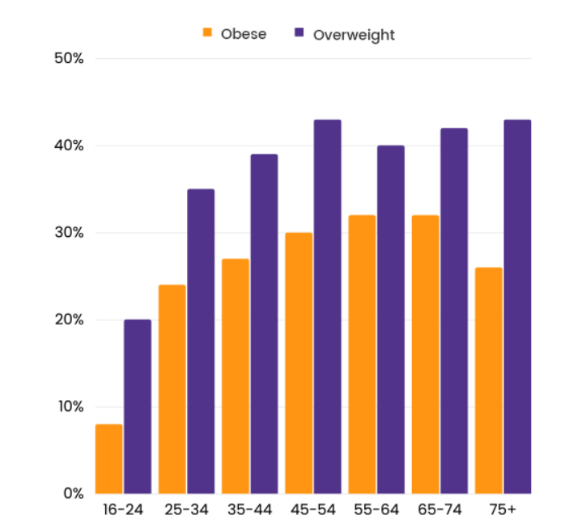
Figure 1: Age-wise obesity distribution in the UK
(Source: Health Express, 2026)
Obesity is an important health concern because it gives rise to other chronic diseases like cardiovascular disease, osteoarthritis and Type 2 Diabetes burden in the UK (Haase et al., 2021). For the associated health burden, T2D is an important health concern.

Designed digital technology
I have developed a design which can enhance a healthy lifestyle in people and restrict obesity. 'Healthy Habits AI (artificial intelligence) coach’ is the designed application. Habit Coach has an AI-driven health coach application that guides a healthy lifestyle through understanding the written input provided by the user and then assuming the future (Habit Coach, 2025). I have modified the existing version by adding the feature of logging healthy habits utilising the phone's camera. Meal, hydration, mood, movement activity, all will be captured and uploaded on the AI platform and following those, modified lifestyle guidance will be provided.

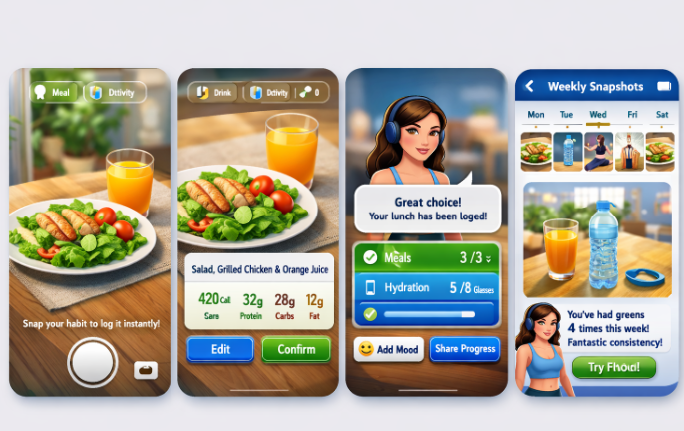
Figure 2: A layout of the proposed technology
(Source: created by me utilising Co-Pilot command)

Utilisation in health promotion
Motivating the Healthy Habits AI coach users to change their lifestyle for reducing the burden of obesity is the health promotion here. According to Wadden, Tronieri and Butryn (2020), health promotion initiatives for reducing obesity start with changing towards a healthy lifestyle. As the user clicks the photos of meal, movement, mood and uploads them on the AI application, the app algorithm will assess the lifestyle of the individual and will make a healthy lifestyle plan. Being guided by daily app-based guidance, service users will develop a habit of having a balanced diet and exercise.

Critical discussion of the impacts (disadvantages and advantages)
The advantage of the mobile-based AI application is that it can guide people to adopt a healthy lifestyle. According to Aggarwal et al. (2023), in 40% of the cases where people have subscribed to lifestyle-changing mobile applications, they have developed a healthy lifestyle habit. AI-based health applications have a confidentiality issue as a technical glitch in software can disclose sensitive information (Shoghli, Darvish and Sadeghian, 2024). The confidentiality issues can be protected through improving the security measures of the software platform of the new application and addressing glitch reports quickly.

References
Blog 1
Better Health (n.d.) Power up with the NHS Quit Smoking app. Available at: https://www.nhs.uk/better-health/quit-smoking/ (Accessed on: 26th March 2026)
Cobos-Campos, R., de Lafuente, A.S., Apiñaniz, A., Parraza, N., Llanos, I.P. and Orive, G. (2020) Effectiveness of mobile applications to quit smoking: systematic review and meta-analysis. Tobacco prevention & cessation, 6, pp.1-11. https://pmc.ncbi.nlm.nih.gov/articles/PMC7682489/pdf/TPC-6-62.pdf
Jackson, S., Cox, S. and Brown, J. (2025) Trends in health-related economic inactivity by smoking status in England, 2013–2025: a population-based analysis. The Lancet Regional Health–Europe, 57. pp.1-12. https://www.thelancet.com/pdfs/journals/lanepe/PIIS2666-7762(25)00211-X.pdf
Public Health England (PHE) (2019) Health matters: stopping smoking – what works? Available at: https://www.gov.uk/government/publications/health-matters-stopping-smoking-what-works/health-matters-stopping-smoking-what-works (Accessed on: 26th March 2026)
World Health Organization (WHO) (2025) Tobacco. Available at: https://www.who.int/news-room/fact-sheets/detail/tobacco#:~:text=Key%20facts,%2D%20and%20middle%2Dincome%20countries. (Accessed on: 26th March 2026)
Blog 2
Aggarwal, A., Tam, C.C., Wu, D., Li, X. and Qiao, S. (2023) Artificial intelligence–based chatbots for promoting health behavioral changes: systematic review. Journal of medical Internet research, 25, pp.1-17. https://www.jmir.org/2023/1/e40789/
Haase, C.L., Eriksen, K.T., Lopes, S., Satylganova, A., Schnecke, V. and McEwan, P. (2021) Body mass index and risk of obesity‐related conditions in a cohort of 2.9 million people: evidence from a UK primary care database. Obesity science & practice, 7(2), pp.137-147. https://onlinelibrary.wiley.com/doi/pdf/10.1002/osp4.474
Habit Coach (2025) Reach your goals with an AI coach. Available at: https://www.habitcoach.ai/ (Accessed on: 26th March 2026)
Health Express (2026) Obesity Statistics 2024: Facts and Figures in the UK. Available at: https://www.healthexpress.co.uk/obesity-statistics-uk (Accessed on: 26th March 2026)
Shoghli, A., Darvish, M. and Sadeghian, Y. (2024) Balancing innovation and privacy: ethical challenges in AI-driven healthcare. Journal of Reviews in Medical Sciences, 4(1), pp.1-11. https://julista.sinaweb.net/article_211430_5bacafdc31021049a76d382bbcc9cbb8.pdf
Wadden, T.A., Tronieri, J.S. and Butryn, M.L (2020) Lifestyle modification approaches for the treatment of obesity in adults. American psychologist, 75(2), pp.1-43. https://psycnet.apa.org/manuscript/2020-09435-009.pdf
World Health Organization (WHO) (2025) Obesity and overweight. Available at: https://www.who.int/news-room/fact-sheets/detail/obesity-and-overweight (Accessed on: 26th March 2026)

