  Component One: Student Journal (learning log) 750 words +/- 10%  Contribution to Overall Module Assessment: 25% | Student No: | 2245303  Georgiana Pangonis
 | Module Title: | HOTEL PLACEMENT – HOTEL ADMINISTRATION & FRONT OFFICE OPERATIONS
 | Module Code: | BMIH4004
 | Lecturer: | Ben Chong
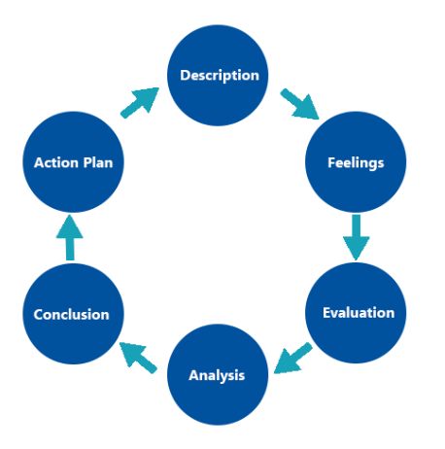
Figure 1: Gibbs reflective model
(Source: Adeani et al. 2020)
Description:
During my placement in IBIS Budget Birmingham, I was given tasks which were part of front office department that included serving at the reception desk, preparing the key cards for the new arrivals and members of the ACCOR ALL PLUS Club, working on different administrative duties related to managing/creating bookings. I was part of the meet and great team to do check-ins and check-outs, to process reservations and to answer guest inquiries regarding the hotel services and local tourist points. Furthermore, I was taking payments for extra services, applying penalty charges to the guests breaking the no smoking rule and assisting guest that required Special Assistance. (Adeani et al. 2020).
Feelings and Emotions:
After some time I have received rotational duties with the other departments like F&B where I have supported and assisted during busy times at breakfast with clearing tables and set them up for the rest of the day, preparing drinks hot or cold, preparing meals that are available to order 24hr, taking the stock and assisting the chef in the preparations. At this time blended feelings of novelty and problems have shown up as at the beginning I was simply excited to use the skills I was learning in college and to come into contact with people from different cultural backgrounds in the hospitality industry. On the other hand, despite the increasing complexity of the role, I experienced multiple tasks to be managed simultaneously, handling difficult situations related to customers, and providing high-pressure service. Despites the difficulties, my willingness for learning and adapting to the dynamic environment of the hotel did not diminish. (Markkanen et al. 2020).
Evaluation of Performance and Skills:
Once I had the chance to analyse my performance during the placement, I identified my strong and weak points. I proved competence in tasks like greeting guests with a friendly attitude, efficiently handing over the check-in and checkouts processes, and solving problems customers had until they were satisfied by using the soft and hard skills set I have acquired in time, organizing and assessing the administrative tasks and at the same time, I also acknowledge my need to work on my time management skills in order to be able to deliver all the stats of the in house guests and ensure everyone safety. (Adeani et al. 2020).
Analysis of Experience and Impact on Understanding:
The role of Front Office supported this realization that it heavily affects the entire guest experience and even management of the hotel. Having deeper grasp of the concept of professionalism, efficiency, and empathy in guest service delivery, I was able to discern the need of these statements being embodied by the employees. Besides the ability to work effectively in a multicultural environment, I developed skills in the navigation of cultural differences and ethical issues that arise when working with guests from different backgrounds. Such experiences underlined my resolve in observing ethical standards and in the same time, promoting equality in hospitality industry. (Markkanen et al. 2020).
While I was doing my placement, I have become acquainted with many ethical and cultural dilemmas that made me realize that these concepts exist and both of them should be treated carefully and respectfully. I would start by saying that the diversity of cultural elements is one of my strong points and, with view to explaining about cultural differences, I always speak to foreign visitors and guests. The approach of ethical acceptance comprised of guests’ rights invocation, data maintenance through follow-ups was important to gain the ethics of clientele and their satisfaction.
Conclusion:
In conclusion, my student work placement at IBIS Budget Birmingham was a good experience, which boosted my personal and professional development. I came to master essential qualities of guest service, administration, and cultural competence, that will be important assets in my future career achievements. I pledge to remain a student of my own success and believe in self-improvement as I proceed with my career in the hospitality industry. Along with my personal and professional growth, having done my placement with IBIS Budget Birmingham departments convinced me again of the importance of teamwork and adaptability in a bustling hospitality business.
Action plan:
To further enhance my capabilities and performance in the Front Office department, I have devised the following action plan:
- Time Management Improvement: By relying on techniques like task prioritization, goal setting that is attainable and the use of the tools for time management I am enhancing effectiveness of completion of responsibilities in order that I leave work fulfilling targets on time. (Ingham-Broomfield, 2021).
- Communication Skills Development: I will pursue relentless engagement in practice sessions and with peers to improve my communication competencies through their evaluation and exercise training. This is represented by trying to clearly pass necessary information to the co-workers, communication with guests regarding inquiries in the cabin with due respect and addressing special requests in a timely and polite manner by going the extra mile.
Professional Development: I will, moreover, be on the lookout for further training, re- certification, and the specialization in front office best practices, guest service excellence, and inclusiveness facilitation. (Markkanen et al. 2020).

Component Two
Contribution to Overall Module Assessment: 25%
Trip Advisor Review Response 150 words +/-10%
Screen shot of referenced Trip Advisor review used:
Figure 2: Trip Advisor Review
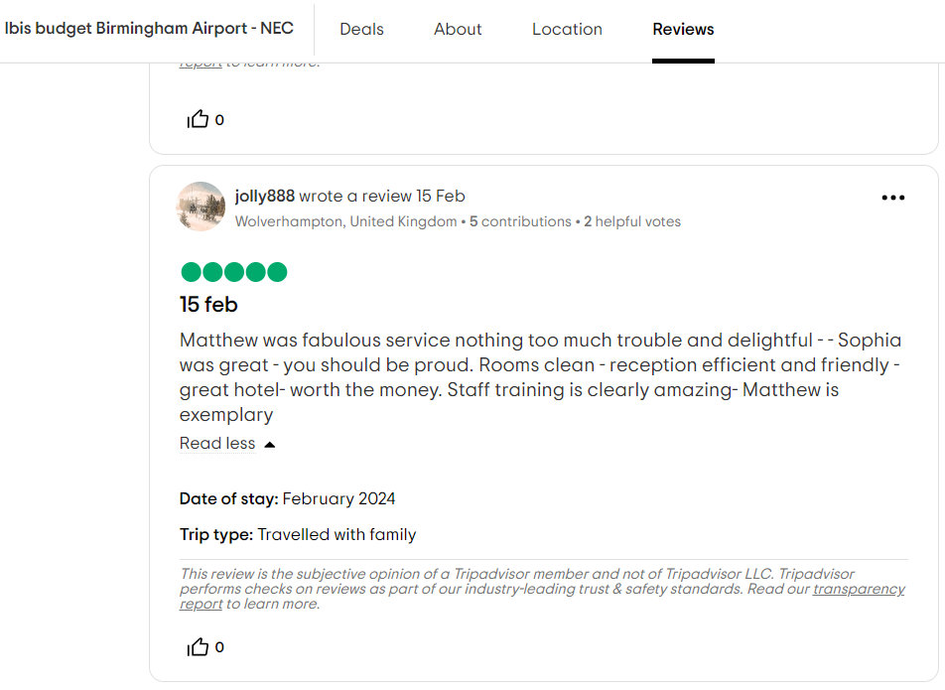
(Source: Trip Advisor 2024)

Trip Advisor review
Response
Thank you for taking the time to share your positive experience at the Ibis Budget Birmingham Airport hotel. We are delighted to hear that you found our rooms clean and enjoyed the contact you had with our staff members. Our team strives to provide friendly and informative service to all of our guests, so we're thrilled to learn that you had a pleasant interaction with them.
We are fortunate to have such a good location for an easy reach of the NEC and the airport and this is part of our hotel overall charm together with all the hard work that our team members are putting in. Your feedback is valuable to us, as it allows us to address issues promptly and ensure a comfortable stay for all our guests. Rest assured, we will pass your message to our team members Matthew and Sophia, and we will do our best to keep our high standards of guest services in the future.

Letter of complaint response 500 words +/- 1-%
Georgiana Pangonis
Reception Team Leader
IBIS Budget Birmingham
Ambassador Road, Bickenhill - Solihull
Birmingham, West Midlands B26 3AW
h6359@accor.com
+44(0)1217805800

Mrs. Joanna Blake
558 Longford Road
Swansea
SA1 2AR
January 15th, 2024
Subject: Response to Complaint
Dear Mrs. Blake,
This is to extend my apology for the experience you had during your stay at IBIS budget hotels in Birmingham, which turned out to be a big letdown. Appreciate what you say the most, we will pay particular attention to that. We set a focus on solving this and prevent others from happening.
In the first place, I feel the need to let you know that I truly understand the difficulties that you had during your stay with us. Please allow us to offer our most heartfelt, sorry for the shortcomings that happened during your visit here. After thorough investigation of the situation, we are strongly recommending to our guests to report immediately any issues regarding the rooms at the time of the check-in. We also do our best to make sure that our housekeeping team utilises the best possible standards of cleanliness and attention to details while tending the house. However, have no fear that we have taken steps to improve our proficiency through better safety training and quality control procedures to avoid future problems of this kind.
The extension of the Wi-Fi structure is under our attention to offer a stable internet connection for our guests so that they can work and complete their tasks. Since that time, we had gone through a review process for our Wi-Fi infrastructure, and we undertook some upgrade steps to guarantee a prompt and stable internet connection zone on the entire hotel premises.
I also want to highlight the disturbance of noise pollution you have encountered during your stay. If there is any situation that has been followed by the unruly behaviour of other visitors, please accept our apology for your troubled time. It is a mission for our team to create an atmosphere of serenity and quietness for the guests at our hotel, and we will intensively enforce the noise regulations in order to ensure minimal disturbance for the overnight guests and keep the hotel quiet. Also as we are located by the airport and sometimes the noise level it can be high we are providing on request earplugs so our guests will enjoy a good night sleep.
Additionally, the fact that you have been treated in a way that was below the expected service level has saddened and also disappointed us. The first and foremost priority for us is certainly the quality of service being provided and I cannot imagine that such situation could take place here due to the fact that we do not let our standards drop. Along with the staff, we are holding extra training sessions regarding the need to stay at the time of the attentive and responsive guest service and as well closely monitoring the staff tasks to the point that all the inquiries and wishes of the guests are processed timely and properly.
As it is we would like to offer you a FREE ROOM UPGRADE on your next stay with us and a complimentary breakfast for you.
If you need any further assistance, please do not hesitate to contact us on our reception email: 224XXXX@accor.com.
Warm regards,
Georgiana,
Reception Team Leader
IBIS Budget Birmingham

Component Three:
Contribution to Overall Module Assessment: 50% (1000 words +/- 10%)
Key Skill 1 – Customer Service Skills

Customer-facing competencies take the central place in the local hotel business, especially in the front office department, demonstrate a Di prototypical approach to the hotel guests. Indeed, communication being one of the important ingredients of customer service skills, is another component that deserves special attention (Zia et al. 2022). The front office should be equipped with competent staff members who have the skill of verbal and written communications, in order to show courtesy and professionalism towards incoming guests. For example, when welcoming guests at the registration point, employing friendly greetings, active listening techniques can thoroughly impress guests and do determine the tone for the whole period of the stay.
Lastly, empathy and problem-solving skills are central features for those working in the front office teams in the hotels. Let me cite something like that as when dealing with guest complaints or complaints, including their room preferences or billing inquiries, the front office staff need to be empathetic by understanding the guests' perspective and working to resolve the issues accordingly. This skill deals with the art of minimizing anxiety while hearing that dissatisfied guest and finding solutions to ensure that they are happy.
Ultimately, these technical and personal qualities characterize the great employees in the front office: adaptability and flexibility. In this manner, they can leave no probability of guest dissatisfaction and address diverse needs and expectations. For case-in-point, they must work around last-minute booking changes or other unforeseen issues for example maintenance problems with the rooms or flight delays, doing their best to apply flexible and future-oriented approach in finding alternatives to guest inconvenience (Ng, 2020).

Key Skill 2 – Communication Skills

Communication skills are the basic factor for the performance of the staff members in the front office of hotels as they help in the smooth function of the routine of the employees including the guests, co-workers, and stakeholders. Shining verbal communication shows that front office workers can precisely and properly express the information, which is delivered orally, and that might come through a face-to-face encounter during check-in or an inquiry over the phone. For instance, an upbeat tone, a keen listening ear, and expressions of patient and casual language will help to make guests comfortable and maintain their satisfaction (Mukhiddinova et al. 2021).
Moreover, using written language appropriately to record guest preferences, reservation details, and so on is indisputably an essential skill for the receptionists. Faculty managers must be acquainted with various techniques of writing emails, memos and other letters in order to communicate effectively with the clients and co-employees. For example, one of the tasks is confirmation of the reservations or responding to the guest inquiries through the email, during this process clear and concise writing helps in providing clear and professional information which make guests satisfied.
Besides verbal communication requires, physical manifestations, such as bearing, and emotions, exert no less impact on showing professionalism and establishing friendly relationship with guests. Just as an example, keeping eye contact, smiling or even body gesturing can be accepted as an appropriate way to get guests to trust you and believe in your business (Back et al. 2020).

Key Skill 3 – Organisational Skills

Organisation is crucial for things to run the right way, and having an organized hotel front office operation is a must. It is not easy to accomplish. Therefore, front office staff are needed to efficiently deal with an array of operations and have the front office run smoothly. Skills such as sorting and concentrating on what is important, managing time wisely, and being accurate in record keeping and documenting form these core competencies. Tasks such as check-in/out guests, answering inquiries and handing the administrative tasks are but one part of industry this occupation deals with and the performance is expected to remain detailed and cool (Stek and Schiele, 2021).
Similarly, such skills as Organisational abilities give front office staff an opportunity to forecast needs of vacationers and to promptly respond to them. Such as regime of organizing rental system for the guests by looks on their preferences would help the staff to customize the experience for their clients and boost expectations.
Moreover, the ability to show a good Organisational skill is needed to be the one overseeing reservation system and perfecting that rooms will be allocated properly and anywhere they are available. A competency in using reservation software for registration must be done efficiently with records of up-to-date to avoid overbooking and an increase of room revenue (Garavan et al. 2021).

Key Skill 4 – Problem Solving Skills

Problem solving skills are a must for any front office staff in that they can successfully deal with dissatisfied guests, address any issues, and to make sure that guests are happy at the end. This skill has to do with three items: the art of identifying problems, no matter how complex, the understanding of the root causes, and the timely implementation of the correct solutions (Araiza-Alba et al. 2021).
Such example is, when faced with a guest complaint about an out-of-order room air conditioning unit reporting to the front desk staff member, this employee must first evaluate the problem, identify the source (e.g., a technical malfunction or guest error) and coordinate the help from the maintenance team to fix this issue immediately. The staff at the counter is able to resolve the guest's problem and improve his impression about the hotel's service quality.
Besides, problem-solving skills to deal with the unforeseen and emergency situations could be equally and possibly more important than any guest may face. Hence, if an overnight visitor is unlucky to be locked out of his room late at night, then the front desk agent must be having a good temperament and keep his panic at bay and he must assess the situation and then come up a solution, such as issuing a spare key or giving the guest an access to security (Carpenter and Moser, 2020).
Moreover, your front office staff can act independently in problem solving and even foresee possible issues through their proactivity and take measures to mitigate or prevent any guests’ inconvenience. Hence, for instance, when the hotel's reservation system overlooks a technical issue, the front desk agents have to be in a position of applying alternative booking methods or accommodations and in a hurry so as to prevent guests' check-in process disruption.

Reference List
Adeani, I.S., Febriani, R.B. and Syafryadin, S., 2020. Using GIBBS’reflective cycle in making reflections of literary analysis. Indonesian EFL Journal, 6(2), pp.139-148.
Araiza-Alba, P., Keane, T., Chen, W.S. and Kaufman, J., 2021. Immersive virtual reality as a tool to learn problem-solving skills. Computers & Education, 164, p.104121.
Back, A., Tulsky, J.A. and Arnold, R.M., 2020. Communication skills in the age of COVID-19. Annals of internal medicine, 172(11), pp.759-760.
Carpenter, T.P. and Moser, J.M., 2020. The development of addition and subtraction problem-solving skills. In Addition and subtraction (pp. 9-24). Routledge.
Garavan, T., McCarthy, A., Lai, Y., Murphy, K., Sheehan, M. and Carbery, R., 2021. Training and organisational performance: A meta‐analysis of temporal, institutional and organisational context moderators. Human Resource Management Journal, 31(1), pp.93-119.
Ingham-Broomfield, B., 2021. A nurses' guide to using models of reflection. TheAustralian Journal of Advanced Nursing, 38(4), pp.62-67.
Markkanen, P., Välimäki, M., Anttila, M. and Kuuskorpi, M., 2020. A reflective cycle: Understanding challenging situations in a school setting. Educational Research, 62(1), pp.46-62.
Mukhiddinova, D.M., Sodiqova, S.T. and Jurayeva, Z.S., 2021. Developing effective communication skills. Oriental renaissance: Innovative, educational, natural and social sciences, 1(5), pp.966-972.
Ng, L.K., 2020. The perceived importance of soft (service) skills in nursing care: A research study. Nurse education today, 85, p.104302.
Ningrum, Y. and Ariani, N., 2020. Reflective journal writing: A review of the literature. In NEELS (National English Education, Language and Literature Seminar) Proceedings (pp. 305-313).
Stek, K. and Schiele, H., 2021. How to train supply managers–necessary and sufficient purchasing skills leading to success. Journal of Purchasing and Supply Management, 27(4), p.100700.
Tripadvisor, 2024. Hotel ibis budget Birmingham Airport [Online], Available at: https://www.tripadvisor.co.uk/Hotel_Review-g186402-d1158434-Reviews-Ibis_budget_Birmingham_Airport_NEC-Birmingham_West_Midlands_England.html [Accessed on 21st Feb, 2024]
Zia, J.A., Dengfeng, C., Vongvanij, S., Waqar, A. and Khan, T., 2022. Investigating customer trust and positivity of perceived customer service skill on the confidence of online shopping. Journal of Marketing Strategies, 4(2), pp.246-262.

