

LOCATION: SWANSEA | LLEOLIAD: ABERTAWE
LEVEL 4 | LEFEL 4
EXAMINATION PERIOD | CYFNOD ARHOLIADAU
2025 | 2025
MODULE CODE: ACCB4017
SOFTWARE DEVELOPMENT (SOLUTIONS)
(IN-CLASS TEST – time to BE ARRANGED BY MODULE LECTURER)
TIME: 2 HOURS
answer all questions

Equipment or materials required. Please select from the following:
Adnoddau neu ddefnyddiau sydd eu hangen.

Cyfrifiannell/Calculator ☐
Llyfr Agored/Open Book ☒
Arall/Other ☐

Nodwch/Please Note: Students will answer the questions below using the programming language they have studied during the module. The questions/solutions shown below refer to the Python language, but some groups may be studying the module using other programming languages (such as C). Therefore the paper will be adapted to reflect this if required.

Additionally, at some delivery locations, where the test is delivered via electronic means such as Moodle, questions may be drawn from a random pool, but will be in the style and of a similar difficulty level to those listed below.

ANSWER ALL QUESTIONS

1. a) Which variable type would be most suitable to store each of the following values?

p ………….string.........…………………………………..…

2112 ………….int.........…………………………………….…

Emma ………….string .…………………………………….…

4.29 …………..float........…………………………………..…

2H …………..string........…………………………………..…

-314.92 …………..float........…………………………………..…

[1 mark each - 6 marks total]

1 b)

What errors are present in the following program code to add a user's name to an existing list and print out the new list? Write your answers in the box below. Line numbers are included for easy reference
1 print(“Welcome to my program")
2
3 myList = ["Gaynor", "Dave" "Derek", “Bob”] //missing comma [1]
4
5 print("Please enter your name:")
6 myName = input()
7 print("Welcome, myName) //missing quote [1]
8
9 myList[4] = myName //need to use append, as index 4 does not currently exist [2]
10
11 for counter in range(0, len(mylist), 1) //should be myList
12 print(myList(counter))
[5 marks]

1 c) How many iterations do the following loops have?

for i in range(1, 9, 1): ……8……..
print("Hello")

for i in range(0, 6, 2): ……3……..
print("Hello")

[4 marks – 2 marks each]

1. d) What is the value of the integer variable total after the following code is executed?

total = 1
for x in range(1, 7, 1):
total = total + x
if x == 4:
total = 0
total = total + 3

……14…… [3 marks]

1 e) Logic

- Given the following values x=5, y=2, z=15 is the statement below true or false?
x>=y
…true…

- Given the following values x=5, y=3, z=12 is the statement below true or false?
x != z/y
…true…

[2 marks total]

[20 marks total for Question 1]
2. Calculating the volume of a square-based pyramid

The volume of a square-based pyramid is calculated using the formula shown below:
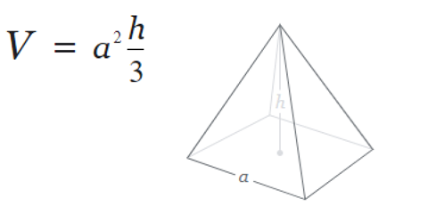
Task:
Write a program to calculate the volume of the pyramid using the above formula.

Allow the user to enter the measurements for a and h. Both a and h should be positive numbers.

Print the volume on the screen to 2 decimal places
[10 marks total for Question 2]
Solution

Students should present efficient code to accomplish the task. A possible solution is shown below.

print("Please enter measurement for a: ")
a = float(input())
while a <= 0:
print("a must be a positive number, please try again")
print("Please enter measurement for a: ")
a = float(input())
print("Please enter measurement for h:")
h = float(input())
while h <= 0:
print("h must be a positive number, please try again")
h = float(input())
volume = (a * a) * (h / 3)
volume = round(volume, 2)
print("The volume of the square-based pyramid is: ", volume)

Required:

Choice of appropriate types [2]
Calculation made and printed out correctly [4]
Validation of user input [4]

3. Using lists (Python) or arrays (C etc)

Task:
Write a program designed to calculate the average age of some people in a room. There are 6 people in the room. Start by declaring an empty list eg
ages = []
1. Prompt the user to enter the six ages (these should be within normal human lifespan!).
2. After the ages have been entered, print each of them on the screen.
3. Calculate the average age of the people in the room (to 2 decimal places) and print it on the screen.
Use loops where appropriate
Sample output:
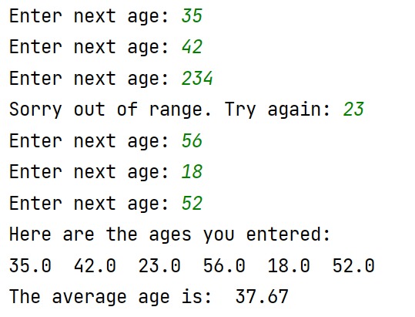
[15 marks total for Question 3]
Solution
Students should present efficient code to accomplish the task. A possible solution is shown below.

ages = []
for i in range(0, 6):
temp = float(input("Enter next age: "))
if temp < 0 or temp > 115:
temp = float(input("Sorry out of range. Try again: "))
ages.append(temp)
total = sum(ages)
average = total / len(ages)
print("Here are the ages you entered: ")
for i in range(0, len(ages)):
print(ages[i], end=" ")
print("\nThe average age is: ", round(average, 2))

Required:

Management of list (no overflow, underflow etc) [5]
Use of loops [5]
Calculation correct [3]
Validation of input [2]

4. Using Functions

Task:
Write a function called entername() to allow the user to enter the name of a conference delegate.
The function should be called 3 times, once for each of 3 conference delegates, and the (local scope) name entered returned to the main program.
Print the names entered from the main program, then calculate the total bill for attending the conference (£65 per person) and print it on the screen
Sample output:
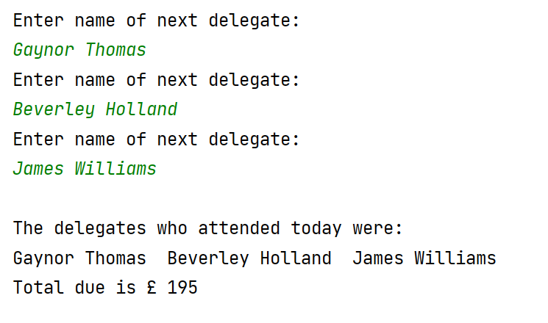
[15 marks total for Question 4]

Solution
Students should present efficient code to accomplish the task. A possible solution is shown below.

def entername():
print("Enter name of next delegate: ")
theName = input()
return theName
names = []
for i in range(0, 3):
names.append(entername())
print("\nThe delegates who attended today were:")
for delegate in names:
print(delegate, end=" ")
total = 65 * len(names)
print("\nTotal due is £", total)

Required:
General efficiency, use of loops where appropriate [4]
Function and its re-use correct [5]
Variable scope correct [3]
Correct output eg calculation etc [3]

Diwedd/End [60 marks total]

