
Academic Discipline of Hospitality & Tourism
Management
BA International Hotel Management
Programme: BA International Hotel Management
Module: Foreign Languages & Cultural Awareness
Module code: BMIH5003
Assignment Title: Intercultural Competence Report
Word count: 1000
Student Name:Irene nakimera
Student ID: 2244610
Hand-in Date: 07/05/2024
Year:2

Executive Summary
The analysis explains the importance of cultural diversification along with key differences in England and South Korea’s cultural and leadership visualization. Furthermore, the analysis of both countries are executed by the assessment of the Globe project results and their national variations on different administration levels. The evaluation also explains the importance of leadership and cultural awareness along with key challenges in the intercultural aspect of the hospital industry such as communication barrier and leadership styles.

Table of Contents
Introduction 4
Main Analysis 4
Outline the key differences between England and South Korea 4
Analysis and comparison of England and South Korea using the GLOBE Project’s culture and leadership study 5
Critically discuss the challenges of intercultural leadership in the hospitality industry 6
Conclusion 6
Recommendations 7
Reference 8

Introduction
The following analysis will explain the significance of cultural diversification and the various ways it is required to be improved to increase customer satisfaction and retention in the hospitality industry. The analysis will also explain the leadership and culture visualization of England and South Korea, along with the differentiation of their cultures and backgrounds through the evaluation of the Globe Project leadership study. Key drivers of intercultural challenges will also be explained in the further assessment along with mitigating ways to solve them in the hospitality industry. The analysis will also provide a set of recommendations which can help employees to overcome cultural challenges.

Main Analysis

Outline the key differences between England and South Korea
The international stage for cultural customs and culture is diversifying intensely with the growth of social media and the inclusion of different perspectives from different lands. The cultural administration of the United Kingdom comprises rich art and history. It is customary to acknowledge the background of the UK to understand the history of the nation. On the other hand, the righteous and courteous nature of South Korea is recognizable through their efficiency with the treatment of people, media influence, influence on history and others (Baciu, 2020, p. 4). The nation holds a deep spiritual belief within their customs whereas the UK is more prone towards their elegant nature and artistic lifestyle. The consumer culture of both countries reflects the buying behaviour of the general population. Consumer behaviour is changing on a global level, which is affecting every nation, and evolving the guest service and delivery market (Arte et al., 2022, p. 3). It is essential to understand the prospects of the consumer market to improvise and change the preferences of the identified nations as well (Ghosal et al., 2021, p. 2). It is observed that the UK is incorporating the internationalisation of brands to attract more customers, whereas South Korea is more prone to promoting its domestic culture for the globalisation of its customs and culture. Both nations comprehend the impact of social media to draw in more travellers of the younger generation who can analyse critically the changing nature of the service and delivery industry.

Analysis and comparison of England and South Korea using the GLOBE Project’s culture and leadership study
England | South Korea
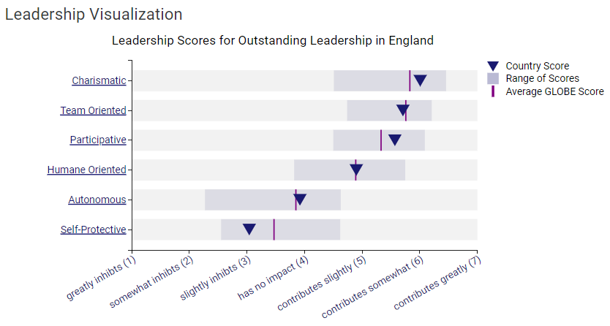 | 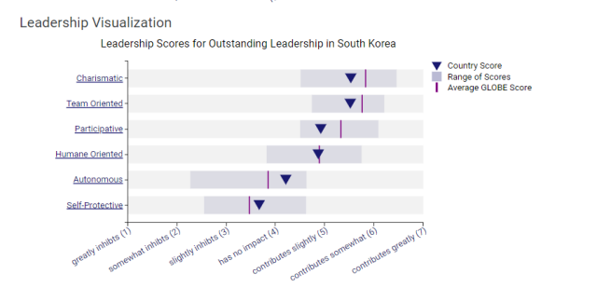
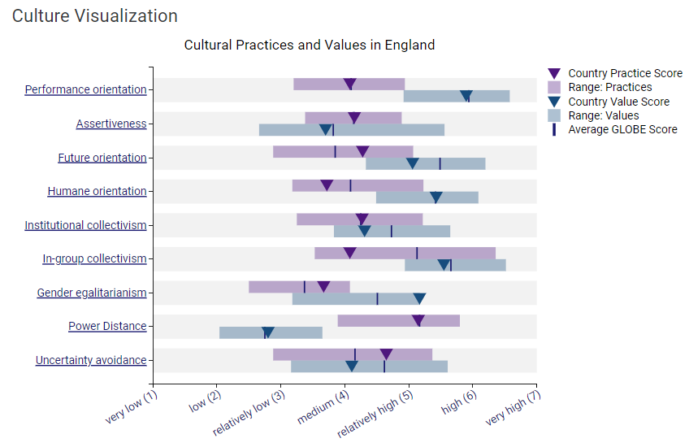 | 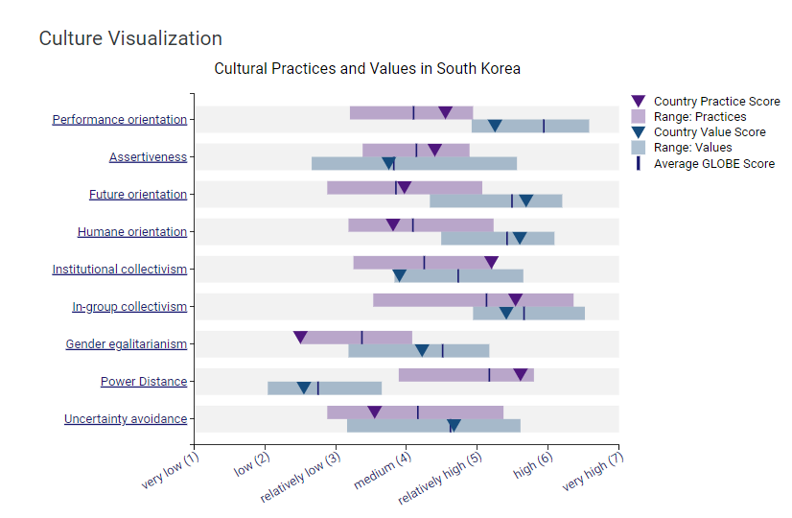
As per the above Globe Project analysis, it is clearly visible that there is a certain difference in leadership and cultural visualization between England and South Korea. The leadership visualization that England is more charismatic, participative, team-oriented, human-oriented and autonomous than South Korea. On the other hand, it is observed that South Korea is more self-protective than England. The practice orientation, gender egalitarianism, and power distance in England are higher and greater than in South Korea(globeproject.com, 2024). On the other hand, assertiveness, future orientation, humane orientation, institutional collectivism, in-group collectivism, and uncertainty avoidance in South Korea are higher than in England (Zhang et al., 2021, p. 3). This describes that the leadership qualities of England are more robust and impactful than South Korea. Subsequently, South Korea is more prone towards looking after the population of the country, which provides them the upper hand in cultural visualization according to the analysis of the Globe Project. This analysis brings forth critical aspects and how Korea is more interested and serious about protecting and promoting its people rather than influencing the global consumer market (Raithel et al., 2021, p. 2). The country is more interested in promoting its cultural heritage to attract customers in the hospitality industry (Sánchez-Sánchez et al., 2021, p. 2). The leadership study also points out that South Korea is more inclined towards highlighting the aspects of its culture than putting implications in the target market.

Critically discuss the challenges of intercultural leadership in the hospitality industry
There are observable intercultural challenges in the hospitality industry that can cause a chain reaction of problems for the management team as well as employees.
Communication Challenges: A communication barrier can happen due to different languages between two individuals. Employees can face dire situations during customer service that can decrease customer satisfaction. This gravely influences customer footfall for corporations in the hospitality industry which can cause a loss of customers also (Gewinner, 2020, p. 2). Cultural elements can also be subject to communication barriers as two people from different cultural backgrounds can face language barriers and difficulty in understanding.
Leadership Styles: It is essential to understand the leadership styles of different nations and how the government body of the country regulates the laws and rules. The core impact of leadership styles affects the general population, as they are more influential than others (Cavazotte et al., 2021, p. 7). Different leadership styles can affect the buying behaviour and habits of consumers which can cause difficult situations on international lands and situations.
Lack of Cultural Knowledge: This affects the customers who are receiving the service if employees are not respectful and empathize with their cultures. Lack of knowledge can cause challenging occurrences such as disrespectful behaviour, discrimination and others (Glow et al., 2021, p. 8). Information on different customer base and their cultural preferences is important in the hospitality industry as it can affect the image and reputation of the hotel in front of their competitors (Rashi et al., 2021, p. 3). It is essential to understand how one small act of disrespectful behaviour can cause a chain reaction within the administration of the hospitality industry.

Conclusion
The analysis has provided critical information on cultural and leadership visualization of England and South Korea. The evaluation explained the critical challenges of both nations in the hospitality industry along with differentiation in cultural and leadership diversity. Through the assessment, intercultural challenges in the hospitality industry such as communication challenges, and leadership challenges are pointed out in the organizational sector of the hospitality industry. The explanation of the two nations concludes how the industry works in the consumer sector and their different buying behaviour which impacts consumerism in the hospitality industry. furthermore, the elaboration also talks about cultural awareness and conceptualization of consumerism on a global scale.

Recommendations
The inclusion of cultural diversity and the distribution of information and knowledge can act as a guideline for employees in the hospitality industry. Proper training sessions and innovative strategic thinking and problem-solving skills can also reduce the intercultural problems between two individuals as well. Gathering knowledge and information through different online forums and resources can help employees to study the customer market and the behaviour of consumers as well.

Reference
Arte, P. and Larimo, J., 2022. Moderating influence of product diversification on the international diversification-performance relationship: A meta-analysis. Journal of Business Research, 139, pp.1408-1423. Available at: https://doi.org/10.1016/j.jbusres.2021.10.037(Accessed: 01 May 2024).
Baciu, D.C., 2020. Cultural life: Theory and empirical testing. Biosystems, 197, p.104208. Available at: https://doi.org/10.1016/j.biosystems.2020.104208(Accessed: 01 May 2024).
Cavazotte, F., Mello, S.F. and Oliveira, L.B., 2021. Expatriate's engagement and burnout: the role of purpose-oriented leadership and cultural intelligence. Journal of Global Mobility: The Home of Expatriate Management Research, 9(1), pp.90-106. Available at: https://doi.org/10.1108/JGM-05-2020-0031(Accessed: 01 May 2024).
Gewinner, I., 2020. Gendered and diversified? Leadership in global hospitality and tourism academia. International Journal of Contemporary Hospitality Management, 32(6), pp.2257-2282. Available at: https://doi.org/10.1108/IJCHM-07-2019-0621(Accessed: 01 May 2024).
Ghosal, I., Prasad, B., Behera, M.P. and Kumar, A., 2021. Depicting the prototype change in rural consumer behaviour: An empirical survey on online purchase intention. Paradigm, 25(2), pp.161-180. Available at: https://doi.org/10.1177/09718907211029030(Accessed: 01 May 2024).
globeproject.com (2024) Globe Project, GLOBE Project. Available at: https://globeproject.com/ (Accessed: 01 May 2024).
Glow, H., Kershaw, A. and Reason, M., 2021. Leading or avoiding change: the problem of audience diversification for arts organisations. International Journal of Cultural Policy, 27(1), pp.130-148. Available at: https://doi.org/10.1080/10286632.2019.1709060(Accessed: 01 May 2024).
Raithel, K., van Knippenberg, D. and Stam, D., 2021. Team leadership and team cultural diversity: The moderating effects of leader cultural background and leader team tenure. Journal of Leadership & Organizational Studies, 28(3), pp.261-272. Available at: https://doi.org/10.1177/15480518211010763(Accessed: 01 May 2024).
Rashi, P., Bist, A.S., Asmawati, A., Budiarto, M. and Prihastiwi, W.Y., 2021. Influence of post covid change in consumer behaviour of millennials on advertising techniques and practices. Aptisi Transactions on Technopreneurship (ATT), 3(2), pp.201-208. Available at: https://doi.org/10.34306/att.v3i2.210(Accessed: 01 May 2024).
Sánchez-Sánchez, M.D., De-Pablos-Heredero, C. and Montes-Botella, J.L., 2021. A behaviour model for cultural tourism: loyalty to destination. Economic research-Ekonomska istraživanja, 34(1), pp.2729-2746. Available at: https://doi.org/10.1080/1331677X.2020.1838313(Accessed: 01 May 2024).
Zhang, X., Liu, H. and Yao, P., 2021. Research jungle on online consumer behaviour in the context of web 2.0: traceability, frontiers and perspectives in the post-pandemic era. Journal of Theoretical and Applied Electronic Commerce Research, 16(5), pp.1740-1767. Available at: https://doi.org/10.3390/jtaer16050098(Accessed: 01 May 2024).

