Executive Summary
NexSpace Health Systems (NHSX), an international healthcare technology organization operating across the UK, India and the UAE, needs working practices that support innovation without weakening clinical safety, data protection or accountability. This report proposes a connected human-capital approach. Task A recommends selective decentralization, cross-functional agile teams, role-sensitive hybrid work, employee autonomy and secure digital knowledge sharing. Task B proposes a talent ecosystem based on skills mapping, continuous learning, transparent career pathways, psychological safety, inclusive leadership and sustainable workloads. Task C considers AI as a decision-support tool and identifies capabilities a future HR professional should develop. The recommendations should be piloted, evaluated against baseline measures and expanded only when evidence supports their effectiveness. The central conclusion is that performance improves when work design, employee development, leadership and responsible governance reinforce one another.

1. Introduction
The Resource-Based View (RBV) argues that resources and organizational capabilities can create sustained competitive advantage when they are valuable, rare, difficult to imitate and effectively organized (Barney, 1991). At NexSpace Health Systems (NHSX), the relevant resources include specialist clinical knowledge, software and artificial-intelligence (AI) expertise, implementation experience and the ability to combine these capabilities. Their value depends on how effectively the organization shares knowledge, questions assumptions and develops employees as digital-health needs change.
NHSX faces connected challenges: centralized decisions may delay experimentation, weak collaboration can limit knowledge exchange, unclear career pathways may encourage turnover, and sustained delivery pressure can undermine wellbeing. This report treats work design and talent development as interdependent parts of one human-capital strategy. Recommendations reflect NHSX’s international context across the UK, India and the UAE, while recognizing that clinical safety, privacy, cyber security and fair employment practices must not be compromised in pursuit of speed.

TASK A: Designing Innovative Working Practices

2. Traditional Work Design versus Contemporary Innovative Practices
Traditional work design relies on specialized roles, formal procedures, hierarchy and central approval. Weber’s (1947) bureaucracy offers consistency, traceability and clear authority, which are essential when healthcare software affects clinical decisions. Its weakness is that rules can slow responses and discourage staff from raising ideas when approval is distant. The issue is therefore not to remove control, but to distinguish non-negotiable safety and data requirements from decisions teams can make locally.
Burns and Stalker (1961) contrast mechanistic structures, which suit stable conditions through formal control, with organic structures, which support adaptation through flexible communication. This is a contingency argument, not proof that organic structures are always better. NHSX needs organic collaboration for uncertain product development, but mechanistic controls for clinical validation, cyber security and release approval. An entirely organic model risks blurred accountability; an entirely mechanistic model risks slow learning. A dual structure is more appropriate: decentralize experimentation within explicit risk boundaries.
High-Performance Work Systems (HPWS) align recruitment, training, participation, appraisal and rewards (Appelbaum et al., 2000). This alignment can improve capability, but the performance effects are not automatic: intensive targets may increase work pressure, and practices copied from another organization may not fit NHSX’s professional and cross-country context. Boxall and Macky (2009) emphasize the importance of employee involvement, suggesting that performance gains should not be judged separately from work quality and employee experience. NHSX should therefore evaluate both operational outcomes and workload, rather than assuming that a bundle of HR practices is inherently beneficial.
High-Involvement Work Systems (HIWS) give employees information, skills and influence. They can surface clinical and technical knowledge that senior leaders lack, but participation without decision rights, time or visible follow-up becomes tokenistic. Conversely, unlimited local discretion can produce inconsistent standards across markets. NHSX should specify which decisions teams own, which require clinical or security review, and how employee suggestions are answered. This makes involvement substantive while retaining accountability.
Agile working uses short cycles, iterative testing and feedback (Beck et al., 2001). It is useful where requirements are uncertain, but it can generate meeting overload, shifting priorities and a focus on velocity rather than safe, usable outcomes. The Agile Manifesto is a set of guiding values, not empirical evidence that every task should use agile methods. NHSX should apply agile cycles to product discovery and prototyping, while retaining formal assurance gates for clinical risk, privacy and cyber security. The best approach is selective adaptation, judged by quality and user outcomes as well as speed.

3. Recommended integrated work-design framework
NHSX should use an integrated framework in which governance sets safe boundaries, teams organize daily work, digital systems enable knowledge exchange and evaluation informs improvement. A six-month pilot should test the model before wider adoption.
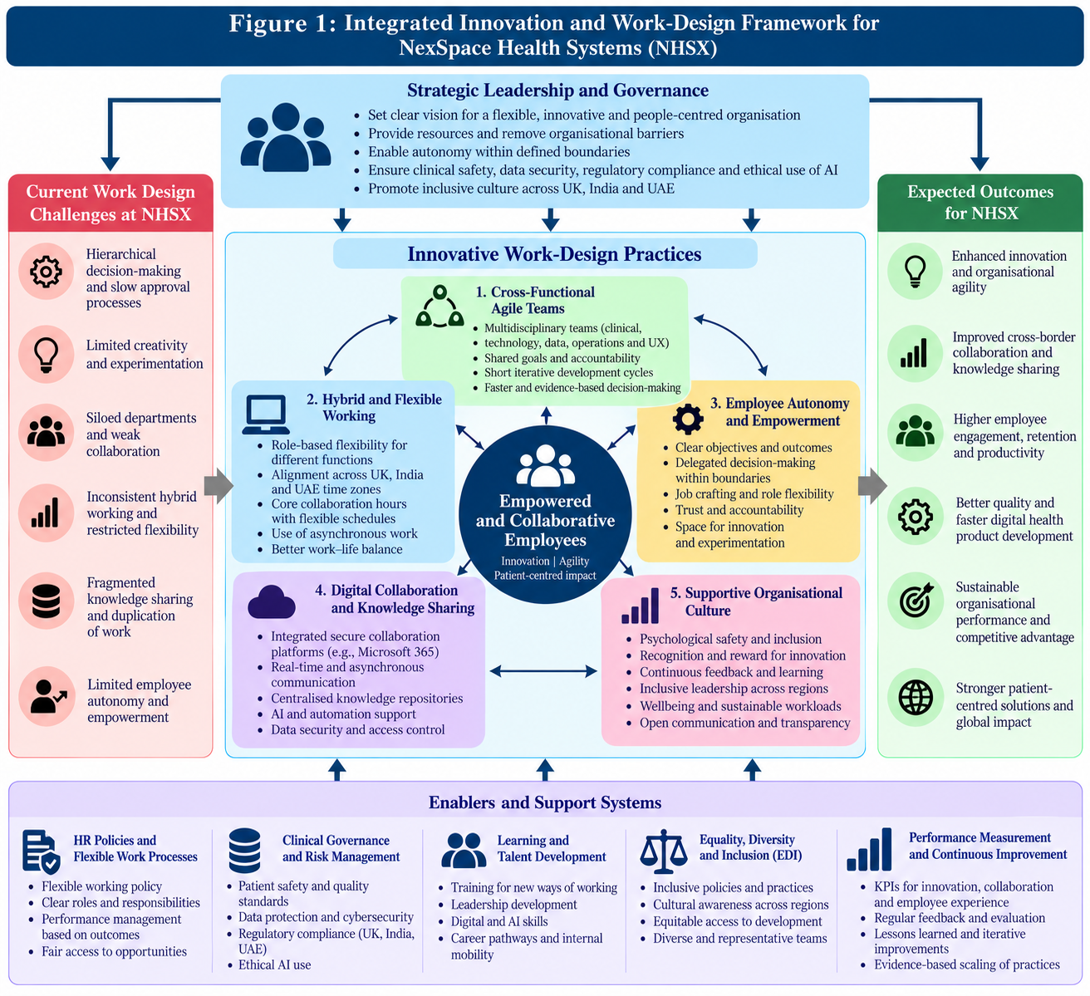
Figure 1. Integrated innovation and work-design framework for NexSpace Health Systems. The framework links leadership and governance with cross-functional agile teams, role-sensitive hybrid work, employee autonomy, digital collaboration and a supportive culture; enabling systems provide the clinical, ethical and performance controls needed to pursue innovation safely.
Source: Author’s synthesis informed by Barney (1991), Appelbaum et al. (2000), Beck et al. (2001) and Trist and Bamforth (1951).

3.1 Cross-functional agile teams
NHSX should create multidisciplinary teams of software engineers, AI specialists, clinicians, user-experience designers, cyber security professionals and implementation staff. Each needs a clear objective, product owner and authority for routine decisions within safety and budget limits. Short cycles and structured user feedback can expose problems early. This recommendation follows agile and sociotechnical principles, but its impact must be tested against comparable teams using prototype time, user-rated usefulness, defects and safety escalations. Portfolio governance should retain minimum standards.

3.2 Hybrid and flexible work across time zones
NHSX should use role-sensitive hybrid arrangements. Focused analysis may suit remote work, while on boarding, complex design and sensitive clinical discussions may benefit from live interaction. UK, India and UAE working hours and public holidays restrict overlap; repeated out-of-hours meetings risk fatigue and unequal burdens. Teams should set limited overlap windows, rotate inconvenient meetings, document decisions asynchronously and assess outputs rather than online presence. Evaluate quality, inclusion and workload before expanding the model. Autonomy without resources can transfer pressure to employees, so capacity reviews and escalation routes are essential.

3.3 Employee autonomy and digital collaboration
Within agreed product, budget and risk limits, employees should choose how to organize tasks and propose improvements. Self-determination theory identifies autonomy, competence and relatedness as important needs supporting motivation (Deci and Ryan, 2000). Autonomy is not unrestricted discretion: high-risk changes still require review, and managers must clarify responsibilities. NHSX should maintain a secure, searchable knowledge environment containing project documentation, decision logs, technical repositories and lessons learned. Teams should record unsuccessful experiments as well as successful ones, without exposing sensitive data. Access controls, data minimisation and information-governance checks should be built into the system. Recognition should include mentoring and knowledge sharing, not only individual delivery.

3.4 Implementation, performance and evaluation
During month one, HR and operations should collect baseline data, select pilot teams and consult employees across the three locations. Months two and three should co-design team agreements and train managers; months three and four should launch the practices and tools; month five should assess outcomes and risks; and month six should decide whether to adapt, stop or scale the pilot.
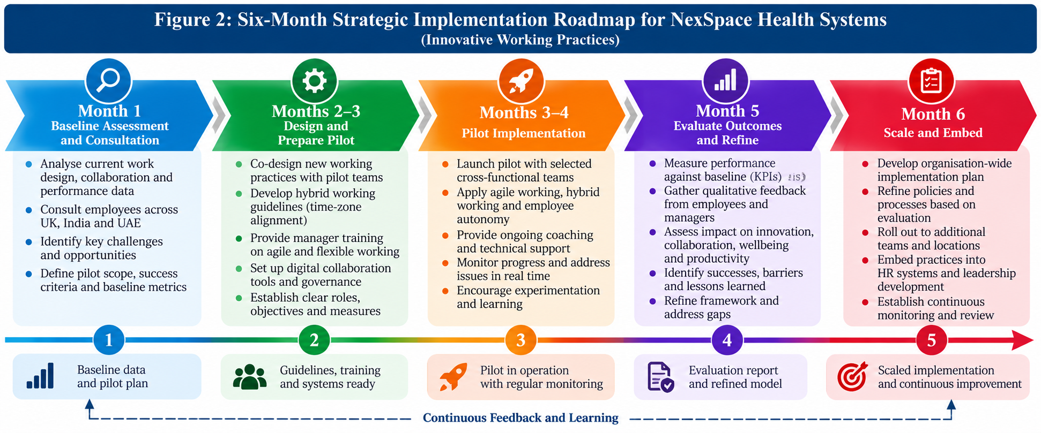
Figure 2. Six-month strategic implementation roadmap. The phases move from baseline assessment and consultation to co-design, pilot delivery, evaluation and wider adoption, with continuous feedback used to refine the approach.
Source: Author’s own work.
Measures should include prototype time, delivery reliability, defects, user feedback, engagement, regretted attrition, collaboration, workload and safety incidents. Set targets after baseline measurement. Where feasible, compare pilot teams with similar teams and record project differences. The causal hypotheses are that agile cycles reduce prototype time, cross-functional design improves user relevance and reduces rework, and role-sensitive hybrid work preserves delivery while improving inclusion. These are not guaranteed effects. Interpret results alongside employee and user feedback: faster delivery is not success if defects, workload or safety concerns rise.

TASK B: Breeding an Environment Where Talent May Grow

4. Critical evaluation of talent development
Learning organization Senge (1990) emphasizes systems thinking, shared vision, team learning and personal mastery; its strength is connecting individual learning with organizational routines. However, it can remain inspirational if staff lack protected time, manager support or authority to change processes. Dweck’s (2006) growth mindset encourages learning from setbacks, but critics of individualized mindset approaches warn that motivation alone cannot overcome poor resources, discrimination or excessive workload. Used carelessly, it can imply that employees are responsible for adapting to structural problems. NHSX should combine mindset-supportive feedback with funded learning time, accessible development and leaders’ responsibility to remove barriers. Neither theory is sufficient alone: organizational conditions must make learning possible.
Psychological safety enables people to question assumptions and report errors without humiliation (Edmondson, 1999), which is especially important when clinicians and developers hold different kinds of expertise. Yet safety does not mean comfort, consensus or freedom from standards; teams still need evidence, constructive challenge and clear accountability. A culture that encourages speaking up but ignores reports will lose trust, while a high-accountability culture without safety may suppress bad news. NHSX should pair leader openness with documented responses to concerns, learning reviews and clear escalation routes, measuring not only whether staff feel safe but whether issues lead to action.
Self-determination theory proposes that autonomy, competence and relatedness are important psychological needs (Deci and Ryan, 2000). Meaningful responsibility, development opportunities and supportive relationships can strengthen motivation, although individual career aspirations differ. Strategic talent management focuses attention on capabilities that are important to organizational priorities (Collings and Mellahi, 2009). Its risk is that investment in a small group of ‘high potentials’ may appear exclusive and undermine wider engagement. Critical role planning should therefore coexist with accessible development opportunities for all employees.
Job crafting allows employees to reshape aspects of tasks, relationships and their understanding of work (Wrzesniewski and Dutton, 2001). It may increase meaning and fit, but uncontrolled changes can cause role ambiguity or uneven workloads. Managerial oversight should ensure that individual initiative supports team objectives. Employee experience also depends on how HR practices are enacted by line managers, not simply on formal policies (Kahn, 1990; Purcell and Hutchinson, 2007). Surveys should therefore be combined with interviews, retention data and evidence about actual working conditions.

5. NHSX strategic talent-growth ecosystem
NHSX should connect workforce planning, learning, career progression, inclusive leadership and wellbeing. Skills data and employee aspirations inform development; managers create opportunities to practice; evaluation identifies which interventions improve capability, retention and service quality. The expected chain is that accessible development improves applied skills, transparent pathways improve perceived fairness, and psychological safety supports learning and early risk reporting. Each link needs testing because pay, workload and labor-market conditions also affect outcomes.
The ecosystem should follow the employee journey: recruitment identifies role-related skills; on boarding explains clinical, data and cultural responsibilities; development conversations identify gaps and aspirations; internal opportunities let staff apply new capabilities. Publish consistent criteria for training, stretch assignments and promotion to reduce reliance on informal networks. Offer lateral moves between product, clinical implementation and governance teams. Monitor access and outcomes by location and job family while protecting privacy.
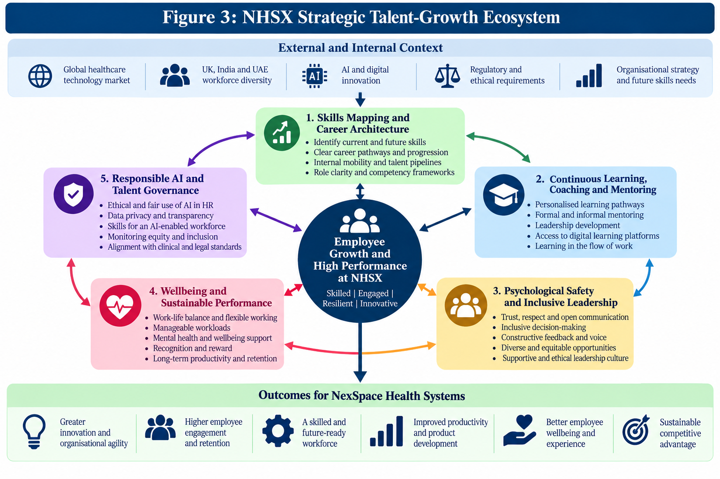
Figure 3. Strategic talent-growth ecosystem for NHSX. Skills mapping, learning, mentoring, psychological safety, inclusive leadership, wellbeing and responsible AI governance are presented as mutually reinforcing practices intended to improve capability, engagement, retention and performance.
Source: Author’s synthesis informed by Senge (1990), Dweck (2006), Edmondson (1999) and Collings and Mellahi (2009).

5.1 Skills, career pathways and continuous learning
HR should audit skills using self-assessment, manager feedback, project evidence and workforce plans. Priorities include AI governance, clinical integration, cyber security, product development and international implementation. Publish pathways for technical specialists, clinical experts, project leaders and managers, including specialist routes without management promotion. Combine courses with coaching, mentoring, job shadowing and supervised assignments. Assess impact through demonstrated skills, internal mobility, project quality and retention, not attendance alone. Ensure cross-border mentoring and protected learning time are equitable.

5.2 Psychological safety, inclusion and employee experience
Employee Experience (EX) spans recruitment, on boarding, manager relationships, learning, recognition and progression. At NHSX, employees should understand their contribution, receive support across locations and raise concerns without disadvantage due to remote work. Surveys can mislead if staff fear speaking honestly, and wellbeing benefits cannot compensate for unfair promotion or understaffing. Combine confidential pulse surveys, stay interviews and exit themes; publish actions and progress. Train managers in coaching, feedback, inclusion and workload management. Track survey trends alongside response rates, attrition and development access rather than relying on positive messaging.

5.3 Wellbeing, responsible AI and evaluation
The job demands-resources model suggests that excessive demands can cause strain, while adequate resources support motivation (Bakker and Demerouti, 2007). NHSX should monitor workload, overtime, meeting intensity, leave and feedback. Wellbeing initiatives cannot substitute for correcting unrealistic deadlines or inadequate staffing.
AI may support skills-gap analysis and workforce forecasting, but historical data can reproduce bias and opaque scores may appear objective. Accuracy alone is insufficient if a tool is unfair or unsuitable for consequential decisions. NHSX should require human review, bias checks, data minimization, explanations and routes to challenge decisions. The Equality Act 2010 and Data Protection Act 2018 provide legal foundations, but compliance alone does not guarantee ethical practice. A quarterly dashboard should track skills, promotion, attrition, mentoring, engagement, psychological safety, workload and employee experience. Set baselines and thresholds, assign owners and investigate unexplained differences before acting on AI recommendations.
HR, team leaders and employee representatives should review the dashboard quarterly and record actions, owners and review dates. If training rises but applied skills do not, review course relevance and protected learning time; if engagement improves while overtime and attrition worsen, investigate workload. Training completion is an activity measure, not proof of capability or organizational benefit.

TASK C: Reflective Report

6. AI, professional development and future HRM capability
AI can help HR professionals analyze workforce trends, forecast skills needs, support recruitment administration and suggest learning opportunities. It can improve the speed and breadth of analysis, but outputs depend on data quality, model design and assumptions. Historical recruitment data may reproduce discrimination, while performance analytics may overlook adjustments, caring responsibilities or different working conditions. AI should therefore inform rather than replace professional judgment. HR practitioners remain responsible for confidentiality, fairness, empathy, verification and decisions that affect people’s employment.

6.1 Reflective analysis of AI use

AI supported my assignment planning, academic writing and critical review. However, its usefulness depended on my ability to evaluate suggestions critically and maintain responsibility for the final work.
First, I used AI to organize the assignment into Tasks A, B and C and identify relevant theories. This improved structure and helped me address the assessment requirements. However, AI could encourage me to describe several theories without critically comparing them. I therefore refined the work-design discussion by considering when mechanistic controls are necessary and when organic teamwork is more appropriate. I learned that AI can support planning, but selecting suitable theories and evaluating their limitations requires academic judgment. In future, I would create a claim-and-evidence table and verify arguments against original academic sources.
Second, AI helped refine figure captions and explanations of the relationships between governance, work practices and talent development. Nevertheless, fluent explanations can overstate the evidence. I therefore needed to ensure that figures accurately represented the proposed framework rather than presenting recommendations as proven outcomes. This taught me to distinguish visual clarity from evidential validity. In future, I would seek peer feedback to identify unclear labels and strengthen explanations.
Third, AI feedback helped identify repetition, weak theoretical connections and missing evaluation measures. However, AI-generated grades are not authoritative and may overlook inaccurate citations or assessment criteria. I learned that suggestions should not be accepted simply because they sound academic. Instead, I must verify sources, retain independent judgment and ensure recommendations address the assignment brief. In future, I would document accepted and rejected suggestions and complete the final citation and assessment-rubric checks myself.

6.2 Personal capability development plan
Capability | Planned action | Timescale | Evidence of progress
Critical analysis | Read original research, compare competing theories and identify limitations before forming conclusions. | 3 months | A referenced report that evaluates alternatives and supports its conclusions.
AI and digital literacy | Study AI limitations, bias and responsible data use; keep a record of verification steps when using AI. | 6 months | A written evaluation of an AI-supported task, including checks and limitations.
Ethical HR judgement | Develop knowledge of equality, confidentiality and data protection; apply an ethical checklist to HR scenarios. | 6 months | A documented case analysis showing risks, safeguards and reasons for the final judgement.
I will review progress quarterly and log each AI task, source checks, changes, limitations and final decision. Within three months I will practice comparing original studies and competing explanations; within six months I will complete an ethical analysis of an AI-supported HR scenario, documenting fairness, privacy and accountability safeguards. Progress will mean stronger evidence-based reasoning, not simply faster completion.

7. Conclusion
NHSX needs an integrated human-capital approach rather than isolated changes to work arrangements or training. Selective decentralization, agile teams, role-sensitive hybrid work and secure knowledge sharing can improve responsiveness while preserving clinical and information-governance controls. Talent growth requires accessible learning, transparent career pathways, psychological safety, inclusion and sustainable workloads. AI should support, not replace, human judgment. A measured pilot and quarterly evaluation will help NHSX distinguish genuine improvement from short-term gains that conceal employee strain or quality risks.

