Student: Nadya khan
Student Number: 2409193
Title: BSC Health and Social Care BMHP5023
Case study report on asthma in adolescence
Lecture: Parese Ahmed

Introduction
This report examines a case study on asthma in adolescence, a chronic respiratory condition that affects the airways and impairs normal breathing. Asthma may be triggered by a variety of environmental and physiological factors, including viral infections, dust mites, pets, physical exertion, allergens, tobacco smoke, and changes in the weather. When exposed to these triggers, individuals with asthma typically experience inflammation of the airways, tightening of the surrounding muscles, and increased mucus production. These physiological responses narrow the airways, making breathing significantly more difficult (NHS, 2021).
This report is to describe the structure of the respiratory system and analyse how asthma disrupts its normal function. It will also explore the broader impacts of the condition on adolescent health, outline methods for monitoring asthma, and evaluate the potential benefits of lifestyle modifications in managing the disease.
Section 1 Anatomy and Physiology asthma:
The respiratory system structure
The respiratory system facilitates the exchange of gases primarily oxygen and carbon dioxide between the body and its external environment. It comprises several essential anatomical structures, including the nasal cavity, pharynx, larynx, trachea, bronchi, bronchioles, and alveoli. Additionally, the diaphragm and intercostal muscles play a vital role in the mechanics of breathing (Ionescu, 2013). Surrounding the lungs are the rib cage, blood vessels, and supportive musculature, which collectively contribute to respiratory function.
During inhalation, the diaphragm contracts and moves downward while the intercostal muscles lift the rib cage, increasing thoracic volume and reducing pressure within the lungs. This allows air to flow in through the nose and mouth, eventually reaching the alveoli where gas exchange occurs. Oxygen is absorbed into the bloodstream, and carbon dioxide a waste product of cellular respiration is expelled during exhalation. This process is typically passive, relying on the elastic recoil of lung tissue to push air out (Patwa & Shah, 2015). As the diaphragm relaxes and ascends, and the intercostal muscles return to their resting position, the thoracic cavity decreases in size, compressing the lungs and forcing air out.
There are over 3.5 million red blood cells in our body which are made up of bone marrow. As you breathe in, oxygen travels through microscopic air sacs called alveoli in your lungs and into your blood. Most of this oxygen adheres to haemoglobin; a unique red protein found in your red blood cells. A small amount dissolves into your blood's liquid component, known as plasma. They work together to transport oxygen throughout your body. The oxygen separates from the haemoglobin and enters your cells as the blood reaches your muscles and organs. This keeps your body functioning correctly by assisting them in producing energy through a process known as respiration (BBC Bitesize, no date)
Below is an image of the structure of respiratory system it shows how the air enters the body down to where the air turns into gas. How the rib cage moves during respiration. The image shows a great deal of information about the respiratory system.
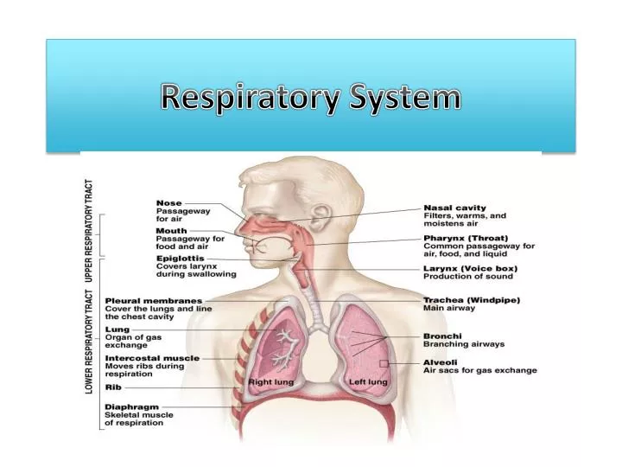
Picture 1 above (Bing, no date)
Image two illustrates the changes that occur in the respiratory system during an asthma attack, contrasting normal airways with those affected by inflammation. During an episode, the lining of the bronchial tubes becomes swollen, and the bronchioles produce an excessive amount of mucus compared to normal levels. The surrounding muscles tighten, and the airways become narrowed and obstructed by mucus, making it difficult to breathe.
These physiological changes can lead to symptoms such as persistent coughing, shortness of breath, and a sensation of chest tightness or constriction. Individuals may also experience a high-pitched whistling sound. The name for the sound is wheezing. You will hear this when breathing in and out, because of the airflow passing through narrowed airways (Neal and Lanese, 2025).
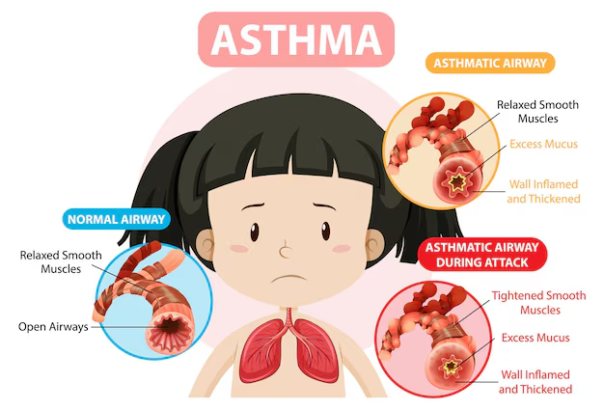(Freepik, 2024)
Section 2: Pathophysiology
Asthma is a chronic inflammatory condition of the airways, often triggered by irritants such as pollen, dust, smoke, or pollution. When these irritants the respiratory tract, they activate immune cells like mast cells and eosinophils, which release chemical mediators that cause inflammation. This leads to swelling of the airway lining, tightening of the surrounding muscles, and increased mucus production. As the airways narrow, it becomes harder for oxygen to enter the lungs and for carbon dioxide to be released. This results in symptoms such as wheezing, persistent coughing, chest tightness, and difficulty breathing especially at night or during an asthma attack. In severe cases, the chest wall may visibly retract as the body struggles to draw in air, and the build-up of mucus can cause vomiting or further coughing as the body attempts to clear the airways (Tillie-Leblond et al.,)
Inflammation in asthma does not only affect the lower respiratory tract; it can also impact the upper airways, including the pharynx (throat). Just before an asthma attack, individuals may experience an itchy throat due to postnasal drip where mucus from the nasal passages accumulates and drips down the back of the throat. This can lead to symptoms such as a runny nose, nasal congestion, and a blocked or irritated feeling in the throat. These upper airway symptoms are often early warning signs of an impending asthma episode and reflect the systemic nature of airway inflammation (Win, and Hussain, 2009).
Impact of Smoking and Vaping on Asthma and Lung Health
Smoking and vaping have a significant impact on asthma and overall respiratory function. Even passive smoking exposure to second-hand smoke can irritate the airways and trigger asthma symptoms. Although e-cigarettes and vaping devices contain fewer toxins than traditional cigarettes, they still contribute to airway inflammation and sensitivity, particularly in individuals with asthma (Hancox et al., 2016).
Cigarette smoke contains over 4,000 chemicals, with at least 250 identified as harmful (Tobacco-Free Life, no date). Smoking also contributes to indoor air pollution, especially in enclosed environments where smoke particles linger and circulate. This poses a serious health risk to others, particularly children and individuals with pre-existing respiratory conditions.
Long-term smoking leads to the accumulation of black tar in the lungs, reduces lung apacity, and can diminish the effectiveness of asthma medications. While most individuals turn to vaping as a method to quit smoking, research indicates that vaping still carries notable health risks and should not be considered a harmless alternative (Kotoulas et al., 2021).
Image number 3 shows the difference between healthy and smoker’s lungs. Healthy lungs appear clean and light pink, where the lungs of a smoker are dark and tar-filled, and visibly damaged. Quitting smoking can lead to gradual improvements in lung health and respiratory function.
(Image 3 below)
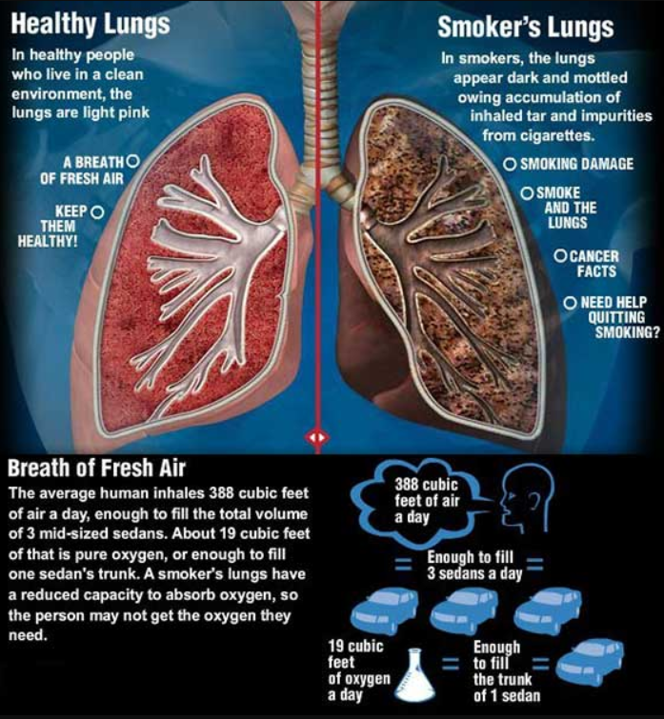
(Twimg, 2025)

Section 3: Monitoring and Data Use in Asthma Care
Health professionals monitor asthma using digital health technologies, such as computer platforms, specialised, internet connectivity, and medical sensors. These tools improve how clinical information is recorded, documented, and communicated, leading to more accurate and efficient patient care (De Keyser et al., 2025).
Asthma can be monitored using peak flow measurements. This involves tracking a person’s highest and lowest peak expiratory flow rates, which indicate how well air moves out of the lungs. These readings are recorded in the patient’s asthma action plan and hospital records, helping to identify patterns and guide treatment decisions. In addition, smart inhalers are used to monitor breathing and medication usage. These devices collect data on inhaler technique and frequency, helping to reduce flare-ups and prevent asthma attacks by promoting better adherence and early intervention (Mosnaim et al., 2022).
In hospital settings, spirometry is used to assess how well your lungs are functioning. This test measures how much air you can breathe in and out, and how quickly you can exhale. To ensure accurate results, the test is usually repeated at least three times. For younger children, a more engaging approach is often used. They may be asked to blow into a machine designed like a game, such as one that simulates blowing out candles. This helps them perform the test correctly while making the experience less intimidating (Gallucci et al., 2019).
Routine data plays a crucial role in managing asthma by enabling healthcare professionals to provide accurate, personalised information to adolescents. This empowers young people to understand their condition and develop effective self-management strategies, including knowing how to respond during an asthma attack. By using routine data to inform care and education, asthma management becomes more. initiative-taking and tailored to individual needs. This leads to improved quality of life, fewer exacerbations, reduced hospital admissions, and better overall control of the condition. Routine data also supports wider communication across settings such as schools, colleges, and workplaces. It ensures that staff are informed about a young person’s asthma needs and know how to respond appropriately in the event of an emergency. Additionally, it enhances coordination between departments, promoting consistent and safe care across different environments (‌Pinnock, 2015).
Section 4 lifestyle recommendations:
Research indicates that over 300 million people currently live with asthma worldwide, and this number is expected to rise by 100 million by 2025, largely due to lifestyle-related factors (Nyenhuis, Dixon and Ma, 2018). To help reverse this trend, individuals and communities must adopt healthier habits that support respiratory health and reduce exposure to asthma triggers.
Making positive lifestyle changes can significantly improve asthma control and reduce the risk of flare-ups. Example of things you can do to improve your asthma control:
Stop smoking
Smoking aggravates airway inflammation and increases sensitivity to asthma triggers. Second-hand smoke exposure can have similar harmful effects. Research shows that the effectiveness of inhaled corticosteroids commonly used to control asthma is often reduced in smokers. After quitting, these medications work more efficiently, leading to better symptom control and improved lung function. Clearer lungs mean fewer breathing difficulties and a lower risk of severe attacks (DevSupport, 2016).
Healthy Weight
Research studies have shown that losing just 5–10% of body weight can lead to noticeable improvements in asthma symptoms and overall quality of life. Excess weight places additional pressure on the lungs and increases systemic inflammation, which can worsen asthma control (Stoodley et al., 2019). By adopting healthier eating habits and engaging in regular physical activity, individuals can reduce airway resistance, improve breathing efficiency, and enhance their response to asthma medication. Weight loss not only supports better respiratory health but also contributes to increased energy levels, reduced fatigue, and improved emotional well-being making it a key lifestyle factor in long-term asthma management (Kingsley, 2023)
Attend appointments
Attending scheduled healthcare appointments, and monitoring lung function with peak flow readings are also important with managing asthma. These habits help individuals detect early changes, stay on top of their condition, and make informed decisions about treatment and lifestyle.
Conclusion
Making lifestyle changes is essential to properly controlling asthma. Even though medicine is still the primary form of treatment, embracing healthier practices like consistent exercise, a well-balanced diet, managing stress, not smoking or vaping, and avoiding triggers in the environment may significantly reduce the intensity of symptoms and enhance quality of life. These adjustments improve immunological response, promote respiratory health, and provide people the ability to actively manage their illness. People with asthma can live more active, self-assured, and satisfying lives by combining lifestyle recommendations with medical treatment.

References
Ionescu, C.M., 2013. The human respiratory system. In The Human Respiratory System: An Analysis of the Interplay between Anatomy, Structure, Breathing and Fractal Dynamics (pp. 13-22). London: Springer London.
Patwa, A. and Shah, A., 2015. Anatomy and physiology of respiratory system relevant to anaesthesia. Indian journal of anaesthesia, 59(9), pp.533-541.
Neal, C. and Lanese, N. (2025). What happens to the body during an asthma attack? [online] livescience.com. Available at: https://www.livescience.com/health/viruses-infections-disease/what-happens-to-the-body-during-an-asthma-attack. (Accessed: 19 September 2025)
Tillie‐Leblond, I., Montani, D., Crestani, B., De Blic, J., Humbert, M., Tunon‐de‐Lara, M., Magnan, A., Roche, N., Ostinelli, J. and Chanez, P., 2009. Relation between inflammation and symptoms in asthma. Allergy, 64(3), pp.354-367.
‌ Win, P.H. and Hussain, I., 2009. Asthma triggers: what really matters? Clinical Asthma, p.149. [accessed 20 Sep.25]
Kotoulas, S.C., Katsaounou, P., Riha, R., Grigoriou, I., Papakosta, D., Spyratos, D., Porpodis, K., Domvri, K. and Pataka, A., 2021. Electronic cigarettes and asthma: what do we know so far? Journal of Personalized Medicine, 11(8), p.723.
Tobacco-Free Life. (n.d.). What’s In a Cigarette? Shocking List of Cigarette Ingredients. [online] Available at: https://tobaccofreelife.org/why-quit-smoking/cigarette-ingredients/. (Accessed: 20 September 2025)
Twimg.com. (2025). Available at: https://pbs.twimg.com/media/CI-fK5uWsAAzYpU.jpg (Accessed: 19 September 2025). Picture 3
De Keyser, H.H., Anderson, W.C., Stempel, D.A. and Szefler, S.J. (2025). Digital Health for Asthma Management: Electronic Medication Monitoring for Adherence as a Case Example. The journal of allergy and clinical immunology. In practice, [online] pp. S2213-2198(25)000522. Doi: https://doi.org/10.1016/j.jaip.2024.12.042.
Mosnaim, G.S., Greiwe, J., Jariwala, S.P., Pleasants, R. and Merchant, R., 2022. Digital inhalers and remote patient monitoring for asthma. The Journal of Allergy and Clinical Immunology: In Practice, 10(10), pp.2525-2533.
‌ Gallucci, M., Carbonara, P., Pacilli, A.M.G., Di Palmo, E., Ricci, G. and Nava, S., 2019. Use of symptoms scores, spirometry, and other pulmonary function testing for asthma monitoring. Frontiers in pediatrics, 7, p.54.
‌ Pinnock, H., 2015. Supported self-management for asthma. Breathe, 11(2), pp.98-109.
NHS (2021). Asthma. [online] NHS. Available at: https://www.nhs.uk/conditions/asthma/. (Accessed: 22 September 2025)
Hancox, R.J., Gray, A.R., Poulton, R. and Sears, M.R., 2016. The effect of cigarette smoking on lung function in young adults with asthma. American journal of respiratory and critical care medicine, 194(3), pp.276-284.
‌ devsupport (2016). Smoking cessation and management of patients with asthma. [online] Nursing in Practice. Available at: https://www.nursinginpractice.com/clinical/respiratory/smoking-cessation-and-management-of-patients-with-asthma/. (Accessed: 29 September 2025)
. Maintaining a healthy weight in people with Asthma: Steps, Benefits, and Safety Precautions - The Kingsley Clinic. [online] The Kingsley Clinic. Available at: https://thekingsleyclinic.com/respiratory-system-goal-to-achieve/maintaining-a-healthy-weight-in-people-with-asthma-steps-benefits-and-safety-precautions/ (Accessed: 29 September 2025)
Nyenhuis, S.M., Dixon, A.E. and Ma, J. (2018). Impact of Lifestyle Interventions Targeting Healthy Diet, Physical Activity, and Weight Loss on Asthma in Adults: What Is the Evidence? The Journal of Allergy and Clinical Immunology: In Practice, 6(3), pp.751–763. doi:https://doi.org/10.1016/j.jaip.2017.10.026.
Stoodley, I., Williams, L., Thompson, C., Scott, H., and Wood, L. (2019). Evidence for Lifestyle Interventions in Asthma. Breathe, [online] 15(2), pp.50–61. Doi: HTTPs://doi.org/10.1183/20734735.0019-2019.
BBC Bitesize. (n.d.). The four components of the blood - Respiration and gas exchange - KS3 Biology. [online] Available at: https://www.bbc.co.uk/bitesize/articles/zr3vsk7#zf33f82. (Accessed 30 September 2025)
‌Freepik. (2024). Lungs asthma asthmatic and normal airway | Premium Vector. [online] Available at: https://www.freepik.com/premium-vector/lungs-asthma-asthmatic-normal-airway_249672191.htm#from_element=cross_selling__vector [Accessed 14 Oct. 2025]. Picture 2

‌
‌
‌
‌
‌

