Appendix
Appendix 1 – Approved ethics form text:
APPLICATION FOR ETHICAL APPROVAL
In order for research to result in benefit and minimise risk of harm, it must be conducted ethically. A researcher may not be covered by the University’s insurance if ethical approval has not been obtained prior to commencement.
The University follows the OECD Frascati manual definition of research activity: “creative work undertaken on a systematic basis in order to increase the stock of knowledge, including knowledge of man, culture and society, and the use of this stock of knowledge to devise new applications”. As such this covers activities undertaken by members of staff, postgraduate research students, and both taught postgraduate and undergraduate students working on dissertations/projects.
The individual undertaking the research activity is known as the “principal researcher”.
Ethical approval is not required for routine audits, performance reviews, quality assurance studies, testing within normal educational requirements, and literary or artistic criticism.
Please read the notes for guidance before completing ALL sections of the form.
This form must be completed and approved prior to undertaking any research activity. Please see Checklist for details of process for different categories of application.

SECTION A: About You (Principal Researcher)
Full Name: Thomas Joseph Poole Tick all boxes which apply: Member of staff: ☐ Student: x Honorary research fellow: ☐

Faculty/School/Centre: SWWCTE: YR ATHROFA Campus: Carmarthen E-mail address: 1600380@student.uwtsd.ac.uk Contact Telephone Number: 07583542289 For students: Student Number: 1600380 Undergraduate x Programme of Study: BA Primary Education with QTS Taught Postgraduate ☐ Director of Studies/Supervisor: Dr. Sioned V Hughes Research ☐

SECTION B: Approval for Research Activity
Has the research activity received approval in principle? (please check the Guidance Notes as to the appropriate approval process for different levels of research by different categories of individual)
YES x NO ☐ Date
If Yes, please indicate source of approval (and date where known):
Research Degrees Committee ☐ Faculty Research Committee ☐ Other (write in) x 08/02/19 Approval in principle must be obtained from the relevant source prior to seeking ethical approval.

PG2 / E1 FORM
July 2017 2 Ethical Approval Form v6
SECTION C: External Ethical Guidance Materials
Please list the core ethical guidance documents that have been referred to during the completion of this form (including any discipline-specific codes of research ethics, and also any specific ethical guidance relating to the proposed methodology). Please tick to confirm that your research proposal adheres to these codes and guidelines. The research is within the bounds of the normal classroom and in accordance with the Yr Athrofa school guidelines for parental consent as per Yr Athrofa letter. x The research will be conducted within BERA (British Educational Research Association) guidelines – Ethical Guidelines for Educational Research (2018). x The research will adhere to the University research guidelines. x The research will adhere to the Education Workforce Council (EWC) x

SECTION D: External Collaborative Research Activity
Does the research activity involve collaborators outside of the University? YES ☐ NO x
If Yes, please provide the name of the external organisation and name and contact details for the main contact person: Institution Contact person name Contact person e-mail address
Where research activity is carried out in collaboration with an external organisation Does this organisation have its own ethics approval system? YES ☐ NO x If Yes, please attach a copy of any final approval (or interim approval) from the organisation

SECTION E: Details of Research Activity

Indicative title: Can being involved with sport influence children’s well-being?
Proposed start date: 11/02/19 Proposed end date: 29/04/19
Purpose of research activity (including aims and objectives) Outline the purpose, aims and objectives of the research activity, including key research questions. Show briefly how existing research has informed the proposed activity and explain what the research activity will add and how it addresses an area of importance. (Maximum 300 words) The research project aims to explore and discover whether participating in sports can influence a child’s well-being within Key Stage 2 learners. The research aims to capture the views and experiences of children participating in sport activities and staff members observing and assessing the well-being of these children before, during and after their engagement with sporting activities. This will be done in order to contribute to an informed dissertation regarding the impact and influence sporting activities can have on children’s well-being. Personal experiences of engagement with sport has significantly influenced my sense of physical, social and emotional well-being and I have improved my physical health, self-esteem and collaborative ability as a result of sport activities. With Donaldson’s (2015) new curriculum on the horizon and the growing sense of awareness of children’s argued deterioration in well-being and mental health suggests that more emphasis needs to be placed upon the development of children’s well-being and mental health. (Bradshaw and Main, 2016) Indeed, Bradshaw and Main (2016) suggest that the UK ranks 11th and 14th out of 15 countries for pupils’ well-being and mental health, placing the UK near the bottom in international comparisons of pupils’ subjective well-being and mental health. My research aims to provide a possible method for improving children’s well-being and mental health through sporting activites.
PG2 / E1 FORM
July 2017 3 Ethical Approval Form v6

Key Questions: Pupils • How do you feel? • On a scale of 1 to 5 (1=high, 5=low), how much have you enjoyed/engaged with the session today? • Were you aware of the time during the session today? If yes, how often? • Do you think that you have improved your self-esteem/confidence during the sports session? • Would you like to participate in another sports session in the future? • Would you prefer to participate in a sporting activity alone or with others? Why? • What was your favourite part of the session? Why? • What was your least favourite part of the session? Why? • What could improve future sports sessions?

Key Questions: Staff • Schools should provide more opportunities for pupils to participate in sports related activities. Strongly agree; Agree; Neither agree nor disagree; Disagree; Strongly Disagree. • Following a sports session, most children have an improved sense of well-being. Strongly agree; Agree; Neither agree nor disagree; Disagree; Strongly Disagree. • In your opinion, how important is pupil well-being? Please give a reason to support your answer. • What strategies are in place to assess and monitor pupil well-being? • Overall, what terms would you use to summarise the well-being of the children during the sports session? • Currently, how much time is allocated to sporting activities in the school week? 0-30 mins, 31-60 mins, 61-90 mins, 91-120 mins, over 121 mins. Circle as appropriate. • In your opinion, have you observed a general increase in pupil well-being following sporting sessions? • Do you think pupils would benefit from further sporting sessions? Why or why not? • Do you think Child A; Child B or Child C has demonstrated an increase in well-being following sporting sessions.
These questions may be rephrased and/or removed or added to, as becomes appropriate and/or necessary for the purpose of the research.
(this box should expand as you type) Proposed methods Provide a brief summary of all the methods that may be used in the research activity, making it clear what specific techniques may be used. If methods other than those listed in this section are deemed appropriate later, additional ethical approval for those methods will be needed. (Maximum 600 words) Interviews: After the analysing of data gained from whole class engagement in a sporting activity, particular individuals will be invited to take part in an interview where they will respond to key questions of the research, as detailed above. Exit: The children will not be forced to participate and will be free to decline to answer a particular question and/or leave the interview if they no longer wish to participate at any time. Children will use the consent cards with a happy, indifferent and sad face to express their feelings about continuing to be part of the interview.
Observations/Field notes: I will observe whole groups of children participating in sporting sessions with their class teacher as this will enable me to observe good practice. In an observation notebook, I will make note of the children’s engagement and well-being during the session using well-being measures such as the Leuven Scale of well-being and involvement. Both the teacher and children will have access to their notes, should they request this. Exit: I will ask the children and the class
PG2 / E1 FORM
July 2017 4 Ethical Approval Form v6
teacher at the end of the session whether they are happy for me to use their data or if they wish for me not to use their data.
Photography/Video and Audio recordings: During observation of children participating in a sports session, photographs and/or video and audio recordings may be used in order to gain an understanding of children’s well-being and collaboration with the teacher and peers during the session. I may also record interviews with children so that accurate information can be obtained from their answers to the key questions of the research.
Questionnaire: A questionnaire may be provided to children and staff members in order to gain further insight into the influence that participation in sports can have on children’s well-being. Throughout the creation of a questionnaire, I will adhere to the training provided by the University during my second year of study when the design and distribution of a questionnaire was necessary for a specific module. However, they will be asked to share their status in the school (i.e. pupil or teacher) if the questionnaire is completed by both learners and staff and a participant’s role is significant to the analysis. The participant will have the right to keep hold of their response to the questionnaire should they not wish for their data to be published. A cover letter explaining these terms may also be provided.
Learning Walk: To support my research, I may conduct a learning walk through the school to observe displays and discuss certain aspects of provision with members of staff or pupils. These learning walks will be self-directed and/or facilitated by a learner, group of learners or member of staff. Prior to conducting this learning walk, I will gain permission from a member of staff.
(this box should expand as you type)

Location of research activity Identify all locations where research activity will take place. The proposed research will be conducted in a large primary school in Pembrokeshire and a partnership primary school for Professional Teaching Experience 3 (school details have yet to be released by faculty).
(this box should expand as you type) Research activity outside of the UK If research activity will take place overseas, you are responsible for ensuring that local ethical considerations are complied with and that the relevant permissions are sought. Specify any local guidelines (e.g. from local professional associations/learned societies/universities) that exist and whether these involve any ethical stipulations beyond those usual in the UK (provide details of any licenses or permissions required). Also specify whether there are any specific ethical issues raised by the local context in which the research activity is taking place, for example, particular cultural sensitivities or vulnerabilities of participants. Not applicable.
(this box should expand as you type)

SECTION F: Scope of Research Activity
Will the research activity include: YES

NO Use of a questionnaire or similar research instrument? x ☐ Use of interviews? x ☐ Use of diaries? x ☐ Participant observation with their knowledge? x ☐
PG2 / E1 FORM
July 2017 5 Ethical Approval Form v6
Participant observation without their knowledge? x ☐ Use of video or audio recording? x ☐ Access to personal or confidential information without the participants’ specific consent? x ☐ Administration of any questions, test stimuli, presentation that may be experienced as physically, mentally or emotionally harmful / offensive? ☐ x Performance of any acts which may cause embarrassment or affect self-esteem? x ☐ Investigation of participants involved in illegal activities? ☐ x Use of procedures that involve deception? ☐ x Administration of any substance, agent or placebo? ☐ x Working with live vertebrate animals? ☐ x Other primary data collection methods, please explain in this box Photography use.

x ☐

If NO to every question, then the research activity is (ethically) low risk and may be exempt from some of the following sections (please refer to Guidance Notes).
If YES to any question, then no research activity should be undertaken until full ethical approval has been obtained.
SECTION G: Intended Participants
Who are the intended participants: YES
NO Students or staff at the University? ☐ x Adults (over the age of 18 and competent to give consent)? x ☐ Vulnerable adults? ☐ x Children under 18? x ☐ Prisoners? ☐ x Young offenders? ☐ x Those who could be considered to have a particularly dependent relationship with the investigator or a gatekeeper? ☐ x People engaged in illegal activities? ☐ x Others (please identify):

☐ x

Participant numbers and source Provide an estimate of the expected number of participants. How will you identify participants and how will they be recruited? The estimated number of participants will be 100 children aged between 7 and 11. However, this number is subject to change. Additionally, headteachers, teachers, support staff, school staff and possibly parents will be invited to take part in the research. Prior to conducting the research, I will obtain consent from the Headteacher or senior mentor in the school setting.

PG2 / E1 FORM
July 2017 6 Ethical Approval Form v6
this box should expand as you type)

Information for participants: YES NO

N/A
Will you describe the main research procedures to participants in advance, so that they are informed about what to expect? x ☐ ☐ Will you tell participants that their participation is voluntary? x ☐ ☐ Will you obtain written consent for participation? x ☐ ☐ Will you explain to participants that refusal to participate in the research will not affect their treatment or education (if relevant)? x ☐ ☐ If the research is observational, will you ask participants for their consent to being observed? x ☐ ☐ Will you tell participants that they may withdraw from the research at any time and for any reason? x ☐ ☐ With questionnaires, will you give participants the option of omitting questions they do not want to answer? x ☐ ☐ Will you tell participants that their data will be treated with full confidentiality and that, if published, it will not be identifiable as theirs? x ☐ ☐ Will you debrief participants at the end of their participation, in a way appropriate to the type of research undertaken? x ☐ ☐ If NO to any of above questions, please give an explanation

(this box should expand as you type)
Information for participants: YES NO

N/A Will participants be paid? ☐ x ☐ Is specialist electrical or other equipment to be used with participants? ☐ x ☐ Are there any financial or other interests to the investigator or University arising from this study? ☐ x ☐ Will the research activity involve deliberately misleading participants in any way, or the partial or full concealment of the specific study aims? ☐ x ☐ If YES to any question, please provide full details

(this box should expand as you type)
SECTION H: Anticipated Risks
Outline any anticipated risks that may adversely affect any of the participants, the researchers and/or the University, and the steps that will be taken to address them.
If you have completed a full risk assessment (for example as required by a laboratory, or external research collaborator) you may append that to this form. Full risk assessment completed and appended?
Yes ☐ No x
Risks to participants
PG2 / E1 FORM
July 2017 7 Ethical Approval Form v6
For example: emotional distress, financial disclosure, physical harm, transfer of personal data, sensitive organisational information The risk to participants is that they may be involved in the research without consent. Therefore, I will ensure that all consent procedures are in place by informing the children and staff of my research. I will explain to the children and staff (and parents if applicable) that they have the right to withdraw and can leave the research, or express that they do not wish for any of their data to be used at any time. For example, I will ask the children if I can use their answers from the interviews in my research and share my notes. I will also monitor the children’s well-being and stop any activity if any child is becoming upset/uncomfortable.

(this box should expand as you type)
If research activity may include sensitive, embarrassing or upsetting topics (e.g. sexual activity, drug use) or issues likely to disclose information requiring further action (e.g. criminal activity), give details of the procedures to deal with these issues, including any support/advice (e.g. helpline numbers) to be offered to participants. Note that where applicable, consent procedures should make it clear that if something potentially or actually illegal is discovered in the course of a project, it may need to be disclosed to the proper authorities N/A

(this box should expand as you type)
Risks to investigator For example: personal safety, physical harm, emotional distress, risk of accusation of harm/impropriety, conflict of interest The risk to the investigator is that I may be accused of unprofessional practices. I will manage this risk by adhering to the BERA guidelines and following my plan of ethical practice.

(this box should expand as you type)
University/institutional risks For example: adverse publicity, financial loss, data protection There should be very little risk to the University if I manage the risk to participants and the investigator as detailed above. I will conduct the research and represent the results honestly. I will always comply with ethical, legal and professional frameworks, obligations and standards as required by the statutory and regulatory authorities, as well as with the University’s Research Integrity and Ethics Code of Practice.

(this box should expand as you type)
Adverse outcomes List measures put in place to limit any adverse effects or outcomes of research activity where appropriate. Include any emergency protocols. I will manage the risk by adhering to the BERA guidelines and following my plan of ethical practice. I will always comply with ethical, legal and professional frameworks, obligations and standards as required by the statutory and regulatory authorities, as well as with the University’s Research and Integrity and Ethics Code of Practice. There is also risk of a loss of data – Upon collection of research I will assume full responsibility for the safekeeping of the data. To ensure the participant’s response is safe, it will be kept in a folder and on a secured memory stick upon my person until the research has been analysed and utilised. At this time, the data will be destroyed. If in the event that a participant’s response is lost at the fault of the author or a third party, then the individual will not be able to be identified as no personal details are listed on the questionnaire.

(this box should expand as you type)
Disclosure and Barring Service If the research activity involves children or vulnerable adults, a Disclosure and Barring Service (DBS) certificate must be obtained before any contact with such participants.

PG2 / E1 FORM
July 2017 8 Ethical Approval Form v6
YES NO N/A Has a DBS certificate been obtained? x ☐ ☐

SECTION I: Feedback, Consent and Confidentiality
Feedback What feedback will be provided to participants, how will this be done and when?

I will not be providing feedback to participants as it is not relevant for the research. If the participants request feedback from the response, then I as the investigator, will provide a summary of the data collected.

(this box should expand as you type)
Informed consent Describe the arrangements to inform potential participants, before providing consent, of what is involved in participating. Describe the arrangements for participants to provide full consent before data collection begins. If gaining consent in this way is inappropriate, explain how consent will be obtained and recorded.

Participation Consent/Assent: Children I will converse with my class teacher and senior mentor and inform them of the research I will be undertaking, providing reason and rationale behind the research. However, I will verbally ask children identified to participate whether they wish to participate, e.g. use 3 different consent cards with 1 happy, 1 sad and 1 casual face. If the children show the happy face, I know that they are happy to participate. The sad face would indicate their lack of consent to taking part, with the indifferent face indicating they wish to take a break to think about the decision and return later. This will be done individually so that children are encouraged to respond honestly with their interest and well-being in mind. Children will also be informed that they can approach me at any time and discuss their contribution to the research project and explain whether they wish to participate.
Participation Consent: Teachers For the class teachers, I will ask them to sign a document if they agree to take part in the research. If they are not willing to sign this document, then I shall not use them in my research. The consent form will include a box for the participant to tick if they agree to the statements, e.g. I confirm that I have read and understood the information and have asked any questions I wish and had these answered satisfactorily. I understand that my participation is voluntary and that I am free to withdraw at any time, without giving any reason. I understand that any information provided by myself may be used in future reports, presentations or articles by the research team. I understand that my name will not appear in any report, articles or presentations. I agree to participate in the above study.
Participation Consent: Parents (If applicable) Should parents be involved in the research, I will ask them to sign the same document detailed in the Participation Consent: Teachers section above, with the same terms applying to parents as to the teachers.

(this box should expand as you type)
Confidentiality / Anonymity Set out how anonymity of participants and confidentiality will be ensured in any outputs. If anonymity is not being offered, explain why this is the case. I will ensure that no individual data (e.g. raw scores, individual identifiable performance outcomes) are made available to schools/parents etc. Only non-identifiable summary/aggregate data can be provided in this way.

PG2 / E1 FORM
July 2017 9 Ethical Approval Form v6
I will also place a statement on the consent form indicating that ‘if you decide to remain anonymous, maintaining your anonymity will be a priority and every practical precaution will be taken to disguise your identity. If you prefer anonymity, there will not be any identifying information on audiotapes and transcripts without your prior consent. All materials generated from this or any interview will remain confidential.’
SECTION J: Data Protection and Storage
In completing this section refer to the University’s Research Data Management Policy and the extensive resources on the University’s Research Data Management web pages (http://uwtsd.ac.uk/library/research-data-management/). YES NO Does the research activity involve personal data (as defined by the Data Protection Act)? “personal data” means data which relate to a living individual who can be identified— (a) from those data, or (b) from those data and other information which is in the possession of, or is likely to come into the possession of, the data controller, and includes any expression of opinion about the individual and any indication of the intentions of the data controller or any other person in respect of the individual. ☐ x If YES, provide a description of the data and explain why this data needs to be collected:

(this box should expand as you type)
Does it involve sensitive personal data (as defined by the Data Protection Act)? “Sensitive personal data” means personal data consisting of information as to – (a) the racial or ethnic origin of the data subject, (b) his political opinions, (c ) his religious beliefs or other beliefs of a similar nature, (d) whether he is a member of a trade union (within the meaning of the Trade Union and Labour Relations (Consolidation) Act 1992), (e) his physical or mental health or condition, (f) his sexual life, (g) the commission or alleged commission by him of any offence, or (h) any proceedings for any offence committed or alleged to have been committed by him, the disposal of such proceedings or the sentence of any court in such proceedings.
☐ x
If YES, provide a description of the data and explain why this data needs to be collected:

(this box should expand as you type)
Will the research activity involve storing personal data on one of the following:
YES NO Manual files (i.e. in paper form)? x ☐ University computers? x ☐ Private company computers? ☐ x Home or other personal computers? x ☐ Laptop computers/ CDs/ Portable disk-drives/ memory sticks? x ☐ “Cloud” storage or websites? x ☐ Other – specify:
☐ x For all stored data, explain the measures in place to ensure data confidentiality, including details of password protection, encryption and anonymisation:
PG2 / E1 FORM
July 2017 10 Ethical Approval Form v6
Any names will be anonymised. E.g. Participant A/ Child B. etc. Storage of information will be on a memory stick that will be secured by a password.
(this box should expand as you type)

Will the research activity involve any of the following activities: YES NO Electronic transfer of data in any form? ☐ x Sharing of data with others at the University? ☐ x Sharing of data with other organisations? ☐ x Export of data outside the European Union or importing of data from outside the UK? ☐ x Use of personal addresses, postcodes, faxes, emails or telephone numbers? ☐ x Publication of data that might allow identification of individuals? ☐ x Use of data management system? ☐ x Data archiving? ☐ x If YES to any question, please provide full details, explaining how this will be conducted in accordance with the Data Protection Act (and/or any international equivalent):

(this box should expand as you type)

List all who will have access to the data generated by the research activity:

The investigator, the senior mentor and the module co-ordinator.

(this box should expand as you type)
List who will have control of, and act as custodian(s) for, data generated by the research activity:

The investigator, Thomas Poole.

(this box should expand as you type)
Give details of data storage arrangements, including where data will be stored, how long for, and in what form. Will data be archived – if so how and if not why not. Participants that provide responses will have their data stored securely by the investigator. Once the data has been analysed by the investigator then it will be destroyed so that there is no physical trace of the data. This process will also be in accordance to the Data Protection Act (1998).
The data collection period will range from 11/02/2019 until 29/04/2019. Following the 29/04/2019, there will no longer be a use for the data and all data will be destroyed.
(this box should expand as you type)
PG2 / E1 FORM
July 2017 11 Ethical Approval Form v6
SECTION K: Declaration

The information which I have provided is correct and complete to the best of my knowledge. I have attempted to identify any risks and issues related to the research activity and acknowledge my obligations and the rights of the participants.
In submitting this application I hereby confirm that I undertake to ensure that the above named research activity will meet the University’s Research Ethics and Integrity Code of Practice Signature of applicant:
Thomas Poole.
Date: 07/02/2019

For students: Teacher / Senior Mentor / Headteacher: Dr Sioned V Hughes Signature: S.V.Hughes Date: 09.02.19

Supervisor: Signature:
Date:

Checklist: Please complete the checklist below to ensure that you have completed the form according to the guidelines and attached any required documentation: x I have read the guidance notes supplied before completing the form. x I have completed ALL RELEVANT sections of the form in full. x I confirm that the research activity has received approval in principle ☐ I have attached a copy of final/interim approval from external organisation (where appropriate)
☐

I have attached a full risk assessment (and have NOT completed Section H of this form) (where appropriate)
x I understand that it is my responsibility to ensure that the above named research activity will meet the University’s Research Ethics and Integrity Code of Practice.
x
I understand that before commencing data collection all documents aimed at respondents (including information sheets, consent forms, questionnaires, interview schedules etc.) must be confirmed by the DoS/Supervisor, module tutor or Head of School.

RESEARCH STUDENTS AND STAFF ONLY All communications relating to this application during its processing must be in writing and emailed to pgresearch@uwtsd.ac.uk , with the title ‘Ethical Approval’ followed by your name. You will be informed of the outcome of your claim by email; therefore it is important that you check your University and personal email accounts regularly.

STUDENTS ON UNDERGRADUATE OR TAUGHT MASTERS PROGRAMMES should submit this form (and receive the outcome) via systems explained to you by the supervisor/module leader.

Appendix 2 – Cover letters provided to the elective school:
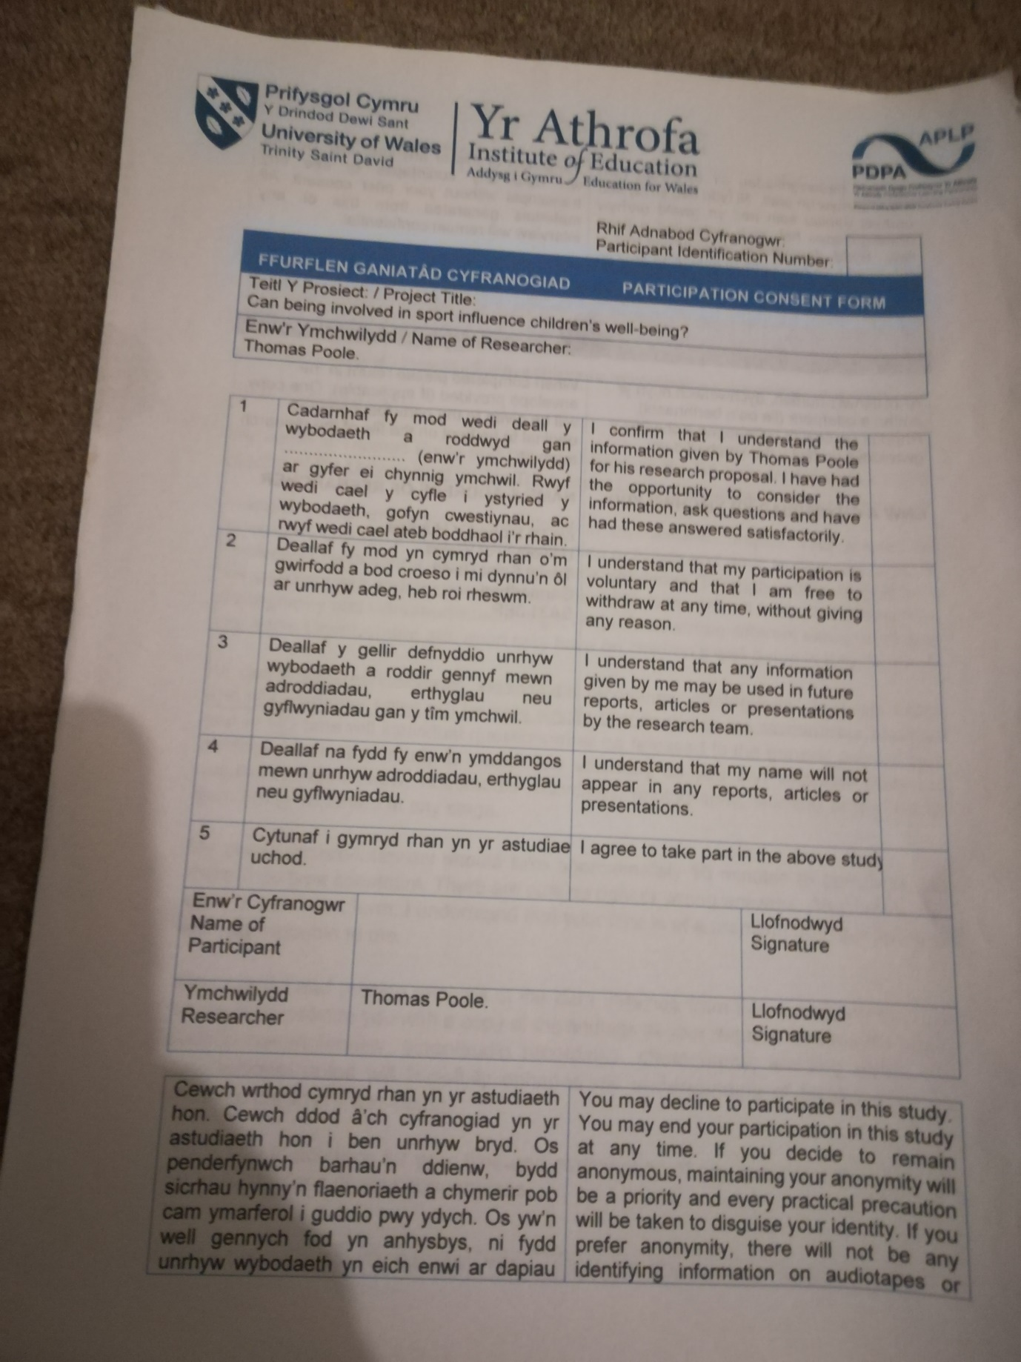
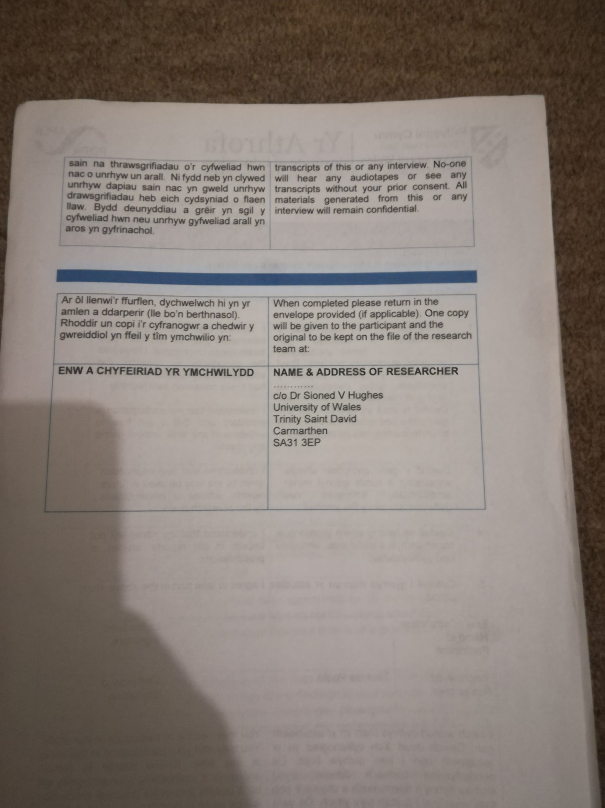
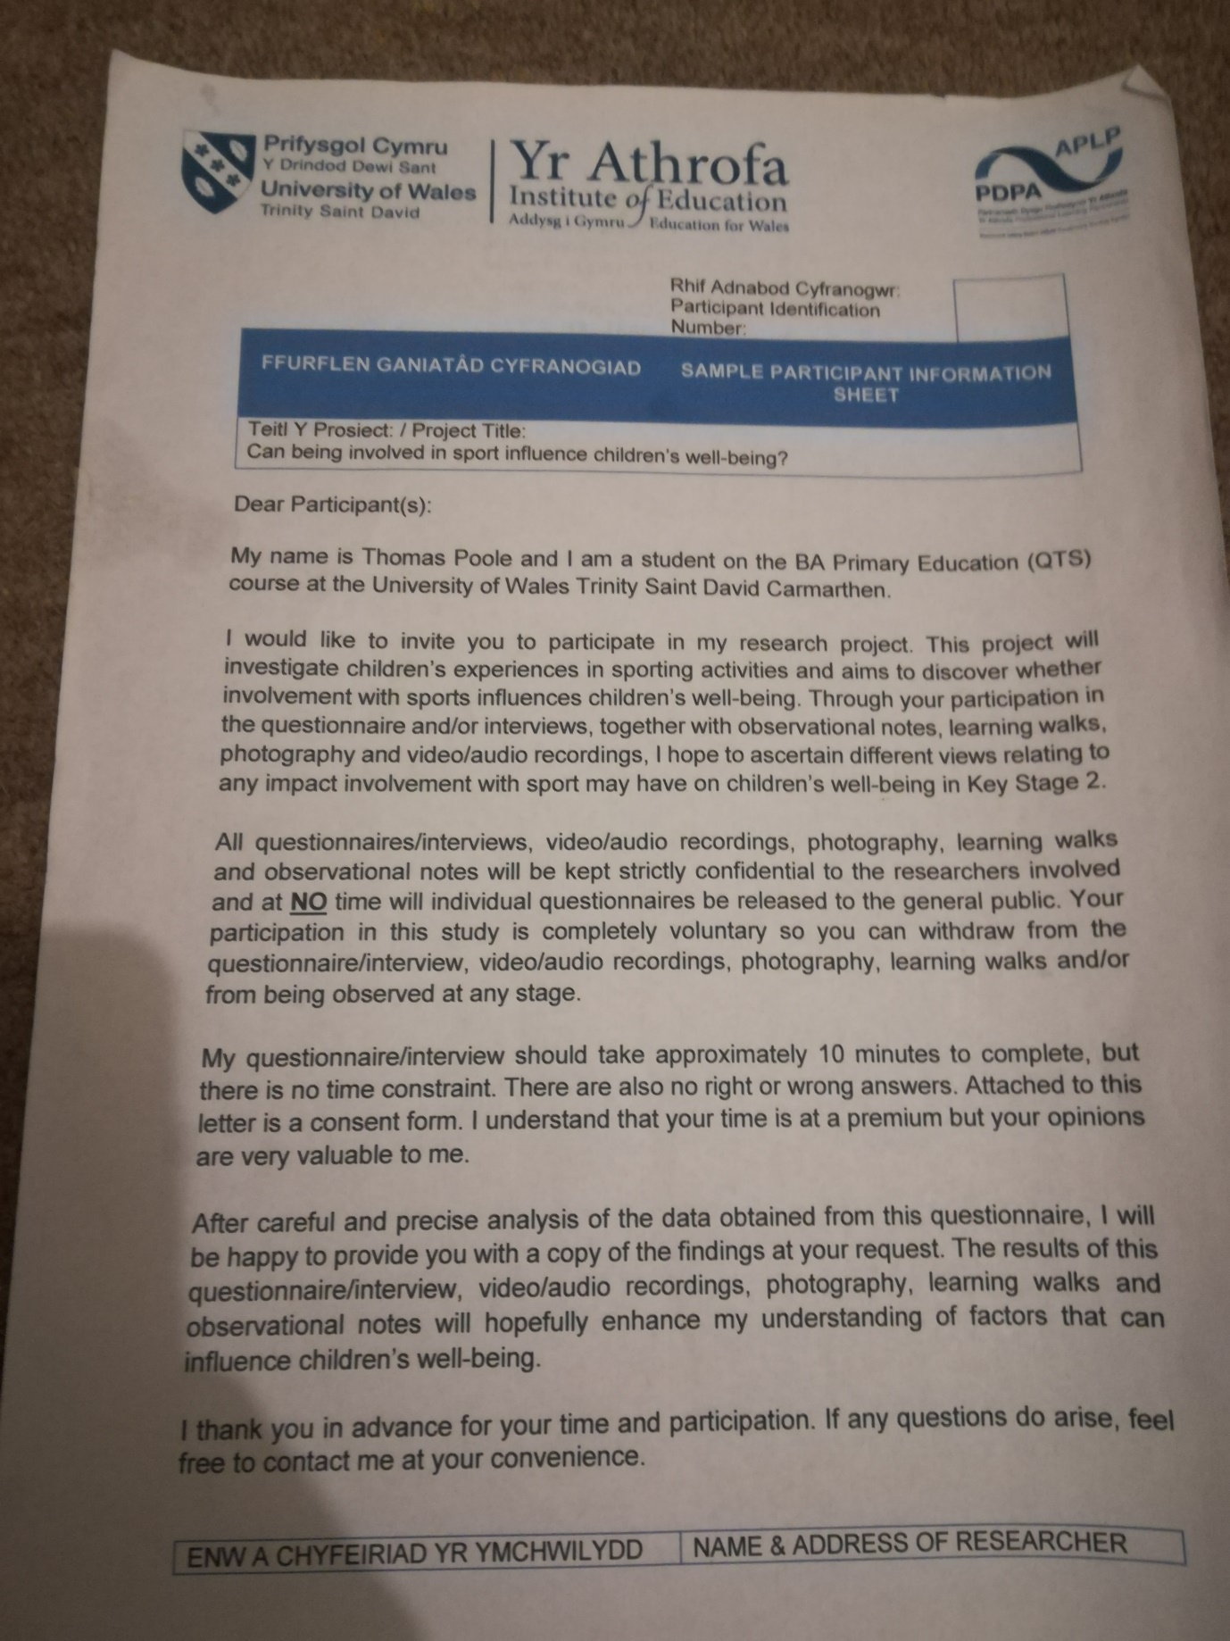


Appendix 3 – Pupil Questionnaire:
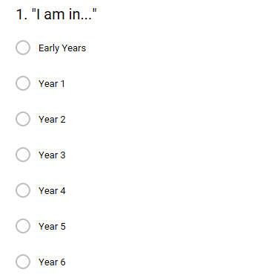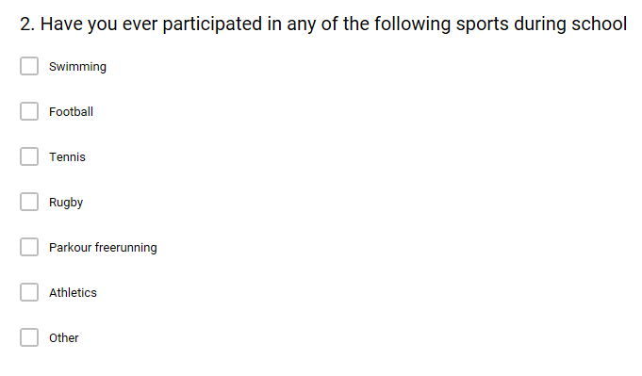
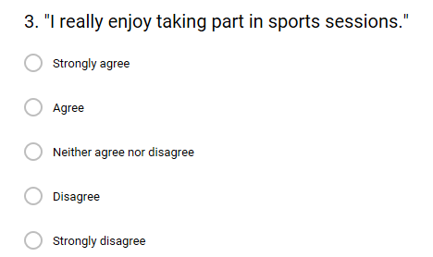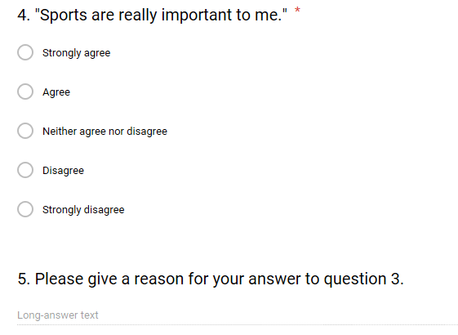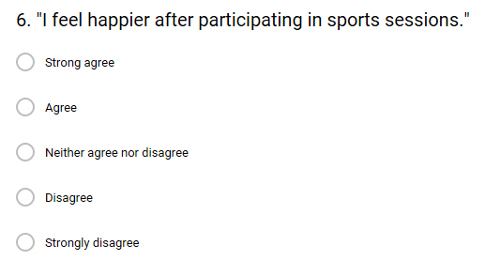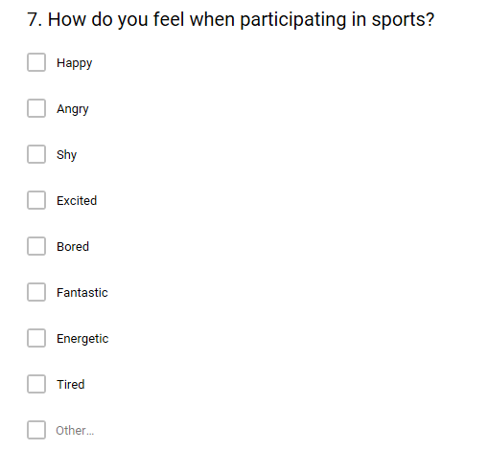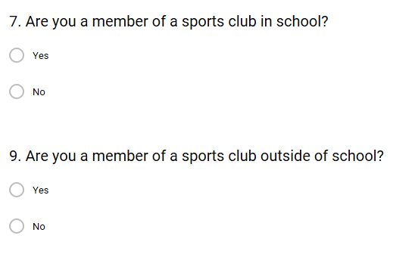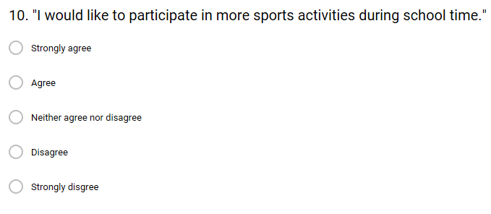
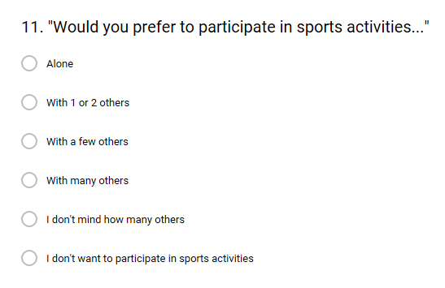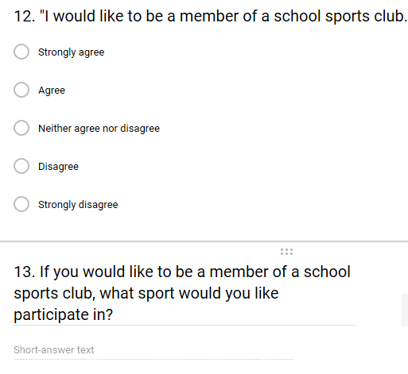
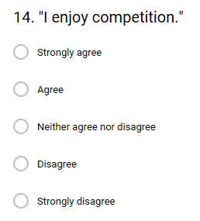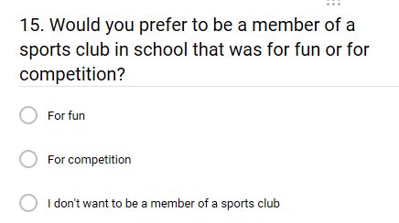

A link to the responses can be found at: https://docs.google.com/forms/d/1GapJR5FUnEoMJZB_FFK39Di362KXP-eGJzdOIXJj7iY/edit#responses

Appendix 4 – Staff Questionnaire:
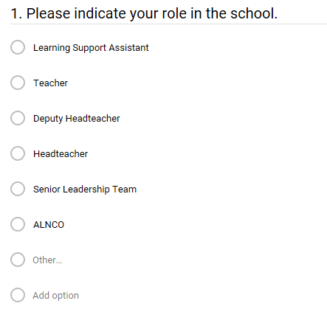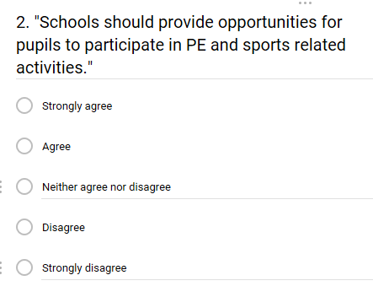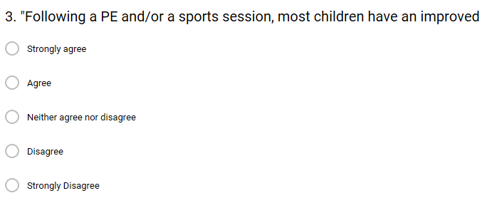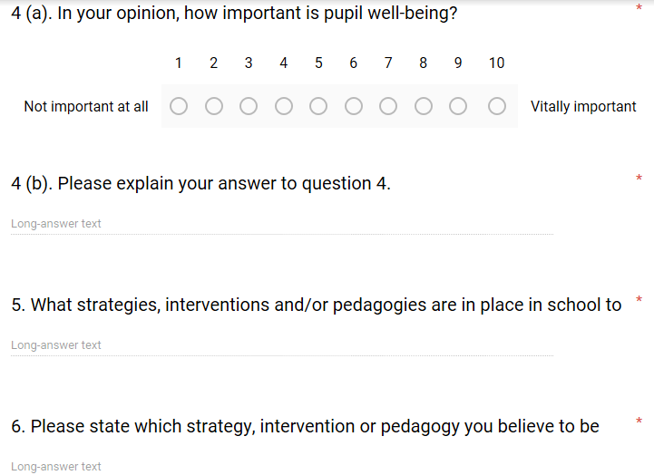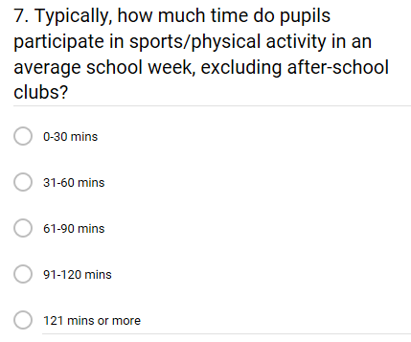
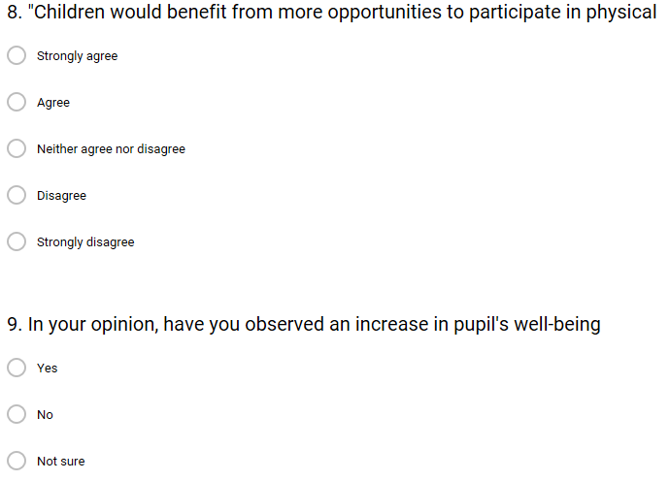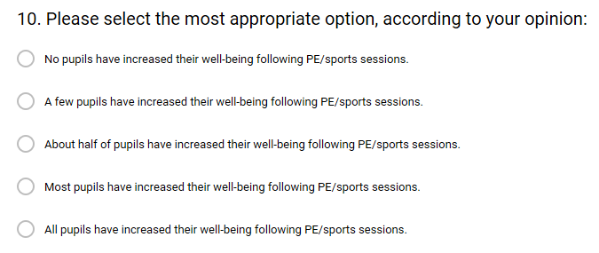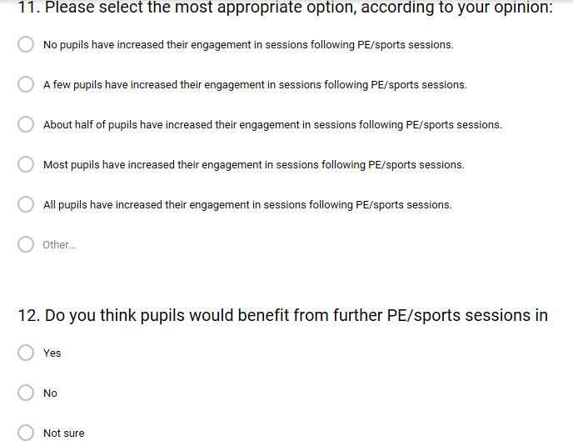
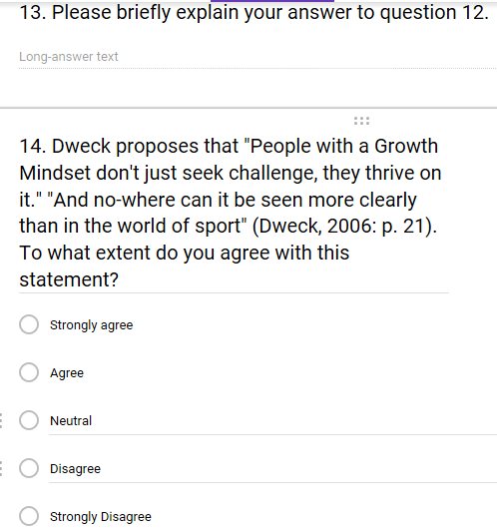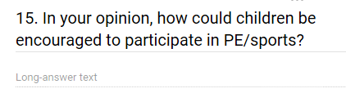
A link to the responses can be found at: https://docs.google.com/forms/d/1wCH67AaKdOw7bxM6JHNHfTUVFcne_NRnW-htig-d1WQ/edit#responses

Appendix 5 – Observation notes of children participating in SaPA activities:
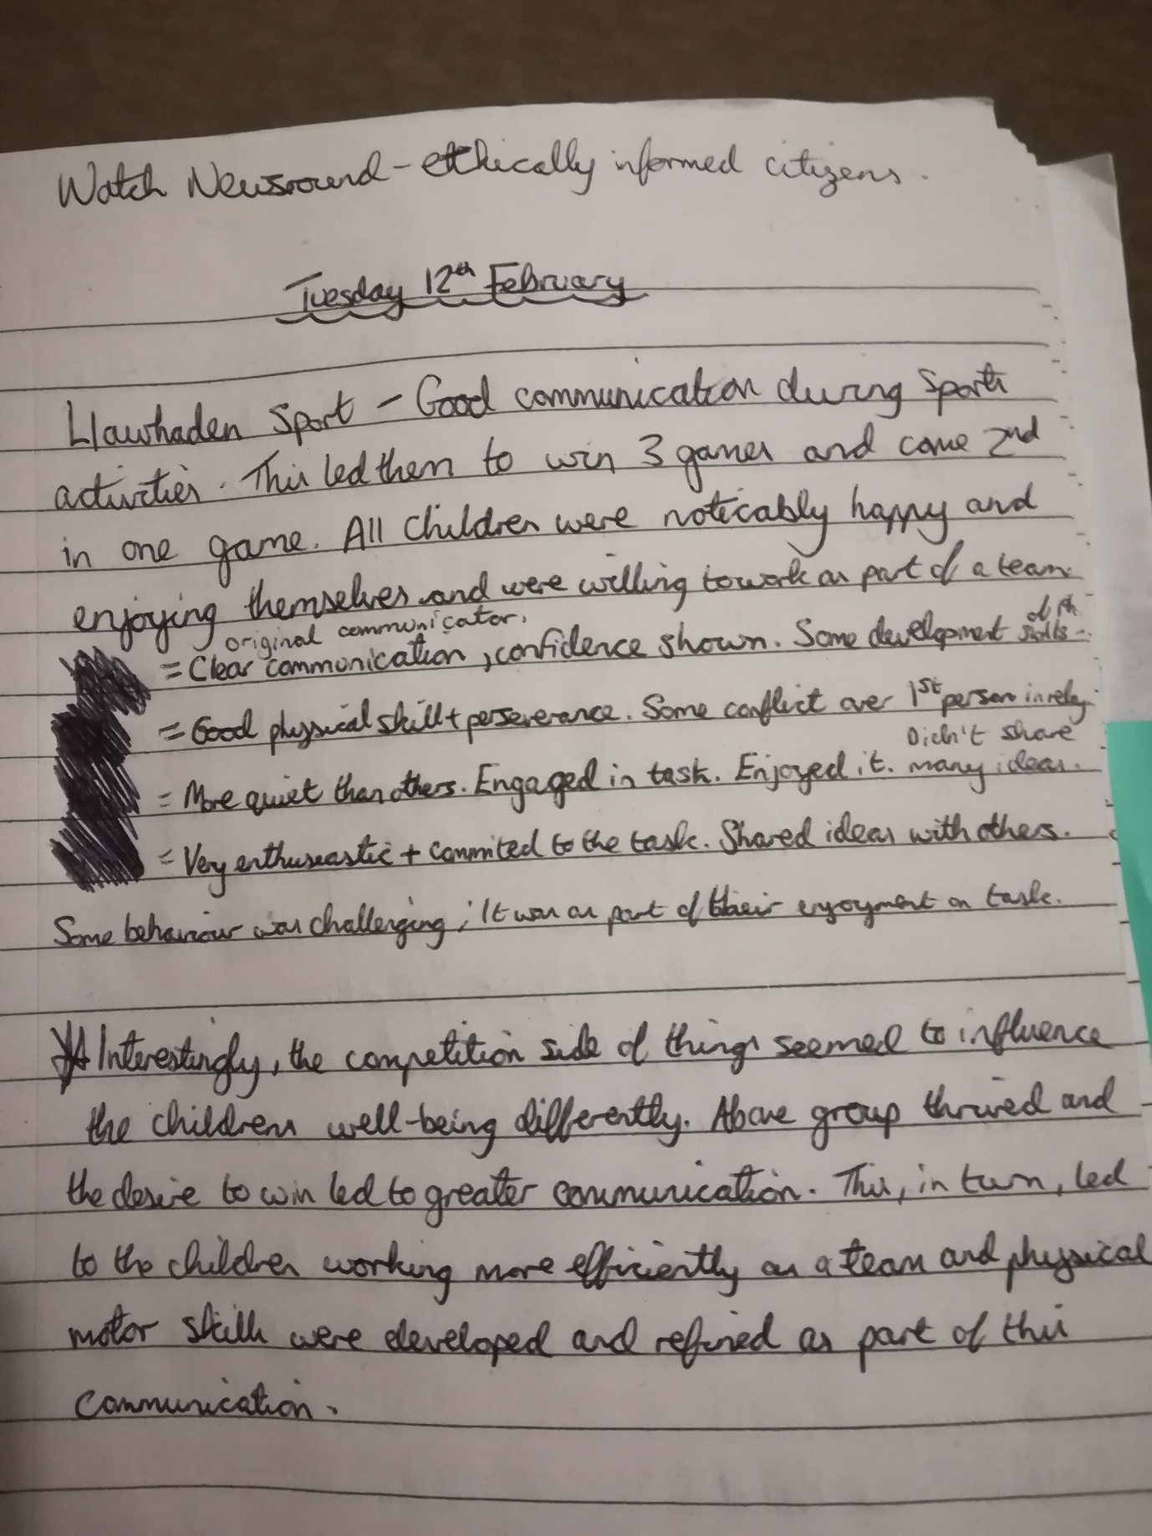

Appendix 6 – Unstructured interview schedule:
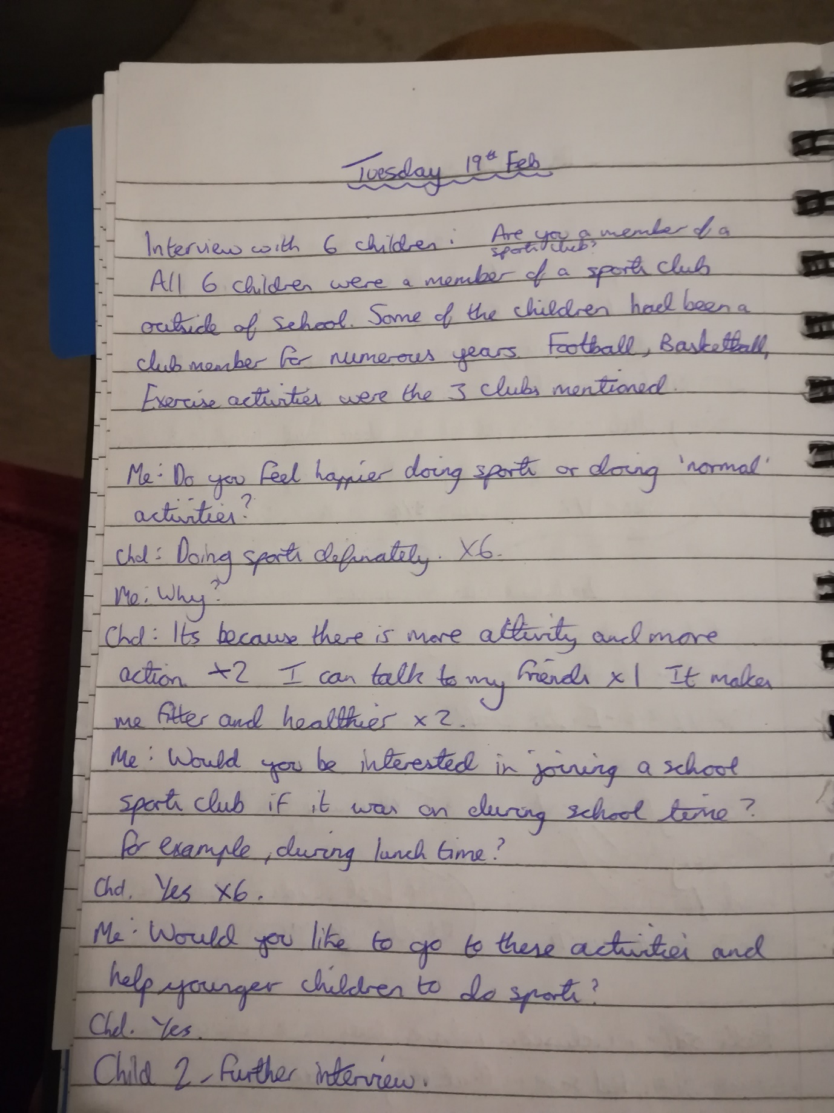

Appendix 7 – Semi-structured interview schedule:
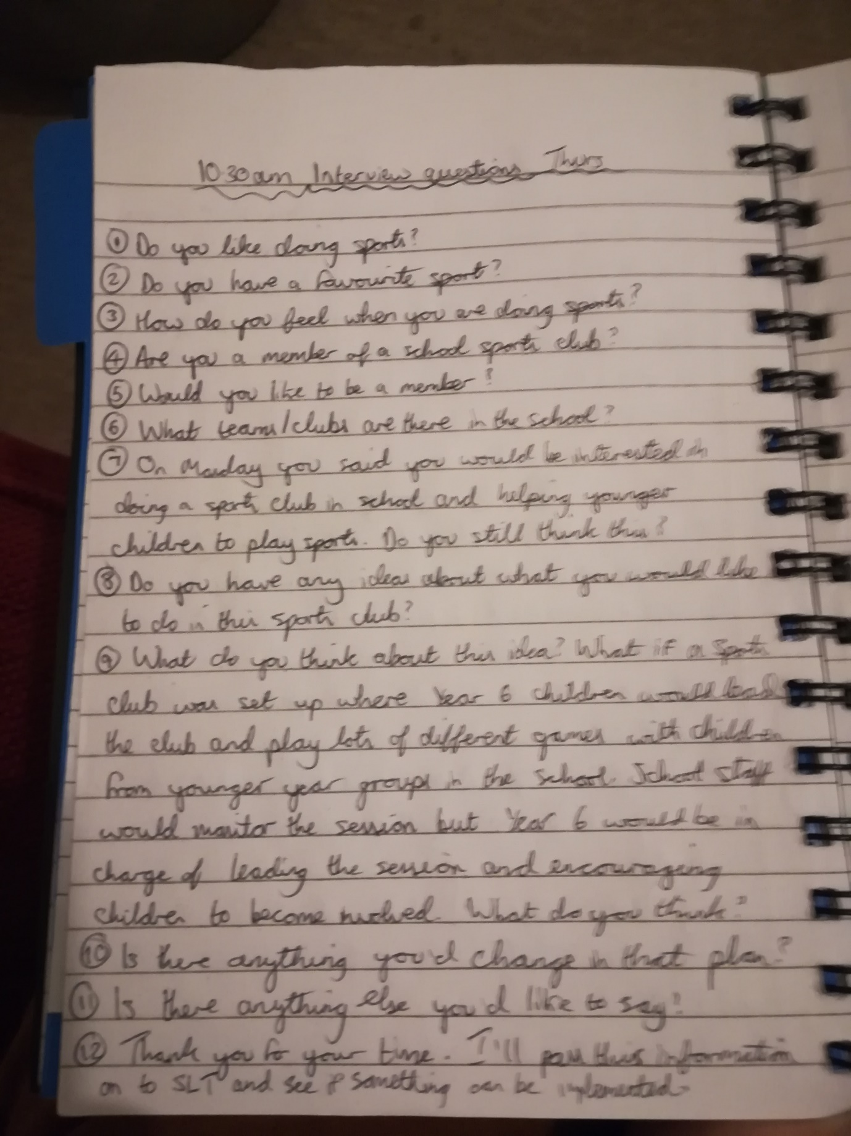
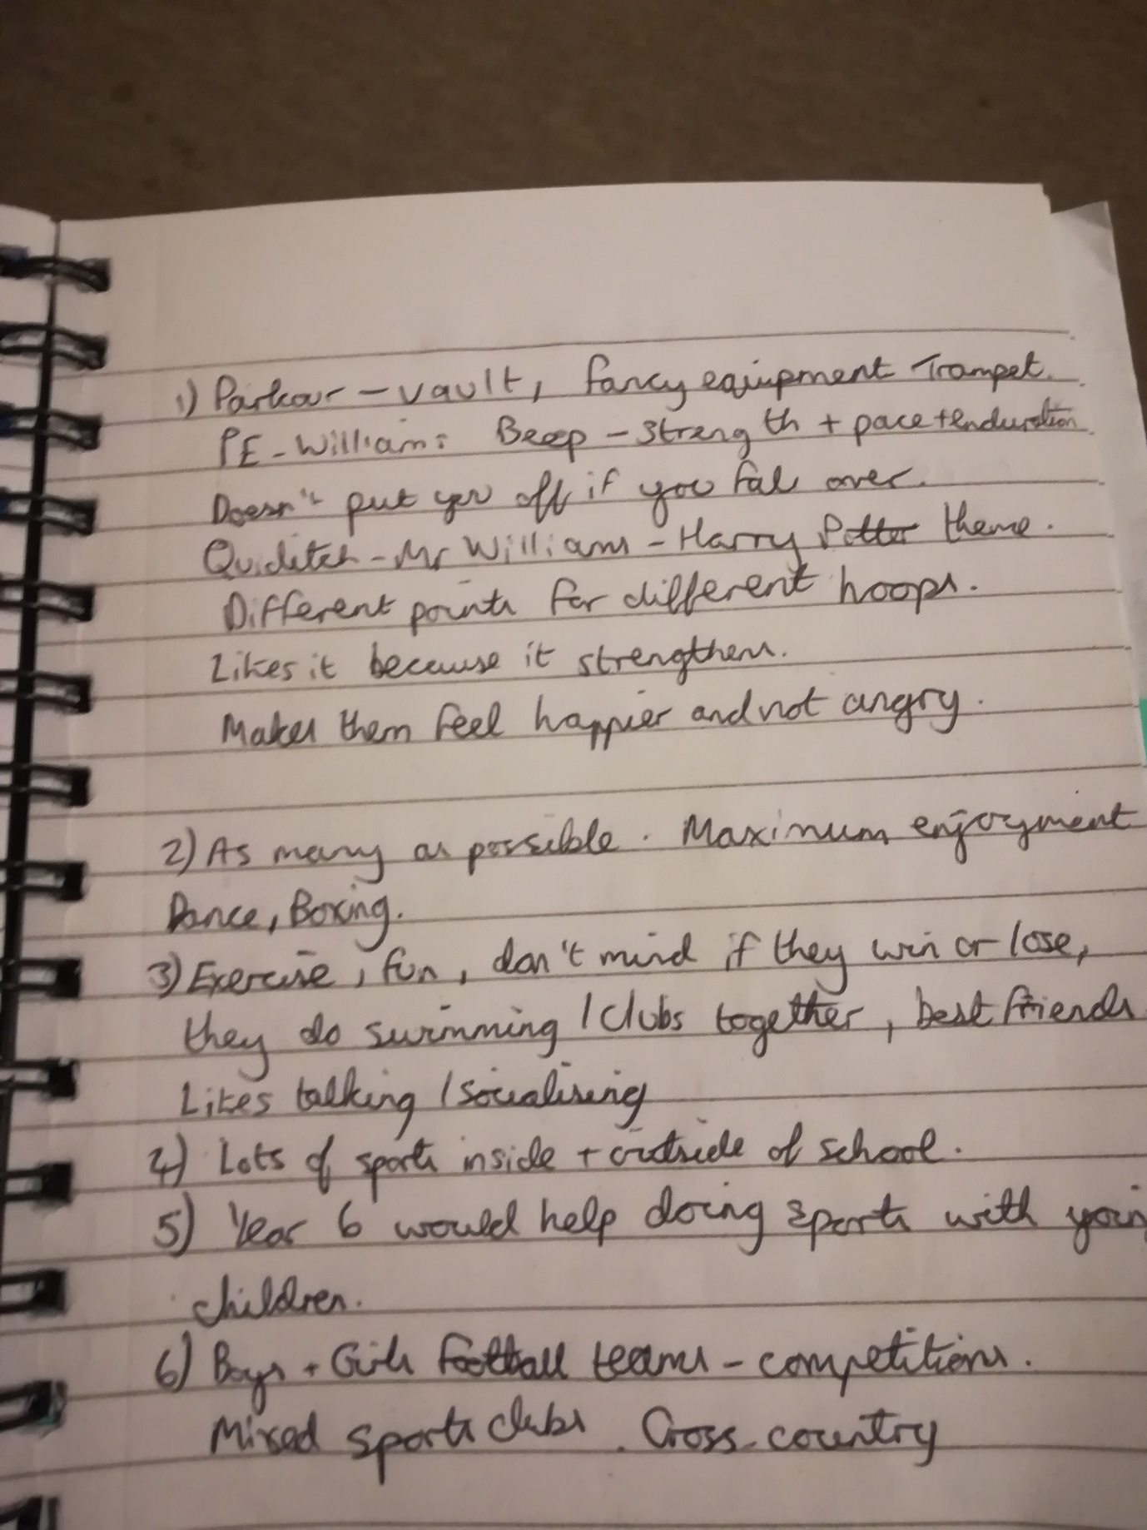

Appendix 8 – Foundation Phase children SaPA observational notes:
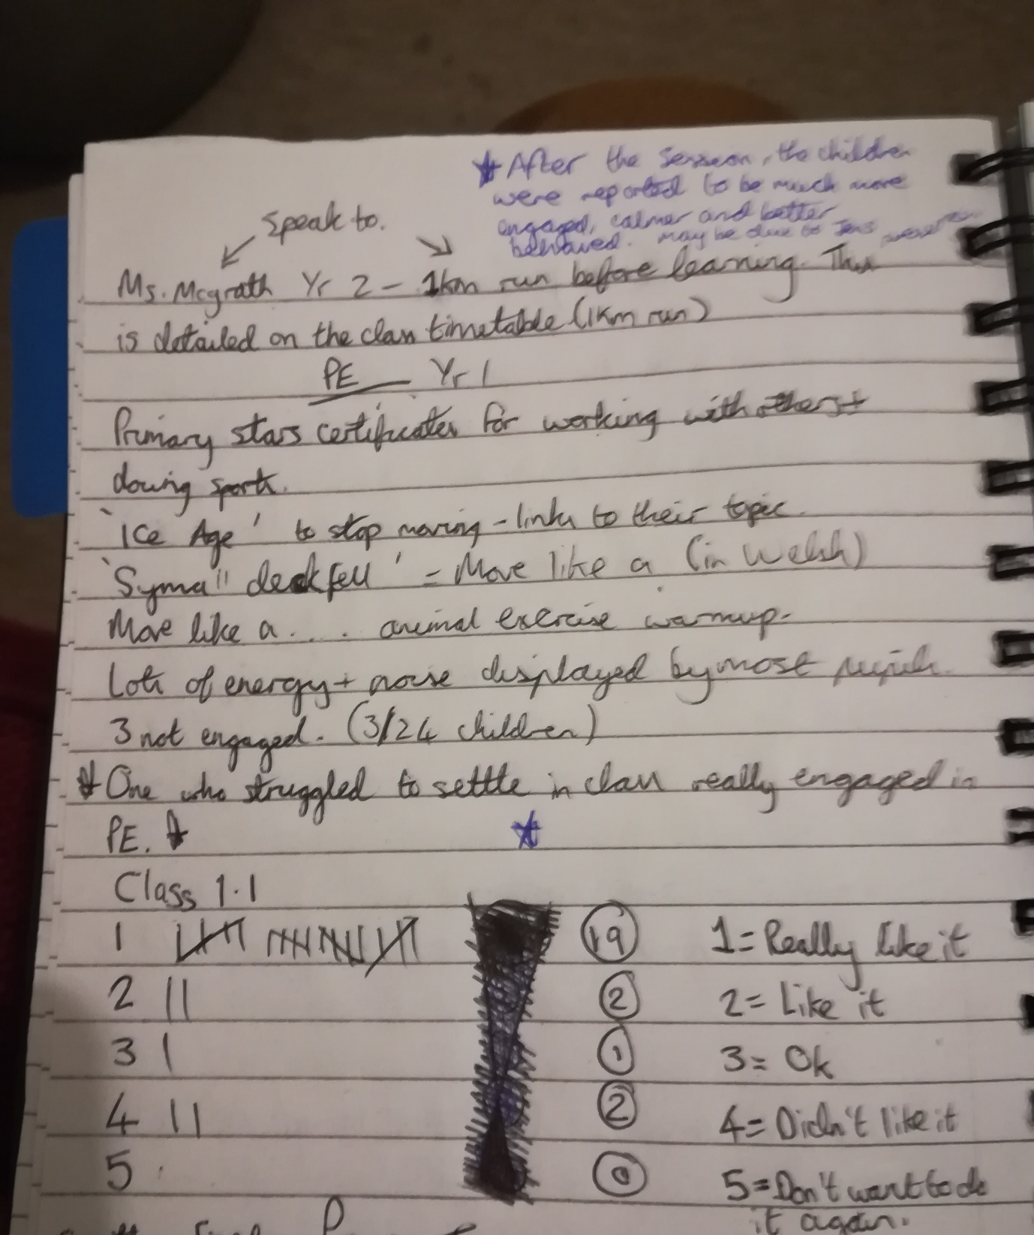

Appendix 9 – Learning Walk notes:
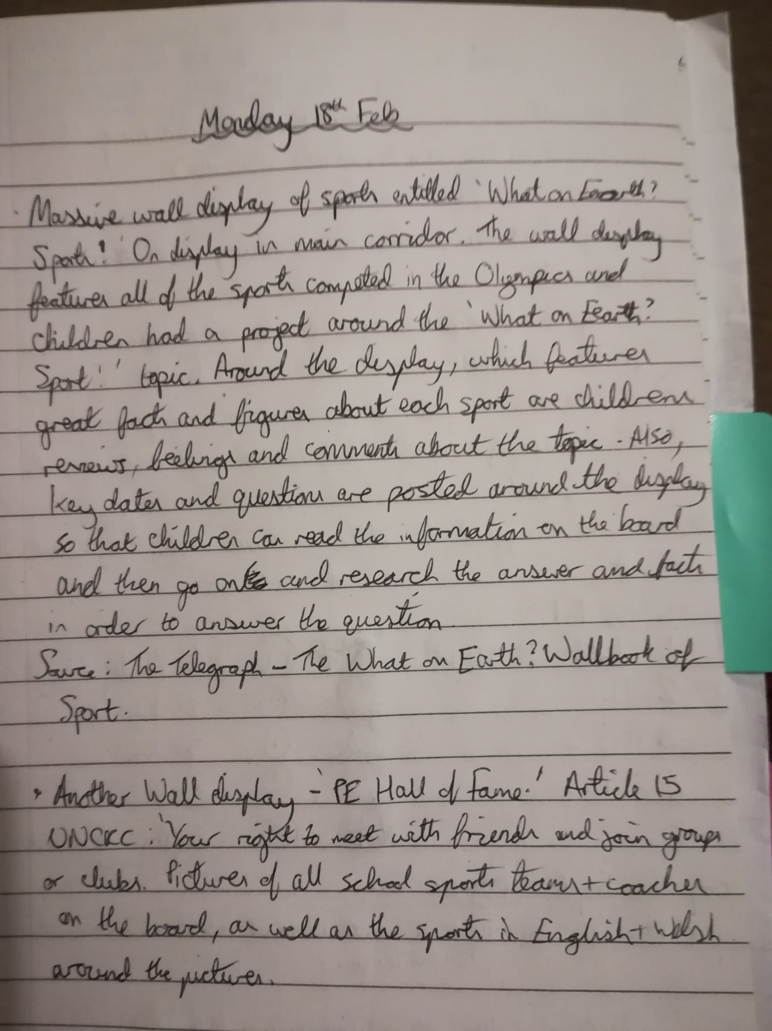
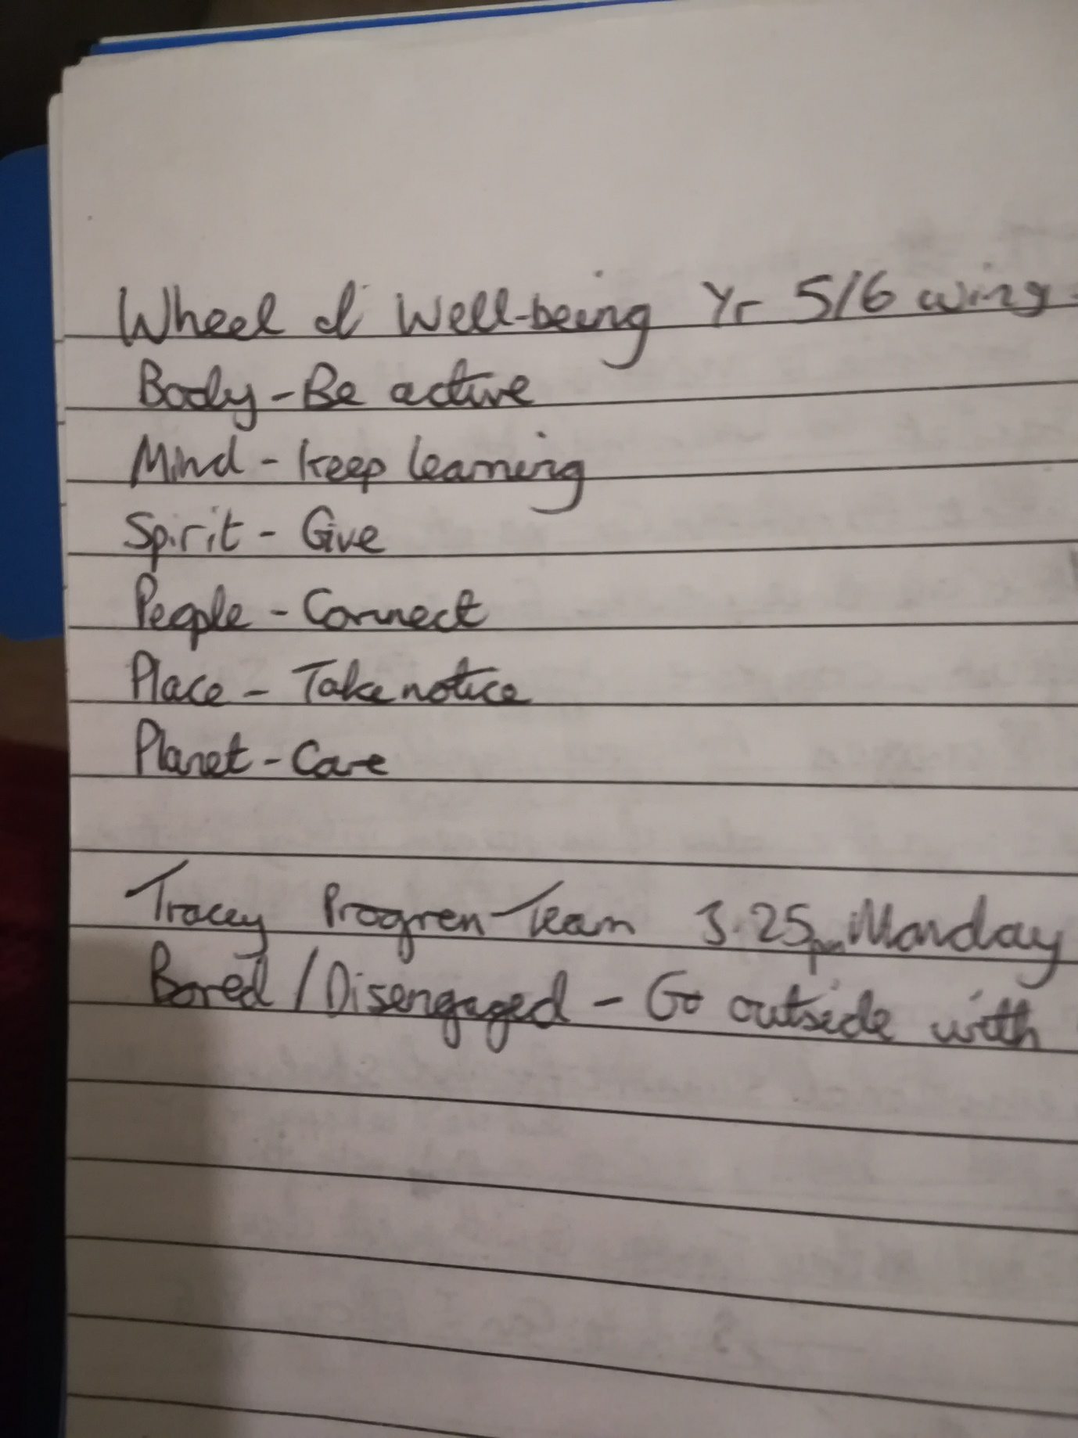

Appendix 10 – Electives school report
Electives Experience Report
Introduction
Bore da, good morning. Thank you very much for providing me with the opportunity to share my experiences with you today. I wish to start my presentation by thanking all members of the school for the support offered to me throughout the duration of the electives experience and, indeed, the experiences I have received on two previous PTEs. Your ethos has definitely helped me develop my practice at the very start of my career and I am very grateful for this.
Context
As detailed in the electives experience handbook, this presentation will take the form of an Estyn report on effective practice, with my personal observations and research contributing to the overall report.
A school located in Pembrokeshire that, at the time of the last inspection in 2016, had 598 pupils on role, aged between 3 and 11 years old. However, upon arrival at the school, I was informed that the current figure is estimated to be 700 pupils, with approximately 33% of pupils being eligible for free school meals. This is higher than the national average. 25% of pupils were identified as ALN in the Estyn report of 2016.
High expectations are held for all children and staff within the school, with staff and pupil collaboration being central to the sharing and development of the schools aims. Currently, the SDP focuses on the development and implementation of Donaldson’s new curriculum for Wales, as the school is categorized as a ‘pioneer school,’ whilst providing a “inclusive, caring and happy environment in which children feel safe, secure, valued and respected.” (school handout) This is complimented by the ‘Rights Respecting School’ ethos which is evidently implemented around the school through its incorporation onto wall display’s and assembly talks.
Discussion
Almost all children were aware of what a ‘Rights Respecting School’ is and what their rights as a child are. The articles detailing the children’s rights are written on the displays around the school in child friendly language and vocabulary, with assembly time further contributing to the children’s awareness of their rights and responsibilities. In the classroom these rights are often referred to and incorporated within sessions, in addition to the responsibilities of the children being discussed and considered alongside their rights. I found this pedagogy to be particularly effective in making children aware of their rights and, thus, strongly links to the “ethical, informed citizens” purpose of the new curriculum. (Donaldson, 2015) Therefore, this is a pedagogy that I will take forward in my career.
The numerous wall displays around the school links learner’s work and experiences to the new curriculum and the four proposed purposes of Donaldson’s curriculum. Moreover, all displays are bright in colour, bold in statements and clear in the messages they convey to both pupils and staff. This ties in effectively with the “visible learning” strategy, developed by Professor John Hattie, that is effectively incorporated into each learner’s daily experiences. This is achieved through skill slips and RAG Rating systems that allow pupils to regularly review their work and their performance in the task and identify their strengths and areas for further development. This allows children to visibly see where they are currently in their learning and what they need to do in order to move forward in their learning.
This ability to identify where they are in their learning and what they need to do in order to further their skills can be seen to link with a “Growth Mindset.” The school incorporates Dweck’s “Growth Mindset” successfully throughout the school and learners are aware of the difference having a “Growth Mindset” can make on their learning journey. Dweck proposes that those with a “Growth Mindset” are ready to thrive on challenges in their learning and believe that learning new things and their intelligence can be developed. Thus, they are resilient to challenges and persevere in tasks that sometimes get them “stuck in the pit.” This, after all, is a clear desire of the new curriculum for Wales, that aims to create “resilient” and “capable” learners. (Donaldson, 2015) Conversely, Dweck suggests that those with “Fixed Mindsets” often struggle to embrace challenge as they tend to believe that their skill set is fixed and cannot be developed further. This can be seen to be in contrast to the aims of the new curriculum, including those mentioned by Donaldson 2015 above. Therefore, adopting a “Growth Mindset” could be argued to be a significant factor when developing and implementing the new curriculum for Wales and is a vitally important ethos that I wish to take forward in my career.
Research for the Research Project Findings
The question that I proposed at the beginning of the electives experience was:
“Can being involved in sports influence children’s well-being?”
To research this question and collect both qualitative and quantitive data in order to inform my conclusion, the following methodologies were adopted throughout the electives experience:
“Pupil questionnaire; staff questionnaire; observation and note taking; learning walks; and interviews with both staff and pupils.”
It is important to note that, at the time of writing, I have received 56 responses to the children’s questionnaire and 13 responses from the staff questionnaire.
Initial reflections upon my data has suggested to me that sports and physical activity is very important to both pupils and staff, with 84% and 77% of children reporting that they enjoy taking part in sports and that sports are important to them respectively. Moreover, various reasons were provided by the children that informed their answers to the enjoyment and importance of sports questions, as mentioned in the prior sentence. Such answers ranged from the ability of sports to keep them fit and healthy, to enjoying being part of a sports session for the simple reason that it is fun. This led to the data revealing that 84% of children desired for more sports and physical activity sessions to be provided in the school.
It must be remembered, though, that other children reported that they did not want to participate in further sports and physical activity sessions in school. Some teachers suggested, in their responses, that a greater range of choice in sporting sessions and the further development of a safe environment in which children can fully participate in a sports session without fear of embarrassment may be a way forward for encouraging these and other children to participate in sports. This may help develop children’s well-being further, as some children reported feeling emotions such as shyness and boredom during sports or physical activity sessions. A safer learning environment and choice over the activity and level of engagement required may develop these children’s well-being further, as 80% of children stated that sports and physical activity made them feel happier after such sessions. This finding compliments the opinions of some staff, with 70% and 69% of staff reporting that most or all children have demonstrated an increase in their well-being and their engagement in sessions following a sports and physical activity session.
Interestingly, upon interviewing two Year 6 pupils about their experiences of sports and physical activity, I was informed that they would be interested in “running” a sports club for younger children in the school in order to encourage those children to become involved in sports, whilst simultaneously increasing their well-being. Some research suggests that sports can have a significant impact on numerous areas of children’s lives, particularly socially, as reduced truancy, improved health and fitness and improved attitudes towards learning are just three of many proposed benefits gained by children through their participation in sports. (Bailey, 2007) Available at: https://www.tandfonline.com/doi/full/10.1080/0013191042000274196?scroll=top&needAccess=true
Therefore, it may be a possibility to develop pupils well-being further through engagement in sporting activities led by peers, rather than staff.
Summary and Conclusion
Once again, I would like to thank all members of the school for their help, advice and support offered throughout my elective experience and through the two previous PTEs. I have successfully gathered data that will inform my extended essay project at UWTSD, in addition to observing effective practice in all parts of the school through the incorporation of a “Growth Mindset” throughout the school. In combination with the UNCRC conveyed to children in appropriate language, children’s well-being is promoted throughout the school and children are set to become “healthy and confident, ethically informed” members of society, as Donaldson proposes as the very purposes of the new curriculum for Wales. (Donaldson, 2015)
Diolch yn fawr!
Thomas Poole, UWTSD.

