MANAGING AND MAINTAINING NETWORK RESOURCES USING NETWORK POLICY AND SECURITY PRACTICES

Network Operating Systems and Services (NOSS) (ACCA5023)

Brian Morris
Student ID 1809130

Contents
Table of Figures 2
Modifying local NTFS permissions 5
Creating a new File Share 10
Creating Group Policy Objects 14
Local Permissions 21
Share Permissions 27
Group Policy Management 36
Group Policy Management Console 37
Sysvol 37
Site Based GPO Example 38
Domain level and OU level GPO 41
Enforcement and blocked inheritance 45
Password management in network environments 48
National Cyber Security Centre Guidance 49
References 53

Table of Figures
Figure 1-Logged on as Admin 5
Figure 2- System Default permissions 6
Figure 3- All inherited permissions removed 6
Figure 4- Adding permissions to local file system 7
Figure 5- Adding additional permissions to the local file system 7
Figure 6- Writing data to local file with administrative account 8
Figure 7- User without write access to the files denied access to update the existing file 9
Figure 8- Default file shares on Domain Controller 10
Figure 9- Create a hidden file share 10
Figure 10- Enabling ABE and offline caching 11
Figure 11- Default Share permissions (Everyone Full Control) 11
Figure 12- Specifying File level permissions within the share 12
Figure 13- Warning when unable to create or modify a file 12
Figure 14- Different warning dialog message when trying to create a file 13
Figure 15 - Modifying user details 13
Figure 16 Modifying User GPO 14
Figure 17 Disabled computer GPO configurations 14
Figure 18 GPO policy applied successfully 14
Figure 19 Disabled Command Prompt GPO settings 15
Figure 20 - Review of GPO settings 15
Figure 21 - Disabled CMD prompt 16
Figure 22 Modifying removable drive settings 16
Figure 23- Removable drive access prohibited 17
Figure 24 - Mounted ISO file 18
Figure 25 Per user install prohibited 18
Figure 26 UAC permissions prompt 19
Figure 27 Password complexity and aging settings 19
Figure 28 Incorrectly applying complex password 20
Figure 29- Basic file level Full control permissions 21
Figure 30 – Write/Modify Access Permissions 21
Figure 31- Advanced permissions available in the GUI 22
Figure 32- Advanced permissions dialog 22
Figure 33 Standard write permissions 23
Figure 34- Explicit Deny rights 24
Figure 35- Explorer view of folder notice ABE has not listed the file with denied access 25
Figure 36 Similar to explorer ABE also applied to views from the command line 25
Figure 37- Explicit permissions applied 26
Figure 38- Explicit write access to a read only file 26
Figure 39- Explicit read only permisons 27
Figure 40 - NTFS permissions applied during share creation 28
Figure 41- Share permissions created by default 28
Figure 42- Share permissions preventing write access 30
Figure 43-Having Full control via the share the NTFS permissions only permit Write access. 31
Figure 44- Despite having Modify security Access via user is only able to read due to the share permissions be Read. 31
Figure 45- User in multiple admin defined security groups 33
Figure 46 - Illustration of effective permissions of selected user 34
Figure 47- Applied Deny security group 35
Figure 48-User1 denied access to the share 35
Figure 49- Group Policy Management Console 37
Figure 50- Defined subnets with Active Directory Sites and Services 38
Figure 51 DC1-NWT advertising it has a shared printer. Management console showing per machine deployment to Site1 GPO 40
Figure 52- Local machine list of printers 41
Figure 53- OOBE screen saver settings 42
Figure 54- Defining domain screen saver policy 42
Figure 55- Access denied modifying screen saver settings 43
Figure 56-Resultant Set of Policies report 43
Figure 57 User1 in appropriate OU 44
Figure 58- RSOP following account move 44
Figure 59- Ribbons screen saver 45
Figure 60- Enable the policy for enforcement 45
Figure 61-Policies applying following enforcement 46
Figure 62- Deny Apply Group Policy to user1 46
Figure 63- applied permissions within the GPO 47
Figure 64- Domain Screen Saver GPO setting denied 47
Figure 65- Info graphic regarding brute force password cracking times. [3] 49
Figure 66-NCSC Password guidance infographic [3] 51

Modifying local NTFS permissions  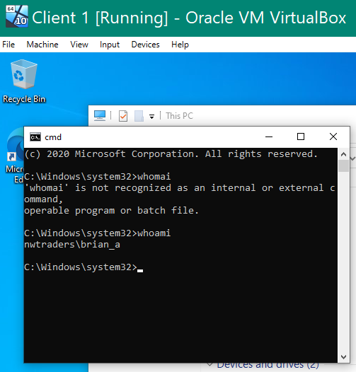  Figure 1-Logged on as Admin | Logged onto clinet1 workstation with an account with Admin permissions
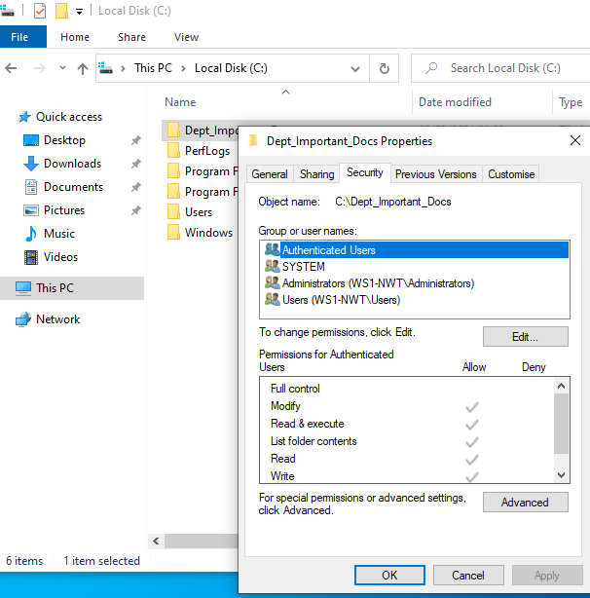  Figure 2- System Default permissions | New folder created Default permissions applied by the system
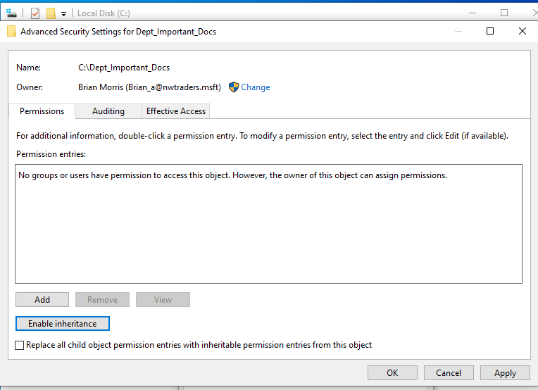  Figure 3- All inherited permissions removed | Removed all inherited permissions
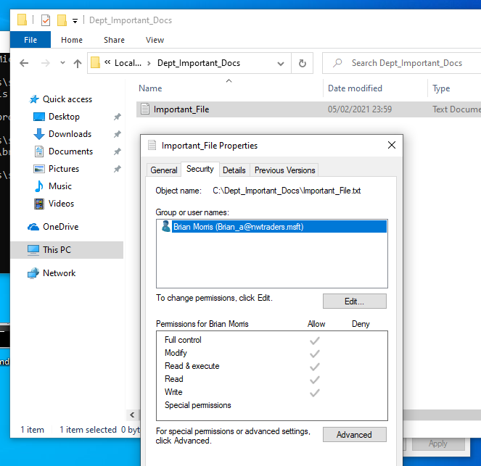  Figure 4- Adding permissions to local file system | Added an administrative account to set peremisisons for non admin users
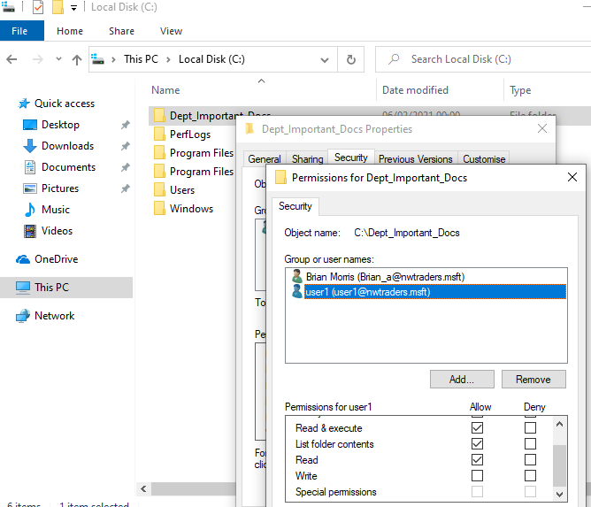 | Added non admin user permissions with read exexcute and list access
Figure 5- Adding additional permissions to the local file system
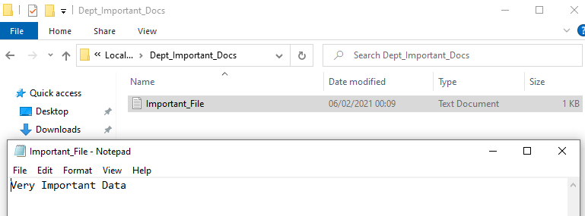  Figure 6- Writing data to local file with administrative account |  | Data written to test file
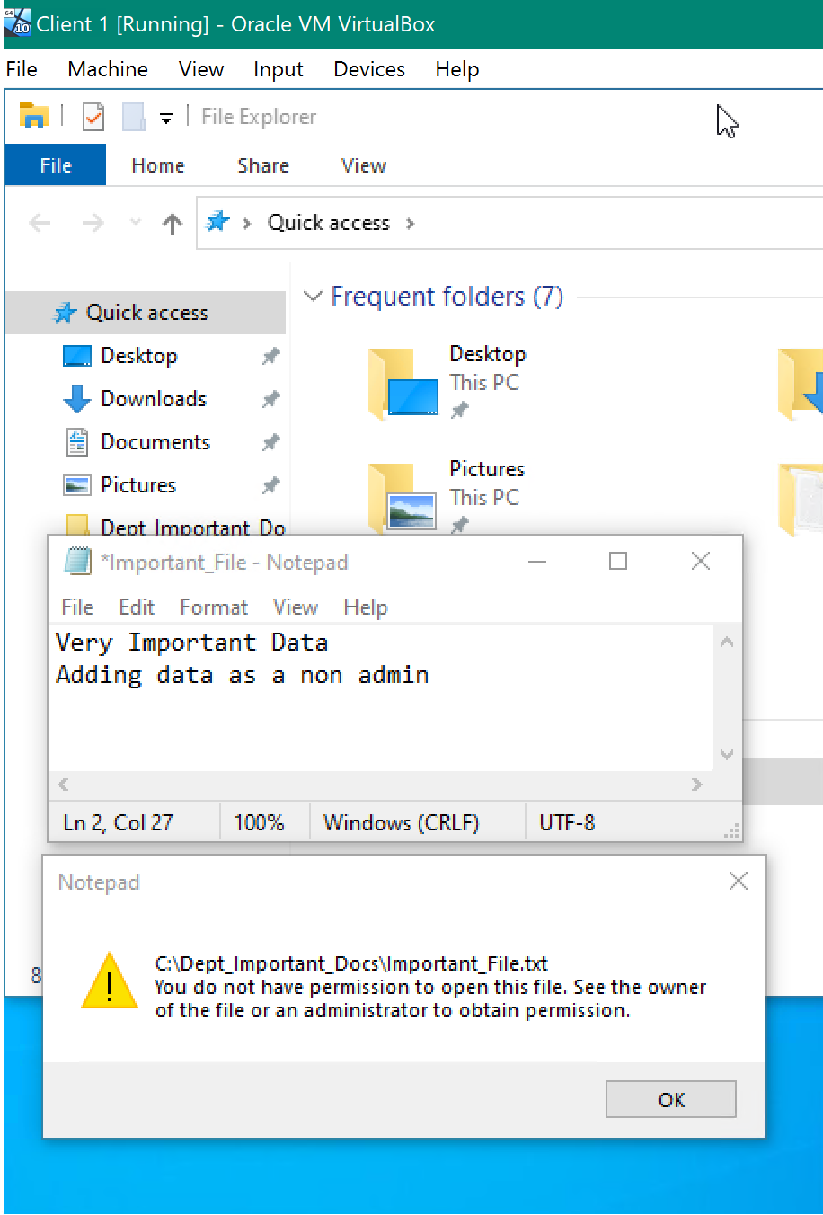  Figure 7- User without write access to the files denied access to update the existing file  Creating a new File Share | Trying to write data to the file as a user without write access permissions  Notice the * infront of the file name indicating the file contents have changed and the file needs saving.
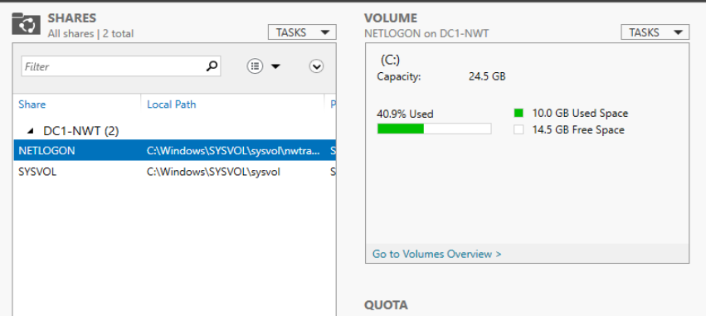  Figure 8- Default file shares on Domain Controller | Default Netlogon and Sysvol shares for domain controler.
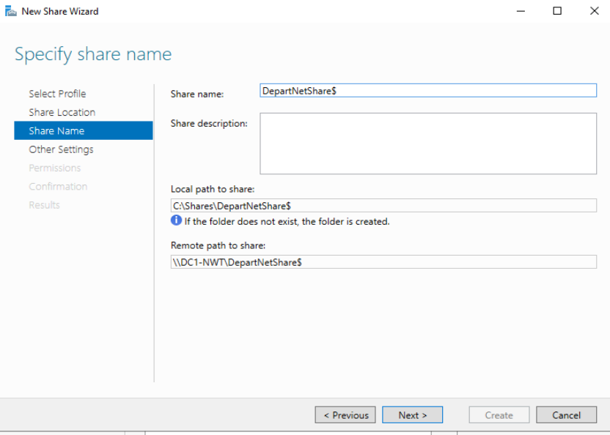  Figure 9- Create a hidden file share | Created new share hidden share.  Note the $ sign at the end of the share name. The system will not advertise this share when users browse for available file shares on the server.
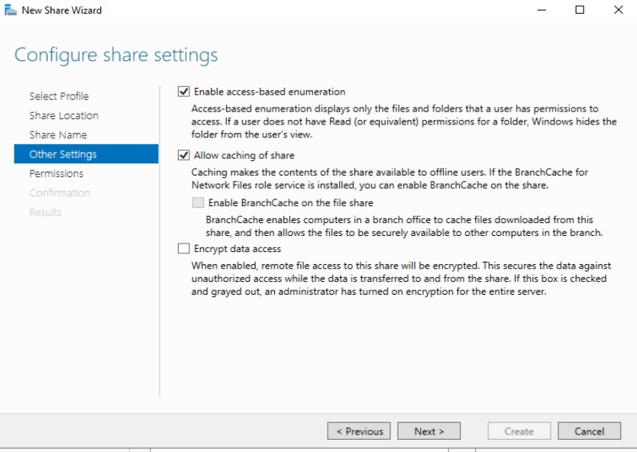  Figure 10- Enabling ABE and offline caching | Enabeling Access Based enumeration.  Permitting the use of file caching on local clients
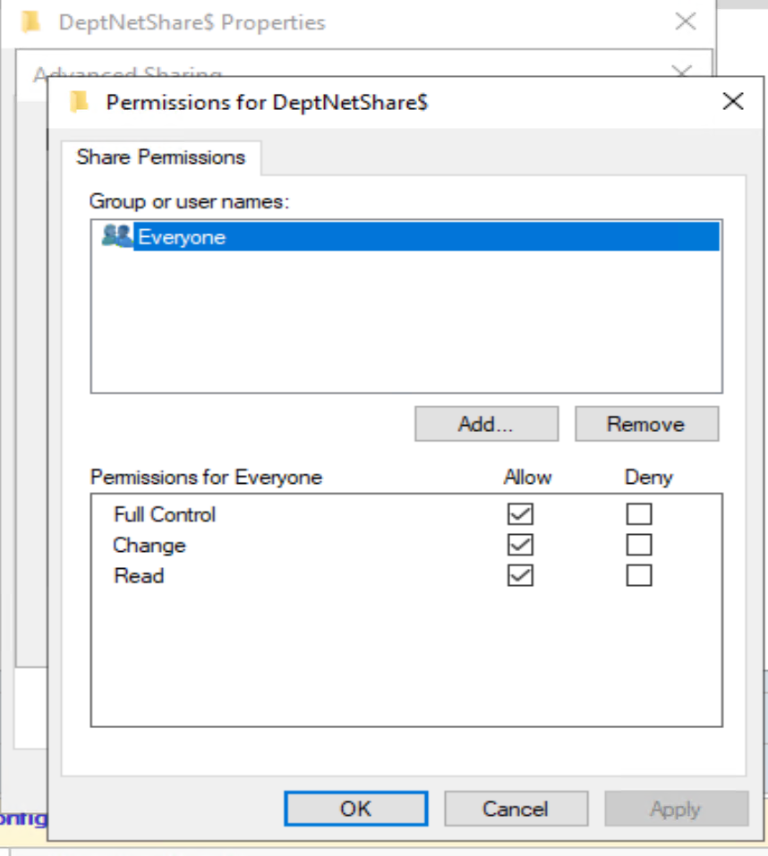  Figure 11- Default Share permissions (Everyone Full Control) | Using the Share Creation Wizard set permissons at a share level to everyone full control. If left as default all user could potentially have access to files within the share.
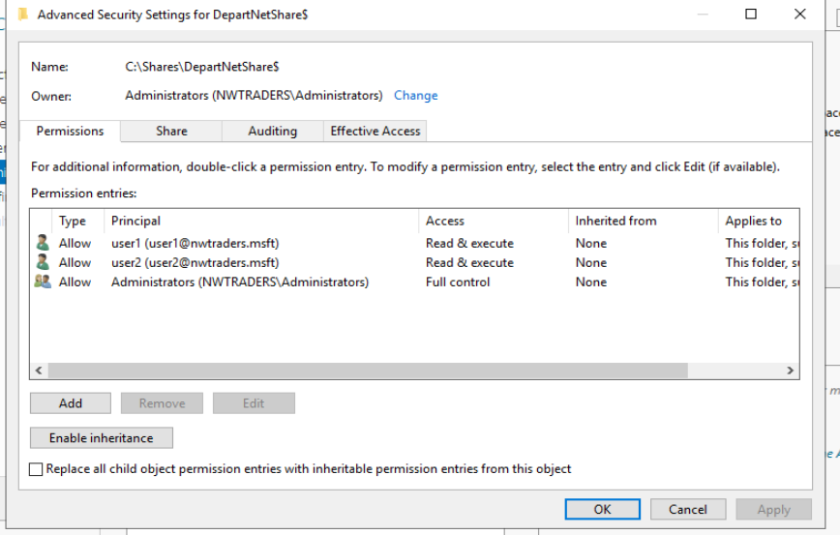  Figure 12- Specifying File level permissions within the share | Setting share permissions on the network share. Admins have full control users Read and Execute
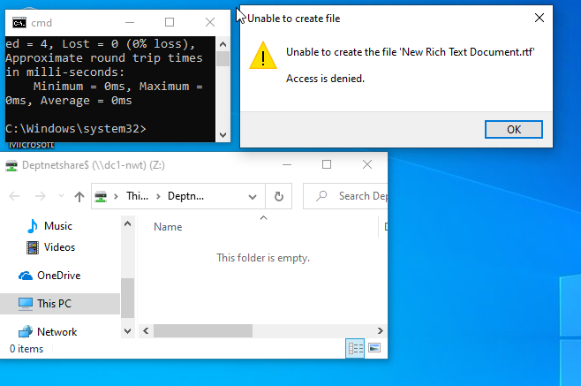  Figure 13- Warning when unable to create or modify a file | Non admin users unable to create RTF file.  Note the different warning message.
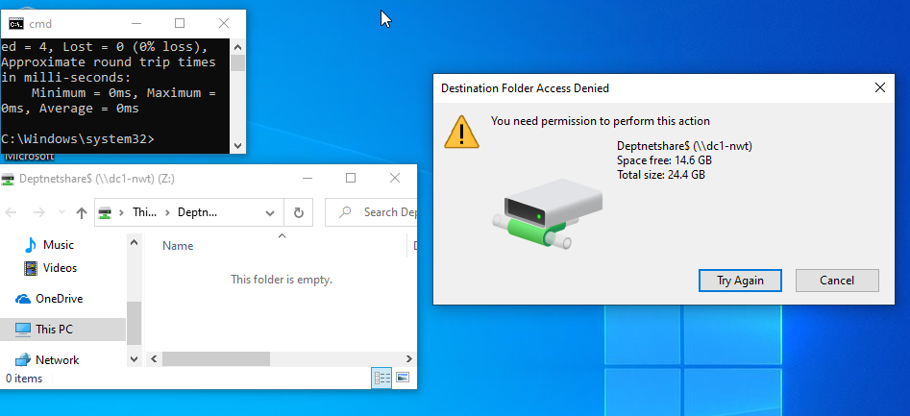  Figure 14- Different warning dialog message when trying to create a file | User unable to create a file in the shared folder note the different warning message for the action for a different file type.
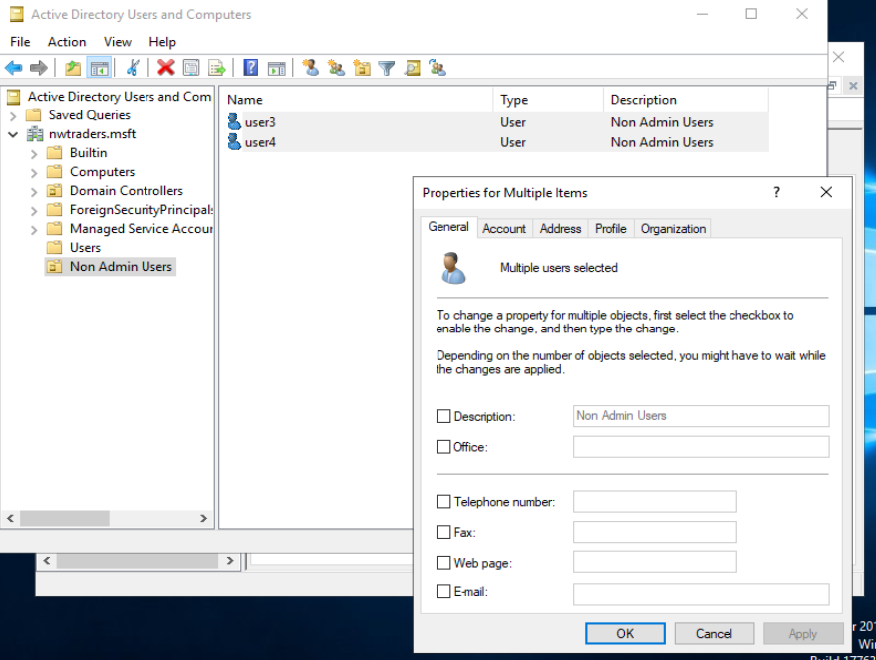  Figure 15 - Modifying user details | Creating muliple users modifing shared attributes within Active Directory Users and computer.

Creating Group Policy Objects  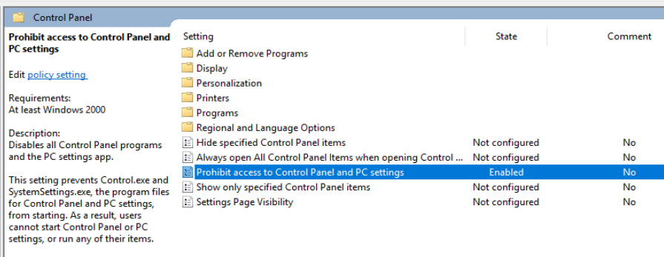  Figure 16 Modifying User GPO | Modifying User policy to disable access to the control panel
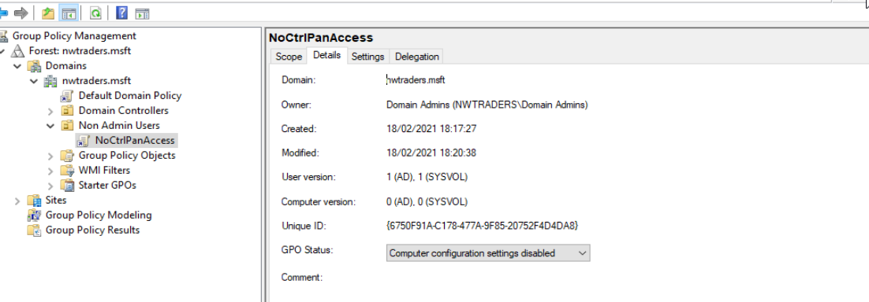  Figure 17 Disabled computer GPO configurations | Disabling the Computer portion of the GPO to reduce time taken to read policy settings and improve boot times
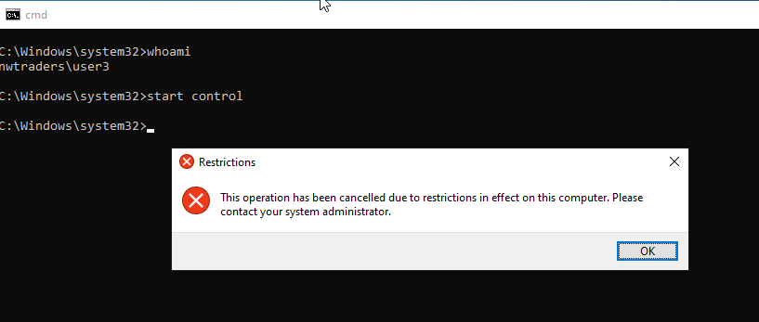  Figure 18 GPO policy applied successfully | Trying to open the Control panel from the start menu failed to adequatly display an error. Started the contol panel from the cmd line reported that the GPO restrictions had applied correctly
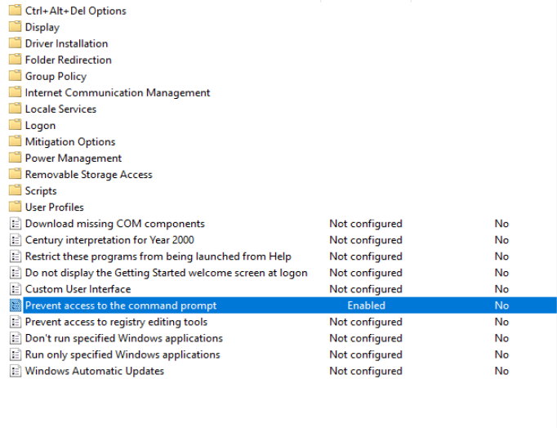  Figure 19 Disabled Command Prompt GPO settings | Modifed Policy to disable access to the Command Prompts
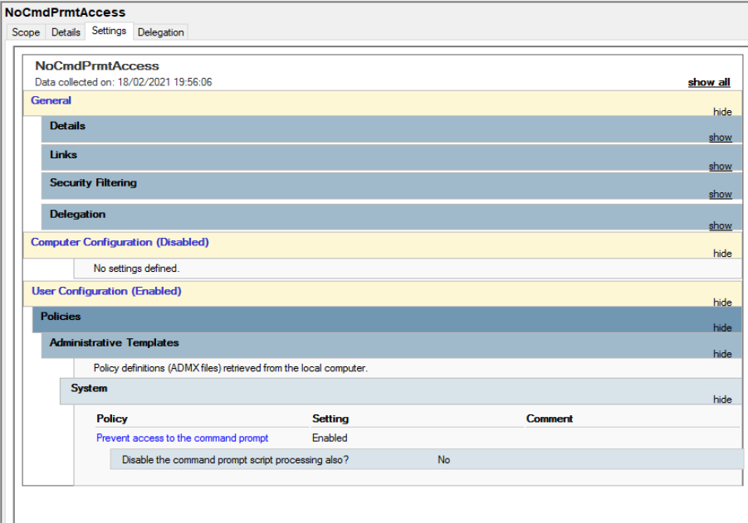  Figure 20 - Review of GPO settings | Reviewed Setting to display the settings set within the GPO.  Also the Computer policy was disabled to improve logon performance
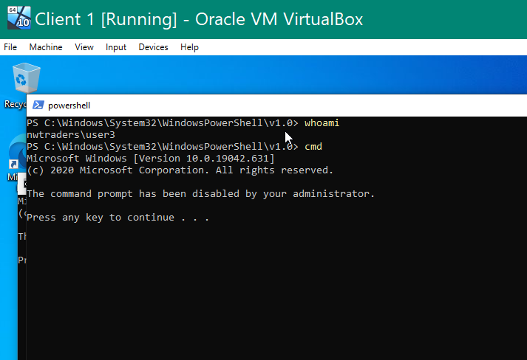  Figure 21 - Disabled CMD prompt | Non-admin user USER3 is able to start up a powershell console but calling the CMD prompt from within the console is disabled as specified via the policy
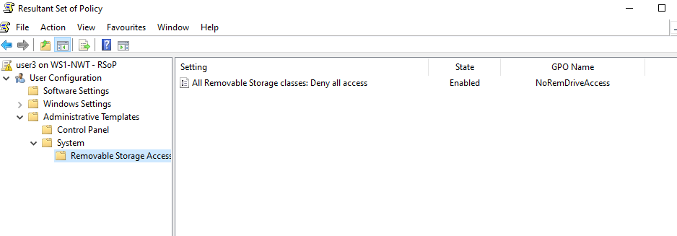  Figure 22 Modifying removable drive settings | Resultant set of policies showing that the policy to disable access to removable storage has been applied to the logged on user
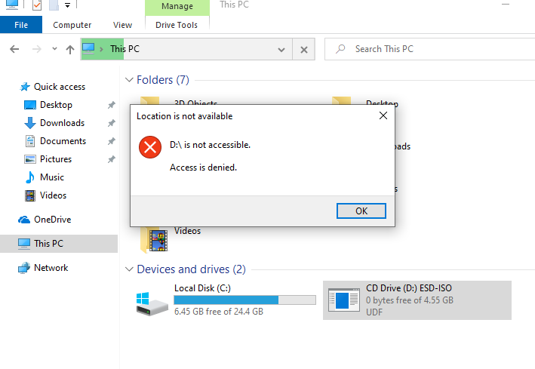  Figure 23- Removable drive access prohibited | Access to the virtual CDROM of the client device has been denied as specifed within the group policy object.

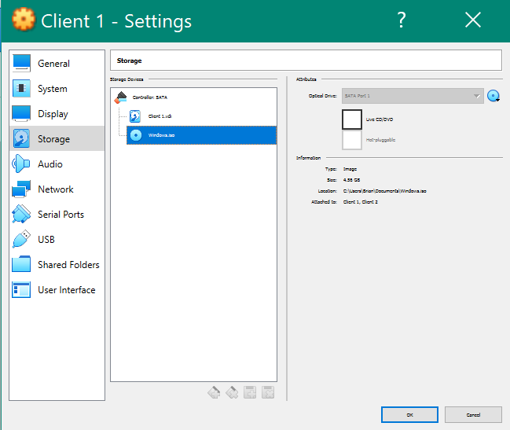  Figure 24 - Mounted ISO file | Verification that the Virtual CD ROM drive did have an ISO file mounted
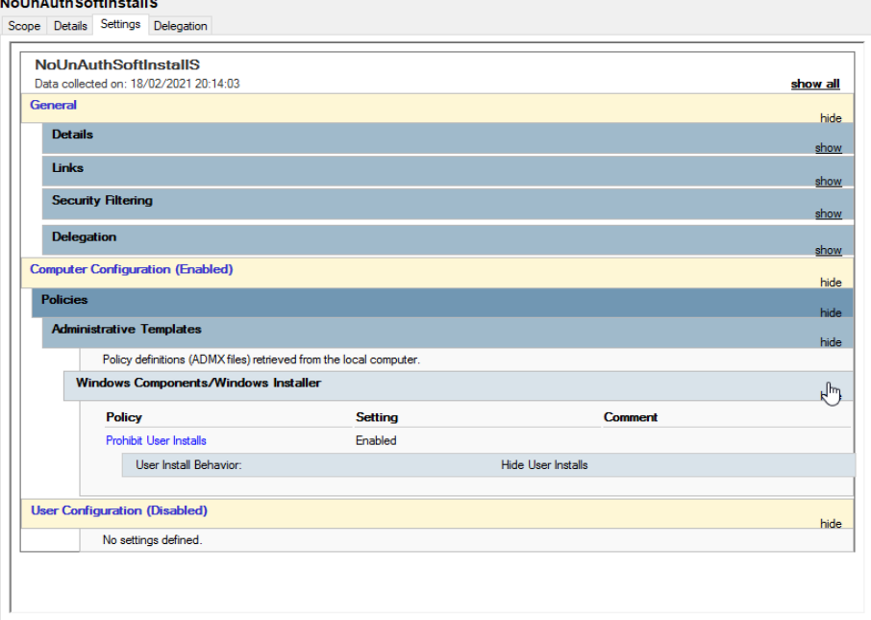  Figure 25 Per user install prohibited | Computer Policy applied to prohibit user application install.  User configuration setting disabled
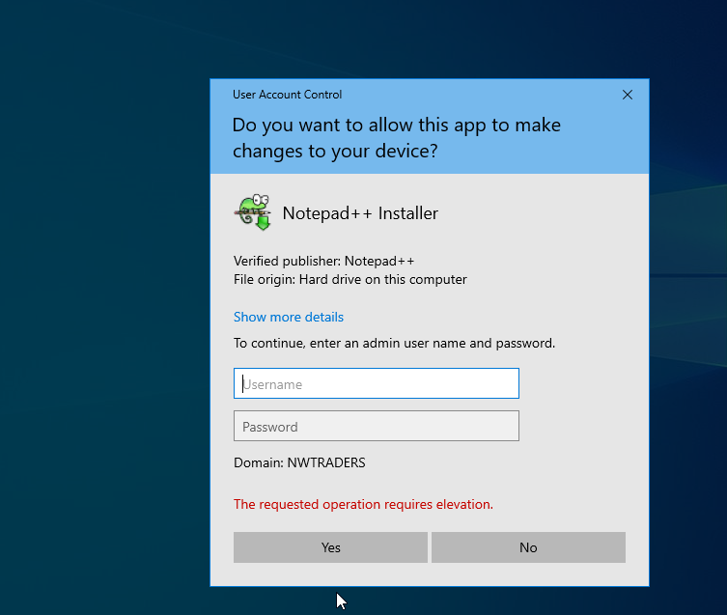  Figure 26 UAC permissions prompt | Administrative Permissions requested by the Operating system requesting rights to install the application for all users. Not just the non administrative user logged into the device

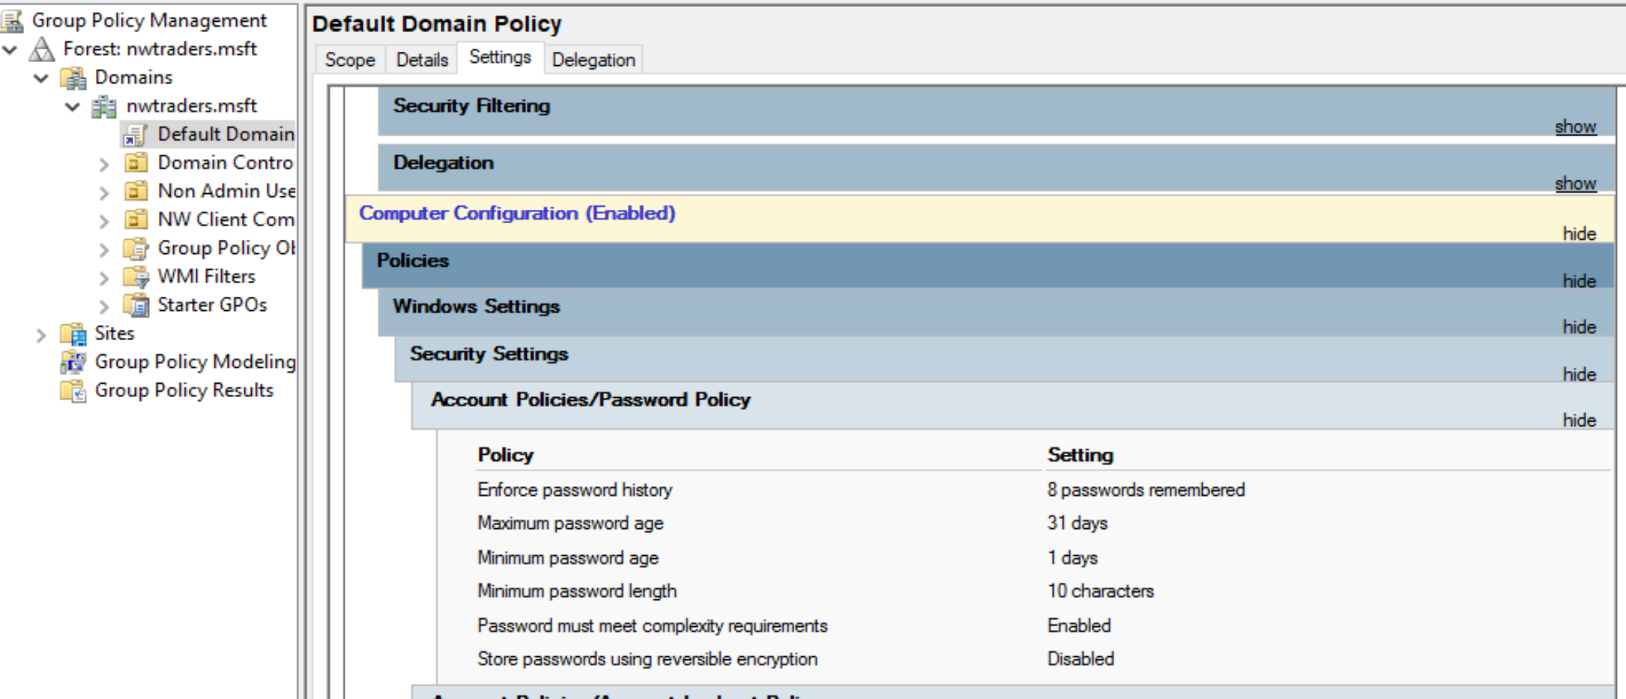  Figure 27 Password complexity and aging settings | Password complexity settings applied to the Default Domain Policy
Password must meet complexity requirements  This security setting determines whether passwords must meet complexity requirements.  If this policy is enabled, passwords must meet the following minimum requirements:  Not contain the user's account name or parts of the user's full name that exceed two consecutive characters  Be at least six characters in length  Contain characters from three of the following four categories:  English uppercase characters (A through Z)  English lowercase characters (a through z)  Base 10 digits (0 through 9)  Non-alphabetic characters (for example, !, $, #, %)  Complexity requirements are enforced when passwords are changed or created.  Default:  Enabled on domain controllers.  Disabled on stand-alone servers.  Note: By default, member computers follow the configuration of their domain controllers. | Password complexity details from the GPO dialog

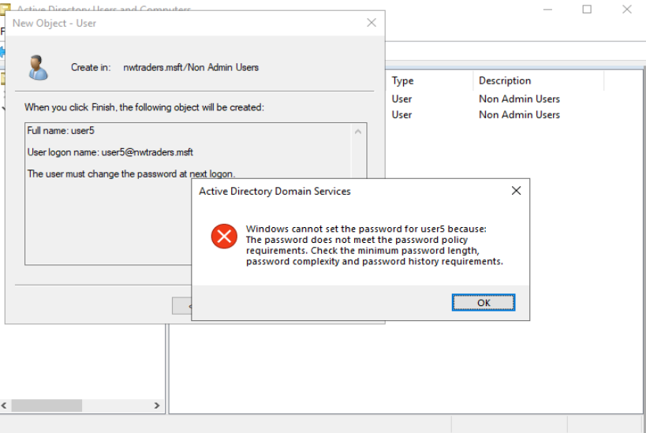  Figure 28 Incorrectly applying complex password | New user created error when a password fails to meet complexity requirements

Local Permissions

New Technology File System or NTFS was introduced with Microsoft Windows NT in 1993. It introduced several improvements to the existing File Allocation Table used by other contemporary systems [1]. Security improvement to the file system were introduced by adding Access Control Lists. The ACL or security descriptor of a file object is parsed by the operating system to verify the user or process can access object before access is granted.
Local file level permissions implemented as part of an ACL apply at the local level and access rights are controlled regardless of the client accessing the data locally or from the network.
Permissions are split between basic and advanced permissions. Below is an example of an account that has full control to the files in the system.
Full control permits the user to not only modify the rights of access to the files but the access rights of others. This type of access would typically be used by the system or an Administrator
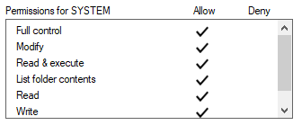

Figure 29- Basic file level Full control permissions

In the following example a group has been grated Modify – The group has nearly the same permissions as full control so is able to add new files, delete files or update existing one. The only permission not applied is the permission to change permissions and take ownership

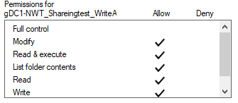
Figure 30 – Write/Modify Access Permissions

There are more granular advanced permissions available to administrators that can be applied to groups or individuals by modifying the attributes via advanced permission.

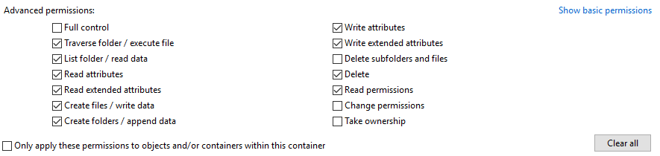
Figure 31- Advanced permissions available in the GUI

In the example below we remove the ability of the security group ‘gDC1-NWT_Sharingtest_WriteAcess’ to delete files. Changes made via the advanced permissions interface are reflected in the standard permissions where there is a clear standard permission. If the permission falls outside of the role the basic permissions are highlighted as ‘Special’
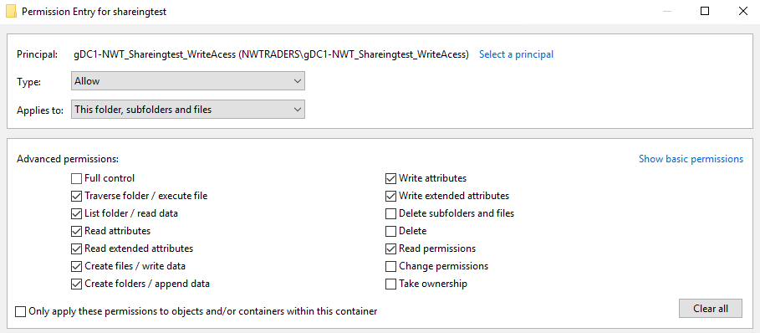

Figure 32- Advanced permissions dialog

By remove the right to delete files via the advanced permissions tool, the ‘standard’ role removes the ‘Modify’ attribute from the standard permissions window.
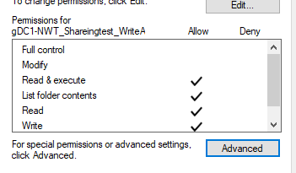
Figure 33 Standard write permissions

Whilst the above group has write access its possible for an administrator to manipulate access further by applying deny rules to files or subfolders as they security of the task demands. Specifically applying an allow or deny permission to a file object can override permissions that would typically be inherited from the parent folder. As permissions explicitly applied override inherited rules.

In the illustration below User1 is a member of the group with Write access however on the file “user1 access denied.txt” the individual user has been explicitly denied access to the file.

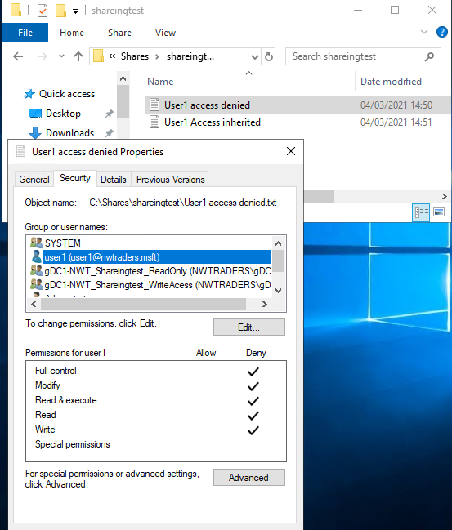
Figure 34- Explicit Deny rights

As we can see from the following screen shot below that the user is not only denied access to the file but as a result of Access Based Enumeration the file itself is not visible to the end user either via the Explorer GUI or via the cmd line.
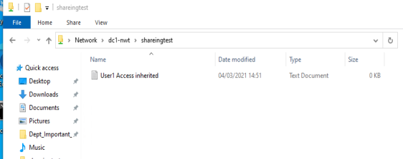

Figure 35- Explorer view of folder notice ABE has not listed the file with denied access

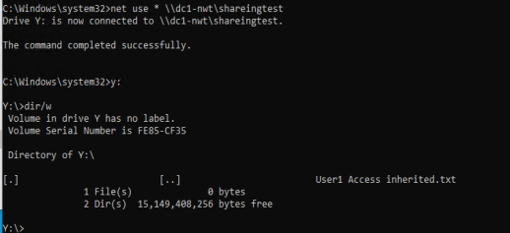

Figure 36 Similar to explorer ABE also applied to views from the command line

Resetting the folder and moving User1 into the global security group ‘gDC1-NWT_Sharingest_ReadOnly’ two files were created and the inherited permissions applied. However the file User1 was explicitly granted write access to the file “User1 Write Access Explicit.txt”.
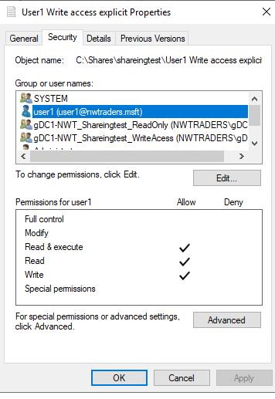
Figure 37- Explicit permissions applied

With the explicit permissions applied User1 was able to update the file within the folder where other members of its group only had read only access.

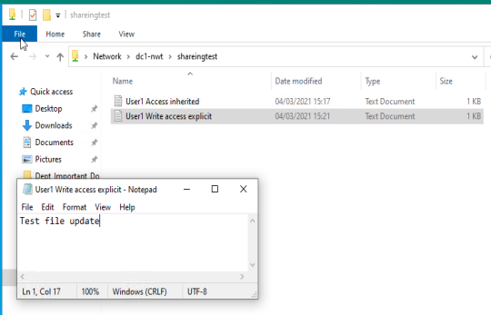
Figure 38- Explicit write access to a read only file

Below we can see that the inherited permissions have prevented the user from writing to the file with the assigned read only permissions.
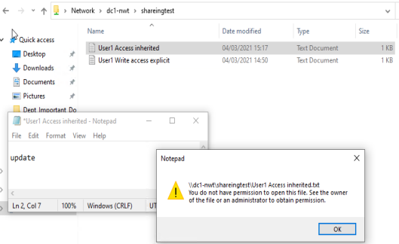
Figure 39- Explicit read only permisons

Share Permissions
While utilizing NTFS access control lists we can modify the rights of groups and individuals to local and remote files and folder, share permission are specifically used to control access to the resource via the network. The Share creation wizard is misleading as the group of users applied are only used for securing the NTFS permissions
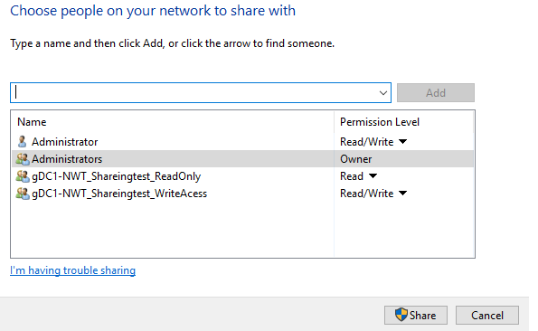
Figure 40 - NTFS permissions applied during share creation

The Advanced Sharing dialog does present the actual applied ‘share’ Permissions
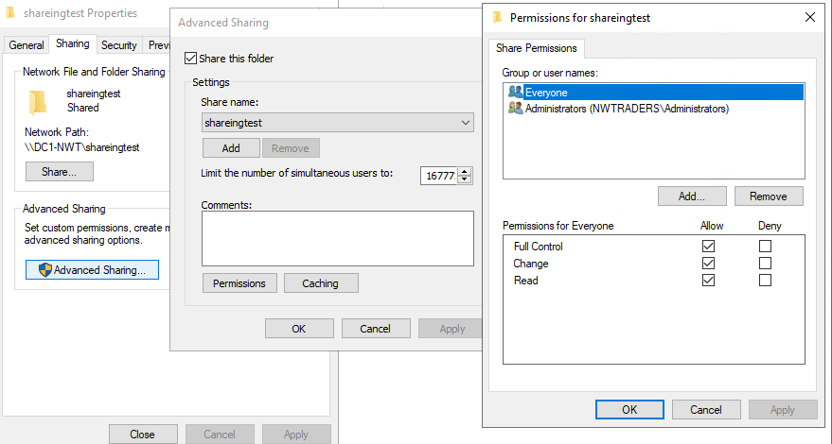

Figure 41- Share permissions created by default

The everyone group includes all authenticated users on the domain. In the above example the everyone group has full control and is reliant on the permissions being set correctly via NTFS. These permissions may be too open for some environments and administrators may choose to tighten up permissions on the shares.
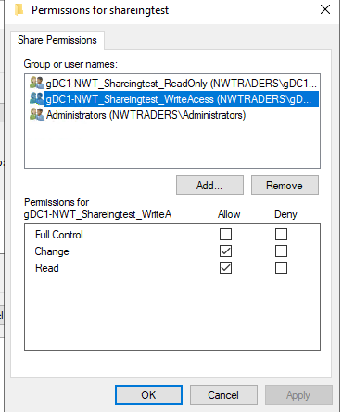

From the worked example two security groups have already been created that have clearly defined roles. These groups have been applied to share permissions. The share permissions and file permissions although separate entities can work together to secure the data. User1 is in the read only group and both Share and NTFS permissions are applied in line with their description. Preventing User1 from writing to the folder
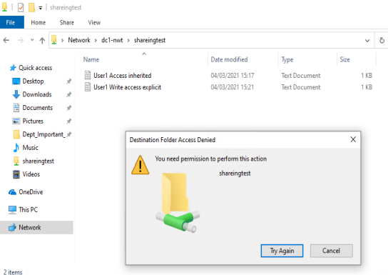

Even with explicit NTFS permissions to write to the file “User1 Write Access Explicit.txt” User1 is unable to write, as the permissions via the share permit Read Only access.

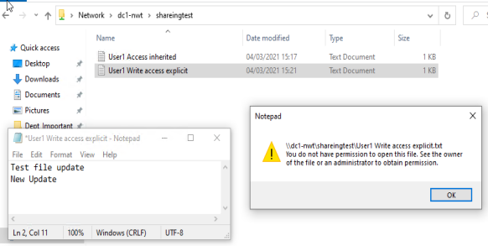
Figure 42- Share permissions preventing write access

This is a process of most restrictive permissions applying to maintain data security across the effective permissions.

Share Permission | NTFS Permission | Effective Permission
Full control  Change  Read | Full control  Modify  Read & Execute  List Folder content  Read  Write | Full control  Modify  Read & Execute  List Folder content  Read  Write
Figure 43-Having Full control via the share the NTFS permissions only permit Write access.

Share Permission | NTFS Permission | Effective Permission
Full control  Change  Read | Full control  Modify  Read & Execute  List Folder content  Read  Write | Full control  Modify  Read & Execute  List Folder content  Read  Write

Figure 44- Despite having Modify security Access via user is only able to read due to the share permissions be Read.

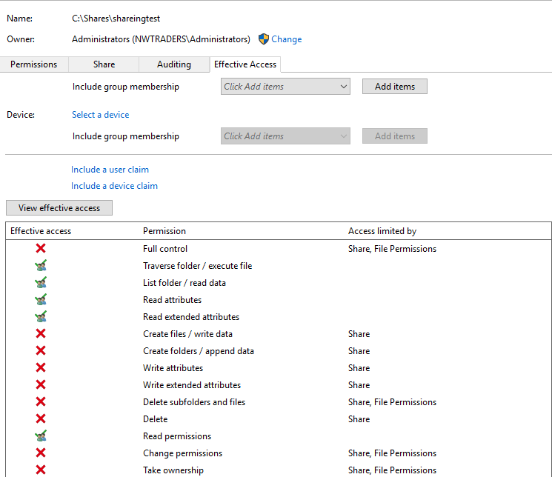
Using the effective permissions dialog, we can identify which access control list is limiting the users rights either the share permissions or the file permisisons.

Administrators can purposefully or inadvertently place users in multiple groups that may have permissions that are less restrictive. For example, User1 could be a member of both groups used to manage access to the file share on DC1-NWT.
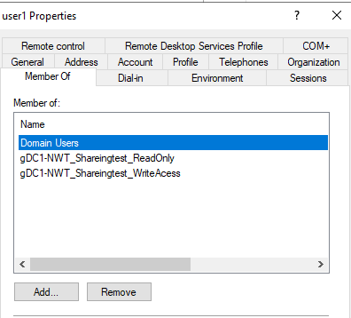

Figure 45- User in multiple admin defined security groups

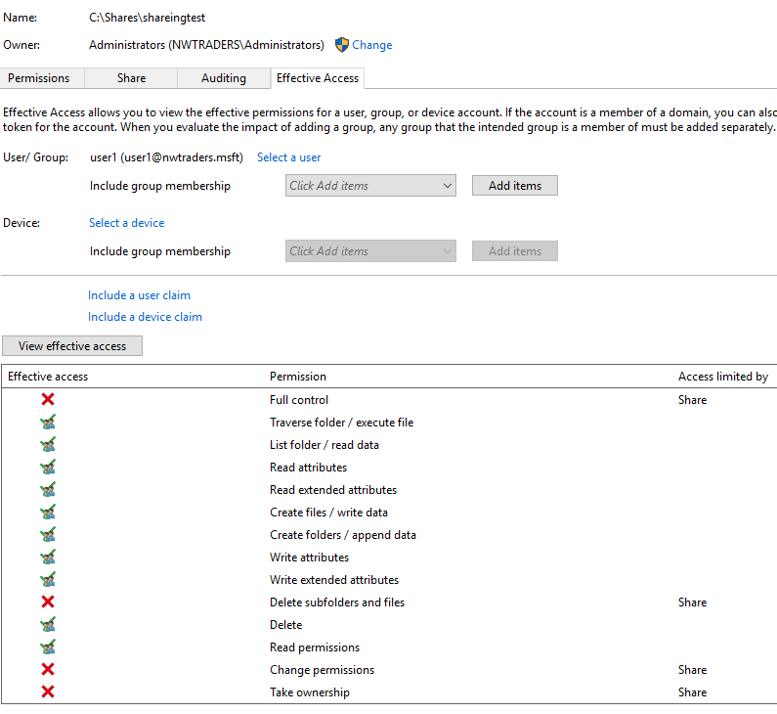
Figure 46 - Illustration of effective permissions of selected user

As the user is in both ‘Write’ and ‘Read’ security groups the least restrictive permission is applying.

However, a Deny rule will take precedence over least restrictive group access.
Placing User1 in a deny group and applying deny permissions as illustrated below.

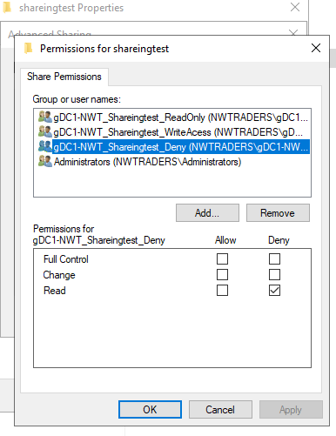  Figure 47- Applied Deny security group | 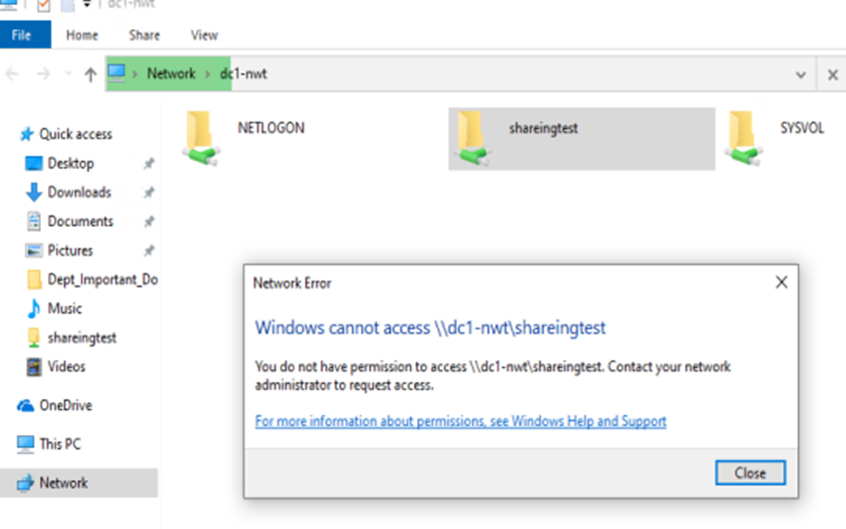  Figure 48-User1 denied access to the share

Group Policy Management

Group Policy Management was introduced with Windows 2000 and replaced the System Policy Editor. Group policies permit an administrator a mechanism to modify settings that can apply to users, computers or applications within the organization or locally on a single device. These settings not only effect the look and feel of the system they can modify how the system operates and is secured
Unless specified the settings that applied are not permanently applied or tattooed into the registry and can be overwritten to allow the users and device experience to change in a more agile way.
GPEDIT.msc is the local devices management console for modifying group policy settings on an individual device. Settings modified via this console are stored here: - C:\WINDOWS\System32\GroupPolicy.
Settings applied here affect the local PC and users that use that PC. Large scale management of computers and users via this mechanism is not practical as each device would need its group policy objects edited before they become effective.

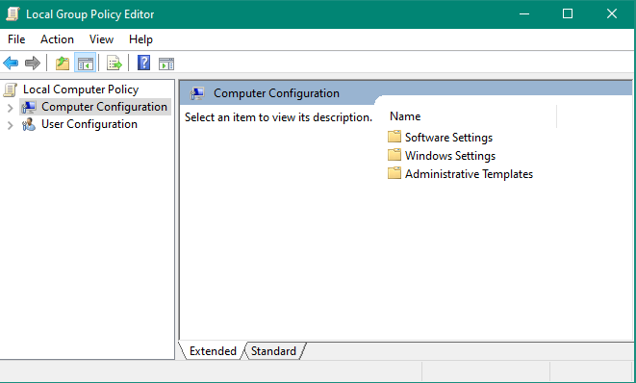

Group Policy Management Console

Within a domain the more effective tool is the Group Policy Management Console ‘GPMC.msc’. Administrators can use this tool to create policies at all levels of an organization. The console also has integrated into it a ‘Resultant Set of Policies’ console that documents the polices that have been applied to a device and user. This helps an administrator to diagnose inconsistencies with the deployment of group policies. Also included is the ‘Group Policy Modelling’ tool which can be used to model the effect of a change of policy or security or user.
Group policies are extensible so their functionality can be extended by the addition of administrative templates supplied by vendors or created by administrators that can be imported. Windows 10 natively come with over 3500 GPO settings when originally release and each updated version adds more settings the 2004 version of Windows 10 added over 100 more new settings.
Spread sheet of GPO settings that can be applied to Windows 10 and Windows Server 2019. [2]

Sysvol
Group Polices modified within the domain are stored within the Sysvol share. This Sysvol utilizes distributed file share replication to copy the GPO across all the available Domain Controllers as required to ensure the is a robust and resilient source for GPOs for the active directory clients to query and read from.

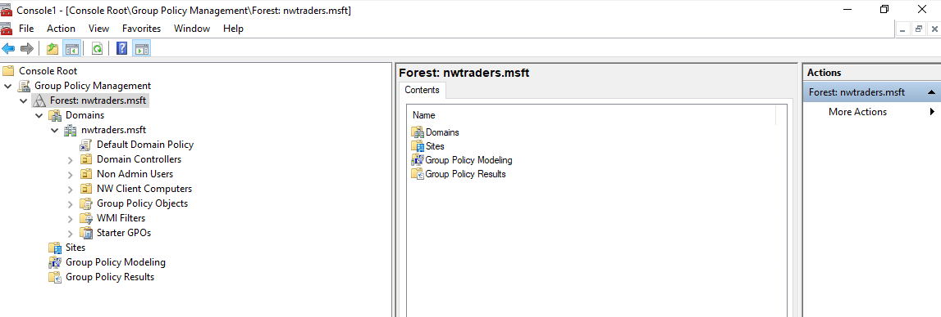
Figure 49- Group Policy Management Console

Group polices can be applied as highlighted above at the local level. However they are also able to be deployed at the Site, Domain or Organization Unit level. The normal order of processing is Local -> Site->Domain->OU with the last policy typically being the policy setting that applies to the device or user. All settings available in the group policy objects are equally available regardless of where within the LSDOU framework the policy applies however an administrator may choose to modify the GPOs and apply them at the level they feel they are appropriate.

Site Based GPO Example
For example, setting up local printers that are specific to one site use a GPO linked at the site level.
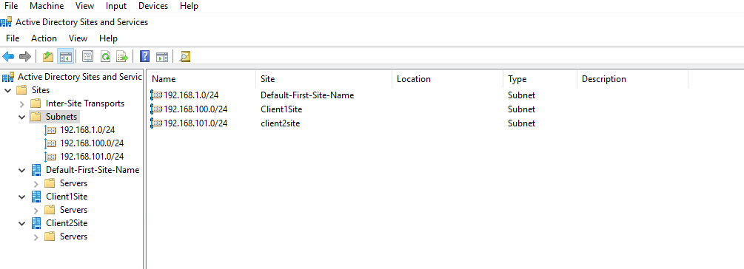
Figure 50- Defined subnets with Active Directory Sites and Services
Using Active Directory Sites and Services the author defined active directory sites based on the subnets from the previous worked examples.

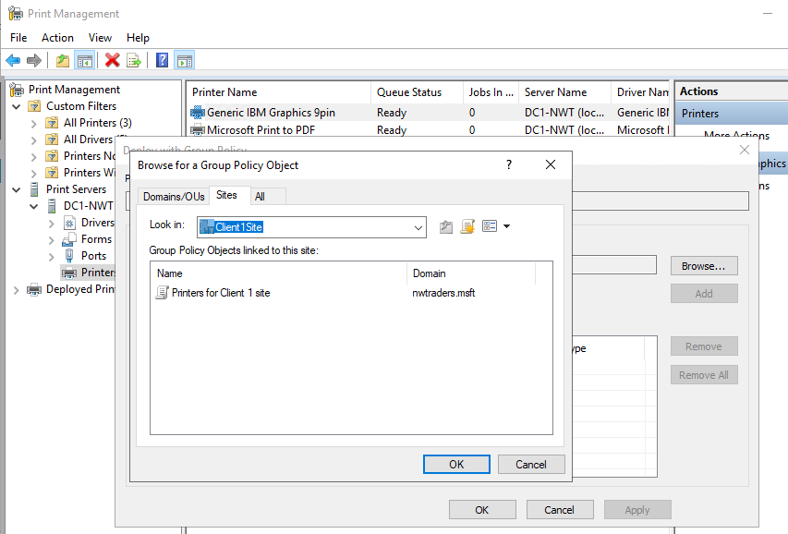
After installing the Printer and Document management services the Print Management console was used to install, share and deploy the printer utilizing a GPO to the required Active Directory site.
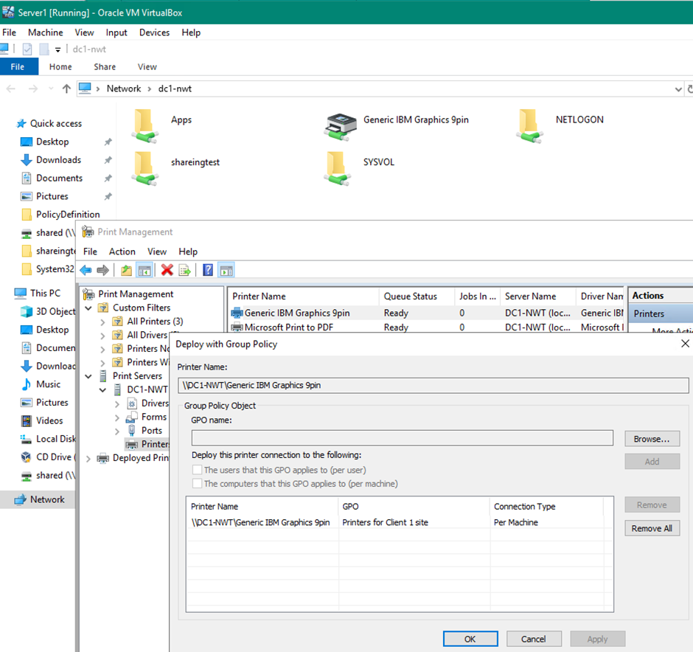
Figure 51 DC1-NWT advertising it has a shared printer. Management console showing per machine deployment to Site1 GPO
In the above screen capture from DC1-NWT we can see the Generic IBM Graphics 9pin printer is shared we can also see within the Printer management console that the above printer is being deployed to all machines in Client1Site
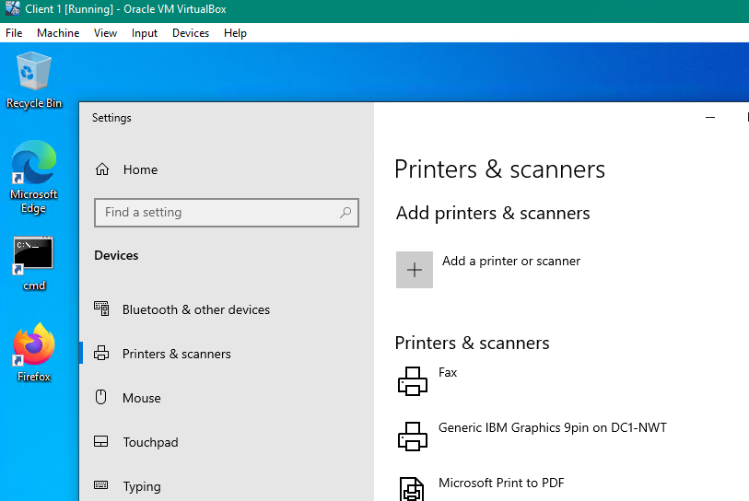
Figure 52- Local machine list of printers
In the above screen shot, the shared printer has been deployed successfully and is listed on a client PC in the Site1 subnet.

Domain level and OU level GPO

Ensuring that everyone in the domain has the same settings a GPO can be linked at the domain level. Settings that are modified further up the process order that have different settings at the lower order then the last settings (closest settings to the object) are applied.
For example, a domain admin wishes to ensure everyone has a 15 minute time out on the screen saver however users in the “Non Admin Users OU” want a different timeout and screen saver as the settings in the OU are closer to the object (computer/user) these settings will apply.

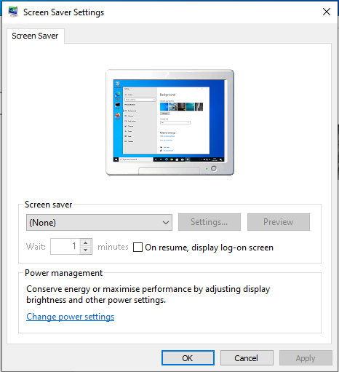  Figure 53- OOBE screen saver settings |  | By default there is no screen saver applied to the system.
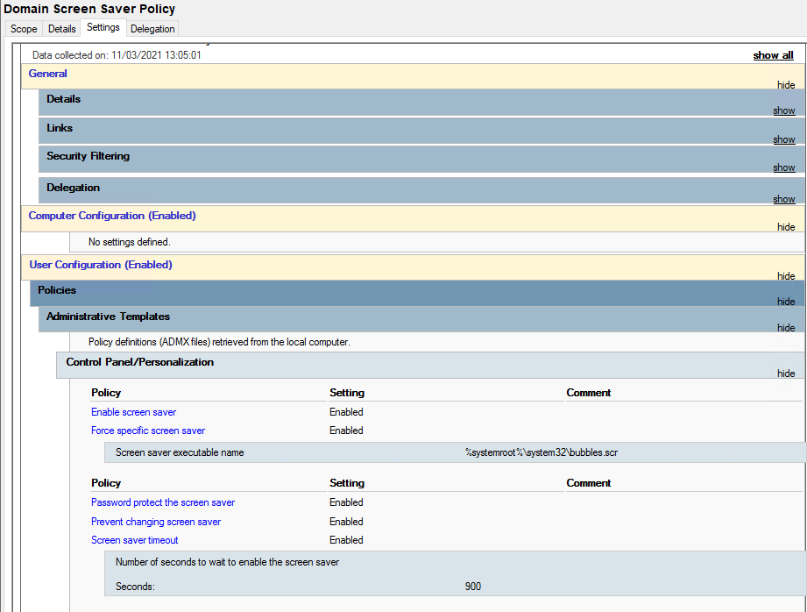
Figure 54- Defining domain screen saver policy
The screen saver for the domain is defined and applied to all users across the domain. Additional settings are also applied to password protect the systems and prevent the users changing the screen saver settings etc.
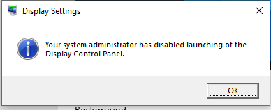
Figure 55- Access denied modifying screen saver settings
The policy settings have been applied to the client user and the user is unable to change the settings

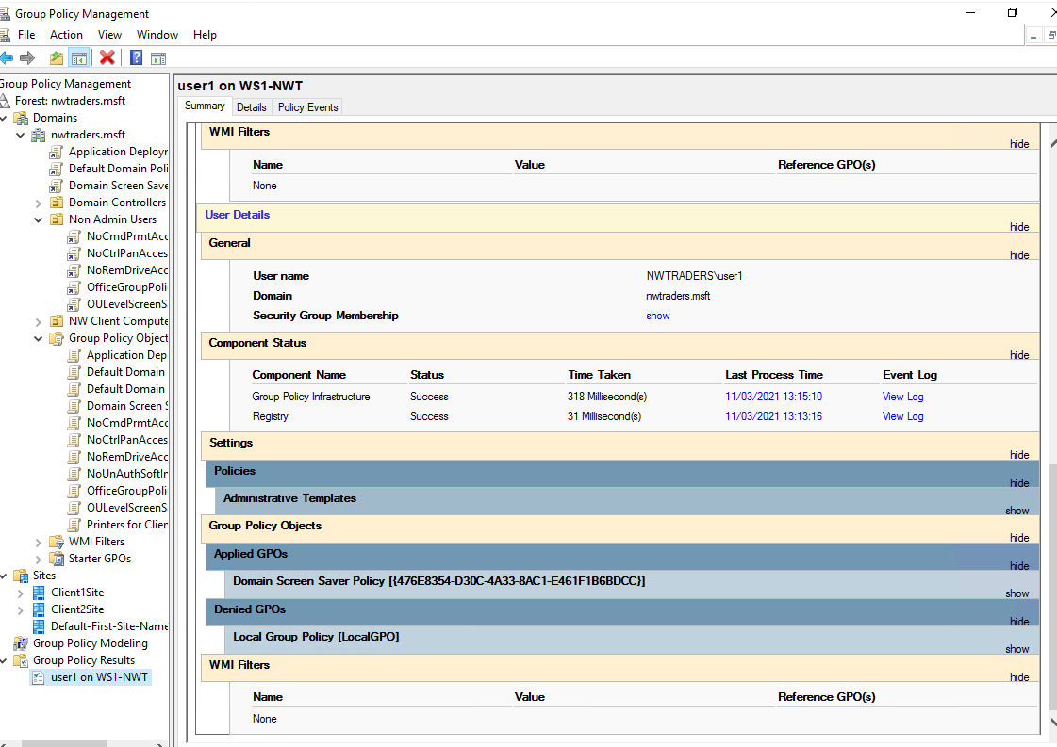
Figure 56-Resultant Set of Policies report
A new policy that overides some of the Domain polices was created and applied to the Non Admin OU. A resultent set of policies report was run and it was evident that the policies had not applied to the user.
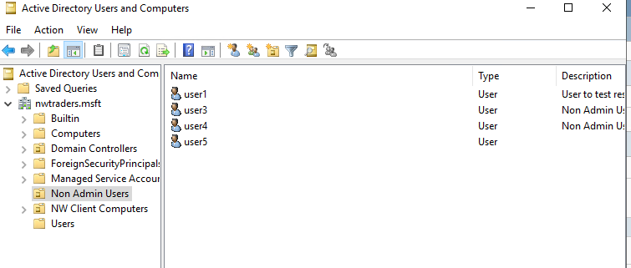
Figure 57 User1 in appropriate OU
The test was being carried out against NWTraders\user1 however the user was origonaly in the ‘Users’ container. The user was moved into the Non Admin Users OU and a new resultant set of policies report was run.

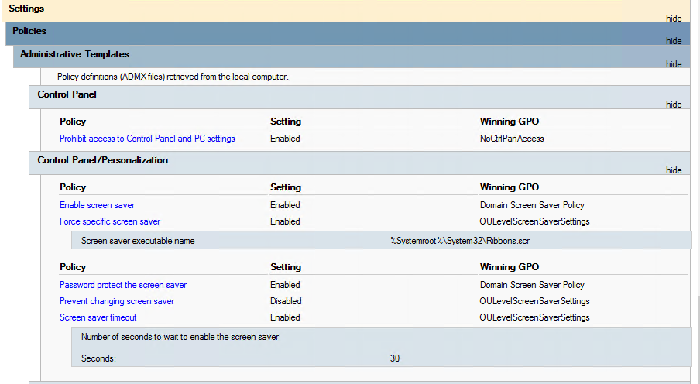
Figure 58- RSOP following account move
The resultant user policy now combines settings from a number of the applied polices. The screen saver time out has changed as well as the screen saver to be applied.

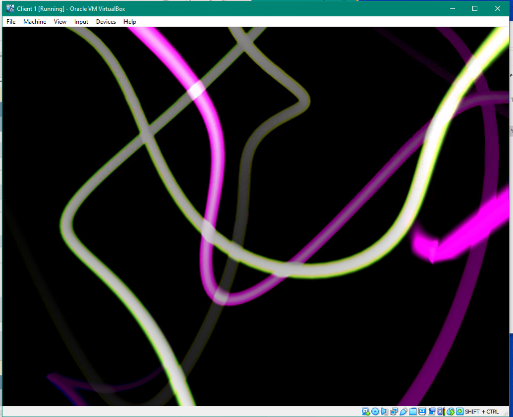  Figure 59- Ribbons screen saver | The ribbons screen saver now applies after 30 seconds as per the applied policy

Enforcement and blocked inheritance

These ‘closer’ settings however can be overridden if an administrator ‘enforces’ the settings then domain policies will take effect. These enforcements themselves can be blocked if the OU has blocked inheritance of GPOs further up the process order. However, in doing so then all GPOs applied above of the OU are ignored. An alternative would be to apply a ‘deny apply’ permissions on the GPO for the security group the users or computers are members of.

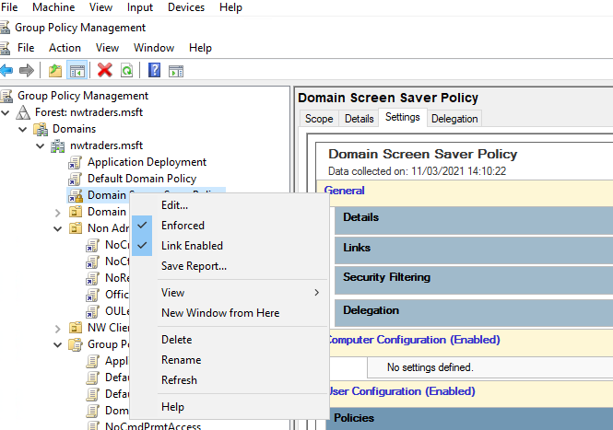
Figure 60- Enable the policy for enforcement
Right clicking on the GPO to bring up its connect menu and select Enforce
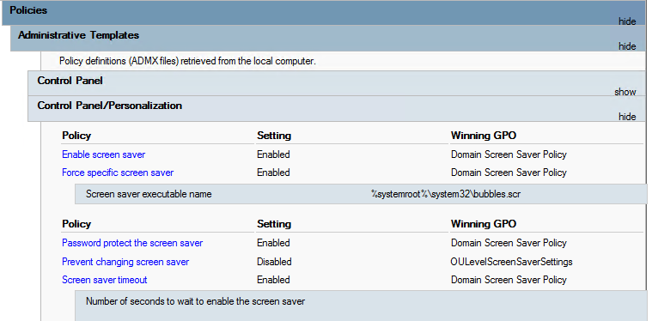
Figure 61-Policies applying following enforcement
A Resultant Set of Polices report was run against the User and Machine notice the enforced Domain level policies applying.

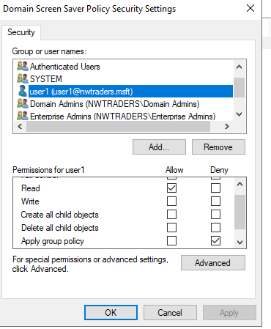
Figure 62- Deny Apply Group Policy to user1
Utilising NTFS security permissions modify the attribute of the users in relation to the Domain Screen Saver GPO and Deny applying the policy to USER1
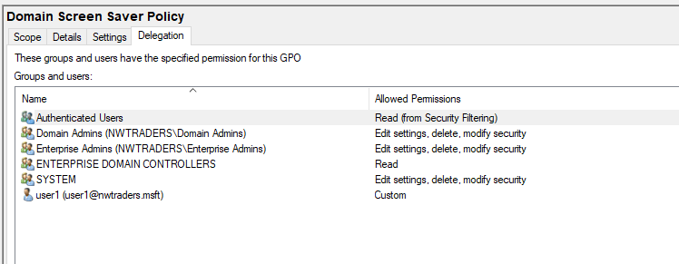
Figure 63- applied permissions within the GPO
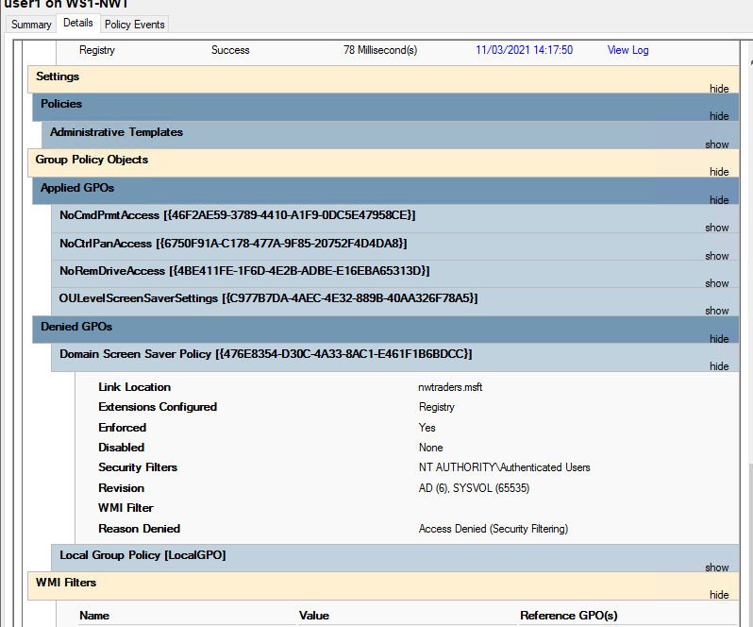
Figure 64- Domain Screen Saver GPO setting denied
Another resultant set of polices was run and the Domain Screen Saver policy was denied being applied against User1 and the OULevelScreenSaver policy takes effect.

Password management in network environments

Password policies have changed over the years in line with the sophistication of the tools available to perform a brute force attack. What was once considered an acceptable good practice has changed as CPU performance has grown and the threat from state actors has increased. The author has seen practices change from where organizations were encouraged to apply passwords with a minimum character set of six character changing the password every thirty days for environments less globally connected than modern networks. To where, in a cloud connected world users are not only accessing local resource but a plethora of services that are hosted by external providers with users expected to access multiple platforms with multifactor authentication and password less technology.

As alluded to above password cracking software have become more sophisticated and readily available utilizing computational horsepower that can uncover a simple password in fractions of seconds not months and this time only gets shorter as technology moves on. Below a simple infographic that highlights the time taken to brute force a password and how increasing the parameters of the password can increase the time taken to reveal the password itself. Whilst these figures cannot be validated as accurate today as the infographic was published in 2018 they can be useful tool when trying to educate end users regarding good password management.

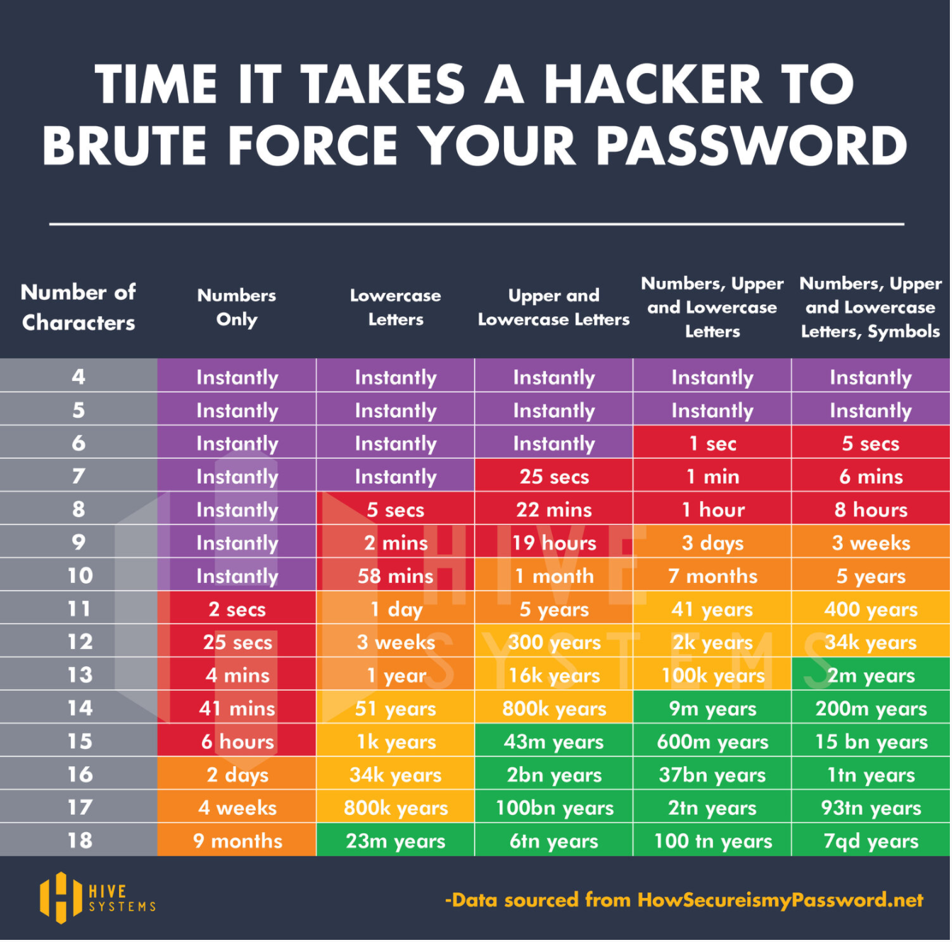
Figure 65- Info graphic regarding brute force password cracking times. [3]

National Cyber Security Centre Guidance
The NCSC [4]has provided guidance on how organizations can help mitigate the burden of multiple complex passwords. Recognizing the limitations or effectiveness of passwords in securing a systems and users ability to retain multiple complex passwords. Highlighting that besides brute force attacks passwords are often reviled via Phishing , having reused passwords stollen from another service, using a simple password commonly found in a password dictionary, stolen password hashes, having someone watch a user type their password, finding passwords stored insecurely written down, key logging, or simply guessing the password based on the users family pet etc.
Single sign on technologies that are linked to multi factor solutions can dramatically reduce the number of passwords a user would need to manage. Linking the domain login credentials to a locally hosted line of business application or utilising pass through authentication or Federated Services ensures that for each service the user uses there is one less password to manage. These systems can also be coupled with some form of multi factor authentication mechanism to ensures that the identification of the user is more secure.
Multi Factor authentication can be split into 5 factors [5]: -
- The Knowledge factor or something you know such as a username, password or PIN code.
- The Possession factor is something you have such as a hardware or software security token a onetime code or smart card.

- The Inheritance factor is based on a physical characteristic. Finger print, facial recognition voice patterns etc. These technologies have recently become more pervasive on mobile devices.

- The Location factor usually based on the sign in location of the users device. Enforcing additional authentication of a user based on conditional access rules from data gathered from the devices trusted or untrusted IP or the GPS data presented as part of the authentication.

- The Time factor refers to user activity based on the time the user connects to the system and if access is permitted within that specific time frame.

These first three are currently the most used factors for multifactor authentication. From the authors own experience one major hurdle to implementing MFA within an organization was the additional cost of multifactor hardware tokens. The ability to co-opt a user personal mobile phones as part of a multi factor authentication greatly accelerated adoption of MFA with a mutual benefit as users realise the benefit of attaching multi factor authentication to their own personal services in one convenient package.

Returning to the actual password guidance NCSC suggest avoiding the enforcement of complex passwords for the sake of complex passwords. P@ssw0rd often meets password complexity rules but is easily guessed and can be brute forced in a short amount of time. The use of password complexity has been found to be counterproductive [6] as users struggle to remember the passwords or reuse the same password on multiple systems. However, a long passphrase of three random words can take far longer to break and can be easier to remember. A simple guidance services as available from https://howsecureismypassword.net/ can guide users in constructing a secure password. The accuracy of the information whilst not validated can be a useful educational tool.
Coupled with this a password policy should avoid capping a password length. Having systems enforce password maximum length makes the process of cracking passwords far easier. Therefore, systems should enforce a minimum password length NIST recommend a minimum of 8 characters [7] . NCSC are advocating the use of three random words. The three random words should not be related and not tied to the service or include easily guessable details of the user for example “Brian Morris Barclays” would be a poor example to use as its not only personally identifying its tying the user to a service. Its also possible the user would be tempted to reuse this password framework for other services such as “Brian Morris Email” or “Brian Morris Netflix”.
“Rifle Tree Cream1” would be a suitably good example as the three unrelated words are suitable long at 17 characters and contains both numbers, special characters with upper and lower case letters that should be easy to remember. Based on this example and referencing the infographic above the password based on current technologies would take 17 trillion years to brute force. If it had not been exposed above.
Password reuse can become a problem as once an attacker has valid credentials, they can begin to move across all the services that the account accesses and begin to access these systems with the same valid stolen credentials.
A password solution should look to utilise a password block list that can not only block the use of simple passwords such as Password or QWERTY but custom lists that may relate to the organization or location plus known passwords that have been seen commonly in the wild or have been stolen from breached services. NCSC [8] have in collaboration with Troy Hunt of Have I Been Pwned produced a data set of 100,000 of the most commonly used passwords that should be included as part of a block list.
To further aid users where they are expected to use multiple passwords a password manager should be utilised to generate and store passwords securely for each individual service the user is required to access. Edge and Chrome both have built in password managers but external password managers such as Lastpass exist to assist users on multiple platforms. Ideally access to these password managers should be permitted via multifactor or password less authentication.
Password less technologies includes such technologies as push notifications where a user has to respond to a notification that an authentication attempt has been initiated, normally via an application on the users phone, the user can then approve or deny the request. There are still some risks with this as a user could inadvertently approve a fraudulent request. However, push notifications can help eliminate man in the middle attacks as the final authentication is via a different out of band platform.

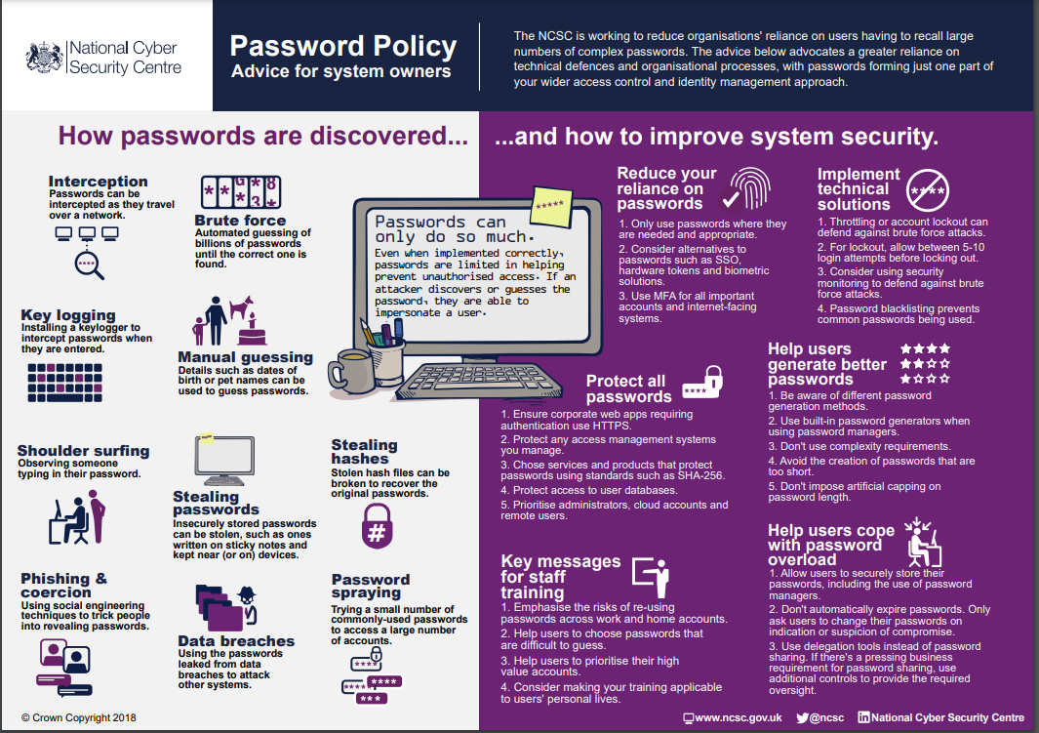
Figure 66-NCSC Password guidance infographic [6]

To summaries a good password policy should have the following: -
Be a minimum of 8 character ideally 12 characters or more
No longer requires password complexity be enforced especially if the password is greater than 12 characters
Do not enforce too short a character length of the password.
Where possible use single sign on systems to avoid the use of additional passwords.
If passwords must be used, use multifactor solutions to secure the service if multi factor authentication is not possible then use a password manager to generate and manage the password.
If possible, employ block lists on systems to avoid known or easily exploited password.
Provide a good level of guidance and education to service users affected by the password policies.

References

[1] | H. Custer, Inside the Windows NT File System, Redmond: Microsoft Press, 1994.
[2] | “Group Policy Settings Reference Spreadsheet for Windows 10 May 2020 Update (2004),” Microsoft, 2020. [Online]. Available: https://www.microsoft.com/en-us/download/101451. [Accessed 11 March 2021].
[3] | Hive systems, “Are your passwords in the Green,” Hive Systems, August 2019. [Online]. Available: https://www.hivesystems.io/blog/are-your-passwords-in-the-green. [Accessed 25 March 2021].
[4] | NCSC, “Password administration for system owners,” NCSC, 19 Nov 2018. [Online]. Available: https://www.ncsc.gov.uk/collection/passwords/updating-your-approach#tip1-password-collection. [Accessed 25 March 2021].
[5] | L. R. etal, “two-factor authentication (2FA),” Techtarget, April 2020. [Online]. Available: https://searchsecurity.techtarget.com/definition/two-factor-authentication. [Accessed 25 March 2021].
[6] | N. C. S. Centre, “Password administration for system owners,” 19 November 2018. [Online]. Available: https://www.ncsc.gov.uk/collection/passwords. [Accessed 18 MArch 21].
[7] | P. A. G. etal, “Digital Identity Guidelines Authentication and Lifecycle Management,” National Institue of Standards and Technology, 1 December 2017. [Online]. Available: https://pages.nist.gov/800-63-3/sp800-63b.html. [Accessed 2021 March 25].
[8] | D. U, “Passwords, passwords everywhere,” NCSC, 21 April 2019. [Online]. Available: https://www.ncsc.gov.uk/blog-post/passwords-passwords-everywhere. [Accessed 25 March 2020].

