

LCMB7035-DISSERTATION PROPOSAL

“THE ROLE OF AI-DRIVEN CUSTOMER INSIGHTS IN ENHANCING COMPETITIVE STRATEGY: A CASE STUDY OF AMAZON IN THE UNITED KINGDOM (UK)”

Student Name: Chiragkumar Somabhai Prajapati
Student ID: 2423111

Table of Contents
1. Introduction 3
2. Literature Review 6
3. Methodology 7
4. Expected Findings 8
5. Limitations 8
6. Timeframe 9
7. Conclusion 10
References 11

1. Introduction
Artificial intelligence (AI) has become an important technology that allows companies to gather, analyse, and process high volumes of customer information to create valuable insights. AI-based customer insights refer to machine learning methods, predictive analytics, and data mining that can be used to identify the behaviours of customers and enhance strategic decision-making (Selvarajan, 2021).
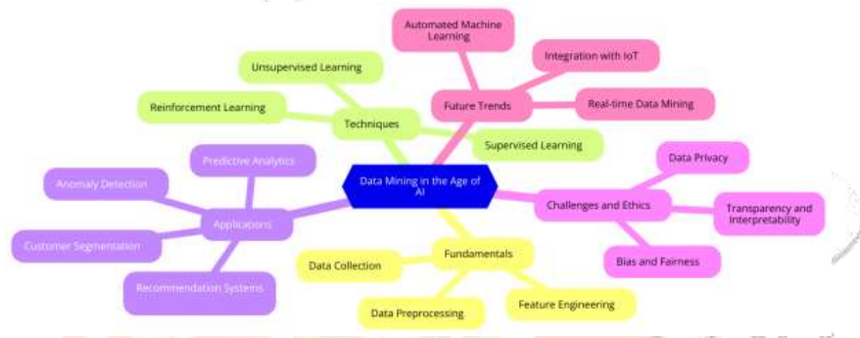
Figure 1: “The age of AI”
(Source: Selvarajan, 2021)
The e-commerce industry, especially in the United Kingdom, has seen a fast growth over the last couple of years. In 2020, the UK Internet sales as a percentage ratio of total retail sales were valued at 20.2%, which rose to 26.2% in 2025 (Ons, 2023). This is due to the technological developments and the fact that more consumers are moving towards online resources.
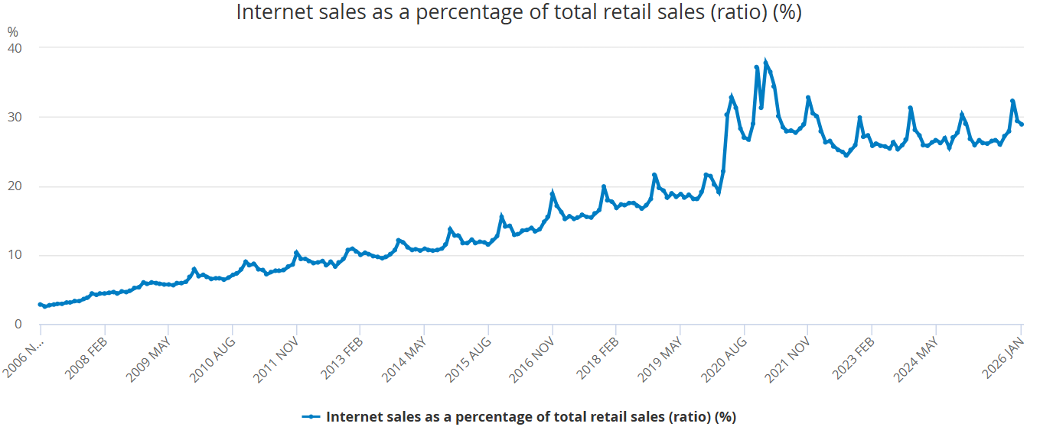
Figure 2 : “Internet sales as a percentage of total retail sales (ratio) (%)”
(Source: Ons, 2023)
80% of the consumers interviewed choose brands with customised experiences and claimed to spend half as much on a brand with customised experiences. Although 92% of retailers that participated in the survey consider that they effectively provide personalized experiences, the consumers do not (48% of consumers agreed) (Deloitte, 2025).
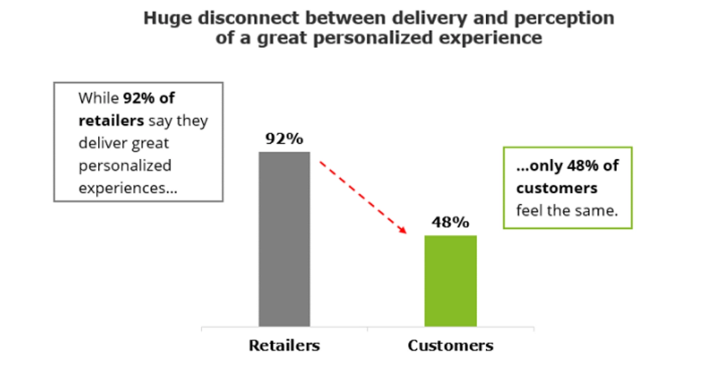
Figure 3: “Personalisation”
(Source: Deloitte, 2025)
Amazon is one of the most successful e-commerce companies that has managed to use AI technologies to preserve its competitive edge. The types of AI-based systems used by the company include recommendation engines, predictive analytics, and dynamic pricing models to promote customer experience and streamline operations. Amazon considers Large Language Model (LLM) at Amazon that assists in editing the product title and emphasises features that it consider as the most essential to the customer and their shopping process (Aboutamazon, 2023).
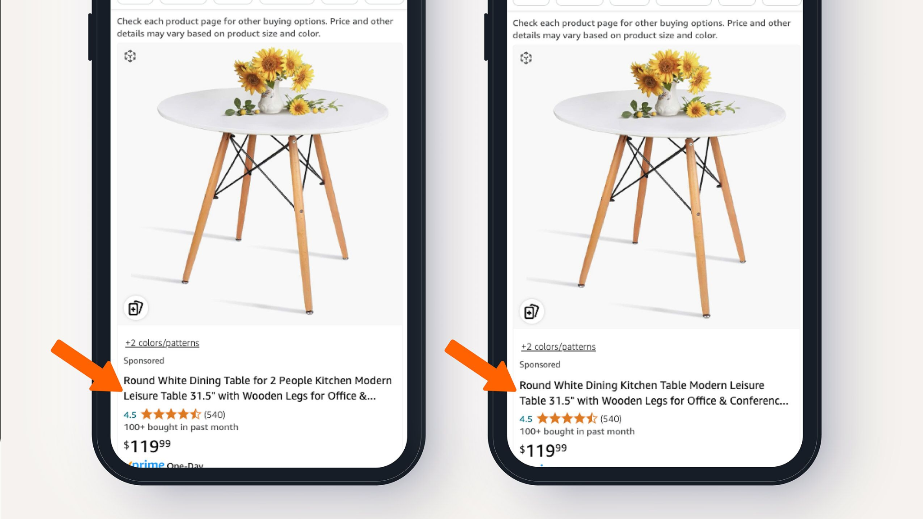
Figure 4: “Large Language Model (LLM) used by Amazon”
(Source: Aboutamazon, 2023)
Research Aim
This study will evaluate the ways in which Amazon uses artificial intelligence technology to work on the data of its customers, and how it has strategically positioned itself in the UK e-commerce market.
Research Objectives
- To explore the possibility of AI-driven customer insights and how it can be strategically used at Amazon in the United Kingdom.
- To find out what Amazon is doing with artificial intelligence and gathering, analyzing, and leveraging customer data to entrench its competitive strategy.
- To determine the most important concerns that Amazon has with the application of AI-based customer insights, which include ethical, data privacy, technological, and operational concerns.
- To suggest the strategic solutions to resolve the challenges identified and streamline the AI-assisted customer insights to remain efficient in maintaining the competitive advantage.
1.4 Research Questions
- How does the use of AI-based customer insights support the competitive strategy in an e-commerce business?
- What about the place of AI technologies that Amazon uses to develop customer insights in the UK market?
- What are the challenges that hinder the use of AI-based customer insights in the operations of Amazon?

2. Literature Review
Customer insights through AI have emerged as a theme in the modern business literature, especially regarding the digital transformation and competitive strategy. AI technologies can be used in various industries such as retail, manufacturing, and e-commerce to efficiently process vast amounts of data and produce predictive information to improve decision-making (Nyoni, 2025).
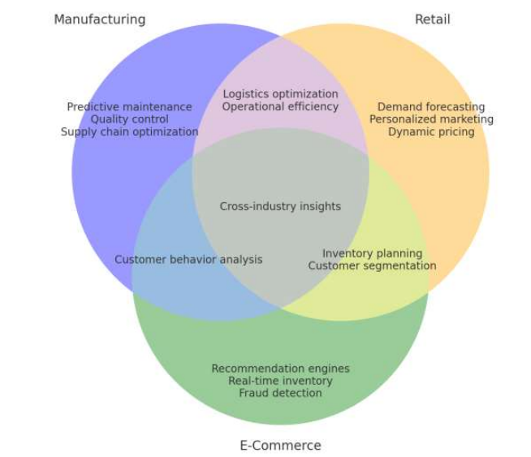
Figure 5: “Predictive Analytics Role”
(Source: Nyoni, 2025)
Personalization is the process of making products, services, and experiences unique to the customer with regard to their preferences. When the companies utilise AI to personalize correctly, Celestin et al. (2024) state that customer satisfaction and retention can be greatly enhanced. Personalized recommendation systems have been found to raise the conversion rates in the e-commerce industry (Kanth et al. 2024).
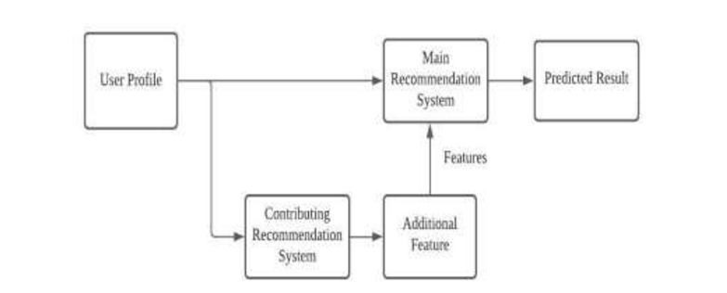
Figure 6: “Hybrid Recommendation System”
(Source: Kanth et al. 2024)
The other vital use of AI is dynamic pricing. It entails real-time adjustment of product prices depending on demand, competition, and customer behaviour. According to studies conducted by Immadisetty, (2025), it is argued that the revenue in online retail settings can be obtained through dynamic pricing strategies. Regardless of these advantages, a number of challenges related to AI-driven customer insights are also mentioned in the literature. One of the biggest issues is data privacy, where organizations gather and process huge amounts of personal information. The consumers are becoming more conscious of the data privacy concerns, and improper use of data may result in loss of trust and reputation (Rahmatiar, 2024).
Algorithms' bias and transparency are also another ethical issue of concern. The results of AI systems can be biased if the data is not representative, and some customer groups will be treated unfairly. Moreover, the deployment of AI technologies would be expensive and require a high level of technical knowledge, and it may be problematic with organizations.

3. Methodology
The study will utilise a qualitative approach and will employ a case study method of conducting research on how AI-based customer insights can be utilised in the competitive strategy of Amazon. A qualitative approach is also suitable because it is aimed at the comprehension of the strategic practices, use of the technologies, and organizational issues, instead of quantifying the reaction of the customers.
The study will be based on secondary sources of data, which will be peer-reviewed journal articles, books, industry reports, annual reports of companies, and other reputable business publications. The reports provided by Deloitte, Statista, and the official publications of Amazon are also considered other important sources. Academic databases like Google Scholar will also be used to collect data using keywords, including: AI-driven customer insights, Amazon AI strategy, and data-driven competitive advantage.
The data collected will be collected through thematic analysis. This will entail the determination of recurrent themes and trends in the application of AI in the Amazon operations. Among the central topics are personalisation, recommendation engines, predictive analytics, dynamic pricing, the improvement of customer experience, and ethical aspects.
Thematic analysis permits a disordered approach to the interpretation of qualitative data and assists in the perception of how AI-based insights can be used to gain a competitive advantage. The approach also helps the researcher to critically review the available literature and establish gaps in the existing research.

4. Expected Findings
The research is expected to evaluate that AI-led customer intelligence can be influential in augmenting Amazon's competitive approach. The use of technologies like recommendation systems, predictive analytics, and dynamic pricing is expected to make the customer experience better and the operations more efficient. The study will also establish the fact that personalization has a great effect on customer satisfaction and buying behavior. Research will gain attention to the issues connected with the privacy of data, ethical values, and the complexity of technology. On the whole, it is expected that the results will demonstrate the correctness of the assumption that AI-based insights play a vital role in maintaining a competitive advantage in the e-commerce sector.

5. Limitations
This study has weaknesses in the sense that it depends on secondary data, which might not give real-time information on the current strategies being applied by Amazon. The research also concentrates on one case organization, thus making the inferences to other businesses or industries limited. Also, there is limited access to internal information and proprietary AI tools of Amazon that can influence the level of analysis. The other limitation is the possibility of bias in the secondary sources since some of the reports might be provided in a positive light. In spite of the limitations, the study offers useful information about the strategic role of AI in e-commerce.

6. Timeframe
“Research Activity | “Week 1-2” | “Week 3-4” | “Week 5-6” | “Week 7-8” | “Week 9-10” | “Week 11-12” | “Week 13-14” | “Week 15-16”
Topic Selection & Proposal Approval
Chapter 1: Introduction Writing
Research Aim, Objectives & Questions Refinement
Initial Literature Search
Chapter 2: Literature Review Writing
Identification of Key Themes (AI, Personalization, etc.)
Chapter 3: Methodology Development
Research Design & Data Collection Strategy
Secondary Data Collection
Chapter 4: Data Analysis (Thematic Analysis)
Theme Development & Interpretation
Chapter 5: Findings & Discussion Writing
Linking Findings with Literature
Chapter 6: Conclusion & Recommendations
Proofreading & Editing
Final Submission”

7. Conclusion
The proposed research is a study of how AI-based customer insights can boost Amazon's competitive edge. The research highlights the increased role of AI technologies in the e-commerce industry and the role of these technologies in improving customer experience and performance. Through a qualitative case study design, the study is expected to offer detailed information regarding the strategic application of AI by Amazon. Though the study has some limitations, it should be helpful to the academic and practical knowledge regarding AI-driven strategies.

References
Aboutamazon (2023) Generative AI [Online] Available at: https://www.aboutamazon.com/news/retail/amazon-generative-ai-product-search-results-and-descriptions (Accessed on: 19/03/2026)
Celestin, M., Vasuki, M., Sujatha, S. and Kumar, A.D., (2024). How businesses create personalized experiences to boost customer retention: The role of technology and human interactions in customer satisfaction. International Journal of Applied and Advanced Scientific Research, 9(2), pp.75-80.
Deloitte (2023) Personalisation Strategy [Online] Available at: https://www.deloitte.com/us/en/programs/chief-marketing-officer/articles/personalization-strategy-in-retail-media.html (Accessed on: 19/03/2026)
Immadisetty, A., (2025). Dynamic pricing strategies in retail: Leveraging real-time data analytics for competitive advantage. Journal of Recent Trends in Computer Science and Engineering, 13(1), pp.53-65.
Kanth, M.L., Mujeeb, M.A., Harshitha, M., Rajinesh, C., Madhu, B., Reddy, G.V. and Sobti, R., (2024). Personalizing the e-commerce–experience: a recommendation system. In MATEC Web of Conferences (Vol. 392, p. 01095). EDP Sciences.
Nyoni, R., (2025). Harnessing data analytics for predictive insights: advancing Decision-Making with big data innovations. International Journal of Research Publication and Reviews, 6(1), pp.2915-2936.
Ons (2023) Retail Industry [Online] Available at: https://www.ons.gov.uk/businessindustryandtrade/retailindustry/timeseries/j4mc/drsi (Accessed on: 19/03/2026)
Rahmatiar, Y., (2024). Legal Protection Of Consumers Against Misuse Of Personal Data By Business Actors In The Digital Era. Jurnal Ekonomi, 13(03), pp.1915-1928.
Selvarajan, G.P., (2021). Harnessing AI-Driven Data Mining for Predictive Insights: A Framework for Enhancing Decision-Making in Dynamic Data Environments. International Journal of Creative Research Thoughts, 9(2), pp.5476-5486.

