
Project planning and management in workplace
Shabilah Hussain 1806501

[Date]
University of Wales Trinity Saint David

Executive Summary
The purpose of this report is to critically analyse project planning and management at Amazon and how they are adapting the impact of the coronavirus outbreak and due to unprecedented challenging measures to try and continue their operations. The report will include the planning and implementation, of its projects and how effectively its management is addressing the handling of the crisis.

Table of Contents
Executive Summary 1
Introduction 4
Main findings Overview Amazon 4
Stakeholder Analysis 5
Fig 1 Internal and external stakeholders 5
Fig 3 Iron Triangle 6
Monitoring 7
Fig 4 Gantt chart 7
Risks 8
Fig 5 Markowitz (2013) theory 9
Evaluation 10
Conclusion 10
Recommendations 11
Reference/ bibliography 11
Appendix 2

Introduction
Mindtools (2020) states the definition of project management is a process that enables many businesses to achieve goals and success at a specified time, projects have finite length and involve many activities and people, have deadlines and budget. Project managers will plan and monitor this and take the right course of action when needed to. Kerzner (2017) suggests that a successful project is a systematic approach to planning, scheduling, and controlling within a period.
Amazon is one of the largest retail websites in the world and continues to grow (Armstrong, 2018) the outbreak of a global pandemic has impacted many businesses including Amazon, with unprecedented measures taken by governments throughout the World. The company had to operate by guidelines set by individual countries; it has been necessary for them to adapt to changes to continue their operations. Coronavirus has affected the economy by storm (BBC, 2020).

Main findings
Overview Amazon
Gregory (2019) stated that Amazon is one of the largest online retailers in the world. Amazon mission statement focuses on active and high-quality service their corporate vision is "to be Earths most customer-centric company where customers can find and discover anything want to buy online".
Amazon's PESTLE analysis reveals the expansion of global power of the e-commerce business, PESTLE analysis model focuses on the governmental and their macro-environment, the following:
Political- political stability, government support and increasing governmental effort this creates an opportunity for the organisation.
Economic- Amazon operates an online and non-online business. Developed market, especially in the US and European countries. The economic stability of developed countries increases the success of Amazon.
Social- Social conditions are a detriment of Amazon the external factors include increasing profit and increasing online habits.
Technological- the external factors for Amazon rapid technological advancement, increasing efficiencies of IT.
Environmental- Amazon is mainly online business and are investing in an environmental program, business sustainability and increasing low carbon lifestyle.
Legal- Amazon must adhere to legal requirement including product regulation, import and export and environmental protection, regulations for business (Gillespie, 2007).

Stakeholder Analysis
Stakeholder analysis is the first step in a project to identify which is a critical process for a project to meet objectives identifying, prioritising and understanding stakeholder to achieve a goal for the project and Who will be impacted by the outcome (Mindtools, 2020).
Stakeholders contribute to the interest of the organisation and can be affected by the objectives. They are internal and external stakeholders (Mendelow,1991)

Fig 1 Internal and external stakeholders
Internal stakeholders | External stakeholders
Employees | Suppliers, Society, Government, Creditors
Managers & Owners | Shareholder & Customers
Amazon stakeholders support organisation growth. Amazon customers are the most critical stakeholders. The company considers customers as the primary source of business success as they significantly affect profit. Amazon employees are trained to maximise customer service, to benefit the performance of the business and to develop new ideas. Support competitive advantage and external stakeholders also play a vital part as they influence consumer perception support education, health care and sustainability and operations. (Fergusan, 2017).
The Ceo Jeff Bezos set out a plan in March 2020 when the UK was hit with COVID 19; the government announced the lockdown. The government allowed keyworkers to continue working, including Amazon; therefore, Amazon continued trading by delivering essentials. Amazon had to adapt in a new way of meeting health and safety measures. Amazon invested 3.2 billion on ensuring that staff and customers were safe during the pandemic (Sky news, 2020).
Fig 2 Quad Chart for Amazon
Quad charts are used for a variety of planning and communication. Due to the current pandemic customers are looking to order products for fast delivery.
Purpose  - Create a safe working environment for employees  - Continue to provide PPE equipment and other essential to vulnerable, health care and customers | Customer  - Employees and customer are protected all the time  - Safely put in new measures
Desired end result  - Profit  - Customer and employee's satisfaction  - Ensure product and service are delivered accordingly | Measure of success  - Customer and employees' feedback  - Ensure that all health and safety measures are met  - Increase in profit

Ford (2015) suggest that Quad charts are used in technical environments for planning and communication stages of composing a process for productive projects. Throughout the COVID 19 pandemic, the demand for health and safety products outpaced supply. Business COVID 19 supplied organisations with the most urgent supplies offering organisations (PPE Equipment) for hospitals and government organisations. Amazon focused on high priority items to ensure the fastest delivery of household, medical supplies, PPE equipment and other high demand products. (Amazon, 2020).

Fig 3 Iron Triangle
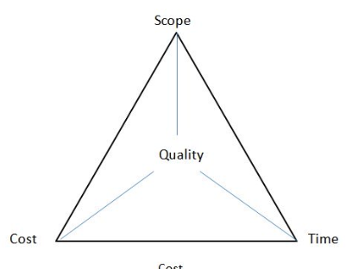
Atkinson (1999) suggests that project management is the application of a collection of tools and techniques towards a task in areas such as planning and control of time, cost, and quality. Dr M Barnes created the iron triangle demonstrating the quality, cost, and time are interrelated that must be managed in project delivery; therefore, to measure the success of a project all three areas must be considered. The project triangle also is known as the triple constraint for Amazon to succeed, the scope which includes the safety of employees delivering products to the customer efficiently and effectively and customer satisfaction will need to consider the time and cost. At Amazon, the project manager job is to ensure the whole triangle do not fall apart; two meet the needs of two areas rather than one. In most projects to bring the finish date, to spend more in resources (cost) to finish the work faster or cut features of the scope, so there is less work to do before the deadline, to finish the project you could meet the cost issue and not meet the time. (Office, 2019)

Monitoring

Fig 4 Gantt chart
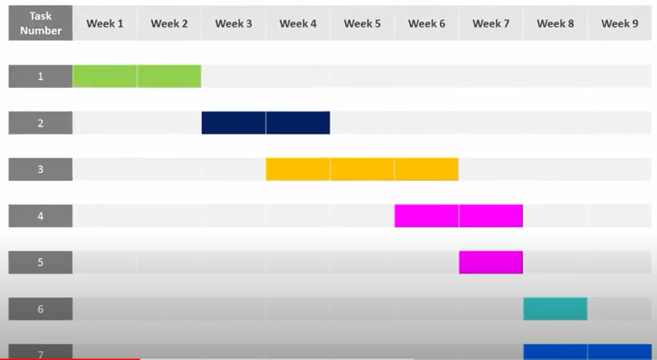
Clark (1922) stated that a Gantt chart is a working tool of management, a tool for project managers for scheduling. Organisations will use this tool to measure the performance in a project. Henry Gantt (1919) suggest two principles for his charts: one, measure activities by the amount of time needed to complete them. Two, the space on the chart can be used to represent the amount of activity should have been done at that time.

A Gantt chart is used in projects to show which tasks need to be completed and the start and the end time for each task highlighting for everyone involved in the project and what needs to be completed before something else can start. A Gantt chart is a graphical representation of a project showing the length of time for the project to run smoothly in order where the project is heading; each task is given time allotment, it is possible to have tasks running at the same time which helps to plan resources and identify problems as they arise. The chart is designed and agreed by everyone; the project helps keep the team and stakeholders informed of the projects progress.
A project life cycle
A project life cycle is describing the life of a project. Every project has a beginning in the middle and the end when the project is complete. There are five stages which come together to form a project management life cycle: 1. Initiating 2.Planning 3.Executing 4. Monitoring and controlling 5. Closing.
Aston (2016) Initiating is starting the project with available information, scope, cost and resources to look at the primary problem, identifying stakeholders. The planning phase plays a critical part to create a road map of delivering the project on time and budget and how to expand on the goal. The third stage, when the planning turns into action, the rules, resources all jump into performing, create and communicate. The fourth stage is keeping the project lifecycle on the track to capture data and complete task, and the fifth stage is a project performance analysis and post-implementation review. the project life cycle provides and highlights that different factors affect each stage and controlling, operating planning and forecasting predictions (Kotler and Keller, 2012).
Using the correct tools at the beginning of a project is vital. One of the essential services for Amazon is the next day delivery. The organisation remains committed to the health and safety of its employees, shareholders and customers. Amazon must provide PPE (personal protective equipment) to all its staff and customers. (Amazon, 2020).
Amazon has seized the opportunity to reinvent itself but at the expense of its workers. Jeff Bezos suggests continual improvement and innovation, even though Amazon has been a very successful company since 1994 with market value $1trn the outbreak has not slowed Amazon, quite the opposite other business have downsized or completely closed down. Amazon customers are spending £8,845 every second on its products and services. The lockdown has confined people to their homes which encourages consumers to use online services. To keep up with the demand, Amazon needs to employee 100,000 new workers (The Guardian, 2020). Krishna (2020) states that Jeff Bezos writes to stakeholders says Amazon focus is to fight coronavirus and to maintain jobs.
Managing a project depends on leadership; the project manager is responsible for monitoring, interactions to ensure the project stays on track, the project manager plans and monitors the task that must be carried out, this involves allocating responsibilities, motivating and ensure that the project team have the facility in order to do the project, early communication, right questions and how big is the work needs to thoroughly investigated and estimation of time and cost and iterative collaboration is necessary to use the knowledge and management decisions (Robertson, 2012).

Risks
Identifying and mitigation project risks is a crucial step in managing a successful project. Risk management has been defined as a range of methods to reduce threats to the project (CMI,2020).
Risks | Warning mechanisms | Mitigating actions
Safety measures for employees and customers | Knowledge about pandemic  Employees infected  Employees resigned | Follow government rules  Deep cleansing
Delivering product and services | Out of supply | More supplies
Financial risk | Increasing costs | Focus on costs
Facing criticism | Bad reputation | More safety for customer and employees
The project risk management process reflects the dynamic nature of project work, capturing and managing emerging risks and reflecting new knowledge in existing risk analyses (APM,2020). Amazon is facing shortages of personal protective equipment for customers and employees. Employees at Amazon are continuing to operate without PPE equipment and deep cleaning the warehouses. (Independent, 2020). Amazon Prime members used to receive their orders in 24hrs -48hrs delays as the coronavirus spreads. The online retailer says certain items could take one month or longer to be delivered (Fortune,2020); therefore, has affected time and cost. Several writers have confirmed cases of employees testing positive for the virus; several workers have walked out of business. Employees demanded closure to warehouses, although Amazon temporarily shut down and cleaning after multiple employees tested positive for COVID 19 (Forbes, 2020) Amazon put in safety measures inside its warehouse, including a six-foot distancing rule and supplying cleaning material and hand wipes for workers. The company also introduced a mandatory temperature check before each shift. Although amazon faced problems, they continued to service customers with essential items (The Guardian, 2020).

Fig 5 Markowitz (2013) theory
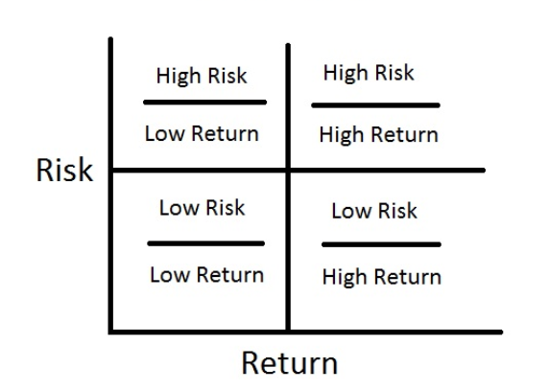

A risk management tool chart is used to analyse the risk may occur during the implementation stage. This helps the project manager to limit the risks leading to higher returns; the theory has four key areas high-risk, low return, low-risk low return, low-risk high return and high-risk, high return. This allows managers to weigh up the impact it will have on the organisation. A high risk, a high return will be risk exposure to employees to a very deadly virus without PPE equipment and could be damaging for the organisation, if the PPE equipment is in place this will be high return for the business.
Although Amazon is facing high risk, they are also facing high return. Although PPE equipment was provided in the UK but not in the USA majority of employees had fallen sick from the virus, and a recent employee death had occurred in New York (Guardian,2020).
Forbes (2020) states that Amazon announced its financial results for its first quarter that ended on 31 March. From its financial results, Amazon's net sales increased by 26% to $75.5 billion in the first quarter compared to 2019's first quarter of $59.7 billion. On the other hand, Lee (2020) suggest that Amazon warns coronavirus cost threatens to wipe out surging sales.

Evaluation
Evaluation is important; it allows us to learn from success or shortcoming; it allows to develop skills for team members or even developing new systems. It Contributes to building a working relationship between the team and also stakeholders that are involved in evaluating a project this will include collecting information, achievements and comparing it with initial objectives. It will include feedback from stakeholders and the project team member asking questions "what could have been done better", it can also appoint independent evaluators so they would offer outside view. Amazon is ensuring that safety of their employees and customers during COVID 19.
Amazon PPE equipment was provided in the UK but not in the USA; the majority of the employees were left without adequate health and safety protection during COVID 19 pandemic (Amnestry,2020).
Amazon had the advantage of surviving two recent disaster hurricane and flooding in America and should have been prepared for this deadly virus as their previous project would have involved risk and planning and build the resilience of handling with the specific process for risk purposes and resilience however this appears that Amazon was prepared for other disasters (Forbes, 2020) the organisation is facing lousy reputation and other organisation such as ASDA, Tesco is striving with planning and monitoring their health and safety for staff(Guardian,2020).
Amazon needs to adhere to government guidelines by supplying employees and customers with PPE equipment and trying to work with safety guidelines, to help amazon understand whether their a subjective or objective. Subjective is quick and easy evaluating the project; however, it can be very biased, or the objective approach based on facts and figures. Once Amazon has decided on which route is beneficial and will decide on hard or soft evaluation. Hard evaluation refers to facts and figures and soft, which would involve personal feedback.
Amazon started with a hard evaluation where they relied on facts and figures to ensure employees where safety and the product delivery to other organisation including the NHS where delivered on time as time moves on they are processing the soft evaluation method to think about the employees and feedback and the resources available and the business to continue with their operations. A tracking tool has been launched for Amazon workers to report and monitor the number of coronaviruses. The tool came about when death was confirmed in America (Guardian,2020),

Conclusion
Project management is essential for strategic alignment, clear focus and objectives and monitoring evaluating to ensure learning success and failure( Mayor, 2010) management is fast growing the formal techniques are being adopted in every industry and organisations. Amazon has followed this process in these unprecedented times of COVID 19 with the whole country in a lockdown they have played a critical part in serving customer and employees with PPE equipment in the UK on the other not as well in other countries. The outcome of Amazon project assumes that they have built knowledge and resources with this new virus that has impacted the world. Burke (2013) suggests "project managers who encounter a problem they look to discover a solution and motivate employees to perform better". This pandemic has closed many businesses down; Amazon is still striving though this period with sales and service and profit. The tool and techniques observed above suggest that amazon monitored the risk appropriately, although some weakness has appeared that some countries did not benefit from.

Recommendations
Although Amazon has dealt with natural disaster before in other countries but has not dealt with a deadly virus as this is the first time dealing there have been advantage and disadvantage with the project for PPE equipment around the world, the organisation needs to plan carefully and more effectively look at the risks involved for stakeholders set up an effective warning mechanism possibly feedback from employees via survey and observe customer feedback through reviews, therefore, can create a capable team and motivate employees which will allow the business to be more successful please for a further reading look at An Analysis of Abraham H. Maslow's a Theory of Human Motivation.

Reference/ bibliography

Amazon.co.uk (2020) Amazon and COVID-19 https://www.amazon.co.uk/gp/help/customer/display.html?nodeId=GDFU3JS5AL6SYHRD (Accessed:27 May 2020).
Amazon: Online giant must do more to protect warehouse and delivery workers during COVID-19 crisis (no date). Available at: https://www.amnesty.org.uk/press-releases/amazon-online-giant-must-do-more-protect-warehouse-and-delivery-workers-during-covid (Accessed: 26 June 2020).
Amazon.co.uk Help: AMAZON AND COVID-19 (no date). Available at: https://www.amazon.co.uk/gp/help/customer/display.html?nodeId=GDFU3JS5AL6SYHRD (Accessed: 26 June 2020).
Amazon's COVID-19 blog: daily updates on how we're responding to the crisis (2020) US Day One Blog. Available at: https://blog.aboutamazon.com/company-news/amazons-actions-to-help-employees-communities-and-customers-affected-by-covid-19 (Accessed: 26 June 2020).

Atkinson, R (1999) Project management: cost, time and quality, two best guesses and a phenomenon, its time to accept other success criteria International Journal of Project Management Vol. 17, No. 6, pp. 337±342, 1[Online]. Available at:http://citeseerx.ist.psu.edu/viewdoc/download?doi=10.1.1.453.1057&rep=rep1&type=pdf
APM (2020) What is risk management? https://www.apm.org.uk/resources/what-is-project-management/what-is-risk-management/ (Accessed:03 June 2020)
Aston, B (2016) Project Management Life Cycle: The Complete Guide https://thedigitalprojectmanager.com/project-management-life-cycle/ ( Accessed : 12 June 2020)

BBC NEWS (2020) Coronavirus: Four ways the economy has been affected https://www.bbc.co.uk/news/52138535 (Accessed: 15 June 2020)

Burke, R., 2013. Project management: planning and control techniques. New Jersey, USA, 26.

Clark, W., (1922). The Gantt chart: A working tool of management. Ronald Press.
CMI, (2020). ‘’Risk Management’’, [Online]. Available: www.managers.org, [04.06.2020].
Costa, H.R., Barros, M.D.O. and Travassos, G.H., 2007. Evaluating software project portfolio risks. Journal of Systems and Software, 80(1), pp.16-31.
David, D. and Palumbo, D. (2020) 'Four ways the coronavirus has hit the UK economy', BBC News, 3 April. Available at: https://www.bbc.com/news/52138535 (Accessed: 26 June 2020).
Demrovsky, C. (no date) Why Amazon HQ2 Will Need An Evacuation Plan, Forbes. Available at: https://www.forbes.com/sites/chloedemrovsky/2018/12/12/why-amazon-hq2-will-need-an-evacuation-plan/ (Accessed: 26 June 2020).

Forbes (2020)Amazon Neither Winning Or Profiting From COVID-19 https://www.forbes.com/sites/moorinsights/2020/05/04/amazon-neither-winning-or-profiting-from-covid-19/#69ce04b6793a (accessed: 05 June 2020)
Fergusan E (2017) amazon stakeholder corporate social responsibility http://panmore.com/ accessed 19 june 2020
Ford, J.D. and Wei, T., 2015. Quad charts in the classroom to reinforce technical communication fundamentals. Journal of Technical Writing and Communication, 45(3), pp.275-284.
Fortune.com (2020) Amazon prime delays https://fortune.com/2020/03/23/amazon-prime-delays-coronavirus/ (Accessed:03 June 2020)
Gillespie, A. (2007). PESTEL analysis of the macro-environment. Foundations of Economics. Oxford University Press, USA.

Gregory (2019) Amazon.com mission statement & vision statement http://panmore.com/amazon-com-inc-vision-statement-mission-statement-analysis Accessed 19 June 2020

Gantt, Henry L. (1919), Organising for Work, New York, New York, USA: Harcourt, Brace, and Howe, LCCN 19014919Reprinted by Hive Publishing Company, Easton, Maryland
Housing Industry Association (2011). An Introduction to PESTLE Analysis.HIA Ltd
Kerzner, H., 2017. Project management: a systems approach to planning, scheduling, and controlling. John Wiley & Sons.
Krishna (2020) Jeff Bezos writes to stakeholders, says Amazon's focus is to fight coronavirus and maintain jobs available at: https://yourstory.com/2020/04/jeff-bezos-amazon-stakeholders-coronavirus-pandemic (Accessed:01 July 2020)
Lee, D. (2020) Amazon warns coronavirus costs threaten to wipe out surging sales. Available at: https://www.ft.com/content/4dc9b8fc-56f5-47ca-b468-a9a2afc2ec7b (Accessed: 26 June 2020).

Morphy, T. Stakeholder map (2008) project management, project planning, template and advice. https://www.stakeholdermap.com/project-management/project-triangle.html#the-iron-triangle-of-time-cost-and-scope-or-quality (Accessed: 20 May 2020)
Murphey, M., & Gause, R. (1974). UCF Research Guides. Industry Analysis. PESTLE Analysis. Business Horizons, 17(5), 27-38.
Mangram, M.E., 2013. A simplified perspective of the Markowitz portfolio theory. Global journal of business research, 7(1), pp.59-70.
Mendelow, A.L. (1981). 'Environmental Scanning - The Impact of the Stakeholder Concept,
Mendelow, A.L., 1981, December. Environmental Scanning-The Impact of the Stakeholder Concept. In ICIS (p. 20).
Maylor, H. (2010). Project management (4th ed.). Harlow: Financial Times Prentice Hall.https://www-dawsonera-com.ezproxy.uwtsd.ac.uk/abstract/9780273743521 (Accessed 25 July 2019)
Paul, K. (2020) 'Tracking tool allows Amazon workers to report Covid-19 cases', The Guardian, 6 May. Available at: https://www.theguardian.com/world/2020/may/06/tracking-tool-allows-amazon-workers-to-report-covid-19-cases (Accessed: 26 June 2020).
Pollack, J., Helm, J. Adler, D. (2018), "What is the Iron Triangle, and how has it changed?", International Journal of Managing Projects in Business, Vol. 11 No. 2, pp. 527-547. https://.org/10.1108/IJMPB-09-2017-0107
Rushe, D. and Sainato, M. (2020) 'Amazon posts $75bn first-quarter revenues but expects to spend $4bn in Covid-19 costs', The Guardian, 30 April. Available at: https://www.theguardian.com/technology/2020/apr/30/amazon-revenues-jeff-bezos-coronavirus-pandemic (Accessed: 26 June 2020).
Saeed, D. M. M. and Asghar, M. A. (2012) 'Examining the Relationship between Training, Motivation and Employees Job Performance – The Moderating Role of Person Job Fit', p. 8.

Stoyanov, S. (2017) An Analysis of Abraham H. Maslow's a Theory of Human Motivation. Milton, UNITED KINGDOM: Macat International Limited. Available at: http://ebookcentral.proquest.com/lib/trinity/detail.action?docID=4906588 (Accessed: 26 June 2020).

Appendix

