the DEcline of Uber.
problem-solving and decision making.

Kersha May Davies (student number) BMSK4004
The Decline of Uber.
Contents
Introduction. 2
Nature of Uber problem. 3
Ubers reputation. 3
SCOPE of Ubers problem. 4
Impact of Ubers problem. 5
Dara Khosrowshahi. 5
SWOT Analysis. 6
Strengths- 6
Strength 1.1 6
Strength 1.2 6
Weaknesses 6
Opportunities 6
Threats 6
PESTLE analysis. 6
Political 6
Economic 6
Social 6
Technological 6
Legal 6
Environmental 6
Conclusion. 6
REFRENCES. 7
Appendices. 8
Appendix A SWOT analysis. 8
Appendix B PESTLE analysis. 8

Introduction.
This report will identify one of the challenges the Uber company encountered that assisted towards the discrimination of their reputation involving their employees, customer satisfaction rate and ultimately the human rights regulations.
This information will highlight the safety regulations within the Uber company and how they failed to correspond to their standard policies.
Research is undertaken to identify the Nature, Scope and Impact of the problem that Uber challenged prior to their development and outstanding profit earnings.
A Swot and Pestle analysis will commence towards an understanding of the problem, guiding Uber to overcome their problem and strive towards a respectable reputation this company previously maintained.

Main findings.

Nature of Uber problem.

Ubers reputation.
Ubers major problem is the loss of profits which were caused by the previous owner and co-founder Travis Kalanick. Travis destroyed Ubers reputation within how he treated his staff and managed his drivers and their cabs.
Kalanick invented the company uber. Ubers rival “Lyft” directed travis to divert from using classy cars to using companies that registered under the Uber name, this was a success for uber, the company produced a substantial number of profits and created the biggest tech cab and delivery company in the world. Travis made several scandals during this time which forced him to leave his company as CEO (2021).
Travis was eager to promote his business and made a substantial amount of profit within his growing business, although his approach of discrimination towards his employees and operating cabs in rural areas where the cabs were lawfully prohibited led to the dismissal of his employment in February 2017 (Lee, 2020- The Financial Times).
However, Kalanick invested $25.000 million to a trip to Las Vegas to illustrate his appreciation to his employees with his newly found stockholders Beyoncé and her husband jay-z.
This increased profits incredibly for uber and created an atmosphere of excitement and opportunities for uber the couple and their employees. This gave the company an opportunity to build their profits and appear attractive to their customers (Isaac, 2019).

SCOPE of Ubers problem.
Global politics insisted that gig-economy workers are treated with standard human rights regulations. Susan Fowler created a blog that stated travis was sexually harassing several of his employees and created an atmosphere of sexualism within the company. Evidence has been uncovered illustrating travis threatening an employee recorded on technical software.
An investigation has previously been carried out by the former US attorney Eric Holder because Uber drivers were forbidden to work within certain areas (Lee, 2020- The Financial Times).
An interrogation was performed on an accused driver who had been accused of rape, an investigation was carried out by the USA police force.
The interrogation exemplified that the accused is an offender and did not have a valid licence as a cab driver while failing to fall into the regulations of Uber drivers.
Uber decided to close their business until they permitted a new licence for their business operations.
This affected Ubers employees and their customers and caused an outburst of anger from the employees and their customers. Many employees were dismissed from the company as Uber did not assess their drivers correctly to their standard procedures and policies.
Their customers were outraged by the allegations made towards Ubers drivers, as Ubers ensures that their customers are their main priority, and their safety procedures ensure that all customers and drivers will be safe within their journeys.
Uber states on their website that cab drivers are thoroughly reviewed within a CBR check, however many of their drivers had previous offences within the court of law. This left uber with a significantly loss of profits from losing their customers and their drivers (Maheshwari, 2017).

Impact of Ubers problem.

Dara Khosrowshahi.
Dara Khosrowshahi achieved the position of CEO in 2017, after Travis ruined the company’s reputation.
Ubers employees were majorly affected as Several employees were dismissed from the company commencing towards a public vote and aggravated employees who challenged the CEO Dara Khosrowshahi.
Dara sustained Ubers employment rate however regular work for Uber drivers faded. This infuriated the employees. This proceeded towards a legal obligation of Dara’s safety and his relocation (Lee, 2020- The Financial Times).
The US police force requested legal action and an integration on Uber within regards to a twenty-seven-year-old woman who alleged the rape of one of Ubers CAB drivers, which took place in India December 8th, 2014.
Travis did not carry out the correct protocols or a professional CRB check on this driver. Therefore, this error commenced towards an unsafety environment for his customers.
Dara requires the USA police force to acknowledge the safety procedures that are in place for their customers and their drivers utilizing their easy access app to reach 911 assistance providing their exact location if an attack takes place (Uber Rape Shock, 2021).

SWOT Analysis.
Strength
Uber is one of the largest CAB companies in the glob and participates in other departments such as Uber eats which is a fast-food delivery franchise.
Uber has the reputation of implementing simplified apps within their CAB and travel department. Customers can order a cab at a tap of a button on the uber app, Shippers can use a one tap button that matches to couriers to them providing an instant booking with upfront pricing, displaying how much income the shippers company will get paid and within their uber eats app. This has increased their customers satisfaction rates and developed new technology and created company competition throughout the CAB and online delivery food industry (Uber Apps, Products, and Offerings | Uber, 2021).

Weaknesses
uber apps may not be suitable or appeal to the older generation to utilise.

Opportunities

Threats
Regulators threaten to shut uber down. Many lawsuits have been filed against uber one of the biggest threats uber faces is the company’s reputation within their drivers Ubers drivers are the face of the company although uber did not follow out the correct procedures on its drivers therefore this led to many drivers having criminal records and left their customers in an unsafe environment sexual assaults all over the glob have been reported on uber drivers their customer safety and satisfaction rate is at its lowest.

PESTLE analysis external factors.

Political
Politicians and elections collaborated against uber recommending that their cab fairs were inexpensive and insisted this was not fair on other cab companies such as the black cabs in London and the yellow cabs in the USA.
Uber has a highly recommended safety procedure performing (CBR) criminal record bureau checks on their drivers. This assists with permitting to their customers that their journey will be safe and secure.

Economic
Uber has a reputation for its inexpensive CAB fairs. With its low-cost fairs and up to date technology, this commenced towards a conflict within the CAB industry.
Uber has a highly recommended safety procedure performing (CBR) criminal record bureau checks on their drivers. This assists with permitting to their customers that their journey will be safe and secure. Kalanick changed the approach towards business transport, enabling society to feel safe when driving with strangers through an established and secure safety travel company.

Social
Uber request the public to demand to the government that they do not close their company, Afterall social attention is not what the government wish for. Social impacts are the key to Ubers success, although uber customers are dissatisfied by the increase of Ubers cab rates, the customers still rely on uber as their main source of travel (Isaac, 2019).
Ubers fairs where reasonably cheap for their customers, although they increased their prices during holiday seasons this left uber customers searching for another company with cheaper expenses (PESTLE case study, 2021).

Technological
In the early 2000s society began to operate mobile devices where software was becoming increasingly attractive, the iPhone seven had recently been invented, this enabled uber to enhance their technical products creating an app that allowed their customers to order a cab at the tap of a button. This increased the company’s profits and enabled most employees to become wealthy and progress within their careers (Isaac, 2019).
Uber operates their business by applying smart phone technology, joining the app called CAB aggregator assisted with calculated fairs for their customers.
Their customers authenticate themselves using their social media account and contact number. Social authentication assists Uber on personal information on their drivers and their customers. The app provides a direct emergency assistance for their customers and drivers providing their exact location (Uber Apps, Products, and Offerings | Uber, 2021).
Travis is discriminated for not following the correct safety procedures and the safety of uber customers. Enabling their customers to be at risk for not identifying uber drivers within their standard regulations and policies.
Travis withheld information and disregarded to carry out appropriate CBR checks on uber drivers. uber customers claimed to be sexually harassed by Ubers drivers and some sexually assaulted, this has left Ubers customers feeling unsafe and they have lost their trust within the company (Maheshwari, 2017).

Legal
Several women have requested lawsuits against Uber drivers for these attacks permitting these attacks should never have taken place if the CRB checks had been reviewed correctly.
There have been over 3000 sexual assault claims and 229 rapes reported on uber drivers in the USA in 2018. Uber cabs were forbidden in rural areas this may have commenced towards these attacks and might never have taken place if the correct procedures were carried out.

Environmental
There is no evidence that uber has an effect on the climate however

Conclusion.

REFRENCES.

Isaac, M.2019. Super pumped. The battle for Uber. New York: W. W. Norton & Co. Inc, p.5.
Maheshwari, N, 2017. Uber taxicab-handling crisis communication. Emerald Emerging Markets Case Studies, 7(4), pp.1-17.
The Sun, 2021. Uber Rape Shock.
Uber. 2021. Uber Apps, Products, And Offerings | Uber. [online] Available at: <https://www.uber.com/us/en/about/uber-offerings/> [Accessed 25 January 2021].
Youtube.com. 2021. [online] Available at: <https://www.youtube.com/results?search_query=the+uber+story+documentary+> [Accessed 6 February 2021].
Youtube.com. 2021. PESTLE case study. [online] Available at: <https://www.youtube.com/results?search_query=outside+factors+that+effect+uber> [Accessed 6 February 2021].
Isaac, M. (2019). Super Pumped: The Battle for Uber. United States: W. W. Norton.

Appendices.

Appendix A SWOT analysis.

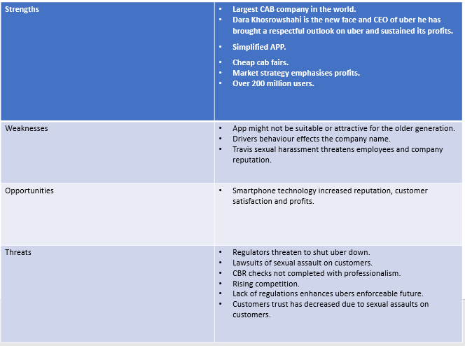

Appendix C PESTLE C (government outside factors analysis).
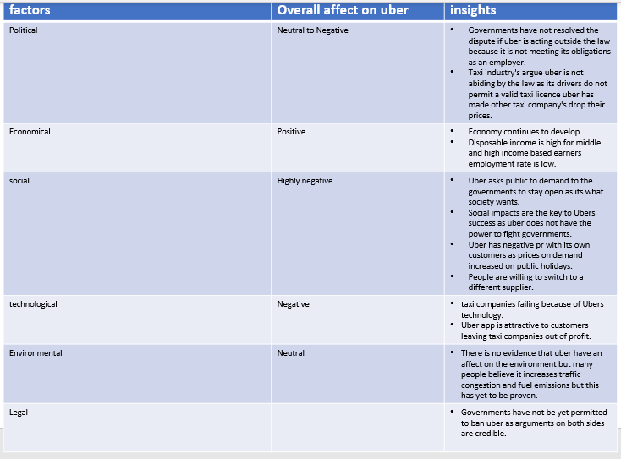
(PESTLE case study, 2021).

Appendix D fishbone diagram.


