

BA International Hotel Management
Management & Organisational Behaviour
BMIH5004
Student Name: Liliana Petrache
Student ID: 2025333
Lecturer: Lola Villard

Introduction
The concept of leadership can be elaborated as the set of skills or ability of an individual to guide and influence others towards achieving goals and objectives. Effective leadership is important to ensure that the employees in the organisation are motivated and efficient with their job roles (forbes, 2023). The essay will concentrate on the management practices of the general manager of the brand, Craig Poole. The Blake and Mouton Managerial Grid will be used to understand which type of management style is being used by Mr Poole. This will further aid in understanding how the management style has impacted the performance of the brand and how it impacted the growth and development of Reading. Further Adair’s model of Action Centred Leadership (ACL), will be used to understand the type of leadership that is followed by Craig Poole which has helped in the process of developing strong management in the brand during the establishment of the brand, Doubletree by Hilton in Reading Pennsylvania.

Discussion
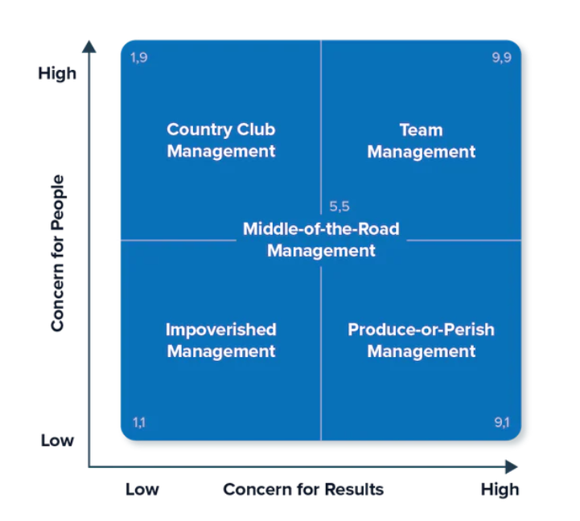
Source: (htraining.net, 2018)
The Blake and Mouton Managerial Grid is a management module that is used to understand the management style of a leader. It aids in understanding the behavioural style of the leaders in the organisation and supports in interpreting how the style could contribute towards the establishment of the management system in the organisation. The module is based on a management grid where the brand’s authority associated with the development of the organisation is based upon two factors, concern for people and concern for work efficiency. Five different types of management styles are recognised through the grid, Impoverished Management (1,1) which has low concerns for the people as well as for work productivity. Produce-or-Perish Management (9,1) is the management style where the management has a low concern for the people although they have a high interest towards work productivity. Middle-of-the-road management (5,5) is a management style where the management strives towards maintaining a balance between the concern for employee welfare and work productivity. Country Club Management (1,9) is a management style where the concern for the people is high whereas the work productivity is the lowest. Finally, Team Management (9,9) where the management of the organisation is the most efficient, puts close attention towards the development and welfare of the employees as well and holds high concern for work productivity (htraining.net, 2018).

Source: (HospitalityMD, 2023)
The hotel Doubletree by Hilton in Reading Pennsylvania is a multimillion-dollar project which has been aimed at providing excellent customer service. Before Double Tree Hilton Hotel had been established the area had high criminal activities and an unsafe neighbourhood. This stood out to be a major cause for poor business since customers hesitated to be in such a neighbourhood. Thus, Craig Poole was hired by Albert Boscov as the general manager of the brand, Doubletree by Hilton in Reading Pennsylvania (HospitalityMD, 2023). As this stood out as a major cause Mr Poole aimed to improve the neighbourhood to boost the brand’s chance at success. Both Mr Poole and Albert Boscove shared the same philosophy where they wanted to build and support the growth of the Reading region. He followed the servant leadership model where he aimed customer service to be the utmost goal of the organisation (Bloisi, W. et al., 2007).
Craig Poole focused on the development of the area to build and support the local community by providing them with a second chance. Craig Poole believed and followed a humanitarian philosophy where he kept people first and profits second. This had a major impact on the development and growth of the local economy (Mullins and Dosser, 2013). Mr Poole hired employees who lived within walking distance of the hotel establishment. He aimed to establish an employee base who were loyal to the brand and additionally aimed to improve the living standard of the people living in the area. Mr Poole focused on the fact that happy and satisfied employees make better positive contributions towards the growth and development of the brand in the region. Hence when he first stepped into his job role he fired the complete maintenance team and started the recruitment process. Out of the 1800 candidates who applied for the job only 220 were hired who lived near the community (Nixon, 2020).
Mr Poole focused on enhancing customer satisfaction and aimed to improve the productivity of the brand. He further contributed towards making the employees more engaged in their work and job roles by introducing them to different training processes (adelegutman, 2021). Mr Poole found the employees to lack financial literacy and thus provided the employees with training to help them become more self-sufficient. By helping employees build their self-esteem and helping them pay their own bills, Mr Poole successfully established his philosophy. This helped them to understand the importance of their jobs and value their growth. This assisted in making the management more efficient and has aided them in the process of establishing a hotel where people have received excellent services (Armstrong, 2012). Craig Pool has aimed to build up a learning and inclusive culture in the organisation. Mr Poole would hold long meetings to break down the complete old management structure and rebuild the organisation with new goals and objectives. He emphasised hospitality and the related concerns to be the most important factors and this helped to change the perspective of the employees in the organisation.

Source: (HospitalityMD, 2023)
This aided the brand in attracting a larger customer base. The brand has been able to build a positive image in the market altering its past image and reality. Mr Poole, being a follower of the servant leadership model had been looking for an employee base who could match his mentality and philosophies (Keith, 2023).
During the recruitment process when thousands had gathered around the block of the hotel, he walked out trying to make conversations with the people standing. The people who did not know Mr Poole and genuinely were outgoing and friendly were hired in the hotel. This approach helps to understand how strongly Mr Poole followed his philosophies. In one of the interviews he states, ‘We wanted to teach them’ and later, ‘We didn’t worry if people had a prison record’. These statements show his dedication towards the cause. Mr Poole promoted the various types of donations and other help that gave the employees an understanding of what help is. He donated clothes toiletries and other necessities that helped them to build their personality (Adair, 2009). He engaged his employees with the Animal Rescue League and other charity work. This helped to provide the warmth and guidance that the employees needed to understand how efficiently customer service can be provided. Therefore it can be said that Mr Poole can be put in the grid of Team Management where his focus has been towards promoting employee betterment and work productivity.
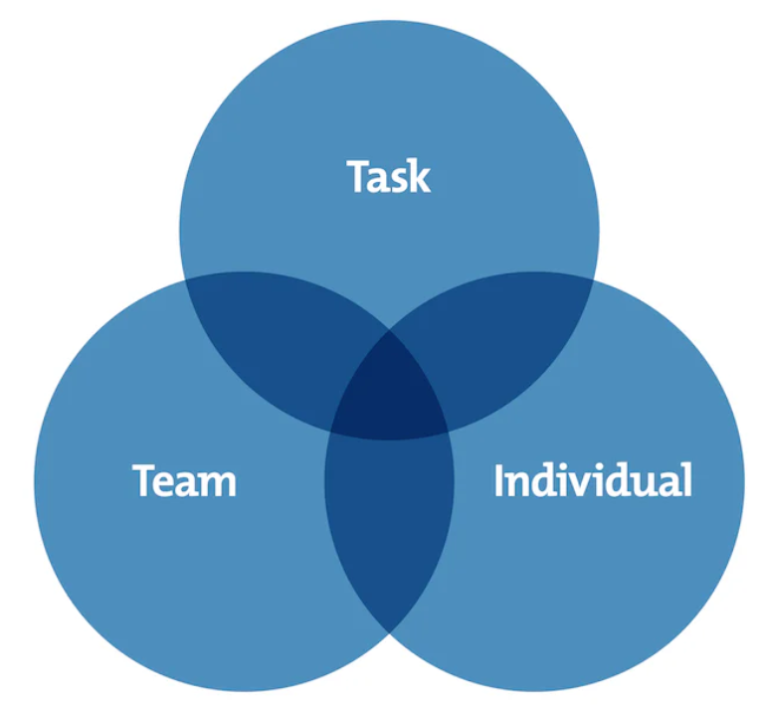
Source: (Ackah, 2019)
Adair’s model of Action action-centred leadership model is an efficient model that concentrates on three circles, task, team and individual. These actions focus on the different areas of development and this helps to concentrate on the important areas where the leader must focus on. It helps to handle pressure and aids in the process of concentrating on how the leader could boost employee productivity and gradually the performance of the organisation as a whole (Ackah, 2019). Mr Poole identified that for the Hotel to be a success, it is important to build a society to which the customers will be attracted. To transform the local community in Reading it was important to provide the locals with a source of income and help them become financially able. Hence, Mr Poole provided the community with job opportunities and a second chance in their life. He provided the employees with financial guidance and helped them with the clothes, food and other amenities that are essential for them to lead a dignified life. Mr Poole broke down the complete old management and maintenance structure rebuilt it with new philosophies and aims and enhanced customer service (forbes, 2019). He established the servant leadership model and established that everyone served the same purpose and this aided in aligning the objectives of the complete management team. Mr Poole stated during an interview, ‘You want to do a job so well, they want to show other people how well you do it, so they come back with their friends.’ This shows the level of commitment Mr Poole has towards contributing to the establishment of the business. Mr Poole being a person who is open to all and always welcoming, many employees have over different interviews stated how welcomed they left and the warmth they received. Mr Poole’s drive and support of an inclusive culture have been reflected in his decision to provide jobs to 20 autistic individuals. He noticed that their joyous behaviour and welcoming personality were always loved and admired by the people (HospitalityMD, 2023). Mr Poole does not believe in hiding these people in the hotel and keeping their movement restricted. Some have been hired in flower arrangements or the laundry. He utilised their tendency to work with repetitive tasks and do it efficiently and to improve their work by paying attention to small details that would be otherwise oblivious to others. This has helped to support Mr Poole's diversity in the hotel. Mr Poole focused on providing the employees with an organisation where the employees are motivated and feel comfortable to be with (Boddy, 2014). During various interviews, employees shared their experiences where they were welcomed during Christmas Eve and were encouraged to share dinner with their extended families, and their coworkers. This has helped Mr Poole to build a supporting and cooperative employee base who looks forward towards meeting the goals and objectives of the employees in the organisation. Mr Poole established efficient and open communication with the employees in the organisation (forbes, 2018). This has helped to build a positive relationship with the employees and the authority in the organisation. Mr Poole followed an individual approach where he looked into the individual needs of the employees and openly communicated with them. The employees would line up to meet Mr Poole and share their experience with the brand. They would share how their job with the hotel had been impactful in developing their living standards and has helped them to grow (readingeagle, 2017). Mr Poole concentrated on being task-oriented and this has helped additionally to concentrate on improving employee’s efficiency with their job roles. He successfully built a work culture in the organisation where employees come to work not out of obligation, but instead due to their own drive to work with Double Tree Hilton. The clothing closet that has been established for the employees is supported to provide the employees with moral support and guidance that improves their motivation to work and contribute towards the brand (Mullins, 2020). Mr Poole looks out for their employees and assists them towards developing their mental growth. Innumerable lives have been changed and transformed to promote growth and development. His focus was to work with people who have been marginalised and became a mentor for them who gave them growth opportunity to become something better (Mullins, 2016). Mr Poole and Boscove aimed together to establish a hotel capable enough to meet the bills without having to borrow (readingeagle, 2017). Mr Poole concentrated on letting the employees fail and helping them understand their mistakes. Further, Mr Poole helped them learn and treated them with the respect and dignity that they deserved and were deprived of. He made sure that the employees were never overworked or were compelled to work with job roles that they were not assigned. This helped to support the growth of responsibility among the employees and aided in promoting quality in the organisation (Buchanan and Huczynski, 2007). Mr Poole has been awarded the Global Hospitality’s Julian Star Award for his immense support and contribution towards the community of Reading and the establishment of the hotel, Double Tree Hilton presented by the International Hospitality Institute. His contribution towards the hospitality industry supported changing the trajectory of the lives of the people who worked with the brand (Milne, 2022). He truly justified his statement, ‘Follow me and I will be behind you.’ Therefore, these contributions of Mr Poole towards the task to develop the community, and team i.e., to build an inclusive and diverse team and his close attention to the individual needs of the employees helps to understand his Action action-centred leadership.

Conclusion
The essay has helped to understand how the Mr Craig Poole has developed the business and how his leadership style and management style has contributed towards development of Reading. His close attention to the needs of the employees and his drive towards building an inclusive and diverse workforce has helped towards the establishment of the hotel. The essay has helped to understand how Mr. Poole fits into the grid of Team Management. Further, Mr. Poole’s contribution towards the development of the employees helps in assisting how he follows the Action action-centred leadership.

References
Ackah, D., (2019). Models of Leadership and Teamwork: Adairs Action-Centred Leadership Model (1973). Worldwide Journal of Multi-disciplinary Studies, 1(5), pp.01-06.
Adair, J. (2009) The Inspirational Leader (2nd Ed), London: Kogan Page
adelegutman, (2021). Craig Poole, GM of the Year, shares a case study of Hospitality Leadership, Culture, and Profit. [Online] Available at: https://www.adelegutman.com/post/craig-poole-hotel-leadership-culture [Accessed 27 September 2023].
Armstrong, M. (2012) Armstrong’s Handbook of Management and Leadership (3rd Ed), London: Kogan Page.
Bloisi, W. et al (2007) Management and Organisational Behaviour, (2nd edition) Maidenhead: McGraw-Hill.
Boddy, D. (2014) Management: An Introduction (6th Ed), Harlow, Pearson.
Buchanan, D. And Huczynski, A. (2007) Organisational Behaviour: An Introductory Text (6th edition), Harlow: Prentice Hall.
forbes, (2017). Leadership Is More Than Just Efficiency And Processes. [Online] Available at: https://www.forbes.com/sites/joyceearussell/2023/04/10/leadership-is-more-than-just-efficiency-and-processes [Accessed 28 September 2023].
forbes, (2018). Strong Communication, Strong Company: How To Advance Workplace Culture And Strategy. [Online] Available at: https://www.forbes.com/sites/theyec/2018/10/08/strong-communication-strong-company-how-to-advance-workplace-culture-and-strategy [Accessed 27 September 2023].
forbes, (2019). Importance of Financial Planning. [Online] Available at: https://www.forbes.com/sites/advisor-intelligence/2019/09/20/importance-of-financial-planning [Accessed 28 September 2023].
HospitalityMD, (2017). Follow Me and I Will Be Behind You FULL DOCUMENTARY. [Online] Available at: https://www.youtube.com/watch?v=Lrh5QIW67Mk [Accessed 24 September 2023].
htraining.net, (2018). Blake Mouton and the Complexities of Good Leadership. [Online] Available at: https://htraining.net/blake-mouton-and-the-complexities-of-good-leadership/ [Accessed 24 September 2023].
Keith, K., (2023). The case for servant leadership. Terrace Press.
Milne, A. G., (2022). Julian Star Award Winning General Manager, Craig Poole talks about, Authentic, Selfless Hospitality. [Online] Available at: https://www.adelegutman.com/post/authentic-hospitality-craig-poole [Accessed 26 September 2023].
Mullins, L & Dosser, P. (2013) Hospitality Management and Organisational Behaviour (5th Ed) Harlow, Pearson.
Mullins, L (2020) Organisational Behaviour in the Workplace (12th edition) Harlow:Pearson
Mullins, L. (2016) Management and Organisational Behaviour (11th edition) Harlow: Pearson
Nixon, D. O., (2020). Changing lives in Reading. [Online] Available at: https://lvb.com/changing-lives-reading [Accessed 25 September 2023].
readingeagle, (2017). Albertr Boscov Remembered in Ceremony by city council in Reading. [Online] Available at: https://www.readingeagle.com/2017/02/14/albert-r-boscov-remembered-in-ceremony-by-city-council-in-reading/ [Accessed 28 September 2023].
readingeagle, (2017). The Conversation: Craig E. Poole. [Online] Available at: https://www.readingeagle.com/2017/10/10/the-conversation-craig-e-poole/ [Accessed 29 September 2023].

