Lab 2 Cyber Security
List Applications:
- Idle
- Scite
- Wireshark
Virtual Machine IP Address:
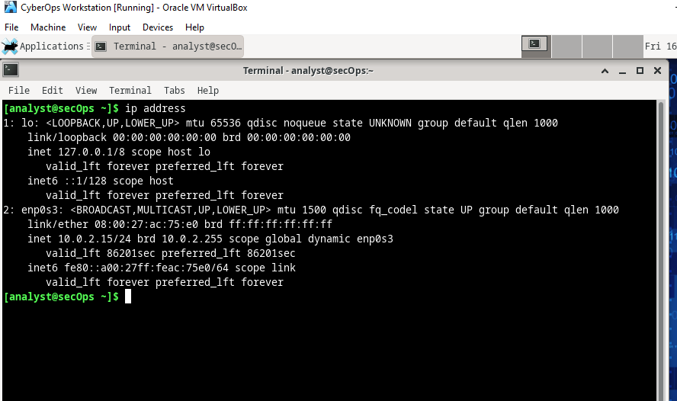
Favourite search engine: Yes Google.
Virtual Machine:
Advantages- Any infections on vm doesn’t affect main computer.
Disadvantages: Takes up a lot of storage.
Node H1
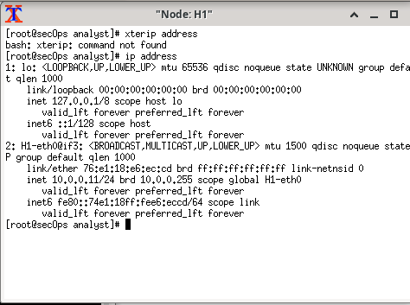
Node H2
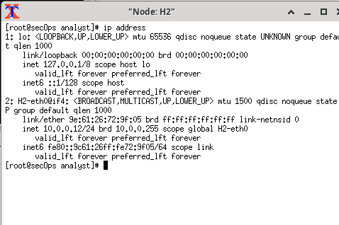
Record of reflection
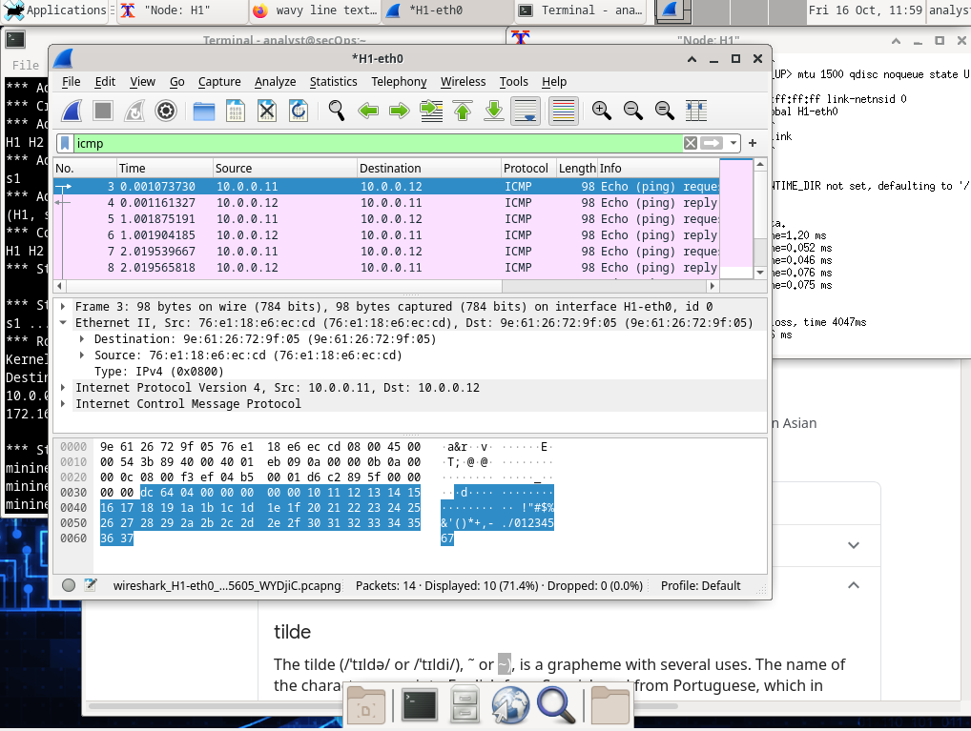
H4 and R1
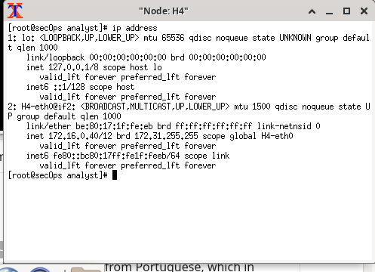
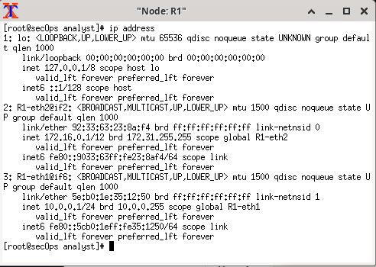

Ip and MAC addresses
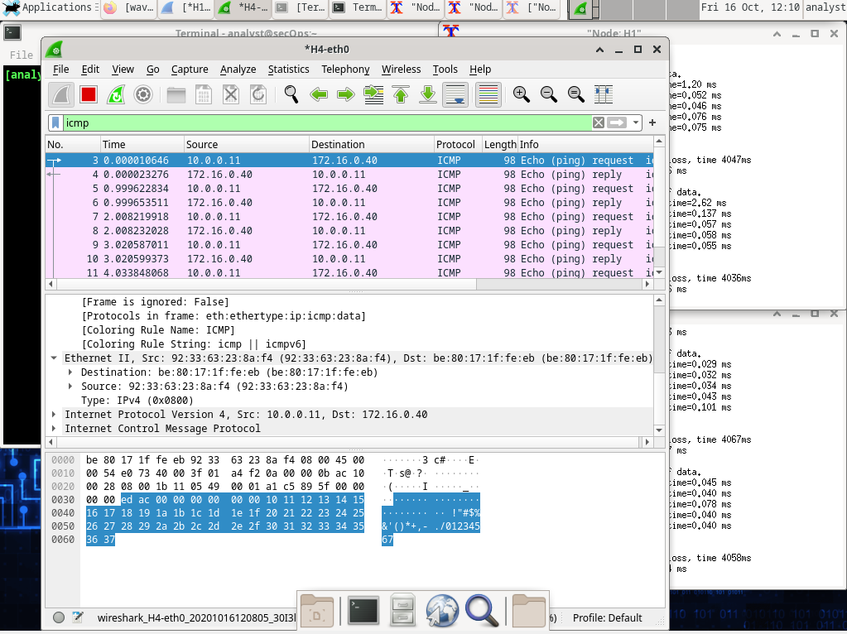

Hops location
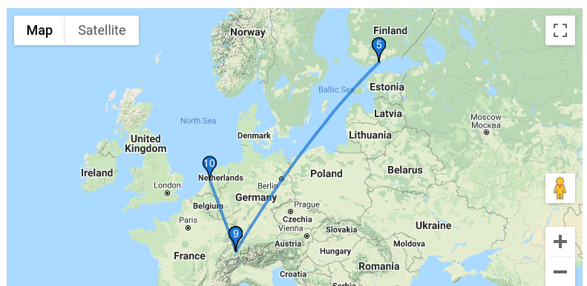
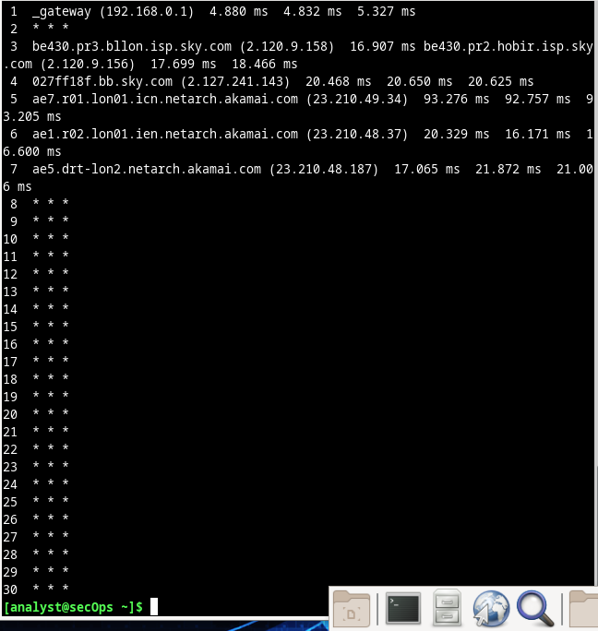
What is significant about the contents of the destination address field?
Going to take a guess and sy all f’s could be the same command over and over again like ddos attack
Why does the PC send out a broadcast ARP prior to sending the first ping request?
To request MAC address
What is the MAC address of the source in the first frame?
F4;8c;50;62;62;6d
What is the Vendor ID (OUI) of the Source’s NIC?
Ea;b1;7a
What is the Source’s NIC serial number? Intelcor_62;62;6d
H3
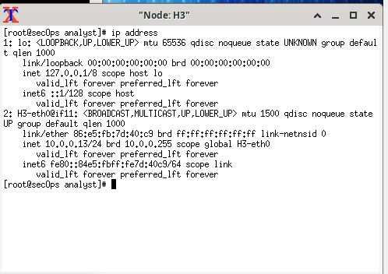
Default gateway: 0.0.0.0
Unable to complete rest of lab due to wireshark-gtk & command not working.



