Engine Performance Characteristics Assignment.
Motorcycle Technology (ACHA4003)
2020 - 2021

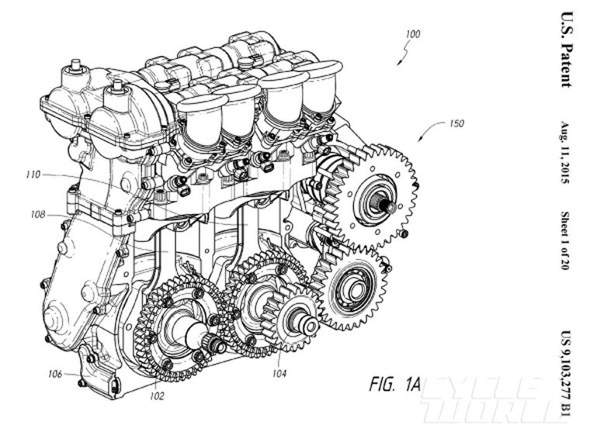
Figure 1: Engine blueprint (Cycle World, 2015)

Ilias Gideon Iatrakis (2011922)
Lecturer: Andrew Harrison

Contents
Contents 2
Introduction 3
1 Testing Equipment 4
1.1 Schenck W230 Dynamometer 4
2 Collected Data 5
3 Torque 6
4 Power 7
4.1 Brake Power 7
4.2 Corrected Power 8
5 B.M.E.P. (Brake Mean Effective Pressure) 9
6 Fuel Consumption 10
6.1 S.F.C. (Specific Fuel consumption) 10
6.2 B.S.F.C (Brake Specific Fuel consumption) 11
7 Overall Thermal Efficiency 12
Conclusion 12
References. 13
Appendices 14

Introduction
The following assignment is an investigation to show the understanding of:

The underlying principles of engine and vehicle technologies, practices for analysis of powertrain and chassis systems including:

- The calculation of performance characteristics such as Corrected Power, Torque, BMEP, SFC and Overall Thermal Efficiency.
- Demonstrating subject specific skills applied to an automotive problem, obtaining and interpreting data in a laboratory environment and drawing relevant conclusions.
- Show cognitive skills with respect to simplification and modelling of real automotive problems.
- The application of fundamental mechanical engineering principles and the analysis of problems and making recommendations on findings.

Testing Equipment

In this part We will explain how the W230 Dynamometer gets used and a brief description of the used Dynamometer.

Schenck W230 Dynamometer

The Schenck W230 Dynamometer is designed for development/ tests of diesel- and fuel engines for passenger cars and commercial vehicles. The Dynamometer has a maximum range of 10 000 RPM and 230 Kw. The W-series Dynamometer can be used to measure force and other parameters put out by the connected engine.

The connected engine gets controlled through a computer interface in the control room next to the dyno room. Via this system we can control the rpm’s and load on the engine. In this case the computer ran an automated sweep test on the engine, this means that the engine was accelerated from idle to full throttle in 5 seconds and then the throttle closed immediately. During this run raw test data which were used for the calculations, were taken.

The 1.6l Vtec Honda engine that is used, is connected by the driveshaft and a flange to the dynamometer. When the engine is running it will drive the Dynamometer’s rotor. The dynamometer’s rotor rotates at the same speed as the engine. When the rotor rotates, it will generate a current and magnetic field which will generate a tension on the outer casing and a load on the engine. As the outer casing wants to rotate, a force will be put on a strain gauge connected to the casing. The strain gauge will then send a signal between 0 and 10 volts to the interface system. The interface then will give us the force put on the dynamometer in Newtons. Most additional data get measured by sensors connected to the engine or systems leading to the engine so we can calculate other data.

Collected Data
We got provided With Raw data (pictured in the appendix, the excel file and Figure 2) collected during the sweep test on the Dynamometer. With these measurements we will be able to calculate further engine characteristics.

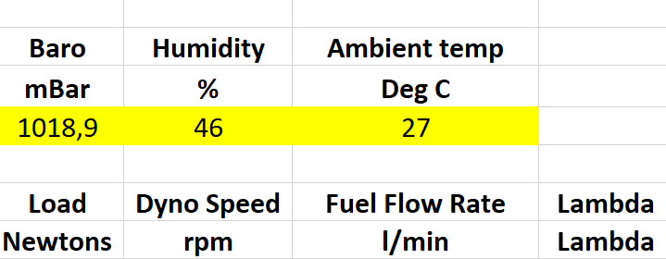
Figure 2: Provided data and units. (Mark Fall, 2020)

Torque
With the previous data we can calculate the torque produced by the engine during the sweep test.

The engine Torque is the tendency to rotate the crankshaft by a force produced by the pistons. The SI-System uses Newtonmeters (Nm) to measure torque.

The Torque is calculated at the end of the Dynamometer’s torque arm, as pictured below. The torque arm radius is 0,815776 meters.

Torque calculation formula:

$$T=F ×r (Nm)$$

Where:

T = Torque (Newtonmeters, Nm)
F = Load (Newtons, N)
r = Radius of the Dynamometer’s Torque arm (meters, m)

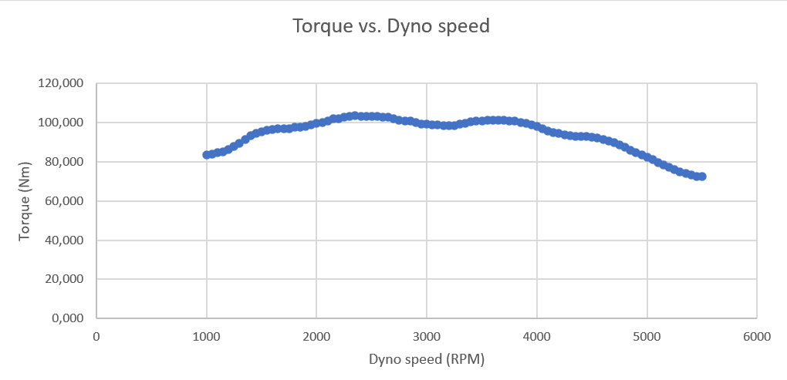
Pictured below in Figure 3 we can see the Torque Vs engine speed graph, As we can see Torque varies with engine speed, in this case the torque increases and tops out at 103,46Nm (Figure 7) but then starts going down again after 3500rpm. For comparison, the manufacturer states that this engine could produce 153Nm when new.
Figure 3: Torque Vs Dyno speed Graph (Iatrakis, 2020)

As we can see in the Torque formula, torque varies in a linear relationship with the load being put out by the engine. As the load put out by the engine gets lower after a certain rpm, the torque will decrease too.

This is because the engine is designed to be most efficient in a certain RPM range, this means that it breathes and detonates the Air Fuel mixture best in between this RPM range to produce as much power as possible, outside this RPM range the efficiency of the engine will decrease following a decrease in Power and Torque.

Power

Brake Power

To calculate the corrected power, we first have to calculate the Brake power.
Brake Power is the Power produced by the engine without any physical losses, therefore it’s capacity.

Brake Power calculation formula:

$$Pb=\frac{2π×N×T}{60 ×1000} (Kw)$$

Where:

Pb= Brake power (Kilowatts, Kw)
N= Engine speed (Rounds per minute, RPM)
T= Torque (Newtonmeters, Nm)

In figure 4 below we can see the relation between Brake power Vs Engine speed. We notice that the power increases until 44,16Kw at 4750RPM and then drops again, this is for the same reason why torque drops at a certain point, in this case the power does keep increasing until higher RPMs in comparison with torque.
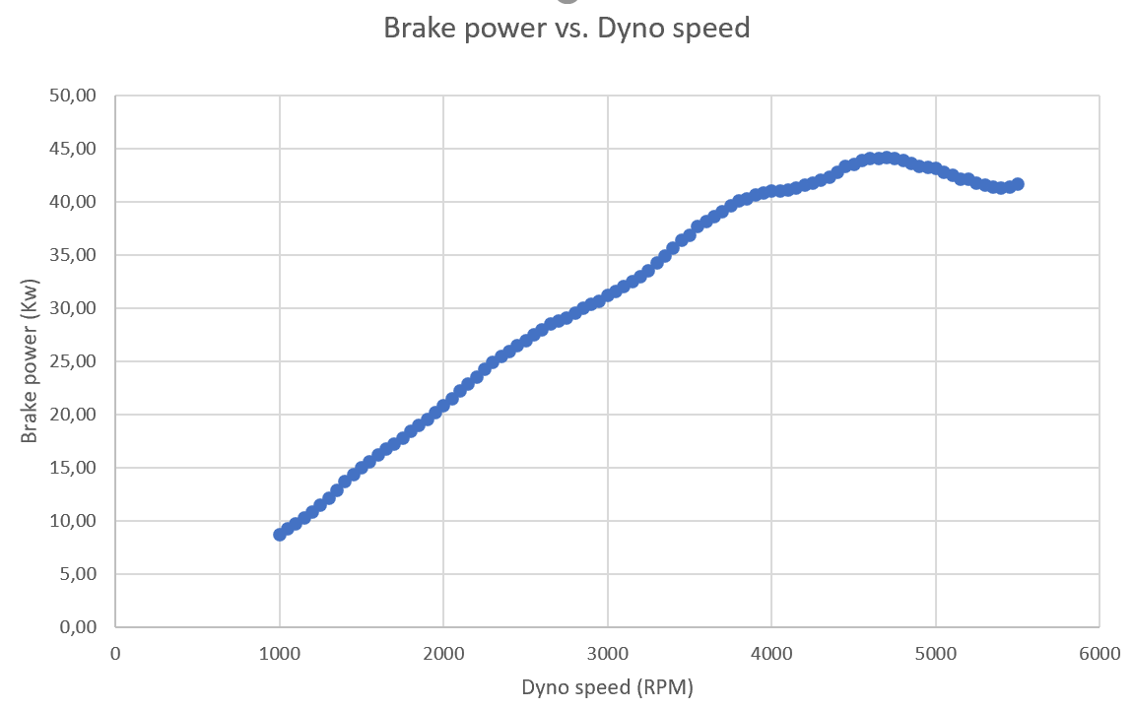
Figure 4: Brake power Vs. Dyno speed (Iatrakis, 2020)

See Figure 7 For result.

Corrected Power

As how well the Fuel/Air mixture burns inside the engine depends on different heights and temperatures due to the amount of oxygen in the air changing. We calculate Corrected power to know the correct amount of power produced in certain weather conditions and locations.

Corrected power calculation formula:

$$Ps=\frac{\frac{Standard pressure}{Ambient pressure}×\sqrt{\frac{Ambient temperature}{Standard temperature}}×Pb}{1000} \left(Kw\right)$$

Where:

Ps= Corrected power (Kilowatts, Kw)
Pb= Brake power (Kilowatts, Kw)
Standard pressure= 1,0135 (Bar)
Standard temperature= 293 (Kelvin, K)

Out of our calculations we find that our peak Corrected power is 44,51 Kw while the manufacturer states that it should make 118Kw, this could be due to poor setting up/ tuning of the engine, the aftermarket air filter and the fact of it being very old and the condition of it being unknown and possibly in bad shape.

See Figure 7 For result.

B.M.E.P. (Brake Mean Effective Pressure)
The definition of Brake Mean Effective Pressure is: the average (mean) pressure which, IF imposed on the pistons uniformly from the top to the bottom of each power stroke, would produce the measured (brake) power output. -EPI Inc.

The B.M.E.P. is purely theoretical and has nothing to do with actual cylinder pressure, it is just a way to evaluate the given efficiency of a given engine at producing torque from a given displacement.

B.M.E.P. calculation formula:

$$BMEP=\frac{Pb×60×2}{L×A×N×n} (Pa)$$

This formula is derived from:

$$Pb=\frac{BMEP×L×A×N×n}{60×2} (Kw)$$
Where in both formulas:

BMEP= Brake Mean Effective Pressure (Pascal, Pa)
Pb= Brake Power (Kilowatts, Kw)
L= Stroke length (meter, m)
A= Bore area (Square meters, m2)
N= Engine speed (Rounds per minute, RPM)
N= Amount of cylinders (No unit)

Engine specs such as Stroke, Bore Area etc. were taken from Engine workshop manual provided by Mark Fall.

See Figure 7 For result.

Fuel Consumption

S.F.C. (Specific Fuel consumption)

Specific fuel Consumption is the specific amount of fuel consumed per time unit. This variable is dependent on the fuel flow rate of the engine.

S.F.C. Calculation formula:

$$S.F.C.=\frac{(Fuel Flow Rate×0,75)}{60} (\frac{Kg}{Sec})$$

Where:

S.F.C.= Specific Fuel Consumption (Kilograms per second, Kg/Sec)
Fuel Flow rate= Variable (Liters per minute, L/Min)
0,75= Specific gravity of fuel (Provided by Andrew Harisson)

In figure 5 seen below we notice the S.F.C. varies with engine speed. As the previous formula states the S.F.C. varies if the Fuel Flow Rate changes, Which is dependent on engine speed.

Figure 5: S.F.C. Vs. Dyno speed (Iatrakis, 2020)

B.S.F.C (Brake Specific Fuel consumption)

Brake Specific fuel Consumption is the specific amount of fuel consumed per Power unit every time unit. This variable helps us determining the efficiency of the engine.

A low B.S.F.C at a certain engine speed and amount of power, means the engine is more efficient, this is because it then can produce more power out of a certain amount of fuel. This means that a less efficient engine will lead to an higher B.S.F.C. , at a given engine speed and power output.

Via the B.S.F.C data/calculations you can compare different types and sizes of engines, to compare the rate of efficiency.
In figure 6 You can see the B.S.F.C. Vs. Dyno speed of our engine.
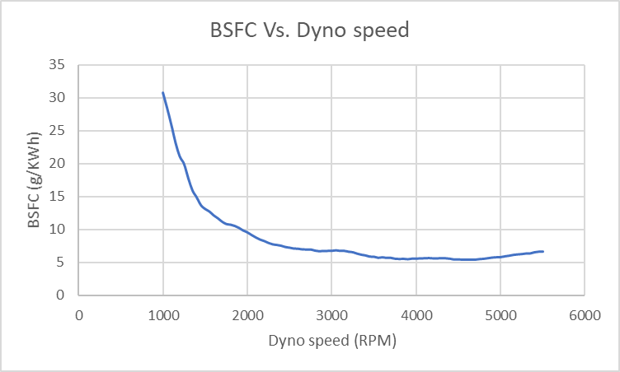
Figure 6: B.S.F.C. Vs. Dyno speed (Iatrakis, 2020)
See Figure 7 For result.

Overall Thermal Efficiency

The thermal efficiency expresses the fraction of heat that becomes useful work.
This gives us the effectiveness which the engine converts the input energy into mechanical power.

The thermal efficiency is represented by the symbol η , and can be calculated using the equation:

$$\text{η =}\frac{Power output}{Rate of energy input}=\frac{Power ×3600}{Gravity of fuel ×calorific Value of Fuel}$$

Researched Calorific Value of fuel (Gasoline) = 44 x 10^6 J/Kg ( Calorific value of Fuel varies through different types of fuels)

See Figure 7 For result.

Conclusion
Out of this assignment I’ve learned how the engine Dynamometer is used and how to calculate various engine performance Characteristics. Out of my research and calculations I have found that the particular engine we tested was Very underpowered in comparison to manufacturer specifications. These manufacturer specifications are from when the engine was new, while ours is fairly old, poorly modified and in unknown condition which all can lead to a lower amount of power and torque etc.

References.
- Carbiketech, 2019. (Online) https://carbiketech.com/engine-torque/ (Torque)

- Sandicliffe,2015. (Online) https://www.sandicliffe.co.uk/blog/the-truth-about-torque-what-is-it-why-does-it-matter (Torque)

- CH. Wendel, 1999. (Book) American Gasoline engines (Fuel)

- Dynomyte Dyno, 2020. (Online) https://dynomitedyno.com/tech-corner/corrected-horsepower/#:~:text=Most%20of%20the%20stated%20horsepower,different%20locations%20and%20weather%20conditions.&text=So%20the%20only%20way%20to,given%20day%20to%20some%20standard (Corrected power)

- Automobile catalog, 1988. (Online) https://www.automobile-catalog.com/car/1998/1117910/honda_civic_1_6_vti.html (Comparison Specs)

- EPI Inc. , 2019. (Online) http://www.epi-eng.com/piston_engine_technology/bmep_performance_yardstick.htm (BMEP)

- X-Engineer, 2020. (Online) https://x-engineer.org/automotive-engineering/internal-combustion-engines/ice-components-systems/mean-effective-pressure-mep/ ( BMEP)

- Collins Dictionary, 2020. (Online) https://www.collinsdictionary.com/dictionary/english/specific-fuel-consumption#:~:text=Specific%20fuel%20consumption%20is%20the,produce%20a%20unit%20of%20thrust (SFC)

- NASA, Nancy H., 2015. (Online)https://www.grc.nasa.gov/www/k-12/airplane/sfc.html ( BSFC)

- Making A Move, 2009. (Online) https://s2.smu.edu/propulsion/Pages/efficiency.htm ( Efficiency)

Appendices
Data acquisition and formulae used in each section of the process of this investigation were provided by Mark fall and Lecturer Andrew Harrison.

Figure 7: Results Calculations

