Ways of perceiving ADAD4010 John Douglas 1703841 Fine Art

Tutors: Ryan Moule / Rob Jones

1530 words including appendix but excluding footnotes and bibliography.

‘We need to talk about curating’ (Shriver 2003 mis-appropriated).
Note: This essay develops a theory of curation ‘fit for today’s world’ to inform an exhibition plan.

In our everyday life we are bombarded with fabricated images. These need to be included in discussion of ‘art’ (Elkins 1999) informed by both art-theory and wider theories of viewing and image-consumption. Artists and the ‘art market’ have, in any case, long agreed [if for very different reasons] an ‘anything goes’ concept of what now counts as ‘art’, so too the ‘graphic-messaging’ industries of Instagram, Facebook, et al. Yet just as “a public space can become so familiar that a person doesn’t see it anymore” (Hoffman 2015) so ‘the mass of images bombarding us’ is so ‘everyday’ and banal it is overlooked in discussion.
Discussion now requires more than just deconstruction of images or even ‘grand narratives’ of art; more than just challenging or subverting traditional rules, the preceding art movement or exhibition paradigm; more than just further ‘opening up’ to more ‘democratic’ inclusion of diverse artist/ gender/ race/ identity/ heritage/ outsider and ‘other’ perspectives. What’s needed is an understanding of how this plethora of ‘everyday images’ [including art images] impacts on the ‘everyday life’ of the ‘everyday person’ , their handling and making sense of these, their making sense of the world, their ‘way of seeing’ (Berger 1972, Lefebrve 1957, de Certeau 1984).
Critical responses have included Baudrillard’s argument that we now live in a ‘hyper-reality’ where everything we see and think is predominantly shaped by ‘images’ and ‘our image of things’, and that ‘things may not actually be as we see’, that we live in a fabricated ‘reality’ where ‘truth’ is fabricated for us (Huxley 1932, Postman 1986, D’Ancona 2017). This relates to critiques of the positioning of the individual in contemporary ‘western/westernised’ societies. The exponential increase in our exposure to images (‘artistic’ or not) has accompanied unprecedented increases in the speed and reach of graphic/image ‘messaging’ technologies (used for news, social networking, entertainment, advertising and political purposes) exposing us as ‘customer/client/consumers’ in economic and political worlds where the abstracted statistics and patterns of our response-behaviours are key drivers of economic and political decisions taken to modify our ‘ways of seeing’ the world .
There is also growing recognition of the ‘simultaneity’ (Soja 1989) of modern or ‘post-modern’ life, a concept seeking to capture the incessant flow of fleeting images, the acceleration of ‘time’, the over-abundance of ‘events’ and shrinking of space in our world (Auge 1992), fostering new ‘horizons’ but also a new ‘depthlessness’ (Vermeulen 2015). The ‘deconstruction’ (Derrida et al) of ‘narratives’ which ‘explained the world’ and even the ‘meta-narratives’ which usurped these, leaves ‘relativism’, ‘post-history’, ‘chaos-theory’, and other ‘non-sequential’ (Soja 1989) narratives as the only logically defensible ‘ways of seeing’. These, not un-coincidently, sit alongside the global predominance of ‘free-market’ ‘anti-regulation’ ‘capitalist’ economics, arguably a ‘meta-narrative without a narrative’.
It is no coincidence that all this has developed alongside an ‘anything goes’ exponential expansion in what ‘counts’ as ‘art’ [the breakdown of regulating narratives]; exponential increases in the numbers of art museums/galleries, exhibitions/events/performances, art-programmes/publications, public-space/on-line art-provision [the work of consumption focussed economics]; increased popular-consumption of all this [or, at least, the image/media/marketing driven impression of this] and an exponential increase in ‘curators’.
For the curator, the breakdown of traditional art narratives, including museum exhibition traditions, has created the need to ‘keep up with the times’, to help museums and patrons to interact with the changing art-world and to rethink the ‘philosophy’ of exhibiting (Serota 1996, Pollock 2007, Obrist 2014, O’Neill 2016).
One driving force has been the commercial / funding pressure to secure viewer numbers and high-profile critical reviews. Herein lies the ‘blockbuster’ exhibition, the ‘great artist’ / ‘great art movement’ show, the ‘consumer-leisure-industry of art’ with supporting provisions [brochures, video-programmes and memento industry]; the ‘society of the spectacle’ (Debord 1967).
A second driving-force came with the rebellion of modern artists against academy exhibition traditions and controls and for exhibition to be more on the artist’s terms (Serota 1996). This has spawned artist/curator collaborations, often hugely creative……but usually with the same commercial or further ‘diversification of images’ outcomes.
A third driving force of change might have been the ‘viewer’. This has ‘history’; the founding-purposes of public museums, the shift to single-line eye-level display, the labelling and explanation of art-works, changing fashions in ‘display-narratives’, provision of refreshment facilities and mementoes were all ‘viewer-centred’ innovations. In reality, however, the viewer has been the most passive, least active of forces, at best the consumer who needs ‘attracting in and catering for’.
The curator, meanwhile, [sometimes working with the artist] has become the key interlocutor between art and public ,‘curating’ the way art is presented to the viewer and determining thereby the nature and role of art in a society where images have become the omnipotent form of messaging.
A key issue therefore is what theory of art, of images, of ways by which people make sense of images should underpin the curator’s practice? One answer is that ‘anything goes’ in the ‘free market’; whatever the curator believes will be commercially successful and/or useful for their career/reputation, and/or believes the consumer wants/needs. The obvious problem here is that the viewer/consumer is essentially passive; a consumer, with lots of choice but only to ‘pick-&-mix’ or follow whatever ‘fashions’ the art-exhibition-industry has fabricated, consuming images at breakneck speed in “a culture that emphasises distraction, distortion and decontextualisation” (Grande 1994), a culture of passing spectacle (Debord 1967) and delusionary individualism (Auge 1992) within Baudrillard’s hyper-reality of fleeting sensation, where consumption has replaced ‘conversation’ (Berger).
There are noteworthy exceptions here. Identity art [Feminist, Black, Indigenous] and ecological-art (Grande 1994) do reflect bodies of knowledge, theories of image and representation, ‘rules’ by which not-anything-goes. These are ‘movements’ which have developed active, engaged viewers. A further distinction is therefore required, between ‘active as in committed’ and ‘active as in enabled to engage’. Argument on how to ‘activate’ audiences has a long history but Ranciere addresses the point; it’s not how we ‘activate’/‘teach’ the viewer, it’s how we support the viewer in finding their own ability to engage as opposed to having yet more things done to them; to ‘grow’ “emancipated spectators” “active interpreters who develop their own translation in order to appropriate the ‘story’ and make it their own” (Ranciere 2009) able to curate for themselves the images others are busy ‘curating’ for them.
The means for achieving this [missing in Ranciere’s argument] lies in non-didactic exhibitions which recognise that every individual has a different ‘preferred learning style’. ‘Fit-for-purpose’ exhibitions in today’s world need to specifically provide for such diverse preferred learning styles to ‘grow’ Ranciere’s ‘emancipated spectator’, support the ‘birth of new readers / viewers’ [Barthes and Foucault], “to be explored by visitors according to their particular interests and sensibilities….in which visitors can experience a sense of discovery” (Serota 1996 p55).

This view of ‘curating’ informs the attached exhibition plan.

Bibliography.
Auge M. (1992) Non-places Verso 2000
Bailey J. / Biggs I. (2012) Delphy Bridge: a deep-mapping project. Journal of Rural Studies 28.
Barthes R. (1977) The death of the author Fontana
Berger J. (1972) Ways of seeing. Penguin
Casey E. (1996) How to get from space to place. In KH Basso Senses of Place. Sch of Am Research
Debord G. (1967) Society of the spectacle. Red and Black 1984
De Certeau (1984) The practice of everyday life. Univ of California.
D’Ancona N. (2017) Post-Truth. Penguin/Ebury
Elkins J. / McGuire K. (2013) Theorising visual studies. RRoutledge.
Elkins J. (1999) The domain of the image. Cornell
Foucault M. (1991) What is an author? Penguin
Grande J.K. (1994) Balance: Art and Nature. Black Rose Montreal.
Hall S. (1997) Representation. Open Univ./Sage
Hoffmann (2015) in Unexpected Art Site Specific works. Ed J Moussa 2015 Chronicle SanFran
Huxley A. (1932) Brave New World. Penguin
Irvin S. (2005) Appropriation and authorship. British Journal of Aesthetics Vol 45 No 2 April 2005
Lefebrve H. (1957) Critique of everyday life. Verso 2014
McCarthy T. (2015) The death of writing The Guardian March 2015
Obrist H. (2014) Ways of curating. Farrar, Strauss, Giroux NY.
O’Neill (2016) ed. Curating research. Open Editions.
Osborne R. (2010) Art Theory. Zidane
Pollock G. / Zemans J. (2007) Museums after modernism. Blackwell.
Postman N. (1986) Amusing ourselves to death. Methuen.
Richards K. (2008) Derrida reframed. IB Taurus, London
Serota N. (1996) Experience or interpretation: the dilemma of museums of modern art. T&H
Shriver L. (2003) We ned to talk about Kevin. Counterpoint.
Soja E. (1989) Post-modern geographies. Verso.
Turner L. The new aesthetics’ speculative promise. www.metamodernism.com 02/07/12
Vermeulin T. (2015) The new depthiness. (Course materials)
Wilson F. (1992) Mining the museum. Maryland Historical Society, Baltimore.

Appendix: an illustrative exhibition plan where the particular themes and works are of secondary importance to the non-didactic provision for viewers to proceed according to their own, particular preferred-learning styles.
Title: ‘To care for ones kind’
Works with floor plans for locations NB works not titled/artist-named (see below)
- Child with dove. Picasso 1901
- Venus with rags. M. Pistoletto 1967 Sub Michelangelo Madonna for Venus?
- When I am pregnant and Descent into Limbo A Kapoor 1992
- A period piece. M Nelson 2019
- Eisenstag. A Kiefer 1986
- Post-Partum (samples of multi-part work, including wool vests) M Kelly 1973 (running around curved wall)
Plus: loop carousel of b&w photos of Jarrow Crusade, US ‘Grapes of Wrath’ migration, Yugoslav war-migrants, Mediterranean boat migrants, Syrian war-migrants and print-images of C18th-C19th Irish and Scottish emigrations.
Arrangements to address different preferred learning styles of viewers:
- Word will have circulated of a Picasso being present (public-interest)

- Impact of first-sightings (Picasso at entry, then Pistoletto, etc)
Then discovery sightings of other works
Other discoveries: carousel of photos, tray-boxes of postcard reproductions of works similar but different to each of the 6 main pieces (e.g. black Madonna)

- Linkage to host-building/site (chapel for seafarers and port)

- Relaxed setting: soundtrack of tidal wash and gulls

- Mix of ‘famous’ / lesser known works; of original / reproductions;
of 3D / 2D; of painting / haptic* / installation / affective / evocative / found / appropriated / assemblage / conceptual / photographic works

- Mix of juxtapositions / thematic-linkages / intertextuality / free-association across images, materials, mediums, concepts of art

- No naming, labelling or textual guidance….but tray-boxes of information cards relating to each piece for viewers to sort through and use if they so choose.

- Space to walk / to sit / to look / to ferret / to read / to watch / to contemplate.

- Opportunities to take photographs (incl. ‘selfies’), to handle/look-through reproductions (W Benjamin’s belief in the ‘opening up of art’ this could achieve); and to take-home prints, photocopies, list of artists, info on particular artists/works.

- Copies of local related-initiative free-publications e.g. The (Swansea) Windrush Project (2018) and Young Migrant and Welsh (2018) (referenced below image-references)
* Haptic art: see https://hapticart.org for an enterprise developing 3D touch-models of 2D paintings, primarily for blind / visually challenged persons but more widely to further enhance all people’s sense of vision.
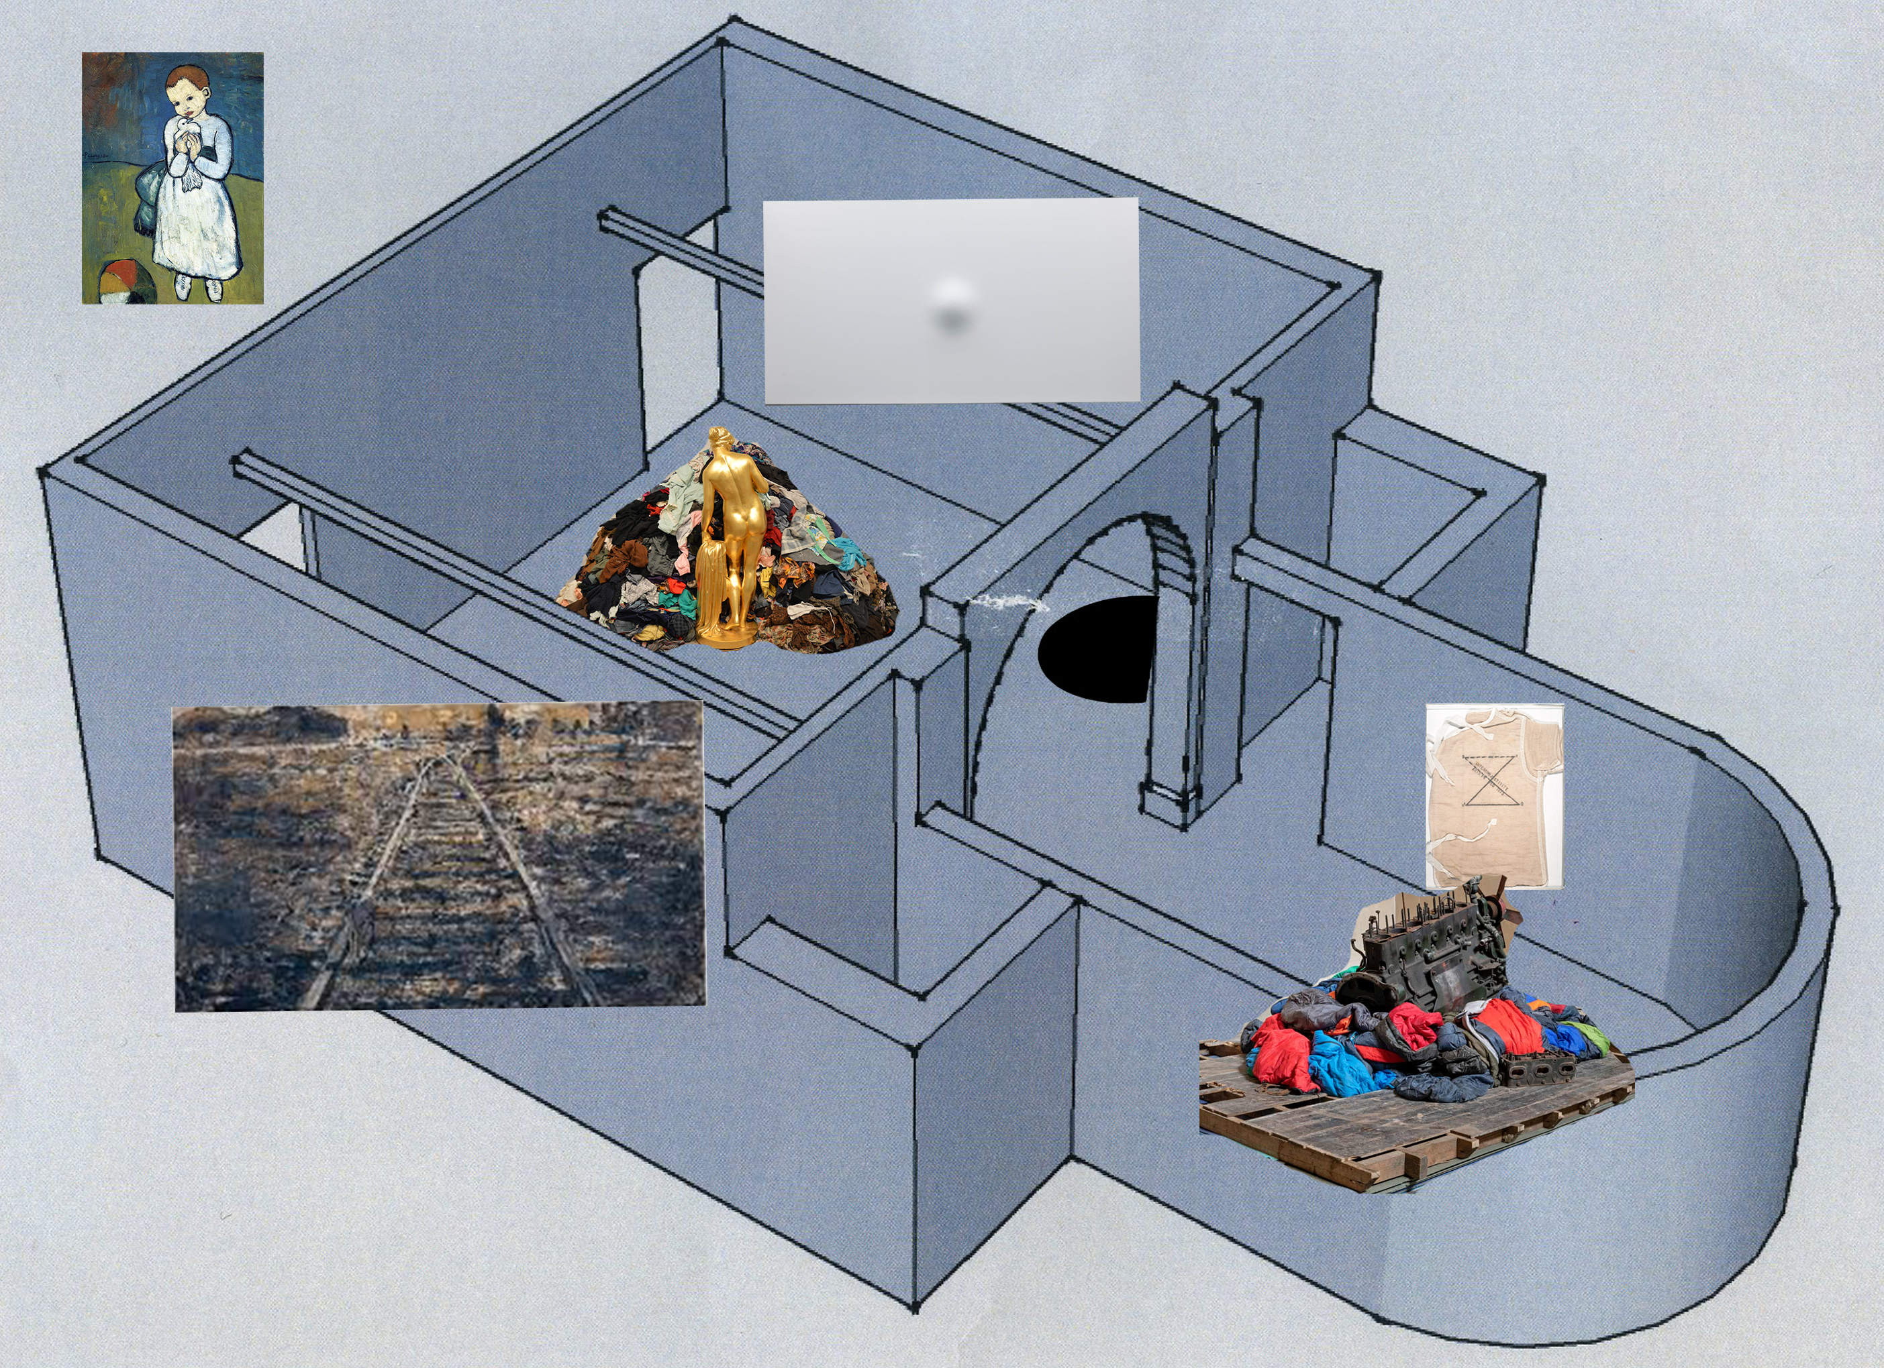
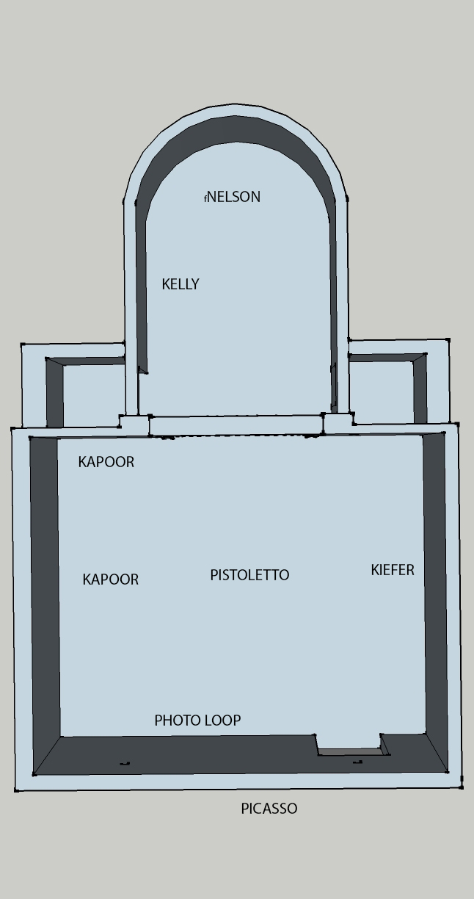
Image referencing:

Picasso P (1901) Child with dove [Oil on canvas] Available at http://www.wikiart.org (Accessed: 2 April 2019)
Pistoletto M (1967) Venus of the rags [Marble and textiles] Available at http://www.publicdelivery.org (Accessed: 2 April 2019)
Kapoor A (1992) When I am pregnant [fibreglass and paint] Available at http://www.realitybitesartblog.blogspot.com (Accessed: 2 April 2019)
Kapoor A (1992) Descent into Limbo [concrete and stucco] Available at http://www.theartstack.com (Accessed: 2 April 2019)
Nelson M (2019) A period piece of the relatively recent past [engine and textiles] Available at http://www.theguardian.com (Accessed: 2 April 2019)
Kelly M (1973) detail: Post-Partum document: Introduction [Perspex unit, white card, wool vest, pencil, ink] Available at http://www.marykellyartist.com (Accessed: 2 April 2019)
Kiefer A (1986) Eisen-stag [oil, acrylic, olive branches, lead, iron, gold-leaf and emulsion on canvas] Available at http://www.christies.com (Accessed: 2 April 2019)

The Windrush Project (Swansea) isioma.ikediash@africancommunitycentre.org.uk
Young Migrant and Welsh (Swansea) http://www.ymw.eyst.org.uk

This is, of course, a (mis)appropriation of Shriver’s title for her story of post-modern US life, a life of confusion, violence, uncertainty, self-doubt and the end of naïve optimism: ‘We need to talk about Kevin’
Given that an increasing proportion of these images are directly informed by art practices and training programmes, they certainly warrant critical analysis informed by both art-theory and wider theories of viewing and image-consumption.
“Contemporary exhibition spaces are full of anything and everything from sharks to photographs, piles of rubbish to multi-screen videos.” (Wood 2002 p6)
adding for globalising reach and/or subtracting for specific localised conditions
Hence the growth in visual/cultural studies and the recognition that the critical study of images, their use and ‘curation’ by others is just as important as the critical study of language and text (Hall 1997, Elkins 2013) and, indeed, wider theories of knowledge and society.
Religion, Classical/Renaissance/Enlightenment ‘Reason’, Positivist confidence in the ‘progressive’ course of ‘Man’ and ‘History’, nationalism of the ‘chosen’ / imperialist / exceptionalist kinds etc
Marxism, Freudianism, Keynsian economics, liberation nationalisms etc
The breaking down of pre-C20th ‘grand narratives’ and the modern metanarratives which replaced these, has been matched by the rethinking of ‘what is art’, removing restrictions, opening up new freedoms of medium and site, the ‘mining’ of archives (Wilson), the rethinking of exhibition, of artist/gallery relationships, of artist/viewer relationships and of the curator’s role.
Paradoxically this confirms Derrida’s view that the visual arts have a special capacity to both reflect and lead wider social, cultural, political and intellectual change (Richards 2008 p58)
Just as it is now argued ‘we are all able to self-identify as artists’ [if we so choose], it is even more the case that each and every one of us has necessarily become ‘a curator’ in order to ‘handle’ the everyday bombardment of images, much as “everybody has a theory of art, although they may not have stopped to consider it.” (Osborne 2010 p1)
together with vastly increased professional opportunities [and alongside the traditional roles and responsibilities of archiving, purchasing, conserving, exhibiting, working with funders/sponsors etc
replicating the pressure on artists themselves to ‘do something new, something original’, to be noticed and commercially competitive.
There are important and instructive exceptions. Perry Grayson’s ‘mining’ of the British Museum 2011/12 for instance addressed at least some of the exhibition-requirements this essay will propose.
Hence the argument that curators have supplanted the role of art-critics ( ).
Note: ‘direct artists’ who present directly to the viewer independently of any curator [e.g. street-art, site-art, artist-event] are also ‘interlocutors’ but only of their own work.
An extended debate was undertaken by the likes of Bloch, Lukacs, Brecht, Benjamin and Adorno through most of the C20th (Aesthetics and Politics 1977)
This addresses the challenge so many have identified: how the everyday person handles and makes sense of the everyday world, realising ‘the birth of the reader/viewer’. See: Lefebrve, de Certeau, Grande, Gauretti, Barthes, Foucault, Casey, Goniza, etc.
This reading of the curator’s responsibility also addresses the issue of ensuring that public places, such as museums, fulfil their public/civic responsibilities (Serota 1996, Pollock 2007 ) becoming “a public place, publicly responsible for stimulating and housing critical thinking in and through art…a critical site for public debate.” (Pollock xx Preface).

