


The Module Title and Code: BMBM6012 – Leading and Developing People

Student name: Ziqi Xu
Student id:2008846

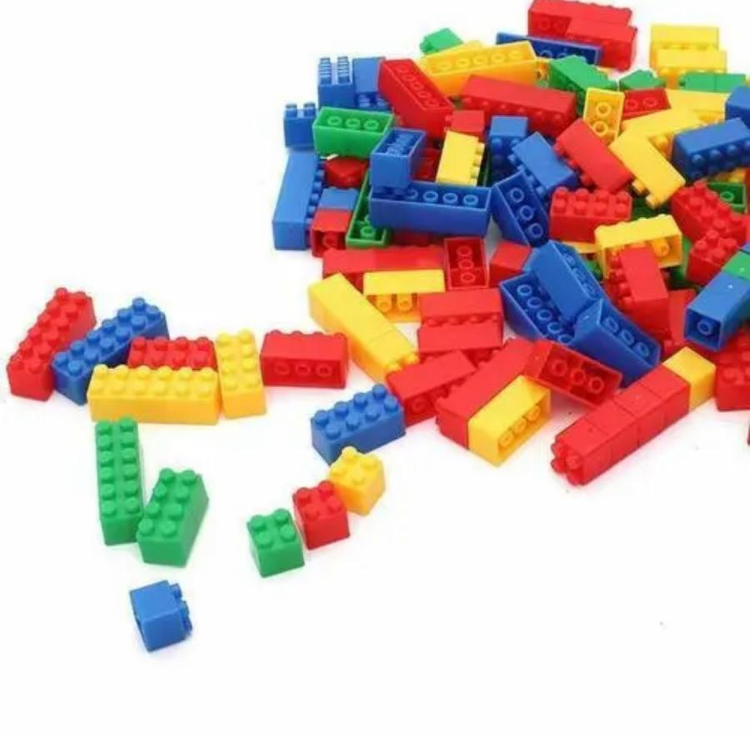
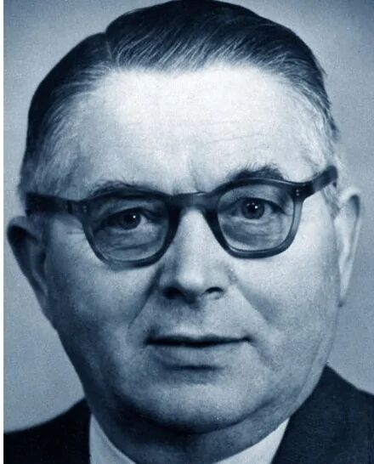

Content
1Introduction 3
2 Main Body 3
3 Conclusions 6
4 Reference 6

1Introduction
In Billund, a small, single-sale town, a company was born called Lego. Ole Kirk Christiansen, the founder of Lego, was born in 1891.He was a skilled carpenter and had his own wood processing plant. (Ian Shapira ,2017).Through his excellent leadership character and outstanding leadership strategy, he was able to successfully overcome the economic crisis in Europe in the 1930s(Excitement Builds for Opening of LEGO(R) Transportation Exhibition: LEGO(R) Wheels, Wings and Waves designed to inspire children of all ages ,2009).Mr. Christensen began to apply his fine wooden craftsmanship and artistic sensibility to wooden toys. He discovered the plasticity of wooden toys. He hung a wooden plaque in the factory with his motto engraved on it: "Only the best is good enough." This motto remains lego's first principle to this day(Daniel Mcginn ,2007).
The great Depression of 1932 hit Pumon, Denmark. The toy market has been hit hard. All the craftsmen couldn't get orders, and his wooden factory laid off its last worker. He did not give up but tried new opportunities and new techniques. (Johnny Davis ,2017) He took the guild's advice and began making household products, making the fateful change to focus his wood factory on toys. Ole Kirk Christiansen saw the importance of toys to his customer base with his clear product positioning and business acumen. He also transformed and pruned the company's sprawling toy portfolio into a global powerhouse.He is not only a democratic leader but also a transformational leader.His most important achievements were his recognition of the importance of toys for children and his discovery of the plasticity of plastic toys opened up a bigger market for Lego(Brick by Brick: How LEGO Rewrote the Rules of Innovation and Conquered the Global Toy Industry,2013). Essay introduced VUCA Environment. This essay theoretically analyzes three leadership models and three management styles. Combined with Lego, this essay analyzes the impact of different leadership modes on the company and the impact of management style on the company. Leadership is also mentioned at the end of the report. References are provided at the end of the essay.

2 Main Body
VUCA environment actually refers to the four factors that will affect the expected object. They are variability, uncertainty, complexity and ambiguity. The term VUCA, derived from military usage, began to be widely applied in the 1990s to various organizational strategies ranging from education to for-profit companies. It can improve the performance of organizations and individuals in the enterprise. Leaders also consider their own management models based on this environment (Troise,2022).
The leadership model is actually a theoretical framework for measuring the best way to manage employees. There are 12 different models of leadership( Northouse, 2019).
Authoritarian leadership is characterized by the concentration of power in the hands of the leader.Employees have no right to participate.Authoritarian leadership is characterized by the concentration of power in the hands of the leader.Employees have no right to participate.(Chiang,2021).Management style is closely related to the style of the leader. The style of the leader will directly determine the management style. Management style will determine the working environment of the company, the way superiors and subordinates interact with each other, and the scope of power of each class. There are five main types of management styles: mediocrity management style, poor management style, authoritative management style, country club management style, and team management style (Barke and Cole, 2009).
Authoritarian leadership is often Authoritarian management. This leader only cares about efficiency. They usually pay more attention to the impact of the work environment on the job rather than personal factors(Caraway and Crowley, 2015).
Democratic leaders distribute power to those who are led.Democratic leaders initiate discussions, brainstorm, and then make decisions about leadership styles. It is required that all work harmoniously and cooperatively. It is manifested as democratic consultation and democratic participation. The former is that managers solicit, accept and adopt the suggestions of their subordinates when making decisions. Leaders establish both top-down and bottom-up, two-way communication (Dorow,2019).Such leaders often adopt a country club style of management. This is a management model that seeks the support and sympathy of subordinates. Managers often rely too much on the advice of their subordinates. He pays close attention to advice and creates a friendly working environment for the company in this management mode(Sulieman, 2017).
Unlike authoritarian leaders, Ole Kirk Christiansen was a typical democratic leader.
Lego is committed to working with its employees and respecting their values and giving them the opportunity to thrive(Gerri,2018).Here's reason.
The atmosphere at Lego is relaxed and creative. The company will respect and consider every designer's design ideas to create many different new products. This is how Christiansen's leadership model influenced the management of the company. This kind of work environment can promote the development of new products, but the management is too loose. Before the 1990s, Lego had no competitors to deal with, so the benefits of this leadership model outweighed the disadvantages(Kollsker and Malaguti, 2021).There is no unified measurement standard for the development of new products. In the face of higher costs, sales fell, resulting in a negative cash flow of $180 million in 2003. That's the downside of Christiansen's leadership model.This is the defect of a country club style of management.(Olsen, 2015).
Lego's leadership model to solve this crisis can be seen as the leadership style of autocratic leaders. Autocratic leaders are more focused on understanding what employees want and controlling their behavior and emotions in order to achieve their goals. Companies that focus on this type of leadership often set clear conditions for employees and they will be fired if they don't meet those conditions. Moreover, in this environment, leaders have more decision-making power and do not worry too much about employees' personal emotions, that is to say, they can sacrifice themselves for the sake of the company(McGillivray and Smith, 2018).
Lego's new leader, Jorgen Knudstorp, took a big axe to several bloated product lines. It lowered the cost of Lego toys and in order to ensure profits it enacted the famous 13.5% rule that from now on, every Lego product should have a profit margin of at least 13.5%, otherwise the product would be obsolete. The leader, who is stronger than Christiansen, has also saved Lego from near-bankruptcy.It defuses the crisis caused by democratic leadership model by cleverly using the characteristics of autocratic leadership model(LEG-GO stilettos: Finn Stone gives new life to stilettos using Legos ,2011).
Transformational leaders attract employees through charisma, leadership charisma, and a nose for the market( Bass and Riggio,2006).Such leaders often adopt a team management style. This is a kind of organization and individual, work and enthusiasm to achieve a high degree of harmony of management mode(Parker, 2008).
He is also a quintessential transformational leader.Christiansen was acutely aware of the need for transformation at the outbreak of The Second World War. During World War II, metal and rubber were not allowed to be used to make toys in order to secure military supplies. Quite part of the toy business was hit, Lego's wooden toys have ushered in a huge business opportunity. He found that wood was a finite resource, and if toys continued to use wood, the cost would go up. At this time, injection molding machine just rise. He turned his attention to cellulosic acetate, or synthetic plastics. The fire-resistant, water-resistant and inexpensive material is not yet widely used. Ole believes in plastic as a toy material that can replace wood. What's more, plastic is more playable for toys. Plastic products are not more plastic and playable. Unlike wooden blocks, they are not limited by shapes and can be built into a variety of shapes. The Lego company did not fall, but thrived in the second World War.His pioneering plastic toys and long-term vision proved him to be a transformational leader (Gonzalez, 2016).It is this spirit of constant innovation that has attracted legions of equally innovative employees to Lego(Ken ,2013).Christiansen's inspiration as a change leader continues to inspire every leader at Lego. Jorgen Knudstorp, who solved the Lego crisis, also learned from his spirit of change by adopting innovative leadership. Each line of toys was given a game mode to attract customers and be successful. In general, Ole Kirk Christiansen's leadership style and management mode have brought more positive influences than negative ones to Lego. (Marie-Emmanuelle Mathieu et al,2012).
Christiansen's three leadership skills are also key to the success of the Lego empire.These skills are Learning Agility, Social Intelligence and Emotional Intelligence.
Emotional intelligence was developed by Peter Salovey and John Mayer. It's a theory of mind. This theory describes what is called emotional intelligence as the ability to sense and acquire emotions. If a person has this ability, he or she is better at thinking, copying, and regulating the emotions of others or himself to promote emotional and intellectual growth than someone with average emotional intelligence. This mental ability can be applied to a wide variety of fields.(Goleman, 2020).Expanding from a small factory to a large one shows that Christiansen is good at driving people and understanding their emotions. That's why so many people are willing to follow him and build lego(Fagerstrøm, 2020).
Learning Agility is the ability to integrate thinking mode and corresponding situational practice. The person who has this ability to delete the knowledge points he has learned and refine and develop them to solve the current dilemma. It is generally accepted in business to allow development, growth and the use of new strategies to solve problems that are now becoming more complex. Learning Agility encompasses a set of qualities and attributes that enable individuals to learn, adapt and apply themselves in changing conditions to better live or achieve existing goals(Bolles,2018).This Ole Kirk Christiansen leadership skill is the most obvious of the three. First, he was good at spotting problems such as the outbreak of The Second World War, which increased the cost of toys made of wood. He immediately saw the plasticity of synthetic plastics. This is the perfect solution to the impact of the Second World War on the business. Because other toy makers have pulled out of the market, Lego has taken over the toy market. This laid a solid foundation for lego's future success. This is also one of Christiansen's key contributions to Lego(Brent Balinski ,2013).
Social intelligence was first described by John Dewey (1909) as the ability to observe and understand the social environment. It is part of the ultimate goal of moral education. The definition of social intelligence evolves over time (see Kihlstrom & Cantor, 2011, for a more detailed history of this evolution). Later, the concept of social intelligence was incorporated into One of Thorndike's (1920) three types of intelligence and was defined as "understanding and managing men and women. Social intelligence comes from the interaction between people, whereas emotional intelligence can only come from one person. In business, people with better social intelligence have a stronger ability to interact with the group, and the group is more likely to be led by such people to achieve corporate goals.(Sternberg and Kostić, 2020).Replacing wooden toys with plastic was an unknown and risky decision. Only Christiansen's third son and some of his staff supported him at the time. This proves to some extent that Christiansen's leadership skill is not as obvious as the previous two skills. Most people obviously didn't understand his decision but they followed it because he was the leader. In the later period of Lego, the lack of this technique resulted in too many product lines. Too much power for designers led to the lego crisis(Jensen and Lettl, 2014).

3 Conclusions
Essay introduced VUCA Environment. This essay critically examines Ole Kirk Christiansen's leadership model. This essay also analyzes three management styles theoretically.Essay theoretically discussed three definitions of autocratic leadership model, democratic leadership model and transformational leadership model. According to their definitions, The essay also judged that Christiansen's leadership model belongs to democratic leader and transformational leader. Essay critically discussed the disadvantages and advantages of the three leadership modes and Christiansen's leadership of Lego and its influence on Lego. Combined with case studies to critically distract from the differences between the three leadership models. Essay also analyzed three kinds of leadership skills and gave their theoretical definitions respectively. Combining the strength of Christiansen's performance in these three skills, this paper analyzes his technical expression in different situations. The depth of his leadership to Lego. Finally, the essay gives all references for analysis.

4 Reference

- ‘Brick by Brick: How LEGO Rewrote the Rules of Innovation and Conquered the Global Toy Industry’ (2013) Publishers Weekly. PWxyz, LLC, p. 123–.
- ‘Excitement Builds for Opening of LEGO(R) Transportation Exhibition: LEGO(R) Wheels, Wings and Waves designed to inspire children of all ages’ (2009) Marketwire [Preprint].
- ‘Excitement Builds for Opening of LEGO(R) Transportation Exhibition: LEGO(R) Wheels, Wings and Waves designed to inspire children of all ages’ (2009) Marketwire [Preprint].
- ‘Job training Serious Play; EnteLead uses Legos, other toys to develop thinking, leadership skills’ (2003) Crain’s Detroit business, 19(17), p. 11–.
- AGE Publications, Inc.
- Barker, S. and Cole, R. (2009) Project Management: What the Best Project Managers Know, Say and Do. Repackaged 1st ed. Place of publication not identified: FT Press.
- Bolles, G. (2018) Learning Agility. Carpenteria, CA: linkedin.com.
- Brent Balinski (2013) ‘Ten controversies involving Lego’, FEN [Preprint].
- Caraway, T.L., Cook, M.L. and Crowley, S. (2015) Working through the past : labor and authoritarian legacies in comparative perspective. Ithaca, New York ;: ILR Press. doi:10.7591/9780801455483.
- Daniel Mcginn (2007) ‘Building an Empire One Block at a Time; In an age of high-tech toys, Lego is reinventing itself. The old-fashioned bricks have never been more popular. Here’s how the company does it: U.S. Edition Edition’, Newsweek, 149(15), p. E.08–.
- Fagerstrøm, A. et al. (2020) ‘The marketing firm and co‐creation: The case of co‐creation by LEGO’, Managerial and decision economics, 41(2), pp. 226–233. doi:10.1002/mde.3077.
- Fryer, M. (2011) Ethics and organizational leadership developing a normative model. Oxford: Oxford University Press.
- Gerri Willis et al. (2018) High Stakes Hearing; Trump on Kavanaugh; Fed Raises Rates; Navy SEALs on Applying Military Experience to Every Day Leadership; Passenger In Indonesia Discovers Assigned Seat Doesn’t Exist; Turtle Gets Lego Wheelchair To Help Him Heal; Amazon’s Four-Star Store, Mornings with Maria. New York: CQ Roll Call.
- Goleman, D. (2020) Emotional intelligence. London: Bloomsbury Publishing PLC.
- Gonzalez, G. (2016) ‘EMPLOYERS CUT LOSSES BY INCLUDING WORKERS IN SAFETY STRATEGIES; Lego, Caterpillar report successes after change in approach’, Business insurance, 50(15), p. 6–.
- Ian Shapira (2017) Lego’s plastic bricks transformed childhood. Are they sturdy enough to survive screens?: Lego, the Danish company founded more than 80 years ago, recently laid off 1,400 employees, but the company has overcome financial struggles before, Washington Post – Blogs. Washington: WP Company LLC d/b/a The Washington Post.
- Jensen, M.B., Hienerth, C. and Lettl, C. (2014) ‘Forecasting the Commercial Attractiveness of User-Generated Designs Using Online Data: An Empirical Study within the LEGO User Community’, The Journal of product innovation management, 31(S1), pp. 75–93. doi:10.1111/jpim.12193.
- Johnny Davis (2017) ‘How Lego conquered the world’, Week (London, England : 1995), (1128), pp. 52–53.
- Ken Perlman (2013) ‘LEGO Leadership Lessons’, Leadership Excellence Essentials, 30(12), p. 9–.
- Kollsker, T. and Malaguti, E. (2021) ‘Models and algorithms for optimising two-dimensional LEGO constructions’, European journal of operational research, 289(1), pp. 270–284. doi:10.1016/j.ejor.2020.07.004.
- LEG-GO stilettos: Finn Stone gives new life to stilettos using Legos (2011) Instablogs. Shimla: Athena Information Solutions Pvt. Ltd.
- Marie-Emmanuelle Mathieu et al. (2012) ‘LIF-Dependent Signaling: New Pieces in the Lego’, Stem cell reviews, 8(1), p. 1–. doi:10.1007/s12015-011-9261-7.
- McGillivray, F. and Smith, A. (2018) Punishing the Prince : A Theory of Interstate Relations, Political Institutions, and Leader Change. Princeton, NJ: Princeton University Press,. doi:10.1515/9780691190372.
- Olsen, P.E. (2015) ‘Save the whales? A public relations crisis at Lego’, Journal of critical incidents, 8, p. 130–.
- Parker, G.M. (2008) Team players and team work : new strategies for developing successful collaboration. 2nd ed. San Francisco, CA: Jossey-Bass.
- Sternberg, R.J. and Kostić, A. (2020) Social Intelligence and Nonverbal Communication. 1st ed. 2020. Cham: Springer International Publishing. doi:10.1007/978-3-030-34964-6.
- Sulieman, M. (2017) ‘Attitudes Of Jordanian Students Toward Managers’ Leadership Styles And Their Relationship To The National Culture’, Journal of applied business research, 33(2), pp. 351–362. doi:10.19030/jabr.v33i2.9909.
- Troise, C. et al. (2022) ‘How can SMEs successfully navigate VUCA environment: The role of agility in the digital transformation era’, Technological forecasting & social change, 174, p. 121227–. doi:10.1016/j.techfore.2021.121227.
- University of St. Augustine for Health Sciences. 2022. 12 Leadership Models That Can Define Your Style - University of St. Augustine for Health Sciences. [online] Available at: <https://www.usa.edu/blog/leadership-models/> [Accessed 20 February 2022].

