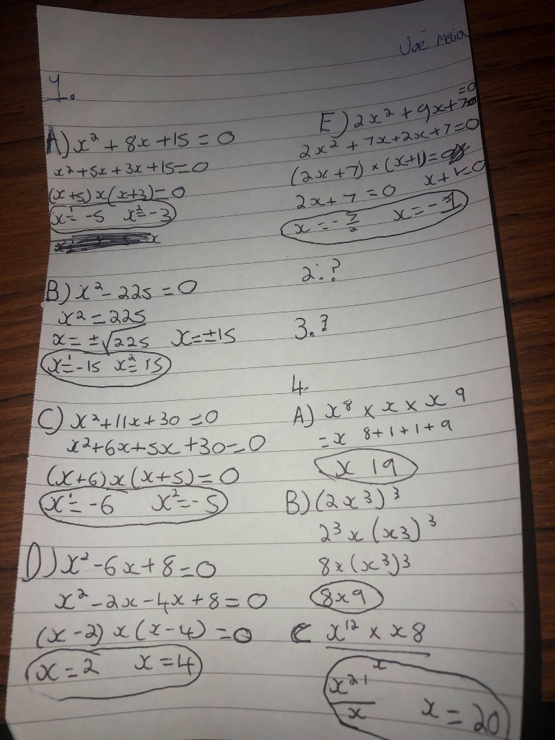
Did questions 1, 3 and 5 as was a little confused on the rest but I gave it my best try. the answers are circled and the rest are workings.


