HTML & CSS Web Development

Internet Technology and Security

University of Wales Trinity Saint David

Jaromir Pauer (1801641)

28/12/2019

Contents
1. Abstract 3
2. Requirements 3
3. Implementation 4
3.1 Screenshots of completed website 4
3.2 Validation 20
3.2.1 HTML & CSS Validation 20
4. Usability and its evaluation 25
5. Search Engine Optimization and its evaluation 26
6. Accessibility and its evaluation 27
7. Conclusion 30
References 31

Abstract

This report outlines the action taken to design and hand code a website on the life and career of football superstar, Lionel Messi. The work involved researching usability, accessibility, and research engine optimisation standards, and describing their roles in the development of the website. The design stage was also informed by papers published by academics and industry experts. Additionally, the report outlines the technical validation process, and the action taken to evaluate the completed website by assessing its usability, accessibility for those with disabilities, and the techniques applied to maximise search engine optimisation.

Requirements

There are many websites that provide accounts of the life and professional achievements of football legend Lionel Messi, but unfortunately, they tend to be too long, or too short, or simply factually inaccurate. The purpose of this website was to fill a gap in the market by providing a concise and accurate profile of Messi that covered relevant aspects of his private life, his football career at club and international levels, and his philanthropy. The website was designed for a number of target audiences, ranging from fans, who wanted a quick reference point, to others who were interested in Messi, but wanted an easy to read profile that would demand little of their time. It was appreciated that some of the target audiences would be disabled. The subject matter is highly relevant as many consider Messi to be the greatest football player of all time. Visual Studio 2017 was the main software used to build the website.

Implementation

3.1 Screenshots of completed website

Home page screenshots:

Part 1
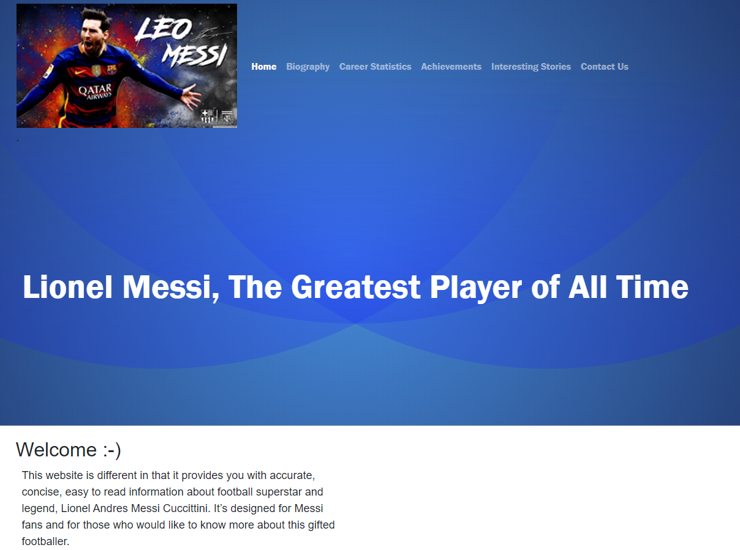

Part 2
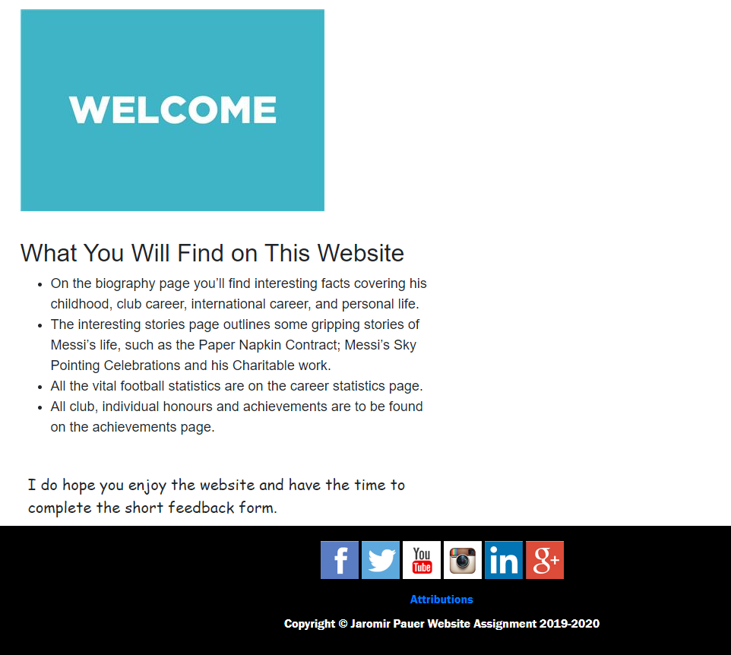

Biography Page screenshots:

Part 1
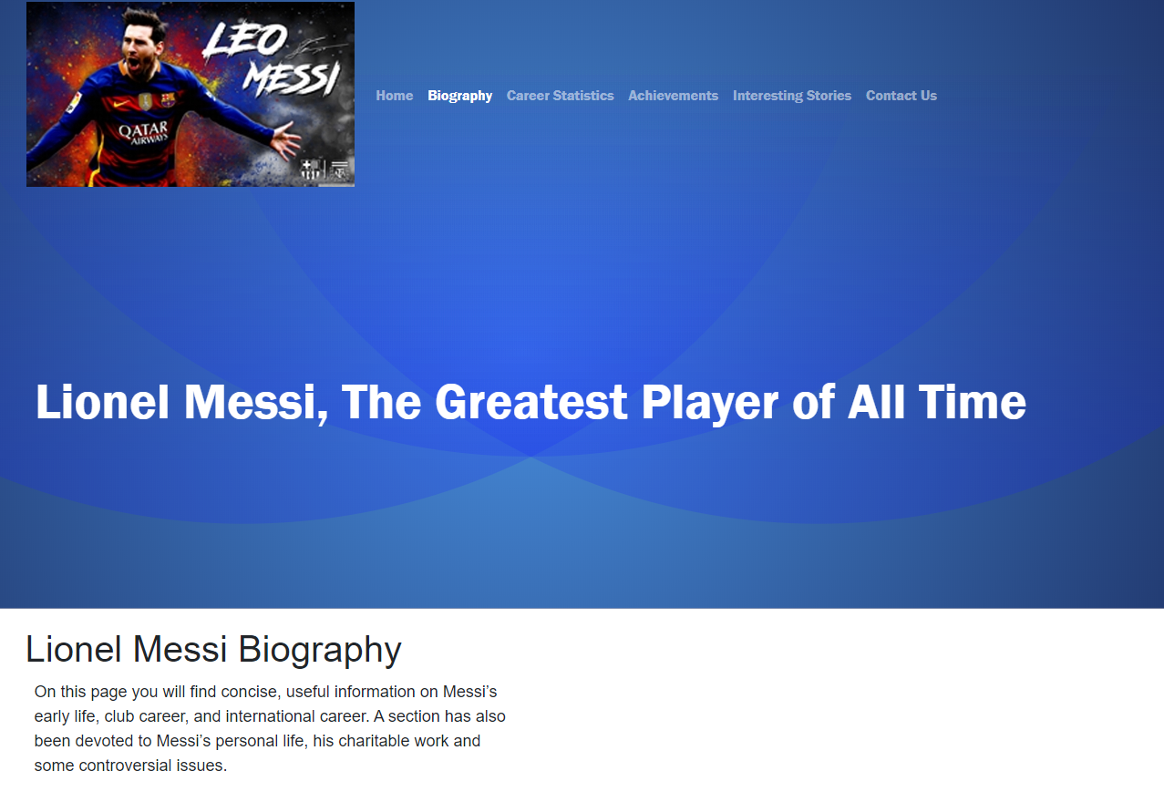

Part 2
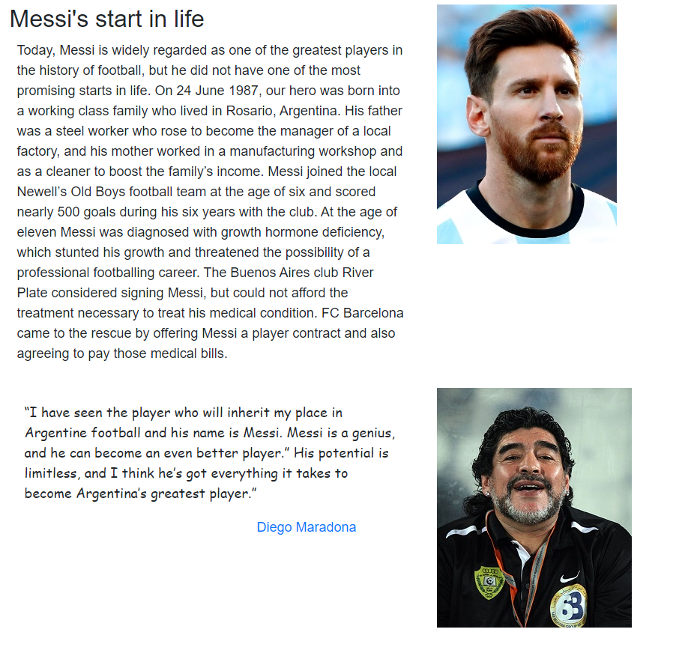

Part 3
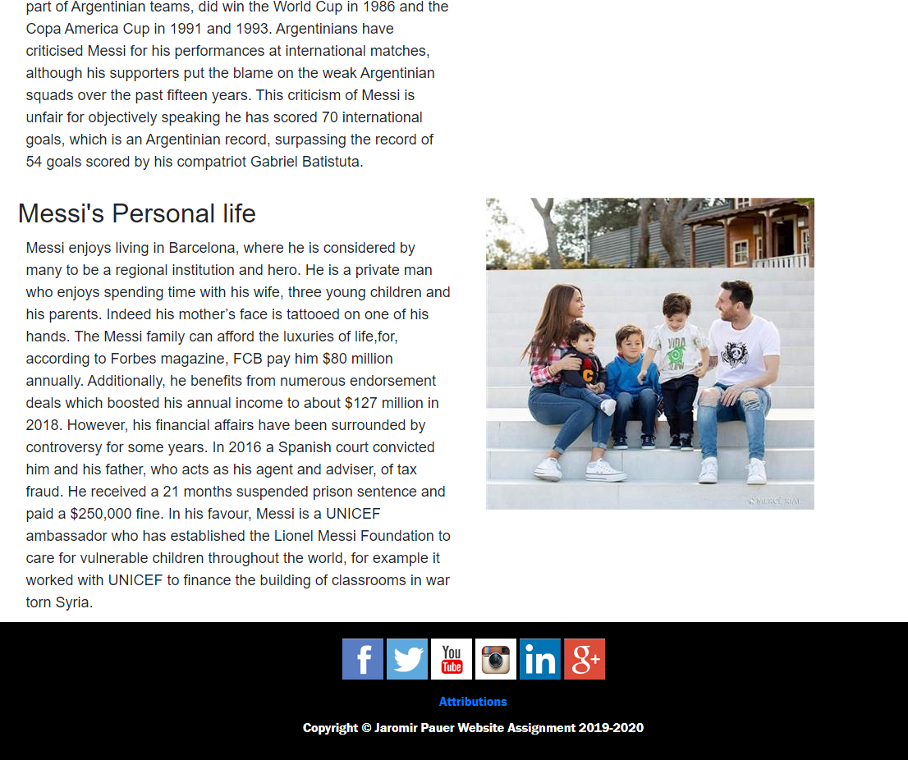

Career Statistics Page screenshots:

Part 1
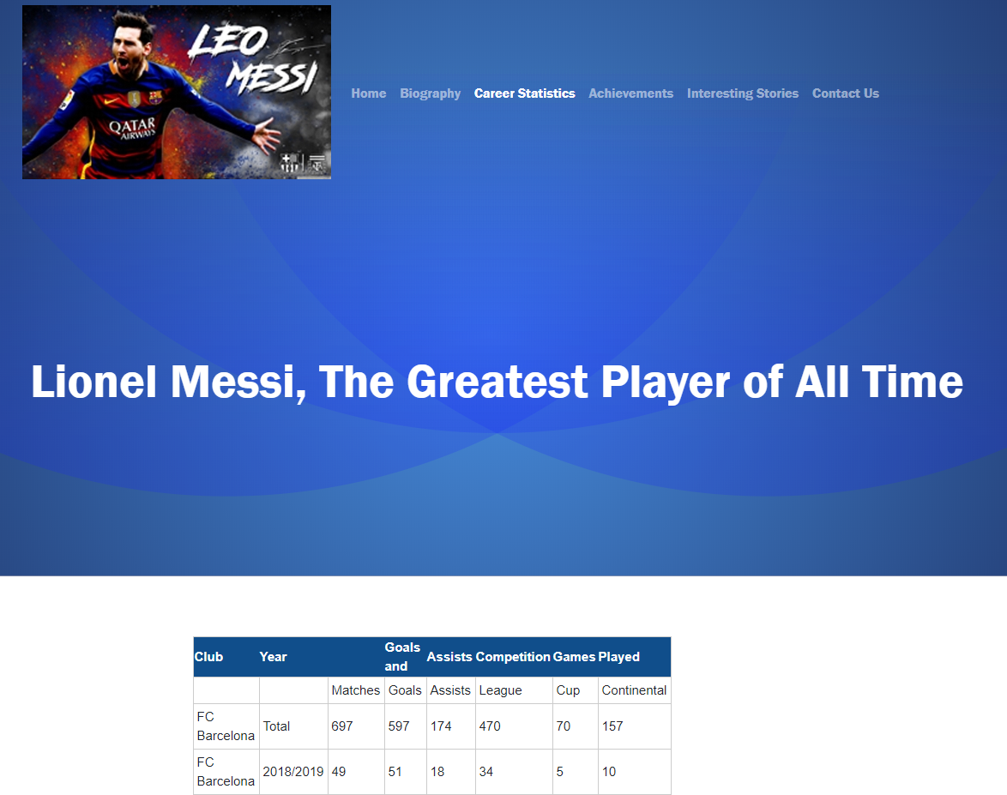

Part 2

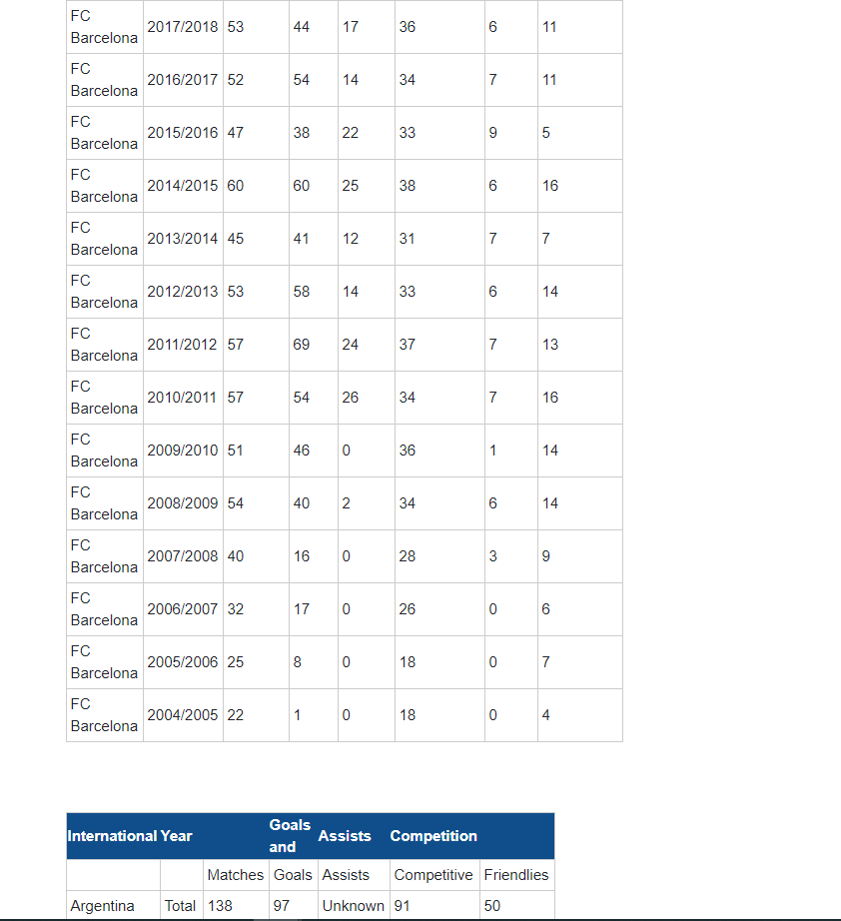

Part 3

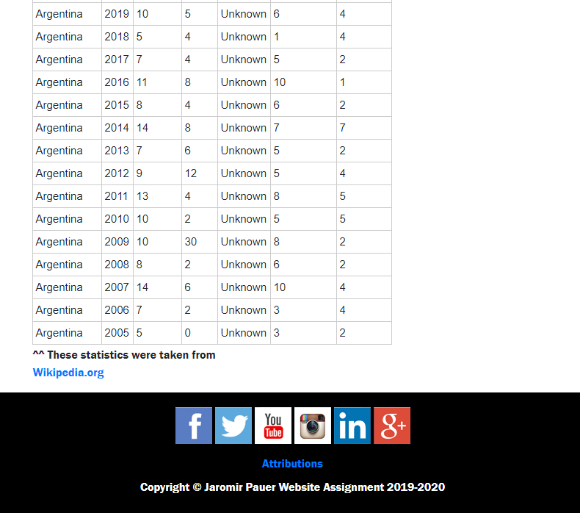

Achievements Page Screenshots:

Part 1
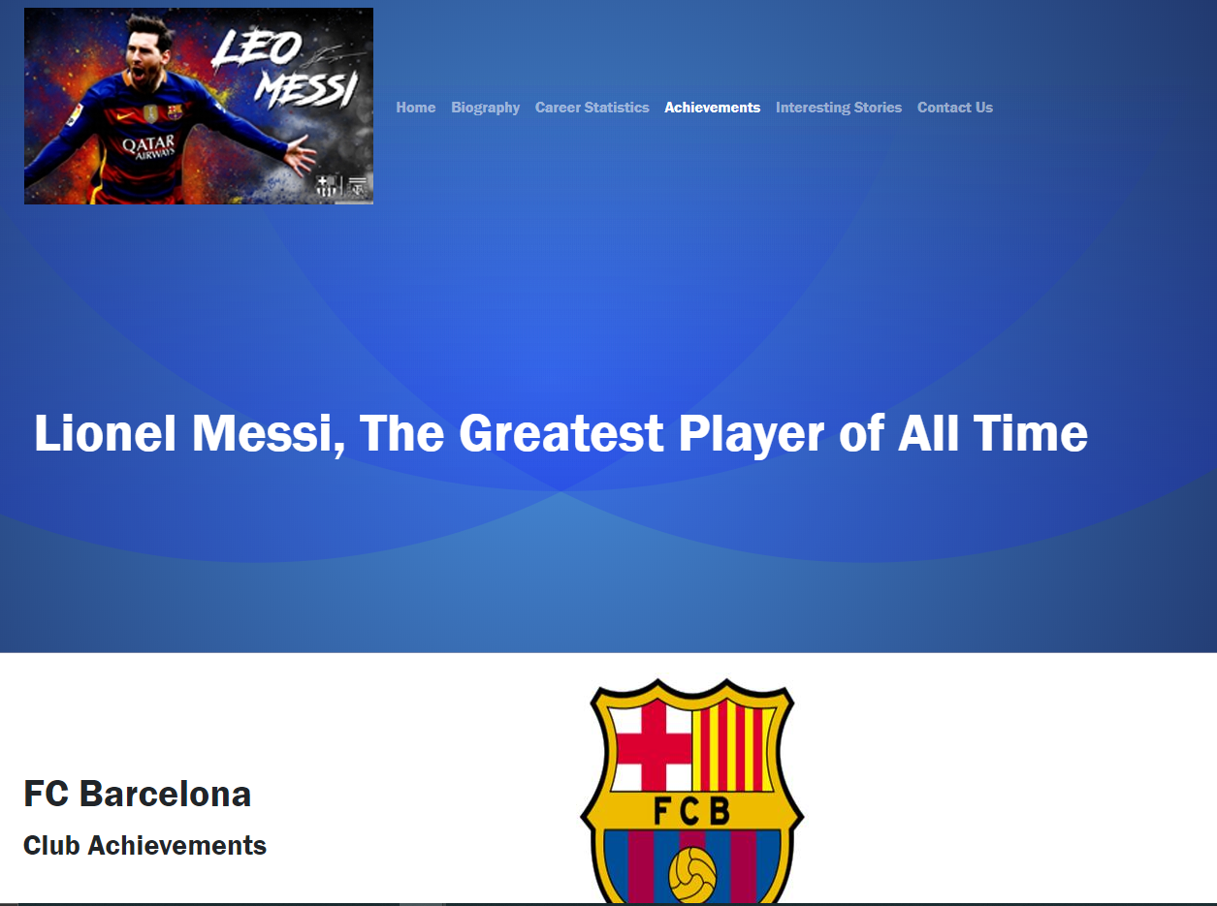

Part 2
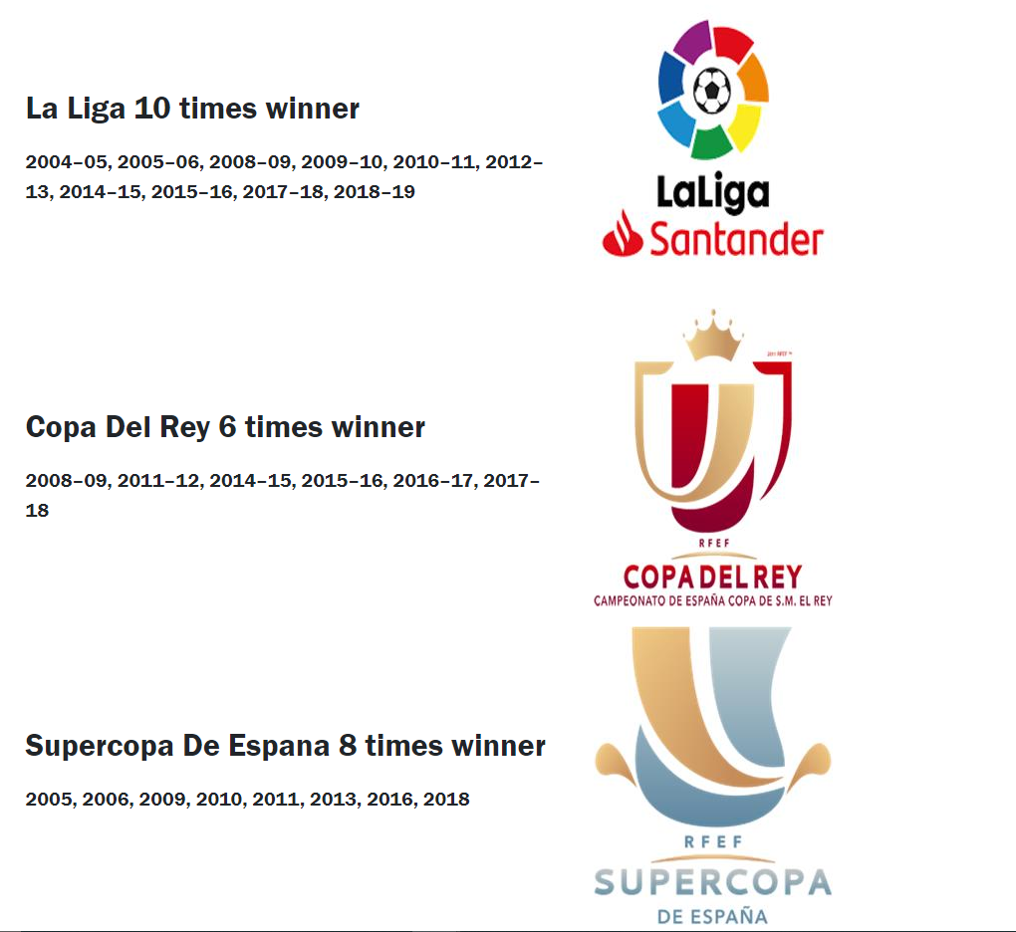

Part 3
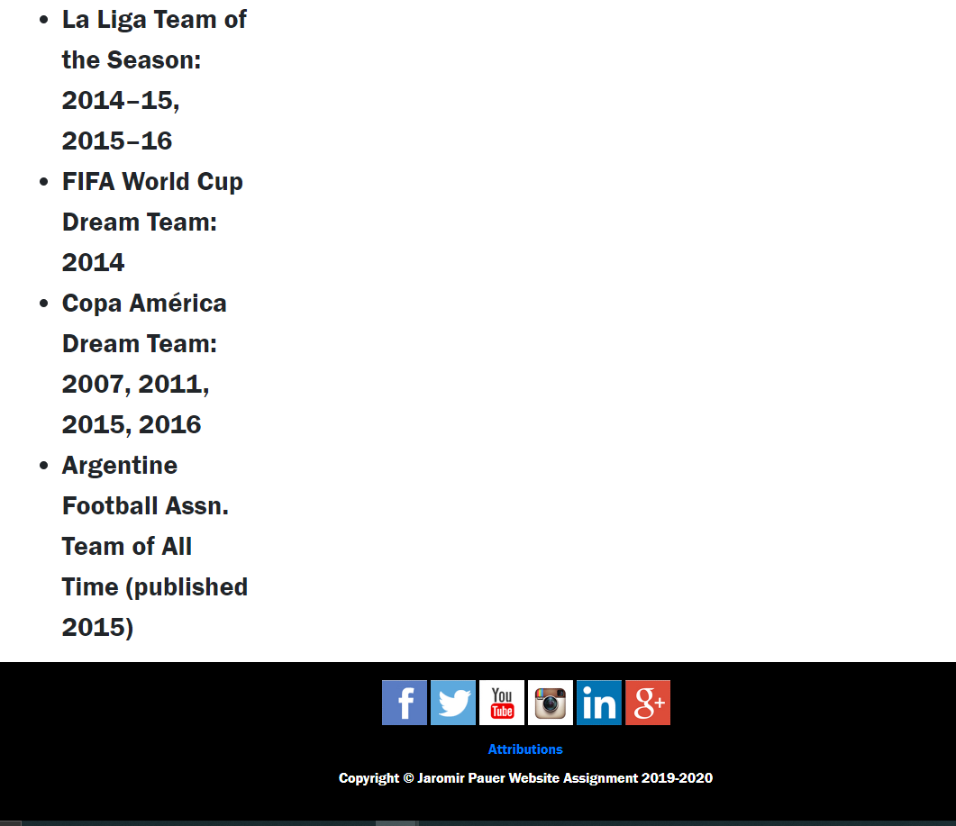

Interesting Stories Page Screenshots:

Part 1
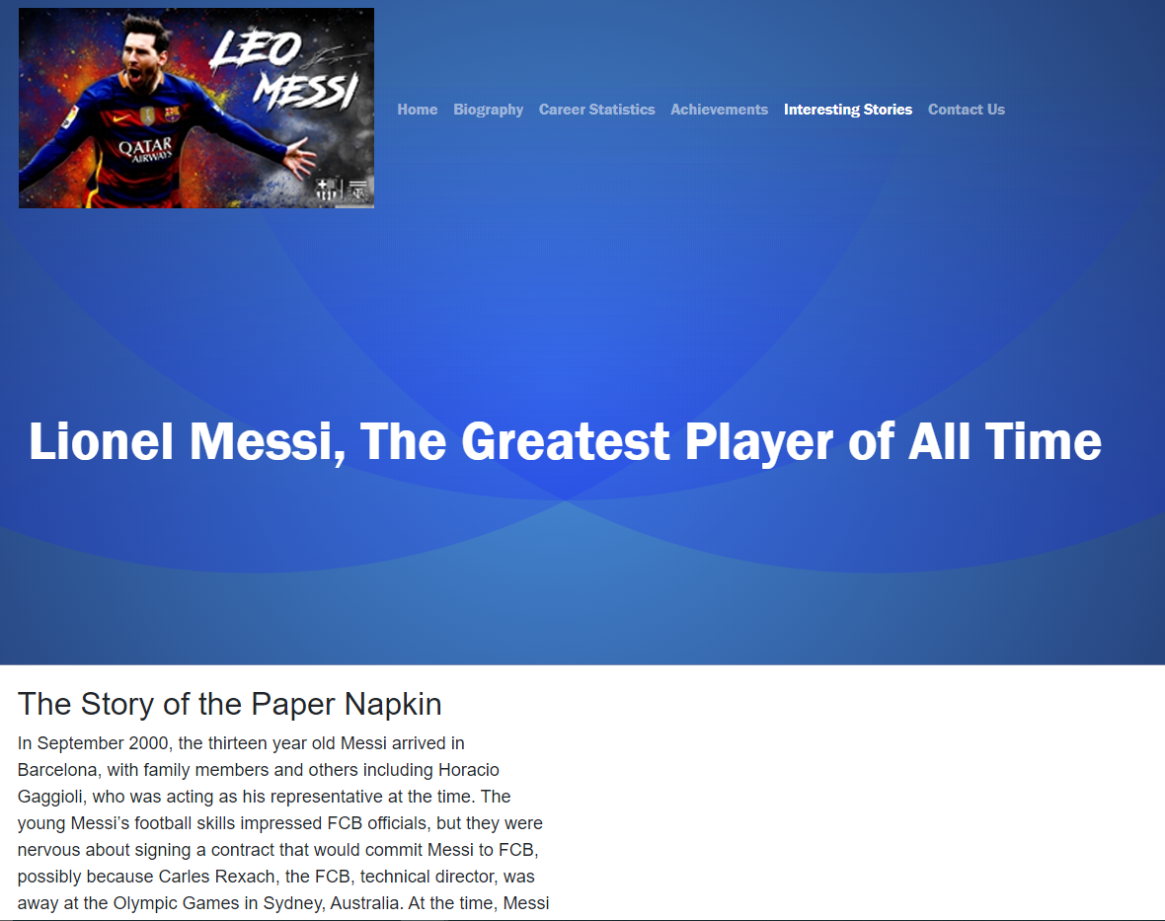

Part 2
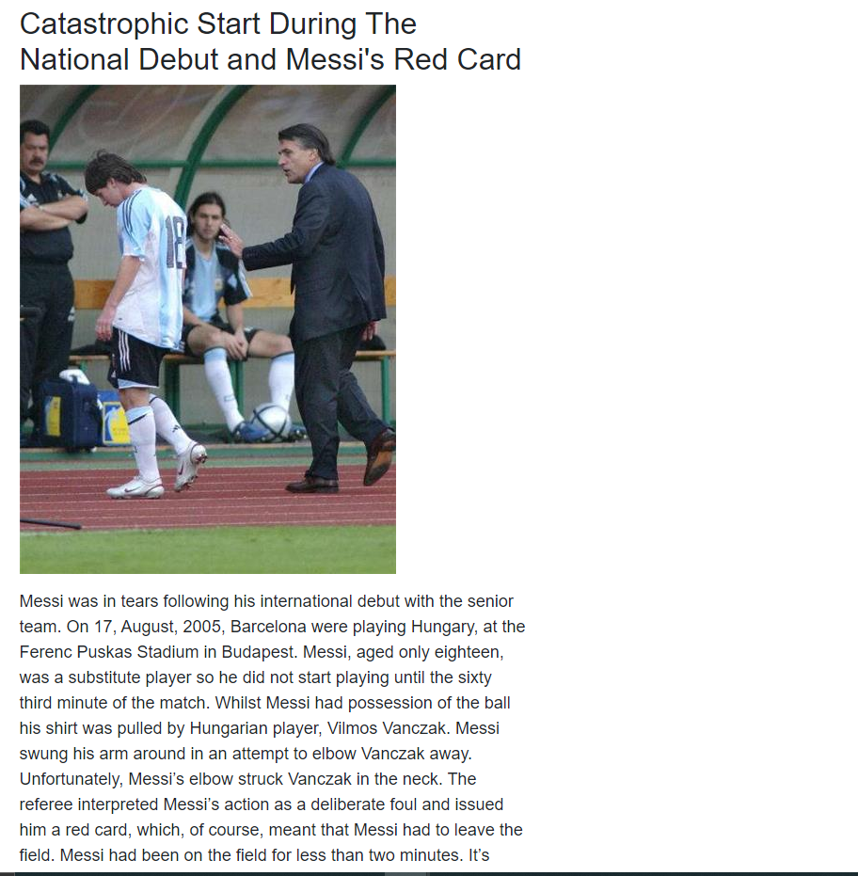

Part 3
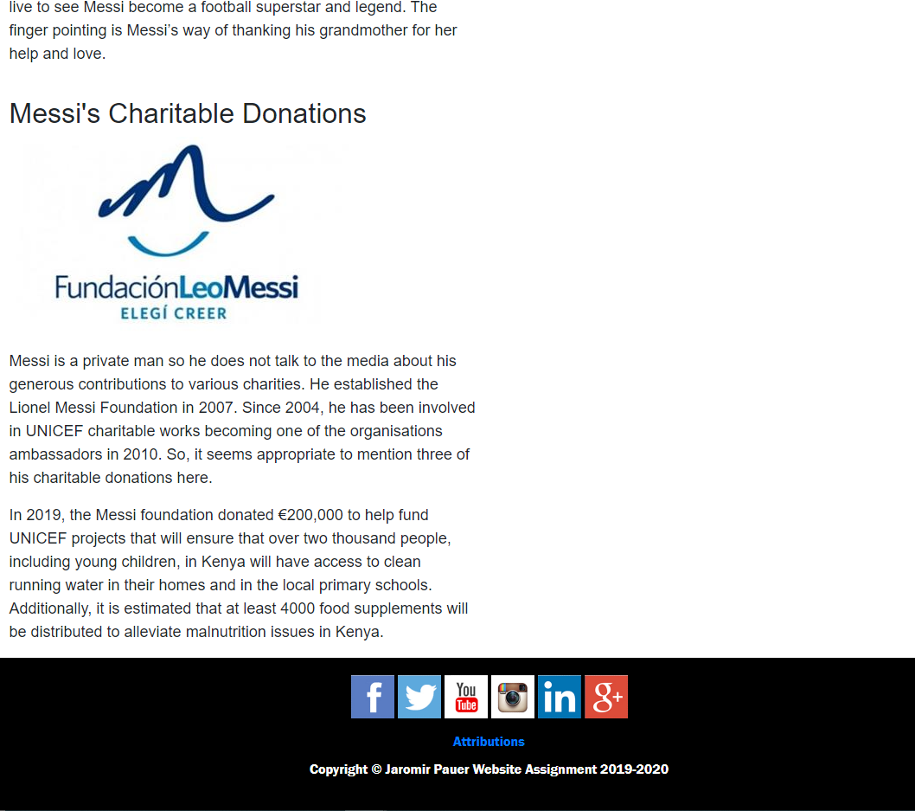

Contact Us Page Screenshots:

Part 1
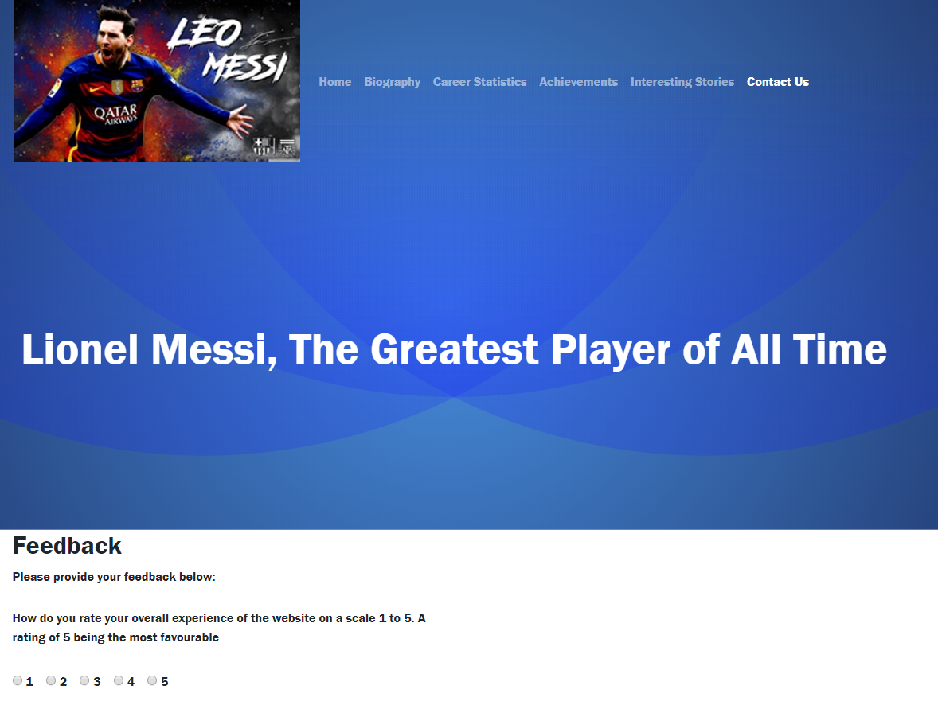

Part 2
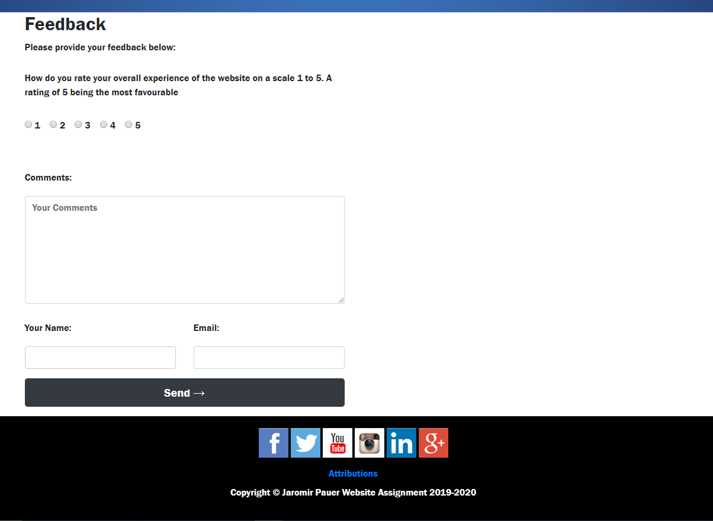

3.2 Validation

3.2.1 HTML & CSS Validation

Using the HTML and CSS validators action was taken to assess the HTML and CSS code of the completed website. No errors were found regarding the HTML pages. Similarly, no errors were found regarding the CSS code, although 9 warnings were indicated regarding lines 30-41, which the designer did not fully comprehend.
Index.html validation screenshot
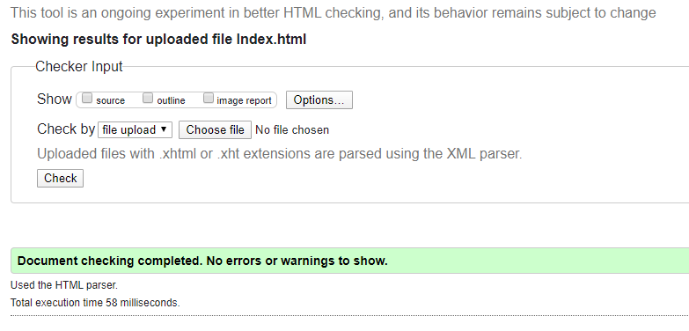
Biography.html validation screenshot
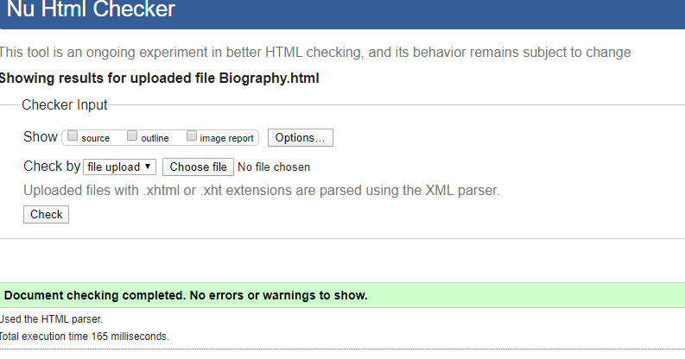
Career.html validation screenshot
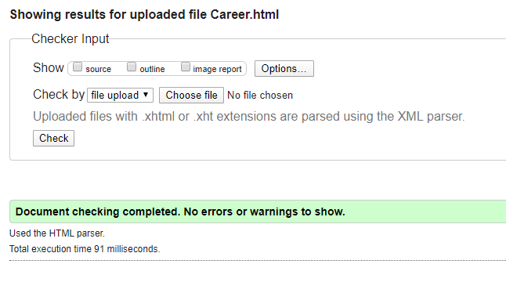
Achievements.html validation screenshot
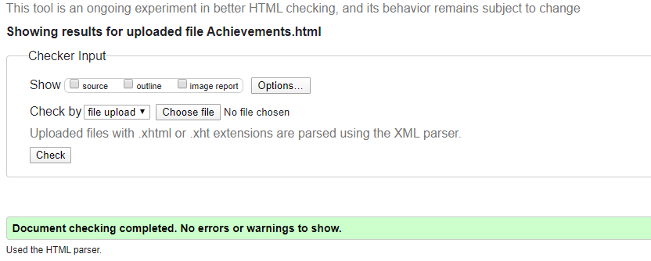

Interesting_facts.html validation screenshot
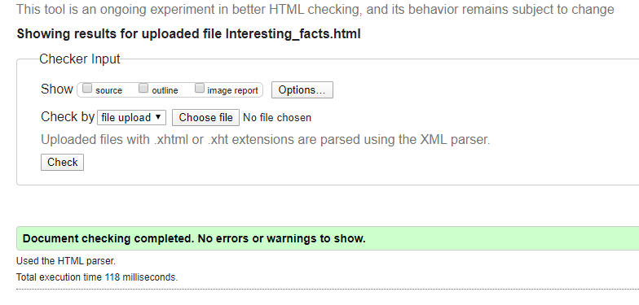
Contact_us.html validation screenshot
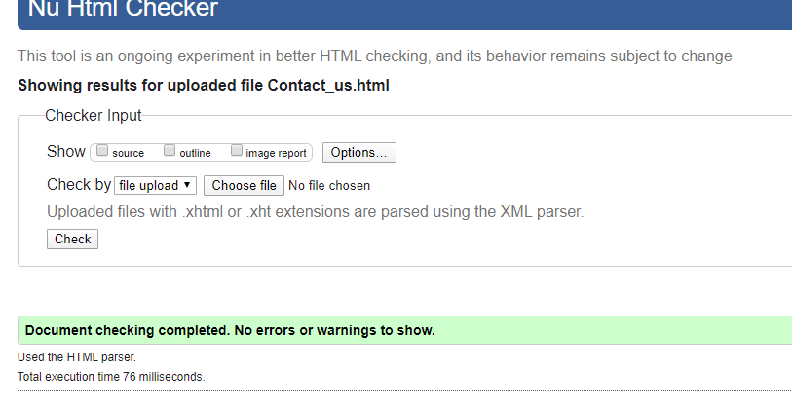

Attributions.html validation screenshot
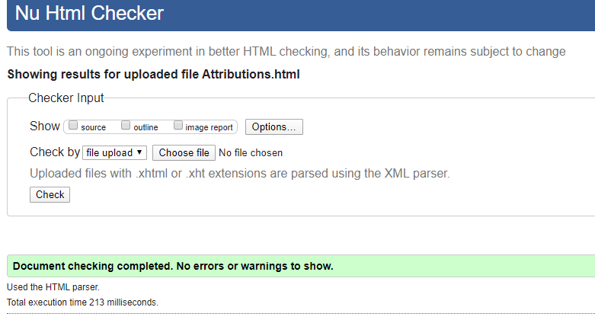

Styles.css validation screenshots part 1
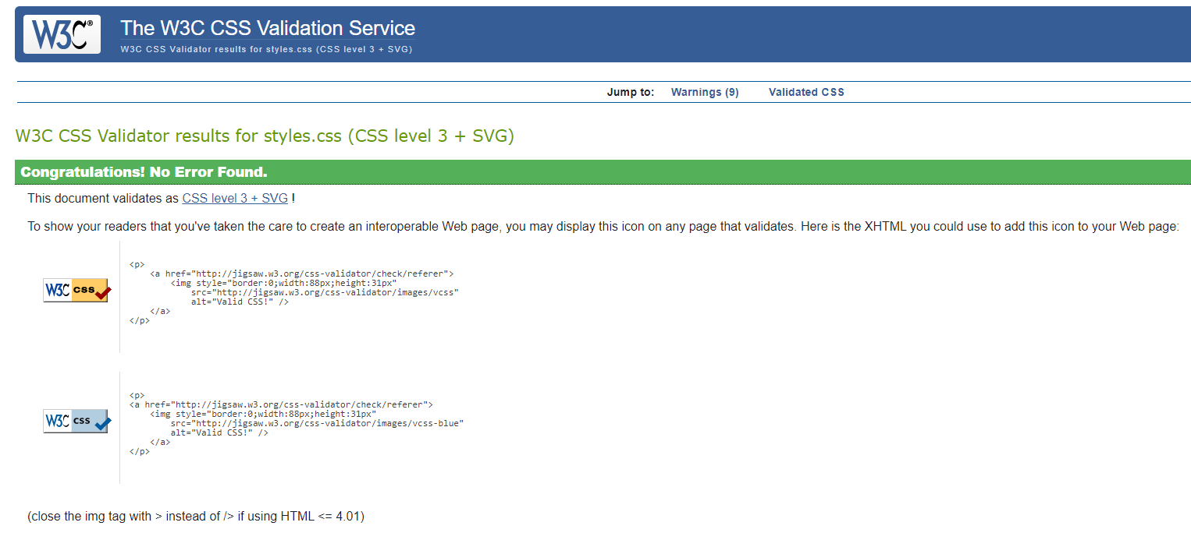

Styles.css validation screenshots part 2
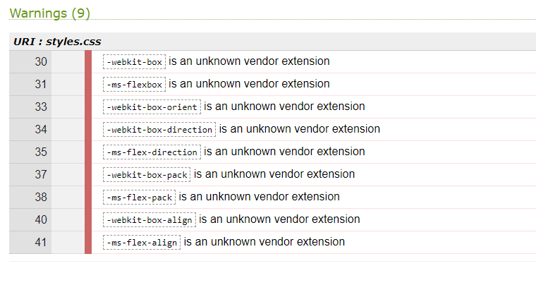

Usability and its evaluation
ISO 9241-11 defines usability as the “extent to which a product can be used by specified users to achieve specified goals with effectiveness, efficiency, and satisfaction in a specified context of use” [1]. A web designer’s task is to design a website that enables the users to complete an activity with accuracy and completeness (effectiveness), relative ease (efficiency) and with a positive appraisal of the website experience (satisfaction). Additionally, action should be taken to measure usability by reference to user performance and satisfaction. So, a designer will have to have clear gaols, set out the usability activities necessary to meet those goals, and stipulate the criteria that will be used to measure user performance and satisfaction. In this instance, the goal was to enable anyone interested in Messi to gain access to a website that provided concise, accurate, easily readable information about his life and career.
Criticisms have been made of IOS 9241, such as it makes no reference to security standards [2]. Bearing this in mind, it was necessary to review a number of research papers to get a fuller understanding of usability requirements. Particular attention was given to a paper by Lee and Kozar [3] who, after reviewing multiple research documents, concluded that there was a lack of academic consensus on the dimensions of website usability. They did, however, identify ten website usability standards that were widely endorsed: simplicity; readability; consistency; credibility, including security, privacy and reliability; navigability, including flexibility; content relevance, including content scope, timeliness and relevance; interactivity; telepresence; learnability, and supportability. Academics and IT experts have also identified specific requirements that can enhance website design, such as: topical images that attract attention or provide orientation during searching; placing a search field above the horizontal navigation bar [4]; varying the use of language depending on the target audience, selecting the choice of fonts, styles and multimedia components to suit the users [5]; using the home page to welcome the user and state the website’s goals; structuring information in order of importance to the user; providing a user feedback facility [6]; facilitating web usage by minimising learnability [7]; avoiding unnecessary information; avoiding unsolicited pop-ups; minimising the use of visuals in pages likely to be printed; considering accessibility issues; avoiding too much text per page; placing the most important items in the top centre of the page; providing a back button; considering the appropriateness of side maps; minimising the need to scroll by having shorter pages; using descriptive headings, titles and labels; considering the appropriateness of using text links; keeping font style and size consistent across pages; appreciating the usefulness of listing; giving images a descriptive label to identify their purpose; generally keeping words simple; placing the search toolbar in the same place on each page [8]; making sure the website is compatible with different screen sizes; considering server uptime; placing secondary links, such as ‘terms of use’, at the bottom of the page; placing the logo on the top left of the page, placing the search field on the top right; inserting an ‘about you’ section; and using short paragraphs, lots of headers and bullet points [9] and [8].
The measurement of usability is important as dissatisfied users are unlikely to return to a website. A range of performance and satisfaction measures should be agreed at the design stage so that monitoring can start early in the life of the website. ISO 9241-11 recommends a minimum of one measure for each of the effectiveness, efficiency and satisfaction categories. In particular, measures of effectiveness are concerned with how accurately and completely the users can achieve the set goals. Efficiency will depend on the resources necessary to achieve the level of effectiveness. Whereas, satisfaction can be measured subjectively by means of a survey [1]. Measures identified in various papers include: the time spent on a page, although this depends on the nature of the page; whether users exit after reading the home page [6]; time taken to perform common tasks; usability error rate; download time; navigation efficiency; readability time; duration of each search request [4] and [3]; number of failed commands; percentage of tasks accomplished; percentage of tasks achieved per unit of time; percentage of users’ favourable and unfavourable comments; time to learn [2]; conversion rate, meaning the percentage of views resulting in sales [10].
The completed website was evaluated against the principles of effectiveness, efficiency and user satisfaction. In accordance with the requirements of ISO 9241-11, effectiveness was assessed by considering how accurately and completely the users could achieve the identified goal set out above. Great care was taken to check the accuracy of the website’s information by reading and comparing source materials. Any contradictory material was discarded. This website did not set out to provide a comprehensive account of Messi’s career and life as that would have required a one volume book. However, this website does largely fulfil the goal of providing a concise and accurate account of Messi life and achievements. Moving on to efficiency, consideration was given to the resources the users would need to invest to accomplish the identified goal. Firstly, it was easy to navigate between the various pages of the website by using the navigation bars on each page. Every page was easy to read as large font sizes were used and sentences and paragraphs were purposely kept short, with appropriate paragraph headings. Accurate records were taken of the times taken to read the two longest sections of the website, namely the biography, and interesting stories pages. The biography page could be read within five and a half minutes and the interesting stories page in about three and half minutes. Regarding the satisfaction criterion, an online feedback form was designed so that users could express their evaluation of the website. Recommendations for future improvements include adding video highlights of Messi’s football achievements and making greater use of background colour schemes throughout the website.

Search Engine Optimization and its evaluation
Search engine optimisation is difficult to achieve as only the search engine companies know their algorithms, and the task is further complicated as the algorithms change over time [11]. Academics have attempted to overcome these problems by attempting to decipher Google’s ranking process, for example Luh et al. [11] relied on data crawling, pre-processing, latent semantic analysis, document scoring and re-ranking. Their key findings were that PageRank was the most significant factor in estimating Google ranking, and that a document’s URL was also an important determiner. Whereas, a document’s title and its snippet had little influence on ranking . The researchers work was based upon a limited set of ranking factors, which raises questions about the generalisability of their research, especially as Google use more than 200 factors in its ranking algorithm [11]. Zilincan [12] found that well-structured paragraphs, easy to read text, and use of key words were essential for a high ranking. However, Zilincan acknowledged that no researcher can guarantee high ranking. It is sensible to be informed by research, but weight should also be given to the guidance published by Google [13]. The guidance includes: using a title tag to introduce the topic of each page; using a descriptive meta tag for each page; using simple URLs; making it easy to navigate the site and using text for this purpose; putting an HTML site map page on the site and using an XML site map file; offering quality content; using key user words; using easy to read text; using suitable anchor text; using the “alt” symbol to communicate image information; using heading tags to draw attention to significant text; restricting crawling by using robot.txt; configuring mobile sites to maximise accurate indexing, and using social media to promote the website. SEO cannot be guaranteed, but a designer who is familiar with the contents of research papers and Google’s guidance is more likely to achieve higher rankings.

As part of the evaluation process a list was prepared of the on-page SEO techniques applied to the website prepared for this assignment. The list included the following elements: using a unique title tag to introduce the topic of each page, for example, on index.html page the title tag was given as ‘Lionel Messi Tribute’; using simple URLs, such as biography.html, and contact_us.html); making navigation easy by using text for this purpose, such as index.html, at lines 18-65, by creating the navigation bar in this section of the code); offering quality content, such as key verified information; using keywords users might choose, for example, King of football, Legend, and Ballon’d’Or winner, which were located in the meta section of the head; using easy to read text by structuring short sentences with uncomplicated words ); using the ‘alt’ symbol to communicate image information, such as, index.html, at line 26: messi-360-261.jpg alt=“header-Messi-image”); using heading tags to draw attention to significant texts, for example, Biography.html, at line 81: <h2> Messi’s start in life </h2>), and facilitating speedy access to social media by inserting icons in the footer section of each page.

Accessibility and its evaluation
According to W3C web accessibility “means that websites, tools and technologies are designed and developed so that people with disabilities can use them” [14]. A number of academic studies [15], [16] and [17] have established the inadequacy of accessibility features on institutional websites. In particular, Conway found that key Australian libraries even had difficult implementing the least demanding WCAG 2 guidelines. The researchers’ proposed the involvement of users throughout the development and evaluation of the websites. Additionally, it was advocated that the testing methods should include a combination of automated, manual and expert evaluation, and that greater use should be made of the HTML documentation format.

An essential W3C message is that the implementation of their guidelines will enable those with disabilities to enrich the web, which would be to everybody’s advantage. The guidelines cover all types of disabilities such as: auditory, cognitive, neurological, physical, speech and visual. The WCAG 2.1 guidelines are based on four principles, stipulating that websites should be perceivable, operable, understandable, and robust [18]. It is important to appreciate that web accessibility is not a concept confined to those with permanent disabilities. Accessibility standards can also assist those with temporary disabilities, such as an injured hand; the elderly, for example those with diminishing limb movements; people in difficult situations, for example those attempting to read mobile screens in strong sunshine; and those using small screens, such as mobile phones or smart watches [14]. Another academic study [19] has highlighted the close relationship between the concepts of visibility and accessibility, for example both able and disabled people will be unable to benefit from a website if it cannot easily be found on search engines. The researchers therefore emphasised the importance of using key words to improve search engine optimisation. So, visibility improves accessibility for everyone.

The WCAG.2 guidelines cover a range of actions such as providing: text alternatives to video or sound recordings; video or audio recordings of texts; video captions; Braille texts; images that have alternative text; sign language interpretation of live or recorded programmes; content that can be viewed on various screen sizes and formats; appropriate use of colour and contrast; text that can be resized by the user; greater emphasis on keyboard functionality and less reliance on a mouse; sufficient response times to online requests, or time adjustable facilities; limiting the use of flash lighting; improved navigability; easily readable text, and clear pronunciation. This is not an exhaustive list as that would require a much longer report, although it should be added that the WCAG guidelines are classified into three levels of conformance ranging from A to the more demanding AAA. W3C considers that most websites should aim to reach level AA, with some aspects of AAA. It is also recommended that designers evaluate accessibility from an early stage of development by making use of the WC3 evaluation tools list [20]. An easy check list is also provided by WC3,which makes it possible to test whether basic accessibility has been built into the web design [21].

The designer was guided by the four principles of accessibility as he designed the various functions and features of this website assignment. The functions and features included: images with alternative descriptive texts; coding enabling users to view the website’s content on various sized screens and formats; texts and backgrounds with contrasting colours; avoiding time limitations on the use of the website; avoiding flash lighting; using font size 18 pixels for the main text, with larger page and paragraph headings. By accessing the website’s code at biography.html, line 26, a test was undertaken by removing the source path to the image on that page. The browser was then launched by means of Visual Studio to ascertain whether the alternative text was displayed instead of the image. This procedure resulted in the display of the alternative text, which demonstrated that this provision was operating successfully. The test was repeated on all other images and no errors were found. Regarding the facility to view the website on different screen sizes, a test was conducted inside the web browser by right clicking the mouse and then clicking the ‘inspect’ wording on the on screen menu. By following this procedure it was possible to see how the pages would look on different sized screens. It was found that the website pages were compatible with all screen sizes. Contrastchecker confirmed that the text/background contrasts were appropriate for those with disabilities, except those suffering from colour blindness. However, the colour blind would have no difficulty reading the text, which they would see in greyscale. The aXe accessibility engine was used to test and analyse the code for every page of the website. Multiple issues were found and rectified, although an issue remains with the navigation bar, which has been given a moderate rating because the landmarks must have a unique role/label/title. It was not possible to test flash lighting or imposed time limitations as these matters were purposely omitted from the website design.

Conclusion

Drafting a concise profile of Messi that could be easily read within a short time was not easy, especially as many source materials were contradictory and inaccurate. A number of drafts were revised to achieve conciseness. Designing the technical aspects of the website often required some trial and error. It was possible to rectify a number of technical issues, but not all, for example landmarks. This experience emphasised the importance of thoroughly researching fundamental concepts, such as website usability, accessibility and search engine optimisation before starting the design process. The importance of taking account of user needs at an early stage of the design process also became apparent, as did the need to evaluate the effectiveness and efficiency of the website. The website passed the evaluation tests, with few exceptions, which was very satisfying.

References

[1] | ISO, “ISO 9241-11-2018(en) Ergonomics of human-system interaction - Part 11: Usability: Definitions and Concepts,” ISO, 2018. [Online]. Available: https://www.iso.org/obp/ui/#iso:std:iso:9241:-11:en/. [Accessed 14 12 2019].
[2] | A. e. al., “Consolidating the ISO Usability Models,” 2003. [Online]. Available: https://www.semanticscholar.org/paper/Consolidating-the-ISO-usability-models-Abran-Suryn/85cbf4b448f363e385da795e4ec26c732b609175. [Accessed 14 12 2019].
[3] | L. a. Kozar, “Understanding of website usability: Specifying and measuring constructs and their relationships,” Elsevier, no. 52, pp. 450-463, 2011.
[4] | Lamberz, “Still Searching or Have You Found It Already? - Usability and Web Design of an Educational Website,” Business Systems Research, vol. 9, no. 1, pp. 19-30, 2018.
[5] | Calongne, “Designing for website usability,” Researchgate, 1 2001. [Online]. Available: https://www.researchgate.net/publication/228802427_Designing_for_web_site_usability. [Accessed 14 12 2019].
[6] | Snider, “Evaluating Web Usability,” Performance Improvement, vol. 51, no. 3, pp. 30-40, 2012.
[7] | K. a. Kremenova, “The Use of Eye Tracking To Assess The Usability of University Website,” in CBU International Conference on Innovation, Technology Transfer and Education, Prague, 2015.
[8] | Bigby, “18 Usability Guidelines and Website Design Standards,” dynomapper, 3 2 2018. [Online]. Available: https://dynomapper.com/blog/19-ux/464-usability-guidelines. [Accessed 15 12 2019].
[9] | Moss, “Web usability: a guide to usability basics,” inviqa, 1 1 2004. [Online]. Available: https://inviqa.com/blog/web-usability-guide-usability-basics. [Accessed 15 12 2019].
[10] | Rawat, “A 7 Step Guide To Website Usability,” usabilitygeek.com, 12 3 2012. [Online]. Available: https://usabilitygeek.com/a-7-step-guide-to-website-usability/. [Accessed 15 12 2019].
[11] | L. e. al., “Estimating Google's search engine ranking function from a search engine optimization perspective,” Emerald Insight, vol. 40, no. 2, pp. 239-255, 2015.
[12] | Zilincan, “Search Engine Optimization,” in CBU International Conference on Innovation, Technology Transfer and Education, Prague, 2015.
[13] | Google, “Search Engine Optimization (SEO) Starter Guide,” Google, Undated. [Online]. Available: https://support.google.com/webmasters/answer/7451184?hl=en. [Accessed 18 12 2019].
[14] | w3, “Introduction to Web Accessibility,” w3, 5 6 2019. [Online]. Available: https://www.w3.org/WAI/fundamentals/accessibility-intro/. [Accessed 18 12 2019].
[15] | Conway, “Website Accessibility: a Comparative Analysis of Australian National and State/Territory Library Websites,” Australian Library Journal, vol. 61, no. 3, pp. 170-187, 2012.
[16] | Wisniewski, “Website Accessibility: Carrots and Sticks,” onlineresearcher.net, [Online]. Available: https://www.thefreelibrary.com/Website+accessibility%3a+Carrots+and+sticks.-a0505319099. [Accessed 19 12 2019].
[17] | Kimmons, “Open to All? Nationwide evaluation of high-priority web accessibility consideration among higher education websites,” Springer, 24 5 2017. [Online]. Available: https://link.springer.com/article/10.1007/s12528-017-9151-3. [Accessed 19 12 2019].
[18] | McGrath, “Start making accessible websites,” wuhcag, [Online]. Available: wuhcag.com. [Accessed 19 12 2019].
[19] | M. Park, “SEO for an open access scholarly information system to improve user experience,” Department of Data Science, School of ICT Convergence, Kangnam University, South Korea, pp. 77-82, 2017.
[20] | w3, “Web Accessibility Evaluation Tools List,” w3, 3 2016. [Online]. Available: https://www.w3.org/WAI/ER/tools/. [Accessed 20 12 2019].
[21] | w3, “Easy Checks – A First Review of Web Accessibility,” w3, 22 12 2017. [Online]. Available: www.w3.org/WAI/test-evaluate/preliminary/). [Accessed 20 12 2019].

marking criteria and Student FEEDBACK

This section details the extent to which the assessment criteria are demonstrated by you, which in turn determines your mark. The marks available for each category of skill are shown. Lecturers will use the space provided to comment on the achievement of the task(s), including those areas in which you have performed well and areas that would benefit from development/improvement.

Common Assessment Criteria Applied (Assignment 1) | Marks available | Marks  awarded
1. Engagement with Literature Skills

Demonstrates excellent engagement with relevant literature. An excellent discussion of the concepts with appropriate related research. Please note the comments below on word count limits. (Grade mark: 96.00%) | 25 | 24
2. Knowledge and Understanding Skills

Demonstrates a generally, good understanding of the standards used to design and implement a website. As mentioned below, aim to improve your understanding of CSS styles and avoid using inline CSS styles. A very good evaluation of the website based on the specified criteria has been provided, but I would have liked to see some more suggestions for improvements. (Grade mark: 75.00%) | 20 | 15
3. Cognitive and Intellectual Skills

4. Practical Application Skills

A very good attempt featuring simple website with information that is entertaining and informative. There is, however, room for improvement. The main area for improvement is the application of CSS styles and knowing when and how to correctly use specific style settings. For example, the styles used on the lower section of the achievement page where you list Messi's awards have not been correctly applied and this has had an impact on your layout. You have also used inline styling (adding a style attribute to elements) on your pages and this is bad practice in web design. You should aim to add all your CSS styles in the separate, linked stylesheet document. Another layout problem was that on some pages you had a single-column layout but because you did not correctly apply the responsive column classes it meant that the content only displayed on a small portion of the page and creating an impression of missing content. (Grade mark: 66.00%) | 50 | 33
5. Transferable Skills for Life and Professional Practice

The report is very well-written, but break up long blocks of text using paragraphs or sub-sections to further improve readability and presentation. Also, aim to write more concisely as your word count was considerably over the limit and this is also an important skill in academic writing and other fields. The university also has a policy for assessments over the word limit, while this has not been applied this time, please see the following link (section 7.7): https://www.uwtsd.ac.uk/media/uwtsd-website/content-assets/documents/academic-office/aqh-chapters/en/chapter-list-en/Chapter_07_Assessment_Taught_Programmes_Pages_72-79.pdf. See your report for other suggested improvements. (Grade mark: 80.00%) | 5 | 4

Assignment Mark (Assessment marks are subject to ratification at the Exam Board. These comments and marks are to give feedback on module work and are for guidance only until they are confirmed. ) | Late Submission Penalties (tick if appropriate) |  | 76%
 | Up to 1 week late (40% Max) |  | 76%
 | Over 1 week late (0%) |  | 76%

