

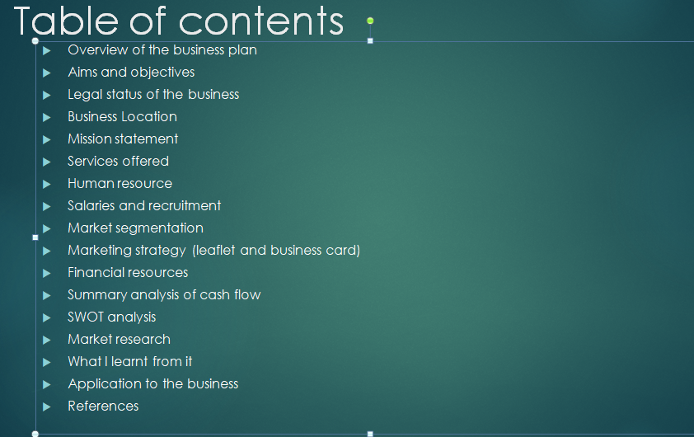

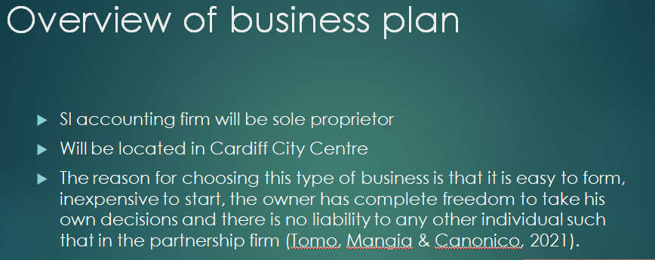
I, Shalma Pervin, intend to start an accounting firm which would provide all sort of financial advices, legal advices and accounting advices.
I have chosen this firm to be a sole proprietor that there would be no partnership in the business. I will be the one who will put on all the initial investment and the entire profit would go to me. I am planning to locate my office at 3 Dylan Place, Roath, Cardiff. It is close to my vicinity and there are less businesses in this area offering this service.
I have named my business SI Accounting Firm.

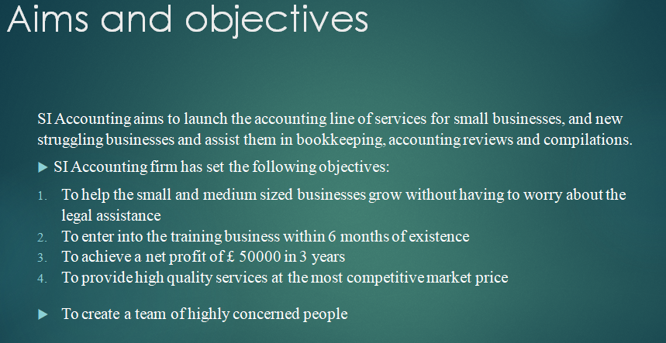

Legal status of the business
Sole proprietorship
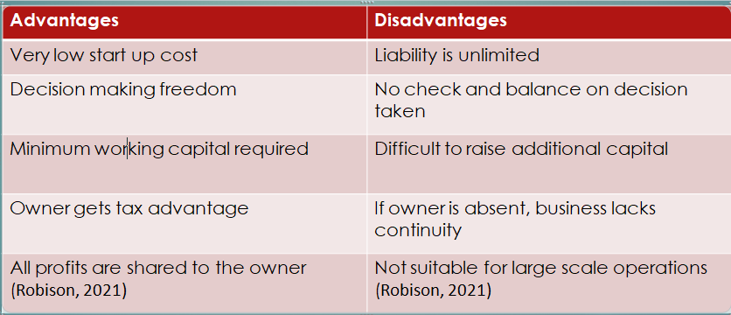

Advantages
Very low start up cost
Decision making freedom
Minimum working capital required
Owner gets tax advantage
All profits are shared to the owner (Robison, 2021)
Disadvantages
Liability is unlimited
No check and balance on decision taken
Difficult to raise additional capital
If owner is absent, business lacks continuity
Not suitable for large scale operations (Robison, 2021)

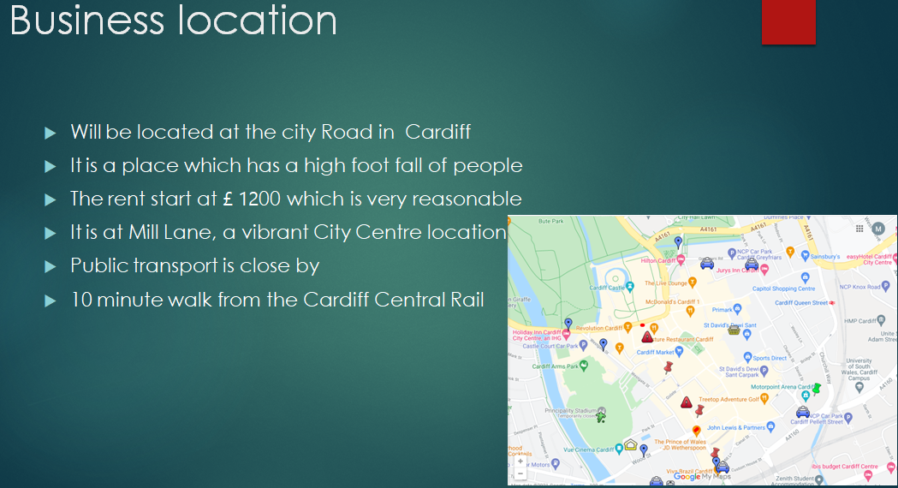
- Will be located at the city road in Cardiff
- It is a place which has a high number of wonderers
- The rent starts at £ 1200 per calendar month, which is very reasonable
- It is at Mill Lane, a vibrant City Centre location
- Public transport is close by
- 10 minute walk from the Cardiff Central Rail
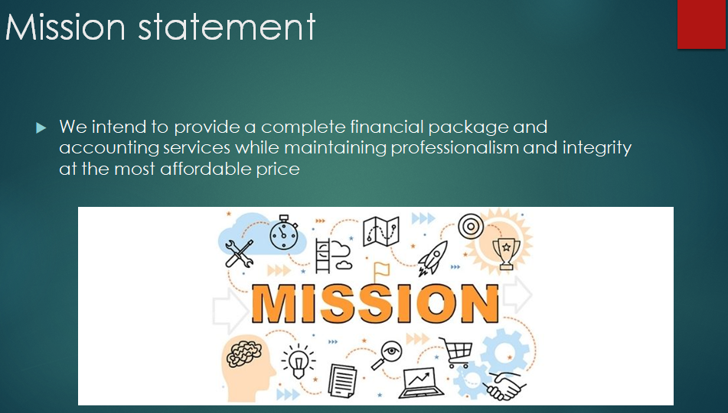
We intend to provide a complete financial package and accounting services while maintaining professionalism and integrity at the most affordable price
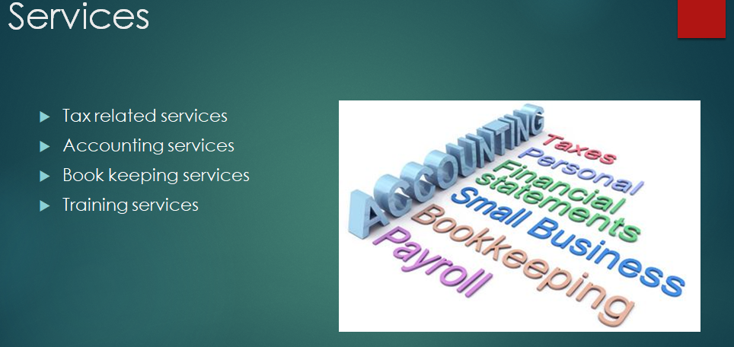

I intend to provide services in these 4 areas that are mentioned above.
For tax services, the services include:
- Preparing the taxes
- Tax planning
- Addressing problems such as audit representations, payroll problems, and bankruptcy

For accounting services, the services include:
- Assisting the businesses for their Audit plans
- Conducting detailed cost and margin analysis
- Assisting the firms for financial projection
- Establishing credit card processing

For book keeping services, the services offered are:
- Account payable and receivable services
- Payroll processing
- Bank reconciliations
- Processing sales tax
- Inventory management
- Preparing the financial statements
- All types of other financial reporting

For training services, I would offer:
- Financial trainings
- Technological skills training
- Leadership and soft skills training
- Negotiation
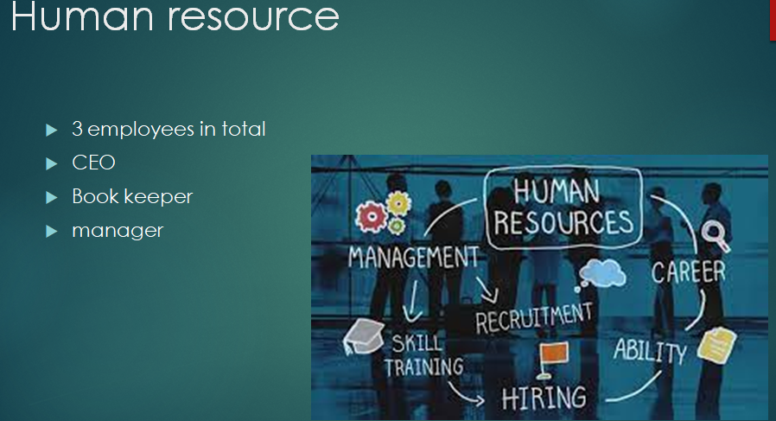

It would be a small office and only 3 employees including me would be working initially.
I would be responsible to get clients and deal with them
The book keeper would be accountable for the accounting services of the clients.
Manager will be responsible for audit and other services including examining the work of the book keeper.
The book keeper would be students who would be in their senior year and would be hired through professional hiring firm.

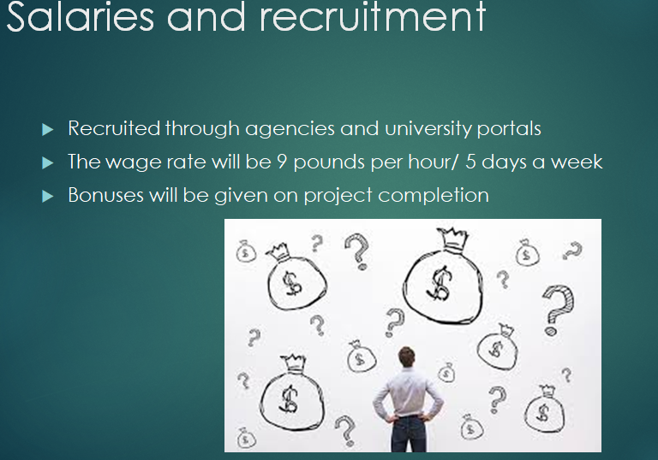

- Recruited through agencies and university portals
- The wage rate will be 9 pounds per hour/ 5 days a week
- Bonuses will be given on project completion

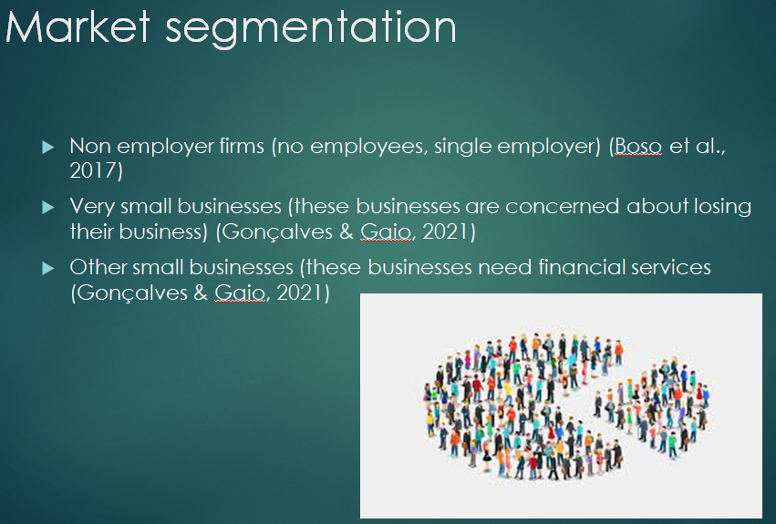
The market will be segmented into three areas.

The non employer firms have no employees and they do not face any concern like larger firms
The very small businesses are concerned with respect to losing their control over the business
Other small businesses require financial services regarding book keeping in their businesses. They prefer to save money of in-house accountant and outsource these services to professionals.

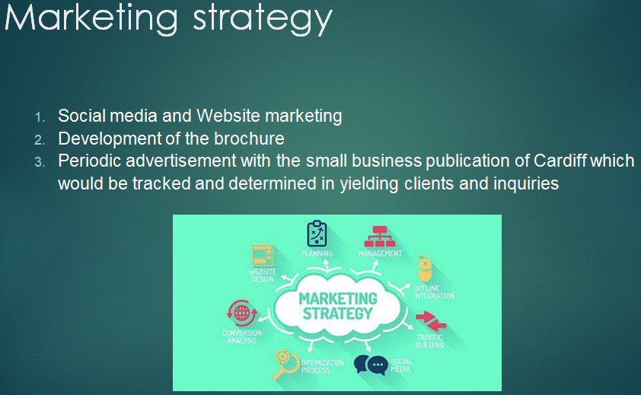

The first and most important type of marketing strategy implemented by SI Accounting would be social media and website marketing.
This would supplement the business and reach the target audience within the region. Platforms such as Facebook, and LinkedIn would be used for social media marketing.
On the other hand, the company will make a website and maintain their current tactics. There will be a focus on Google Adwords with a budget allocated per month to book keeping related keywords in Cardiff market online. In addition to that, the business will be listed on several databases and websites related to small business services and the book keeping and training services in Cardiff.
one of the most important marketing tactics would encompass when the company will search for student book keepers. Whenever the job will be posted on different platforms such as local universities, it would create awareness about the business and would attract concerned people. This will also help the company to recruit the best possible student book keepers and the cost associated with the recruitment would be only one time.


What you see here is the leaflet or poster made by me to be distributed as a marketing technique. It includes short intro about us, the services we offer, phone number to connect with us and the address and website details.
Through this poster, every potential client would get clear idea about us and it will be easy to communicate with them.

Business card

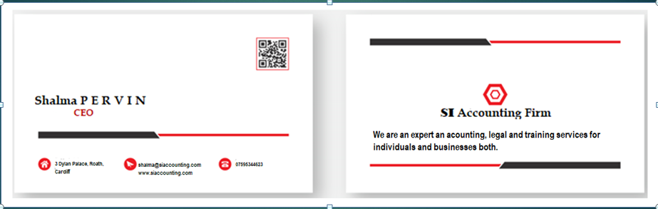

The above business card is made for the owner/CEO of SI accounting Shalma Pervin. It includes a statement which mentions what we are offering, and contact details to connect with us.

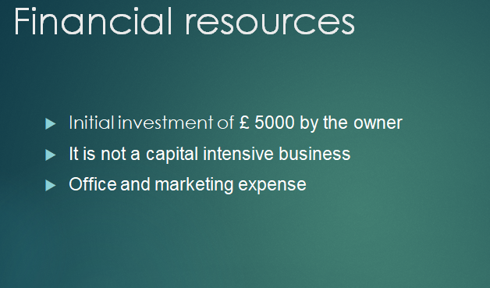

There is no need of any outside investment as the new business is not capital intensive. There will be a fixed cost incurred in the business which will be covered within the few months of start-up. It is expected that the company will receive at least 5 clients in the first month of business for their book keeping services. There will be initial investment of £ 5000 which would cover the office expenses and marketing expenses.

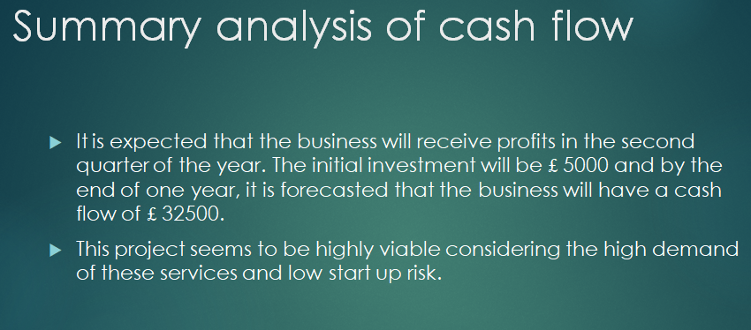

It is expected that the business will receive profits in the second quarter of the year. The initial investment will be £ 5000 and by the end of one year, it is forecasted that the business will have a cash flow of £ 32500.
This project seems to be highly viable considering the high demand of these services and low start up risk.

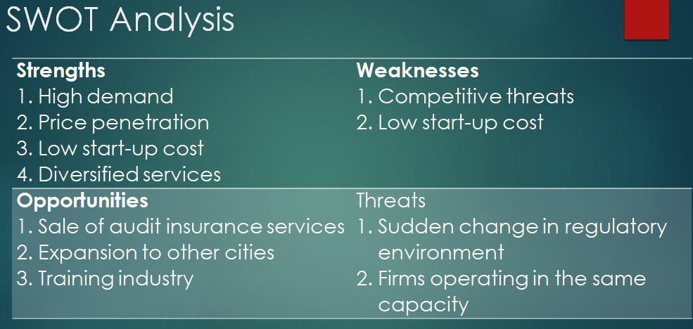

Strengths
- High demand
- Price penetration
- Low start-up cost
Diversified services
Weaknesses
- Competitive threats
Low start-up cost
Opportunities
- Sale of audit insurance services
- Expansion to other cities
Training industry
Threats
- Sudden change in regulatory environment
Firms operating in the same capacity
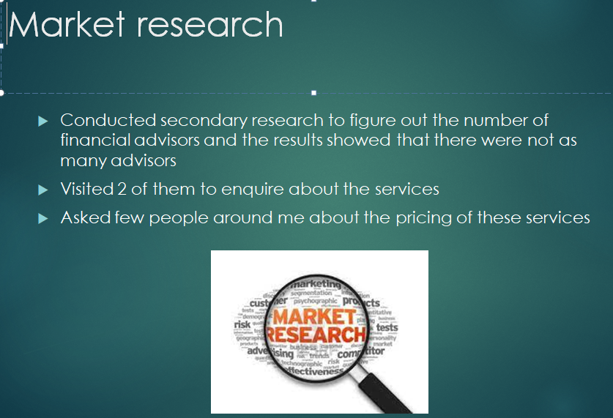

I did market research through secondary means. I did online research regarding all the similar businesses in the region and then also visited two of them to enquire about their services. This helped me list down the services provided by the competitors. I then also asked about the price people would be willing to pay for these services through my personal contact. This helped me set the initial pricing strategy which could be increased with the passage of time.

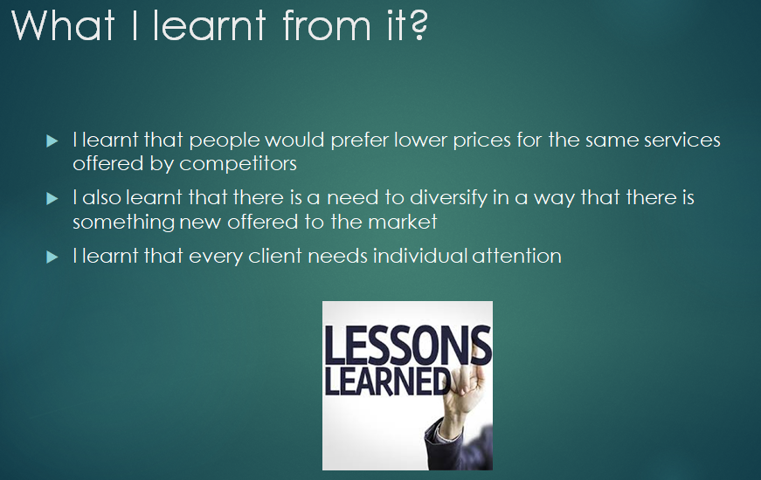

The market research that I conducted for opening up of my business helped me gain a lot. I learnt so much about this industry such that the current market demand and the prices people are willing to pay for these services. I also realized that it is important to diversity my services so that the people would be more attracted. I also realized that in every industry, it is important to provide something different to attract more clients. Giving individual attention to the clients is the key to success. Once we get the client, keeping them and making them stay with is important and this is possible if we provide them with exceptional services at market competitive prices and give them one to one attention.

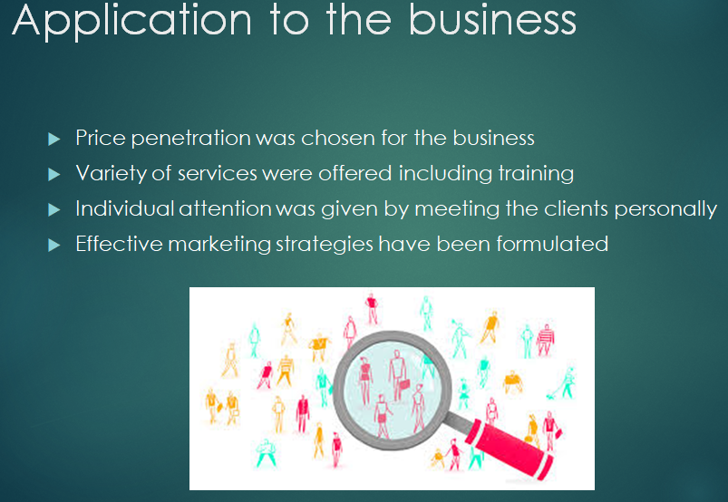

After I learnt so much, I made sure that I will apply the same concepts to my business. Firstly, I have chosen penetration pricing that is lower price strategy to enter the market. This is a very good strategy to start a business in the market. I would also make sure that the services that I offer are different from the market and have something unique in them. There are few businesses offering financial, legal and training businesses altogether which clearly means that I have a great potential to make my market position. I also formulated effective marketing strategies to attract the right team and to attract more clients. I made sure that each of my client would get individual attention so that they are satisfied with the level of services offered to them.

References
- Boso, N., Donbesuur, F., Bendega, T., Annan, J. and Adeola, O., 2017. Does organizational creativity always drive market performance?. Psychology & Marketing, 34(11), pp.1004-1015.
- Duff, A., 2018. Intellectual capital disclosure: evidence from UK accounting firms. Journal of Intellectual Capital.
- Ferry, L. and Ahrens, T., 2021. The future of the regulatory space in local government audit: A comparative study of the four countries of the United Kingdom. Financial Accountability & Management.
- Gill, L., McCarthy, V. and Grimmett, D., 2019. Voice of the customer: Creating client centered cultures in accounting firms for retaining clients and increasing profitability. Journal of Accounting, Business and Management, 26(2), pp.46-58.
- Gonçalves, T. and Gaio, C., 2021. The role of management accounting systems in global value strategies. Journal of Business Research, 124, pp.603-609.
- Huerta, E. and Jensen, S., 2017. An accounting information systems perspective on data analytics and Big Data. Journal of information systems, 31(3), pp.101-114.
- Ishaque, M., 2021. Managing conflict of interests in professional accounting firms: a research synthesis. Journal of Business Ethics, 169(3), pp.537-555.
- Lagat, C. and Frankwick, G.L., 2017. Marketing capability, marketing strategy implementation and performance in small firms. Journal for Global Business Advancement, 10(3), pp.327-345.
- Tomo, A., Mangia, G. and Canonico, P., 2021. Innovating processes and processing innovation: strategic approach to innovation in accounting firms. Journal of Economic and Administrative Sciences.

