

Postgraduate/Distance Learning
Assignment coversheet & feedback form

THIS SHEET MUST BE THE FIRST PAGE OF THE ASSIGNMENT YOU ARE SUBMITTING (DO NOT SEND AS A SEPARATE FILE)

For completion by the student:
Student Name: Emily Carey

Student University Email: 2517646@student.uwtsd.ac.uk
Module code: HPCA7014  Module title: Sacred Geography | Student ID number:  2517646 |  |  | Educational support needs:  N/A
Assignment title: Is sacred space a human construct or a natural phenomenon? Discuss this question through a research project with reference to the work of at least three theorists.
Assignment due date: 5 January 2026
This assignment is for the 1st 2nd 3rd 4th 5th 6th module of the degree
Plagiarism declaration
I confirm that this is my original work and that I have adhered to the University policy on plagiarism.

Artificial Intelligence (AI) declaration
For this assessment, you can use Generative AI to check your own text/creation for grammatical and syntactical mistakes, including rephrasing of your own work within specific standards.*

*See separate guidance in the MA Writing Guidelines

I confirm that I have not used any AI tools in the research and creation of this assignment, except as permitted above. I confirm that I have not presented any AI generated materials as my own work. I confirm I have copies of my drafts, notes, and other resources I used, which I may be asked to provide in evidence.

Signed: Emily Carey

Assignment Mark
1st Marker’s Provisional mark
2nd Marker’s/Moderator’s provisional mark
External Examiner’s mark (if relevant)
Final Mark

NB. All marks are provisional until confirmed by the Final Examination Board.

For completion by Marker 1 :
Comments:

Marker’s signature: |  |  | Date:
For completion by Marker 2/Moderator:

Comments:

Marker’s Signature: |  | Date:
External Examiner’s comments (if relevant)

External Examiner’s Signature: |  | Date:

Is sacred space a human construct or a natural phenomenon? Discuss this question through a research project with reference to the work of at least three theorists.
Is the idea of liminal space a human construct or a natural phenomenon? This research project will explore the idea of liminal space with reference to Bordeaux Harbour.
(Word count: 5,395)
Introduction
The aim of this research is to explore the idea of liminal space as a human construct and as a natural phenomenon, with reference to Bordeaux Harbour as a place, to determine what has, and what continues to draw people to it. Whether that be through its own pull as a naturally existing phenomenon, or, through the push of human interaction with and around the harbour. I have chosen to focus on Bordeaux Harbour, as, while many activities have taken place around the harbour, within the harbour itself, there is a sense of a void, a liminal space that very rarely has people within it. It has maintained a largely natural shape and has not been radically transformed to suit the needs of people using the area. This contrasts with other harbours in Guernsey, which have been extensively adapted to meet the needs of various times and cultures, whether that be in relation to trade, defence, tourism or the movement of tides and people. To research this idea of Bordeaux as a void, a liminal space, I will undertake a literature review of the theory of sacred space using Beldon C. Lane’s three models for ‘giving voice to place’, comparing and contrasting ontological, cultural and phenomenological approaches, and considering whether, as Ingold contends, we can extend ourselves into a place, just as a place extends into us, as a ‘tangle of relationships in which [we] are enmeshed.’ These models will be applied to Bordeaux as a liminal space; focusing on three key themes within liminality, that of being at the margins, as a place of creation and as a gateway to sacrality.
Fieldwork Methodology
The methodology I am using is within a phenomenological framework and includes a literature review of the main philosophical and theological arguments, and a qualitative collection of primary data, using historical, anthropological, psychological and autoethnographic fieldwork approaches. The key theorists included within this study are Beldon C. Lane, Mercia Eliade (1907-1986), Émile Durkheim (1858-1917), Christopher Tilley (1955-2024), and Tim Ingold. According to Tilley, phenomenology is the exploration of subjective experience, what he describes as the relationship between ‘Being and Being-in-the-world’. Tilley says that when people act in the world, they separate themselves from it, they objectify it and attempt to process what they are experiencing from an outsider’s perspective. Human beings recognise their reactions through sense responses, emotions, physical interactions and the purpose of their endeavour, but with no understanding of themselves as the subject who is perceiving. However, for Tilley, this empirical objective world exists only in relationship to a humans egoic consciousness of themselves, a certain world view, and an experience of the world as a projection of their consciousness at that moment in time and space. So, a human being will experience different states of Being at different times in their life’s journey. The same place, object or encounter may be perceived in a distinct form, regardless of its empirical objectivity. Further, this same place, object or encounter may be understood in diverse ways, by unique human beings. This phenomenological framework will be used to explore the concept of liminality as sacred space in the theoretical literature.
As well as a literature review, I will undertake fieldwork at Bordeaux spending time with the Harbour, exploring it at low tide at different times of day, and with different weather patterns. In doing so I hope to understand how the landscape acts as a gateway and a liminal space, and how that experience changes in each unique moment. As Tilley expresses, by ‘walking in and through’ the landscape I want to come into relationship with Bordeaux, becoming a subjective insider to a shared experience. No interviews with other people have taken place, and so my fieldwork is from an entirely subjective viewpoint, as well as referencing other qualitative sources that have become important as part of the autoethnographic approach.
Reflexive considerations
Throughout my research, it has been important to note that my observations have been made by me at a particular point and time. This then is a very subjective study, and reflects a liminal time in my life, at age fifty, having left a career running a mental health charity to inhabit a different space for the next period of my life. As well as reaching a liminal space in my working life, I am also experiencing liminality as a parent, my children have just left or are on the cusp of finishing school and leaving home, and as a woman, I am experiencing the menopause. Culturally, I was born in Guernsey and returned to live here seventeen years ago, it therefore holds many important encounters and memories, all subjective. However, my relationship with Guernsey is also within a liminal space, as I am in the process of leaving to live in Sardinia. In exploring liminality then, I am conscious it is the story of new beginnings, but also of endings, and the space in-between. This research project, while grounded in theory and qualitative data, is reflective of a subjective account of being drawn to Bordeaux Harbour, a perceived liminal space, during a time of significant life-stage liminality. In undertaking fieldwork for this research, I have endeavoured to recognise my own subjective experience, and to embrace this as a way of understanding one element of an interaction with Bordeaux, considering why I have been drawn to this place, rather than anywhere else.
Literature review: liminality as sacred space – three approaches
An ontological approach
According to Beldon Lane, a Presbyterian theologian, a liminal space is an in-between place, a place of transition, where you have left behind one state, but have yet to enter another. Where you ‘question old identities’, and ‘entertain new ones’, much like the Roman God of Doorways, Janus, who ‘looked continually in two directions at once’. For Lane, a liminal space provides a metaphor of an encounter with divinity, with sacrality, where what had once been ‘certain’ has been displaced, and openings have emerged that did not exist before. It is in these places that potential exists, that God appears. The sense of liminality is potent, churning, a radical change to the status quo, a new beginning. Lane is describing his experience of the evangelical revival, and ‘being found by God’, and thus his sacred space is very much a natural phenomenon, an ontological experience of God. Deborah Bird Rose (1946-2018) an Australian-based ethnographer, also describes a liminal space as a natural phenomenon, at the place where the sun rises and sets, at the time of dawn and dusk. She portrays this as a transitional time, when the movement between day and night takes place, day and night having a surety to them, an understanding of what is generally expected. Day is for work and activity, night for rest and sleep, the transitional time is ‘mysterious’, a time of not belonging, which gives ‘fleeting glimpses of life in edgy places.’ A liminal place not central to human existence, but at the periphery, an unknowing, a waiting for what is to come, a place of uncertainty and change.
In contrast, for Mircea Eliade, a historian of religion and a philosopher, a sacrality occurs not at the periphery, but at a ‘fixed point - the center’ which is experienced as akin to ‘creation’. It is a hierophany, a natural irruption of sacrality, that is always there. For Eliade, this is felt, as for Ruldoph Otto, a German theologian, as something numinous, something extraordinary, forceful and awe-inspiring. It is a rebirth, the creation of a new world, a new state of being for the individual. Eliade describes the creation of a new world as being prefaced by the crossing of a threshold, a liminal space, from chaotic, ordinary and profane life to the extraordinary and divine. At this threshold, this place of creation, the two worlds communicate, and ‘passage from the profane to the sacred world becomes possible.’ For Eliade, at this central point can be found the axis mundi, a liminal space which serves as a passageway leading from chaos, experienced as ‘a state of fluidity’ and ‘formlessness’, to order, structure, and a oriented world. For Eliade, Lane and Bird Rose, a sacred experience is ontological, it is a meeting with the divine, however for each, this is experienced in different ways. A liminal space for Eliade is a gateway to divinity, a precursor to the hierophany. It is the central axis, the point of creation, and the only real part of life. For Lane and Bird Rose, divinity is found in the in-between place itself, liminality as the sacred space, experienced on the margins of everyday reality.
A cultural approach
As Lane contends, it is important to remain ‘critical’ of belief claims, what may at first glance seem magical, as if we are experiencing something entirely ‘holy’, must also be explored through the lens of human culture. The ontological approach, providing awe and wonder, and mystery, is tantalising in its security. If we seek for sacred places, then it is likely that we will find them, because we want to and need to find them. We will hunt out the evidence that supports our search and we will ignore the impact of human culture, and its interpretation of nature to meet human needs. As Simon Schama, an English historian, writes, in a world where humans exploit nature as a resource, there is a desire for sacred spaces to be pure, untouched, experienced as entirely natural phenomena. Humans ‘forcibility edit’ the impact of human culture ‘out of the ideal.’ For Schama this is an expression of human ‘guilt and sorrow,’ a recognition that humanity has had an adverse impact on the planet. However, Schama also celebrates the shared experience of humans and nature, so that in recognising the negative, the memory of rich interactions over thousands of years does not have to be discarded, nor the ‘strength of the links that have bound [us] together.’ He recognises that human culture is crucial in establishing sacred space. For Lane, this also is true, he finds that the search for sacrality has often been too far removed from human life, that it ignores the social construction of place, the economic, political and emotional drivers that have propelled human activity throughout history. The potency of human culture, and the great richness of its interactions with nature, can be encapsulated as a liminal space. A space between culture and the experience of sacredness, what humans choose to set apart as different, outside of the reality of human exploitation, and its barrenness, where an idyllic sense of purity, and re-enchantment, can be found.
For Émile Durkheim, a French sociologist, human culture itself creates sacred space. The creation of this sacrality is an expression of collective human morality, produced through collective ways of thinking. A social construction with a superhuman quality of its own, society functions as an embodiment of human history, above the everyday egoist drivers of individual human beings. It is a collective process of becoming more than it was before, many minds over history sharing and consolidating ideas, learning from each other, merging the past and the present. Society is ‘made, unmade and remade incessantly,’ it is continually in a process of liminality, neither here nor there, impossible to grasp, as once one version is created, it is already in the process of reflecting on and contesting ideas, ending and then beginning again. For Durkheim, this continuous flux of human culture, the transformational intensity, awakens a certain necessity of morality, an aspiration for peace, order and security that helps humans make sense of their lives within the chaos. The idea of sacred space is an ‘illusion’, a human construct that helps to soothe human ‘miseries,’ and generate hope. It is experienced through collective symbolic ritual, full of shared meaning, an escape from the chaos of the world into something more than human, a powerful otherness, which represents a symbolic restraint on human behaviour. A belief that there is a divine being who you can pray to for help and support, and a place in heaven to anticipate after death. Life itself acting as the liminal space, death a gateway, and a reward for contributing to a shared moral communal existence.
A phenomenological approach
According to Lane, the ontological approach and the cultural approach to sacred space, while both quintessential expressions of human nature, are also flawed. The ontological approach does not recognise the intermingling of human culture within the sacred, and the cultural approach uncompromisingly insists that ‘sacrality is always a social construction of reality’. The social construction of sacrality does not allow the place itself to participate in any way. The merging of these two approaches enables a third view, a ‘reciprocity’ between human and sacred place, where the character, topography and geographical features of the place itself speaks and is heard. For Ingold, sacred places begin as unfamiliar communities, where people and place live side by side, engaging in a shared experience, but not intertwined, not participating in the experience together. As each gets to know each other, listens to and is heard by each other, consciously and unconsciously, they experience a liminality, a space in-between, where they become ‘joined up’, entangled as ‘countless threads spun by beings of all sorts, both human and non-human’. Laura Sewell, a perceptual psychologist, describes this burgeoning relationship as an ‘ecological self’, where boundaries are fluid, and consciousness, rather than being self-contained and egoic, becomes permeable. For Sewell this ability to ‘perceive [the] context [and] relations’ of a place, and to see the ‘interface between elemental forces’ happens at an interface, where the boundaries of humans and place meet, a liminal space on the limits of human consciousness. A place which can be perceived when searched for, intentionally nurtured by stimulating neural networks, making a choice of where to place attention. At this liminal space is found a relationship, not with God or divinity, but with nature, an extension of our consciousness to the ecological space around us.
Ulrich Neisser (1928-2012), a cognitive psychologist, contends, that in this liminal space, when we allow our cognitive consciousness to extend into the world we become ‘fully oriented’. We become aware of our ecological self, of our relationship with the world, and, as when we are on the top of a high place, ‘we know just where we are and we can see where we might want to go.’ At this point, there is an openness to everything around us, we can see all the potential for action, and at the same time, we are also above and beyond our own ordinary world. Not separate from our human culture, but intimately connected with it, and yet, extended beyond it. We are no longer just cultural or ecological actors, but able to make ecologically oriented moral choices. At once sacred, beyond ourselves, and at the same time social human beings, a construct of our human culture. We enter the liminal space between the two, becoming a part of a wider ecological society. As with Eliade, at the centre of a sacred experience, capable of communicating between different worlds, speaking to, listening to, feeling part of something that feels divine. Also, as with Durkheim, participating in a community that is larger than itself, and is constantly learning and transforming through that participation. Liminality, in this case, is not a direct experience of God, or a human construct through prayer and ritual, but an ecological self, rooted on earth, participating in a shared learning and transforming experience with their ecological surroundings.
Themes - an exploration of Bordeaux as a liminal space
Liminal space at the margins
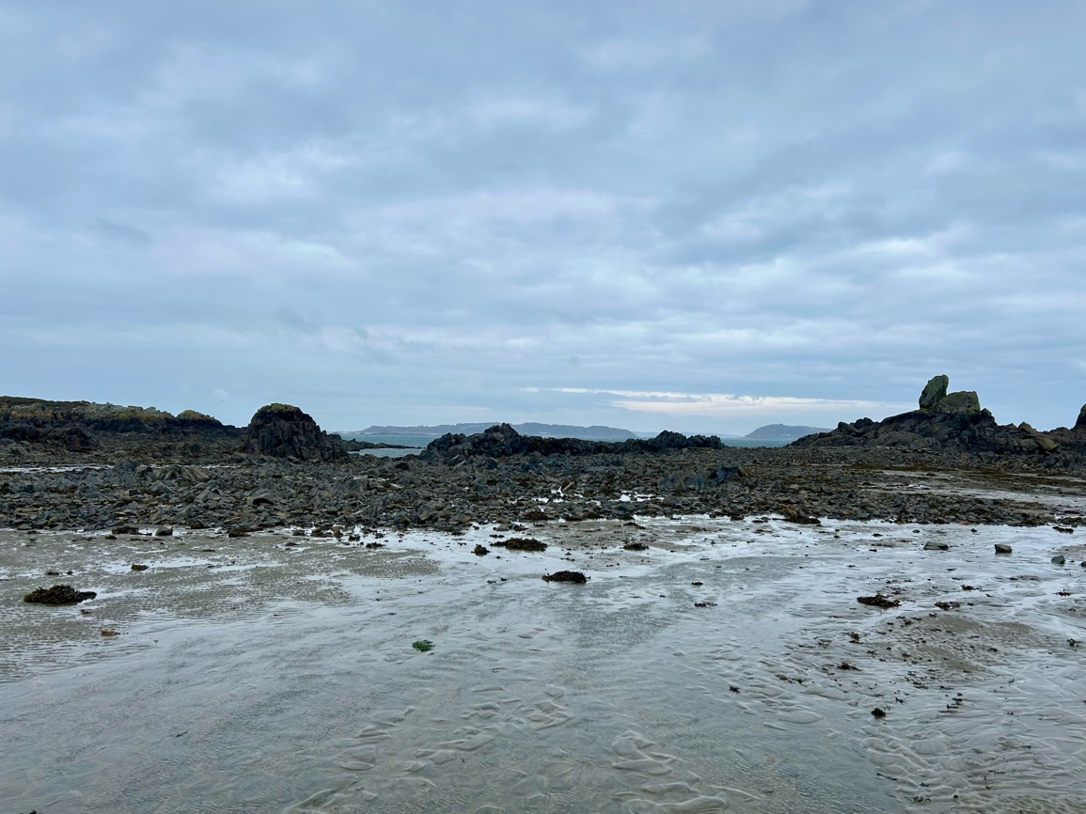
Figure 1: Bordeaux to the east, the Islands of Herm and Jethou in the distance, image by author, 19 Oct 2025
Bordeaux is a small fishing harbour on the northeast coast of Guernsey in the Channel Islands. Figure 1 shows Bordeaux at low tide, when there is a great sense of liminality, a potency. What had once been full to the brim, now is empty, but the energy of the place remains, it is still palpable. A temporary void that can be entered and tread upon, until the tide once again returns. This could be said of any place where land meets water and tides exist, however at Bordeaux there is a sense of walking down into a deep, empty container, one surrounded by rocky gateways. A place set apart, one rarely entered by humans, even when the tide recedes, only a few dog walkers and fishermen can be found there. As a phenomenological space it belongs to the water and the rocks, it is not a shared space, but a borrowed one. Too few humans have been in relationship with this place for human culture to dominate.

Figure 2: Jacques Nicolas Bellin (1703-1772), 1757 map of Guernsey. Image: Wikimedia Commons
As can be seen in Figure 2, Bordeaux is found at the margins, positioned on the northeast coast of Guernsey, in an area known as Le Clos du Valle, separated from the mainland of Guernsey by a tidal stretch of sea, La Braye du Valle, until the early nineteenth century. This land was reclaimed as part of the defence of Guernsey during the Napoleonic wars, but being low-lying and swampy remained mostly farmland until after the Second World War. This sense of being on the periphery, apart from the everyday, means that to be at Bordeaux, still today, is to deliberately travel to find it. It is a place which has been largely left alone by human culture. There are only seven fisherman cottages around the harbour, and no restaurants or shops to attract a steady stream of visitors. It is a sanctuary for nature, to the landed side of Bordeaux is Le Grand Pré Nature Reserve, a wetland of reedbeds, which would previously have been endemic across this area, it attracts birds and insects, and a few walkers around its periphery. In the spring and autumn, themselves liminal spaces in the year between the seasons of summer and winter, migratory birds, such as Reed and Sedge Warblers roost in the area. To the east of Bordeaux, across a narrow stretch of water, known as the Little Russell, is a Ramsar Site designated in 2015, which includes the islands of Herm, Jethou and The Humps and its surrounding waters. This has an exceptionally large and biodiverse tidal range and is a breeding site for nine species of seabird and the Atlantic Grey Seal. Bordeaux’s experience of human culture is one of being left alone, or protected, and walking through its landscape, feels, as Durkheim suggests, like a ritualistic activity. It is a purposeful activity designed to generate transformation, and it is a place that I have been attracted to only during liminal times in my life, after the birth of my children, through divorce and the death of my mother. Times when I too have sought sanctuary, and the protection of a womb-like space where few other humans tread.
Liminal space as a place of creation

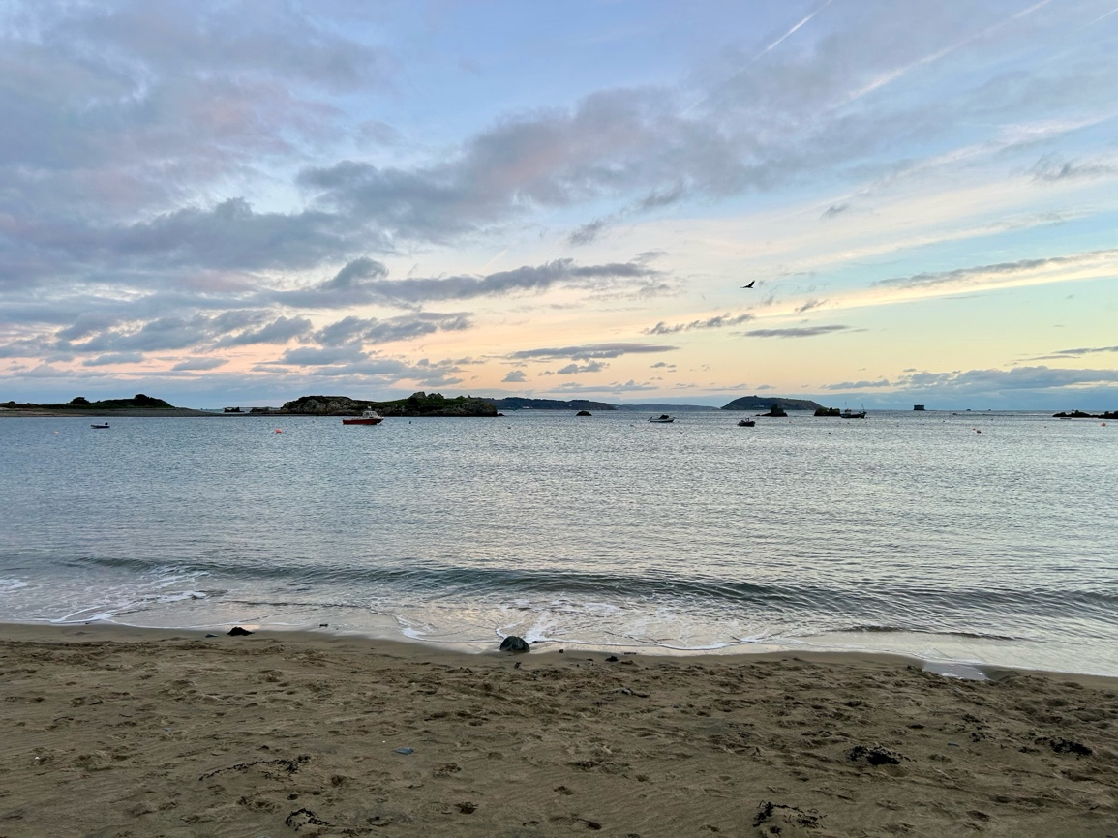
Figure 3: Bordeaux in the evening at high tide, facing east, image by author, 1 January 2026
According to McCormack, a Guernsey historian and architect, as a natural phenomenon, Bordeaux is composed of durable diorite rock, intermingled with granodiorite. It was created, and recreated through volcanic activity, with magma seeping into the cracks of already formed rock. It has been shaped through ice ages, wind - being ‘exposed to the fury of the Atlantic gales’ - and strong tidal currents. At once a place of enormous power and abandon, a sense left by the receding tide, and yet, contained within those gateways, a sense of a beginning waiting to happen, a transformation, portals into the unknown. Lyall Watson, a South African botanist and zoologist, describes every mass of water as having ‘its own tidal character, its own natural frequency and period of oscillation’, he also highlights how water is ‘almost indestructible’, needing to be heated to extreme temperatures for the hydrogen and oxygen atoms to be separated. As a result, water first created three billion years ago still exists, ‘flowing intact down the corridors of time.’ For Lyall, each water molecule has its own skin, its own interface with the world, this skin moulds to create vortices and vibrations with everything they touch, every stone or grain of sand that they move over, between and around. This leaves an impression that defines a body of water and enables a projection of its unique consciousness to others that pass through. So, while Bordeaux is found at the periphery of human culture, as described by Eliade, at this place can also be found a centre, a fixed place, a container, where each new tide brings the creation of a new world with its own unique inherent power expressed each time the water pours back in. Figure 3 shows the harbour at full tide, when it feels like it has found its way to a calm and ordered place, a contentment of a relationship between rock and water that is ‘right’, together, no longer separate.
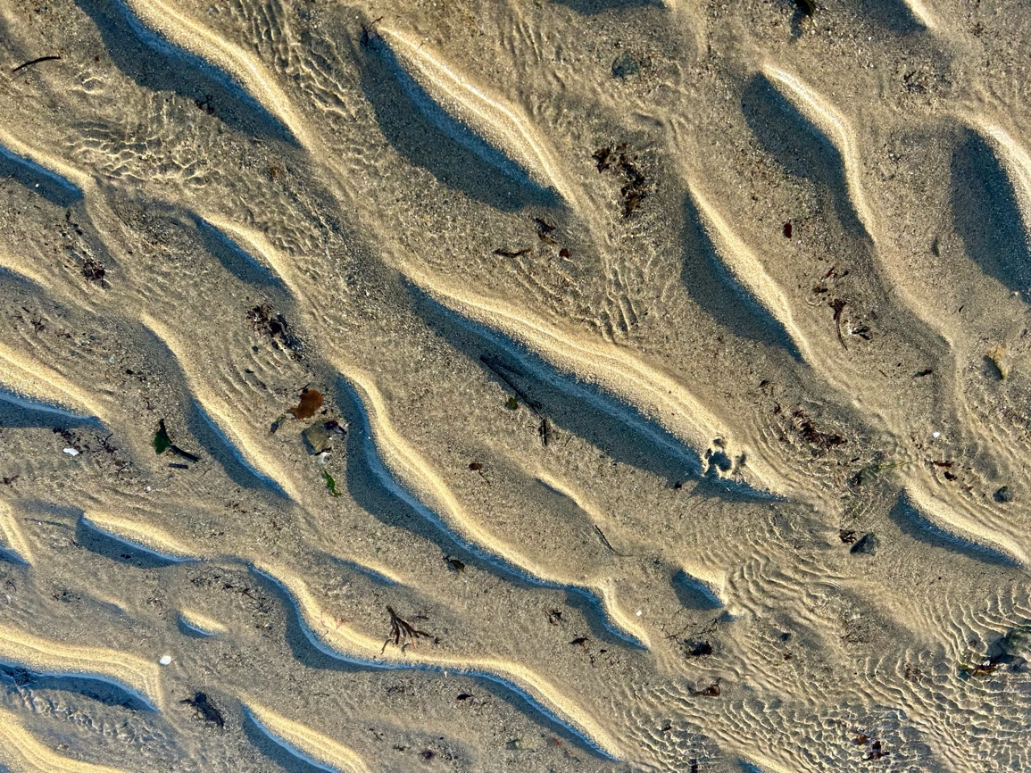
Figure 5: Vortices created by the interaction of water and earth at Bordeaux, image by author, 15 December 2025
Theodor Schwenk, an anthropologist and engineer, describes water as being akin to a sense organ, where different wave patterns create ‘many and diverse movements’ at the interface between water and air. This movement of waves is ‘independent of space’, they are within the space, but are also individual, unique and expressive. For Schwenk, every area of water ‘has its own natural period of vibration’ which creates a rhythm of its own. Where waves move around obstacles, such as rocks, islets and piers in a dance of ‘rhythmical and spiralling movements’. Here two forces interact, the solid, immoveable stone, and the fast fluidity of water, one stationary, and the other inexorably moving forward. At this juncture, vortices are formed, a calm inner space of water, slowed by the obstacle in its way, and faster moving currents, less incumbered. Within these vortices are many boundary surfaces, ‘expanding and contracting’, as Schwenk describes, a multitude of sense organs, or water molecules, interacting, communicating and responding. These vortices leave their mark when the tide recedes, ‘deep veins in the sand’, the shape of boat chains, of seaweed trails, rocks and gateways, gradually hewn into the rock less indestructible than the rest. This is the landscape upon which humans walk at Bordeaux at low tide. The energy of the water still residing in the air, and a visible imprint of activity on the sand, ripples of natural art, a communication between water and land. Figure 4 is one impression of this natural dance, the vortices forming a soft and gentle rhythm in comparison to the long straight tempos created at a wide-open beach. A liminal space, miniature passageways from chaos to orientation, and as Eliade’s describes a gateway to divinity.
Liminal space as a gateway
Bordeaux Harbour provides a multitude of gateways and thresholds. Within the entrance to the harbour are great protruding rocks, forming gateways through which the twice daily tides eddy and swirl. A small L-shaped pier lies to the southeast, and to the northeast is the tidal island of Houmet Benêt. The harbour mouth thus gives the impression of a series of giant stone portals or gateways through which you cross, rather than a wide expanse into which you enter. Each time the tide comes in or out a threshold is crossed, each tide coming in, seeming so natural and right for the water and rocks themselves, while forming a more chaotic reality for humans. Where once the harbour could be entered and walked on, at full tide, Bordeaux, becomes, to human senses, unpredictable. It is no longer a space for humans to inhabit. Yet, it also returns to the ordinary and profane as, when full, it becomes a harbour for boats once again. If, as Eliade contends, the passageway to sacrality is found in the emptiness, the nothingness of the cocoon before the hierophany, then this is to be found in the harbour, left when the tide recedes. To cross the threshold at low tide is to come into relationship with a liminal space, a transition to a different state of being, and the possibility of communication with another world, the divine.
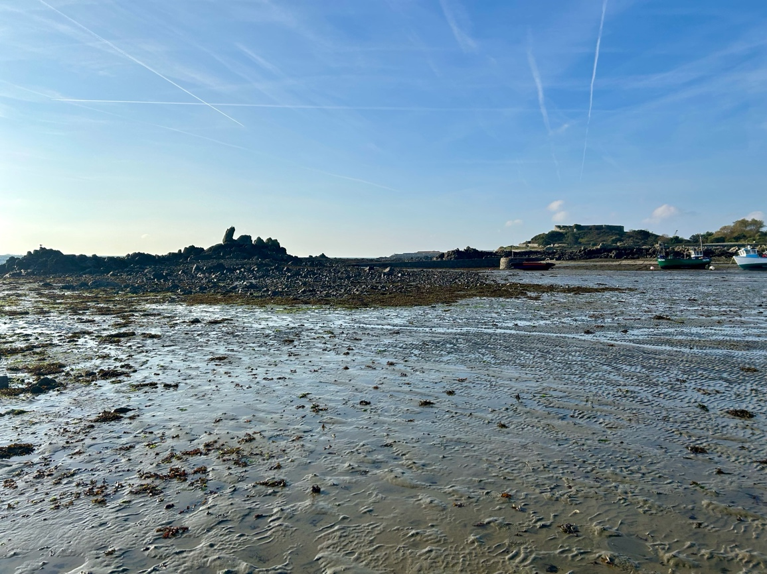
Figure 5: Bordeaux to the southeast, the pier and Vale Castle to the right, image by author, 17 Oct 2025
Human culture too has seen Bordeaux as a gateway. To the south of the site, pictured on the right of Figure 5, is Vale Castle, (Le Château de Saint Michel), a now ruined fortification described as ‘a settlement and a haven’ by James Marr, a Guernsey historian. Marr has identified various possible construction dates, from 966 to 1440, with archaeological finds in the 1980s showing evidence of an iron age hillfort. Local records show that at various times it acted as a refuge for local people to provide protection against pirates, Vikings and French invasion. The small Island of Le Clos du Valle in the north of Guernsey providing a gateway from which to stage an attack on the larger, more heavily fortified southern island, and the Vale Castle a necessary refuge for people living in the area. As with a sanctuary for nature, Bordeaux has again, as a cultural construct, been formed as a gateway through which humans pass for refuge. It is not a place of sanctuary itself, but a gateway to it. A liminal space through which humans pass to reach a sacred space of safety. Perhaps, though as Durkheim describes this liminal gateway to sanctuary is an ‘illusion’ of human morality, a reflection of a symbolic restraint on human behaviour, rather than as part of an ecological consciousness, impacting on all who pass through it, as described by Sewell.
Final thoughts
Three themes were identified during the literature review and the fieldwork, that of liminal space as a place at the margins, as a place of creativity, and as a place of many gateways. I was first drawn to Bordeaux as a liminal space because it felt like a safe container, an empty space where not many people interact, and human culture is on the sidelines. A place to process challenging times and yet a place that has a strong energetic presence. Using Lanes three models, ontological, cultural and phenomenological approaches to explore this energetic presence opened the doorway to liminality as a sacred space. First, observing Bordeaux as a natural phenomenon, where liminal space is a place of uncertainty and change, a place at the margins, and also a gateway to divinity, a place where you feel centred, and in awe all at once; and second, as a social construct, an ideal reflection of nature, set apart, and a product of a shared moral community. It made sense that these models both have value, and indeed by exploring water through the eyes of scientists, and the historical and sociological aspects of Bordeaux, it seemed reasonable to assume that these both exist in tandem. The power of both have created the liminal space. However, it is the psychological entanglement of extended consciousness that brought everything together and brought life to my research and, it is this, the interaction between Bordeaux, the place and the people, their entanglement in an ecological moral community that makes Bordeaux a unique liminal space. It is a feeling of being in an intense therapeutic relationship with nature, where you leave everything behind at the gateway and anything can happen. A place of beginnings, endings and the space in-between.
Conclusion
The aim of this research was to explore the idea of liminal space as a human construct and as a natural phenomenon, with reference to Bordeaux Harbour as a place. The academic rationale for choosing Bordeaux, was that while human culture has taken place around the harbour, within the harbour itself, there is a sense of a void, a liminal space that very rarely has people within it. It is a space that belongs to nature, has largely maintained its natural shape and has not been radically transformed to suit the needs of people. It therefore provided a blank canvas through which to explore liminal space as a human construct and as a natural phenomenon. The methodology used is a phenomenological framework and included a literature review of the main philosophical and theological arguments, and a qualitative collection of primary data, using historical, anthropological, psychological and autoethnographic fieldwork approaches. Bordeaux as a liminal space was explored using the themes of liminality at the margins, as a source of creativity and as a gateway. Following the research I have concluded that Bordeaux, as a liminal space, is both a human construct and a natural phenomenon, and it is their entanglement in an ecological moral community that makes Bordeaux a unique liminal space.
Bibliography
Agriculture, Countryside and Land Management Services, Nature Reserves https://gov.gg/nature [accessed: 20 December 2025]
Bird Rose, Deborah, Shimmer: flying fox exuberance in world of peril, (Edinburgh: Edinburgh University Press, 2022)
Burns, Bob, A Field Guide to the Archaeological Sites of Guernsey, cited in James Marr, The History of Guernsey: The Bailiwicks Story (London: Phillimore & Co. Ltd, 2001)
Durkheim, Émile, The Elementary Forms of Religious Life: A new translation by Carol Cosman (Oxford: Oxford University Press, 2008)
Eliade, Mircea, The Sacred and the Profane: The Nature of Religion, trans. By Willard R. Trask (New York: Harcourt, Inc., 1957)
Ingold, Tim, Lines, 2nd Edn. (Oxon: Routledge Classics, 2016)
Lane, Beldon C., Landscapes of the Sacred: Geography and Narrative in American Spirituality, Expanded Edn. (Baltimore: The John Hopkins University Press, 2002)
La Société: For Nature, History and Science in Guernsey, Guernsey’s Nature Reserves, https://societe.org.gg/wp/nature-reserves/ [accessed 20 December 2025]
Mahy, Geoff, ‘The Vale Castle’, in The Vale: 800 Years of a Guernsey Parish, ed. Dave Wylie (Guernsey, IMK Limited, 2005)
Marr, James, The History of Guernsey: The Bailiwicks Story (London: Phillimore & Co. Ltd, 2001)
McCormack, John, The Guernsey House, 2nd Edn., (Sussex: Phillimore & Co. Ltd., 1987)
Natural History of the Bailiwick of Guernsey: The flora and fauna of Guernsey, Alderney, Sark and Herm, Le Grand Pré Nature Reserve https://bailiwickwildlife.com/le-grand-pre-reserve/ [Accessed 15 December 2025]
Neisser, Ulrich, ‘The Ecological Self and its Metaphors’, in Philosophical Topics, Spring & Fall 1999, Vol. 26, no1/2, The Philosophy of Sydney Showmaker, pp. 201-215 (University of Arkansas Press)
Otto, Rudolph, The Idea of the Holy: An Inquiry into the Non-Rational Factor in the Idea of the Divine and its Relation to the Rational, reprint of 1st English Edn. (Connecticut: Martino Fine Books, 2010)
Schama, Simon, Landscape and Memory (New York: Fontana, 1996)
Schwenk, Theodor, Sensitive Chaos: The Creation of Flowing Forms in Water and Air, 2nd edn. (East Sussex: Sophia Books, 2014)
Sewall, Laura, ‘The Skill of Ecological Perception, in Ecopsychology: Restoring the Earth, Healing the Mind ed. By Theodore Roszak, Mary E. Gomes and Allen D. Kanner (Berkeley: Counterpoint, 1995), pp. 201-215,
Tilley, Christopher, A phenomenology of landscape: places, paths and monuments (Oxford: Berg Publishers, 1994)
Watson, Lyall, The Water Planet: A Celebration of the Wonder of Water (New York: Crown Publishers, Inc. 1988)

Beldon C. Lane, Landscapes of the Sacred: Geography and Narrative in American Spirituality, Expanded Edn. (Baltimore: The John Hopkins University Press, 2002), p. 39
Tim Ingold, Lines, 2nd Edn. (Oxon: Routledge Classics, 2016), p. 3
Christopher Tilley, A phenomenology of landscape: places, paths and monuments (Oxford: Berg Publishers, 1994) p. 12
Tilley, Phenomenology, p. 13
Tilley, Phenomenology, p. 14
Tilley, Phenomenology, p.26
Lane, Landscapes, p. 181
Lane, Landscapes, p. 187
Deborah Bird Rose, Shimmer: flying fox exuberance in world of peril, (Edinburgh: Edinburgh University Press, 2022), p. 21
Mircea Eliade, The Sacred and the Profane: The nature of religion, trans. By Willard R. Trask (New York: Harcourt, Inc., 1957) p. 22
Eliade, Sacred and Profane p.11
Rudolph Otto, The Idea of the Holy: An Inquiry into the Non-Rational Factor in the idea of the Divine and its Relation to the Rational, reprint of 1st English Edn. (Connecticut: Martino Fine Books, 2010), p. 5
Eliade, Sacred and Profane, p. 25
Eliade, Sacred and Profane, p. 36
Eliade, Sacred and Profane, p. 50
Lane, Landscapes, p. 42
Simon Schama, Landscape and Memory (New York: Fontana, 1996), p. 8
Schama, Memory, p. 9
Schama, Memory, p.14
Lane, Landscapes, p. 43
Émile Durkheim, The Elementary Forms of Religious Life: A new translation by Carol Cosman (Oxford: Oxford University Press, 2008), p. 11
Durkheim, Forms, p. 21
Durkheim, Forms, p. 18
Durkheim, Forms, p. 16
Durkheim, Forms, p. 317
Durkheim, Forms, p. 315
Lane, Landscapes, p. 43
Lane, Lanscapes, p. 44
Ingold, Lines, p. 3
Laura, Sewall, ‘The Skill of Ecological Perception, in Ecopsychology: Restoring the Earth, Healing the Mind ed. By Theodore Roszak, Mary E. Gomes and Allen D. Kanner (Berkeley: Counterpoint, 1995), pp. 201-215, p. 203
Sewall, Ecological Perception, p. 208
Sewall, Ecological Perception, p. 207
Ulrich Neisser, ‘The Ecological Self and its Metaphors’, in Philosophical Topics, Spring & Fall 1999, Vol. 26, no1/2, The Philosophy of Sydney Showmaker, pp. 201-215 (University of Arkansas Press), p. 213
Neisser, Ecological Self, p. 213
Geoff Mahy, ‘The Vale Castle’, in The Vale: 800 Years of a Guernsey Parish, ed. Dave Wylie (Guernsey, IMK Limited, 2005) p. 93
Natural History of the Bailiwick of Guernsey: The flora and fauna of Guernsey, Alderney, Sark and Herm, Le Grand Pré Nature Reserve https://bailiwickwildlife.com/le-grand-pre-reserve/ [Accessed 15 December 2025]
La Société: For Nature, History and Science in Guernsey, Guernsey’s Nature Reserves, https://societe.org.gg/wp/nature-reserves/ [accessed 20 December 2025]
Agriculture, Countryside and Land Management Services, Nature Reserves https://gov.gg/nature [accessed: 20 December 2025]
John McCormack, The Guernsey House, 2nd Edn., (Sussex: Phillimore & Co. Ltd., 1987) p. 4
McCormack, House, p. 1
Lyall Watson, The Water Planet: A Celebration of the Wonder of Water (New York: Crown Publishers, Inc. 1988) p. 16
Watson, Water Planet, p. 122
Watson, Water Planet, p. 134
Theodor Schwenk, Sensitive Chaos: The Creation of Flowing Forms in Water and Air, 2nd edn. (East Sussex: Sophia Books, 2014) p. 29
Schwenk, Sensitive Chaos, p. 30
Schwenk, Sensitive Chaos, p. 38
Schwenk, Sensitive Chaos, p. 59
Schwenk, Sensitive Chaos, p. 65
Schwenk, Sensitive Chaos, p. 77
James Marr, The History of Guernsey: The Bailiwicks Story (London: Phillimore & Co. Ltd, 2001) p. 230
Bob Burns, A Field Guide to the Archaeological Sites of Guernsey, cited in James Marr, The History of Guernsey: The Bailiwicks Story (London: Phillimore & Co. Ltd, 2001) p. 230
Mahy, The Vale Castle, p. 93
Durkheim, Forms, p. 315
Sewall, Ecological Perception, p. 203

