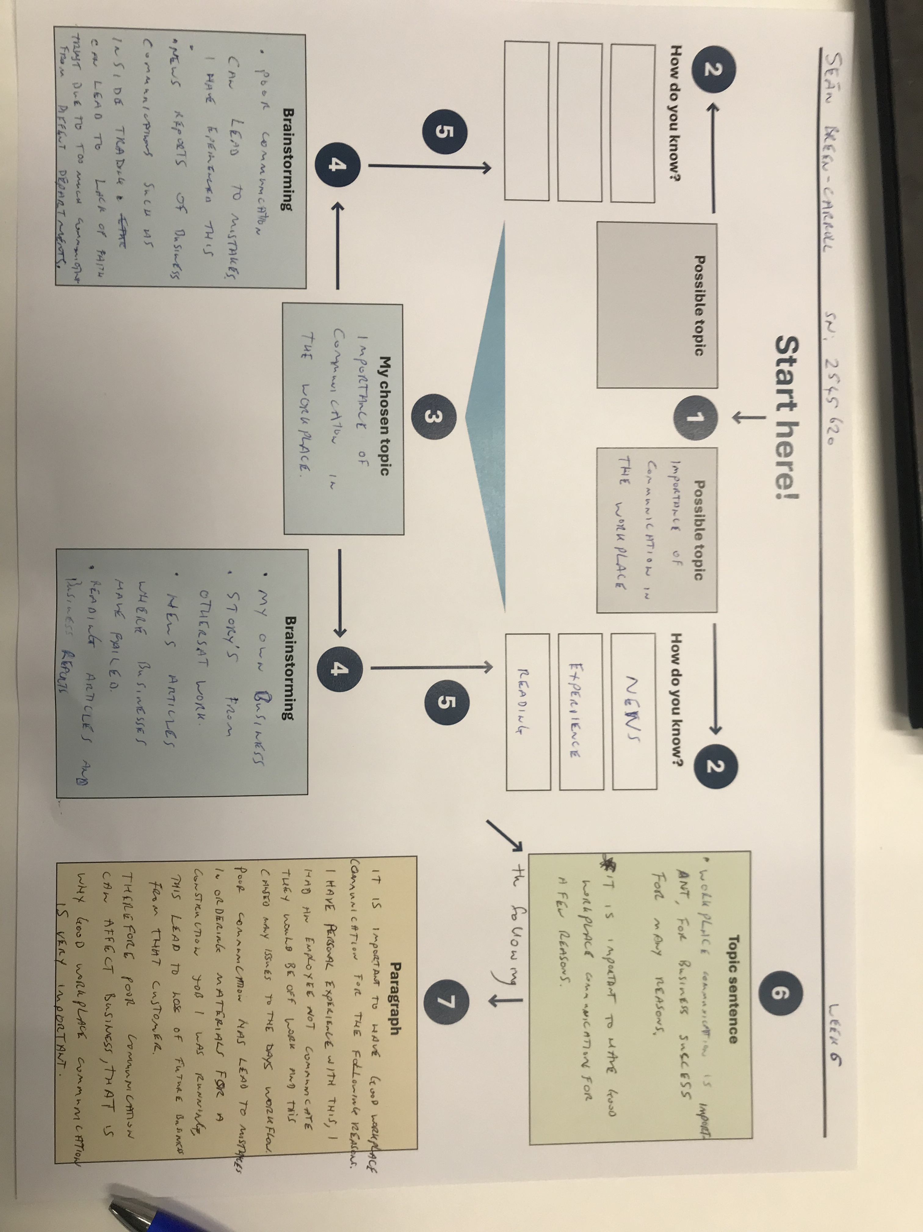
Assessment 2 Template

Complete the below TEEL tasks. Please note the use of AI is not permitted for this task.
- Read the paragraph below.
Identify the TEEL structure in the paragraph.

Write the correct part of TEEL next to each sentence in the square brackets.

- T: Topic Sentence
- EXP: Explanation
- E: Evidence / Example
- L: Link Sentence

Paragraph
[ T ] Using data to make business decisions improves efficiency and reduces risk. Many businesses now analyse data to guide pricing, stock levels, and planning. [ E ] Research from McKinsey Global Institute (2017) found that data-driven organisations are significantly more likely to acquire customers and be profitable than those that rely on intuition. [ EXP ] This shows that using data can directly improve business performance. [ EXP ] It is not just about collecting information. [ EXP ] Additionally, businesses must also use the data to make informed decisions. [ E ] For example, data can highlight which products are selling well and which are not. [ EXP ] This allows managers to adjust quickly and reduce waste. [ EXP ] Over time, these small decisions can lead to higher profits and better use of resources. [ T ] Overall, using data supports more accurate and effective business decision making.

- Find the cohesive devices in the above paragraph and highlight or underline them. Then fill in the answers for each below.

- Device: Topic Sentence, main point Purpose: Explains the main point, or process
- Device: Supporting sentence, example, evidence Purpose: To persuade
- Device: Concluding sentence Purpose: Transition, link two sections of text

- Choose the strongest topic sentence from the options below.

- Time management is important.
- Time management is important because it helps people organise their work.
- Time management is important because it helps employees prioritise tasks, meet deadlines, and reduce workplace stress, leading to higher productivity.

I choose option C

- Choose the strongest explanation sentence
Topic Sentence:
Good teamwork is important in the workplace because it helps employees achieve shared goals efficiently.
Which is the best explanation?
A) Teamwork happens in many workplaces.
B) When employees collaborate effectively, they can share ideas, solve problems faster, and support each other’s strengths.
C) Some people prefer to work alone.
I choose Option B
- Choose the strongest evidence/example
Topic Sentence:
Workplace training is essential because it helps employees improve their skills and performance.
Explanation:
When employees receive proper training, they become more confident and capable in their roles.
Which is the best evidence/example?
a) Training is something companies often provide.
b) A study by LinkedIn (2023) found that 94% of employees said they would stay longer at a company that invests in their learning.
c) Employees go to work every day.
I choose option B

- Choose the best linking sentence
Topic Sentence:
Flexible working hours can improve employee satisfaction and productivity.
Explanation + Evidence:
When employees can manage their own schedules, they are better able to balance work and personal responsibilities. For example, many companies report increased performance after introducing flexible working policies.
Which is the best linking sentence?
A) Flexible working is becoming more common.
B) Employees like flexibility.
C) Overall, flexible working hours contribute to a more productive and satisfied workforce.
I choose option C
Write the final draft of your TEEL paragraph on your chosen topic here. This is the final draft of the paragraph you started in class!
TEEL FINAL DRAFT:
It is important to have good workplace communitcation for the following reasons. I have personal experience with this, I had an employee not communicate in a text message the exact day they would be taking time off and this caused many days of stress and reduced work output. Poor communication also led to the wrong materials been ordered for a job that was coming up, leading to an innefctive workplace. The institute of business describes communitaction as follows “Effective communication is therefore clear, unambiguous, transparent” (aib.edu.au, 2022). As you can see from my personal account the communtication was not clear or transparent from the employee so led to issues within the workplace. This led to loss of future business. Therefore poor communitcation can affect business that is why good workplace communication is essential.

https://www.aib.edu.au/blog/communication/6-reasons-effective-communication-focus-business/

