Professional Practice – Reflective Process Portfolio

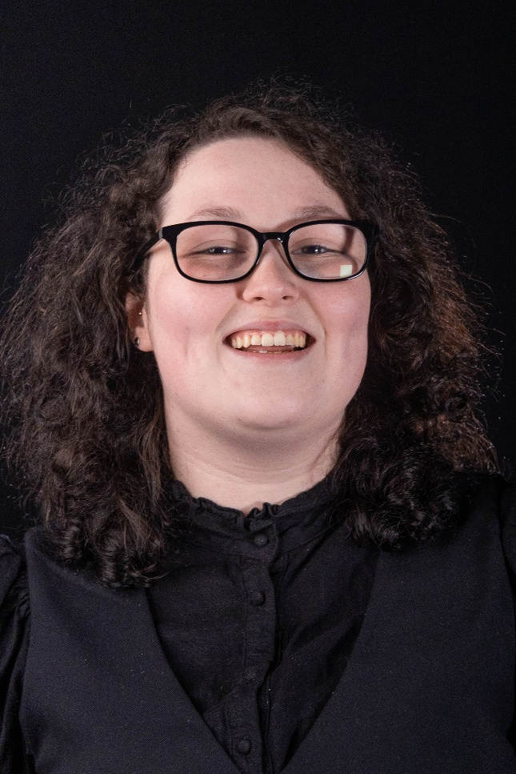
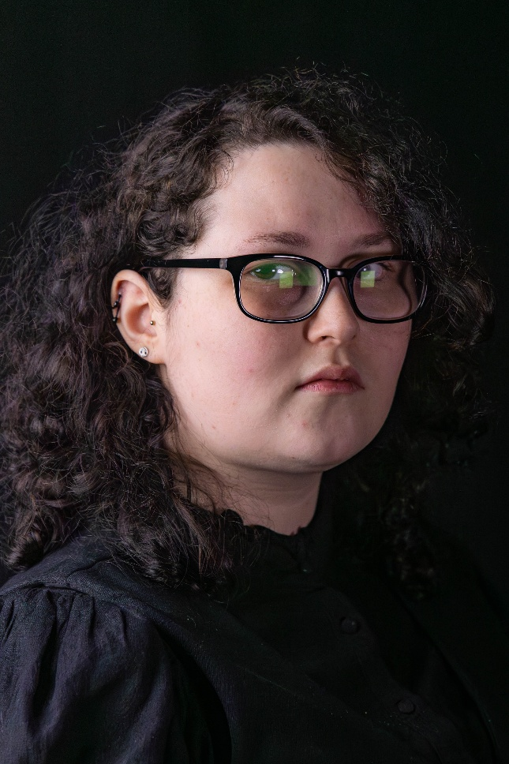
Headshots

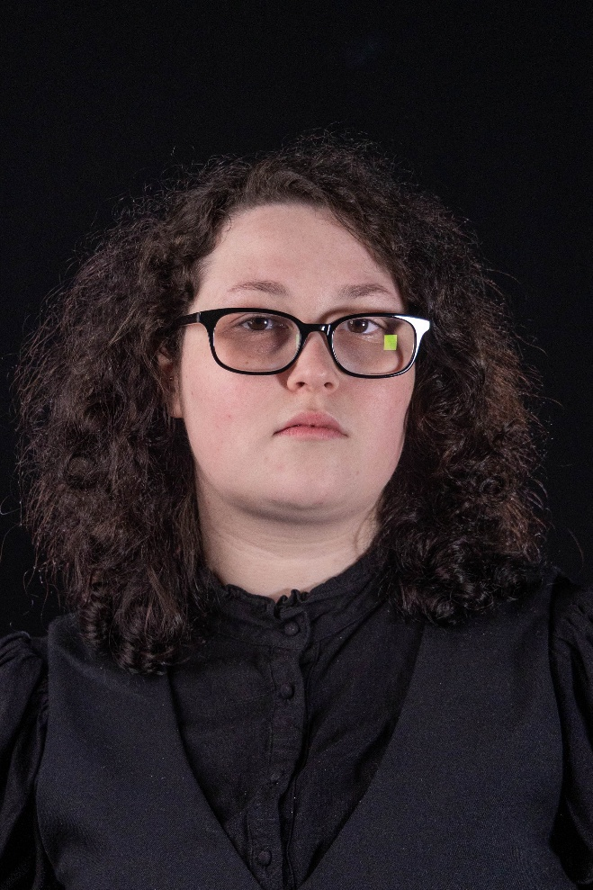

CVs
Old CV
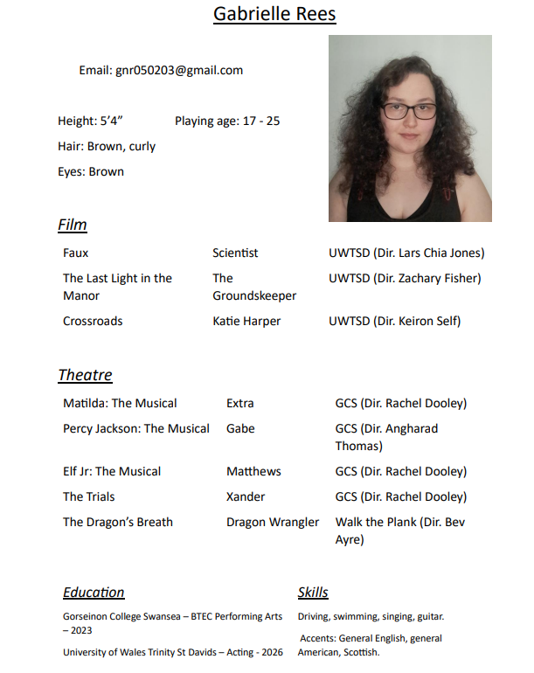

New CV
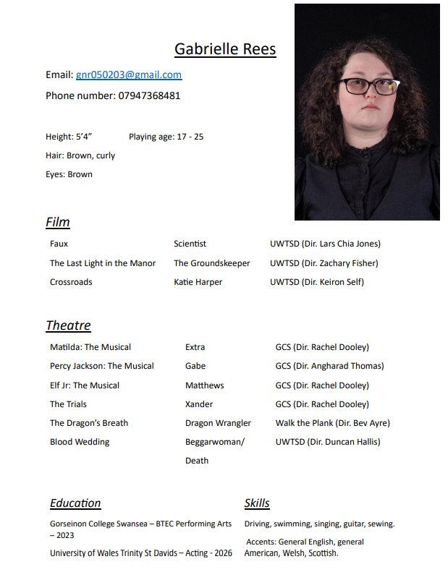

SWOT
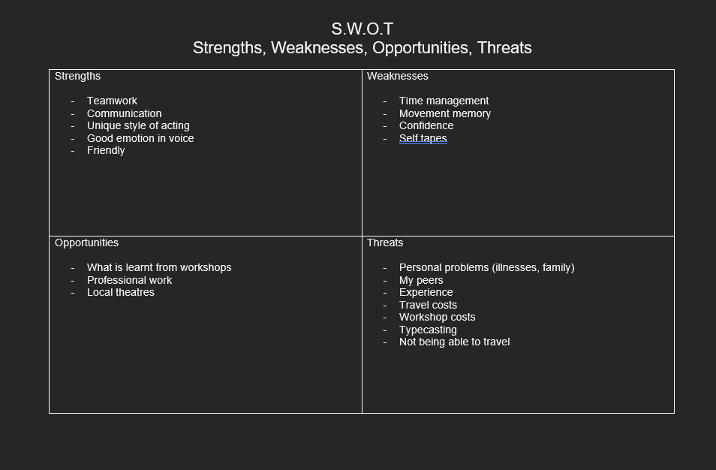

PDP (Personal Development Plan)
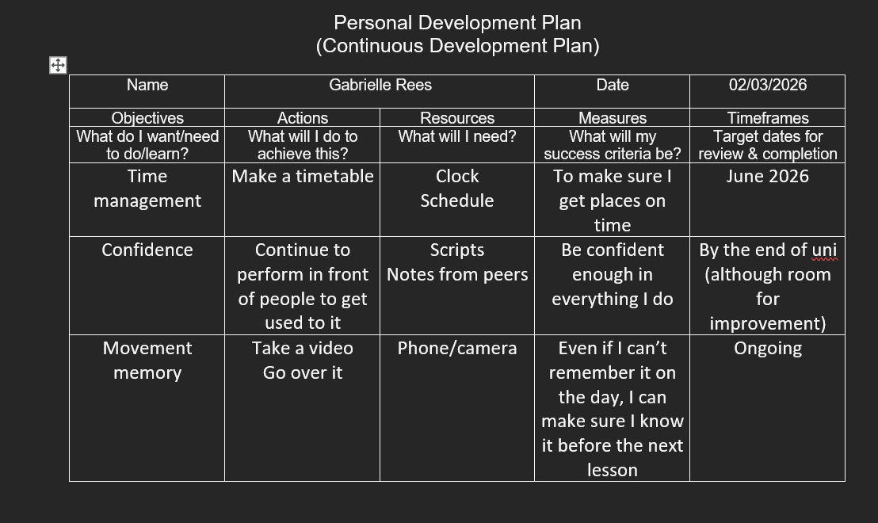
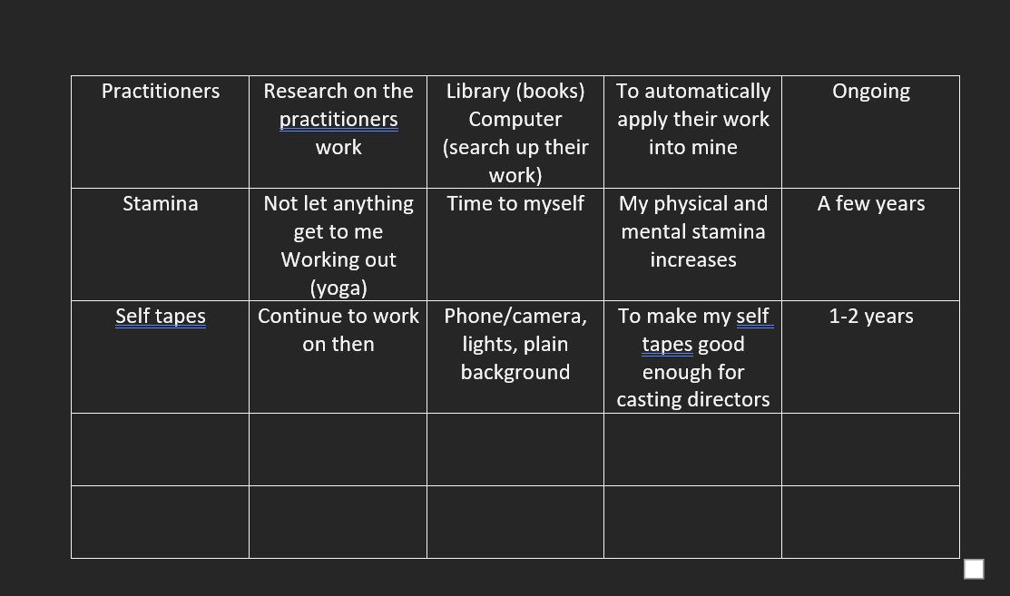

Workshops (websites)
Anon, (n.d.). Arad Goch – Cwmni Theatr Arad Goch. [Online] Available at: https://aradgoch.cymru/?lang=en.
Equity (2019). Equity. [Online] Available at: https://www.equity.org.uk/. [Accessed 13th February]
‌Spotlight (2018). Spotlight: The home of casting. [Online] Available at: https://www.spotlight.com/. [Accessed 18th February]
‌Screen Alliance Wales. (n.d.). SAW | Welcome. [Online] Available at: https://www.screenalliancewales.com/. [Accessed 20th February]
‌Theatr Cymru. (n.d.). Home. [Online] Available at: https://theatr.cymru/en/. [Accessed 27th February]

Songs I suggested for the showcase
musicfromgleeVEVO (2021). Glee Cast - Landslide (Official Audio) ft. Gwyneth Paltrow. [online] YouTube. Available at: https://www.youtube.com/watch?v=A6La_yFNO_w [Accessed 3 Mar. 2026].
‌
Prime Video (2025). Sera’s Confession Sing-Along - Hazbin Hotel S2 | Prime Video. [online] YouTube. Available at: https://www.youtube.com/watch?v=t_MB4WWuqTs [Accessed 3 Mar. 2026].
‌

Scripts I read as suggestions for the showcase
Basden, T. (2014). Holes. London: Nick Hern Books.
Harrower, D. (2006). Blackbird. London: Faber and Faber.
Graham, J. (2016). The Angry Brigade. London: Bloomsbury Publishing.
Wilkinson, M. (2022). Psychodrama. London: Methuen Drama.

Other Research
Mitchell, K. (2008). The directors craft. Oxfordshire: Routledge.

