Portfolio 4 components (25%
weighting per component)

Foreign Languages & Cultural Awareness
BMIH5003
Lecturer: Giulia Chifari
Student name: FloricaAnamaria Ciuta
Student ID: 2243597

2024

Component 1
During my Level 4 placement at the Leman Locke hotel, I witnessed a cultural misunderstanding between a German guest and a fellow food and beverage (F&B) employee during the dinner service in the hotel's restaurant. The incident highlighted the complexities of intercultural communication and underscored the need for cultural competence in the hospitality industry.
The scenario unfolded when the German guest, unfamiliar with some British dining customs, expressed dissatisfaction with the way his steak was prepared. He requested his steak to be cooked "rare," but due to a language barrier and different culinary expectations, the steak was served to him more cooked than he preferred. In Germany, "rare" (blutig) typically means very lightly cooked, almost raw, whereas in the UK, the same term can be interpreted with slightly more leniency. The guest, already frustrated by the miscommunication, became visibly upset, and the F&B employee, unsure of how to address the situation, struggled to find a resolution.
Cultural misunderstandings like this one can occur due to differences in language, non-verbal cues, and cultural norms. According to Hofstede's cultural dimensions theory, individualism versus collectivism and high versus low context communication are key aspects that can lead to misinterpretations (Hofstede, Hofstede, & Minkov, 2010). In high-context cultures, such as Germany, much of the communication is implicit and relies heavily on context, whereas in low-context cultures, like the UK, communication is more direct and explicit (Hall, 1976). This disparity can lead to misunderstandings, especially in service settings where expectations and standards vary.
Reflecting on this experience, I recognize the importance of developing several skills and making behavioural changes to prevent such misunderstandings in the future. Firstly, improving language skills is essential. While English is widely spoken in the hospitality industry, having basic knowledge of common phrases in other languages can greatly enhance communication with international guests. Studies have shown that even a minimal effort to speak a guest's native language can significantly improve their experience and perception of service (Lashley, 2018).
Secondly, cultural awareness and sensitivity training are crucial. Understanding the cultural backgrounds of guests and their dining preferences can help prevent misunderstandings. Engaging in cultural competency training can provide F&B employees with the tools to better navigate cross-cultural interactions. For example, learning about different culinary traditions and dining etiquettes can help employees anticipate and meet the expectations of guests from diverse backgrounds (Reisinger & Turner, 2003).
Lastly, developing active listening and empathy skills is vital. Actively listening to guests' concerns and showing empathy can de-escalate potential conflicts and lead to a more positive outcome. This involves not only hearing the words being said but also paying attention to non-verbal cues and emotional tones (Goleman, 2006). By fostering an environment of understanding and respect, F&B employees can build stronger relationships with guests and provide a more personalized service.
In conclusion, the cultural misunderstanding I observed during my placement at the Leman Locke hotel underscored the need for enhanced cultural competence in the hospitality industry. By improving language skills, undergoing cultural awareness training, and developing active listening and empathy, F&B employees can better navigate the complexities of intercultural communication and provide exceptional service to all guests.
Words 521

Component 2
Training Plan for Enhancing Cultural Competence in F&B Employees
Objective:
To equip all F&B employees at Leman Locke Hotel with the skills and knowledge necessary to effectively manage cultural misunderstandings and provide exceptional service to guests from diverse backgrounds.
Training Components:
1. Language Skills Enhancement
- Objective: Improve basic language proficiency in key languages spoken by guests.
- Activities:
- Language Workshops: Monthly workshops focusing on common phrases and culinary terms in German, French, Spanish, and Mandarin.
- Language Resources: Provide employees with language guides and mobile apps for quick reference (Bailey, 2020).
- Interactive Sessions: Role-playing exercises where employees practice taking orders and addressing concerns in different languages.
2. Cultural Awareness and Sensitivity Training
- Objective: Increase understanding of cultural differences and dining customs.
- Activities:
- Cultural Briefings: Weekly briefings on different cultures, focusing on dining etiquette, common dietary preferences, and communication styles (Brown, 2016).
- Guest Speakers: Invite experts on cultural competence to share insights and experiences.
- Case Studies: Discuss real-life scenarios and solutions to cultural misunderstandings observed in the hospitality industry (Zopiatis&Constanti, 2007).
3. Active Listening and Empathy Development
- Objective: Enhance employees' ability to listen actively and show empathy towards guests.
- Activities:
- Workshops on Active Listening: Training sessions that focus on techniques for active listening, such as paraphrasing and reflective responses (Bodie, 2011).
- Empathy Exercises:Role-playing activities where employees practice responding to guest complaints with empathy and understanding (Gentry et al., 2007).
- Feedback Sessions: Regular sessions where employees can share experiences and receive feedback on their interactions with guests.

4. Continuous Learning and Improvement
- Objective: Ensure ongoing development of cultural competence among staff.
- Activities:
-Regular Assessments: Quarterly assessments to evaluate employees' progress in language skills and cultural awareness.
- Feedback Loop: Establish a system where employees can provide feedback on the training program and suggest improvements.
- Recognition Program: Implement a recognition program to reward employees who demonstrate exceptional cultural competence (Lashley & Morrison, 2000).
Implementation Timeline:
Month 1:
- Launch language workshops and provide language resources.
- Begin weekly cultural briefings and schedule guest speakers.
- Conduct the first workshop on active listening.
Month 2:
- Continue language workshops and cultural briefings.
- Introduce empathy exercises and role-playing activities.
- Establish feedback sessions for employees.
Month 3:
- Conduct the first quarterly assessment.
- Gather feedback from employees and make necessary adjustments to the training plan.
- Implement the recognition program.
Evaluation and Feedback:
- Quarterly Assessments: Use assessments to measure improvements in language proficiency and cultural awareness.
- Employee Feedback: Collect regular feedback from employees to identify areas of improvement and ensure the training remains relevant and effective.
- Guest Satisfaction Surveys: Monitor guest feedback to evaluate the impact of the training on service quality.
This training plan aims to enhance the cultural competence of F&B employees at Leman Locke Hotel, ensuring they are well-equipped to handle cultural misunderstandings and provide exceptional service to a diverse clientele. By focusing on language skills, cultural awareness, active listening, and empathy, the hotel can foster a more inclusive and welcoming environment for all guests.
517 Words
Component 3
Self-Reflection on Cultural Awareness in the Hospitality Industry
Using Gibbs' Reflective Cycle (1988) as my framework, I will critically reflect on my understanding of the importance of cultural awareness within the hospitality industry. This model involves six stages: description, feelings, evaluation, analysis, conclusion, and action plan. Through this reflection, I aim to gain deeper insights into how my understanding has evolved and how I can continue to develop my cultural competence.
Description
During my Level 4 placement at the Leman Locke hotel, I encountered an incident involving an Italian guest that highlighted the significance of cultural awareness. The guest was unhappy with the speed of the dinner service, expecting a more relaxed, leisurely pace typical of Italian dining culture. The F&B staff, accustomed to a faster-paced service, were unaware of this cultural expectation, leading to dissatisfaction and frustration on the part of the guest.
Feelings
Initially, I felt a sense of discomfort and helplessness as I watched the situation unfold. I empathized with the Italian guest, who felt rushed and unable to enjoy his meal fully, and with the staff, who were merely following the standard service protocol. This incident made me acutely aware of the cultural nuances that can significantly impact guest satisfaction.
Evaluation
Reflecting on this incident, I recognized both positive and negative aspects. On the positive side, the situation served as a critical learning experience, emphasizing the need for cultural sensitivity. However, the negative impact was the evident discomfort and dissatisfaction of the guest, which could have been avoided with better cultural understanding.
Analysis
Before this experience, my understanding of cultural awareness was limited to basic etiquette and politeness. This incident deepened my appreciation of its complexity and critical importance in hospitality. As noted by Matveev and Nelson (2004), effective cross-cultural communication involves understanding the deeper values and norms that influence behaviour and expectations.
Through this experience, I learned that cultural competence is not just about avoiding misunderstandings but enhancing the overall guest experience. According to Bennett (2013), cultural awareness involves recognizing and adapting to different cultural expectations and practices. For instance, Italians often value a slower dining experience, where meals are savoured and social interactions are enjoyed, as highlighted by Hall (1976) in his research on cultural context.
Conclusion
The experience underscored the importance of continuous learning and adaptation. It is not enough to rely on initial training; cultural competence must be an ongoing process of learning and development. I realized the necessity of proactive engagement with cultural learning resources and seeking feedback to improve my interactions with guests from diverse backgrounds.

Action Plan
Moving forward, I plan to take several steps to enhance my cultural competence:
1. Engage in Continuous Learning: Participate in cultural awareness workshops and training programs regularly.
2. Seek Feedback:Actively seek feedback from peers and supervisors on my interactions with guests from different cultures.
3. Develop Empathy: Practice empathy by putting myself in the guests' shoes to better understand their perspectives and expectations.
4. Cultural Research: Study the dining customs and expectations of our key guest demographics to better anticipate their needs and preferences.
Conclusion
This reflection has significantly deepened my understanding of the importance of cultural awareness in the hospitality industry. By continuously developing my cultural competence, I can contribute to creating a more inclusive and welcoming environment for all guests. The insights gained from this experience will guide my future interactions and professional development.
Words 565
Component 4
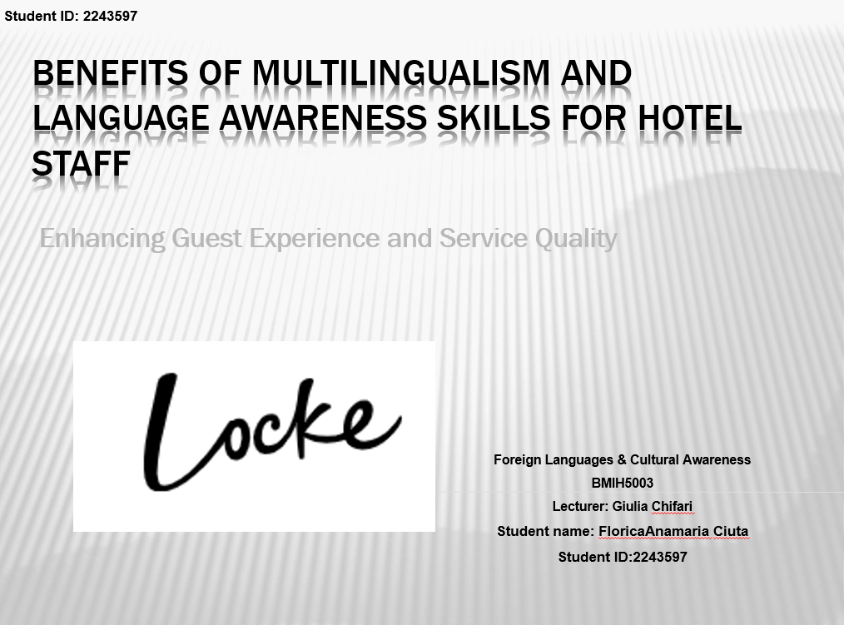
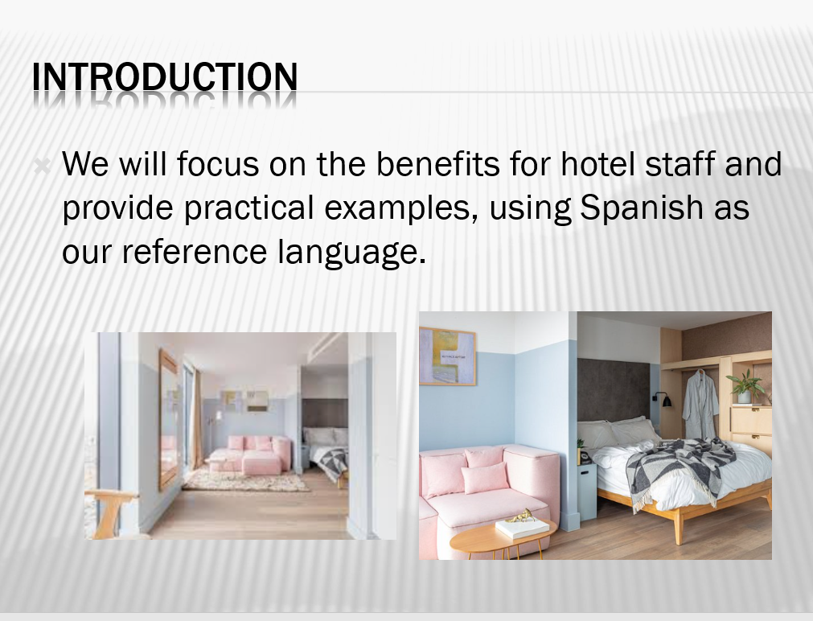
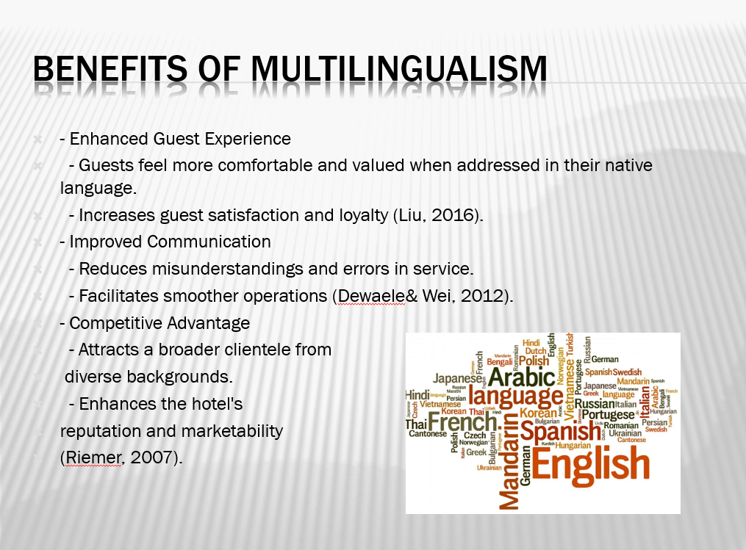

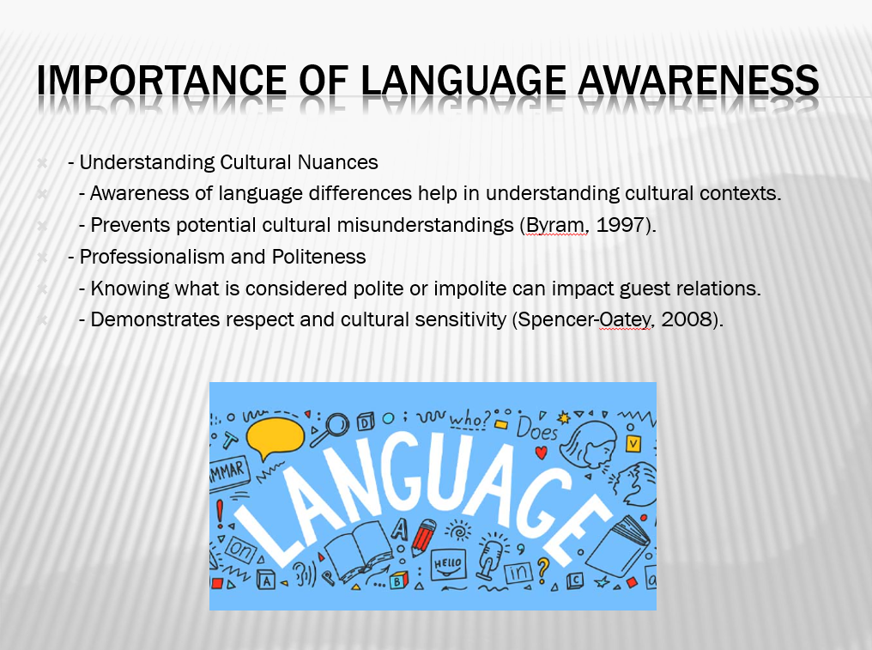
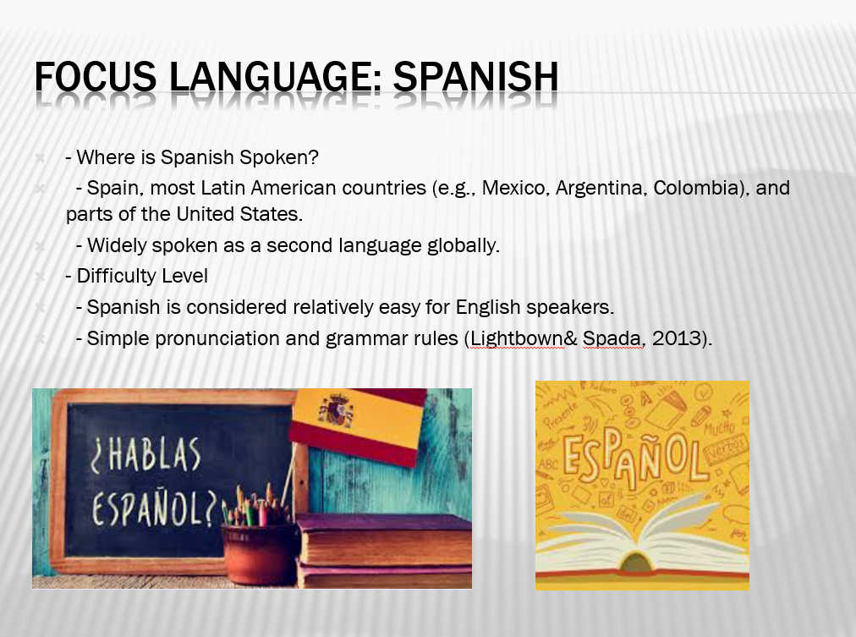
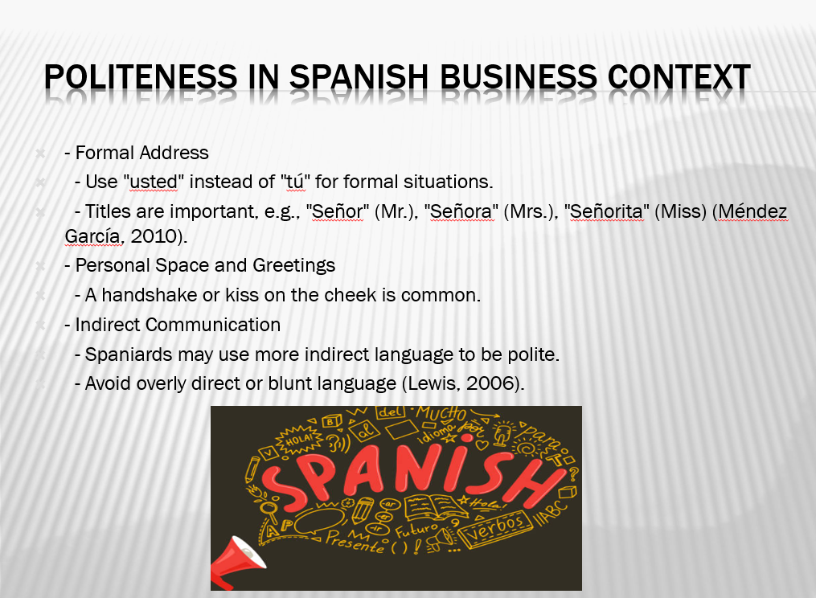
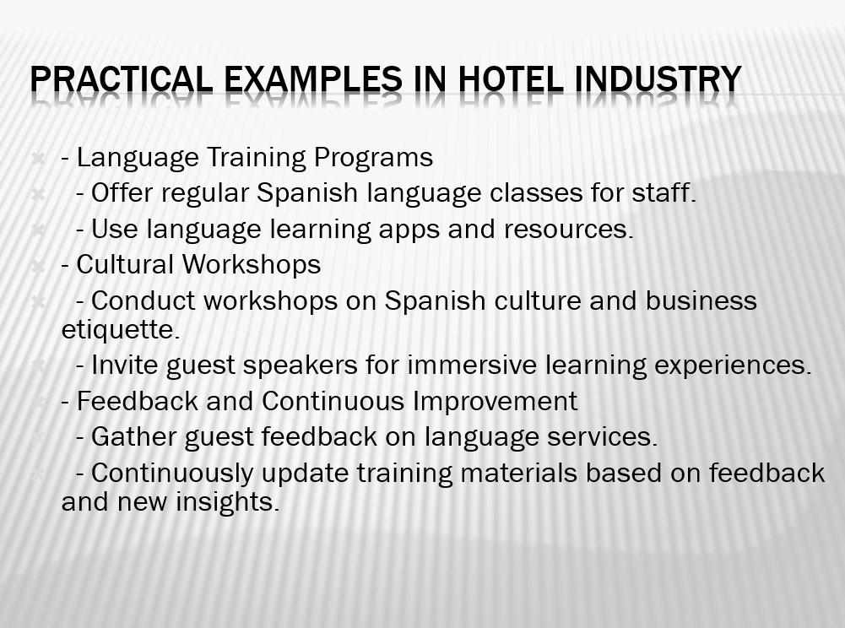
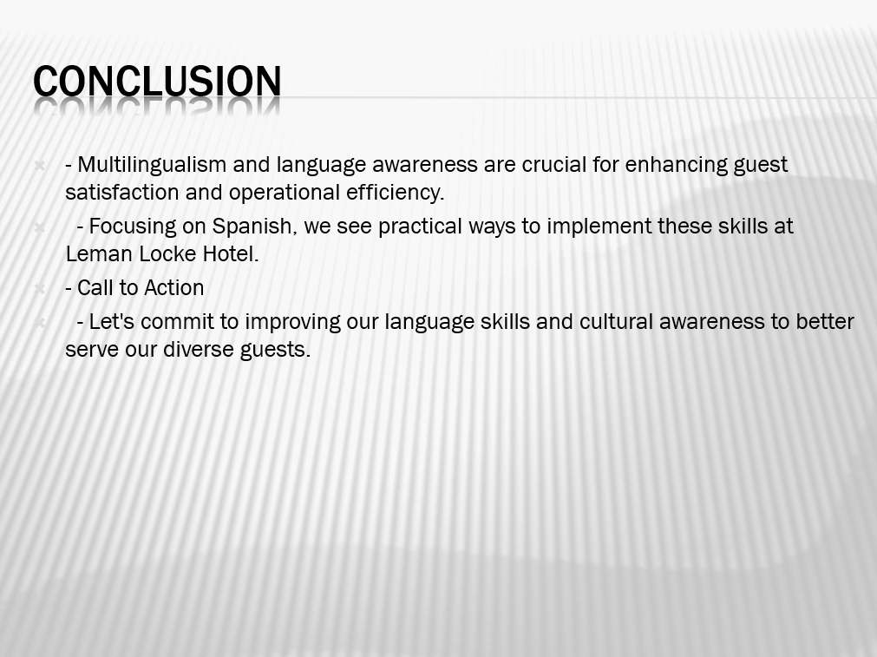
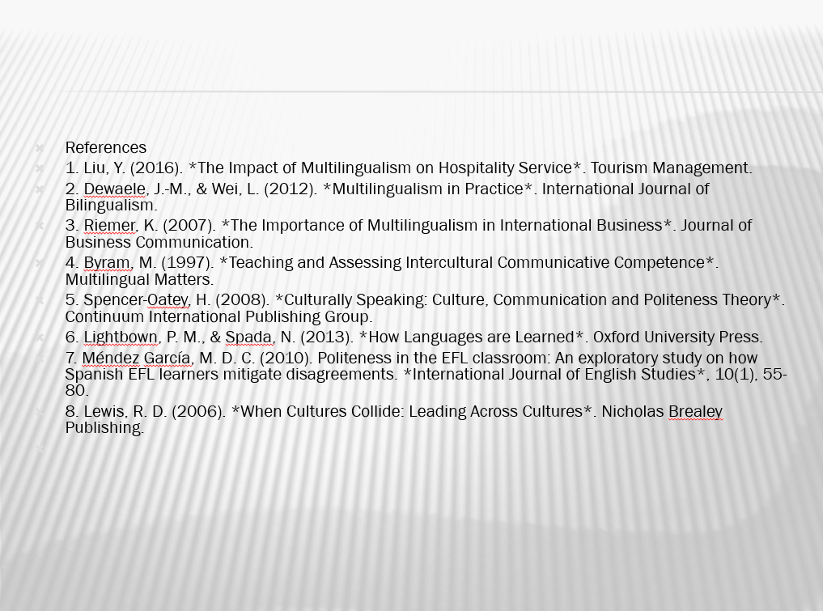

Words 509

Slide 10: References
1. Liu, Y. (2016). *The Impact of Multilingualism on Hospitality Service*. Tourism Management.
2. Dewaele, J.-M., & Wei, L. (2012). *Multilingualism in Practice*. International Journal of Bilingualism.
3. Riemer, K. (2007). *The Importance of Multilingualism in International Business*. Journal of Business Communication.
4. Byram, M. (1997). *Teaching and Assessing Intercultural Communicative Competence*. Multilingual Matters.
5. Spencer-Oatey, H. (2008). *Culturally Speaking: Culture, Communication and Politeness Theory*. Continuum International Publishing Group.
6. Lightbown, P. M., & Spada, N. (2013). *How Languages are Learned*. Oxford University Press.
7. Méndez García, M. D. C. (2010). Politeness in the EFL classroom: An exploratory study on how Spanish EFL learners mitigate disagreements. *International Journal of English Studies*, 10(1), 55-80.
8. Lewis, R. D. (2006). *When Cultures Collide: Leading Across Cultures*. Nicholas Brealey Publishing.

References

1. Liu, Y. (2016). The Impact of Multilingualism on Hospitality Service. Tourism Management.
2. Dewaele, J.-M., & Wei, L. (2012). Multilingualism in Practice. International Journal of Bilingualism.
3. Riemer, K. (2007). The Importance of Multilingualism in International Business. Journal of Business Communication.
4. Byram, M. (1997). Teaching and Assessing Intercultural Communicative Competence. Multilingual Matters.
5. Spencer-Oatey, H. (2008). Culturally Speaking: Culture, Communication and Politeness Theory. Continuum International Publishing Group.
6. Lightbown, P. M., & Spada, N. (2013). How Languages are Learned. Oxford University Press.
7. Méndez García, M. D. C. (2010). Politeness in the EFL classroom: An exploratory study on how Spanish EFL learners mitigate disagreements. International Journal of English Studies, 10(1), 55-80.
8. Lewis, R. D. (2006). When Cultures Collide: Leading Across Cultures. Nicholas Brealey Publishing.
9. Matveev, A. V., & Nelson, P. E. (2004). Cross-cultural communication competence and multicultural team performance: Perceptions of American and Russian managers. International Journal of Cross Cultural Management, 4(2), 253-270.
10. Ting-Toomey, S., & Chung, L. C. (2012). Understanding Intercultural Communication. Oxford University Press.
11. Trompenaars, F., & Hampden-Turner, C. (2011). Riding the Waves of Culture: Understanding Diversity in Global Business. McGraw-Hill.
12. Bennett, M. J. (2013). Basic Concepts of Intercultural Communication: Paradigms, Principles, & Practices. Intercultural Press.
13. Gibbs, G. (1988). Learning by Doing: A Guide to Teaching and Learning Methods. Oxford Polytechnic.
14. Kim, Y. Y. (2009). The identity factor in intercultural competence. In D. K. Deardorff (Ed.), The SAGE Handbook of Intercultural Competence (pp. 53-65). SAGE Publications.

