Programme: MSc Public Health and Social Care in Practice
Module: Health Care System Organisation and Leadership
Module code: LCHS7002

Module Code: LCHS7002
STUDENT NAME: Vishalbhai Mukeshbhai Khristi
STUDENT NO.: 2518470
Lecturer Name: Dr Pascal Navelle

Table of Contents
1. Introduction 3
2. Main body 6
2.a. Identifying the Problem Using Systems Thinking 6
2.a.1 Problem 1: Clinical incompetence and diagnostic error led to failure of harm prevention. 6
2.a.2 Problem 2: Breakdown of internal management, governance, and structural coordination in the hospital. 9
2.b.1 Centralisation vs. Decentralisation 13
2.b.2 Decentralised System within Patient X's Case 14
Definition and applications 14
Advantages 15
Disadvantages 15
2.b.3 Comparative Critical Analysis 15
c. Leadership Theory Application 17
2.c.1 Relevant leadership models 17
2.c.2 Critical evaluations 19
Appropriateness of the Leadership Style 19
Reactive or Proactive Leadership 20
Evidence of Leadership Effectiveness 20
Alternative Leadership Approaches and Lessons Learned 21
3. Recommendations 27
4. Conclusion 29
Reference List 30

1. Introduction
Patient safety is one of the most effective priorities within the modern healthcare systems, which need effective leadership, good governance and coordinated collaborations. All of these factors would help to minimise harm and improve the quality of care. Despite the continuous advancement in healthcare technologies, medication-related harm continues to present major issues for healthcare organisations. As per HSSIB (2025), failures in medication management arise from the complex interactions between communication systems and organisational processes.
The report critically analyses Case Study 2, which examines the death of Patient X by following the interruption of anticoagulation therapy, such as apixaban. At first, apixaban was mostly related to severe epistaxis before the planned procedure. However, repeated delays and a lack of medication review resulted in medication being discontinued for ten days. Patient X also suffered an ischaemic stroke and died later. This investigation demonstrates how governance, leadership, and communication can contribute to patient safety.
Similarly, NHS England reports that more than 806,000 patient safety events occurred during Q1 of 2025 to 2026 (NHS England, 2025). It highlights the priority of leadership and organisational systems within healthcare.
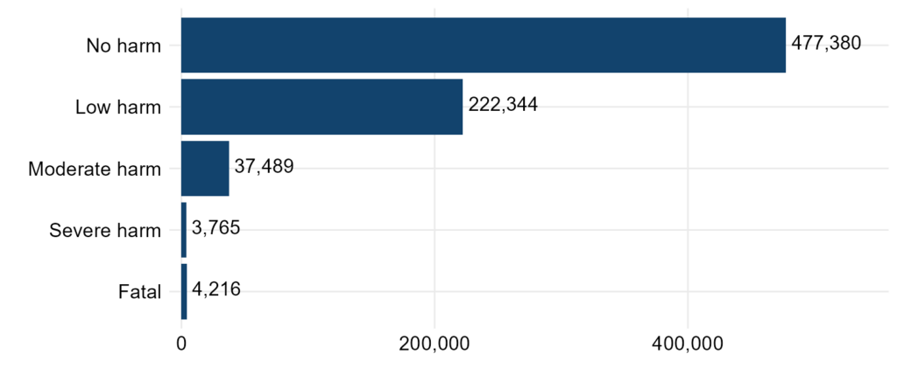
Figure 1: Patient safety incidents by maximum harm
(Source: NHS England, 2025)
Healthcare organisations mostly operate with a combination of centralised and decentralised leadership structures. Centralised helps in the decision-making process within the senior management. It ensures the clinical governance, standardised policies and organisational consistency. Whereas decentralised systems enable faster decision-making with higher autonomy.
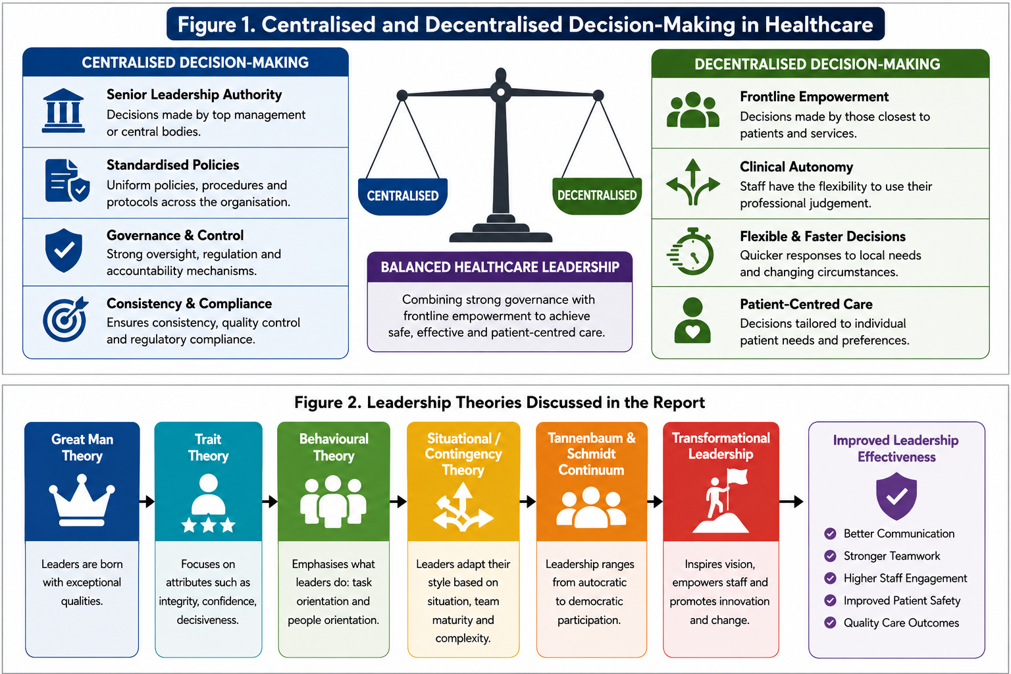
Figure 2: The centralised and decentralised decision-making process in healthcare
(Source: Self-developed)
Several leadership theories provide valuable aspects to identify organisational failures identified in Patient X's case. The Great Man Theory suggests exceptional leaders influence the organisational outcomes during times of issues. Trait Theory shows that effective leadership is influenced by characteristics such as integrity, confidence, and emotional intelligence; all of them support the principles of the Health System performance assessment framework introduced in Week 9.
The study will select the most effective leadership style during organisational change, patient safety, and clinical uncertainty, which is suitable for healthcare situations. As per Henry Mintzberg's Managerial Roles Model in Week 3, effective healthcare leaders perform the decisional, informational and interpersonal roles by maintaining multidisciplinary teams.
The report applies the systematic thinking approach to identify the underlying causes of the medication-related harm faced by Patient X. The study evaluates the influence of centralized and decentralized healthcare systems. The study analyses the relevant leadership theories and their application to the case. This examines organisational performances through the HSPA framework and proposes the evidence-based recommendations to develop leadership effectiveness, governance, and patient safety.

2. Main body

2.a. Identifying the Problem Using Systems Thinking

2.a.1 Problem 1: Clinical incompetence and diagnostic error led to failure of harm prevention.
- Central Concepts
Patient X’s anticoagulation medicine apixaban was stopped because of nose bleeding, but the procedural delays for the medical intervention resulted in the suspension of apixaban for 10 days. The discontinuation of apixaban ultimately caused a massive ischemic stroke 2 days later, following which Patient X passed away. The problem revolved around clinical mismanagement to subdue Patient X’s anticoagulation risks regarding thrombosis and bleeding.
- Description
The inappropriate suspension of apixaben reflects inefficiencies in health system building blocks of service delivery and health workforce (Week 1 Health Care Systems, Slide 11). The withholding of anticoagulation medicine is a local governance issue, but the issue has profound global relevance, as in the UK only around 30,000 people die due to thrombosis (Johnson, 2024).
- Example

Source | Statistics | Relevance
WHO (2025) | 93.8 million People around the world died from strokes. | Lack of medical equipment and medication causes disparity in access to proper healthcare
NHS (2025) | 14,428 cases of medical negligence were reported in the UK in 2025, with a 4.7% increase. | £3.09bn was paid to settle medical negligence claims (Gadsby, 2025).
BMJ Group (2025) | 1 in 14 patients experience a diagnostic error, and 85% of these errors are preventable. | Increased risk of mortality.
Table 1: Example of National and International Data Supporting Problem Analysis
(Source: Self-developed)
- Key Idea
In a clinical trial on 3.9 million patients, apixaban is proven to produce more positive outcomes compared to other anticoagulation medicines (Buckley et al. 2022). Failing to reinitiate apixaban reflects a systemic weakness: a lack of accountability, which becomes evident in a lack of responsive clinical diagnosis, a structural evaluation of blood clotting against blood-thinning risk.
- System Weakness
- Absence of formal anticoagulation assessment
- Failing to assess prior medication history while prescribing the delayed medical procedure
- Oversight to reinitiate apixaban
- Lack of accountability and proper risk management protocol even for high-risk patients
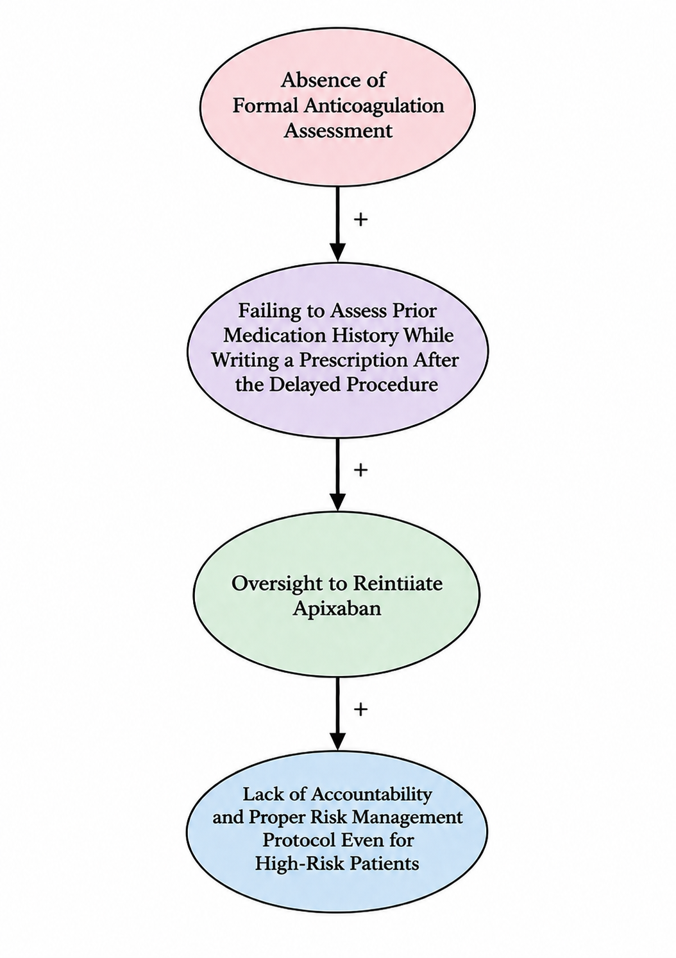
Figure 3: Conceptual representation of system weakness
(Source: Inspired by Week 2 Lecture, Slide 18)
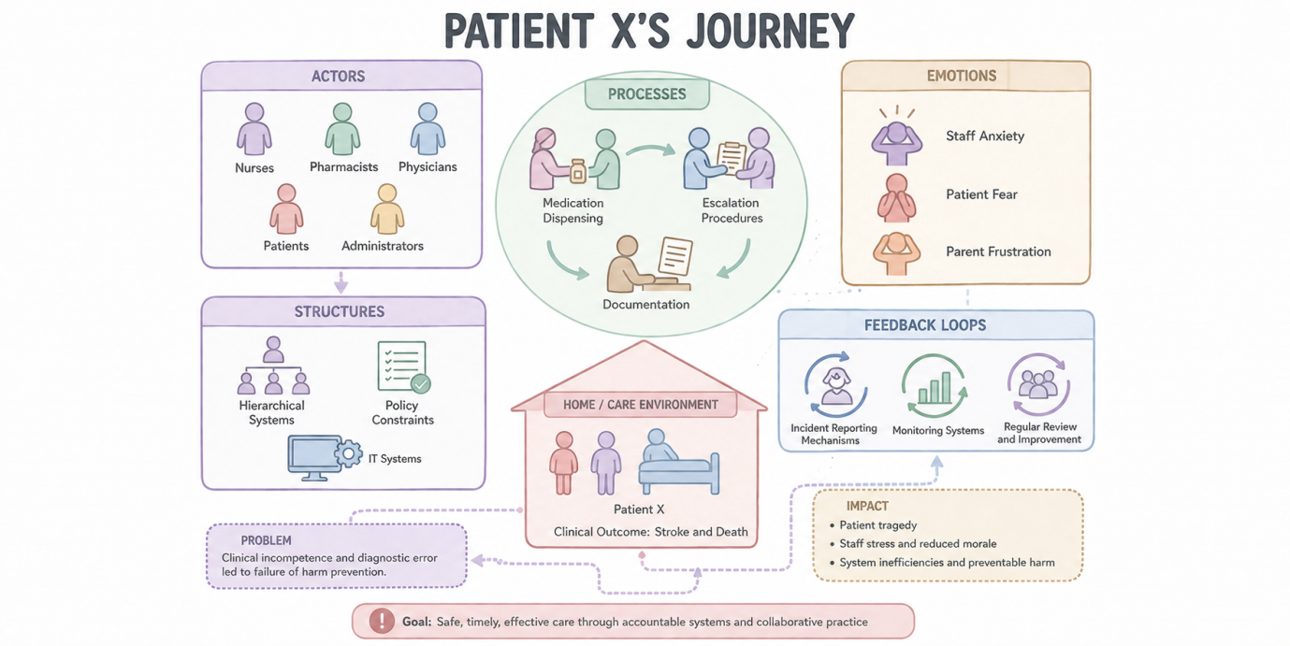

Figure 4: Rich picture demonstrating problem 1
(Source: Inspired by Week 3 Leadership Importance, Slide 39)
From a systems thinking perspective, small negligence and missed clinical diagnoses may have a life-threatening impact. In thrombosis, the mortality rate is 37% even after diagnosis (Johnson, 2024).

2.a.2 Problem 2: Breakdown of internal management, governance, and structural coordination in the hospital.
- Central Concepts
From a managerial perspective, there was clear failure to make informed decisions about closely overseeing anticoagulation therapy for Patient X, whose condition was undoubtedly serious. Different medical teams were involved before and after the medical procedure, but the concerns to reinitiate anticoagulation medication were not conveyed across medical teams, causing a fatal ischemic stroke, which underscores mismanagement and lack of governance effectiveness.
- Description
A case of systematic weakness in interdepartmental communication, tracking patients’ medication, and making informed decisions about patients' medications during writing post-procedural prescriptions aligns with the ineffectiveness of leadership and governance and the health information system in the health system blocks (Week 1 Health Care Systems, Slide 11). Although this problem resonates with local governance failure, it holds global relevance, as 24% of patients received poor care in the NHS in 2024 due to poor management issues (The Guardian, 2025).
- Example
Source | Statistics | Relevance
WHO (2025) | By 2030, the staff shortage in healthcare is expected to reach 11 million globally. | Staff shortage may lead to mistakes in drug administration and compromise quality of care.
NHS (2026) | Between January and March 2026, 9288 patients received delayed treatment. | 55.1% of NHS healthcare staff is professionally trained, but 45% of untrained staff can lead to communication issues and governance issues.
IHI (2023) | Out of 7,600 cases of clinical misdiagnostics, 33% of diagnostic errors occurred during the follow-up and inter-departmental coordination period, and 8% of errors resulted in patient deaths. | Diagnostic errors during follow-up and departmental transfers imply systematic communication and leadership inefficiencies causing patient deaths.
Table 2: Example of National and International Data Supporting Problem Analysis
(Source: Self-developed)
- Key Idea
The communication gaps during inter-departmental handover are rooted in communication and leadership ineffectiveness. In total, 79% of hospital leaders convey concerns over burnout due to heavy workloads, which eventually affect decision-making capability (NHS, 2026). The problem demonstrates a lack of accountability in coordinating medication after the medical procedure, re-evaluation of anticoagulation therapy, and absence of structured safety checks. Failing to administer timely anticoagulation therapy marks an organisational problem because Patient X was treated by the emergency department, surgical department, and various specialist physicians and healthcare staff, and none of them asked the other team about whether anticoagulation medicine had been started or not.
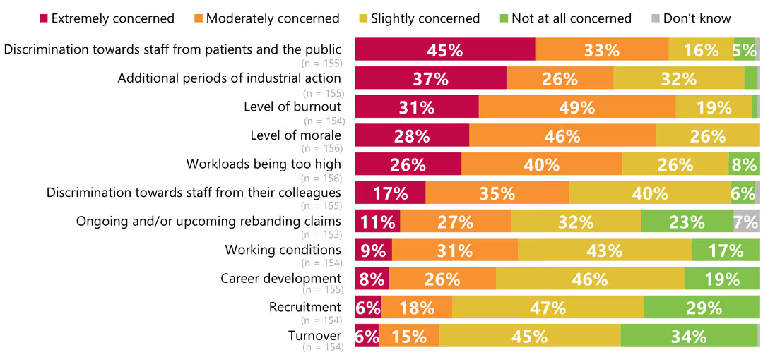
Figure 5: Leadership challenges of burnout and excessive workload
(Source: NHS, 2026)
- System Weakness
- Broken information flow leading to misunderstanding
- Patient’s anticoagulation medication details are poorly communicated during departmental handover
- Weak governance failing to define responsibilities
- Failing to perform medical intervention in scheduled time
- Clear absence of structured safety protocols and effective leadership oversight
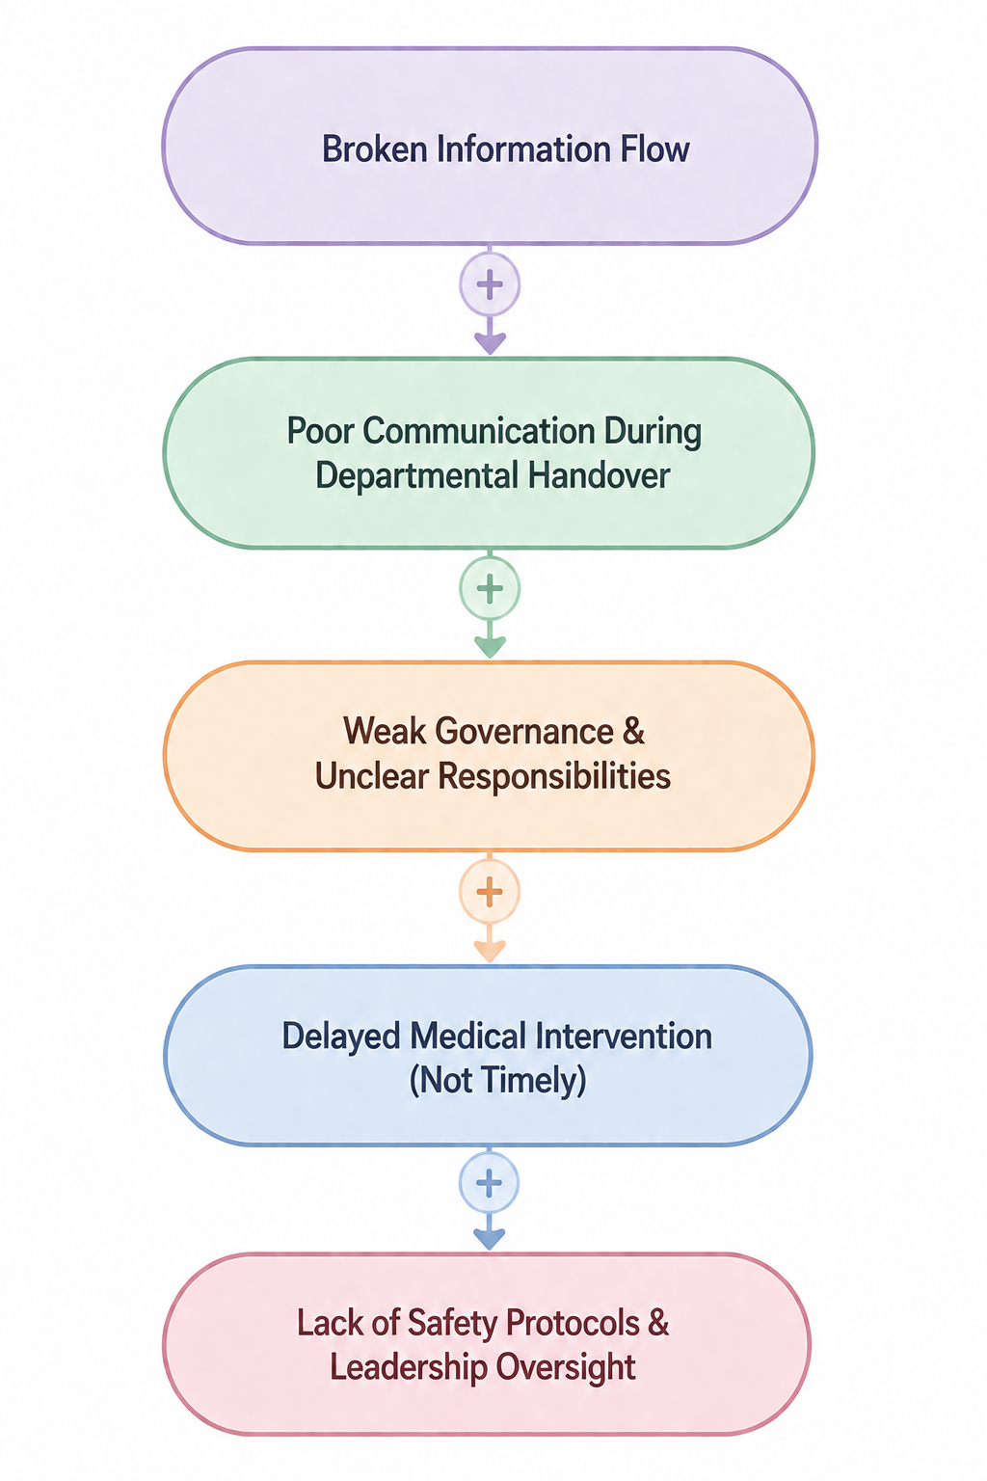
Figure 6: Conceptual representation of system weakness
(Source: Inspired by Week 2 Lecture, Slide 18)
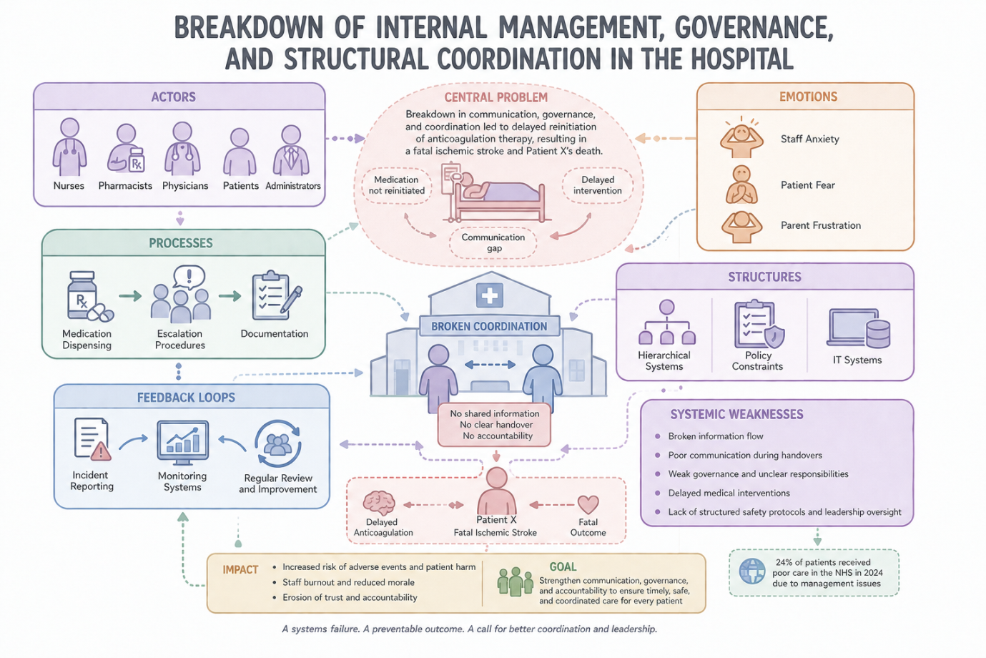
Figure 7: Rich picture demonstrating problem 1
(Source: Inspired by Week 3 Leadership Importance, Slide 39)
From a systems thinking perspective, no singular person can be held responsible for Patient X’s demise; rather, it is an infrastructural problem due to negligence in administering responsive care, as 25% of hospital leaders are worried that clinical and non-clinical staff are not capable of delivering high-quality care (NHS, 2026).

2.b.1 Centralisation vs. Decentralisation
Example application with Pros and Cons of Centralisation failure
In a centralised system, decision-making authority is reserved for senior healthcare professionals and doctors, following the standardised top-down hierarchy structure of a hospital or healthcare institute (Buckley et al. 2022). Healthcare staff such as nurses, junior doctors, or pharmacists does not possess any authority or autonomy to reinitiate a medication that has been suspended by hierarchy. Patient X’s case exemplifies centralised systems and top-down decision-making, as the senior medical staff overseeing Patient X’s case may have thought that decisions regarding restarting apixaben fall under the jurisdiction of another team’s head during inter-departmental handover. Despite 10 days procedural delay, the junior doctors or nurses did not have the authority to reinitiate apixaban, inviting a massive stroke.
Advantages and disadvantages linked to the case study
Advantages
- Centralisation supports standardisation of clinical protocols and evidence-based clinical guidelines, which have not been appropriately followed in this case study.
- Unifying governance leads to elimination of 40% administrative silos and maximises resource optimisation to enhance resource optimisation efficiency in healthcare services (Shikshin et al., 2025).
Disadvantages
- Slower response time due to bureaucratic delays, which led to a 10-day delay in monitoring a 10-day in restarting apixaban.
- 25% reduction in the autonomy of frontline staff creates a drop in productivity, which negatively impacts operational effectiveness (Maisonneuve et al., 2025).
- Greater administrative friction and poor operational autonomy have been noticed in the case of integrating centralisation and aligning with structural workflows.
Discussion

In discussing the key factors, it has been found that centralisation has not acted as an appropriate strategy for healthcare organisations. Frontline workers and their immediate leaders needed to modify the medication follow-up process so that no such cases of 10-day delay in restarting apixaban occur. Poor awareness about anti-coagulation measures also contributed to a 24% reduction in the need for multiple revisions of patients’ charts, which is evident from the missing medication intervention (Ru et al., 2026). Hence, centralisation led to disconnection from local realities in providing high-quality healthcare services.

2.b.2 Decentralised System within Patient X's Case

Definition and applications
The decentralised healthcare system is based on the decision-making authority of different healthcare professionals. As suggested by Ansbro et al. (2025), this approach helps the frontline nurses, pharmacists and multidisciplinary teams to take timely clinical decisions based on the changing conditions of the patients. In Patient X's case, the decentralisation was evident by the involvement of multiple professionals. As per HSSIB (2025), medication-related harm can arise from failures in communication and continuity of care.

Advantages
- The decentralised system allows healthcare professionals to respond rapidly to the changing outcomes with patients (Klapper et al., 2025).
- It encourages the multidisciplinary teams to improve continuity of care and support the patient-centred decision-making process.
- As per WHO (2023), effective patient safety depends on the collaborative leadership process and strong communication across the clinical teams.

Disadvantages
- Decentralised culture may reduce accountability if the responsibilities are not defined properly. In Patient X's case, no team views the ownership for reviewing the anticoagulants after the repeated procedural delays.
- As per WHO (2023), almost one in ten hospitalised patients faces harm. Almost 50% of these events can be preventable which shows the effectiveness of the clear governance and coordination of the multidisciplinary leadership process.

2.b.3 Comparative Critical Analysis
Patient X's case shows that a particular centralised or decentralised healthcare system is not sufficient to determine the safe medication process. Across the globe, more than 22 countries are following Decentralised method, and has been able to cut down the cost by 56% (Almogadwy and Alqarafi, 2025). On the other hand, centralised healthcare provision has yielded more than 15% higher attendance for preventavie healthcare.
Under the centralised system, the initial decision was to discontinue apixaban as the severe epistaxis followed the development of the clinical guidance and governance procedures. This helps to ensure consistency in the patient care process. Moreover, repeated procedural delays need a proper assessment process to mitigate the thromboembolic risks, due to centralised decision-making process also lacked flexibility and resulted in delays in the medication process that is why more than 60% healthcare organisations have adopted decentralised decision-making. AS per Wu et al. (2025), the decentralised structure helped in the consultations with junior doctors, nurses and pharmacists and has speed up the operation by more than 15%.
From the crisis management part, the leadership plays a reactive role rather than a proactive one. The clinical teams responded to the immediate bleeding risk of the patient but failed to adapt the management plan as the clinical situation changed. As per HSSIB (2025), the medication-related harm frequency results from the interactions between communication failures and the issues in the clinical decision-making process. All of these show that stronger governance with multidisciplinary collaboration is effective during complex situations (Arsenault et al., 2025). The global healthcare market size was USD 44.97 billion in 2025 and will reach USD 87.61 billion by 2035 at a CAGR of 6.9% ( Precedence Research, 2026).
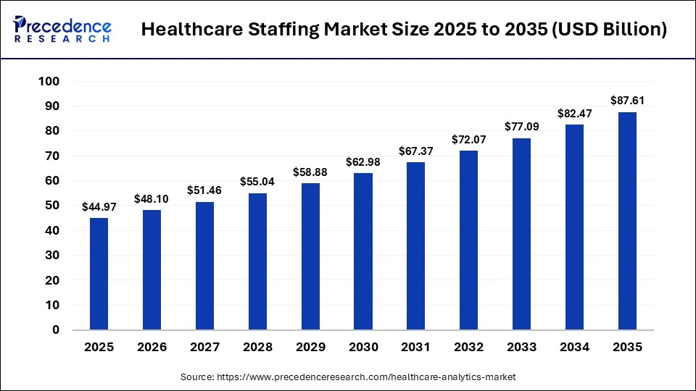
Figure 8: The growth rate of the healthcare staff
(Source: Precedence research, 2026)
By supporting the findings, NHS England reported almost 804,000 patient safety incidents during Q4. Moreover, in the NHS Staff survey, there were 48.6% of staff left involved in the decision-making process, which affected their work. Moreover, as per the WHO (2023), 50% of the harm-related incidents are preventable. Moreover, the hybrid governance model, along with centralised clinical governance with decentralised multidisciplinary decision making, would have developed the accountability process.

c. Leadership Theory Application

2.c.1 Relevant leadership models
Theory/Model | Application Example | Supporting Data & Critique
Great Man Theory | In Patient X’s case, the theory can be applied by considering the role of senior consultants and clinical leaders in managing the anticoagulation therapy (Alharbi et al., 2025). | Decisive leadership is valuable during clinical emergencies, but the authority was insufficient in this case. The investigation showed that patient X's death resulted from multiple interactions with organisational failures. As reported by HSSIB (2025), medication-related harm arises from the complex system, which needs organisational learning. Furthermore, NHS England reported over 804,000 patient safety incidents during 2025-2026. This highlights that sustainable patient safety depends on the higher systems. Therefore, the Great Man Theory supports decisive action on issues (Bowditch et al., 2026).
Trait theory | In Patient X's case, the Trait theory shows that the senior clinicians need to have shown higher accountability and emotional intelligence by reviewing the patient's case. However, leaders with effective communication could have coordinated doctors, nurses and pharmacists to manage the risks of thrombosis (Ali et al., 2025). This proactive leadership would have reduced the communication failure and improved continuity of care. | These leadership traits were not demonstrated properly in most of the organisations. As per the findings of HSSIB (2025), unclear clinical responsibilities and lack of medication review resulted in delaying anticoagulation management and avoiding patient harm. The 2021 NHS Staff Survey reported that emotionally intelligent leaders faced 22% of higher staff satisfaction. The findings from the 2025 NHS Staff Survey involve over 760,000 NHS Staff. This showed a 66% of response rate and highlights the effectiveness of the compassionate leadership and staff engagement within the NHS (NHS England, 2026)
Behavioural Theory | In Patient X's case, the behavioural theory highlights that healthcare leaders focused mostly on the operational tasks. This includes the management of procedural delays and the clinical priorities. However, the ineffective communications and the absence of regular discussions caused the harm. This is the main cause of the patient's stroke and death. | The leadership approach stayed largely task-focused and reactive (Aunger et al., 2025). This resulted in fragmented communications and poor coordination among the clinical teams. A hospital adopting both task and people-oriented leadership reported 30% fewer patient safety incidents (Jimenez-Caceres et al., 2025). Moreover, the NHS staff survey reported that only 48.6% of NHS employees felt involved in the decisions affecting their work. As per CQC (2025), ineffective communications and poor multidisciplinary collaborations continue to be the highest contributing factors. Therefore, the Behavioural Theory suggest that enhancing the communications team.
Situational/Contingency Theory | In Patient X's case, the situational theory is highly applicable as the patient's condition changes without the hospital stay. Although apixaban was initially discontinued mostly due to the severe epistaxis before the planned procedure. Adaptive healthcare leaders need to have recognised these changing clinical issues by organising regular multidisciplinary reviews involving consultants, nurses, pharmacists and the anticoagulation team to reassess the balance of the risk of thromboembolism. | However, the leadership within this case stayed reactive rather than proactive as clinical decisions were not modified, resulting in procedural delays and increasing clinical risks (Setyawibawa and Tahir, 2025). Similarly, OECD (2022) reported that adaptive leadership is related to a 15-20% faster recovery during clinical incidents. This highlights the benefits of flexible leadership in complex healthcare settings. Moreover, as per the WHO (2023), non-communicable diseases contribute almost US$42 billion to the avoidable healthcare costs.
Tannenbaum & Schmidt Continuum wo | In Patient X's case, this shows that medication management is based highly on the clinical-led decisions with limited involvement of multidisciplinary teams. Moreover, the participative leadership approach helps to encourage regular medication reviews. It further allows the frontline staff to maintain the therapy (Alfi et al., 2026). | This leadership is mostly leader-centred and reactive, which resulted in fragmented communications and unclear responsibility to restart the anticoagulation therapy. Furthermore, the NHS Staff Survey report of 2025 showed that 72.2% of staff felt they needed workplace with respectful manager.
Transformational theory | In the case of Patient X, the transformational leadership could mitigate the organisational weakness which contributed to the interruption of anticoagulation therapy. The transformational leaders need to foster psychological safety and shared accountability to ensure the timely reassessment of the patient's issues (AlDhaen, 2025). This approach is aligned with the "Health System Performance Assessment (HSPA)" framework to ensure quality, safety and organisational learning. | The leadership showed that this case is largely reactive rather than purpose-driven. It mostly focuses on responding to immediate clinical issues while implementing the proactive safety systems. The transformational leadership is related with 19% of better patient safety outcomes and 23% of higher staff morale (Ghasemi et al., 2025).
Table 3: Leadership Theory Application with Examples and Supporting Data
(Source: Self-developed)

2.c.2 Critical evaluations

Appropriateness of the Leadership Style
Each leadership theory was effective for managing Patient X's anticoagulation therapy. By comparing the Great Man, Trait, Behavioural, Situational/Contingency, Tannenbaum and Schmidt Continuum, and Transformational Leadership theories, it can be stated that the Great Man and Trait theories are suitable for complex medication safety issues among multiple healthcare professionals.
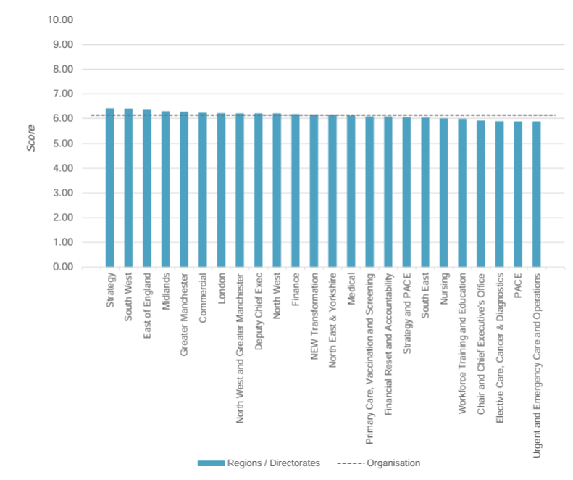
Figure 9: The staff survey reported a safe and healthy workplace
(Source: HSSIB, 2025)

Reactive or Proactive Leadership
The investigation shows that leadership was largely reactive and proactive as well. The clinical teams responded to Patient X's bleeding risk due to procedural delays. However, a proactive leader can prevent that medication error.
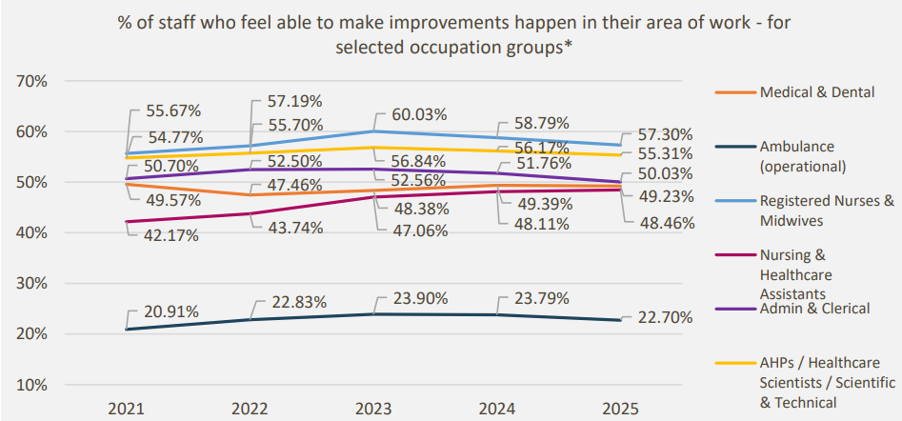
Figure 10: Staff who want improvement within their organisations
(Source: NHS England, 2026)

Evidence of Leadership Effectiveness
As per the NHS workforce report (2023), the organisations adopt the mixed leadership approach by combining managerial decisions with the staff to face 12% lower staff turnover. Moreover, the 2025 NHS Staff survey (2025) shows 48.6% of NHS staff felt involved in the decisions. Whereas 69.5% of them stated organisations encouraged them to report errors and reduce the chance of misses.
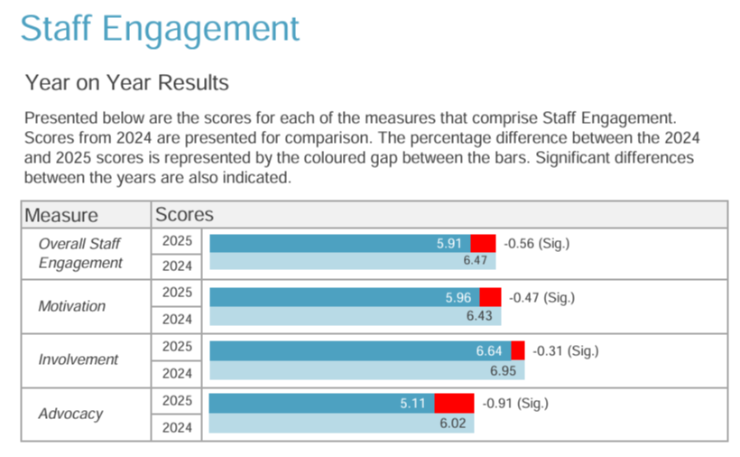
Figure 11: The staff engagement rate at the NHS
(Source: NHS England, 2026)

Alternative Leadership Approaches and Lessons Learned
Patient X’s condition shows that no single leadership is sufficient to manage the complex conditions. However, integrating Transformational leadership can promote organisational learning (Ghasemi et al., 2025). Situational leadership helps to adapt to the clinical risks, and Tannenbaum and Schmidt's perspective helps to improve multidisciplinary decision-making.
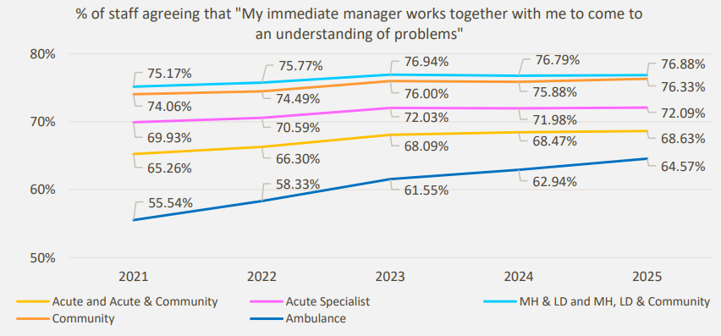
Figure 12: Compassionate leadership at the NHS
(Source: NHS England, 2026)
2.d. Critique, Improvements and Lessons Learned
Problem 1: Clinical incompetence, diagnostic error and lack of timely follow-up led to failure in harm prevention

Problem categories | Evidence | Improvement strategy
Clinical incompetence in developing a failproof system to restart apixaban | 14% low compliance rates in the context of standardised coagulation monitoring | ~ Implementation of mandatory clinical checklist
Diagnostic error | Limited awareness of monitoring protocols among 35%-40% staff in the context of high-risk treatments such as invasive respiratory procedures | ~ Use of computerised physician order entry (CPOE) alerts to enhance 23% coagulation treatment efficiency (Alkathiri et al., 2025)
Lack of timely follow-up | 10-day delay in administering timely reversal agents and poor knowledge of recommended clinical windows | ~ Preferring a multidisciplinary protocol to ensure rapid-response tracking of appropriate anticoagulants
Knowledge of harm prevention | Observations associated with preventable bleeding due to missed time-sensitive medication | Conducting regular staff education while standardising safety guidelines in medication management (Ahmed and Tamim, 2025)
Table 4: Problem data and improvement analysis
(Source: Self-developed)
KPIs for improvement strategy as per the recent gaps in practice
- Time in Therapeutic Range (TTR) Compliance Rate: The mentioned KPI can be linked to other coagulation monitoring metrics to identify the exact therapeutic window, ensuring greater effectiveness of precision medicine (Ifergan et al., 2026).
- On-time medication administration audit: This KPI helps identify successful and unsuccessful cases of time-sensitive antithrombotic medication administration, providing appropriate suggestions to maximise clinical operational efficiency (Omer et al., 2025).
- Adherence rates to pre-procedure coagulation checklist: This KPI tracks the percentage of patients following the necessary coagulation safety process while adopting invasive procedures in the context of high-risk treatments.
- Smart infusion compliance rate: The mentioned KPI tracks the percentage of high-alert anticoagulant infusion programmes every month.
A critique of the key events shows that pausing regular apixaban for Patient X at the emergency department has not been evenly communicated across other departments. Use of informed prescribing decisions has not been fulfilled due to a fragmented medical communication system. It has been noted that apixaban was required to be paused to balance blood clot risk and risk of everyday bleeding. 26% poor effectiveness in deciding the therapeutic window has led to a 10-day delay, which consequently led to patient stroke and death (Lee et al., 2025).
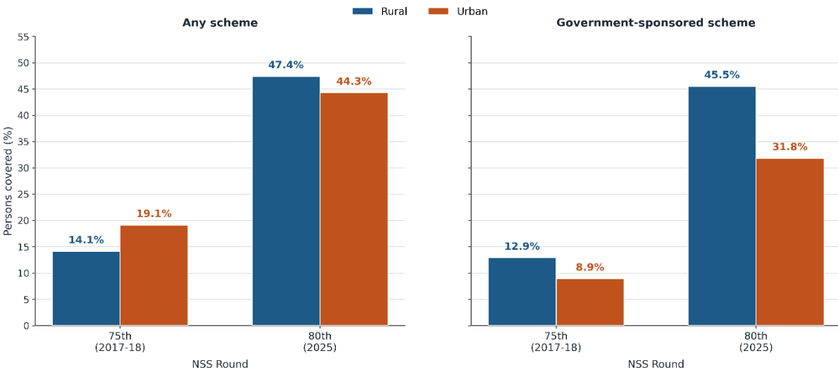
Figure 13: Increasing insurance costs (healthcare burden) due to high-risk treatments and poor therapeutic intervention
(Source: Kurian, 2026)
In addition, coagulation monitoring metrics have not been reviewed in the hospital, which played a vital role in delaying restraining of apixaban for Patient X. A lack of pre-procedure coagulation techniques negatively impacted compliance operations in the healthcare organisation. Lack of safety checks before initiation leads to 24% delays in identifying key errors in medication management for high-risk treatments (Sharbati et al., 2025). It plays a vital role in increasing dose errors and reducing patient safety. Hence, a gap in time-sensitive antithrombotic medications has been identified as a structural failure and a potential inconsistency in medical services, which led to the loss of life for Patient X.
Problem 2: Breakdown of internal management, governance, and structural coordination in the hospital
Problem categories | Evidence | Improvement strategy
Communication ineffectiveness and information flow breakdown | ~ Lack of dedicated communication channels  ~ Poor accountability among hospital departments in the context of patient safety | ~ Reorganising hospital governance framework  ~ Lack of clear lines of authority  ~ Development of cross-departmental committees to improve communication (Jiang and Jiang, 2025)
Lack of accountability and oversight mechanisms | ~ Absence of standardised oversight mechanisms to improve compliance management  ~ Poor tracking of performance gaps and clinical policies | ~ Creation of leadership and policy audits  ~ Use of accountability audits  ~ Providing continuous quality improvement training
Administration silos and poor coordination between departments | ~ Fragmented patient care led to poor follow-up and failure to observe a 10-day delay in restarting apixaban, which was removed as a standard procedure in the emergency department  ~ Conflicting interests, poor management of employee burnout and delayed decision-making | ~ Implementing integrated management information systems (MIS) to improve the efficiency of hospital administration (Li and Xu, 2025)
Table 5: Problem data and improvement analysis
(Source: Self-developed)
KPIs for improvement strategy as per the recent gaps in practice
- Cross-departmental meeting adherence rate: The mentioned KPI has been preferred to measure the frequency of scheduled inter-disciplinary meetings to track the scope of cross-functional collaboration
- Policy compliance and audit completion rate: This KPI tracks insights from regular governance and accountability audits for the organisation to standardise clinical and administrative policies
- Incident escalation resolution rate: This KPI helps to collect information on clarity, transparency and timeliness of quarterly feedback surveys
The critique of the situation shows that poor cross-departmental information transfer and lack of accountability audits lead to negligence in performing healthcare duties. As an improvement strategy, revision of operational directives within due intervals has been suggested to reduce the chances of gaps in medication management. A 28% improvement in staff performance can be ensured as a higher internal satisfaction rate is obtained through quantifying transparency and timeliness of employee feedback surveys (Shabankareh et al., 2025). The information from employee surveys identifies the areas that can be used to streamline workflows (through AI-based tools) and reveal administrative gaps so that the process of restarting apixaban is not delayed for 10 days.
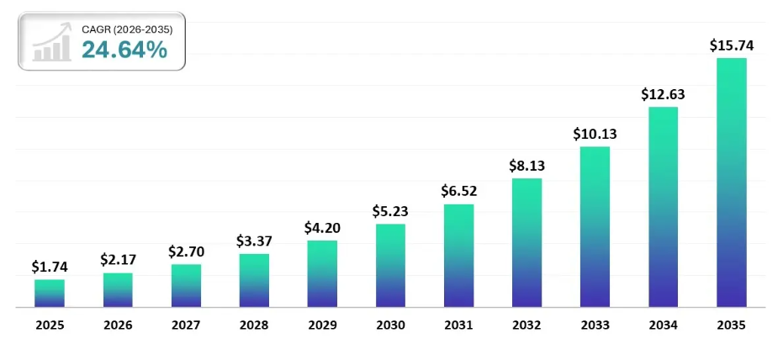
Figure 14: Scope of AI usage in diagnostic market
(Source: Towards Healthcare, 2025)
Apart from that, task resolution rate is also recognised as a KPI in the given context as it marks the efficiency where patient follow-up responsibilities can be transferred between multiple stakeholders. The integrated MIS platform has provided a 26%-30% chance to modify clinical and administrative policies (Ludușanu et al., 2025).

3. Recommendations
Recommendation 1: To implement an integrated anticoagulation stewardship program while ensuring patient safety in the context of transferring between departments
Based on the discussion, it has been recommended that passive guidelines have to be replaced with integration of computerised physician order entry (CPOE) alerts. It is expected to form mandatory digital checklists for patients moved between medical departments. Use of checklists results in a 61%-65% drop in human errors in administering medication and arranging appropriate follow-up programmes (May et al., 2025).
In the present context, it can be said that recommended pre-procedure coagulation can be standardised to reduce risks of bleeding or blood loss in patients before and after other medical procedures. It can lead to developing a foundation of an integrated anticoagulation stewardship programme to maximise patient safety. Appropriate use of reversal agents and communicating the information about the optimal clinical time window for each patient across multiple departments has been recommended.
Apart from that, clear evidence of decentralisation failure has been observed in the case study. It also implies delays in decision-making and developing intervention strategies, which often contribute to the loss of patients’ lives. To address the issue, it is recommended that structured handover practices are developed so that each department knows about the current state of the patient who is being transferred across the departments. Notifications about patients requiring urgent follow-ups can be updated in the dashboard or digital information systems to improve patient monitoring efficiency by 29% (Vornhagen et al., 2026).
Recommendation 2: To restructure organisational governance standards to eliminate silos and maximise accountability
Structural fragmentation is a vital concern as lines of authority have to be redefined so that inputs from cross-functional leadership committees are utilised to make changes in organisational governance. It has been found that medication reconciliation has to be integrated with organisational governance systems so that all the concerned staff are notified about follow-up routines without waiting for orders from the top authority. To improve 11%-13% monitoring efficiency, key areas of operational bottlenecks have to be identified and reduced through bi-directional communication channels (Draeger et al., 2025). Cooperation between clinical and administrative boards has to be ensured to highlight clinical priorities and link them with strategic hospital objectives. To improve accountability, reports on medical reconciliation have to be aligned with the daily healthcare activities of the organisation.
In addition, inputs for modifying current organisational governance standards can be obtained from documentation gaps in the healthcare system. 16% better patient follow-up and deployment of decision support mechanisms have been recommended to improve accountability and eliminate silos (Stoel, 2025).

Figure 15: Key recommendations
(Source: Self-developed)
Recommendation 3: To deploy a data-driven management information system (MIS) for continuous quality audits
Adoption of centralised digital MIS platforms has been recommended to improve tracking efficiency of current practices followed in the healthcare organisation. Development of standardised platforms leads to effective tracking of operational workflows so that the conflict resolution process can be automated. It can lead to a 36% increase in compliance rates so that performance metrics can be regularly reviewed to provide strategic recommendations to the frontline staff (Lin et al., 2026). Use of continuous quality audits has been considered to generate insights for anti-coagulation awareness training for employees. Appropriate performance metrics have been recommended so that accountability can be integrated in each step in hospital management. It also forms the foundation of learning among healthcare staff that can be refined with each new case. Scope of alternative interventions should also be considered so that multiple routes are present to maximise patient safety in the healthcare industry.

4. Conclusion
In concluding the findings from the case study analysis, it can be said that Patient X is a victim of leadership failure and structural/operational dysfunctions in a healthcare organisation. It has been found that fragmented institutional governance has been linked with siloed operations in the organisation. Misaligned priorities among staff have been observed, as a 10-day delay in restarting apixaban has led to the tragic death of Patient X.
Conflicting directives and poor accountability of medication processes have been recorded due to the development of top-down policies and poor communication with frontline staff. Policy-related and structural challenges contributed to a 19% failure rate in meeting professional care outcomes. Along with issues of departmental unaccountability, a focus on active alternatives rather than passive compliance mechanisms has been considered to improve real-time tracking of patient care facilities. Also, the absence of data-driven oversight is a key issue, which contributed to operational bottlenecks and recurring systemic failures.
Apart from that, the findings revealed that the case study included workflow disconnections with time-critical medications. For instance, the necessary collaboration between departments required in the context of administering high-risk medications was absent. This has led to 12%-20% delays in identifying crucial coagulation parameters. A lack of a continuous auditing framework has further compromised patient safety factors. In discussing improvement strategies, it is expected that the organisation focuses on creating rapid response pathways so that anticoagulants and reversal agents can be used appropriately.
For internal management, governance restructuring has been mentioned to eliminate administrative silos in healthcare. Although apixaban was paused as a necessary step in the emergency department, no staff checked for apixaban restarting needs of the patient. Appropriate training processes have been recommended to increase awareness among staff members in coagulation-based medication, which indicated rapid structural changes in the organisation.

Reference List

Ahmed, R. and Tamim, T.R., 2025. Enhancing medication safety: the role of community and hospital pharmacists in modern healthcare systems. Radinka Journal of Health Science, 2(3), pp.328-355.
AlDhaen, F.S., 2025, January. AI-powered transformation of healthcare: enhancing patient safety through AI interventions with the mediating role of operational efficiency and moderating role of digital competence—insights from the Gulf Cooperation Council region. In Healthcare (Vol. 13, No. 6, p. 614). Multidisciplinary Digital Publishing Institute. https://www.mdpi.com/2227-9032/13/6/614?ref=dannoyes.com
Alfi, E.M., Bajudah, R.M., Alshehri, R.S., Aldawsari, A.S.S., Alqulib, S.K., Alasmari, F., Alhudaib, K.M., Almalki, S.Y., Sanah, A.Y., Badawood, A.S.A. and Almuawi, S.M., 2026. Interdisciplinary Integration among Clinical Pharmacists, Medical Technologists, Patient Care Technicians, and CSSD Technicians: A Conceptual Framework for Enhancing Patient Safety and Healthcare Quality. Journal of Daoist Studies, 19(S7), pp.637-656. https://journalofdaoiststudies.org/index.php/journal/article/download/1272/839
Alharbi, H.A., Alharbi, W.A.N., Alawfi, A.M.M., Altorgmi, H.B., Al-Saedi, B.N., Alharbi, K.M., Aljabri, A.G.M., Alsaedi, A.B., Alsaedi, N.G. and Alsaedi, A.M., 2025. Impact of Leadership Styles on Patient Safety Culture: A Systematic Review. The Review of Diabetic Studies, pp.620-634. https://link.springer.com/content/pdf/10.1186/s12913-025-13118-5.pdf
Ali, H.I., Othman, A.A., Atta, M.H.R., Mohamed, S.S. and Mohamed, S.H., 2025. Revelation of the mediation role of moral sensitivity on safety attitude and personality traits among critical care nurses. BMC nursing, 24(1), p.261. https://link.springer.com/content/pdf/10.1186/s12912-025-02868-6.pdf
Alison Johnson, (2024). How dangerous are venous blood clots and how can they be avoided?. Available at: https://www.penningtonslaw.com/insights/how-dangerous-are-venous-blood-clots-and-how-can-they-be-avoided/ [Accessed on: 20/07/2026]
Alkathiri, S., Alothman, R., Ata, S. and Alruthia, Y., 2025, April. Evaluating the Wasfaty e-prescribing platform against best practices for computerized provider order entry. In Healthcare (Vol. 13, No. 8, p. 946). MDPI.
Almogadwy, B. and Alqarafi, A., 2025. Fused federated learning framework for secure and decentralized patient monitoring in healthcare 5.0 using IoMT. Scientific Reports, 15(1), p.24263. https://www.nature.com/articles/s41598-025-06574-w.pdf
Ansbro, É., Schmid, B., Willis, R., M-Amen, K., Mahmood, K., Abdulkareem, I., Frederiksen, S., Roswall, J., Perone, S.A., Roberts, B. and Blanchet, K., 2025. Decentralising healthcare for diabetes and hypertension from secondary to primary level in a humanitarian setting in Kurdistan, Iraq: a qualitative study. BMC health services research, 25(1), p.548. https://link.springer.com/content/pdf/10.1186/s12913-025-12571-6.pdf
Arsenault, C., Ravishankar, S., Lewis, T., Armeni, P., Croke, K., Doubova, S.V., McKee, M., Tarricone, R. and Kruk, M.E., 2025. The role of health systems in shaping vaccine decisions: Insights from Italy, Mexico, the United Kingdom, and the United States. Vaccine, 54, p.127134. https://www.sciencedirect.com/science/article/pii/S0264410X25004311
Aunger, J., Maben, J. and Westbrook, J.I., 2025. How unprofessional behaviours between healthcare staff threaten patient care and safety. Expert review of pharmacoeconomics & outcomes research, 25(5), pp.635-638. https://www.tandfonline.com/doi/pdf/10.1080/14737167.2025.2460518
BMJ Group, (2025). Harmful diagnostic errors may occur in 1 in every 14 general medical hospital patients. Available at: https://bmjgroup.com/harmful-diagnostic-errors-may-occur-in-1-in-every-14-general-medical-hospital-patients/ [Accessed on: 16/07/2026]
Bowditch, L., Molloy, C., King, B., Abedi, M., Jackson, S., Bierbaum, M., Yu, Y., Raggett, L., Salmon, P., Braithwaite, J. and Westbrook, J.I., 2026. Do patient safety incident investigations align with systems thinking? An analysis of contributing factors and recommendations. BMJ Quality & Safety, 35(7), pp.443-455. https://qualitysafety.bmj.com/content/qhc/35/7/443.full.pdf
Buckley, B.J., Lane, D.A., Calvert, P., Zhang, J., Gent, D., Mullins, C.D., Dorian, P., Kohsaka, S., Hohnloser, S.H. and Lip, G.Y., (2022). Effectiveness and safety of apixaban in over 3.9 million people with atrial fibrillation: a systematic review and meta-analysis. Journal of clinical medicine, 11(13), p.3788. https://doi.org/10.3390/jcm11133788
CQC, (2026). We're CQC, the independent regulator of health and social care in England. Available at: https://www.cqc.org.uk/ [Accessed on: 21/07/2026]
Draeger, L., Fleischmann-Struzek, C., Gehrke-Beck, S., Heintze, C., Thomas-Rueddel, D.O. and Schmidt, K. (2025). Barriers and facilitators to optimal sepsis care – a systematized review of healthcare professionals’ perspectives. BMC health services research, [online] 25(1). doi:10.1186/s12913-025-12777-8.
Ghasemi, F., Mahdinia, M. and Doosti-Irani, A., 2025. Safety-specific transformational leadership and safety outcomes at workplaces: a scoping review study. BMC Public Health, 25(1), p.2723. https://link.springer.com/content/pdf/10.1186/s12889-025-24044-w.pdf
Gillian Gadsby, (2025). NHS Medical Negligence Claims Statistics 2024/2025: National & Essex Data. Available at: https://www.gadsbywicks.co.uk/insights/medical-negligence/nhs-medical-negligence-claims-statsistics [Accessed on: 17/07/2026]
HSSIB, (2024). Medication not given: administration of time critical medication in the emergency department. Available at: https://www.hssib.org.uk/patient-safety-investigations/medication-related-harm/investigation-report/ [Accessed on: 21/07/2026]
Ifergan, A., Loutati, R., Tvito, A., Shuvy, M., Carasso, S., Deeb, D., Taha, L., Karmi, M., Manassra, M., Brin, A. and Rabi, O., 2026. Impact of time in therapeutic range (TTR) within the first 72 h on prognosis in patients with pulmonary embolism treated with unfractionated heparin. Journal of Thrombosis and Thrombolysis, 59(1), pp.188-195.
IHI, (2023). Overlooking Diagnostic Errors: The Grave Potential Consequences for Patient Safety. Available at: https://www.ihi.org/library/blog/overlooking-diagnostic-errors-grave-potential-consequences-patient-safety [Accessed on: 19/07/2026]
Jiang, J. and Jiang, D., 2025. Research on cross-departmental standard coordination mechanism in public governance. Journal of Humanities and Nature, 1(3).
Jimenez-Caceres, A., Agusti-Boada, A., Caro-Benito, C. and Monistrol, O., 2025. Relationship between different leadership styles of nursing managers and nurses’ turnover intention in hospitals: an integrative review. BMC nursing, 24(1), p.939. https://link.springer.com/content/pdf/10.1186/s12912-025-03573-0.pdf
Klapper, P., Kulasegaran-Shylini, R., Dodgson, A., Sudhanva, M., Blandford, E., Tunkel, S., Hill, S., Hopkins, S. and Fowler, T., 2025. Climate change and diagnostic samples-Opening Pandora's (post) box. Public Health, 249, p.105983. https://www.sciencedirect.com/science/article/pii/S0033350625004299
Kurian, O.C. (2026). India’s 2025 national health survey update: Higher access, persistent financial risk. [online] Orfonline.org. Available at: https://www.orfonline.org/expert-speak/india-s-2025-national-health-survey-update-higher-access-persistent-financial-risk [Accessed on: 11/07/2026].
Lee, J.K., Nicholas, J.S., Albadawi, A. and Insel, K.C., 2025. Developing decision support algorithm for hypertension medications for use in a digital therapeutic system. Frontiers in Drug Safety and Regulation, 5, p.1476998.
Li, F. and Xu, J., 2025. Revolutionizing AI-enabled information systems using integrated big data analytics and multi-modal data fusion. IEEE Access.
Lin, X., Lv, Y., Xiang, Q., Cai, M. and Wang, P. (2026). Artificial intelligence for monitoring hand hygiene compliance in healthcare settings: A scoping review. PLOS one, 21(4), p.e0347683. doi:10.1371/journal.pone.0347683.
Maisonneuve, F., Galy, A., Groulx, P., Chênevert, D., Grady, C. and Coderre-Ball, A.M., 2025. Managing resilience and exhaustion among health care workers through psychological self-care: the impact of job autonomy in interaction with role overload. Journal of Healthcare Leadership, pp.63-73.
May, J.E., Allen, A.L., Bannow, B.T.S., O’Connor, C., Sylvester, K.W. and Kaatz, S., 2025. Safe and effective anticoagulation use: case studies in anticoagulation stewardship. Journal of Thrombosis and Haemostasis, 23(3), pp.779-789.
NHS England, (2025). Quarter 1 2025/26 (April, May, June 2025) Patient Safety Event Data Quarterly Publication. Available at: https://www.england.nhs.uk/statistics/statistical-work-areas/patient-safety-data/2025-26/q1/ [Accessed on: 19/07/2026]
NHS England, (2026). NHS England’s 2025 staff survey results. Available at: https://www.england.nhs.uk/publication/nhs-englands-2025-staff-survey-results/ [Accessed on: 21/07/2026]
NHS, (2025). NHS Resolution Delivers Record Early Resolutions of Claims As New Strategy Shows Impact. Available at: https://resolution.nhs.uk/2026/07/09/nhs-resolution-delivers-record-early-resolution-of-claims-as-new-strategy-shows-impact/ [Accessed on: 19/07/2026]
NHS, (2026). NHS Workforce Statistics - March 2026. Available at: https://digital.nhs.uk/data-and-information/publications/statistical/nhs-workforce-statistics/march-2026 [Accessed on: 18/07/2026]
NHS, (2026). Patient Safety Event Data Quarterly Publication. Available at: https://www.england.nhs.uk/statistics/statistical-work-areas/patient-safety-data/2025-26/q4/ [Accessed on: 17/07/2026]
NHS, (2026). Workforce challenges and morale. Available at: https://thenhsalliance.org/resources/state-of-the-provider-sector-2025/workforce-challenges-and-morale [Accessed on: 19/07/2026]
OCED, (2022). Health at a Glance: Europe 2022. Available at: https://www.oecd.org/en/publications/health-at-a-glance-europe-2022_507433b0-en.html [Accessed on: 21/07/2026]
Omer, Y.Z., Chakraborty, M., Phillips, K., Ponniah, G. and Strens, L., 2025. Impact of Electronic Prescribing on Parkinson’s Disease Medication Management: A Retrospective Before-and-After Audit at a UK Teaching Hospital. Cureus, 17(11).
Precedence research, (2026). What is the Healthcare Staffing Market Size?. Available at: https://www.precedenceresearch.com/healthcare-staffing-market [Accessed on: 21/07/2026]
Ru, X., Wang, T., Gao, J., Yang, H., Gao, J., Kong, B., Yuan, G., Yang, Q., Ma, Y. and Pan, Z. (2026). Influence of a clinical decision support system on the anticoagulation treatment knowledge, attitude and practice of general practitioners and their using experience: A mixed method study. BMC primary care, 27(1). doi:10.1186/s12875-026-03205-9.
Setyawibawa, R.A. and Tahir, R., 2025. Evolution of Leadership Theories in Organizational Management. International Journal of Understanding New Insights in Value, Enterprise, Resources, Strategy, and Leadership, 1(1), pp.1-16. https://jurnal.unsaka.ac.id/index.php/universal/article/download/162/114
Shabankareh, M., Khamoushi Sahne, S.S., Nazarian, A. and Foroudi, P., 2025. The impact of AI perceived transparency on trust in AI recommendations in healthcare applications. Asia-Pacific Journal of Business Administration.
Sharbati, A., Movahed, A.B., Abyaneh, A.G. and Rahmanian, F., 2025. Risk assessment of healthcare systems using the FMEA method: medication management process. Journal of Future Digital Optimization, 1(1), pp.71-85.
Shishkin, Sheiman, I., Potapchik, E., Vasily Vlassov and Sazhina, S. (2025). The impact of centralization on structural changes in healthcare: When it works. Frontiers in Health services, 5. doi:10.3389/frhs.2025.1484225.
Simion Ludușanu, D.G., Fertu, D.I., Tinică, G. and Gavrilescu, M., 2025. Integrated quality and environmental management in healthcare: impacts, implementation, and future directions toward sustainability. Sustainability, 17(11), p.5156.
Stoel, M. (2025). Healing collaboration: Barriers and improvement strategies in Healthcare management. [online] Available at: https://studenttheses.uu.nl/bitstream/handle/20.500.12932/50335/Businessreport_Isala.pdf?sequence=1 [Accessed on: 02/07/2026].
The Guardian, (2025). Quarter of people in England had poor NHS care in past year, report says. Available at: https://www.theguardian.com/society/2025/jan/27/nhs-care-report-survey-healthwatch-england-complaints [Accessed on: 04/07/2026]
Towards Healthcare (2025). AI in Diagnostics market leads 24.64% Solid CAGR by 2034. [online] Towardshealthcare.com. Towards Healthcare. Available at: https://www.towardshealthcare.com/insights/ai-in-diagnostics-market-sizing [Accessed 21 July 2026].
Vornhagen, H., Barrett, S., Carroll, C., Iladiva, L.K., Martin, G., McKeown, D. and Martin, J. (2026). Design practices for data dashboards in Health care: Scoping review. Journal of Medical internet research, [online] 28, p.e77361. doi:10.2196/77361.
WHO (2023). Patient Safety. Available at: https://www.who.int/news-room/fact-sheets/detail/patient-safety [Accessed on: 16/07/2026]
WHO, (2025). Health workforce. Available at: https://www.who.int/health-topics/health-workforce#tab=tab_1 [Accessed on: 10/07/2026]
WHO, (2025). Stroke. Available at: https://www.who.int/news-room/fact-sheets/detail/stroke [Accessed on: 18/07/2026]
Wu, Q., Reps, J.M., Li, L., Zhang, B., Lu, Y., Tong, J., Zhang, D., Lumley, T., Brand, M.T., Van Zandt, M. and Falconer, T., 2025. COLA-GLM: collaborative one-shot and lossless algorithms of generalized linear models for decentralized observational healthcare data. npj Digital Medicine, 8(1), p.442. https://www.nature.com/articles/s41746-025-01781-1.pdf

