MANAGING PROJECTS IN THE ORGANISATION
BMSW5104_LON

Laura Pino
1915292

Balendran Kandasemy

University of Wales Trinity Saint David

28/04/2021

EXECUTIVE SUMMARY

This report analysed the organisation Zalando, an online fashion platform which is based in Berlin. Zalando implemented its project do.MORE, aiming to became the first 100% sustainable fashion platform by 2023 (Preuss, 2021), launching it in 2019 (Zalando report, 2021). The do.MORE project is divided in three main goals: reduce carbon emissions, recycle packaging and recycle fashion clothing (Preuss, 2021).
Zalando’s scope is to become the first European platform of sustainable fashion and it wants to raise their gross merchandising volume to a target of 25%, from the current 20%, by 2023 (Zalando progress report, 2021).
The report examined their changing fashion clothes sector and from this project the main beneficiaries will be the company, as they expect to attract over 10% of the European fashion market’s business after coronavirus and by 2025 their plan is to double their growth (Yahoo financial, 2021). There are different tools and techniques for a project manager to utilise to deliver their projects and for this report, a work breakdown structure was used as a first step for do.MORE; consequently, it utilised the Gantt chart to help efficiently with time management and the simple display showed the completed tasks in percentages, which supported the project manager to coordinate the work with the team (Analysistabs, 2021). The methodology chosen was Agile project manager, which is a framework to help manage the project, and it describes an approach to software that aids in breaking down a plan into steps and analysing the entire project during the developmental stage (Ajay, 2018).
In delivering the plan to the employees, it is important for the project manager to have a smart approach in order to communicate efficiently with the team, keeping in focus with the goal of the project and ensuring it is attainable by everyone (Project smart, 2020).
For the do.MORE project analysed, the project manager can oversee and monitor risks through the help of the critical part, extrapolated from the Gantt chart. The critical part is important to identify the longest section in the project, based on the dependency’s activities, understanding the total time the team needs to complete that part (Slate, 2018).
In conclusion, the report analysed the project manager strengths and weaknesses, examining them through an appropriated self-assessment plan, in order to fill their skills gaps.

TABLE OF CONTENTS

Introduction…………………………………………………………………………….…... p.3

Section 1: Tools and techniques………………………………………………………… p.4

Section 2: 1 Planning …………………………………………………………………… p.7
2 Scheduling…………………………………………………………………. p.10
3 Monitoring …………………………………………………………………. p.12
4 Communication plan ……………………………………………………… p.15

Section 3: S.W.O.T. analysis and self-assessment plan ……………………………. p.15

Conclusion ……………………………………………………………………………….. p.17

References ………………………………………………………………………………. p.19

Appendix ……………………………………………………………………………….… p.24

Introduction

The COVID-19 pandemic has been the source of much change in all aspects of the populations personal and working life since last year.
With the measures taken by the government, such as temporary closures of schools, shops and offices, in order to stop the spread of the virus, people had to adapt their behaviours to the coronavirus’ restrictions, having less contact between friends and colleagues.
Consequently, the work environment has moved into the home and therefore changed the normal organisational routine, in terms of private life and teamwork communication.
In regard to the interaction within companies in this period, communication technology platforms such as Microsoft Teams and Zoom have been developed and popularised to facilitate this process remotely from home out of necessity for businesses to continue to run.
In the described picture, the companies have also had to adapt to this new change of system, pledging to keep their employees involved and motivated in their job and goals.
Therefore, it is a challenge for the project manager to preserve high quality communication amongst the team and deliver the task with them, in order to obtain productive results for the success of the company.
This report analysed the organisation Zalando, an online fashion platform which is based in Berlin. Zalando was founded in 2008 by Robert Gentz and David Schneider, it specialised in selling shoes and from 2012 it started the collaboration with labels of clothes and merchandising (Zalando report, 2021). In 2019 Zalando started to implement its project do.MORE, aiming to became the first 100% sustainable fashion platform by 2023 (Preuss, 2021), launching the project the same year (Zalando report, 2021). The do.MORE project is divided in three main goals: reduce carbon emissions, recycle packaging and recycle fashion clothes (Preuss, 2021).
The report analysed the recycle fashion clothing project and I chose it because I have followed Zalando from the beginning, whilst working in the fashion industry, thus, the author found this initiative innovative and interesting to investigate.
The report examined their changing fashion clothes sector, which started on 30th March, 2021 and finished 144 days later.
From this project the main beneficiaries will be the company, as they expect to attract over 10% of the European fashion market’s business after coronavirus and by 2025 their plan is to double their growth (Yahoo financial, 2021), also endeavouring to have a more positive impact on people and the planet (Zalando corporate, 2020).
If the project fails, Zalando will lose its credibility and value in sustainability fashion and will, ultimately, affect business income (Zalando corporate, 2020).

To introduce a new project in a company, it is important to build a strong internal structure in the organisation, this allows the project manager to work efficiently and complete their objectives (Roberts, 2011).
Indeed, the project manager is the person who manages and cares for projects in the company, giving direction and detailing the structure of the plan with the necessary activities from the begging to the end (Roberts, 2011).
Thus, project management is the process of getting things done, dividing the tasks in order of importance, time and following a specific budget; arriving to achieve the goal in the period they have calculated (Barnes, 2012).
In light of this, the aim of the paper is to show how a project manager has to plan and organise the work through the use of techniques like the Work Breakdown Structure, Gantt chart and the Agile methodology framework. Consequently, they can identify the critical path in order to be able to calculate the durations of the project. In the end, this report explained how these tools helped the project manager to keep track and monitor the progress of each task and how these are helpful in the COVID-19 scenario.

Section 1

Tools and techniques

There are different tools and techniques for a project manager to utilise, they have to understand what the best way is to deliver their projects, exercising the most efficient path for the team, but if these are incorrect the work can fail (Togglplan, 2021).
The report operated a work breakdown structure as the first step for this Zalando project; it was necessary to use this diagram because it is a tool that segmented the project into different parts, assisting in articulating the scope of the objective and helping the project manager to organise all the steps to undertake in order to complete the work on time (Reddy, 2021). One of the best benefits of the tool is that it recognises the risks that can affect the project, giving the opportunity to create a different plan to reduce the chances of them occurring (Reddy, 2021).
The tool is structured where, the top of the diagram there is written the product that the project is going to deliver, below it, in sequence, there are all the other tasks’ titles related to each other in order of importance, time and cost (Roberts, 2011).
For example, in Zalando’s project the name of the main product to put on the top of the diagram is do.MORE, this sustainable fashion project, and after one has to write all the series of activities needed to complete the deliverability of the project itself.
Moreover, the tool is useful to clarify cost estimates, giving the input and idea on what is necessary for the project and what is not (Reddy, 2021).
As Reddy states (2021), some of the disadvantages that a work breakdown structure can create, is limited finer details of the project, it could be difficult to clarify the accurate specification for each activity, generating uncertainty through vague tasks.
Another technique used to examine the Zalando project is the Gantt chart, which helps to schedule time and duration of the task activities, in order to manage deadlines (Singh, 2020). For a project manager it is the best tool to keep track of the time of the project (Analysistabs, 2021), because with the evident visibility of tasks, sub-tasks and milestones, one has a clear vision of dates and a deadline for it. Indeed, Gantt charts help efficiently in time management, with the simple display of the completed tasks in percentages, supporting the project manager to coordinate the project with the team (Analysistabs, 2021).
Additionally, identifying the milestone and visualising it in the chart will allow the team to be on track with the project and monitor the progress of it (Singh, 2020). However, the disadvantages of it are that to build a Gantt chart one requires more effort and specialised skills in the use of this tool; thus, managing the graph can become tedious work, for example, when there is the necessity to update the project, is a very time consuming; all the tasks are not visible in a single observation (Analysistabs, 2021).
Regardless of the disadvantages, the Gantt chart is still a powerful tool to manage a project, because the team can have a clear vision of the whole project and the division of the tasks scheduled but in order to have a successful planification, the team must understand it and be in agreement (Class lesson, 2021).
The Gantt chart is an effective way to deliver the Zalando project because when a project is complex and contains multiple subtasks, as with do.MORE, it is easy to keep track of the development and visualise the progress of the project through the dependencies from task to task (Wilson, 2019).
For this project the methodology chosen is Agile project manager, which is a framework to help manage the project, and it describes an approach to software that provides to break down projects into steps and analyse the entire project during the development stage (Ajay, 2018).
This analysis is useful during changes in the project, as it helps to easily identify and adapt it accordingly with the needs (Ajay, 2018). Indeed, Agile methods is based on rapid cycles with the interaction of the customer, where in each new cycle, the software develops an incrementation, based on the previous cycle results, considering the customer’s feedback (Kukhnavets, 2016). This constant cooperation allows the Agile methods to become flexible and responsive to the changes, however, as with all software it works efficiently with some projects and it is weak with others (Kukhnavets, 2016).
I fact, as Kukhnavets states (2016), it cannot permit the organisation of the long-term design for the projects, because it is in continuous development, hence, it is difficult to plan.
As the Agile handbook states (2021), it is a software designed for the unexpected, in fact it is possible that during the course of the project some changes may occur and the software can be updated in line with the project manager, if any alterations in the marketplace could affect the project. Therefore, Agile allows you to divide the activities into blocks, so that it is easier for the team to change and modify something in the project, during its course (Agile handbook, 2021). For example, this is something that is impossible to do in traditional software such as waterfall.
Indeed, techniques such as a waterfall, that it is the traditional tool, is not been used in the do.MORE project because it is practised in particular projects where there is a gradual development of activities (Davidson, 2021), thus it is built with succeeding tasks, where each task depends on the previous one, and can only continue when the precedent task is performed (Wilson, 2019).
Therefore, the waterfall methodology is used in linear and simple projects and for example, it is not suitable for building the Zalando sustainable project.
Another tool that the Zalando project is not employing for its do.MORE project, but similar to the Gantt chart, is the Network diagram. This technique is used to schedule the activities of the project and then in base of their interdependencies, the project manager draws the diagram using arrows to point to the next task, helping to visualise the process of their sequences according to the logical relationships between them (Verma, 2021).
If the team then follows the arrows drawn, they can easily identify the duration of the project (Verma, 2021).
It is fundamental to select the correct tools and techniques, during the delivery of a project, because it is a consistence guideline for the manager project’s team to understand all the present activities easily, involving the specification of resources, team members, budget, deadline and suppliers (Smartsheet, 2021).

Section 2

1 Planning

A project manager creates a checklist of activities that will then be split amongst the team, in order to make boundaries around the work they are building and define the processes through which they will accomplish the goal (Berkun, 2008).
Subsequently, they identify the purpose of the project, to which they then have to deliver to the stakeholders, who are the persons involved in the company such as investors, employees, customers and suppliers, thus, they all must accordingly agree with the plan because if they do not, it could affect the current and future objectives (Fernando, 2021).
For example, in Zalando, 2,000 colleagues are working for the company, with more than 200 teams and over 34 million customers around the world (Zalando report, 2021).
It is important that teams and stakeholders must have an understanding of what the product they are going to build is and which result it will create for the company, to enhance their motivation and their benefits (Zalando report, 2021).
The Zalando company actively engages its stakeholders by enhancing their transparency in delivering its belief and vision of fashion sustainability to its workforce and also the clients; they believe that if the customers understand the project, they will follow it with more dedicated action and subsequently, build a loyal following through a positive promotion of the company image (Zalando progress report, 2020).
However, Zalando’s engagement with their stakeholders’ changes based on their influence and relevance in the impact of the company (Annual report, 2016).
For example, their stakeholder groups are society, customers, employees, industry, politics and suppliers.

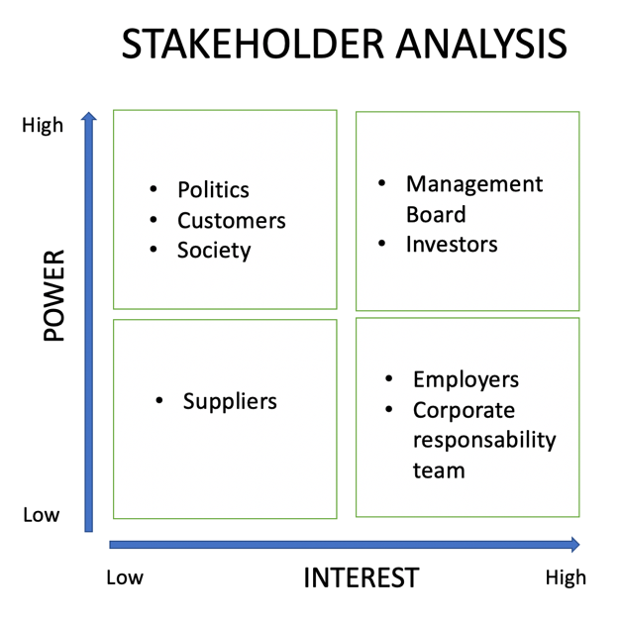
Source: Laura Pino
For the do.MORE project, Zalando has involved all of the teams employed in the company, with different skills focusing on a creative vision, problem solving, effective decision making, knowledge in sustainable fashion, effective analysis and communication, mega-trends, adapting roles, in order to apply intervention for the company’s changes and working with the supply chain of their brand partner (Zalando report, 2020).
Therefore, Zalando’s commitment is to offer opportunity of growth of their employee’s skills and ensure that all of them have a specific programme, in order to develop their ability (Zalando report, 2020).
Zalando wants to change its internal mindset to become a 100% sustainable company and the Zalando progress report affirms (2021), how this pandemic created challenges in terms of people’s behavioural changes, adopting themselves to the government’s restrictions and also how, in less than a year, scientists have developed a vaccine.
In 2019, Zalando built their strategy founded on the idea of becoming a sustainable fashion platform with the initiation of the project do.MORE.
As a platform that host 3,500 brands, Zalando created ethical standards to select these labels, that requires the use of specific fibres, materials and manufacturing processes, in order to respect their code of conduct to which all the stakeholders have to adhere (Zalando progress report, 2021).
In fact, as a scope, the company wanted to increase their recycled clothing sales and in 2019, they launched the collection Zign, encouraging their clients to make this change, identifying their brand as a flag for recycling (Zalando report, 2019).
Indeed, scope is understanding the end of the project, what it will take as a result and this is important to identify because through it one can manage the quality for the project’s success (Class lesson, 2021).
For example, if one does not have a scope, they cannot control a project’s deadline and its budget because they do not know which direction they are taking and by incorporating all of these aspects in the plan, a project manager will be able to manage its success (Class lesson, 2021).
With this vision, Zalando is creating a circularity strategy, that it is their first step to achieve their goal, by recycling sustainable fashion through a chain starting from the design of the products; to selling the clothes to customers that they will then use; the company then gives their clients the opportunity to donate old clothes in order to close the cycle; generating new items from the older ones (Zalando progress report, 2021).
Therefore, they are trying to anticipate customer needs, creating an experience of digital engagement by combining a wide range of choices and affordable prices to involve as many customers as possible (Zalando progress report, 2021).
The COVID-19 pandemic has accelerated the process to move from offline to online, thus Zalando is creating a digital experience through its platform, enhancing the value the campaign of sustainable fashion (Zalando roadshow, 2021).
The partnerships with the Sustainable Apparel Coalition and Higg Index Suit tool are helping Zalando to provide trusted and information to their stakeholders in regard to the current project (Apparel Coalition, 2021).
Therefore, another important partnership is with the company Kinnevik, who began investing in Zalando in 2010 having financed a total of SEK 7.9bn, in the last 10 years, now worth an estimated SEK 55.1bn, around 21% of company shares (Kinnevik, 2021).
Zalando also has four other shareholders to a combined 52% of shares in the company, holding a majority influence on the future of the business (Simplywall, 2020). The research analysed shows that given these numbers, the investment in the new do.MORE project between Zalando and its shareholders, will be around €1 million, similar to the opening investment from the company Kinnevik (Kinnevik, 2021).
In light of this, it is also important to explain how Zalando wants to raise their gross merchandising volume, to a target of 25% from the current 20%, by 2023 (Zalando progress report, 2021).

2 Scheduling

Once the scope is clear, a project manager can manage the stages to be faced in the project and with the help of the work breaking down technique, they are able to understand how many activities there are to complete in the project and which colleague has the perfect skills to approach them with (Berkun, 2008).
The report uses the work breakdown structure tool, in order to show a detailed overview of the tasks and budget for the whole project and deliver this information to the stakeholders.
Zalando and their do.MORE project strategy has fifteen tasks identified and positioned in a visual diagram, in order to understand the workflow of the project.

Work Breakdown Structure
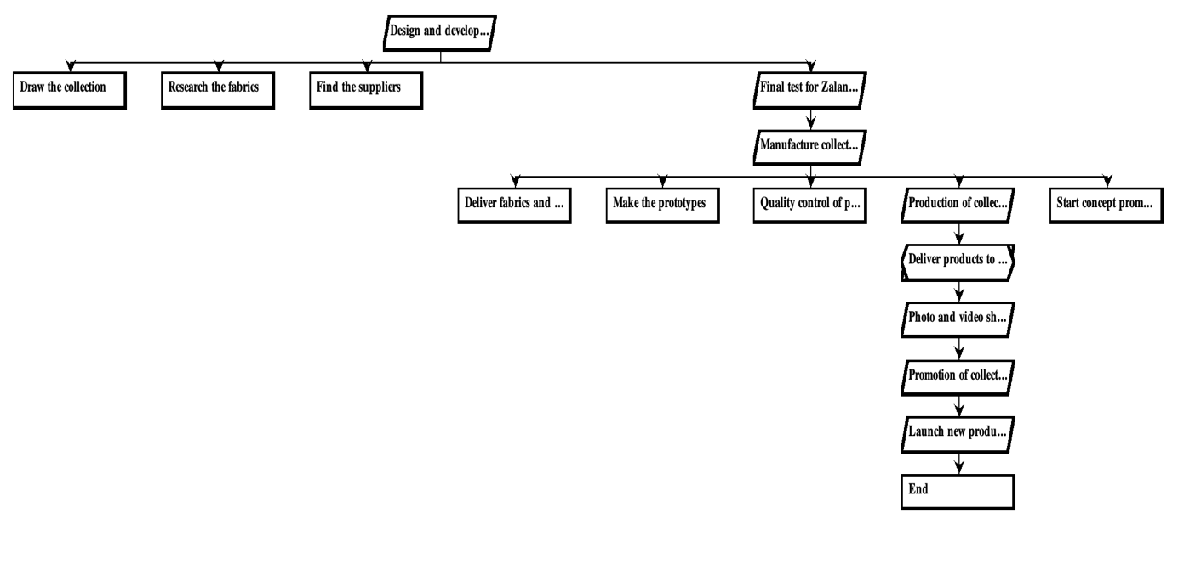
Source: Laura Pino

All of these parts divided in the scheme, helps the team to visualise the whole project, understand cost, which task is related to the other one and which is important to complete first in line with the deadline before it becomes a problem that involves additional cost to amend (Roberts, 2011).
The project manager has to identify the milestone in the projects, in order to show to the team, in the chart one is using, a particular event that is important for development (Class lesson, 2021). Usually, in the chart, the milestone is marked with a black diamond thus, it is visible and recognisable for the employees (Class lesson, 2021).
Zalando’s milestone is identified in the work breakdown structure project and is the moment when the sustainable clothes will be delivered and stored in the warehouse, because it is necessary to find the appropriate packaging to keep the clothes safe.
As Berkun affirms (2008), after a project manager delivers the scope and divides the work into activities one has to schedule them through the use of techniques such as the Gantt chart.

W.B.S.
Task  Identifier | Task Description | Predecessor  Tasks | Time (days)
1 | Zalando Sustainable Clothing Collection | - | 1 day
2 | Design and develop the collection | 1 | 67 days
3 | Draw the collection | 1 | 60 days
4 | Research the fabrics | 1 | 30 days
5 | Find the suppliers | 1 | 20 days
6 | Final test for Zalando  Sustainable standards | 3,4,5 | 7 days
7 | Manufacture collection | 2,6 | 48 days
8 | Deliver fabrics and designs to factory | 6 | 1 day
9 | Make prototypes | 8 | 10 days
10 | Quality control of prototypes | 9 | 7 days
11 | Production of collection | 10 | 30 days
12 | Start concept promotion | 10 | 20 days
13 | Delivery products to the Zalando storage and distribution warehouse | 7,11,12 | 1 day
14 | Photo and video shoots of collection to create contents | 13 | 7 days
15 | Promotion of collection | 14 | 20 days
16 | Launch new products in Zalando e-commerce | 15 | 1 day

With the identification of the predecessor tasks, the employees can schedule the project in the long term and be able to eventually make changes accordingly with the team, respecting the timeline of the activities.

Gantt chart
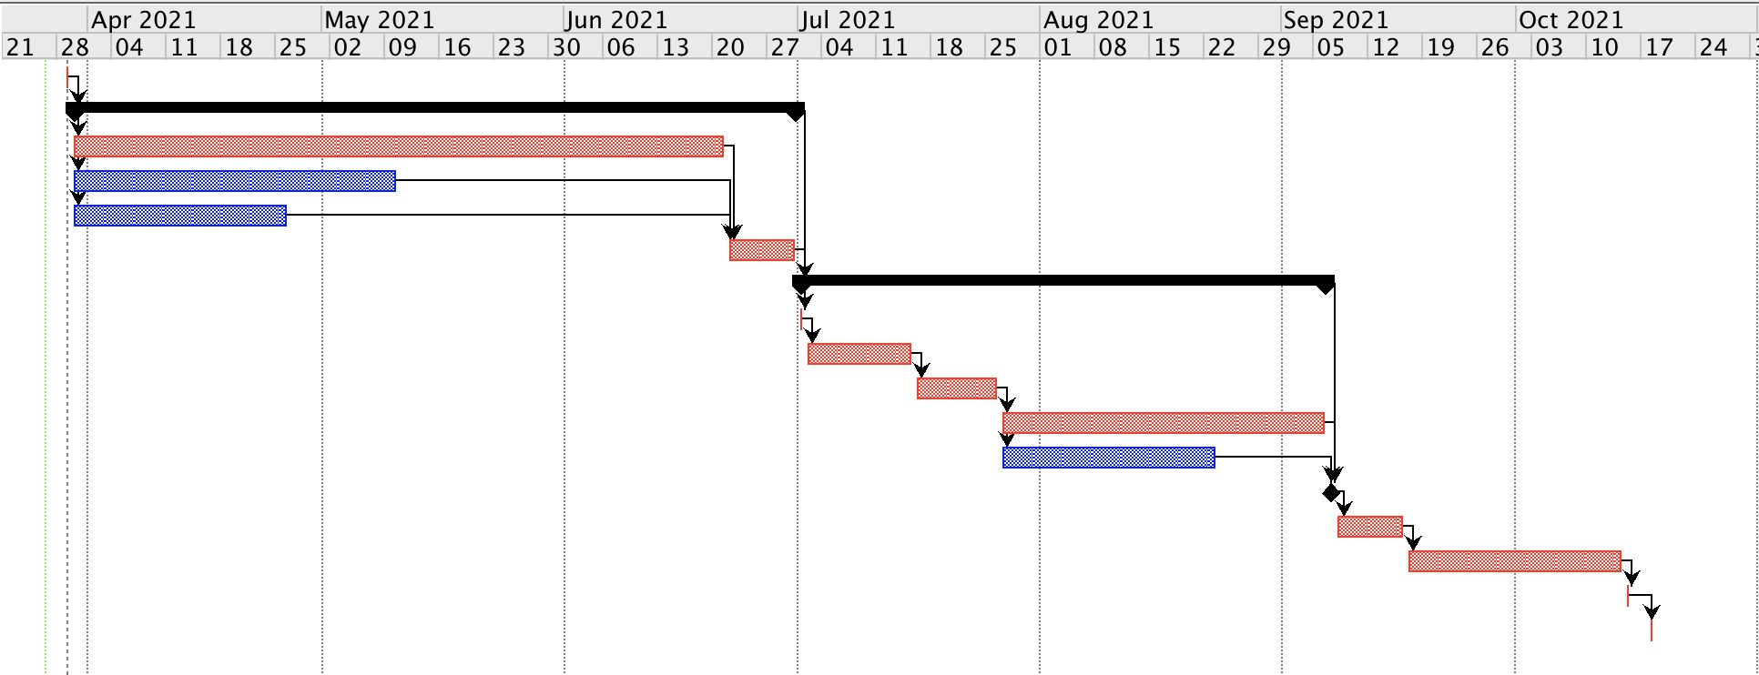
Source: Laura Pino

The use of the Gantt chart will help the employees to visualise the whole project with the respective time schedule and understand the various subtasks of the activities (Analysistabs, 2021).
In the Gantt chart there are two sections that contain subtasks, the first starts when Zalando’s team design and develop the collection and it takes 67 days and this part end with the final test of the prototype, that if it does not correspond to their standards, this process will have to be repeated until the result obtained is positive. While the second main section, starts from manufacture of the collection, that takes 48 days to complete all correlated activities.
From the chart the employees can understand how long the project will take and for Zalando do.MORE; it will involve a total of 144 days.

3 Monitoring

Risk is the uncertainty that can affect the project, which is divided in two aspects: probability, if something can happen, and the impact that will can affect the outcome (Class lesson, 2021).
Moreover, the risks can be affected positively or negatively through expectation (Class lesson, 2021). For example, from an unexpected occurrence, one can create an innovative solution or bring different opportunities.
For example, Zalando, during the COVID-19 pandemic, had a decline of income, thus, the platform decided to respond to the crisis by enhancing the experience for the customers on their website, adding value to the digital shopping and offering to other shops to sell through their platform with a zero-commission fee, in order to incentivise them (Business of fashion, 2020).
However, with a negative vision the risk can affect and compromise the whole project. Analysing the negative aspects in the do.MORE plan, there are three main risks that can impact the outcome of the project: supplier delay, the final product test and storage of the stock. Any delay, related from COVID-19, from the suppliers can potentially postpone the whole project, consequently, not being on time for the launch of the final collection. Proceeding with the manufacturing task relies on the success of the final prototype test; if it is not following in the expectation of the designers, they have to make another sample and test it again until the result of the clothes will be respecting Zalando’s standard. Similarly, the risk and potential problem that could be created in the final test, will be the same outcome of supplier delay, meaning a change in the timeline of the project. Moreover, if the stock is not stored properly, the clothes could be damaged and Zalando could lose its investment and create a debit in the company. Therefore, it is important to prevent this and find a plan of action to solve these risks.
Indeed, the Zalando management board have the responsibility to calculate and contain any risks in the company, therefore, they have created a department called Governance, Risk and Compliance, specialised in analysing, managing and controlling them in their initial phase (Annual report, 2016). These risk management methods are reported in a manual which ensures all procedures for implementing risks and opportunities are standardised in the company, in order to document them in the appropriate systems and ensure success during the decision-making process (Annual report, 2016).
For the project analysed, the project manager can oversee and monitor risks through the help of the critical part, extrapolated from the Gantt chart. The critical part is important to identify the longest section in the project, based on the dependency’s activities, understanding the total time the team needs to complete that part (Slate, 2018).
Thus, the project manager can govern the time of the other activities, respecting the final deadline of the whole project (Slate, 2018).

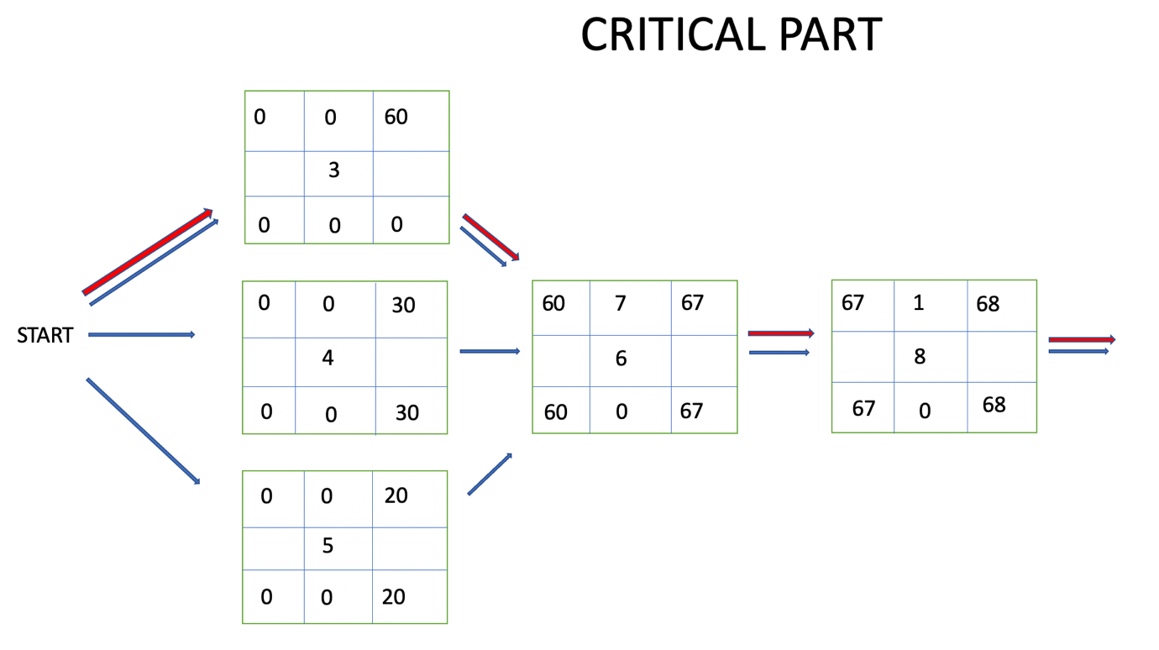
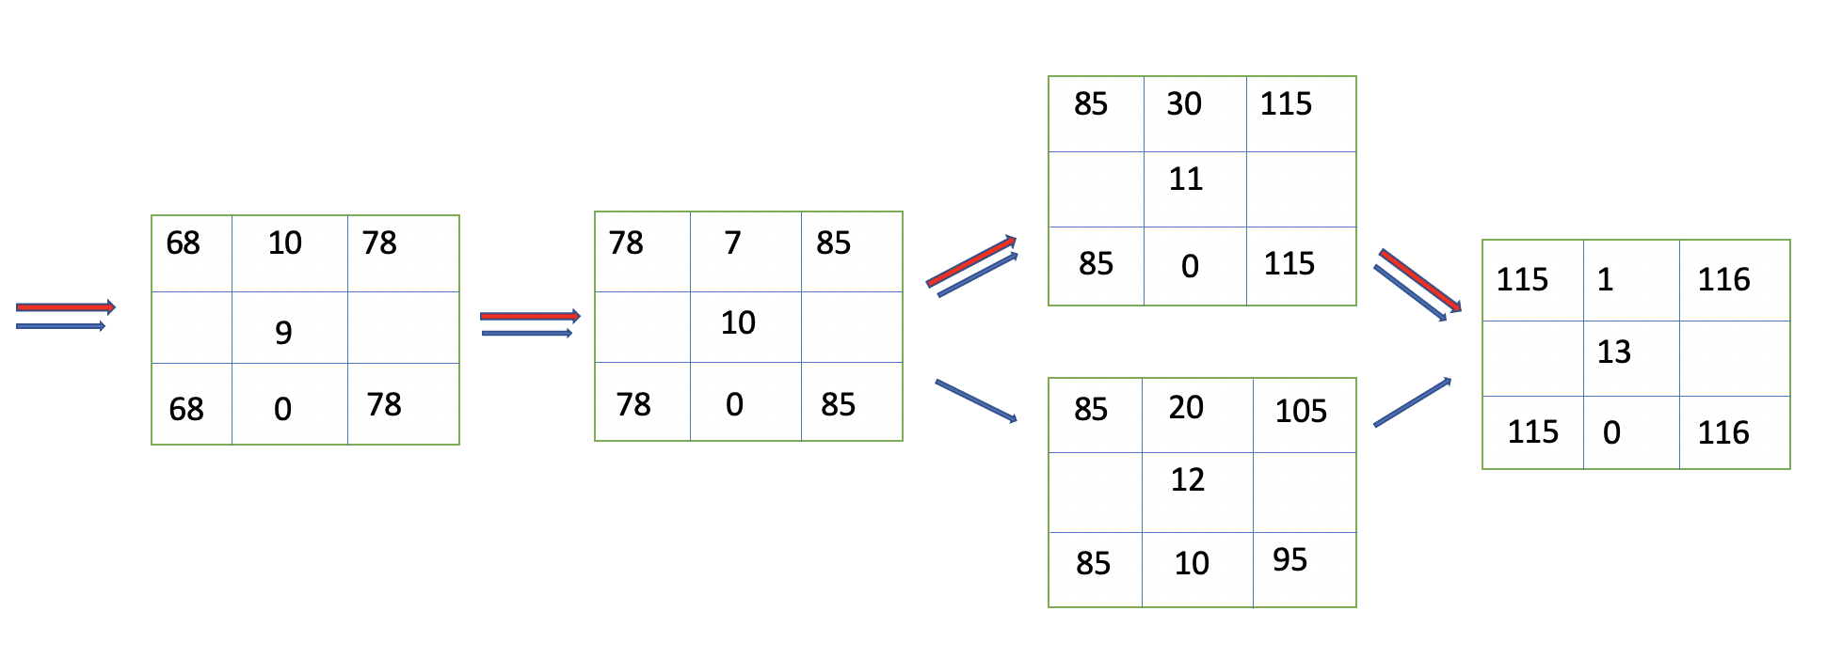
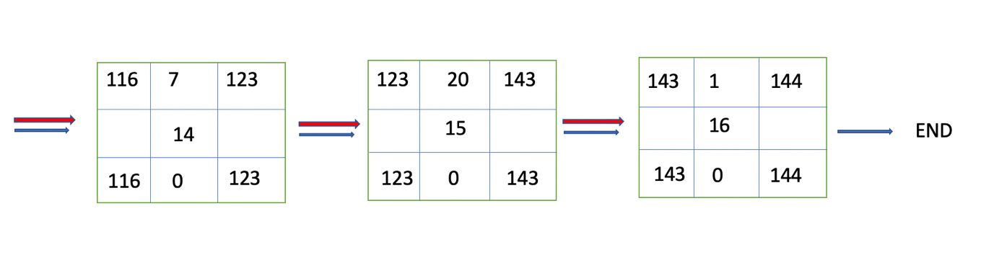

Source: Laura Pino

In the do.MORE project the longest part is combined of 144 days, as shown by the red path, from the tasks numbered: 3, which is sixty days; 6, seven days; 8, one day; 9, ten days; 10, seven days; 11, thirty days; 13, one day; 14, seven days; 15, twenty days; and 16, ten days. Consequently, the activities that can have slack are tasks numbered: 4, with 30 days; 5, with 40 days; and 12, with 10 days of potential slack.

4 Communicate the plan

For a project manager, the communication plays an important role in delivering a project clearly and precisely (Berkun, 2008). They constantly need to keep a high standard of communication performance with the team, and they also have to build relationships with them (Berkun, 2008).
Indeed, as Berkun states (2008), the positive relationships enhance communication, for example, a project manager has to motivate and empower the team, with the approach of continuously evaluating employees working in the project. However, Berkun affirms (2008), their behaviour should be to encourage them to give suggestions, improvements or ideas, in order that everyone in the group benefits from these relationships.
When the communication with the team fails, the project will also fail, because to be successful in delivering a project it is important to put in place the smart approach, which is the acronym of: specific, measurable, achievable, relevant, time bound (Project smart, 2020). This approach allows the team to be in focus with the goal of the project and to be attainable by everyone (Project smart, 2020).
Moreover, when the project manager plans the activities, it is fundamental to be specific in their explanation; using charts such as a Gantt chart, for example, they are showing to the team how to be measurable and progress in the project, evaluating the possible problems through the identification of the milestone; they also must be attainable, making sure the goal of the project will respect a certain timeframe; be relevant with the goal that is in line with the companies values; finally, the time based refers to an realistic end-date, prioritising the tasks of the project (Indeed, 2020).

Section 3

S.W.O.T. analysis and self-assessment plan

Every project is different and has their own challenges, because sometimes they can be affected from external or internal problems, such as a stakeholder that may change or influence the project or its outcome (Sunindijio, 2015). However, the project manager should be able to change and adapt some circumstances during the project life cycle (Sunindijio, 2015).
To being a successful project manager one must have a fundamental ability and understanding of the importance of people skills, in order to lead an effective project (Nesbit, 2009).
Therefore, as Nesbit states (2009), the success of the project is connected with the relationship that a project manager builds with their team, this is why they need to have relevant skills such as leadership, motivation, delegation, monitoring, controlling, good communication and with a particular attention in following deadlines.

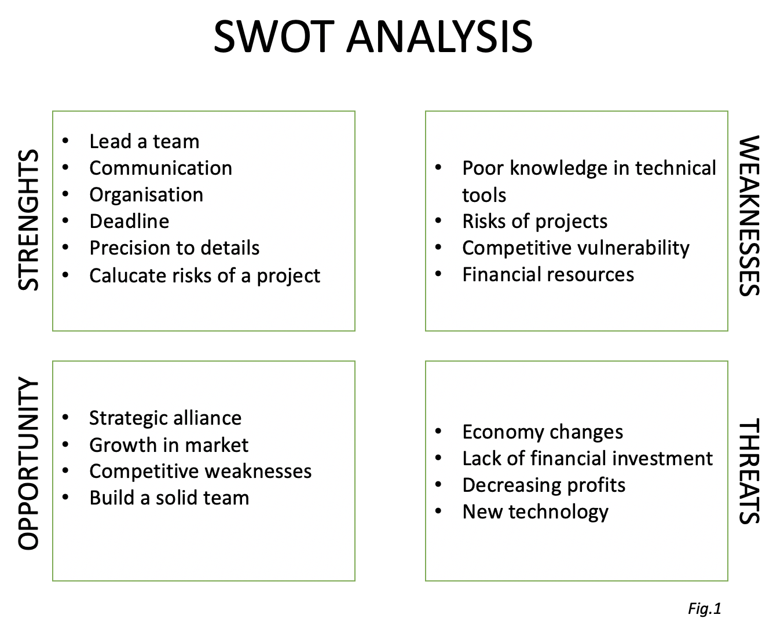
Source: Laura Pino

As the S.W.O.T. analysis shows in Fig.1 the strengths of the project manager are good enough to lead a team, because the ability of leadership, being an effective communicator, following deadlines, being organised and precise, can allow one to be professional in this context.
However, the weaknesses displayed in Fig.1 are not all necessary requirements as important skills, for example the risk of a project is connected to the project itself and one can try to develop a plan to predict it, but it is not always possible. While in this case, the main weaknesses such as having a poor knowledge in technical software are an essential requirement to improve, because a project manager must delivery their projects through the use of professional tools and techniques as for example, ProjectLibre.
Indeed, to become a successful project manager it is fundamental to have a full competence in the use of main software tools that help them in building and delivering projects easily to the team (Bermayehvar, 2013).
Consequently, after analysing the strengths and weaknesses shown in Fig.1, it is essential to develop a self-assessment plan, in order to fill this gap.
Self-assessment is an efficient way to examine progress and develop in a personal career, thus, it is an effective way to ask feedback to the manager and colleagues in regard to one’s performance; helping to reflect and keep on track in personal progress (Indeed, 2021).
The tool is important also to enhance communication between colleagues and manager, as it becomes an opportunity to review past and precedent performance and improve some aspects of these, discussing it accordingly to the person in question (Uzialko, 2021). Therefore, the self-assessment is an opportunity to evaluate and set both the individuals and team goals (Uzialko, 2021).
Moreover, to be able to manage and handle tools and techniques like the Gantt chart, the Network diagram or software like Agile, Prince2, related to Fig.1, the project manager can fill this gap in knowledge quickly, in order to be more beneficial for the team, delivering projects in as professional and clear a way as possible. Hence, based on Fig.1 the lack of knowledge in technological software, it will be covered by specific training.
Certainly, creating a self-assessment evaluation where one considers their strengths and weaknesses, is important to the growth first, as an individual person, then as an employee; generating more profitability for the company one is working for (Uzialko, 2021).

Conclusion

The report has analysed the Zalando’s do.MORE sustainability project, enhancing the importance of its value in recycling clothes (Zalando report, 2021). The company wants to become 100% sustainable by 2025 and in 2019 it launched its first fashion collection which was entirely recycled (Zalando report, 2021).
The paper explained the main roles of the project managers and which steps they had to undertake to develop the project. In fact, they followed relevant stages such as planning, where the project is delineated, explaining its scope and benefits; scheduling, which they will chose and select appropriate techniques to deliver it; monitoring, the process of keeping track of the project’s progress and potential risks. In these steps it was fundamental to consider the scenario of the COVID-19 pandemic, in order to calculate any risks that could affect the outcome of the project.
In fact, in this picture, the challenges of project managers to plan, manage stakeholders and risks correlated to the project, are expected to be performed to a high standard, bringing successful results for the company and achieving its goals.
During the delicate part of project delivery, the communication with the team plays an important role. It is necessary that the project manager establishes a relationship of recognition and trust of the work they will carry out, explaining the purpose of it and the benefits that will result from it, creating an atmosphere of motivation and a sense of collaboration (Berkun, 2008). As Zalando states (Zalando report, 2021), they want to create a trust between their stakeholders, through a transparency of information that the company makes available to them, enhancing customer engagement though an improved digital experience and building a solid communication between teams; putting the employees in the conditions to be able to express their opinions and increase the growth possibilities of Zalando. In fact, with a smart approach everyone will feel more involved and in focus with the pre-set objective and with the help of tools, the project manager outlines the roles, within the project, of each employee who will take part in it (Project smart, 2020). Hence, the paper analysed which tools and techniques are required for the project, taking in account and demonstrating that the use of work breakdown structure, Gantt chart and Agile methodology, were more strong to identify all steps of the do.MORE project, in order to be delivered clearly and efficiently to the team. With the help of these tools, it was possible to subdivide the activities necessary to complete the project, setting deadlines and budgets. In fact, these tools, in the monitoring phase, helped to more easily visualise the completed activities and which ones were still to be finished, showing a percentage of each of them, thus, the employees with the project manager can keep track of the progress of the work. In the end, the paper, examines the strength and weaknesses of managing a project, developing a self-assessment, based on the Fig.1, in order to be aware of the skills required to performing as a successful project manager; it is important to have a positive attitude to fill these gaps in their poor knowledge base in order to develop one’s career and maintain a high performance throughout their work.

References

Agile handbook, 2021. Agile Handbook. [online] Available at:
http://agilehandbook.com/agile-handbook.pdf
(Accessed: 18/04/2021).

Ajay, S., 2018. Waterfall vs Agile vs Scrum- Which is Better?. [online] Available at:
https://www.linkedin.com/pulse/waterfall-vs-agile-scrum-which-better-ajay-s
(Accessed: 15/04/2021).

Analysistabs, 2021. Advantages & Disadvantages of Gantt Charts. [online] Available at:
https://analysistabs.com/gantt-chart/advantages-disadvantages/
(Accessed: 18/04/2021).

Annual Report Zalando, 2016. Corporate Responsibility. [online] Available at:
https://annual-report.zalando.com/2016/fileadmin/user_upload/zalando2016_corporate_responsibility.pdf
(Accessed: 10/04/2021).
Apparel Coalition, 2021. The SAC celebrates 10 Years of BOLD PROGRESS. [online] Available at: https://apparelcoalition.org (Accessed: 21/04/2021).

Barnes, M., 2012. What is project management?. [online] Available at:
https://www.apm.org.uk/resources/what-is-project-management/
(Accessed: 06/04/2021).

Berkun, S., 2008. Making Things Happen: Mastering Project Management.

Bermayehvar, B., 2013. Being an Effective Project Manager: An exploration within project- oriented organisations. [online] Available at:
https://www.escholar.manchester.ac.uk/api/datastream?publicationPid=uk-ac-man-scw:205162&datastreamId=FULL-TEXT.PDF
(Accessed: 19/04/2021).

Corporate Zalando, 2019. The Starting Point for Fashion. [online] Available at:
https://corporate.zalando.com/sites/default/files/media-download/2019-02-28%20Zalando%20CMD%202019%20-%20David%20Robert%20Rubin%20-%20The%20starting%20point%20for%20fashion%20-%20Web.pdf
(Accessed: 07/04/2021).

Corporate Zalando, 2020. Zalando’s Equity Story- Why to Invest?. [online] Available at:
https://corporate.zalando.com/en/investor-relations/zalandos-equity-story-why-invest
(Accessed: 17/04/2021).
Davidson, C., 2021. What is A Waterfall Chart?. [online] Available at:
https://www.indicative.com/data-defined/waterfall-chart/
(Accessed: 15/04/2021).

Fernando, J., 2021. Stakeholder. [online] Available at:
https://www.investopedia.com/terms/s/stakeholder.asp
(Accessed: 06/04/2021).

Indeed, 2021. How to Write a Self-Assessment. [online] Available at:
https://www.indeed.com/career-advice/career-development/self-evaluation
(Accessed: 20/04/2021).

Indeed, 2020. SMART Goals: Definition and Examples. [online] Available at:
https://www.indeed.com/career-advice/career-development/smart-goals
(Accessed: 19/04/2021).

Inside Zalando, 2020. [online] Available at:
https://www.youtube.com/watch?v=ibiyKV8HxSY
(Accessed: 06/04/2021).

Kinnevik, 2021. Kinnevik intends to propose a distribution of its Zalando shareholding to its shareholders, accelerating Kinnevik’s strategic transformation. [online] Available at: https://www.kinnevik.com/media--contact/press-releases/2021/2/2459858-Kinnevik-intends-to-propose-a-distribution-of-its-Zalando-shareholding-to-its-shareholders-accelerating-Kinneviks-strategic-transformation
(Accessed: 21/04/2021).

Kukhnavets, P., 2016. Strong and Weak points of Agile. [online] Available at:
https://hygger.io/blog/agile-strong-and-weak-points/
(Accessed: 15/04/2021).

Nesbit, T., 2009. Project Manager Skills: for Employability in information Technology. [online] Available at:
https://www.researchgate.net/publication/242264270_Project_Manager_Skills_for_Employability_in_Information_Technology
(Accessed: 20/04/2021).

Preuss, S., 2021. Zalando presents first sustainability progress report. [online] Available at:
https://fashionunited.uk/news/business/zalando-presents-first-sustainability-progress-report/2021031754511
(Accessed: 10/04/2021).
Project Smart, 2020. ‘SMART Goals’. Available at:
https://www.projectsmart.co.uk/smart-goals.php
(Accessed: 17/04/2021).

Reddy, C., 2021. Work breakdown Structure: Advantages and Disadvantages. [online] Available at:
https://content.wisestep.com/work-breakdown-structure-advantages-disadvantages/
(Accessed: 18/04/2021).

Roberts, P., 2011. Effective Project Manager. London, UK Philadelphia, PA: Kogan Page.

Simlpywall, 2020. What Kind of Investors Own Most of Zalando SE (ETR:ZAL)?. [online] Available at: https://simplywall.st/stocks/de/retail/etr-zal/zalando-shares/news/what-kind-of-investors-own-most-of-zalando-se-etrzal (Accessed: 22/04/2021).

Singh, R., 2020. What is a Gantt chart and why is it important?. [online] Available at:
https://www.appvizer.com/magazine/operations/project-management/what-is-a-gantt-chart-and-why-is-it-important
(Accessed: 15/04/2021).

Slate, A., 2018. Critical Path Method: A Project Management Essential. [online] Available at:
https://www.wrike.com/blog/critical-path-is-easy-as-123/
(Accessed: 16/04/2021).

Smartsheet, 2021. How to Choose the Right Project Management Methodology. [online] Available at:
https://www.smartsheet.com/content-center/best-practices/project-management/project-management-guide/how-choose-project-management-methodology
(Accessed: 18/04/2021).

Sunindijio, R., Y., 2015. Project manager Skills for improving project performance. [online] Available at:
https://www.researchgate.net/publication/281789499_Project_manager_skills_for_improving_project_performance
(Accessed: 20/04/2021).

Togglplan, 2021. Choosing the Right Project Management Software: a PM’S Guide. [online] Available at:
https://toggl.com/blog/guide-select-project-management-software
(Accessed: 16/04/2021).

Uzialko, A., 2021. Self- Assessment: 5 Tips for Writing Your Performance Evaluation. [online] Available at:
https://www.businessnewsdaily.com/5379-writing-self-assessment.html
(Accessed: 20/04/2021).

Verma, E., 2021. Network Diagram: An Important Tool for Effective Time Management. [online] Available at:
https://www.simplilearn.com/network-diagram-as-an-effective-time-management-tool-rar224-article
(Accessed: 15/04/2021).

Wilson, F., 2019. Project Management Tools and Techniques That Really Work. [online] Available at: https://www.ntaskmanager.com/blog/project-management-tools-and-techniques/ (Accessed: 07/04/2021).

Yahoo Financial, 2021. Zalando aims for more than 10% of Europe fashion market. [online] Available at: https://finance.yahoo.com/news/zalando-aims-more-10-europe-072002095.html
(Accessed: 09/04/2021).

Zalando corporate, 2020. Half- Year Report H1 2020. [online] Available at:
https://corporate.zalando.com/sites/default/files/media-download/Zalando-SE_Half-Year-Report_2020.pdf
(Accessed: 16/04/2021).

Zalando corporate, 2020. One Year of do.MORE. [online] Available at:
https://corporate.zalando.com/en/newsroom/news-stories/one-year-domore
(Accessed: 10/04/2021).

Zalando Progress Report, 2020. Sustainability Progress Report 2020. [online] Available at:
https://corporate.zalando.com/en/sustainability-progress-report-2020
(Accessed: 06/04/2021).

Zalando Roadshow, 2021. Investment Highlights. [online] Available at: https://corporate.zalando.com/sites/default/files/media-download/Zalando%20SE%20Roadshow%20Presentation%20Q4_20_vf_2.pdf
(Accessed: 22/04/2021).

Appendix

Project Libre, Zalando sustainability clothes. Link available:
https://uowtsd-my.sharepoint.com/:u:/g/personal/1915292_student_uwtsd_ac_uk/EQvDdfPRb8BGvBSJ2y4PuNoBJHDTubeB9928AU-9LVPqXw?e=rDOmo1

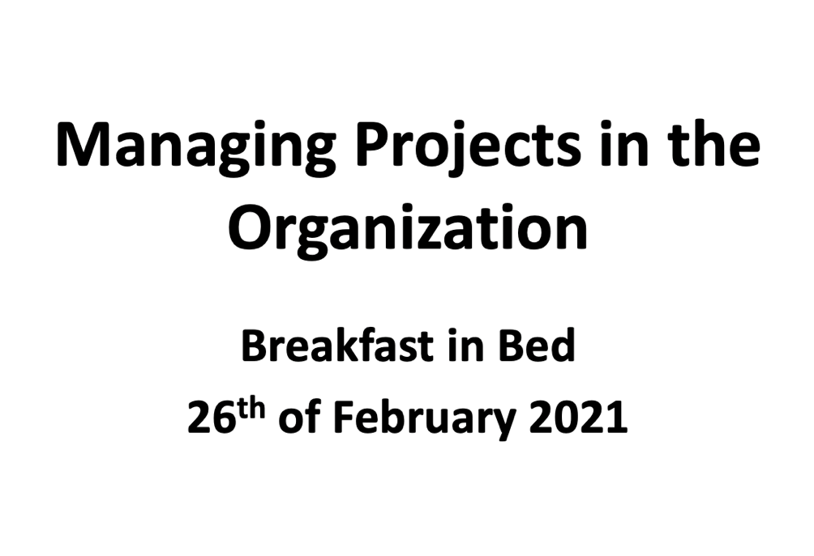

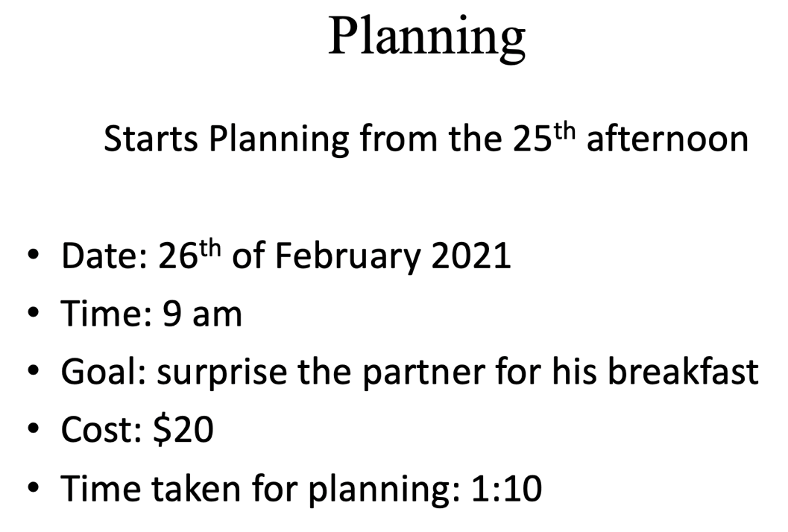

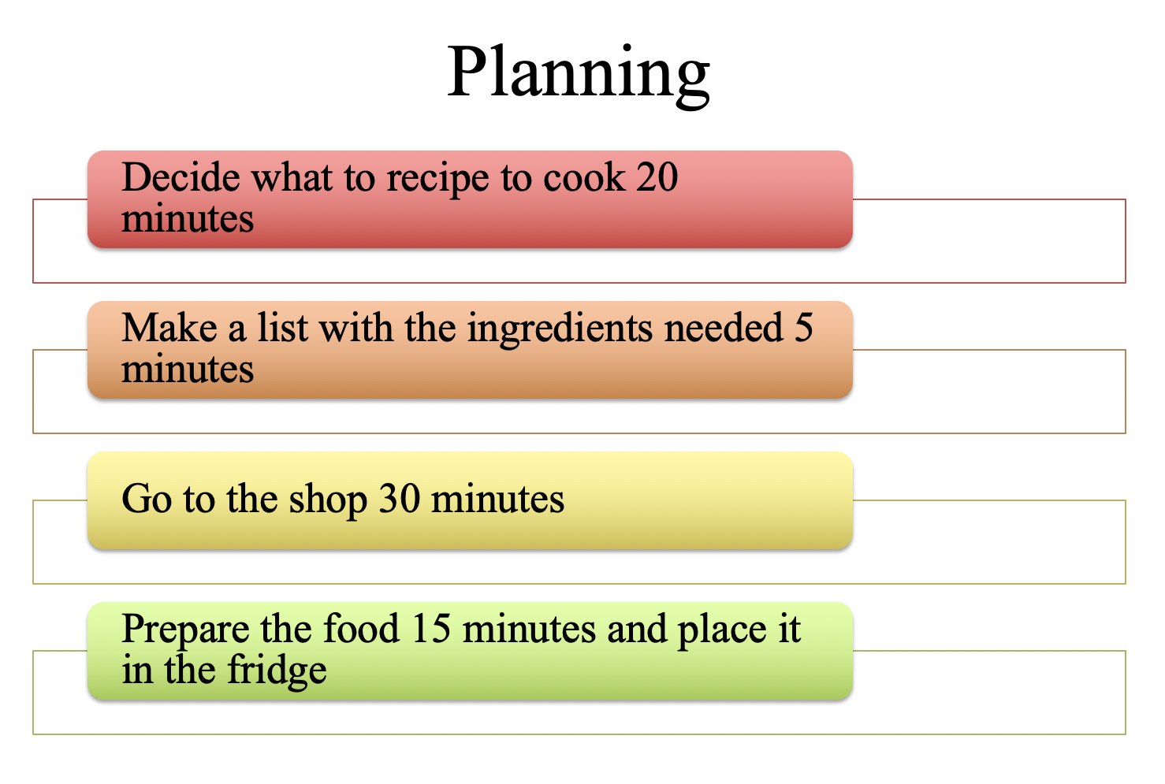

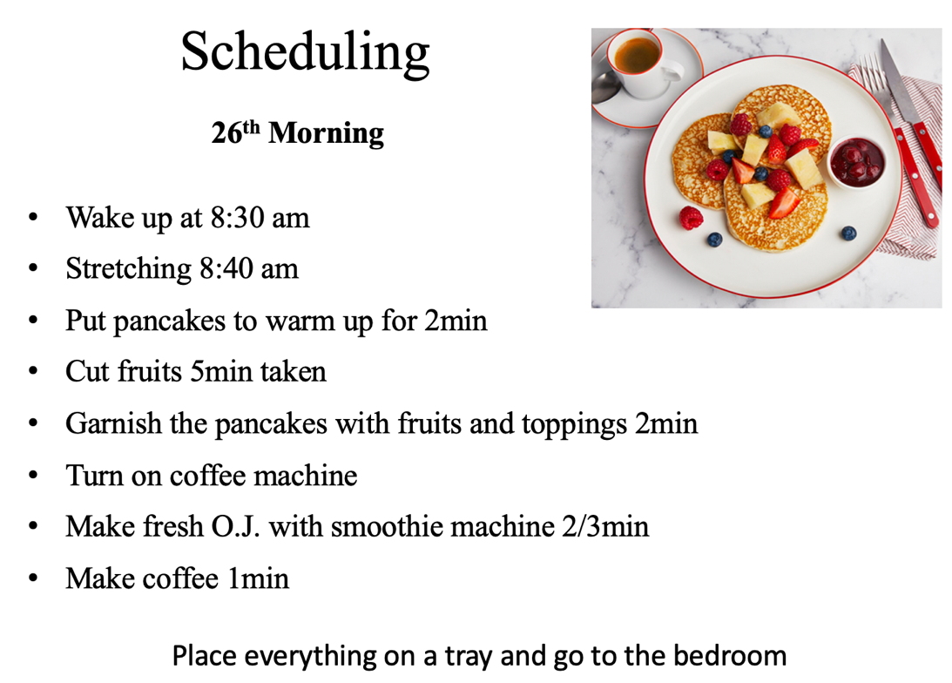

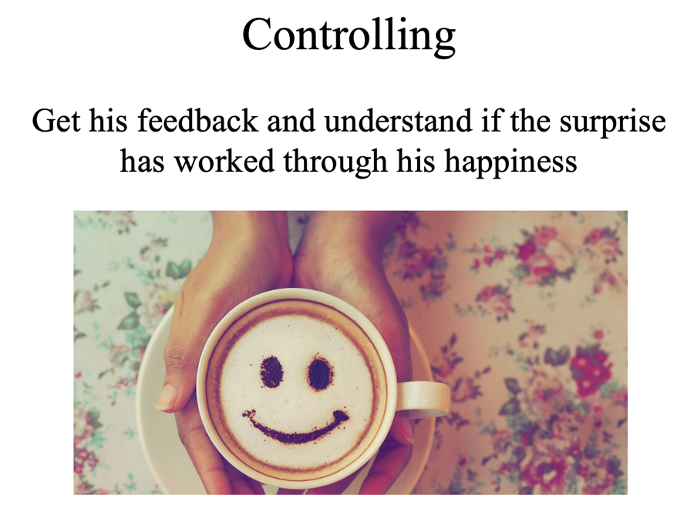
Example 1: homework in group.

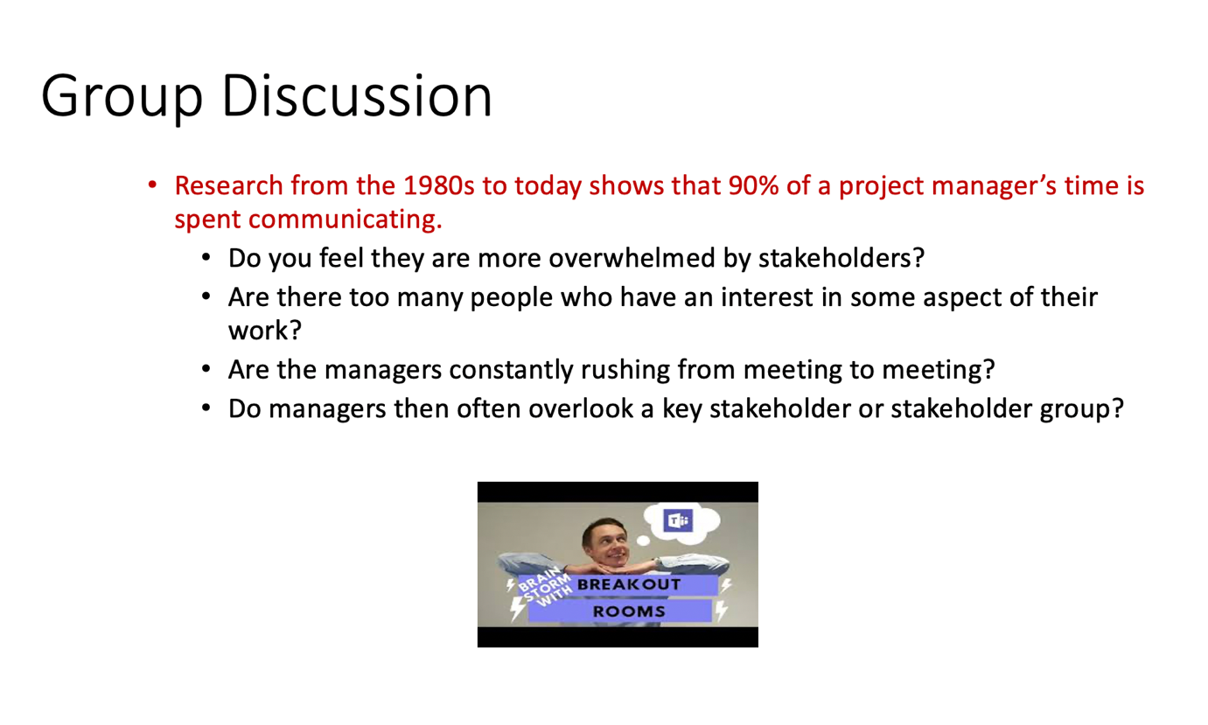
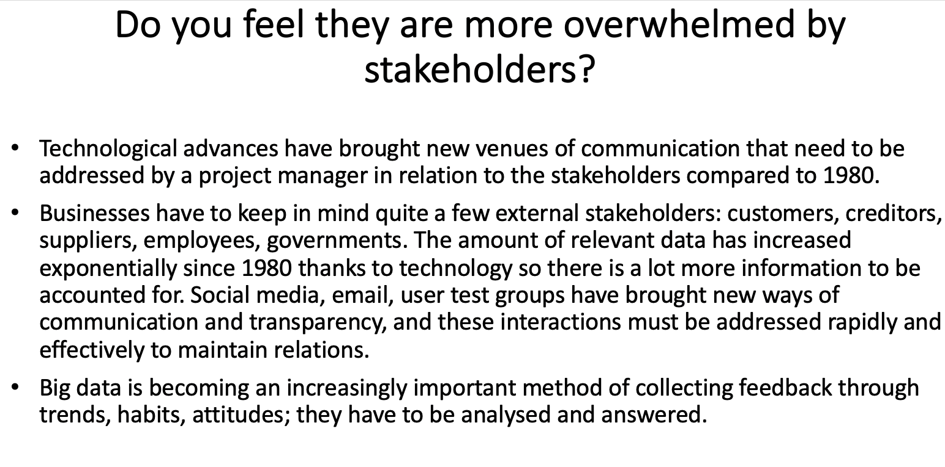

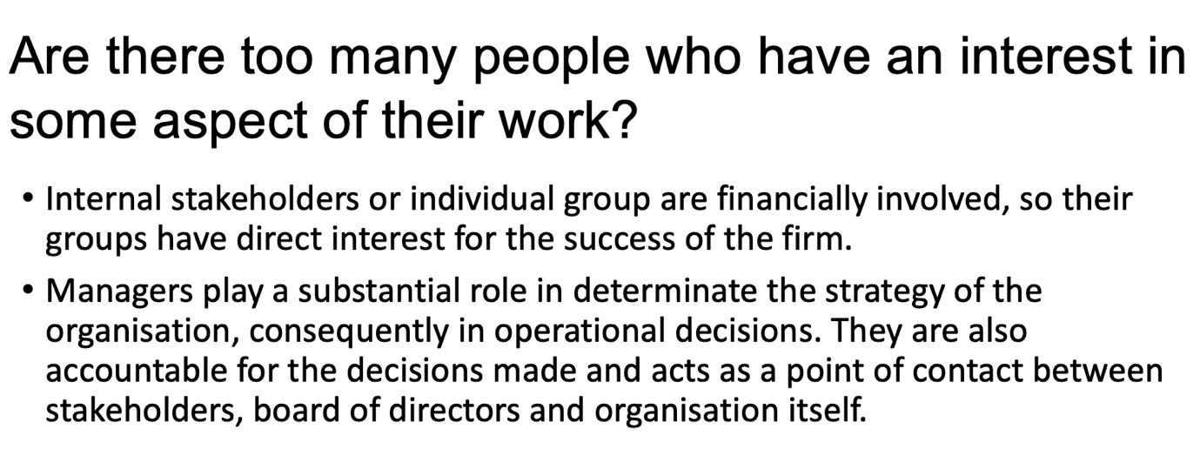

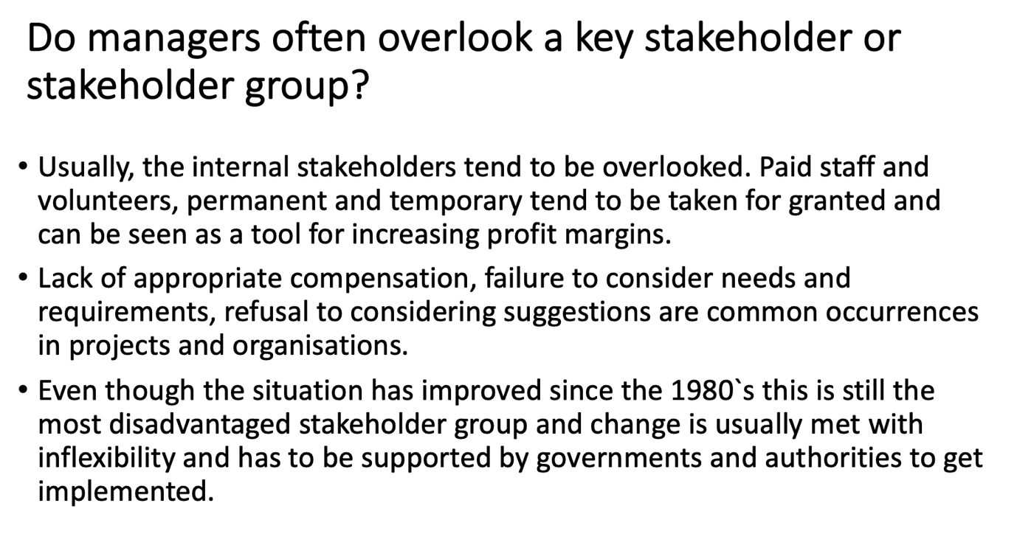

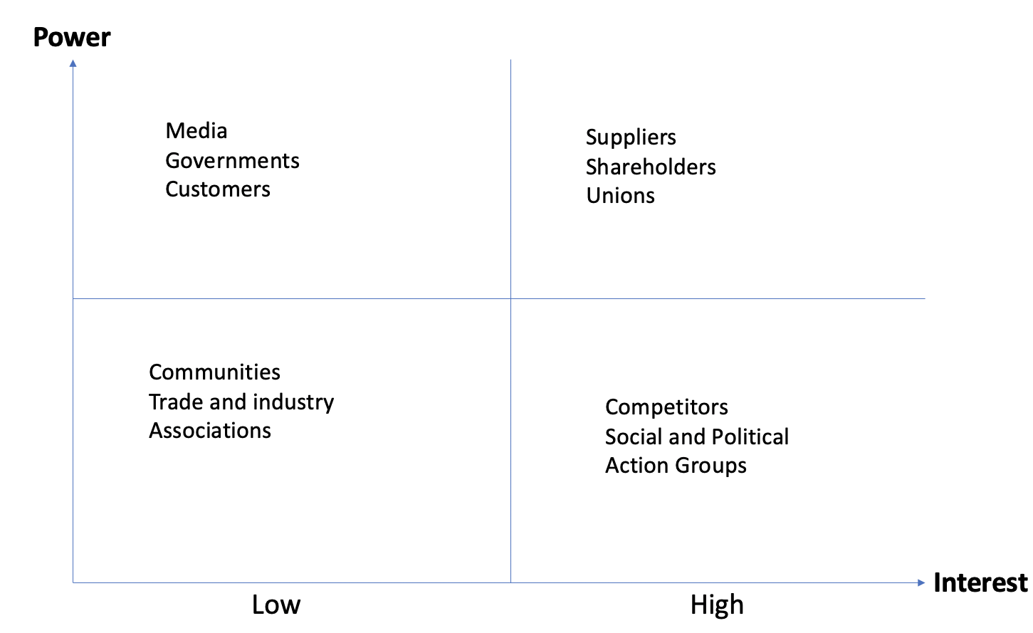c
Example 2: homework in group.

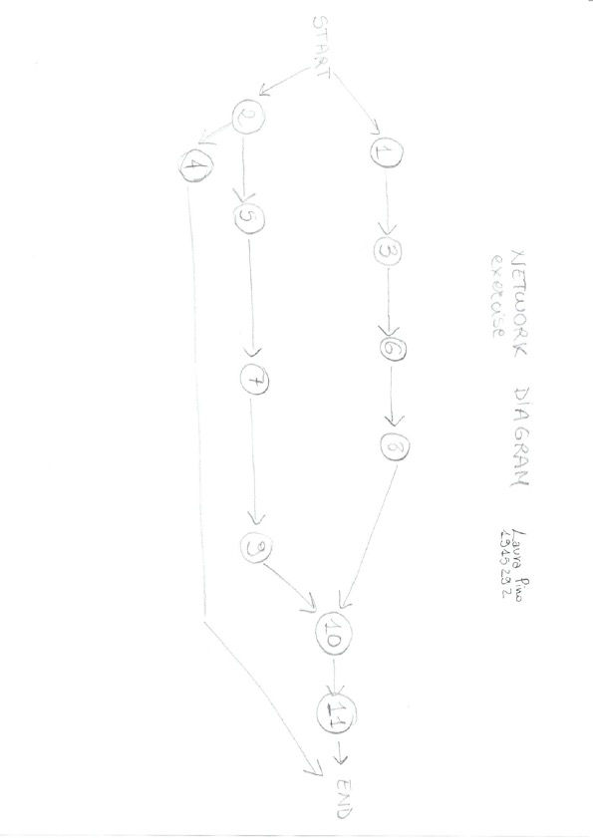

Example 3: homework.

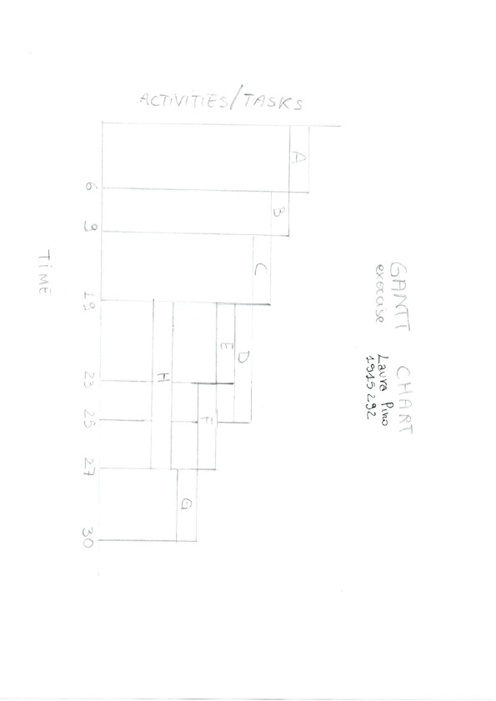
Example 4: homework.

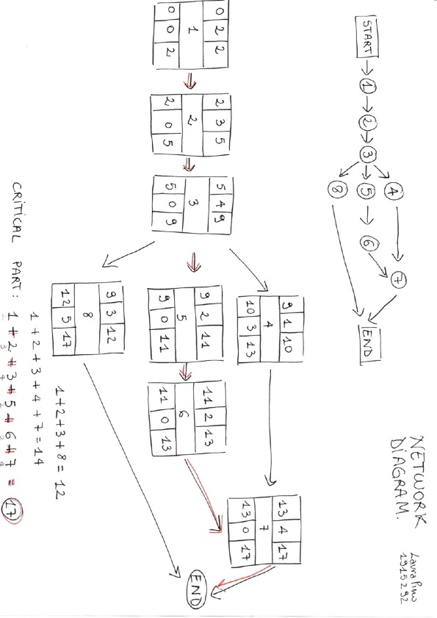
Example 5: homework.

