 | Targets | What I have done to improve this target
Target 1 | 1. Engage with an even wider range of literature and double-check your referencing technique for accuracy. Please see the Harvard referencing handbook here: Referencing handbooks | UWTSD Intranet along with information in the InfoSkills section of the Library's webpages to find out more about searching for relevant literature. | In this assignment I ensured to use more reliable resources from the Welsh Government website. I also engaged with more books including a range of books that were not on the reading list. I also used the Harvard referencing guide to support me throughout my essay.
Target 2 | 2. Further strengthen your critical writing by making references to literature throughout your writing. This will help to avoid large chunks of descriptive writing and unsupported conclusions towards the end of your work. | I ensured to link my writing back to literature more throughout my paragraphs. Including when I explained my lesson plan and resource
Target 3 | 3. Make greater use of tentative language and maintain an academic tone throughout. Please see pages marked for accuracy and other comments for examples. | In this assignment I ensured o maintain a more academic language throughout whilst using one tense throughout.

4014 assignment - Demonstrate how cross-curricular teaching and learning can influence in-depth skills and understanding. Underpin this with reference to relevant research, a detailed lesson plan and an enhanced provision material

Introduction

Throughout education in Wales teaching and learning was based on a one subject at a time, timetable. Creating an education system that diminished creative ideas and children’s holistic development. This is reiterated by Plowden (1967, quoted in Kerry, 2015, p.3) as he states, “we stress that children’s learning does not fit into subject categories”. During 2014 the Welsh Government asked Professor Graham Donaldson to review the curriculum to ensure each child benefited from an inclusive and rewarding education system (Donaldson, 2015). Within the curriculum, Donaldson discussed many changes that We have now implemented into the Welsh curriculum, such as the twelve pedagogical principles and the use of progression steps instead of assessing children against their age (Donaldson, 2015). However, an important change that was reviewed was the areas of learning as he advised there should only be six areas of learning due to the importance of employing creative thinking skills and to promote progression (Donaldson, 2015). Donaldson also reviewed the cross-curricular responsibilities. In Donaldsons review he explained the importance of the numeracy and literacy framework in providing children essential skills in life. Additionally, to this he also introduced the digital competence framework as the last cross-curricular responsibility due to the developing modern world we live in (Donaldson, 2015).

Foundation learning is implemented into schools to support children aged 3 to 7 within Wales. Similarly, to the Welsh curriculum, foundation learning also promotes cross-curricular teaching and learning by using the literacy, numeracy, and digital competence frameworks (Welsh Government, 2015). Unlike the Welsh curriculum, foundation learning emphasises the importance of cross-curricular teaching and learning through practical experiences, child centred activities and effective interactions (Kerry, 2015, p.58). This has been observed on placement when the children are taken to a local shop. As a result, this simple activity not only allows children to have a practical experience which promotes Frobel’s theory of supporting children to develop “their natural desire to explore, experiment and make connections” (Bradbury and Swailes, 2022, p.44). The task also allowed children to explore their community which links to humanities, the children bought food in the shop relating to mathematics and numeracy. Additionally, the communication between the public and children is also developing their literacy, language, and communication skills. Therefore, this task had many benefits such as real-life concepts and ability to gain a greater understanding.

Cross-curricular teaching and learning is defined as “the skills, knowledge and attitudes of a number of different disciplines are applied to a single experience” (Barnes, 2015, p.11). Like any new or developed way of teaching there are advantages and negatives that must be taken into consideration such as cross-curricular learning can provide children with motivation, relevant learning, and better engagement (Kerry, 2015, p.59). On the other hand, there are disadvantages that prevent teachers from imbedding this experience into schools. These include deprivation, resources, and lack of staff (Nrich, unknown date). In this assignment I will be exploring how cross-curricular teaching and learning can be used in schools and the negatives that are preventing teachers and schools from adapting to this new way of teaching.

Main body

Since 2015 Wales has made detrimental improvements to the Welsh curriculum, changing the outcome for children in Wales. The Welsh curriculum is made up of different areas that schools and teachers must use as guidance ensuring children are receiving the best education possible. During the review in 2015 three cross-curricular frameworks were developed and added to create an education system that supports children’s progression in different skills (Welsh Government, 2022). To ensure these benefits are being met the schools must follow the 3 frameworks that are provided. Similarly, to the six areas of learning the cross-curricular frameworks are made up of what matter statements, descriptions of learning and then divided into progression steps (Welsh Government, 2022). Firstly, what matter statements are individual depending on the cross-curricular framework and provide the “big ideas” which are mandatory to learn (Welsh Government, 2020). Within each framework there are also descriptions of learning which provide guidance on skills that children will need to develop and learn through progression steps (Welsh Government, 2020). Unlike the old curriculum where children were assessed and grouped by their age the Welsh curriculum now divides the skills children must develop into progression steps (Welsh Government, 2020). Therefore, children can now develop at a suitable rate for themselves over a series of years providing a more child centred approach to learning (Welsh Government, 2020). Whist on placement, I have witnessed the different cross-curricular frameworks being used especially when the children are tasked with an enhanced provision activity such as using the I pads to draw a dinosaur theme including labels.

Within any classroom there can be a range of ten to thirty-five children in a class that need to be able to leave at the end of each day understanding what they have learnt to develop that knowledge further. A key issue I have witnessed in placement is ensuring children are engaged in the learning. As a result, when children are engaged in the learning, they are able to progress and show improved behaviour which can lead to more time spent on learning (Atanasiu, 2022, p. 5). Unlike the curriculum now, the old curriculum divided learning into subject areas causing an education system that does not allow children to widen their knowledge across subjects, providing children with a false sense of the real word and decreasing the levels of engagement (Schidies, 2018). On the other hand, cross-curricular learning can provide a more creative and inclusive way of teaching and learning leading to better engagement. This was reported in an Estyn report during 2018 when a school in Cardiff implemented a cross-curricular approach to promote and support children to work towards the four purposes and allow the activities and learning to engage children (Estyn, 2018). This was ensured by activities that promoted hands on experiences and different areas of learning such as the school were able to purchase a weather machine which allowed the children to collect live data everyday promoting mathematics, humanities, and the digital literacy competence framework. The school discovered that teaching cross-curricular allowed children to engage in the activities but also made the learning purposeful (Estyn, 2018). When planning my enhanced provision, I ensured that my lesson was not only purposeful but also engaging to ensure that children were learning. As a result, I made sure to use cross-curricular teaching for children to get different experiences such as reading a book, then going outside to practice directions and positions then using the bee bots. On the other hand, Dcox (2016) states that cross curricular teaching “wastes teachers time”. She believes that focusing on one subject at a time can allow children to gain a greater understanding of the subject or topic in a simpler way (Dcox, 2016).

To ensure a school is safe and can provide children with the right to an education there are different staff members with individual roles to provide this support. Since 2023 the amount of support staff has made an enormous increase allowing children to gain more support and spend more time teaching cross-curricular (Welsh Government, 2023). With any classroom task an extra pair of hands are useful especially when teaching cross-curricular. However, an Ofsted report disagreed and raised their concerns stating that the teaching assistants were tasked with taking the lower ability or disruptive children out of the class (Kerry, 2015, p.143). As a result, vital learning time was being missed and these children were not gaining the same cross-curricular experience from the qualified teacher which resulted in progress of pupils being affected (Kerry, 2015, p.143). On the other hand, when teaching cross-curricular, teaching assistants are vitally important as they are “maximising learning time” and can “bring a wide range of personal skills” (Kerry, 2015, p.144). This has been observed on placement, when teaching assistants are cohesively working with the teacher to plan different provision areas and lesson plans. Therefore, within my lesson I have maximised this support ensuring the teaching assistants are continuously apart of the lesson supporting myself or a range of children in the class.

To meet the aim of my assignment I was tasked to create a lesson plan and enhanced provision resource that promoted cross-curricular teaching and learning. Overall, my lesson is based on mathematics and numeracy as the children were developing their knowledge of compasses and positioning’s. The statement of what matters that supports this is “Geometry focuses on relationships involving shape, space and position, and measurement focuses on quantifying phenomena in the physical world” (Welsh Government, 2022) as seen in appendix one. The class my lesson is aimed at is year two therefore when deciding on a progression step, I wanted them to work towards I had to ensure that it was suitable and allowed them to develop at their own pace and make meaningful progress (Welsh Government, 2021). Therefore, the progression that best suits my lesson and resource is progression step two, which is “I can describe and quantify the position of objects in relation to other objects” (Welsh Government, 2020). To ensure children were working towards this progression step and the target to understand a four compass scale I split my lesson into three parts. First, as a whole class I read the book sunk and created a discussion on maps and compasses ensuring to write their ideas down. Then, the children were split into their ability groups and were able to practically use a compass outside alongside the teaching assistant. This was a good example of using health and wellbeing within my lesson for extra cross-curricular skills. Lastly, within mixed ability groups the children used the bee bots to help him explore the map and get to the five different locations including the boat and volcano as seen in appendix two. Using their sheet in appendix two, they recorded their answers. Overall, this one lesson allowed the children to develop skills across the different areas of learning but also developed their digital competence which is a main cross curricular skill. By using the bee bots, the children developed their producing skills by changing and controlling the bee bot with different instructions (Welsh Government, unknown date).

Additionally, ensuring my lesson and resource were both cross-curricular and allowed the children to meet their targets and progress I also ensured to refer to the twelve pedagogical principles to promote better experiences in the classroom environment. For example, within my lesson the children will practically use a compass and gain a better understanding which is reiterated by the principle “creates authentic contexts for learning” (Welsh Government, 2023). Frobel’s theory also supports this principle as he believes children should have the opportunity to use “their natural desire to explore and experiment” (Bradbury and Swailes, 2022, p.44). For this lesson I continually used a range of teaching approaches such as whole class, ability, and mixed ability groups which is reiterated by the principle “employing a blend of approaches including direct teaching” (Welsh Government, 2023). This is important because in ability groups the teaching assistant was able to individualise the amount of time spent and support with the children. As a result, the children were able to have a more child centred approach to their lesson (Logsdon, 2022). On the other hand, I also ensured that children had time to learn in mixed ability groups as a result the children can support and learn from one another. This is reiterated by Vygotsky’s theory as he believed knowledge was developed “through interactions with more experienced others” (Arthur and Cremin, 2010, p.32).
Conclusion
To conclude, throughout this assignment and while at placement I have been able to see the advantages of using a cross-curricular teaching approach in schools such as the ability to promote better engagement and support overall progression (Kerry, 2015, p.59). However, my main source of knowledge has come from creating an enhanced provision resource and lesson plan to work alongside it. This practical experience has allowed me to gain a greater understanding on how teaching cross-curricular can provide children with a verity of experiences such as going outside to practically use the equipment and to use the bee bots. Overall, I believe my lesson and resource promoted cross-curricular learning whilst also allowing myself to develop QTS standards. Such as I was able to provide differentiation in my lesson when the children went outside with the teaching assistant, she individualised the support for them depending on their groups. Additionally, on the work sheet the children completed there was a shoot star task that was used to challenge children if needed (Welsh Government, 2019). As I have previously said I also used “blended learning experiences” and “real life, authentic contexts” which are part of the pedagogy practice that need to be promoted as part of the QTS standards (Welsh Government, 2019). However, if I were to plan this lesson again, I would provide more differentiation by supplying different maps. As a result, the children would have more of a targeted lesson for their ability.

References:
Arthur, J and Cremin, T. (2010) learning to teach in the primary school. 2nd edn. Oxon: Routledge

Atanasiu, A. (2022) ‘Low student engagement level in struggling learners and ways to address it’, Sunderland reflective action in education, 1(3), pp. 5-17. Available at: https://www.google.com/url?sa=t&source=web&rct=j&opi=89978449&url=https://ojs.sunderland.ac.uk/index.php/sunrae/article/download/3/2&ved=2ahUKEwjoj_qVsLKFAxVKQEEAHZL6DvwQFnoECCoQAQ&usg=AOvVaw00yfcQOOMNMxTTYZiT4GZ9 (Accessed: 8TH April)

Barnes, J. (2015) Cross-curricular learning 3-14. London: SAGE.

Bradbury, A and Swailes, R. (2022) Early childhood theories. London: SAGE.

Dcox. (2016) ‘Don’t waste time on cross curricular projects or wedging in other subjects into your lessons’, My views on teaching & education [blog]. 11 December. Available at: https://missdcoxblog.wordpress.com/2016/12/11/dont-waste-time-on-cross-curricular-projects-or-wedging-in-other-subjects-into-your-lessons/ (Accessed: 8TH April).

Donaldson, G. (2015) ‘Successful Futures’. Independent review of curriculum and assessment arrangements in Wales, by Professor Graham Donaldson. Available at:https://www.gov.wales/sites/default/files/publications/2018-03/successful-futures.pdf (Accessed: 28th March)

Estyn (2018) providing enriched experiences to develop skills. Available at: https://www.estyn.gov.wales/effective-practice/providing-enriched-experiences-develop-skills (Accessed: 8th April).
Kerry, T. (2015) cross-curricular teaching in the primary school. 2nd edn. Oxon: Routledge.

Logsdon, A. (2022) can ability grouping in school help your child. Available at: https://www.verywellfamily.com/what-is-ability-grouping-2161808 (Accessed: 10th April).

Nrich (Unknown date) key obstacles hindering cross-curricular teaching. Available at: https://nrich.maths.org/8453 (Accessed: 28th March)

Sheidies, C. (2018) Disadvantages of subject -centered curriculum. Available at: https://classroom.synonym.com/disadvantages-subjectcentered-curriculum-12000458.html (Accessed: 8th April).

Welsh Government (2015) Foundation phase framework. Available at: https://hwb.gov.wales/storage/d5d8e39c-b534-40cb-a3f5-7e2e126d8077/foundation-phase-framework.pdf (Accessed: 28th March)

Welsh Government (2019) professional standards for teaching and leadership. Available at: https://hwb.gov.wales/api/storage/19bc948b-8a3f-41e0-944a-7bf2cadf7d18/professional-standards-for-teaching-and-leadership-interactive-pdf-for-pc.pdf (Accessed: 11th April)

Welsh Government (2020) ‘‘Areas of Learning and Experience’ as a central element of the new curriculum’, Education Wales [blog]. 2nd March. Available at: https://educationwales.blog.gov.wales/2020/03/02/areas-of-learning-and-experience-as-a-central-element-of-the-new-curriculum/#:~:text=Expressive%20Arts%3B%20Health%20and%20Well,and%20what%20do%20they%20comprise%3F (Accessed: 5th April).
Welsh Government (2020) Mathematics and numeracy. Available at: https://hwb.gov.wales/curriculum-for-wales/mathematics-and-numeracy/descriptions-of-learning/ (Accessed: 10th April)

Welsh Government (2021) The curriculum for Wales- progression code. Available at: https://www.gov.wales/sites/default/files/publications/2021-11/curriculum-for-wales-progression-code.pdf (Accessed: 10th April)

Welsh Government (2022) Cross-curricular skills frameworks. Available at: https://hwb.gov.wales/curriculum-for-wales/cross-curricular-skills-frameworks (Accessed: 5th April)

Welsh Government (2022) Mathematics and numeracy. Available at: https://hwb.gov.wales/curriculum-for-wales/mathematics-and-numeracy/statements-of-what-matters/ (Accessed: 10th April)

Welsh Government (2023) Pedagogy. Available at:https://hwb.gov.wales/curriculum-for-wales/designing-your-curriculum/pedagogy (Accessed: 10th April)

Welsh Government (2023) Schools’ census results: January 2023. Available at: https://www.gov.wales/schools-census-results-january-2023-html#130508 (Accessed: 9th April).

Welsh Government (unknown date) Digital competence framework. Available at: https://hwb.gov.wales/curriculum-for-wales/cross-curricular-skills-frameworks/digital-competence-framework (Accessed: 10th April)

Appendix

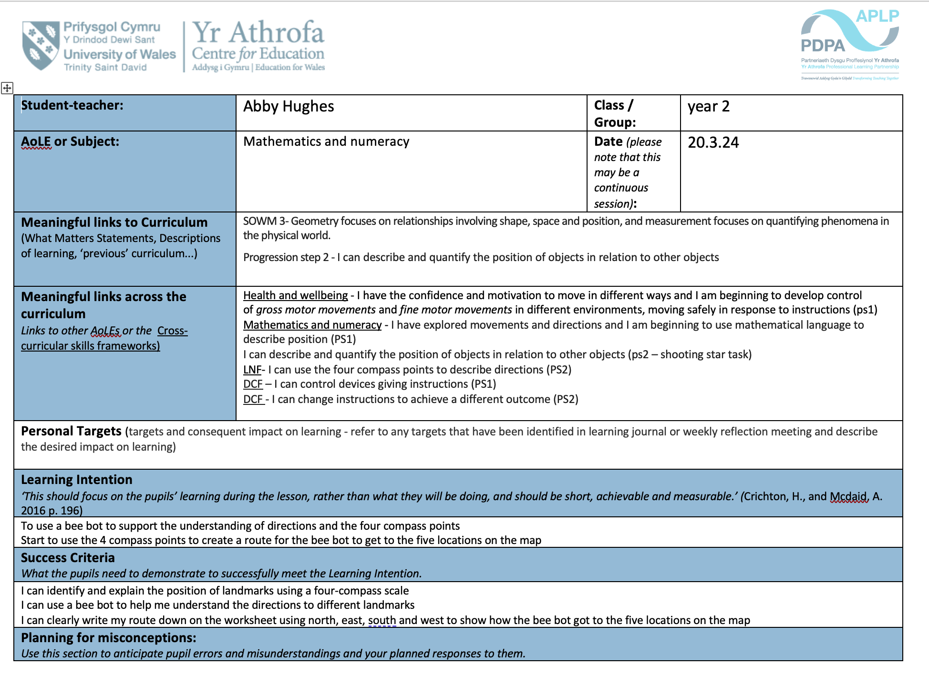
Appendix 1- lesson plan

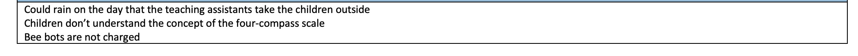

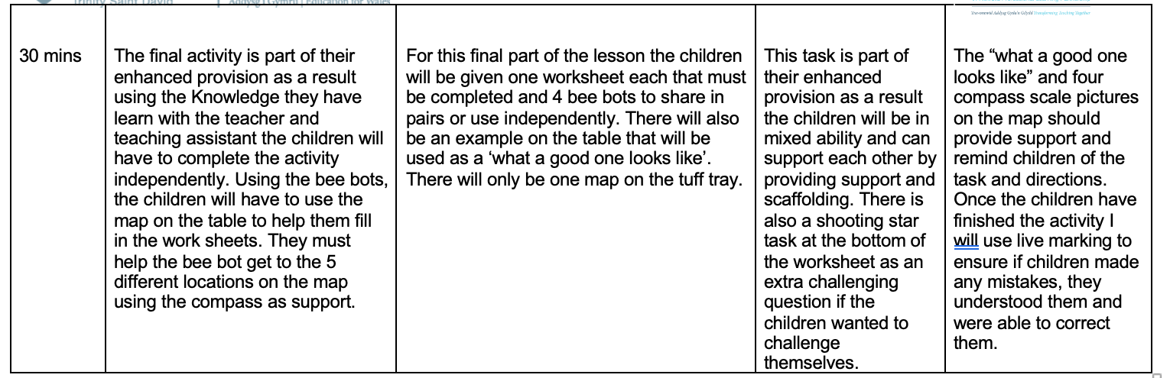
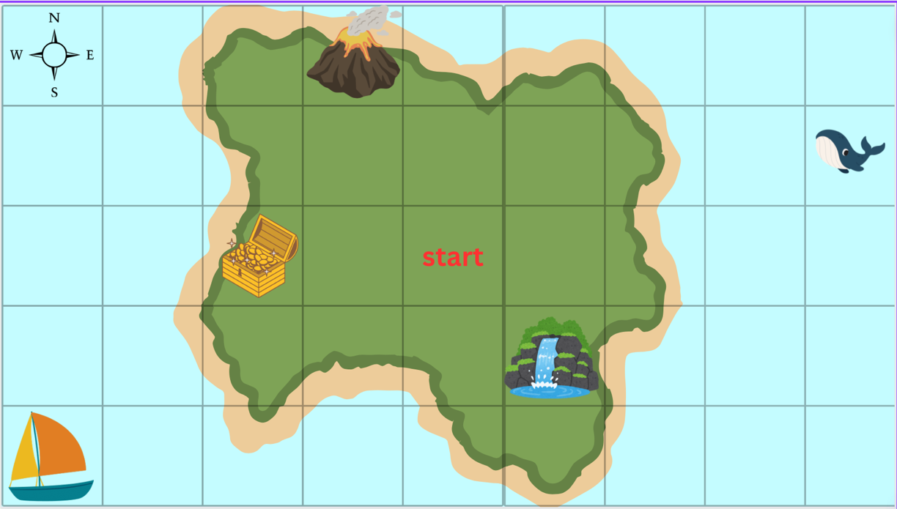
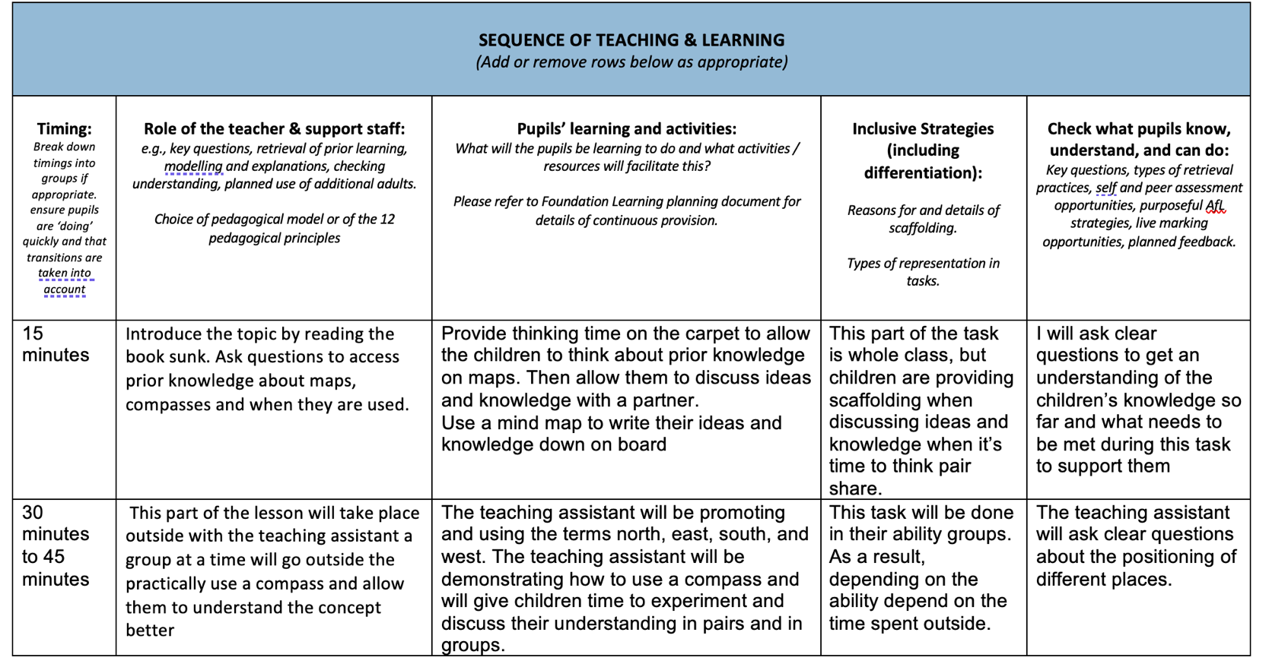

Appendix 2 – bee bot map and worksheet


