Professional Career Development

NAME:OUMAR KITWE KASULE

I.D:1807321

LECTURERS NAMES:NAVAMI SUDARSAN

MODULE:4005
Table of Contents
Introduction 3
My Professional Lifeline 4
Identification of the skills and knowledge important for employability 4
Personal evaluation 6
My learning style 6

VARK learning style 6
Honey and Mumford learning style 8
Johari Window 10
My current professional evaluation: SWOT Analysis 12
My SMART Objectives for professional development 13
Analysis of the findings from evaluation 16
Review of the understanding 17
My Career Mission Statement (CMS) 17
Areas for improvement 17
Action plan and my Personal Development Plan (PDP) 18
Conclusion 21
References 22

Introduction
All organization around the world is experiencing changes due to globalization as well as technological advancements in the logistics and communication sector. There cannot be improvement without change, this applies the same for employees to change and improve on their career. This is the reason why most firms have self-development schemes to help their staff improve their skills. Therefore, as a result of acquisition of new skills, it helps them in gaining personal growth and successful long-term career. Thus, it is important for individuals and professionals to develop a proper, rational, logical and effective professional development plan required for achieving the predetermined and selected career goal. Furthermore, there are a number of new skills which are becoming very important in the job market whereas several skills are becoming obsolete. It is highly recommended that ‘’be the person with the right skills in the right place at the right time. This report will discuss the different aspects and strategies of developing and generating a professional development plan. The knowledge, skills, expertise required in the workplace to establish a strong professional life. In addition to that, the steps and procedures of developing a professional development plan will be discussed in details. Along with these, a professional development plan of mine will be developed and provided in the report.

My Professional Lifeline
I come from Uganda, a small east African country. Am a second born in the large family, I completed my pre-primary school and secondary education at local educational center. During the later years of my primary I joined a school boxing club that later shaped my life and got me a scholarship to free secondary education and other opportunities in my youth and adult life. I boxed both national and international and a champion. Due to injuries and failure to qualify for Barcelona(1998) Olympics coupled with increased responsibility , I had to take another career route into coaching youngsters, and it is through coaching that I got the chance to come to England on all expenses paid. I did all kinds of work until I was granted a permanent stay in England. Currently, I am employed with network rail as a security officer. After many years working in public enterprises I got a chance of joining a university to further my career and I grabbed it, I have improved my employability skills, decision making, teamwork and the general aspects of my profession career and life. I want to complete a degree in Business Management, specialization in Human Resource Management. I want to establish myself as a human resource manager at a renowned business organization. In the long run I would like to go into business on my own and start a company.
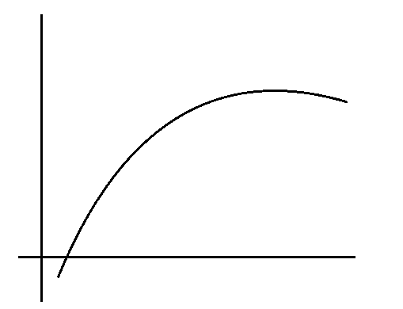
Prospect of own business in the long run
Expect to receive higher education in the fiend of HRM
Starting job at a Security company
Joining business management course
Coming to UK

Identification of the skills and knowledge important for employability
The concept of professional self-evaluation represents the skills and competencies which are required in the selected job or career field of a particular individual and comparing these with the actual skills and competencies possessed by the person in order to identify the overall situation, condition and aptitude level of the person to enter the job market. As a professional and individual interested to develop a career in the human resource management sector, I have to develop strong communication and interpersonal skills in order to manage the workforce effectively and efficiently for performing my job roles and responsibilities. The identification of the personality traits, skills and aptitudes which are possessed by successful human resource managers must be identified. It is very common and highly expected that there will be a lot of different obstacles, complications and hindrances in the way of developing effective and important skills by a professional. It is the personal level of self-motivation which supports and influences a person to keep going through the self development and skill development process and to become a successful professional by achieving desired career growth and job position as well as social status (6 Core benefits of personal development. Take charge of your life., 2017).
In the case of mine, I am currently working as a security officer in human resource management. I have to communicate with the employees working for the organization in different divisions and departments on a regular basis in order to allocate responsibilities to them, keep record of their working hours and performances, listening to their problems and sharing these with the upper level management in order to provide timely and effective solutions to the problems. I need to develop strong set of interpersonal skills and several technical skills.

Personal evaluation

My learning style
Learning style is the process which is applicable and effective for a person to learn new things. There are several different steps and processes of learning. I reflect with identity of my values and rules for living I consider important and I honestly ask myself if I live up to them, also observing how friends and family interacts and trusts me. Lastly, I ask those I trust for honest feedback.

VARK learning style
Learning styles are a core part of psychology. Learning styles are also important for education purpose as people can know how easily people can have better learning with minimum effort. The VARK learning model indicates that there are four different kinds of learners exist in world. They are-
- Auditory learners
- Kinesthetic learners
- Visual learners
- Reading/writing learners(Read/Write Strategies | VARK, 2018)

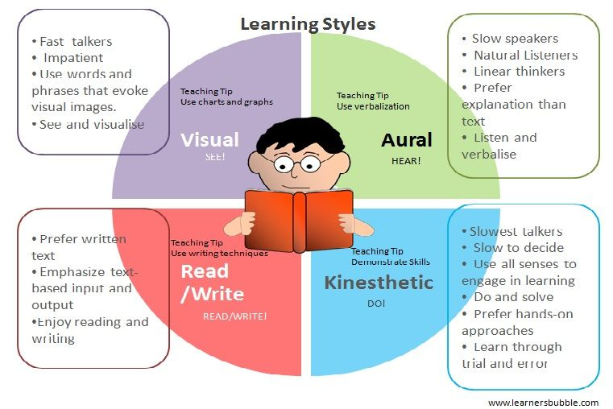
Figure: VARK learning style
Source: (David Kolb 's Four Distinct Learning Styles, 2018)
For education purpose there is a big debate that is it true that if school and college’s educational method and other activities match to the students characteristics that will leads to effective learning. This concept was developed in the era of 1970-1980s. Some researcher said that personal learning has no impact on learning outcome. On the other hand current researcher said that teaching and styles are not interrelated factors(Personal development plan (PDP) - Help Centre - Open University, 2017).
VARK model as the Fleming's model learners are categorized by different ways. Some prefer visual learning like observing the entity by eyes, some prefer auditory learning like audio method, some prefer reading and writing like making notes and some prefer kinesthetic learning like body language(Personal Development Planning — University of Leicester, 2017). After conducting an in depth self evaluation of myself, I have found out that, I am a kinesthetic learner because I prefer learning something by practicing in in real life. This is the learning style which suits me the most and is highly effective for me.

Honey and Mumford learning style
Peter Honey and Alan Mumford established the learning styles named “A follow up to the work of David Kolb and his Experiential Learning Theory”. They considered four segments of learning like activist, pragmatist, theorist, and reflector. They said that different peoples are comfortable with different learning styles. But to be successful one individual has to discover his own learning style which is best for him(Benefits Of Personal Development | Career Success For Ambitious Accountants, 2015).
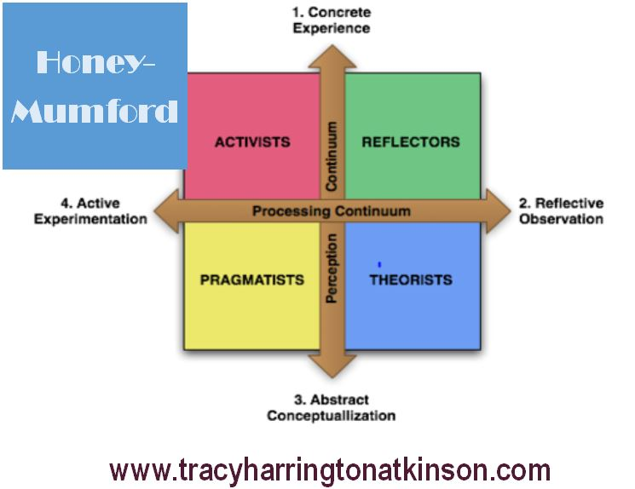
Figure: honey and mumford learning style
Source: (Rolfe Et Al., 2018)

Activists
Activists are highly responsive. They usually get involved into the learning situation and take the feedbacks. They welcomed every aspects and change. Whatever is valuable to them they just take it. They are positive to any new change and attempt to try the change to derive positive outcomes. They are highly challenging and learn in a group, individually or in a team. Role playing methods is also used by them(Log In to Mind Tools, 2018).
Theorists
Theorists are careful about any aspects. Their every work is prejudged. They think carefully whenever they do any work. They are highly logical and their every job is logically approved. They do much research to anticipate the future outcomes of any objects and go for further analysis if initial investigation is ok. They are tends to make a base form and tries to remain within that boundary. Their works are much more statistical and based on approved and established theory(Thum and Thum, 2012).
Reflectors
Reflectors are less likely to take challenge rather they like to observe any situation and then take actions(What is reflective practice and how do I do it? | The Chartered Society of Physiotherapy, 2015). They usually don’t get involved to any problem rather when the problem solution solved they just implement it can make some changes and solve their related problems. Reflectors intend to use interview, questionnaire to have feedback. They just observed the feedback and implement policies or take the result to solve their current or future problems (LearnHigher - Oral Communication -Selecting the Content, 2015).
Pragmatists
Pragmatists are those who work with theories and practical decision making process. They accumulated these two aspects for their learning purpose. They believe in testing and examining situations and based on the outcomes they learn how to react. They don’t do any work under any assumption or anticipation rather they believe in experiment and the tested result (Personal development planning | University of Bath, 2015). I believe I am a pragmatist as I do not assume and my actions are based on learning and the situation I am in.

Johari Window
This concept was developed, established and proposed by Joseph Luft and Harry Ingham. Back in the year 1955, this theory was proposed by these two academicians and researchers. The major objective of this theory is to ensure the desired level of mutual understanding among different people working in the organization. Another major objective of this theory is to support professionals and individuals working in different organizations for achieving a desired and high level of awareness about his or her own professional and personal characteristics and attributes so that he or she can take required and necessary initiatives accordingly. The concepts and specification described by this concept are presented and discussed below:
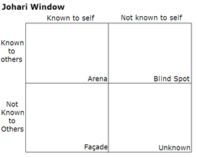
Arena/open self: it is the set of personality and characteristics of a person or professional which are not only known to him or her but also other people around the person in their personal and professional life.
Blind self: These are the set of personality traits which are unknown and not realized by the person but are noticed by the people around them.
Façade/hidden self: This personality of a person is hidden from other people in the workplace and to the people in the personal life as well.
Unknown self: This side of the personality as well as the characteristics features of a person is unknown to public and to the person as well.
As a person and professional willing to develop a career in the human resource sector and is interested to start a business venture of my own, I need to communicate with a lot of people and need to experience and deal with a number of wide varieties of complications and challenges throughout my professional career. For this reason, this is highly important for me to develop and conduct a Johari Window evaluation in order to identify my possessed, current and hidden characteristics which I can utilize to achieve desired success in professional life.
Arena/open self  - Strong leadership skills  - Strong communication skills  - Strong interpersonal skills | Blind self  - Socially awkward  - Anger issues  - Highly sensitive
Façade/hidden self  - Strong mental strength to achieve success and follow my passion | Unknown self  - I act rude and very strict sometimes which are unpleasant for some people

According to my Johari Window assessment, I have a strong set of personality traits which are effective for achieving desired success in the professional life. In addition to that, there are some weaknesses, flaws and problematic issues in my personality as well which must be overcome by me in order to ensure the achievement of the highest level of success in my life.

My current professional evaluation: SWOT Analysis
Professional evaluation is one kind of self-evaluating system. Here current professional situation is analyzed by using different analytical tools. This evaluation system enables one to identify his strength and the weaknesses that may cause suffer in long run. To evaluate oneself one can use the SWOT analysis. It is most commonly used analytical tool. This tool will enable one to identify the strengths, weaknesses, opportunities and threats he or she can have in professional life. By using SWOT analysis tool I can develop my career much easier. The SWOT analysis of my professional evaluation is described below:
Strengths  - I have the ability to make proper communication with the people. Am approachable.  - Usually I have a smiley face that makes every customers and upper level subordinates to communicate with me in interactive way.  - I am punctual in my workplace. I do my works on time.  - I maintain proper connection with every customer. Who knows one of them can turn my company profit in a higher level. | Opportunities  - I am studying in a university for a higher degree. After getting the degree will add significant value to my professional career.  - I have a great opportunity in my work place as I am highly skilled in this sector.
Weakness  - Handling the human resource is too much tough. I take much time to identify the right person for the right work.  - Whenever I failed or things don’t go in my way I got under pressure. It may lead me to take any wrong decision. | Threats  - Any mistake in Human Resource management can have devastating outcome for the whole organization.  - Huge work pressure can harm my study.  - Legislative objects can affect my Human Resource policies as well as performance.

My SMART Objectives for professional development
The concept and model of SMART objectives represents the objectives that are specific, measurable, achievable, realistic, and time bound for a particular individual and professional. This particular goal setting and planning model allows and supports individuals to identify the most appropriate set of objectives and long term as well as short term, logical, rational, feasible and achievable career goals and objectives. In addition to that, the development of SMART objectives support the overall in detailed professional development planning and helps the person to achieve desired success in the professional life.
The ultimate career goal of mine is to become a successful human resource manager and to start my own business venture at some stage of my career. In order to achieve these career objectives, I need to develop a proper professional development plan and an important part of this is the development and selection of SMART objectives. The SMART objectives which will be effective and are important for my career development are presented below:
Skills or ability area | Specific tasks | Measurement | Agreed activities | Realistic | Timing (start / finish dates) | Remarks
Master’s degree in Human Resource Management from a reputed university | I am required to learn the basics, concepts and strategies of human resource management | I want to complete my Master’s with a good CGPA so that I can achieve desired success. | Attending class lectures on a regular basis, giving attention to lectures, completing assigned tasks and assignments are my responsibilities. | Yes | December 2020
Developing human resource management skills | Performing the different job roles regarding human resource management in different organizations | I want to become a human resource manager within the next 7 years | Conducting my responsibilities and tasks sincerely in the workplace, trying to develop specific skills, the development of required knowledge are my responsibilities. | yes | December 2025
Development of management and leadership skills | Performing organizational roles and responsibilities | Learning management and leadership theories, apply these in the job place in order to find out the most effective leadership style and managerial approach for me | Taking part in different training activities, self learning | yes | December 2023
Establishing my own business venture | I need to select the type and kind of business which I am interested in | I need to develop and maintain strong links in the respective business sector and raise the required investment | Developing entrepreneurial skills | Yes | January 2030.

Analysis of the findings from evaluation
Professional career can be changed if there is any change in the nature of the business or business process. To understand the business sustainability in future further analysis is badly required. It doesn’t matter how much internal efficiency the organization achieved but it can’t control the external factors. These external factors are highly influential that it can harm the sustainability of the organization. So better understanding about external factors over my current organization is required. The PEST analysis is the perfect solution to understand the influences of external factors over my organization. It will provide me a broader picture of my organization about its sustainability in future.
Political factors: I have observed that European Union business arena is going through a tough situation. The business nature dramatically changed after the BREXIT issue. As there are new regulations in employment sectors like workplace safety, minimum wage, working hours etc. EU businesses are going through a hard time and I am a part of it. These situations can badly impact my career as well as my future.
Economic factors: The economy of the EU is going through a tough time. European economy is suffering as like world economy due to an economic downsize. The economic condition can hamper the organization and that will directly lead to negative impact on my career. Interest rate is also high that indicate about the probability future business collision.
Social factors: The socialfactors of the country have greater influence on the business. People’s life style can be a good example. As security issues are getting vital day by day people are concerning by their security. I have great chance to train my personals to fulfill this need.
Technological factors: As technology is changing rapidly the HR has to be changed according to this. As technology is replacing human force, there are lots of threats to our organization. For security issue people are now using latest technology rather than human force. I have to train my HR force in way that they have involve themselves to technology so that they will not lose their job and that is the ultimate safeguard.

Review of the understanding
My ultimate career goal is to become the chief human resource manager in a renowned global and multinational company and establish a strong reputation of myself as a successful human resource manager. In addition to that, I want to be a successful entrepreneur as well and have the dream of having my own business venture at some point of my career.

My Career Mission Statement (CMS)
To assure the most utilization of my skills, competencies and experiences to achieve desired career goal and have noteworthy contribution in the human resource sector.
Professional goal
The ultimate professional goal of mine is to acquire the required skills and competencies to the greatest level and achieve high level of success within my current and future workplaces.

Areas for improvement
Needed skills, education and experiences
In order to achieve my desired career goals and objectives, I need a specific set of skills. The most common of these are: communication and interpersonal skills along with some management skills. In addition to that, I need to complete my higher education and need to have a Master’s degree in Human resource management from a renowned institution. I also need to develop an adequate level of experience of working in the human resource sector in order to establish myself as a successful human resource manager serving a famous and large global company.

Action plan and my Personal Development Plan (PDP)
Personal development plans are highly effective for individuals and professionals with clear career goals and objective. This plan helps the person to develop small details and achievable short term targets which will be leading to the achievement of the ultimate career goal. The personal development plan of mine is presented below:
What do I want/need to learn? | What will I do to achieve this? | What resources or support will I need? | What will my success criteria be? | Target dates for review and completion
Management skills | - Take training  - Participate in managerial and team working activities  - Acquire knowledge about management theories and approaches  - Practice managerial styles in the workplace | - Training opportunity from the employer  - Support from coworkers and subordinates  - Required resources for knowledge development | Being able to exhibit the personality traits of a successful manager | December 2022
Negotiation skills | - Take training  - Participate in negotiating and deal finalizing activities  - Acquire knowledge about tactics of negotiation  - Practice negotiation styles in the workplace | - Training opportunity from the employer  - Support from coworkers and subordinates  - Required resources for knowledge development | Being able to negotiate effectively and efficiently in order to ensure the highest profitability and gain for myself and my workplaces and employers | July 2021
Human resource management skills | - Take training  - Participate in human resource managerial and team working activities  - Acquire knowledge about human resource management theories and approaches  - Practice human resource managerial styles in the workplace | - Training opportunity from the employer  - Support from coworkers and subordinates  - Required resources for knowledge development | Being able to manage the other employees, subordinate and workforce more effectively and efficiently and complete my job roles and responsibilities as a human resource professional properly. | December 2020

Conclusion
For having successful career one need to straggle a lot. To gain success in professional life expertise in related field in badly needed. Another important aspect is the experience. Having a good experience in professional life directly leads to higher level of skill that is the core component for being successful. I need to discover my strength, weakness, opportunities and threats to evaluate myself. If I don’t know myself I will not be able to develop myself. At first I need to develop myself to achieve professional expertise in my field. I have to analysis internal as well as external factors that may have impact my organization and my career. After further analysis I can have the safeguards to save my career. It is the responsibility of each and every individual to develop an effective personal and professional development plan and follow these accordingly in order to achieve the desired level of success in professional life and in the career. This is a quite sincere and practical as well as rational approach of developing a strong and successful career and ensures the desired level of success and achievement in life.

References
6 Core benefits of personal development. Take charge of your life. 2017. Coaching Positive Performance. Available at: http://www.coachingpositiveperformance.com/6-core-benefits-personal-development/ [6 December 2016].
Introduction To Personal Development Plan Personal Development Essay. 2017. UKEssays. Available at: https://www.ukessays.com/essays/personal-development/introduction-to-personal-development-plan-personal-development-essay.php [6 December 2016].
Personal development plan (PDP) - Help Centre - Open University. 2017. Www2.open.ac.uk. Available at: http://www2.open.ac.uk/students/help/pdp [6 January 2017].
Personal Development Planning — University of Leicester. 2017. Www2.le.ac.uk. Available at: http://www2.le.ac.uk/offices/ld/personal-development-planning-pdp [5 January 2017].
Benefits Of Personal Development | Career Success For Ambitious Accountants. 2015. Goalsandachievements.com. Available at: http://goalsandachievements.com/tag/benefits-of-personal-development/ [26 December 2014].
LearnHigher - Oral Communication -Selecting the Content. 2015. Brunel.ac.uk. Available at: http://www.brunel.ac.uk/learnhigher/giving-oral-presentations/selecting-the-content.shtml [2 January 2015].
Personal development planning | University of Bath. 2015. Bath.ac.uk. Available at: http://www.bath.ac.uk/learningandteaching/enhance-learning-experiences/personal-development-planning.html [1 January 2015].
What is reflective practice and how do I do it? | The Chartered Society of Physiotherapy. 2015. Csp.org.uk. Available at: http://www.csp.org.uk/faqs/cpd/what-reflective-practice-how-do-i-do-it [10 January 2015].
ThumMThum M. 2012. What is Personal Development?. MyrkoThum. Available at: http://www.myrkothum.com/what-is-personal-development/ [8 May 2015].
David Kolb 's Four Distinct Learning Styles. 2018. ELN Resources. Available at: https://resources.eln.io/david-kolb-learning-styles/ [8 January 2018].
Log In to Mind Tools. 2018. Mindtools.com. Available at: https://www.mindtools.com/community/pages/article/newTMC_05_1.php [8 January 2018].
Read/Write Strategies | VARK. 2018. Vark-learn.com. Available at: http://vark-learn.com/strategies/readwrite-strategies/ [8 January 2018].
Rolfe Et Al. 2018. Rolfe et al.’s (2001) reflective model. Available at: https://my.cumbria.ac.uk/media/MyCumbria/Documents/ReflectiveModelRolfe.pdf [8 January 2018].

