


Principles of Pedagogy M6X01438
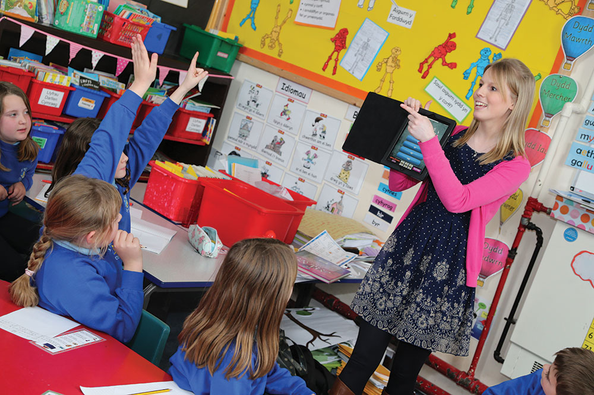

Bridging Days: Reflections

POP Bridging 1: Lesson observation
How do teachers in the primary school organise and manage their classroom and pupils’ learning?
- Complete the following table noting when different ways of organising pupils in the classroom occur and from your observations of the role of the teacher and pupils’ engagement in the lesson and activities. Suggest advantages and disadvantages of each type of organisation.

Organisation | When used | Advantages | Disadvantages
Whole-class work
Group work
Individual work

- Draw up a timetable of a ‘typical’ day for the class you are working with:

- Relationships, Rules and Routines

- What techniques does the teacher use to gain pupils’ attention at the start of activities or during activities?

- What rules or routines are used to get the pupils to listen whilst the teacher is speaking?

- What conventions are expected for the asking and answering of questions? Does the strategy vary with the type of question? Why does the teacher use these strategies?

- What do you notice about the way the teacher deals with minor disruptions?

- To what extent does the teacher praise and encourage pupils?

POP Bridging 2: Lesson observation
Linking with one of the session titles from this Module (listed below), describe a learning event which has happened during your observation. Reflect upon what took place using Rolfe’s Reflective Model below:

POP Session Titles
- Introduction/ Self-esteem & Mindset
- Learning Environment
- Questioning
- Children as Learners
- Observation and assessment
- Learning theories in action
- Play/active learning
- Bilingualism
- Exploratory Talk
- Foundation Phase
- Assignment & Study Skills
- Thinking & Metacognition
- Outdoor Learning
- ALN
- Attachment Theory
- Multilingualism & Diversity

Rolfe et al (2001) – Framework for reflective practice

This is a simple model which poses the questions:
‘What? So what? And Now what?’

- What describe the situation; achievements, consequences, responses, feelings, and problems.

- So what – discuss what has been learnt; learning about self, relationships, models, attitudes, cultures, actions, thoughts, understanding, and improvements.

- Now what – identify what needs to be done in order to; improve future outcomes, and develop learning

Your reflections:

