

Effective Communication, Administrative Skills, and Collaborative Working in Healthcare: A Case Study of Mr Ahmed's Post-Stroke Care

LCHS4003
Introduction to Health and Social Care
Module Leader: Mumtaz Goolam

Student Name: Natasha Rose Ilsley
Student ID: 2506011

Date of Submission: March 27, 2026

Table of Contents

Introduction 3
Effective Communication in Mr Ahmed’s Care 3
Importance of Communication 3
Interaction with Service Users 4
Interaction with Family Members 4
Incorporating a Communication Model 4
The Importance of Good Administrative Skills in Mr Ahmed’s Care 6
Record-Keeping and Data Protection 6
Data Protection Act 2018 6
Laws and Policy Regulations 6
The Role of Technology 7
Collaborative Working in Mr Ahmed’s Care 8
Collaboration among Professionals 8
Developing Successful Teaming 8
Workplace issues in Multi-Agency Working 9
Conclusion 10
Reference 11

Introduction

Mr Ahmed is an elderly patient of 68 who has been discharged out of the hospital after a stroke. He resides with his wife in a flat on the ground floor and is given domiciliary services thrice a day to take care of him, give medication, and prepare meals. He speaks Bengali as a first language and this create difficult to communicate especially when complex English is used in conversations. A multidisciplinary team is associated with Mr Ahmed care. It consists of his GP, district nurse, speech therapist, and domiciliary care workers. In the recent past, the issue of missed visits has also been of concern and this has caused a delay in medication. This report will discuss the significance of proper communication, administrative ability and cooperation in the treatment of Mr Ahmed to have a thorough method of his healing. These spheres are key to the concerns of the issues in the care of Mr Ahmed, taking into account his health condition, language disparities, and the presence of more than one professional.

Effective Communication in Mr Ahmed’s Care

Importance of Communication
Communication is an essential aspect in the health care field particularly when dealing with people with complex needs, such as Mr Ahmed case. Communication helps to make sure that every professional is on board regarding the care plans, so there are no chances of errors or misunderstanding (Sharkiya, 2023). In the case of Mr Ahmed, it will be necessary that the medical staff may use straightforward language and direct means of communication because of his language barrier and post-stroke recovery. A breakdown in communication may result in prescription errors, appointment delays or even physical injuries and particularly among the aged with cognitive impairments. Therefore, the state of Mr Ahmed and his recovery highly depend on the quality of open and transparent communication.

Interaction with Service Users

The best way of communicating with Mr Ahmed is to make sure that it is inclusive especially by the provisions of the Equality Act 2010 (Legislation.gov.uk, 2026). The Act requires that they should not be discriminated against on basis of language barriers and reasonable adjustments should be made to make the understanding possible. In the case of Mr Ahmed, communication should be modified to consider his poor level of English language proficiency. This can be made possible by use of simple language, translation services and visual aids. The aim is to make Mr Ahmed feel empowered to make his care choices, and uphold his autonomy and dignity. Transactional model of communication refer for interaction as this model emphasises on simultaneous, dynamic process (Barnlund, 2008).
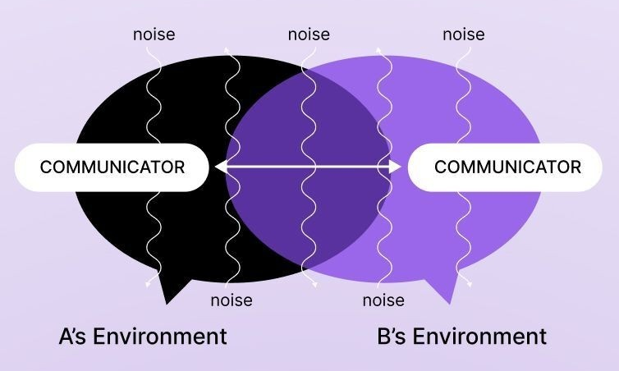
Figure 2: Transactional Models of Communication (Barnlund, 2008)

Interaction with Family Members

The role of the wife of Mr Ahmed is important since she acts as a communication channel between him and the care team. She helps in passing information and decision-making process keeping in mind that the wishes of Mr Ahmed should be considered. The open communication between the healthcare team and her, as well as making her a participant in the care discussions is imperative (‌Glasby, 2017). However, this puts in question confidentiality and consent. Healthcare workers should make sure that Mr Ahmed gave his consent of his wife to represent him but family consideration should not be at the expense of his privacy.

Incorporating a Communication Model

Shannon-Weaver Communication Model can be used to understand how information is supposed to flow in the care team (Omojuwa, 2025). A sender, on this case healthcare professional, sends a message and then it is decoded by the receiver such as Mr Ahmed or his wife. Language and health damages are just some of the barriers that might cause distortion of the message in this case. In order to cut such barriers, the message should be concise and reachable. The feedback loop can be used to confirm Mr Ahmed should be able to get the information relayed. This model emphasizes that feedback and clarity also play a significant role in ensuring that effective communication between the care team, Mr Ahmed, and his family remains effective.
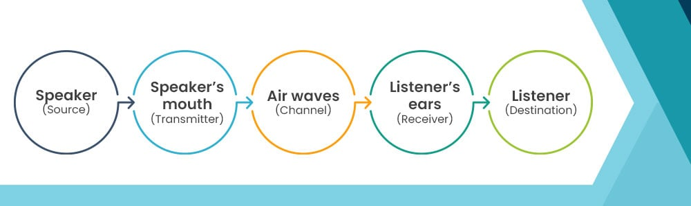
Figure 1: Shannon and Weaver Model of Communication (Omojuwa, 2025)

The Importance of Good Administrative Skills in Mr Ahmed’s Care

Record-Keeping and Data Protection

Healthcare requires accuracy in registry to assurance continuity of care and avoid mistakes (‌Glasby, 2017). The care plan of Mr Ahmed which involves medicine intake, appointments and updates on his progress should be recorded properly. This allows medical workers to monitor the treatment and make amendments where necessary. An example is that failure to take medication resulting to administrative mistakes would have terrible consequences on the recovery of Mr Ahmed. That is why the role of correct and prompt record keeping should never be underrated. It also allows staying informed and making informed decisions concerning the care of Mr Ahmed by the multidisciplinary team.

Data Protection Act 2018

Data Protection Act 2018 plays a vital role in the protection of personal information of Mr Ahmed (Legislation.gov.uk, 2018). There should be security in the storage of his medical records and only the people directly concerned with his treatment should access it. According to this law, his data must undergo lawful, fair, and transparent processing. Sharing of the information of Mr Ahmed should be done with his consent or mandated by the law, and should not go outside. For example, in exchanging records with the care team, the professionals are expected to make sure that information they exchange is transferred safely and only to authorized staff.

Laws and Policy Regulations

Besides the Data Protection Act, there are other appropriate frameworks which healthcare professionals should adhere to including the Care Quality Commission (CQC) standards (Cqc.org.uk, 2026). These standards govern record keeping so that the quality of care is always high. These standards should be observed by healthcare professionals to have proper documentation done, protocols observed as well as facilitation of care across board. Following these types of policies will make the provision of care to comply with the law, consistent, and organized.

The Role of Technology

Technology, especially electronic health records (EHRs) improve the efficiency of the administration (Evans, 2016). EHRs can decrease incidences of errors caused by handwritten notes, enhance real-time access to medical histories and enhance communication between professionals by digitizing records. The EHRs would be useful in the case of Mr Ahmed in ensuring that the GP, district nurse, and domiciliary care agency coordinate better in his case. Having only one and current record accessible to everyone in the team, the care team would be able to work more efficiently, which making sure that Mr Ahmed gets the right care in time.

Collaborative Working in Mr Ahmed’s Care

Collaboration among Professionals

The team of professionals that Mr Ahmed needs includes his GP, district nurse, domiciliary care workers, and speech and language therapist to provide him with necessary care. All these professionals come with certain expertise on board (Aveyard and Sharp, 2017). The GP keeps track of the medical status of Mr Ahmed, the district nurse takes care of wounds and BP, the domiciliary care workers help in the daily activities, and the speech therapist provides care to the swallowing and communication problems. Proper teamwork will also see that every matter concerning his recovery will not be left out thus increasing the chances of his recovery.

Developing Successful Teaming

In order to enhance a good working team, team meetings should be a routine (Aveyard and Sharp, 2017). During these meetings, all care team members will be able to discuss the progress of Mr Ahmed, exchange their observations and review care plans. There should be clear roles and responsibilities so that there is no misunderstanding and so that every professional can make their contributions to the process of care. In the case of Mr Ahmed, his preferences will be taken into consideration and respected despite the fact that he might have limited communication. The readiness to cooperate with the professionals and pursue a shared agenda would be also important to effective collaboration, and a joint dedication to the well-being of Mr Ahmed. In this case SBAR communication tool can standardise and improve the quality of handovers and referrals and able to ensure critical information is conveyed clearly and concisely (Griffith and Tengnah,2020).
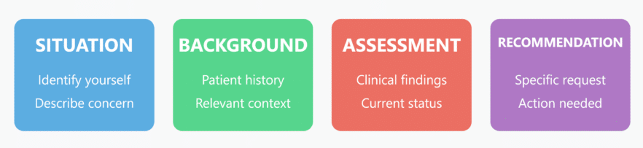
Figure 3: SBAR Communication tool nursing practice (Griffith and Tengnah,2020)

Workplace issues in Multi-Agency Working

Miscommunication, different priorities, or role uncertainty can be among the challenges that can be encountered by multi-agency working (Aveyard and Sharp, 2017). In fact, lack of knowledge to the domiciliary care agency of any changes in the treatment plan of Mr Ahmed, may lead to a missed care. In order to eliminate these difficulties, regular meetings are to be conducted and care plans should be presented and updated on a real-time basis. To overcome these challenges, it is possible to develop specific guidelines on the sharing of information and to make every team member understand their role. Through the emphasis on coordination and open communication, the team will be able to collaborate better, which will result in Mr Ahmed being properly taken care of.

Conclusion

In conclusion, efficient communication, management, and teamwork are essential factors in the delivery of quality care to Mr Ahmed. Clear communication especially under the influence of his language barrier is a way of ensuring the team members are all in line and Mr Ahmed is aware of his treatment plan. Proper record keeping and compliance with data protection laws are also good administrative skills that will make sure his medical history is properly written and shared safely. Lastly, the multidisciplinary team has to work together to ensure that every aspect of Mr Ahmed care is handled in an efficient manner. In the future, healthcare providers should focus on these aspects in order to enhance the coordination of care, eliminate mistakes, and increase patient outcomes. Through communication, administration, and collaboration, care teams will be able to offer improved and coordinated care to patients such as Mr Ahmed, eventually enhancing their life quality and recovery.

Reference
Aveyard, H. and Sharp, P., (2017). EBOOK: A Beginners Guide to Evidence Based Practice in Health and Social Care. McGraw-Hill Education (UK).
Barnlund, D.C. (2008) 'A transactional model of communication', in C.D. Mortensen (ed.) Communication Theory. 2nd edn. New Brunswick: Transaction Publishers, pp. 47-57.
Cqc.org.uk. (2026). The fundamental standards of care - Care Quality Commission. [online] Available at: https://www.cqc.org.uk/about-us/fundamental-standards [Accessed 9 Mar. 2026].
Evans, R.S. (2016). Electronic Health Records: Then, Now, and in the Future. Yearbook of Medical Informatics, [online] 25(S 01), pp.S48–S61. doi:https://doi.org/10.15265/iys-2016-s006.
‌Glasby, J., (2017). Understanding health and social care. Policy Press.
Griffith, R. and Tengnah, C. (2020) Law and Professional Issues in Nursing. 5th edn. London: SAGE Publications.
Legislation.gov.uk. (2018). Data Protection Act 2018. [online] Available at: https://www.legislation.gov.uk/ukpga/2018/12/contents [Accessed 9 Mar. 2026].
Legislation.gov.uk. (2026). Equality Act 2010. [online] Available at: https://www.legislation.gov.uk/ukpga/2010/15/contents [Accessed 9 Mar. 2026].
Omojuwa, B.A., (2025). Exploring the Communication Process Model. Mount Saint Vincent University.
Sharkiya, S.H. (2023). Quality communication can improve patient-centred health outcomes among older patients: A rapid review. BMC Health Services Research, [online] 23(1), pp.1–14. doi:https://doi.org/10.1186/s12913-023-09869-8.

‌

