University of Wales Trinity Saint David
Design for X Project
Thomas Rosser
2214462
Apprenticeship in Mechanical and Manufacturing Engineering (BEng)
3rd of July 2023
Manufacturing Design & Technology



Contents
Executive summary 2
Additive manufacturing 3
Component choice and background 3
Process of generative design 6
Draw original design. 6
Set Geometry 6
Material selection 7
Generative design and Render 8
FEA 9
Additive manufacturing method 10
Summary 11
Concept design appraisal 12
Product life cycle 12
QFD 12
Product design specification 13
Manufacturing Process Proposal 15
Assembly line production 15
Design and development work undertaken. 17
SCAMPER 17
FMEA 18
Product/process redesign 19
Assembly of the wind turbine tail 20
Summary 21
References 22

Executive summary
This report consists of two Tasks. Task one is looking into a component called a linear aperture which is used in a laser ablation process. This component filters the laser to ensure it is the correct size to meet the product specification. The issue with the component is that it is out of date in terms of technology as it’s still the original trail part from 2013, being out of date causes it to promote cumulative error reducing the accuracy of the products made. Using generative design, a new aperture was designed using titanium which is then ready to be additive manufactured using a powder bed fusion technique. With this new design and manufacturing technique, finite element analysis was undertaken to ensure the component had sufficient properties for the task its allocated to do.
Task two is a project to which a product – portable wind turbine – has already been designed and started prototyping. However before entering mass production the task it to make the propduct and the production of the product better. This was done by using multiple design for X tools such as SCAMPER, a QFD and FMEA. With these tools the failures In the parts where highlighted, these were assembly of the blades, there was no way of the customer assembling the blades in the correct orientation. As well as the assembly of the tail, the tail way found to have too many components so it was redesigned to reduce this significantly.
Task 1

Additive manufacturing
Additive manufacturing uses computer-aided design (CAD) or 3D object scanners to create objects with precise geometric shapes. These are built layer by layer, like a 3D printing process, as opposed to traditional manufacturing, which frequently requires machining or other techniques to remove excess material (TWI, 2019). To gain the most from additive manufacturing it is essential that a complex design is used. Due to the time and cost associated with additive manufacturing it can be a waste of money/energy if a simple shape that can be made manually or with a CNC machine is made.
To make these complex shapes a software can be used, this software is generative design. Generative design is a design exploration process. The design goals, as well as parameters like performance or spatial requirements, materials, manufacturing processes and cost constraints are entered into the software. The software then quickly generates design alternatives by investigating every variation of a potential solution. With each iteration, it tests new ideas and determines what works and what doesn't (Autodesk, 2018). Using this generative design software, a component will be redesigned for the production using an additive manufacturing process.

Component choice and background
The component that has been chosen to be resigned using the fusion 360 generative design software is the linear aperture. This component is found within an ablation process that produces scale.

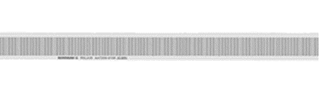
Scale is high accuracy (±5 μm/m), stainless steel track of ablated lines with pitches ranging from 20µm to 40 µm. There are two types of ablation. Incremental which is as displayed like a ruler; one, two, three etc and requires reference marks for locating (Top of figure 1). Absolute which takes a form of a barcode and the code along the scale is given a numerical value, not needing reference (bottom of figure 1).
  - Figure 1 – Scale Types

The ablation process consists of a class 4 laser being focused to a line and hit into a piece of stainless-steel spar to create a length of scale. The point at which the laser hits the scale is moved across a bed of granite using a carriage that is floating on a bed of air using air airings and is pulled by a motor.
To create the ideal line length to fit evenly onto the piece of spar, the focused laser is filtered through what is called an aperture (Figure 2). This is a part that is bolted onto the carriage with an air hose connected to it, this air hose in a vacuum that sucks away the degree caused by the ablation process.
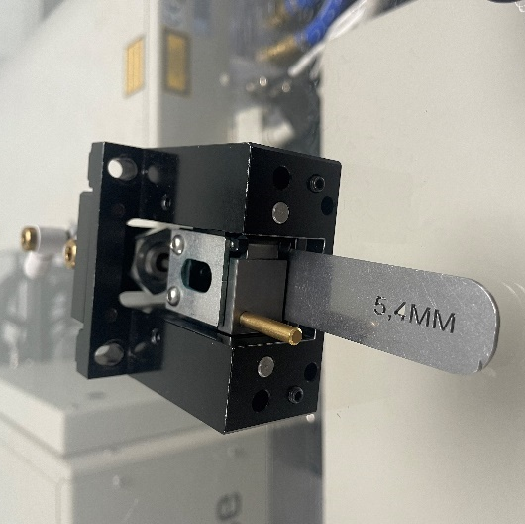
  - Figure 2 – Linear aperture
The current aperture fitted, is the original version that was put in place when the laser ablation process was going through its trail phases in 2013. Since then, many things on the carriage and the overall process have been improved to make more accurate scale and reduce the production of scrap. However, the aperture has been overlooked. Due to the aperture being the original prototype it is a rough design with multiple parts bolted together, this opens a chance to improve it.
As the carriage is being moved on a pocket of air using the air bearings, the heavier the carriage, the more air is needed to lift the carriage. The more air being supplied into the carriage creates more vibrations through the carriage. These vibrations have a negative impact on the production of the scale, the vibrations can be isolated as noise.
To measure the noise a speed logger test is run. A speed logger test is where the carriage is moved up the granite bed, its constant speed is then plotted against the distance of the granite in a graph. In a perfect world the line in the graph would be a constant flat line from 0 to 3.6m. However with variables such as temperature, contaminates and maintenance of the process, this is not the case.
The line of the graph will be a base of the accuracy of the scale produced and the more inconsistencies in the speed the more error is accumulated when its being ablated. The noise of the line will also be directly related to the accuracy of the scale, causing a noisy plot that can affect overall accuracy. Figure 2 shows a quiet graph that is likely to produce good scale. Figure 3 shows a noisy sporadic graph that is likely to produce scrap scale.
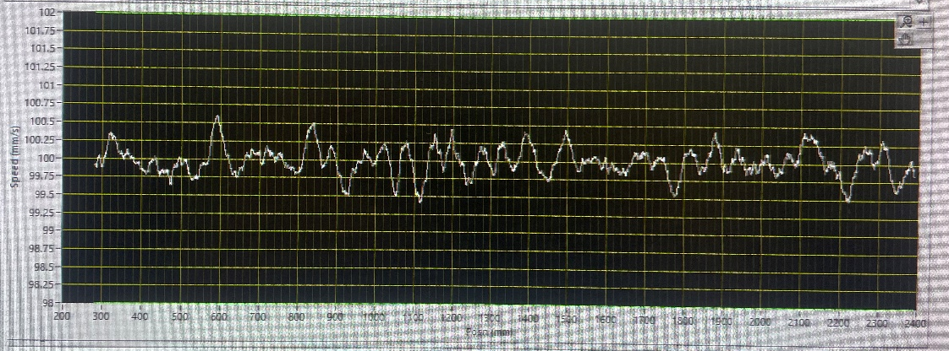
  - Figure 3 – Quiet plot
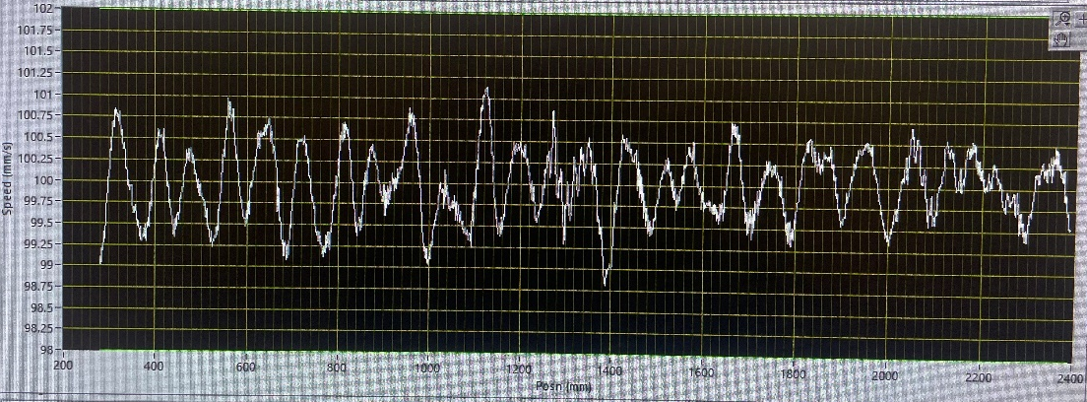
  - Figure 4 – Noisy plot
When redesigning the linear aperture there are 3 factors that can be improved to reduce the error in the accuracy and the noise within the speed-logger graph:
- Reducing the overall weight of the part so the air pressure going to the air bearings can be turned down. This will cause less vibration through the carriage which will reduce the noise on the speed logger graph.
- The addition of a more efficient extraction method. The extraction is put in place to remove any debris caused by the ablation process to avoid the particles effecting the accuracy of the part being made. The current method of extracting is inefficient due to it only being from one side, meaning that the debris being created on the furthest side away from extraction may not be caught, or to catch it the extraction needs to be increased which has the same effect to the noise as the previous statement.
- Elimination of assembly and bolts. The current aperture is an assembly made of multiple parts all being held in place by nuts and threaded holes. These nuts must be tightened every month as a part of the maintenance for the carriage, the aperture then needs to be set back into place which is a lengthy process. If the aperture was one solid piece, it would eliminate the need for this practice.

Process of generative design

Draw original design.
Before putting a design through generative design an original model needed to be made (Figure 4). This was done by working from a photo of the linear aperture a manual measurement taken with a vernier calliper. An original drawing was not available due to the part originally being made as a trail part. The part was modelled using fusion 360.
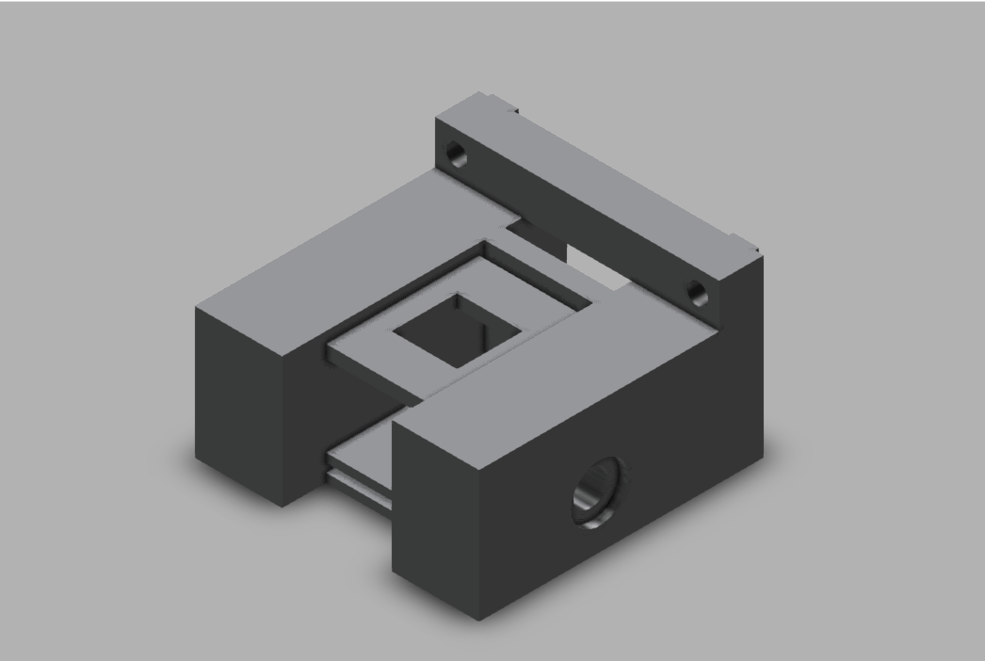
  - Figure 4 – Original aperture

Set Geometry
Once this part was created and a general understanding of the part was ascertained. A new drawing from which the generative design was made (Figure 5). The drawing for generative design requires you to assign parts, or as called in the software, geometry.
Within the design space there is a geometry type called 'preserve geometry'. It is assigned to bodies to incorporate into the final shape of the design but do not want to change. Preserved geometries are shown as green before the generative design takes place (help.autodesk.com, 2023). Within this design the preserved geometries are the extraction set and the face connecting the body to the carriage. This is because the extraction needs to be a certain side to fit the hose onto and the face that meets the carriage has a small recess to which it needs to fit onto to. However, the main preserved geometry for this design is the face to which the laser passes through. This face cannot be changed as the face is requires to be a certain size, and for health and safety reasons the face cannot be angles as it may reflect the beam towards the operator.
Also, within the design space there is an obstacle geometry. it is assigned to bodies that represent area to which needs to be avoided when generative designed. The bodies within the drawing are red (help.autodesk.com, 2023). There are 4 types of obstacle geometry in this design. The holes which you bolt the aperture onto the carriage, the obstacle is extended out so the bolt can still be accessed. Another obstacle geometry being where the extraction pipes would enter the aperture, this is in place to avoid it being built over, preventing the pipe from being able to be connected to the aperture. The same for the inside of the extraction unit, there is an obstacle geometry within the unit to prevent the design from blocking it off which would make it either less efficient or useless. The final obstacle geometry is the path the laser travels through the aperture, this cannot be designed over as the laser would not be able to follow its correct path and ablate the part properly.
The grey bodies are unassigned, this means that they are open for the generative design software to interpret into its most efficient and effective form. Gravity and structural loads have been applied to the design to gain a more realistic feature, without these the design would be sporadic and if made it would not hold up on itself.
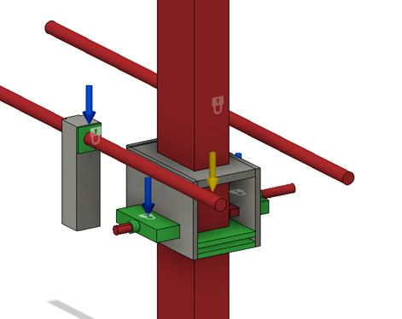
  - Figure 5 – Geometries

Material selection
Before starting the generative design, a manufacturing method and materials need to be chosen. In this case the manufacturing method is additive manufacturing. Without the selection of this option the design would be limited to operations that could only be completed with from a milling operation.
The materials chosen for the generative design were, Aluminium, Stainless-steel, Titanium and Nylon. These were chosen as they are provided by fusion and cover a wide variety of properties. There were properties however which the materials needed to be before the selection of the generative design. These were:
Due to health and safety concerns the material needs to be non-reflective, this is due to it being in contact with the laser. If the laser was to hit a reflective material, it would reflect and possibly contact someone causing a possible serious eye injury.
The material for the aperture needs to be durable. If the part is deformed or worn it could cause the lines to be ablated incorrectly such as too wide or too narrow which would cause the part to be scrap.
The part cannot have a high thermal conductivity. The aperture will be in contact with a small amount of the laser, which is being cut off, it is important that the material does not get too hot to deform or cause injury if made contact with. This will not be a high temperature so a metal will be sufficient.

Generative design and Render
Once the geometries have been set, materials selected and structural loads applied, the generative design can now be generated. Once generated the software presents you with solutions for each material choice, all varying slightly. The design which was most applicable to the application was the titanium model (Figure 6). The titanium model looked and preformed ideally for the use of the linear aperture; titanium also fits the materials specifications such as a high strength to weight ratio.
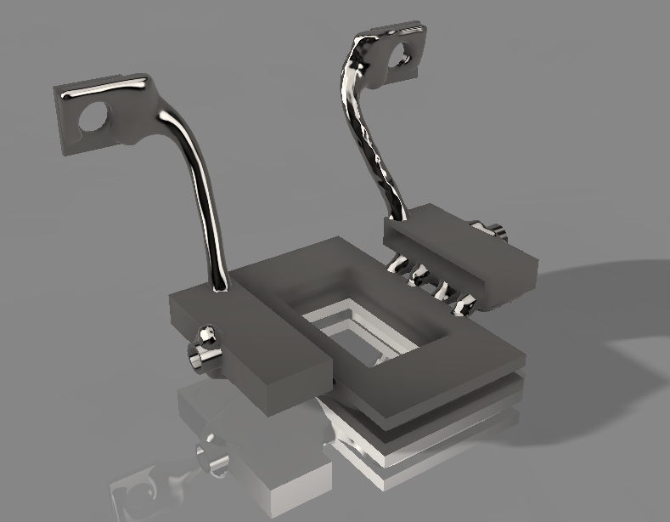
  - Figure 6 – Render of generative design

FEA
The process of simulating a part or assembly's behaviour under specific conditions so that it can be evaluated using the finite element method (FEM) is known as finite element analysis (FEA) (twi-global.com, 2019). When applying FEA to the generative designed part, the stress applied onto the part (Figure 7) and the deformation (Figure 8) can be seen. These properties both relate to how the aperture reacts under load and stress which is stated in the material specification. As shown, the part reacts the stress well and hardly deforms which would not affect production.
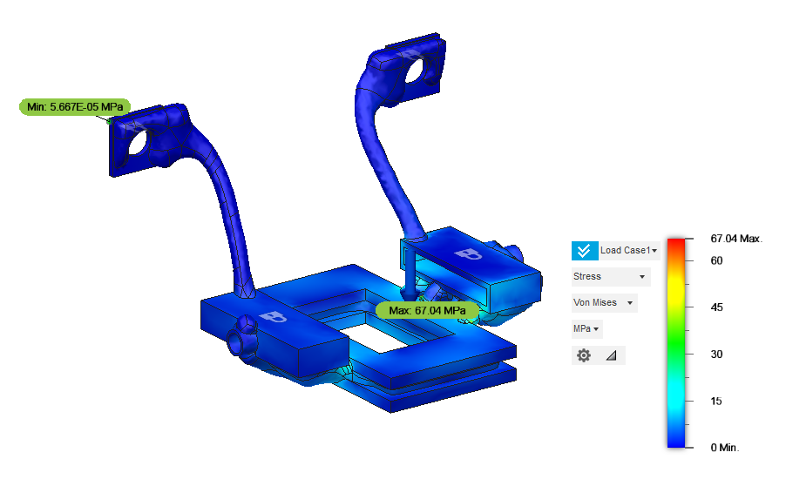
  - Figure 7 – Stress analysis
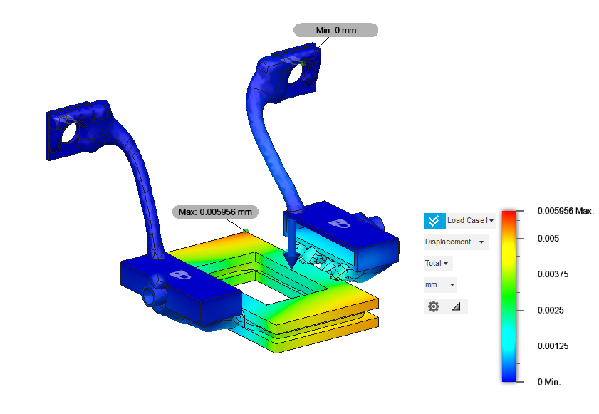
  - Figure 8 – Deformation analysis

Additive manufacturing method
Now that the product is designed and tested it need to be produced. Due to the complexity of the design, it must be done using an additive manufacturing technique, however there are multiple types to choose from. Type of additive manufacturing include:
- VAT Photopolymerization, this can also be called stereolithography which uses a vat of liquid photopolymer resin. A platform is made from this resin, layer by layer, which can be between 0.025mm and 0.5mm thick. The resin is then cured using a UV light (Applied Engineering, 2022).
- Material extrusion – This is often called 3D printers, such like the type that can be found on desktops. The material is drawn through a nozzle once heated and deposited in a continuous stream. The nozzle dispensing the material then moves along the 3 axis continuously building the product. Materials than can be used are plastics such as PLA (Gebhardt, Kessler and Thurn, 2019)
- Powder Bed fusion – During this process a layer of power is applied to the bed, then a thermal energy such as a laser or electron beam fuses the powder in place. This process is then repeated layer by layer. Materials such as metals and polymers can be used for this process (Volpp, 2019).

For the linear aperture the powder bed fusion is the best additive manufacturing process to produce the design. This is due to being able to make the part out of the designed material titanium as well as other advantages such as A Powder bed fusion additive manufacturing machine is accessible at the workplace for which the linear aperture Is part of, so there will be no initial cost of the machine or excessive cost of sending the part to a contractor. Powder bed fusion created parts with good mechanical properties such as strength, durability, and fatigue resistance. These are due to the parts having a high density and integrity due to the sintering and melting of the powdered particles. A sufficient surface will be manufactured by the process as its rough due to the layering, as if the surface was smooth and shiny it would need to be roughened as having shiny surfaces with a laser Is a health and safety concern.
With the advantages of powder bed fusion, it is the process that will be used. However, it does come with its downsides such as support structures, these are put in place to support bodies of a part that are not build on the original plane as they cannot float, with these support structures a post process would need to be put into place to remove them.

Summary
Throughout this report the development of the linear aperture has been shown. The component itself has been re designed to improve the overall accuracy of the product it is assisting to make. With the generative design software, it has expanded the vision on what the component could look like and what materials it can be made out of, this will play a key role in not only this component but many components in the future.

Task 2

Concept design appraisal

Product life cycle
A product's life cycle is the period from when it is first made available to consumers until it is discontinued. Introduction, growth, maturity, and decline are the four stages that make up a product's life cycle (Worthing and Wasson, 1971). The Portable wind turbine is currently in the prototyping phase which means it is still in the “introduction” stage of the product life cycle. The tools and designs in this report will assist the product into the taking the step into the next stage of the cycle.

QFD
QFD is an approach for gathering client needs and transforming them into goods or services. It emphasises listening to the requirements and desires of the consumers before selecting what product features or services to develop to suit their expectations (Nguyen, 2023). Figure 9 shows a QFD on the portable wind turbine.
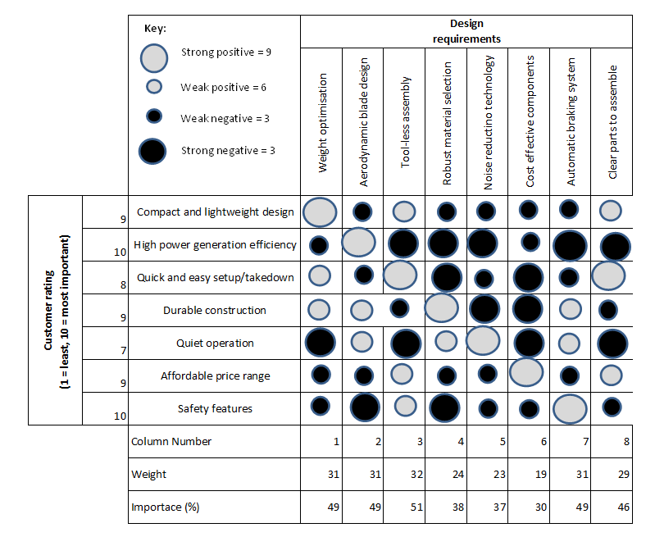
  - Figure 9 – QFD
From this QFD, a further understanding of the key attributes in which the customer is looking for in this product can be seen, such as a compact lightweight design and an affordable price range. From these the design requirements were made, rated against the customer requirements and given an importance rating. These importance ratings will be a factor when redesigning the part.

Product design specification
From using this initial tool, a design specification can then be written. A Product Design Specification (PDS) is a document that specifies a product's needs, specifications, and design criteria. It is a guide for engineers and designers to grasp the aims and limits of the product design process (devsupport, 2022)
Product Description: The portable wind turbine is a compact and lightweight device designed to generate electricity from wind energy. It is intended for outdoor use and suitable for camping, hiking, or off-grid power needs.
Design Objectives:
Portability: The wind turbine should be easily transportable and lightweight, allowing users to carry it in a backpack or small vehicle.
Efficiency: The turbine should efficiently capture wind energy and convert it into electrical power.
Durability: The design should be rugged and capable of withstanding outdoor conditions, including wind, rain, and temperature variations.
Ease of Use: The turbine should be user-friendly, with simple setup and operation procedures.
Safety: The design should incorporate safety features to prevent accidents and ensure user protection.
Technical Specifications:
Power Output: The wind turbine should have a minimum power output of X watts, providing sufficient electricity for charging small electronic devices or powering low-energy appliances.
Wind Speed Range: The turbine should be able to generate power efficiently within a wind speed range of X to Y mph.
Size and Weight: The turbine should have a compact size and lightweight design, weighing no more than Z kilograms for easy portability.
Materials: The turbine components should be made of durable and weather-resistant materials, capable of withstanding outdoor conditions.
Noise Level: The turbine should operate quietly to minimize disturbance in outdoor environments.
Functional Requirements:
Automatic Start/Stop: The turbine should have an automatic start and stop mechanism based on wind conditions.
Stability: The design should incorporate features to ensure stability and resistance against wind gusts.
Charging Capabilities: The turbine should include outlets or ports for directly charging electronic devices or storing generated electricity in batteries.
Assembly and Disassembly: The turbine should have a modular design that allows for easy assembly and disassembly without requiring complex tools.
Regulatory and Compliance Requirements:
The wind turbine should comply with relevant safety standards and certifications, such as electrical safety standards and environmental regulations.
Manufacturing and Cost Considerations:
The design should consider cost-effective manufacturing processes and materials to achieve an affordable retail price.
It should be feasible to manufacture the wind turbine in large quantities while maintaining quality and consistency.
This PDS serves as the starting point for the product design process, giving engineers and designers clear guidelines and specifications to create a portable wind turbine that complies with the required specifications.

Manufacturing Process Proposal
As stated, the market research suggested production volumes of between 1000 and 2000 units per week will be produced. Before selecting a manufacturing process for this product, it is important to grasp an understanding of the number of units needing to be produced. Below is a broken-down view of the units being produced per week assuming that production is run 24/7.
2000 units per week
286 units per day
12 units per hour
1 unit per 5 minutes
From these numbers it can be assumed that this is going to be a large operation requiring a lot of planning and labour. A production process that is most likely to be suitable for this product Is an assembly line production.

Assembly line production
Assembly lines are the most common method for mass producing products. An assembly line is an industrial method that divides the production of a product into steps that must be completed in a specific order as shown below (Banton, 2022) (Figure 10).
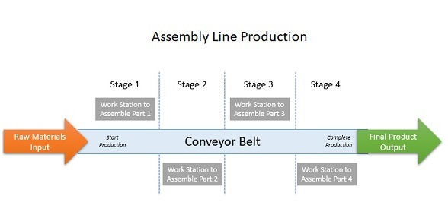
  - Figure 10 – ALP Example (Team, 2022)
This production method may be attractive to the stakeholders as it may relate to their business/cost needs. Business needs can be defined as the fundamental requirements that a company must meet in order to achieve its goals and maintain its operations.
Assembly lines' efficiency and speed result in significant cost savings because more units can be produced at a lower cost per unit. Manufacturers can use this advantage in their pricing strategies to increase profit margins and, as a result, revenue (Lacoma, 2012)
Assembly lines enable quick and easy product assembly at all stages of production. An assembly line does not require any complex stages to function; instead, components are fitted together in simple stages to create a finished product. This means that the work can be done with little training, lowering the overall cost of skilled labour and the overall complexity of production (Toby, 2017).
With shareholders being interested in research and development. Assembly lines are a leap in the right direction. Assembly lines promote technological advancement and the development of new manufacturing methods. Through time this has resulted in advancements such as automation and robotics, which further increase efficiency. (Boyce, 2023)
Due to the consistency of a production line, there is less variation/error in the assembly of the product resulting in less faulty final products. With a reduction of these faulty products, it gives the company name a better reputation and promotes an environmentally friendly work ethic which can be translated throughout the factory into more daily tasks.

Design and development work undertaken.
Now that the product has been assigned its specifications from the PDS and its production method, it can be redesigned and/or improved to become more efficient and a all-round better product. Re-design opportunities for the production and costumer use of this product will be highlighted using tools such as SCAMPER and a FMEA.

SCAMPER
SCAMPER is a technique for generating new ideas and improving existing processes or products. Substitute, combine, adapt, modify/magnify, put to other uses, eliminate, and reverse/rearrange are the prompts for considering potential improvements represented by each letter in SCAMPER (MTCT, 2023). Substitute, combine, adapt, modify/magnify, put to other uses, eliminate, and reverse/rearrange. Using scamper, improvements will be recommended towards the production of the portable wind turbine (Figure 11).
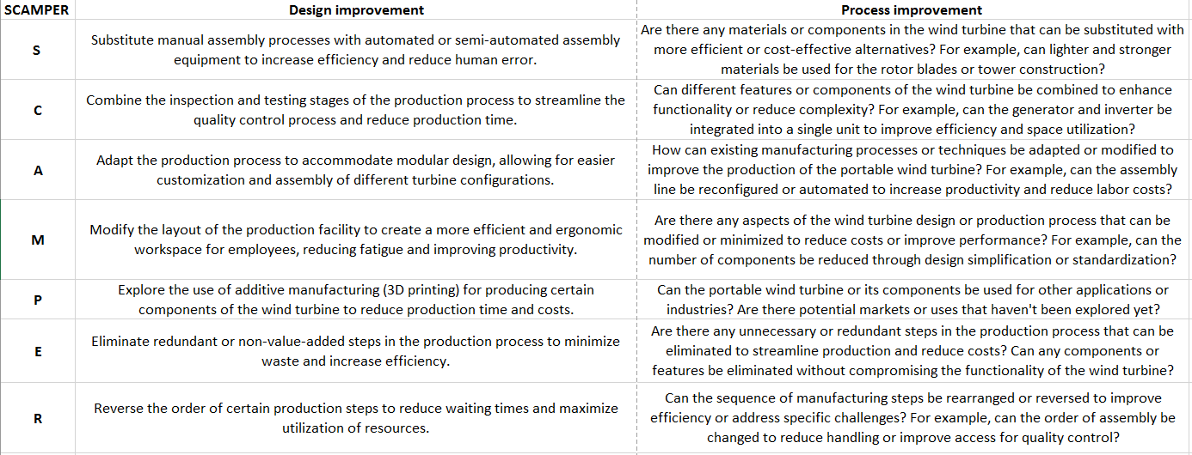
  - Figure 11 – SCAMPER

FMEA
Failure Mode and Effects Analysis (FMEA) is a proactive method of identifying potential failures in business processes to prevent them from occurring or to mitigate their impact by establishing where they may occur and the impact they may have. The systematic approach of FMEA to identifying and addressing failure causes can help to prevent costly manufacturing issues, improve product quality and service reliability, and boost customer satisfaction (Stamatis, 2003). An FMEA on the key components of the wind turbine can be seen in figure 11.
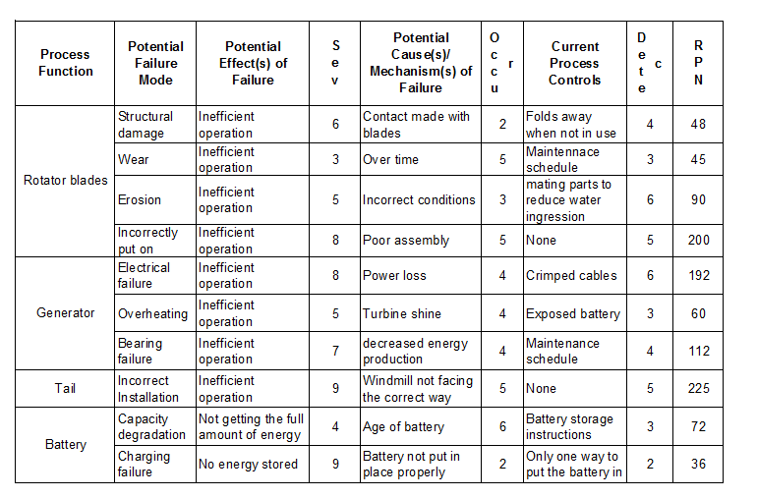
  - Figure 11 – FMEA

From this FMEA there are two apparent failure modes with the highest Risk-Priority-Number. These are the Rotator blades being incorrectly put on the wrong way and the tail being installed incorrectly.

Product/process redesign
Two of the issues that are related to many points within the SCAMPER and the FMEA was the assembly of the part and the design containing too many screws and separate parts. Both these issues can relate to customer dissatisfaction either directly or indirectly. Due to this, the redesigns will be based upon the principle of making the part easier to assemble and with less parts to do so.
A method that will be used to achieve this goal is a method names poke-yoke. Poka-yoke is a Japanese term that means "mistake-proofing," it refers to any tool or mechanism that prevents a person from performing an action incorrectly (Cyger, 2018). As another benefit, poke-yoke is also a main leader in reducing waste as there are less incorrectly assembled parts being scrapped. This would reflect positively on the stakeholders as it contributes to towards the business needs of reducing waste, cost and environmental impact.
The first design that was changed to implement a poke-yoke system was the blades. The blades are used to contact the wind, rotating the main body, hence generating electricity. These blades are designed in a way so they are more efficient in a certain orientation. However, there is no way stopping the operator or customer from assembling the blades in the wrong orientation, if this was to happen it is likely that the wind turbine would not work, or hardly work.
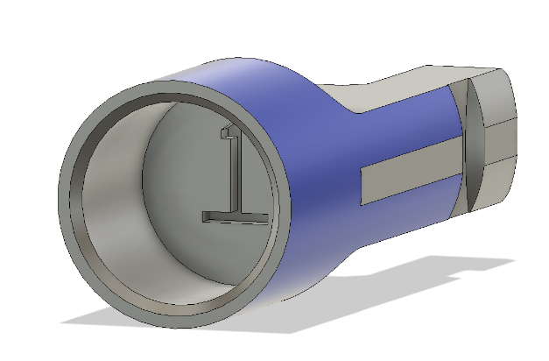
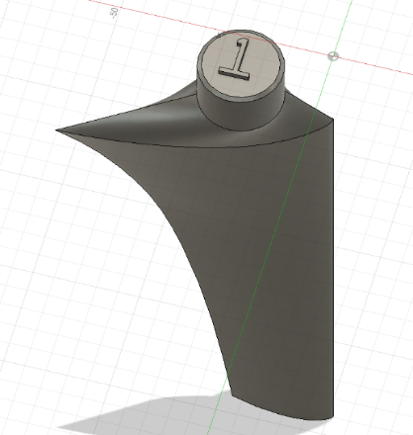
To avoid this error from occurring, each blade and socket are allocated with a number one to four. These numbers are extruded onto the mating face of the blade and cut into the mating face of the socket (Figure 12). This means that only the correct blade can be put in the correct socket in the correct orientation.
  - Figure 12 – Extrusion and cut of numbers.

Assembly of the wind turbine tail
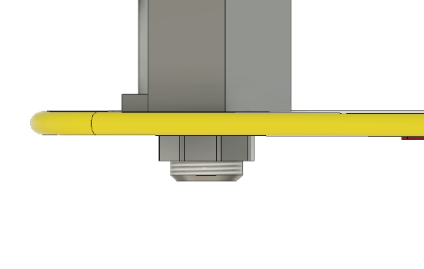
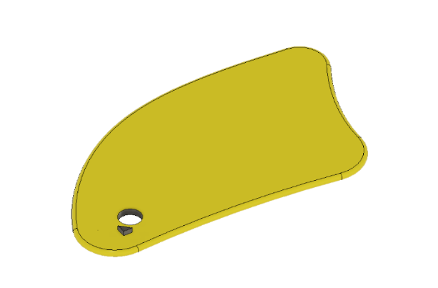
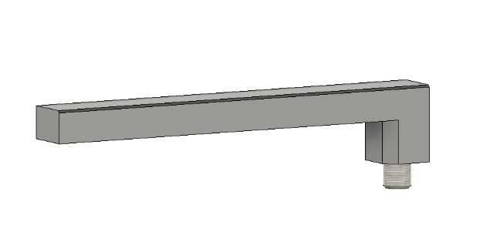
The assembly of adding the tail onto the wind turbine currently has a combination of 9 parts. consisting of bolts and fittings. With this redesign the tail will only consist of 3 parts. 1 of which being the main shaft than joins the tail to the main body. The thread on the main shaft had a chamfer on the start of it to reduce the risk of stripping a thread. The second being the tail itself. And the third being the threaded screw that holds the tail onto the shaft connecting it to the main body. The new way of fascinating the tail on the shaft concludes of tightening the screw onto the thread connecting to the thread, the tail can only be put on in the correct orientation as the tail now consists of an extruded triangular shape which fits into the shaft (Figure 13). This is also replicated at the other end of the shaft which meets the main body. These were implemented due to the importance of the tail being in the correct position. This assembly also reduces the need for hand tools which was highlighted in the QFD.
  - Figure 13 – Tail assembly

These two designs are prevention-based poke-yoke systems to stop the error from occurring. There is another poke-yoke system and that is detection based, this is where if the error occurs it is spotted so it can be rectified. An example of this, and one that can be implemented in the production line of the portable wind turbine is a go-no go Keyence camera system. This is a camera that is placed above the workstation and when the assembly Is complete the camera will scan the part, if the part is what is expected it will let the operator carry on, if not it will prevent the operator from proceeding (Figure14). Depending on the equipment it may state the error that it has found allowing the operator to correct its mistake. By implementing a system like this it further reduces the scrap being produced and the faulty products being send out to customer, this has both a positive impact on the environment and the profits that the company makes.
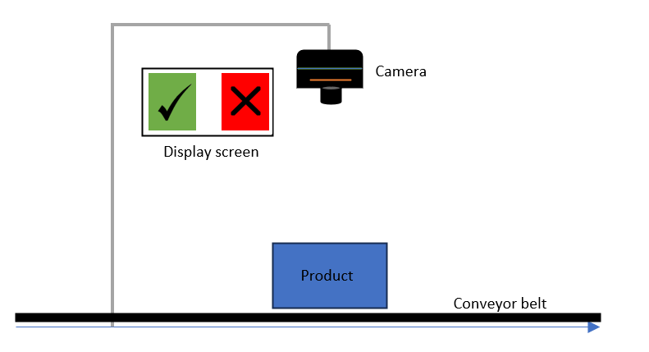
  - Figure 14 – Detection poke-yoke system

Summary
Throughout this task a range of tool have been used to understand the product further and the customers requirements of the product. Using these tools such as the QFD and FMEA, weaknesses within the design could be highlighted such as the complication of the assembly. Using this information, redesigns of the product were introduced to ensure these weaknesses were reduced to increase customer satisfaction. With these changes in place the RPN will be reduced.
A manufacture process for the large numbers of units was also suggested, this was an assembly line production, which could give more consistence and efficiency to the product whilst keeping the stakeholders happy with the increase of profits. This report has shown how important the prototyping phase Is of a product and how the product life cycle is not something to be looked over.

References
Applied Engineering. (2022). 7 Types of Additive Manufacturing. [online] Available at: https://www.appliedengineering.com/blog/2021/1/22/7-types-of-additive-manufacturing [Accessed 1 Jul. 2023].
Autodesk (2018). What is Generative Design | Tools & Software | Autodesk. [online] Autodesk.com. Available at: https://www.autodesk.com/solutions/generative-design [Accessed 2 Jul. 2023].
Banton, C. (2022). Assembly Line. [online] Investopedia. Available at: https://www.investopedia.com/terms/a/assembly-line.asp-0 [Accessed 1 Jul. 2023].
Boyce, P. (2023). Assembly Line: Definition, Pros, Cons & Examples. [online] BoyceWire. Available at: https://boycewire.com/assembly-line/ [Accessed 1 Jul. 2023].
Cyger (2018). Poka-Yoke Definition. [online] iSixSigma. Available at: https://www.isixsigma.com/dictionary/poka-yoke/.
devsupport (2022). What is a product design specification (PDS)? [online] Technical Foam Services. Available at: https://technicalfoamservices.co.uk/blog/what-is-a-product-design-specification-pds/ [Accessed 1 Jul. 2023].
Fransico , E. (2023). FMEA: Definition, Steps, Types, & Tools. [online] SafetyCulture. Available at: https://safetyculture.com/topics/fmea/ [Accessed 2 Jul. 2023].
Gebhardt, A., Kessler, J. and Thurn, L. (2019). 3D printing : understanding additive manufacturing. Munich, Germany ; Cincinnati, Ohio: Hanser Publishers.
help.autodesk.com. (2023). Fusion 360 Help. [online] Available at: https://help.autodesk.com/view/fusion360/ENU/?guid=GD-PRESERVE-GEOM.
Lacoma, T. (2012). Pros & Cons of Manufacturing Products With Assembly Lines. [online] Chron.com. Available at: https://smallbusiness.chron.com/pros-cons-manufacturing-products-assembly-lines-40809.html [Accessed 1 Jul. 2023].
MTCT (2023). MindTools | Home. [online] www.mindtools.com. Available at: https://www.mindtools.com/ao2rt8j/scamper [Accessed 2 Jul. 2023].
Nguyen, S. (2023). What is quality function deployment (QFD)? Phases, example. [online] LogRocket Blog. Available at: https://blog.logrocket.com/product-management/quality-function-deployment-qfd-example-phases/ [Accessed 1 Jul. 2023].
Stamatis, D.H. (2003). Failure mode and effect analysis : FMEA from theory to execution. Milwaukee, Wisc.: Asq Quality Press.
Team, M.S. (2022). Assembly Line Meaning, Importance, Types, Process & Example. [online] MBA Skool. Available at: https://www.mbaskool.com/business-concepts/operations-logistics-supply-chain-terms/18081-assembly-line.html [Accessed 1 Jul. 2023].
Toby (2017). The Advantages Of Assembly Line Production | Embedded Engineering. [online] EMBEDDED ENGINEERING . Available at: http://www.embedded-engineers.co.uk/the-advantages-of-assembly-line-production/ [Accessed 1 Jul. 2023].
TWI (2019). What is Additive Manufacturing? - Definition and Processes. [online] Twi-global.com. Available at: https://www.twi-global.com/technical-knowledge/faqs/what-is-additive-manufacturing [Accessed 2 Jul. 2023].
TWI (2021). What Is a Product Life Cycle? (Definition, Stages and Examples). [online] www.twi-global.com. Available at: https://www.twi-global.com/technical-knowledge/faqs/what-is-a-product-life-cycle [Accessed 2 Jul. 2023].
twi-global.com. (2019). What is Finite Element Analysis (FEA)? [online] Available at: https://www.twi-global.com/technical-knowledge/faqs/finite-element-analysis [Accessed 1 Jul. 2023].
Volpp, J. (2019). Powder particle movement during Powder Bed Fusion. Procedia Manufacturing, 36, pp.26–32. doi:https://doi.org/10.1016/j.promfg.2019.08.005.
Worthing, P.M. and Wasson, C.R. (1971). Product Management: Product Life Cycles and Competitive Marketing Strategy. Journal of Marketing, 35(4), p.110. doi:https://doi.org/10.2307/1250474.

