Construction Materials

Module: ACBA4016
Assignment 1
Lecturer: Alan Nantel
Student: Rhys Cosker 2513065

Contents
Introduction 2
Elements and method of construction 3
Analysis of the framing materials 4
The framing materials strength, durability and climatic resistance, given the environmental conditions 4
Time, Labour, Programme and Cost when compared to steel framing 5
The frames ease of assembly and the potential ease of its adaptation to different building shape and building use, within the life cycle of the building. 5
The problems faced by the integration of services provision, and how these problems are overcome. 6
The specific challenges faced at the point of the building’s potential demolition, at end of life. 6
Negative impact of the concrete production process, in terms of community and the environment. 7
Sieve Analysis 8
Aggregate percentage 8
Particle size distribution line graph 9
Particle size distribution and suitability for use as an aggregate 9
References 10

Introduction
This assignment will report on the elements and methods of construction and provide an analysis of framing materials of the Burj Khalifa, including the use of references and figures. In addition, the negative impact of concrete production will be evaluated in terms of the community and environment. Finally, a sieve analysis will be undertaken and will include the percentage of fine and coarse aggregates along with a particle size distribution line graph. Furthermore, this graph will be analysed and a conclusion will be produced on whether the particle size distribution is suitable for utilisation in applications.

Elements and method of construction
Following research into concrete framed structures, the Burj Khalifa was selected for the case study due to its innovative structural design and advanced construction techniques.
This skyscraper sits at 828 meters tall, with around 330,000 m3 of concrete and 39,000 tonnes of steel reinforcement used during construction. Lueste, unknown date
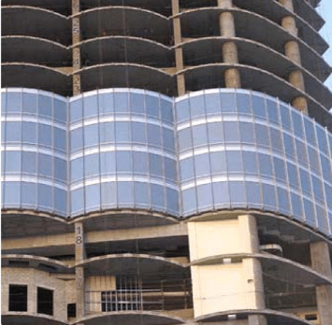
The method of construction involved a buttressed core system, where the central concrete core incorporates a hexagon shape supported by three wings. Designed by Adrian Smith, this building incorporates a Y-shaped floor plan, inspired by the spider lily desert flower. This is observed from where the building increases in height, in resemblance to the flower’s petals, re-configuring the shape of the building until it reaches a more slender appearance at the top, from the surface area decreasing rising up. The utilisation of this design reduces the wind and other elements impact on the Burj Khalifa Institution of Civil Engineers, unknown date
The tower utilises a lateral load resisting system, constructed with reinforced concrete ductile core walls connected to the exterior reinforced concrete columns. The main materials used were concrete, glass and stainless-steel Go Construct, unknown date
This tower is designed to comprise a curtain wall system made of reflective glazing as well as aluminium and textured stainless-steel panels to produce a modern aesthetic tower.
Figure one
Figure one showcases the external cladding system
Regarding the substructure, the foundation system involves a 3.7-meter-thick concrete raft supported by 194 bored cast-in-place piles, with an extension of 43m deep.
Concrete was set in-situ with a high-performance concrete pumping system. The core and walls used a hydraulically operated, self-climbing formwork that resulted in fast and repetitive pouring. 2 Brothers Concrete & Pumping, 2026
Furthermore, the construction involved a vertical sequencing method, meaning the central core was constructed ahead of the floor plates using the self-climbing formwork, allowing for quick upward construction of the building. Utilisation of tower cranes within the structure increased in height as construction progressed, allowing for efficient material handling.

Analysis of the framing materials

The framing materials strength, durability and climatic resistance, given the environmental conditions
The location of this tower is Dubai, where the soil composition is comprised of mainly coastal sand. This makes the strata extremely weak for structural foundations, especially with the amount of load capacity on the Burj Khalifa. To combat this massive defect, 194 friction piles were erected 43 meters below the surface Go Construct.
Coupled with a 3.7m thick concrete raft, with approximately 12,500m3 of concrete, the Burj Khalifa relies on friction rather than just resting on bedrock, improving the structural support of the tower alongside improving the strength and durability.
Dubai is located in a desert, where the extreme heat would mean that the concrete couldn’t be set in day and was set in the night with ice added into the mix to prevent premature cracking due to the heat of hydration Pumps & Systems
The exterior of the tower incorporates 24,000 reflective panels to minimize heat gain along with an energy-efficient cooling system installed, aiming to improve human comfort in the hot climate.
Additives were added in the concrete for extra strength and durability. It comprised of cement, fly ash and silica fume, which all aids in the concrete reaching a strength of C80-C100. In addition, retards were used such as gypsum to slow down the setting of the concrete, controlling the heat of hydration while simultaneously allowing for extreme pumping heights for the world’s tallest building. C&EN
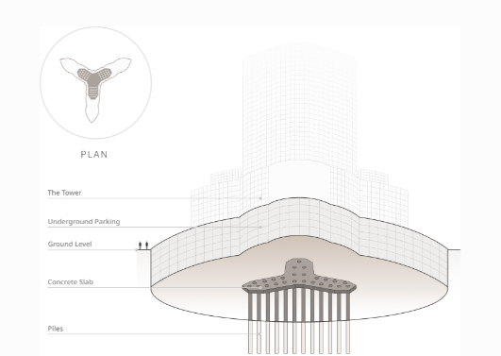Figure two
Figure two above portrays an image of the foundations for the Burj Khalifa

Time, Labour, Programme and Cost when compared to steel framing
Steel offers several performative benefits in comparison to concrete. For example, the concrete was set in-situ for this building whereas steel is prefabricated and produced off site. This reduces waste and would allow for quicker erection compared to concrete, which needs time and certain weather conditions for setting.
Steel is also able to generally withstand the harsh climate of Dubai more efficiently compared to concrete. Concrete has a higher likelihood of cracking whereas steel retains its shape for a longer timescale. This reduces the possible cost of maintenance and labour
Steel is generally lighter than a reinforced concrete frame, which would require smaller foundations, reducing labour time. Steel also requires machinery to be moved and placed instead of doing manual work that is seen with concrete.
The schedule of works can be shortened when using steel as there can be paralleled workflows as the steel is being prepared in the factory compared to concrete, where typically all other work needs to stop to allow laying and setting of concrete. This could allow for fewer labour costs and improved programme certainty Birkbeck

The frames ease of assembly and the potential ease of its adaptation to different building shape and building use, within the life cycle of the building.
The use of concrete framing especially with the utilisation of using flat slabs or beams, sometimes providing clear spans and open floor plans, results in much easier reconfiguration of internal spaces in accordance with the uses in the building Building, 2007
Concrete can be assembled in different ways, however, for the Burj Khalifa, self-consolidating concrete was utilised to allow the concrete to flow into heavily reinforced formwork under its own weight, allowing for a reduced vibration and decreasing the time of the placement process. Including the use of robust cores and shear walls, the management of lateral loads is maintained while being adaptable for different floor plans for high-rise buildings
Due to the great strength and durability of concrete framing, it allows for a great flexibility in changing internal layouts and services, which is vital for adapting the uses of the building over time. Existing concrete framing can also be retrofitted over the life cycle of the building.
Concrete can be assembled both in-situ into customised formwork to produce different shapes internally for the different uses, and precast where it is manufactured off-site for faster site assembly. However, concrete framing is generally square in shape to allow for the maximum amount of spacing.

The problems faced by the integration of services provision, and how these problems are overcome.
The Burj Khalifa’s reinforced concrete frame construction experienced a lot of challenges with integrating mechanical, electrical and plumbing services mostly due to the extreme height and the density of the reinforcement.
Controlling the gravitational forced pressures was a major problem since the water system needed to deliver around 1 million litres daily to heights around 600m. This could’ve built up massive pressures at the lower floors if not managed accordingly
To overcome the pressure and weight, mechanical zoning was used, dividing the services for different floors. MEP equipment such as electrical substations, pumps and water tanks were all fitted into their own specialised mechanical floor, allowing for a restart in the pressure systems at different height SCRIBD
Management of condensation was an additional defect with the structure, which needed to be effectively drained without weakening the structure. To counter this, a pipe system was installed to collect condensation and takes it the basement holding tank, where it is then recycled.
The concrete framing needed to withstand thermal expansion and movement in Dubai’s height and installing rigid service pipes in these conditions created a risk of joint failure. To counter this, there is a service core design, where the central core acts as a spine, where services and 57 lifts are located, protected against the tower’s external structural stresses

The specific challenges faced at the point of the building’s potential demolition, at end of life.
The location of the Burj Khalifa is within a very dense urban surrounding, coupled with the building’s extreme height and structural design, it will prove to be really difficult to dismantle the Burj Khalifa at the end of its life. Demolition workers would have to ascend to around 800m in the sky while using heavy machinery, making the process more dangerous and time-consuming.
Issues would arise due to the transport of materials and machinery through the dense urban environment, leading to an increase in traffic for vehicles. Coupled with an increase in noise pollution from the dismantling process, could possibly lead to a decrease in tourist numbers to Dubai.
The dismantling process would have to involve a top-down deconstruction. However, doing this method could run the risk of disrupting the load distribution that provides the stability. Furthermore, the lower levels are not designed to withstand the high number of excavators needed for demolition, potentially leading to other parts collapsing, not to mention the dust and debris management needed for the upper floors, which can be challenging at such heights and in the specific sandy climate.
Negative impact of the concrete production process, in terms of community and the environment.
In order to produce concrete, cement needs to be produced, which is the most carbon-intense portion of the concrete process, particularly from heating of cement kilns, releasing greenhouse gases such as carbon dioxide, which is the main contributor for global warming. Additionally, the calcination of limestone process releases large amount of CO2 from the chemical reaction.
Extraction of materials is essential for concrete production. This is conducted through removing topsoil, drilling and blasting to create quarries. This is incredibly harmful to the surrounding biodiversity, creates noise and air pollution and creates a loss of natural carbon sinks. These quarries are inevitably abandoned, leaving behind massive holes in the ground, damaging flora and fauna while also becoming visually unappealing for the community ECOS
Production of concrete releases high amounts of toxic substances into the surrounding environment, resulting in worsened air quality and causes harmful diseases to the community.
Concrete is infamous for magnifying heat in hot climates, creating the ‘heat island effect’. This can increase urban temperatures, especially in Dubai, worsening human comfort Fair Planet
Even though Dubai is surrounded by sand, it could not be utilised for the production of cement. This is due to the impurities found in the aggregates. This resulted in imports, particularly from Australia, to ensure structural stability. This resulted in the release of high CO2 numbers from transportation, negatively impacting the environment.

Sieve Analysis
Original sample size: 1250g
Figure three
Sieve Size (mm) | Mass (g) | % on sieve | % passing
125 | 0 | 0 | 100
75 | 0 | 0 | 100
63 | 0 | 0 | 100
37.5 | 120 | 9.6 | 90.4
20 | 137 | 10.96 | 79.44
10 | 143 | 11.44 | 68
6.3 | 105 | 8.4 | 59.6
3.35 | 45 | 3.6 | 56
2 | 130 | 10.4 | 45.6
1.18 | 63 | 5.04 | 40.56
0.6 | 105 | 8.4 | 32.16
0.3 | 102 | 8.16 | 24
0.212 | 109 | 8.72 | 15.28
0.15 | 98 | 7.84 | 7.44
0.063 | 55 | 4.4 | 3.04
Figure three shows the sieve analysis table

Aggregate percentage
Percentage of fine aggregates=58%
Percentage of coarse aggregates=42%
At 6.3mm the % passing is 59.6
At 3.35mm the % passing is 56
6.3-5/6.3-3.35
=1.3/2.95
=0.44
Difference in % passing =59.6-56=3.6
0.44 x 3.6=1.58
=59.6−1.58≈58.0%

Particle size distribution line graph
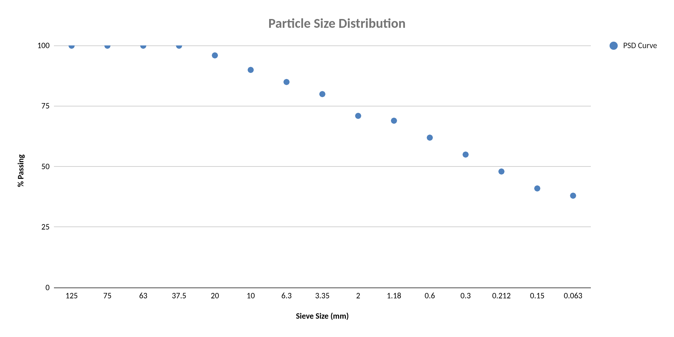Figure four
Figure 4 above is a line graph representing the particle size distribution in accordance with the sieve size (mm) and the % passing. This graph was created on Excel. The graph shows a downward trend in the percentage passing as the sieve size decreases

Particle size distribution and suitability for use as an aggregate
As shown in figure 4, the particle size distribution portrays a continuous downtrend from coarse to fine aggregates with hardly any sharp changes in the curve. As a conclusion, this shows the sample is well graded and contains a good range in the sizes of particles. Well graded aggregate is desirable because it improves strength and leads to better compaction.
However, there is a high proportion of fines, and in excess can cause an increase in water demand and may reduce workability in certain mixes.
Overall, the aggregate is suitable for use but may benefit from some adjustments such as blending with coarser materials and other modifications to improve the overall workability for specific applications

References
Institution Of Civil Engineers. (Unknown). How the Burj Khalifa was built. [Online]. ICE. Last Updated: Unknown. Available at: https://www.ice.org.uk/what-is-civil-engineering/infrastructure-projects/burj-khalifa [Accessed 10 March 2026].
Go Construct. (Unknown). Iconic construction projects Burj Khalifa. [Online]. Go Construct. Last Updated: Unknown. Available at: https://www.goconstruct.org/news-and-features/iconic-construction-projects-burj-khalifa [Accessed 10 March 2026].
2 Brothers Concrete & Pouring. (2026). Concrete Around the World: 5 Amazing Structures You Never Knew Were Made of Concrete. [Online]. 2 Brothers Concrete & Pouring. Last Updated: 23rd January 2026. Available at: https://www.2brothers.uk/news/5-amazing-structures-you-never-knew-were-made-of-concrete#:~:text=3.,e [Accessed 10 March 2026].
Lueste. (Unknown). Burj Khalifa and the use of concrete in its construction. [Online]. Lueste. Last Updated: Unknown. Available at: https://lueste.com/en/blog/concrete-guide-and-best-practices-1/burj-khalifa-and-the-use-of-concrete- [Accessed 10 March 2026].
Putzmeister. (2015). Concrete Pumps Reach Record-Breaking Heights at Burj Khalifa. [Online]. Pumps & Systems. Last Updated: 07/20/2015. Available at: https://www.pumpsandsystems.com/concrete-pumps-reach-record-breaking-heights-burj-khalifa#:~:text=Th [Accessed 10 March 2026].
Alexander H. Tullo. (2010). BASF Additives Used In The Burj Dubai. [Online]. C&EN. Last Updated: 11/01/2010. Available at: https://cen.acs.org/articles/88/i2/BASF-Additives-Used-Burj-Dubai.html#:~:text=Credit:%20BASF,and%20 [Accessed 10 March 2026].
Birkbeck. (Unknown). Why Choose Steel Over Concrete?. [Online]. Birkbeck. Last Updated: Unknown. Available at: https://www.birkbeck-structures.com/why-choose-steel-over-concrete/#:~:text=Sustainability-,Flexibil [Accessed 12 March 2026].
Francis Ryder. (2007). Economic sense. [Online]. Building. Last Updated: 23 March 2007. Available at: https://www.building.co.uk/focus/economic-sense/3083447.article#:~:text=Flexibility,of%20work%20and% [Accessed 12 March 2026].
Anon. (unknown). Burj Khalifa’s unbeatable structural design. [Online]. Burj Khalifa. Last Updated: unknown. Available at: https://www.burjkhalifa.ae/the-tower/structures/#:~:text=Home,the%20tower%20to%20the%20ground. [Accessed 12 March 2026].
AFJAL MOHSIN ANSARI. (unknown). Burj Khalifa: Design Challenges and Innovations. [Online]. SCRIBD. Last Updated: unknown. Available at: https://www.scribd.com/document/821854224/civil-BURJ-KHALIFA-report#:~:text=d)%20Structural%20System [Accessed 12 March 2026].
Gerardo Bandera. (2024). Why is concrete so damaging to the environment?. [Online]. Fair Planet. Last Updated: December 26, 2024. Available at: https://www.fairplanet.org/story/concrete-climate-change-environmental-injustice/ [Accessed 15 March 2026].
Thea Lyngseth. (2023). Quarries are temporary, but their environmental impacts are forever: How ecodesign can help. [Online]. ECOS. Last Updated: 03 October 2023. Available at: https://ecostandard.org/news_events/quarries-are-temporary-but-their-environmental-impacts-are-forev [Accessed 15 March 2026].

