Modernism and Postmodernism
Experience of an exhibition:
Visionary Art is one of the best museums to exhibit the paintings. Tourists and local people wait to see the exhibitions in this museum. We decided to organize out Art exhibition on Saturday evening in the Mission Gallery Swansea.
It is one of the best art galleries in Swansea. Tickets were sold before the event and many close friends were invited for the event. And our team members decided to name the exhibition, “Glimpse of modernism and postmodernism”.
On the day of the event many people came for the Art display of the famous artists of two different eras. Many people who appreciate the Art work and understand the deep meaning of the paintings were invited for the day and they were looking very happy.
We decided that we will open the Art gallery once everyone reached the Studio.
Art gallery we selected was very big and the interior was very attracting light and cool colors were selected for the decoration and big vases with natural flowers and chandeliers with bright lights were arranged on the hallway. All the guests gathered in the hallway where we arranged seating area for the guests to wait for others.
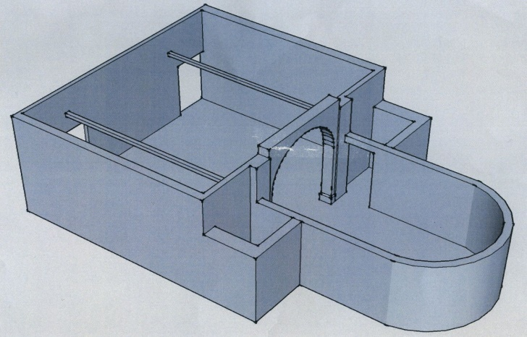
Tea was served while waiting. Waiting time was scheduled little and luckily everyone was punctual so we did not have to wait for long. Once everyone came we opened the hall where all the art work was displayed in the interesting pattern and all the visitors were greatly influenced by the arrangement.
Media was invited to cover the entire exhibition. We hired the guide who knew about all the famous Artists and their work to explain people about the theme of the paintings and purpose of the exhibition. He explained the two paintings in his way to educate people
One painting we selected was ‘The persistence of memory’ by Salvador Dali. He was a Spanish artist and the original painting is in the Museum of Modern Art in New York City since 1934. (Richman-Abdou, 2017)
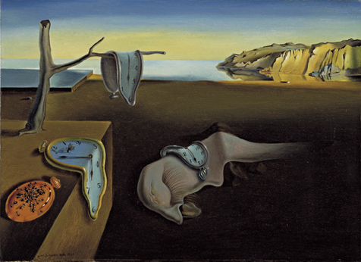
We get the painting from the museum for the day. This piece of Salvador Dali from 1931 is still considered as a great example of Postmodernism.
Postmodernism is the late 20th century time, it starts after modernism. Salvador described his painting as Hand painting and draws melting and bending clock to illustrate time we waste and importance of time but in fact time is something which can be altered at any time.
His painting shows that time is not constant all the time it can change any time the melting and the perception of time because today we think that time is constant and we do not care about the bending shows us the alteration of time at any time but this representation is not true representation of daily life.
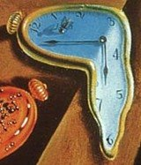
The ants and melting clock represents the hardness and softness from his perceptions. He uses the shapes and building objects and warm and cool colors adds the delicacy
He used many shapes like rectangle, triangle, circle in a very unique way.
Dali drew animal like creature which is also an example of postmodernism this figure lays in the center of the painting. His painting elements show that his memory is the reflection of postmodernism and he is greatly influenced by it.
Salvador Dali is one of the great artists of twentieth century. And just like other artists he used his surroundings and get ideas from it for the paining.
This picture shows the twentieth century people mind set when people go excited over movement, theories and other ideas.
He uses his sarcastic nature to show that people are losing their precious time and now bending and melting of clocks shows that clocks are losing their powers. We are now struggling with the time now every time we are in a great rush and we are moving so fast that we do not realize that how to use our time into something useful.
All the news channels were covering the artist lectures and people were giving interviews. There were many other paintings which were also getting attention of people. This painting was also from postmodernism era and known as Floor Burger (Giant Hamburger). We also got one other painting from a famous artist of history to differentiate the Modernism from Postmodernism. This painting was big and leaving so many questions and ideas on the viewer’s mind. Everyone was assuming the theme of the painting by their own perception. This painting was also gaining the attention of people so he started explaining the next painting
This painting was arranged on the other side of ‘The persistence of memory’ by Salvador Dali painting.
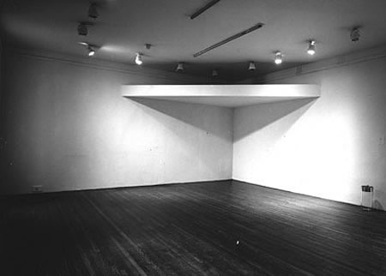
This type of wall of the gallery was selected to display both paintings. Both of the paintings were contrasting and giving the opposite meaning and describing the two different eras. And it was easy for the artist guide to explain the difference. This next painting was the symbol of ‘’Modernism’’ and as the theme of the exhibition which was, Glimpse of Modernism and Postmodernism this painting was completing the theme of the evening. Artist of the painting was busy in giving the interview so his assistant for the evening started to explain the picture and its importance.
This painting was named ‘Les Demoiselles d’Avignon’ by the artist. This painting was clearly differentiating the two eras.
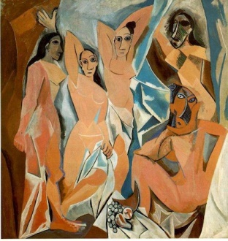

This painting of Pablo Picasso was painted in 1907 and shows the modernism of the society through his paintings. He used the geometric forms and drew women body to depict the rise of Cubism and Abstract Art. (Pablo's punks, 2017)
He uses women faces in his paintings and become the famous artist of modernism. He used African tribe women to show the changing of perceptions of ideas and society. He used female body to show the idealized expressions of female body rather than drawing the geometric shapes and showing the nature beauty in other things.
This painting took nine months to complete and shows the true efforts of Picasso. This painting represents the novelty in the paintings. This painting is also very important because it was considered as the first painting of Cubism Artwork.
In this painting Spanish Women are wearing the African masks and this picture is also showing the body image of women from the society perspective. The curves and smooth body shape was showing the rejection of traditional perspective of women (Les Demoiselles d'Avignon, 1907 by Pablo Picasso, 2018)
Conclusion:
Event ended late night and the response was more than what we expected. People told us that their knowledge about the painting, artists and different eras influencing the artist to draw the picture increased and they were happy that we arranged this exhibition. Postmodernism artist used their skills of art to educate people and tried to make influence on their lives by telling the truth of people’ nature or their behavior. They used to draw the nature on the canvas and then modernism Artists perceptions changed and they started drawing the portraits and figures showing the insights of people’s mind and their desires.
Our focused was to arrange the exhibition which can beautifully differentiate both eras of life and enhance the information and interests of people in Art. This evening was a complete success for us as organizers and for the people who were invited.

References:
Pablo's punks. (2017). Retrieved from Jonathan Jones: https://www.theguardian.com/culture/2007/jan/09/2
Les Demoiselles d'Avignon, 1907 by Pablo Picasso. (2018). Retrieved from Pablo Piccaso: https://www.pablopicasso.org/avignon.jsp
Richman-Abdou, K. (2017). Art History: Salvador Dalí’s Strange and Surreal ‘Persistence of Memory. Retrieved from My modern met: https://mymodernmet.com/the-persistence-of-memory-salvador-dali/

