
Games of positive impact – ACCA4041
Pitch Presentation

Sam lewis
2501827
BA Computer Games design

Contents
Video Presentation Link: 2
Link to Presentation: 2

Video Presentation Link: https://youtu.be/omiubNrpVQ0
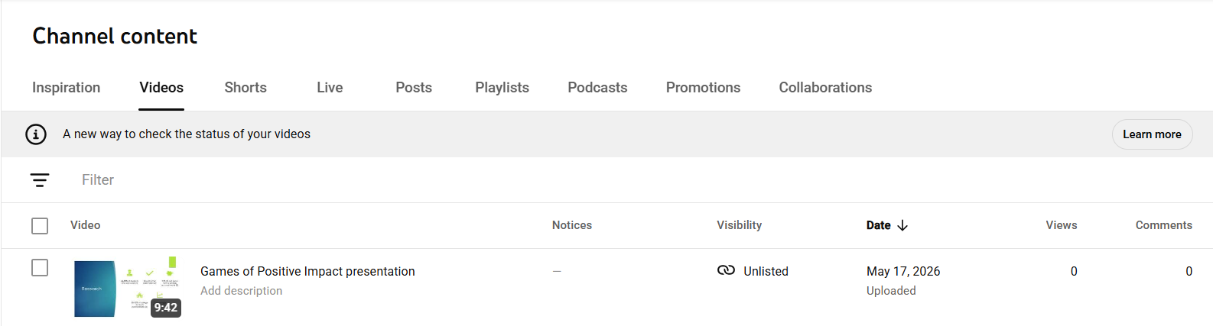

Link to Presentation:
Games of Positive Impact - GDD presentation.pptx

