Practical Test Analysis of System Requirements
(Celtic Caterers Scenario)
Christopher Hopkins (1911310)

Below are the 4 diagrams for the Celtic Caterers scenario:

Diagram 1 – Context Diagram

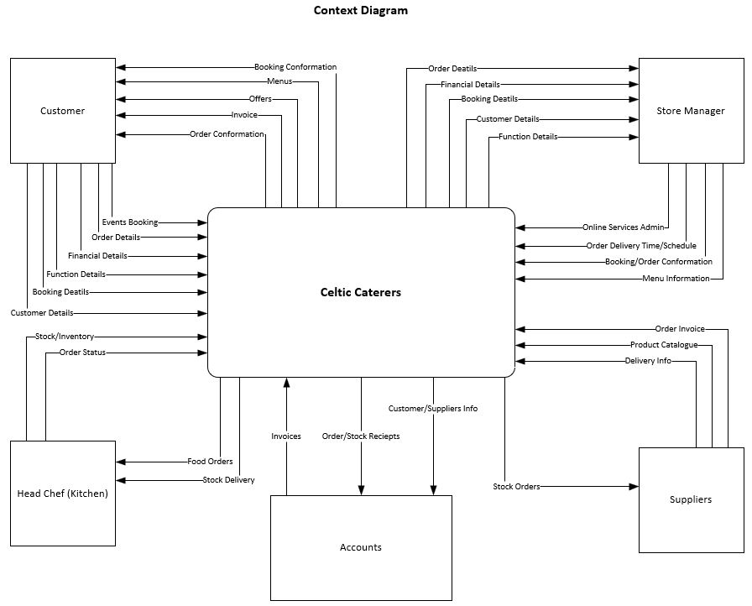

Diagram 2 – Level 0 DFD
In this diagram, the Processes, interfaces and data flows involved are covered in more detail.
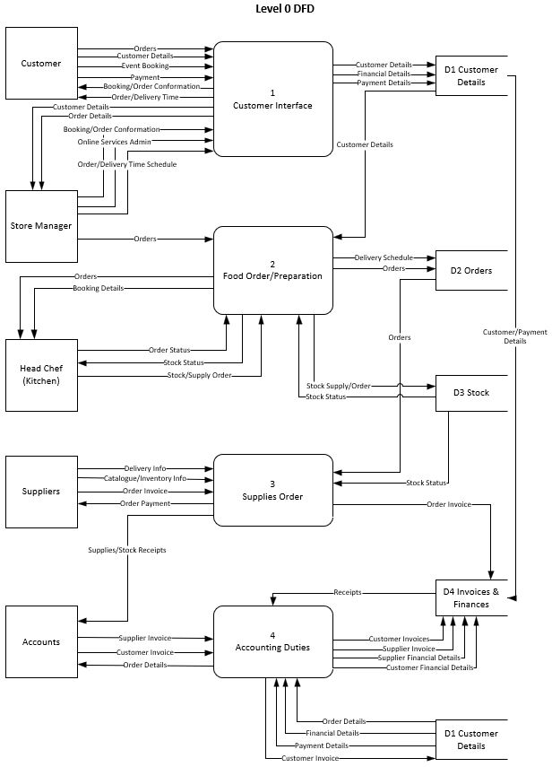

Diagram 3 – Level 1 DFD
In this diagram the processes involved in customer interface are covered in more detail, and the addition of online services to the company is expanded upon.

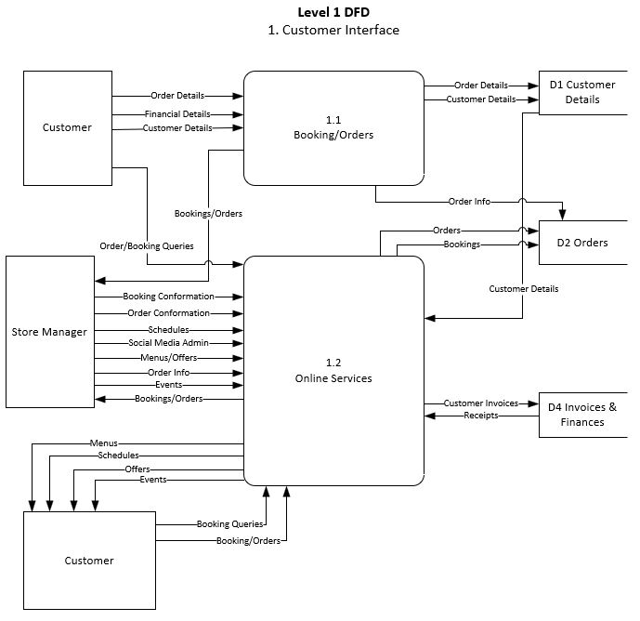

Diagram 4 – ERD
This diagram shows the relationships between the entities involved using the crow’s feet system.



