BMIH5004
Management & Organisational Behaviour
Syeda Shafna Begum
2128508
Charlotte Joyner
Table of Contents
Introduction 1
Organisation overview 1
Organisation structure, culture and goals 2
Organisational structure 2
Organisational culture 4
Organisational goals of Hyatt Hotel Group 7
Recent change initiatives and its impact 7
Strategic direction and current business performance 8
Strategic directions 8
Current business performance of Hyatt Hotel Group 9
Conclusion 10
Recommendations 10
References 11

Introduction
Nowadays, the hospitality industry faces revolutionary changes in its industry (Kinderlerer, 2022). In addition, by changing consumer behaviour and modern trends, organisations need to adopt several management and organisational behavioural approaches to maintain an environment within workplaces (Mullins, 2020). So, this report aims to shed light on several aspects of a selected organisation in terms of understanding its structure, goals, culture and business functions. For grabbing the best findings from this report, a multinational hospitality company is selected named Hyatt Hotel Group. This report will cover the organisational overviews as well as discuss its organisational structure, culture and goals. Additionally, this report will cover the current business performance of this organisation alongside its strategic direction. Some recommendations will be also presented in this presentation to provide a way for this company to make future improvements.

Organisation overview
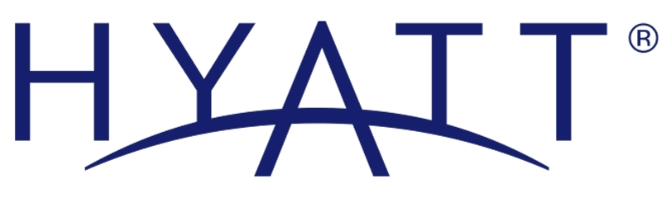
Figure 1: Logo of Hyatt Hotel Group.
Source: (Hyatt.com, 2023).
Hyatt Hotel Group is known as a multinational hospitality company and the headquarters of this company is in Chicago. In addition, this organisation is managed by the Pritzker family. This organisation was established in the year 1957 and in recent times the organization has 1350 hotels in different locations across the world (Hyatt.com, 2022). Moreover, the net income of this business was 455 million US dollars as well as total revenue was 5.89 billion US dollars in the year 2022. In this organisation, 189,000 employees are working to ensure the good operation of this business (Lawlor and Jayawardena, 2023). In recent years, this company has been dedicated to practising sustainable and responsible business by taking numerous eco-friendly initiatives.

Organisation structure, culture and goals

Organisational structure
There are so many organisation structures like flat structure, team structure, circular structure, hierarchical structure and so on that are followed by the different organisations within the hospitality industry (Armstrong, 2012). In addition, the Hyatt Hotel Group is followed by a hierarchical structure because it reflects its commitment to efficient operations and excellent customer service (Boddy, 2014).
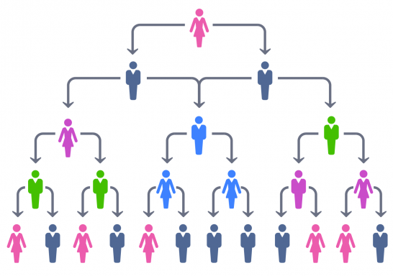
Figure 2: Hierarchical organisational structure
Source: (Kofjac, Bavec and Skraba, 2021).
As a prominent player in the hospitality industry, Hyatt Hotel Group utilises a hierarchical organisational structure that can help this organisation align with its traditional principles of management. This hierarchical structure consists of clear levels of authority as well as a well-defined command chain (Adair, 2009). In addition, at the top of the hierarchy, the chief executive officer of this company is found to oversee the entire organisation and set the strategic direction. Reporting directly to the CEO are key executives responsible for various functional areas such as finance, operations, marketing, and human resources. Moreover, this top-down approach ensures centralised decision-making and accountability (Mullins and Dossor, 2013). Furthermore, within each functional area of this organisation, there are further hierarchal levels found in this organisation. For instance, the operation department of the organisation has a regional director overseeing the specific geographic areas where the command is followed by the individual hotel manager to conduct day-to-day operations (Huczynski and Buchanan, 2013). Following this kind of organisational structure helps this organisation to enable a path for ensuring effective management and supervision control at different levels. Additionally, the hierarchical organisational structure of Hyatt Hotel Group facilitates efficiency and specialisation whereas employees of this organisation have well-defined roles and responsibilities to complete their tasks which contributes to streamlining the workflow. Moreover, clear reporting relationships aid in maintaining discipline and order which is necessary to ensure precision and service quality within the hospitality industry (Puranam and Maciejovsky, 2021). However, some drawbacks are found for the use of this kind of organisational structure where it can have the ability slow the process of decision-making due to the need for approval from several levels of this organisation. Simultaneously, it can hinder the organisational responsibility to the rapidly changing conditions of the market. In essence, Hyatt Hotel Group's hierarchical organisational structure reflects a traditional approach to management that aids in providing clarity in terms of responsibility and rules (Boddy, 2014). Although it aids in ensuring day-to-day operations, this organisation needs to improve their response structure to adapt to changing trends within the hospitality industry to ensure the success of the organisation.

Organisational culture
The below organisational culture of this organisation is discussed through the aid of a handy model of organisational culture:
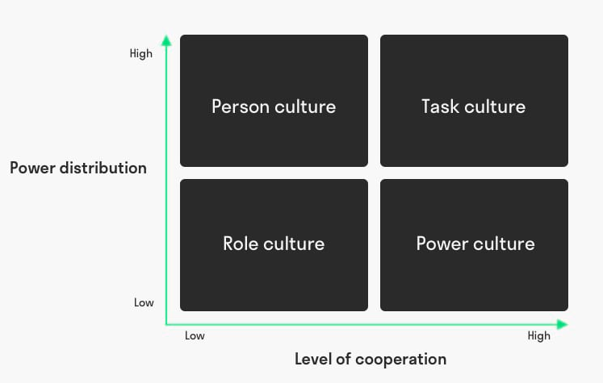
Figure 3: Handy model of organisational culture.
Source: (Holyoak, 2022).
An environment which consists of a set of values, beliefs, rules and attitudes within an organisation that influence and outline employee behaviour is known as organisational culture (Bloisi et al., 2007). To ensure the whole organisational culture, organisations must employ some strategies to ensure a well-working environment which encourages employees to do their best effort to ensure the success of the organisation as well as enhance employee satisfaction through a good culture within the working environment (Arnold, 2005). In the aspect of the Handy model of organisation culture, consists of two dimensions that introduce the level of cooperation and power distribution. In the aspect of these two dimensions, four types of culture are shown in this model which are role culture, power culture, task culture and power culture.
Role culture: This type of culture is a highly job-oriented culture which is often found in bureaucratic organisation structures (Buchanan and Huczynski, 2007). This culture is known for its strict rules, obligations, and agreements. For maintaining strict roles which do not allow flexibility often. With a clean job description, employees or managers take the responsibility to do their tasks within an organisation (Holyoak, 2022). In the aspect of this handy model, this culture of organisation introduces a low level of cooperation and a low level of power distribution.
Power culture: This kind of culture is often found in entrepreneurial organisations as well as hierarchical organisation structures. In this couture, the boss or higher authorities of the organisation have full power to make the direction to ensure success. In the asset of this culture, the boss of this organisation orders all types of directions to maintain the working flow well (Huczynski and Buchanan, 2013). In addition, high cooperation is needed in this type of organisational culture. Moreover, the culture provides high flexibility among the employees by creating good relationships. In the aspect of this handy model, this culture of organisation introduces a high level of cooperation and a low level of power distance.
Person culture: This type of culture is found in the aspect of a professional organisation where each employee has complete power. This culture is properly people-oriented. In this culture of the organisation where individuals have the knowledge and expertise to do any work which enhances the chance to meet personal satisfaction by doing their task (Mullins, 2016). In this culture, employee numbers are very low. For that reason, according to the handy model, this culture has a low level of cooperation and a high level of power distance.
Task culture: This kind of culture is found within the organisation which follows a hierarchical organisational structure by focusing on the result. In this culture, results are more important than rules (Robbins et al., 2008). In this culture, employees are given the task of completing their work in time to increase the efficiency of the organisation. For that reason, according to the handy model, this culture has a high level of cooperation and a high level of power distance.
As a prominent player in the hospitality industry, Hyatt Hotel Group follow the culture and power culture as it follows a hierarchical organisation structure in their organisation. In addition, following power culture where this culture is found among the heads of authority who provide direction to the lower employees to ensure a well-defined command chain (Mullins, 2020). By implementing this culture, the head of the authorities of this organisation can provide flexibility to the employees of the organisation to provide the best effort to ensure the best customer service. However, task culture emphasises teamwork and collaboration to achieve specific goals related to providing seamless customer services. In Hyatt, this culture is likely prevalent among project teams or departments working on specific initiatives (Rollinson et al., 2008). Cross-functional cooperation is crucial in providing seamless guest experiences and executing events. Moreover, this adaptability across Handy's cultural dimensions allows Hyatt Hotel Group to navigate the diverse challenges of the hospitality industry while maintaining a commitment to service excellence.

Organisational goals of Hyatt Hotel Group
The primary goals of the Hyatt Hotel Group encompass providing exceptional hospitality experiences by maintaining high service standards and ensuring guest satisfaction. Hyatt Hotel Group focuses on expanding its international presence while upholding a commitment to environmental sustainability to strive for global excellence in the hospitality sector (Lawlor and Jayawardena, 2023). Additionally, to ensure the organisation's long-term viability, financial growth and profitability are integral goals. By emphasising innovation, employee development, and community engagement, Hyatt aims to create memorable stays for guests by promoting a positive work environment and contributing positively to the communities (Hyatt.com, 2023).

Recent change initiatives and its impact
In recent times several changing initiatives have been found in terms of Hyatt Hotel Group. In addition, to protect the environment and ensure sustainability, this organisation has been followed to strengthen the engagement of hotels to adopt renewable electricity opportunities (Lawlor and Jayawardena, 2023). Adopting this change initiative has a great impact on the environment by reducing pollution as well as decreasing the operational cost of this organisation. According to Lucas (2023), it is found that to resolve the social issue, this organisation has provided a skill development programme that increases job opportunities for individuals in the hospitality industry. Adopting the initiative has a great impact on enhancing the brand image of this organization within the hospitality industry and creating a great path for grabbing the attention of new customers (Buhalis and Law, 2022). In addition, the organisation faces revolutionary changes in the aspect of advanced technology where Hyatt has used advanced technology to streamline the bookings or check-ins which has had a great impact on this organisation to enhance operational experiences and more seamless guest experiences (Lee, 2023). Simultaneously, by utilising advanced technology, it reduces the environmental footprint and enhances proactive brand reputation.
In the aspect of this organisation, these initiatives which were taken by this organisation were well managed by this organisation. To ensure the success of these initiatives, this organisation ensured effective management by making clear communication with their employee to understand the aspects to ensure well implementation of these initiatives to get the positive outcome from these (Lawlor and Jayawardena, 2023). To ensure the success of these initiatives, this organisation created a training programme to develop skills among employees to ensure positive outcomes from the changing natives that are taken by the organisation.

Strategic direction and current business performance

Strategic directions
To enhance the business performance of the Hyatt Hotel group, some key strategic directions are focused on by this organisation which are discussed below:
Global expansion: In recent times this organisation consists of 1350 hotels in different locations across the world. In addition, to capitalise on the opportunities for growing travel trends and garb diverse ranges of the customer, this organisation tries to expand their presence more in the key global markets (Kinderlerer, 2022).
Brand differentiation: To maintain and establish a strong brand identity, this organisation needs to differentiate their organisation from its competitors (Lucas, 2023). In addition to differentiating, this organisation can attract specific target markets and stand out in a competitive landscape.
Sustainability initiatives: Many hospitality companies are increasingly adopting sustainable practices to meet the growing demand for eco-friendly options. (Holyoak, 2022) For that reason, this organisation uses energy-efficient operations, waste reduction, and other environmentally conscious initiatives to make a strong brand reputation in the hospitality industry.
Technological integration: To adapt to the modern trend, this organisation implements digital innovations like online booking platforms, mobile apps, and contactless services that enhance the overall guest experience (Mullins and Dossor, 2013).

Current business performance of Hyatt Hotel Group
Hyatt Hotel Group has been performing well in recent times. In addition, the net income of this organisation is found in the year 2023 is 294 million US dollars which created good conditions for this organisation after facing losses in the year 2021 (Lucas, 2023). To get in-depth details of the business performance of this organisation it needs to analyse its financial performance where it is found that the overall revenue of this organisation increased by 1.3 billion in 2023 (Hyatt.com, 2023). Moreover, in the year 2023, this organisation secured a 14.97% growth rate (Shoemaker and Lewis, 2023). In essence, it can be realised that the overall business performance of this organisation in 2023 has been impressive compared to the previous years. This company has made significant progress in recent times by improving its business performance.

Conclusion
To conclude, this report shows several aspects of the Hyatt Hotel Group where it is found that this organisation has a hierarchical structure to ensure a well-defined command chain to ensure seamless customer services. Simultaneously, this organisation follows a task and power culture where this report shows that task culture emphasises teamwork and collaboration to achieve specific goals related to providing seamless customer services. Moreover, Hyatt Hotel Group's strategic focus on global expansion, brand differentiation, sustainability initiatives, and technological integration has contributed to its impressive business performance in 2023.

Recommendations
- Hyatt Hotel Group may emphasise continuous employee training programs to enhance adaptability and ensure effective implementation of technological advancements (Lee, 2023).
- Explore further sustainable practices and initiatives to strengthen the organisation's commitment to environmental responsibility which may attract environmentally conscious customers as well as enhance brand reputation (Pirani and Arafat, 2023).

References
Adair, J. (2009). The inspirational leader. 2nd ed. London: Kogan Page.
Armstrong, M. (2012). Armstrong’s handbook of management and leadership: developing effective people skills for better leadership and management. 3rd ed. London: Kogan Page.
Arnold, J. (2005). Work Psychology. 4th ed. Harlow: Prentice Hall.
Bloisi, W., Cook, C., Hunsaker, L. and Phillip, G. (2007). Management and organisational behaviour: second edition. 2nd ed. Maidenhead: McGraw-Hill.
Boddy, D. (2014). Management: An Introduction. 6th ed. Harlow: Pearson.
Buchanan, D. and Huczynski, A. (2007). Organizational behaviour: an introductory text. 6th ed. Harlow: Prentice Hall.
Buhalis, D. and Law, R. (2022). Progress in Information Technology and Hospitality Management: 20 Years on and 10 Years after the Internet—The State of Hospitality Research. Hospitality Management, 29(4), pp.609–623.
Holyoak, L. (2022). Organisational Culture: Organisational Change? Leadership & Organization Development Journal, 23(6), pp.354–355.
Huczynski, A. and Buchanan, D. (2013). Organizational Behaviour. 8th ed. Harlow: Pearson.
Hyatt.com (2022). Hyatt History. [online] Hyatt About. Available at: https://about.hyatt.com/en/hyatthistory.html [Accessed 23 Jan. 2024].
Hyatt.com (2023). About Hyatt. [online] Hyatt About. Available at: https://about.hyatt.com/en.html [Accessed 24 Jan. 2024].
Kinderlerer, J. (2022). Responsible hospitality. International Journal of Hospitality Management, 16(3), pp.313–315.
Kofjac, D., Bavec, B. and Skraba, A. (2021). Hierarchical Organizational Structure Optimization. Journal of Business Management, 48(3), pp.177–186.
Lawlor, F. and Jayawardena, C. (2023). Purchasing hotels: the Case of Hyatt Hotel Group. International Journal of Contemporary Hospitality Management, 15(6), pp.346–348.
Lee, P.C. (2023). Training and Development Trends in the Hospitality Industry. Journal of Tourism Research & Hospitality, 06(02).
Lucas, D. (2023). Hyatt Shares Environmental and Social Impact Reporting, Eclipses Critical DE&I Goals and Sustains Momentum with Key 2023 Initiatives. Hyatt Newsroom, 45(5).
Mullins, L.J. (2016). Management & Organisational Behaviour. 11th ed. Harlow: Pearson.
Mullins, L.J. (2020). Organisational Behaviour in the Workplace. 12th ed. Harlow: Pearson.
Mullins, L.J. and Dossor, P. (2013). Hospitality management and organisational behaviour. 5th ed. Harlow: Pearson.
Pirani, S.I. and Arafat, H.A. (2023). Solid waste management in the hospitality industry: A review. Journal of Hospitality Development, 146(34), pp.320–336.
Puranam, P. and Maciejovsky, B. (2021). Organizational Structure and Organizational Learning. SSRN Electronic Journal, 34(34).
Robbins, S., Judge, T., Campbell, T.T. and Lucas, R. (2008). Organizational Behaviour. 5th ed. Harlow: Pearson Education Ltd.
Rollinson, D.R., Broadfield, F., Edwards, Y. and Edwards, J. (2008). Organisational behaviour and analysis. 4th ed. Harlow: Addison-Wesley Longman.
Shoemaker, S. and Lewis, R.C. (2023). Customer loyalty: the future of hospitality marketing. International Journal of Hospitality Management, 18(4), pp.345–370.

