Leading and Implementing Workplace Change
BMSW6103
Change Management Plan

Elena Gabriela Snopu – 2019133
MD Kalam
EXECUTIVE SUMMARY
The report has summarised the knowledge on change management working on the chosen organisation Tesco Plc, the leading supermarket chain in the United Kingdom. Tesco Plc changed its yoghurt line packaging for creating awareness of food waste management. The report regarding this topic of change process involved brief knowledge of the change process and the areas of improvement. Moreover, the report has included the critical evaluation of Lewin’s change management model, ADKAR model and Kotter’s 8-step model. ADKAR model has been chosen as the most appropriate one based on the approach of Tesco plc’s sustainable approach. The preferable leadership approach and strategic action of the change model have been illuminated in a step-by-step manner. To encapsulate the recommendations based on the challenges that may be encountered by the organisation have been discussed in detail.
Table of Contents
Introduction 5
Main Body 6
Section 1- Critical evaluation of the adopted change management process and Identification of the suitable strategic change option 6
A brief overview of the chosen company with its existing history of dealing with changes 6
What were the external factors during and post-covid time that acted as change drivers for the selected company and how your selected organisation managed change? 6
What leadership styles did your selected company use to manage the change? 9
How was the organisational culture impacted due to the development and implementation of change? 9
Were there any areas that your selected organisation could have done better in the process of change management? 9
Identify any suitable areas 10
Section 2- Critical Evaluation of the Change Management Models 11
Critically Evaluate at least 3 Change Management Models 11
Identify the suitable change management model that may be of use to implement the identified suitable strategic change for your chosen organisation 15
Section 3- Proposal and Implementation of Change Strategy 17
Change management plan based on the suitable change management model 17
Leadership approaches would be suitable for initiating and implementing identified strategic change 18
Step-by-step process to implement the change Strategy 19
Identification of the probable impact of the implementation of change strategy on the Culture 20
Conclusion and Recommendations 22
Reference List 23

Introduction
In the contemporary business environment, organisations are opting for change and adapting to them to stay competitive in the market (Mansaray, 2019). However, in order to adapt to change successfully there is the necessity of using strategic plans and implementing actions that may provide positive outcomes of the change process. This report is going to highlight a change initiative by the chosen organisation and shows the improvement opportunity through better approaches to change management. The chosen business in this report is Tesco Plc due to its recent initiative in waste management through changing product packages. To implement change management ideas and actions effectively within the organisation, the report will use the PESTLE framework for analysing the external business environment of the organisation. Moreover, change management models like Lewin’s 3-step model, ADKAR model and Kotter’s 8-step change management models will be critically evaluated within the report. This report will be comprising three sections with main findings where the first section will give an idea of the recent change by the organisation and adoption of a strategic plan based on external environment analysis. The second section will involve a critical analysis of the prominent change management models. Finally, the third section will show the proposed change idea and implementation of the change strategy by aligning the same with the organisational culture.

Main Body

Section 1- Critical evaluation of the adopted change management process and Identification of the suitable strategic change option

A brief overview of the chosen company with its existing history of dealing with changes.
The chosen organisation in this report is Tesco Plc which is the leading grocery retailer business in the United Kingdom retail industry. Tesco Plc was founded by Jack Cohen in 1919 as a small store in London. However, the constant effort and innovative ideas of the leaders helped the company to establish 4,752 stores across the globe including 4,074 stores in the United Kingdom only (Statista, 2022, a). The company has the intense support of its employees and other stakeholders while opting for any innovation and change. A humongous workforce of 345,000 colleagues across the globe helps the business to operate with more excellence (tescoplc, 2023, a). In recent times, Tesco Plc has taken an initiative regarding the labelling of yoghurt packages to control food waste. The company is going to change the dates from "use by" to "best before" for 30 yoghurt lines to make consumers aware of the expiry of yoghurt. This move holds the reason for the wastage of 54,000 tonnes of yoghurt which is 9% volume of the total yoghurts sold and half of these yoghurts are thrown in a condition where packages were unopened (tescoplc, 2023, b). Through the move, the company wants to make aware of eating food in fresh conditions and not wasting food in support of the chain's waste management initiative.

What were the external factors during and post-covid time that acted as change drivers for the selected company and how your selected organisation managed change?
ELEMENTS | FACTORS | INFLUENCES
Political | Trade Cooperation Agreement | After the pandemic, businesses in the United Kingdom gained an advantage in their operations in terms of the Trade Cooperation Agreement between the EU and the UK. The Agreement is a permission for the parties to trade freely in each other's boundaries and it was implemented on 1 January 2021 (trade.gov, 2022). As food waste management is a global issue, the change was an influence of this scenario. In order to operate in the EU markets and make consumers aware of the wastage was a necessary concern for Tesco Plc.
Economic | Inflation Rate in the United Kingdom | The inflation rate as of March 2023 increased by 8.9% from the same period in the previous year (ons.gov.uk, 2023). This increase in inflation rate is seen in the United Kingdom after the Covid-19 pandemic and consecutive lockdowns. However, Tesco plc has a competitive edge over the other companies in the United Kingdom supermarket chain industry due to its competitive features and abilities. This initiative of food waste management is an action of fostering the corporate social responsibility of the company and it will help to engage more stakeholders in the United Kingdom such as consumers. It will help the company to mitigate the risks of an increase in inflation rate and sales reduction.
Social | Impact of Covid-19 pandemic on Consumer behaviour | The covid-19 pandemic had a global impact in terms of affecting business performance negatively. Tesco Plc also tasted the same effects during the pandemic due to a brief change in consumer behaviour. Consumers in the Tesco stores were visiting less during the pandemic situation from 2020 to 2021 (Partridge and Butler, 2021). However, it was also seen by the company that consumers during their visits were buying 50% more from the stores which cost the company a decrease in profit due to offset sale surge. This was another reason for the increased waste of food products as the visit of consumers were not frequent and they were storing the food products over the demand.
Technological | Internet Penetration Rate in the United Kingdom. | The Internet penetration rate in the United Kingdom has gone over 94.62% of the total population as of the year 2020 which elaborates higher access to the Internet for individuals (statista, 2023). Tesco Plc is a widely renowned online service platform for retail merchandise delivery in the UK apart from its offline delivery channels it has online websites to engage with consumers. Tesco Plc through its websites make consumer aware of the approaches and actions taken and also the latest news about the company. The company has tried to reach a larger audience with its initiative by releasing the change initiative on its website. This is going to aware more people and make them act more responsibly while buying food products and using them.
Environmental | Sustainable Development Goals | United Nation’s Sustainable development goal 12 is for ensuring sustainable production and consumption patterns which also elaborates that governments, private sector businesses and citizens should act together to reduce food waste and enhance resource efficiency (un.org, 2023). Tesco Plc has a target of reducing food waste to zero by 2025 and staying five years ahead of the UN's sustainable development goal in 2023. This change initiative of the company is also a part of the market-leading waste initiative which was taken in 2018 to reach the target (tescoplc, 2023, b).
Legal | Equality Act 2010 | Equality Act (2010), in the United Kingdom, is for the effective maintenance of social characteristics and preventing individuals from being discriminated against on the basis of their age, race, gender, sexual orientation, region and others (gov.uk, 2023). This lawsuit is meant to be abided by the public and private sector businesses also in order to prevent discrimination within the workplaces. Tesco Plc workplaces are culturally rich and involve diversity which allows its employees to innovate 20% more within the workplaces (tescoplc, 2023, c). This has a greater influence in taking the change decision by leaders as they have the idea of employee capabilities and supportive nature.
Table No. 1: PESTEL Analysis
(Source: Created by the learner)

What leadership styles did your selected company use to manage the change?
As per the survey by the United Nations, it has been estimated that 17% of the total food available to consumers (almost 931 million metric tons) in the year 2020. The food was wasted from three primary sources which are households, retail levels and food service (un.org, 2023). This is a rising situation for business organisations to take a step toward food waste management and Tesco Plc has done the same it shows a situational leadership practice by the organisation. The concept of situational leadership elaborates on actions and ideas adopted by leaders based on specific business situations (Thompson and Glasø, 2018). The leaders of the company have also influenced employees to take participate in the food waste management initiative by offering them the food products for free before their expiry date. Moreover, the company for its colleagues and customers have given the main focus to save money and waste reduction through campaigns and offers.

How was the organisational culture impacted due to the development and implementation of change?
The organisational value or culture of Tesco Plc is to provide better service every day to the consumers, communities, and the planet (tesco-careers, 2023). This change initiative by Tesco Plc can make a wider impact on society as it serves a large audience. The company has provided a campaign to its consumers named "Use up Day" and the campaign aware people that families could save almost 260 British pounds a year by cooking one time meal using the food they are having in their kitchen. Whereas, for employees, the company must provide items for free which are close to their expiry date so that they can maximise the use of resources available. Moreover, creating awareness among the people through this change is an act of fostering corporate social responsibilities through environmental development. This will help people grow more sustainable habits and contribute toward the planet more responsibly.

Were there any areas that your selected organisation could have done better in the process of change management?
The organisation has offered a range of benefits to the stakeholders and has gathered more attention from colleagues and consumers by providing cost-saving opportunities. Providing these opportunities to consumers and colleagues can lead the organisation toward lower profitability from the operations by increasing the operational expenses. This feature of the organisation can lower the market share in the competitive market which is a negative factor for the long-term growth of the organisation. In addition to this, the organisation has changed the expiry date labelling for many other brands apart from the Tesco yoghurt lines which also impacts the competitiveness of the organisation. Providing identical products will not reflect the creativity of the products that the company offers even though it will create wider awareness.

Identify any suitable areas.
The company has lacked creativity while implementing the change and is required to take care of the profitability of the organisation. In this context, the company has also influenced the employees by offering them benefits which shows that the focus on food waste management has no depth in the workplace culture. Transformational leadership in this context is the solution for the company to improve workplace culture and bring the necessary creativity to the change process. The concept of transformational leadership elaborates on influencing employees through the leader's perception and making them ignore their self-interest to achieve the organisational goals and objectives (Asbari, Santoso, and Prasetya, 2020). Transformational leadership within the organisation increase the will to innovate among employees and provide better and more creative results. In addition to this, the organisation using transformational leadership would have found a culture where employees are influenced without any extrinsic factors and prioritise the organisational goals and objectives. In this way, the organisation could have also cut down relevant expenses and enhanced the profitability of the business.

Section 2- Critical Evaluation of the Change Management Models

Critically Evaluate at least 3 Change Management Models
Change management is a wider concept in contemporary times and requires proper techniques and strategies implement effectively within business organisations. In this same context, the use of change management models in an effective manner can help organisations to change processes effectively. Some of the notable change management models for effective implementation of change are Lewin's three-step model, Kotter's 8 step model and the ADKAR model. Here is the evaluation of the models for critical understanding –
Lewin’s Change Management Model
Change is highly essential for business organisations in a competitive business environment. Using change management models will help businesses to maintain their competitive advantage through effective change implementation. According to Hussain et al. (2018), Lewin's change management model is one of the traditional, early, and effective models of change which elaborates on implementing change effectively through maintaining the status quotient of the business organisations. The model explains three different stages for implementing change within organisations which are “Unfreeze, Change, and Refreeze”. The unfreezing stage of the model is dependent on the organisational leaders and their decision-making abilities. Organisational leaders in this phase evaluate and analyse organisational capabilities and resources to set strategic directions for the organisation and the workforce. The main intention of business leaders remains fulfilling the dynamically ever-changing needs of the external and internal stakeholders. This analysis and evaluation phase enables the strategies that can provide positive outcomes to the organisation. During this stage, managers and leaders engage with the employees in discussing change through using meetings and interactive activities.
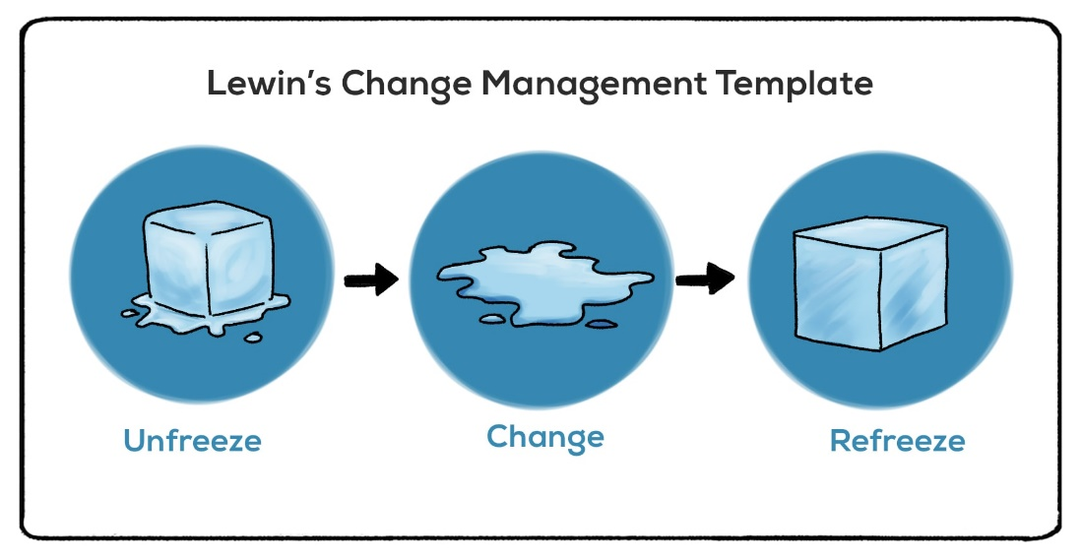
Figure No. 1: Lewin’s Change Management Model
(Source: Inspired by Hussain et al., 2018)
On the other hand, Hamdo (2021), has claimed that the second stage of the model is elaborated as the phase for changing the areas with the help of employees where change should be applied. Managers and leaders in contemporary businesses, during this phase, engage employees in the change processes for their active participation and bring efficiency to the change process. As this stage involves employee participation, organisations must work on training and development of employees to bring out the best in their changed work processes.
Besides that, the final stage of the model elaborates refreezing which means evaluation of the change results and having feedback from change participants. In the context of organisational work performance, internal stakeholders such as customers and employees are essential elements to gather feedback from. They can provide ideas that how the change is working for them. Whereas external stakeholders such as the investors, suppliers and government must be asked the same question to know the effect on the resource and capabilities of the organisation.
Kotter's 8-Step Change Management Model
In the same context of change management, models Kotter's 8-step change model provides a brief idea of the change implementation techniques and strategies through 8 simple steps. According to Sittrop and Crosthwaite (2021), the stages of the model provide direct and indirect support to the change process of the organisation. The first stage of the model is developing a sense of urgency which means involving the key recipients of change and stating to them the importance and influence of the planned change. Stakeholder analysis in this stage can classify the key internal and external stakeholders impacted by the change. The next stage elaborates on a guided coalition that refers to the power, leadership, and expertise of the organisation in creating coalitions or using change agents. Creation of the vision is the third stage of the model where leaders and managers organise the vision. In this stage, setting the key objectives and goals of the organisation are necessary for the leaders to create a set strategic path. The fourth stage of the model is communicating the vision which elaborates on mentioning the exact reason for the change to the key recipients so that no uncertainties can create barriers in mid-way change.

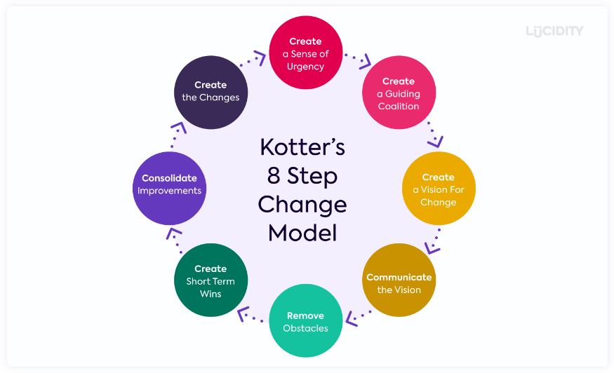
Figure No. 2: Kotter's 8-Step Change Model
(Source: Inspired by Laig and Abocejo, 2021)
On the other hand, the fifth stage of the model is empowering others to act on the vision. In this stage leaders and managers use their leadership and management styles to remove the obstacles of the change process (Laig and Abocejo, 2021). The four key sources of obstacles within the change process can be skills, structure, systems, and supervisors. Moreover, the next stage of the model is for creating shorter objectives and reaching them will be marked as a win which is essential for motivating the participants in change. The seventh stage, consolidating improvements and developing more changes is for identifying further changes required within the organisation. Finally, the eighth stage of the model is the cyclic phase to create more changes by institutionalising more changes through new and creative approaches.
Apart from Kotter’s eight-step change management theory and Lewin’s model of organisational change, another effective change management model is the ADKAR model. This model is certainly framework-based and effective in accumulating all those strategic actions needed for an effective change within any organisation. Preferably considering the communication strategy to achieve the objective-based goals, the ADKAR model plans the organisational change focusing on the people’s perception and organisational goal orientation. To be very specific, the change management model includes five definite intangible outcomes that are acquired by the people in order to obtain long-term and lasting change (Bekmukhambetova, 2021).
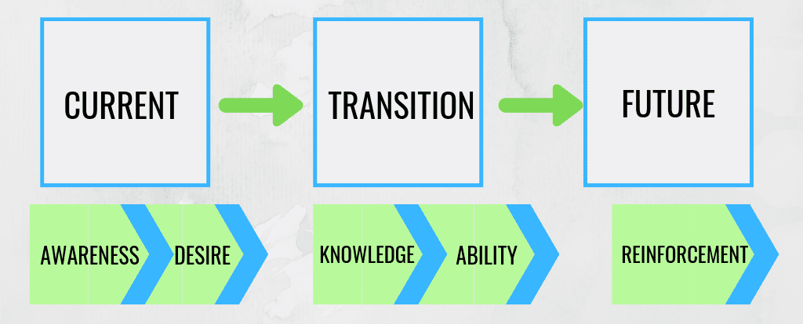
Figure 3: ADKAR model of change management
(Source: Motivated by Bekmukhambetova, 2021)
The first one is awareness where everyone, involved in the process is supposed to understand the need and requirements of the change. Next, is the desire for change where active participation, engagement and support from the people are necessary for a change to take place. Knowledge is, furthermore, very important for a proper entailment of the change where people can get an insight of the future consequences of the change. According to the perception of Cameron and Green, (2019), the process of getting intense knowledge must include the acquisition of experiences which can also change the behavioural aspect of the people around them. On the other hand, the ability is more evident to be presented which encapsulates the skills of the people engaged to implement the actual change. Lastly, reinforcement is required for efficient management where the sustainability of the change needs the most cognitive development strategy from the organisational end.
Considering the global organisation Tesco Plc, operating from the United Kingdom there are primary focus is the change the orientation to more sustainability engaging all the stakeholders by a certain means. Although, on the contrary, it has some drawbacks also as it only considers the intangible bigger attributes and does not consider the micro-details. In this case, wider change in any organisation such as transformational or transitional might be tougher and critical, certainly overlooking the management concern and strategic action considering a bigger extent and scope (Tahir, 2019).

Identify the suitable change management model that may be of use to implement the identified suitable strategic change for your chosen organisation.
Tesco plc, in the UK context, is a renowned supermarket chain serving a huge number of people throughout its global orientation. In recent days, according to the global sustainability approach, Tesco has taken a lot of strategic aims to introduce its sustainable management and change in the operational practice and supply chain management. To mention its goals, Tesco in the year 2020, has taken a resolution to halve the percentage of waste by the year 2030, typically focusing on sustainable development goals. Also, through a genuine purpose to associate with the supply chain management, by the year 2050, the venture with target a net zero condition, aligned with a huge operational budget (tescoplc, 2023 e).
This approach of the company can be managed by the ADKAR model of change management most appropriately and through this, it can come up with a better and more productive outcome for the consumer base. Awareness is so much significant as waste management is a prior need considering the contemporary global socio-economic perception. According to a survey of the Waste and Resources Action Programme, in the UK, over 54,000 tonnes of yoghurt are wasted by customers per year where half of it is unopened and 70% are just thrown away for passing the ‘best before’ date (tescoplc, 2023 b). The desire is completely based on market trends and results of customer preferences report where the need enhances, and the organisation is supposed to make the effective change. According to current statistics of 2022, over 80% of people are believed in sustainable products and eco-friendly packaging to reduce waste management (statista, 2023 c).
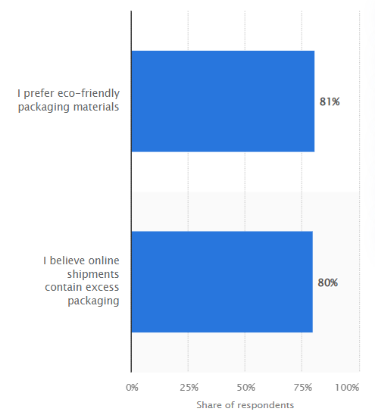
Figure 4: People, intrigued by sustainable waste management.
(Source: statista, 2023 c)
The reports and statistics certainly can encompass a genuine range of knowledge which can support the organisational change that will be driven by Tesco plc in upcoming years. Also, the stakeholder’s perception may allow the better engagement of suppliers where the company can uplift the supply chain management. In the global context, the supply chain was certainly disrupted after the Covid-19 pandemic and Brexit event in the UK and in this regard, change is a certain need. Ability can be enhanced by acquiring transformational leadership where the leaders are more intrigued by employee-level innovation and the objectives-based company success, solving the ongoing business obstacles. According to the understanding of Kotamena, Senjaya and Prasetya (2020), transformational leadership is the relationship between leaders’ and employees’ confidence, reverence, and appreciation. Lastly, Reinforcement needs to be done from a collaborative approach where the organisation and all its stakeholders are supposed to take different actions towards the change. Considering Tesco plc, they unveil a strategic approach to cut down the food waste by changing the yoghurt labelling and adding two different date descriptions to bring awareness and knowledge to the consumers.

Section 3- Proposal and Implementation of Change Strategy

Change management plan based on the suitable change management model.
From a certain aspect, the ADKAR model is one of the most effective models in the process of organisational change management where employees reinforce the most efficient management in the whole change process. Towards develop the change management plan based on this model five definite steps need to be taken which are described below -
Generating Awareness: In this step of the change management model, people along with the organisation as a whole need to recognise the effectiveness of the required change. In this regard, the main goals should be the refurbishment of the supply chain disorder, specifically after Covid-19 and implementing the sustainable development goals.
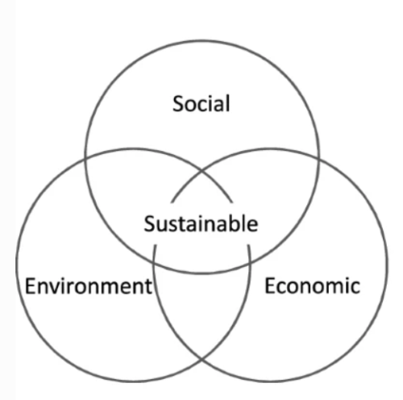
Figure 5: Three Pillars of Sustainability
(Source: Motivated by Purvis, Mao and Robinson, 2019)
To be very specific, the three pillars of sustainability and its effective implementation are the prior focus encapsulating the social, environmental, and economic upbringing of the company (Purvis, Mao and Robinson, 2019). Tesco plc among all the ventures in the UK context was the first to incorporate sustainability goals to reshape the supply chain finance while engaging more suppliers to the scientific emission and waste reduction targets (tescoplc, 2021 f).
Collaborating the Desires: Based on the above-mentioned objectives, the desire of the global chain Tesco Plc is so much evident to that of sustainable upbringing. The strategic approach as mentioned is changing labels for its yoghurt product line is an aligned thing in this regard. To be more specific about the waste management goals of this company, it is certainly intrigued in striving for eliminating food waste from the operation and supply chain management (tescoplc, 2021 g). This is mainly to foster more awareness among the people decreasing the waste at their homes.
Developing the Knowledge: Knowledge development and market-based research is the next step in the change management plan where the company needs to depend on its research and development department. News and success measures projection will be based on other competitors’ approaches where the company is supposed to implement the decisions. Sourcing the ingredients and raw materials can also be mentioned as the suggested things for the change which can minimise the impact on the environment and uplift the socio-economic perspectives.
Uplifting the Abilities: To encapsulate transformational leadership or situational leadership, certain abilities in the form of transferable skills need to be developed for the leaders in this organisation, Tesco plc. Communication and decision-making ability are certainly the prior ones along with adaptability, accountability, critical thinking, and conflict management skills are to be mentioned. According to Kamales, (2019), Communication reinforcement is the best ability which is a significant tool to encompass all the people and facilitate the strategic action towards the organisational goals.
Reinforcement of the change: Feedback management can be one effective step to analysing the organisational strength and drawbacks to be mitigated. Some long-term and short-term objectives need to be set, achieving which the employees can get a certain range of motivation to do betterment in their profound efficacy. Monitoring is another approach where the focus will be to evaluate the innovation for the desired change.

Leadership approaches would be suitable for initiating and implementing identified strategic change.
In any organisational change management, the pivotal role is to ensure the efficiency of the leadership for the further motivation of the employee. People management and innovation upbringing are to be fostered by the leadership and through some strategic action, transformational leadership is to be incorporated by a certain means. In a usual manner, within any organisation, transformational leadership can take serious actions to make the individual aware of the change and the social value of the change.
Through some genuine support from the organisation, the innovativeness of the employees needs more concern as this innovative implementation can enhance the efficacy of the employees as well as the organisation. Tesco Plc, in this order, is supposed to take more consideration in people management and effective quality assurance objectives. Within the range of transformational leadership, four things require more emphasis which are “Idealised influence, inspirational motivation, intellectual stimulation and individual consideration” which all are significant for employee upliftment (Shafi et al., 2020).
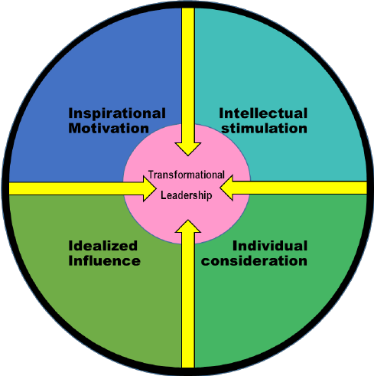
Figure 6: Basis of Transformational leadership
(Source: Motivated by Shafi et al., 2020)
The focal point of the brand, Tesco Plc is the make effective changes in its sustainable management and supply chain refurbishment the innovative implementations are certainly important keeping the competitive edges in mind within the wider market. In the process of transformational leadership management, pre-contemplation and contemplation stages can foster people’s awareness about the current problem and relative solution of the same (aihr, 2023). The preparation stage is the next when all the people need to take several actions to make an effective change. Maintenance through effective supervision and integration of change can encompass the on-point efficacy of the leaders and the strategic action that led the organisation to optimum success.

Step-by-step process to implement the change Strategy.
Awareness: Generating awareness is the first step of the strategic approaches where people’s engagement and stakeholder management should be the prior concern for any organisation. Changing and managing sustainable objectives need the consideration of the environment along with the upliftment of the economic stability of the organisations. According to Tesco plc, customers and investors are the main ones in the change process, who can encompass the effectiveness of the environmental credentials along with reducing the trade-off aspects to balance the revenue returns (Holton, 2021).
Desire: Waste management and reducing carbon emissions are the desires of any organisation in accordance with the organisational change to contribute to nature and maintain the socio-economic perspectives. UK-based Tesco plc in the financial year 2021, revealed its plan towards sustainable change by altering different aspects of the product line through a supply chain finance programme (retail-insight-network, 2021). Based on this, it has become the first in the UK to help the suppliers engage them more in a low-carbon economy.
Knowledge: Technological upliftment in this aspect can enhance the capabilities of the research and development department which can further help the operation management to get an insight of the market trends and customer preferences. Objectives should be made in this manner so that the future implications can be managed by the leadership and for this, the gaining of knowledge should be optimum.
Ability: Skill enhancement is the strategy where effective training and development need to be fostered by the organisation, Tesco plc where communication and motivation are the genuine purposes. Praising the development of the employees is also necessary where rewards and recognition might help the employees to boost their esteem and gradually do betterment.
Reinforcement: Effective monitoring can be the most appropriate strategy for the company, Tesco plc as the people is the main asset for the venture to encompass the necessary steps of the change management. Motivating the employees, they are certainly intrigued in valuing the mental health and wellbeing of the people as over 74% of the colleagues came up with the perception that Tesco is safe and respects their health and wellbeing of them (tescoplc, 2023 h).

Identification of the probable impact of the implementation of change strategy on the Culture
Organisational culture refurbishment can be one definite strategy for any organisation where they need to take serious responsibilities to implement the change strategies. Through the ADKAR model, Tesco plc can change its operational model and make strategic decisions to engage all the people in its goal of sustainable waste management and reshaping of supply chain management. In this regard, it can be mentioned that a few obstacles or challenges may disrupt the efficacy of the leaders and the leadership style need to be altered by a certain means. The core is to imply different aspects of sustainability where environmental, social and economic perspectives are the definite consideration.
Leader enablement and people engagement can be the first challenge for the organisation where lack of awareness can hamper the major aspects of the organisational operation. The leaders often lack the potential and knowledge to recognise the key performance indicators and fail to upskill their subordinates to foster betterment within the workplace. Some inherent complexities are often looked after by the leaders which are atrocious for the organisation as optimum results cannot be achieved by the venture to reach the goals (bcg, 2022). Secondly, market research can be one difficult area due to the lack of potential for research and development. Also, it can be mentioned that technological upliftment needs serious consideration through which the R&D department can evaluate the market trends and public preferences along with their perception towards sustainable approaches. Lastly, funding for the acquisition of materials and relative information can be one challenge which can slow down change management, which needs to be mitigated by certain means.

Conclusion and Recommendations
From the above discussion, it can be concluded that the chosen organisation, Tesco plc is operating successfully in the global context even after the post-covid timing. Considering the external environment, the political trade barriers, and environmental and technological upliftment are some opportunistic things towards the organisational change, sustainable waste management and reshaping the supply chain in this regard. The change management models, Kotter’s change management mode, Lewin’s model and ADKAR model are evaluated effectively among which ADKAR is chosen to be most appropriate. The purpose of waste management by the organisation Tesco plc and their action to change the labelling of its product line of yoghurt is certainly aligned thing with the ADKAR model. In this aspect, the strategies are also encapsulated with the challenges.
In the direction of manage the challenge of people and leader engagement, transformational leadership, as mentioned need to be implemented in both short-term and long-term orientation to encompass the innovation level. Market research can be driven with more efficacy if artificial intelligence and machine learning are encapsulated. It is certainly important as AI and machine learning can include some virtual agents which can evaluate people’s preferences and can be deployed in different problem mitigation domains (Berente et al., 2021). If not implemented, the R&D will be delayed and eventually the organisational performance towards the change to sustainability. Lastly, to manage the funding complexity, different fund acquisition strategies can be incorporated, and, in this aspect, a bank loan can be appropriate. based on the supply chain and demand from the organisation in the wider market, strategic approaches are recommended to take a long-term goal to refurbish its funding capabilities.

Reference List
aihr (2023). Transformational Change. Available at: https://www.aihr.com/hr-glossary/transformational-change/#:~:text=The%20key%20benefits%20of%20transformational,levels%20of%20creativity%20and%20innovation (Accessed: 2 May 2023)
Asbari, M., Santoso, P.B. and Prasetya, A.B., (2020). Elitical and antidemocratic transformational leadership critics: is it still relevant? (A literature study). INTERNATIONAL JOURNAL OF SOCIAL, POLICY AND LAW, 1(1), pp.12-16.
bcg (2022). The Challenges of a Sustainability Transformation. Available at: https://www.bcg.com/publications/2022/the-challenges-of-a-sustainability-transformation (Accessed: 2 May 2023)
Bekmukhambetova, A. (2021). Comparative analysis of change management Models Based on an Exploratory Literature Review.
Berente, N., Gu, B., Recker, J. and Santhanam, R. (2021). Managing artificial intelligence. MIS quarterly, 45(3).
Cameron, E. and Green, M. (2019). Making sense of change management: A complete guide to the models, tools and techniques of organizational change. Kogan Page Publishers.
gov.uk, (2023). Equality Act 2010: guidance Available at: https://www.gov.uk/guidance/equality-act-2010-guidance#:~:text=Print%20this%20page-,Overview,strengthening%20protection%20in%20some%20situations. (Accessed: 2 May 2023)
Hamdo, S.S., (2021). Change Management Models: A Comparative Review. Unpublished PhD thesis. Istanbul: Istanbul Okan University.
Holton, K. (2021). Tesco treads tricky path to greener future. Available at: https://www.reuters.com/business/sustainable-business/reuters-impact-tesco-treads-tricky-path-greener-future-2021-10-05/ (Accessed: 2 May 2023)
Hussain, S.T., Lei, S., Akram, T., Haider, M.J., Hussain, S.H. and Ali, M., (2018). Kurt Lewin's change model: A critical review of the role of leadership and employee involvement in organizational change. Journal of Innovation & Knowledge, 3(3), pp.123-127.
Kamales, N. and Knorr, H. (2019). Leaders with managing cultural diversity and communication. Asia Pacific Journal of Religions and Cultures, 3(1), pp.63-72.
Kotamena, F., Senjaya, P. and Prasetya, A.B. (2020). A literature review: Is transformational leadership elitist and antidemocratic? International Journal of Social, Policy and Law, 1(1), pp.36-43.
Laig, R.B.D. and Abocejo, F.T., (2021). Change management process in a mining company: Kotter’s 8-Step change model. Journal of Management, Economics, and Industrial Organization, 5(3), pp.31-50.
Mansaray, H.E., (2019). The role of leadership style in organisational change management: a literature review. Journal of Human Resource Management, 7(1), pp.18-31.
ons.gov.uk, (2023). Inflation and price indices Available at: https://www.ons.gov.uk/economy/inflationandpriceindices (Accessed: 2 May 2023)
Partridge, J., and Butler, S., (2021). Tesco profits fall as Covid costs offset sales surge Available at: https://www.theguardian.com/business/2021/apr/14/tesco-profits-fall-as-covid-costs-offset-sales-surge (Accessed: 2 May 2023)
Purvis, B., Mao, Y. and Robinson, D. (2019). Three pillars of sustainability: in search of conceptual origins. Sustainability science, 14, pp.681-695.
retail-insight-network (2021). Tesco announces sustainability-linked finance programme for suppliers Available at: https://www.retail-insight-network.com/news/tesco-supply-chain-sustainability/ (Accessed: 2 May 2023)
Shafi, M., Lei, Z., Song, X. and Sarker, M.N.I., (2020). The effects of transformational leadership on employee creativity: Moderating role of intrinsic motivation. Asia Pacific Management Review, 25(3), pp.166-176.
Sittrop, D. and Crosthwaite, C., (2021). Minimising risk—the application of kotter’s change management model on customer relationship management systems: A case study. Journal of Risk and Financial Management, 14(10), p.496.
statista (2023) c. Opinions of consumers on sustainable packaging in the United Kingdom (UK) in 2022 Available at: https://www.statista.com/statistics/1316659/consumers-opinions-on-sustainable-packaging-uk/ (Accessed: 2 May 2023)
statista, (2022) a. Tesco PLC - Statistics and Facts Available at: https://www.statista.com/topics/3807/tesco-plc/ (Accessed: 2 May 2023)
statista, (2023) b. UK internet penetration: percentage of population using the internet in the United Kingdom from 2000 to 2020 Available at: https://www.statista.com/statistics/468663/uk-internet-penetration/ (Accessed: 2 May 2023)
Tahir (2019). ADKAR Model of Change Management. Available at: https://changemanagementinsight.com/adkar-model-of-change-management/ (Accessed: 2 May 2023)
tesco-careers, (2023), d. Our Culture Available at: https://www.tesco-careers.com/explore-our-world/our-culture/ (Accessed: 2 May 2023)
tescoplc (2021) f. Tesco set to become first UK retailer to offer sustainability-linked supply chain finance. Available at: https://www.tescoplc.com/news/2021/tesco-set-to-become-first-uk-retailer-to-offer-sustainability-linked-supply-chain-finance/ (Accessed: 2 May 2023)
tescoplc (2021) g. Tesco Group Environment Policy. Available at: https://www.tescoplc.com/sustainability/documents/policies/tesco-group-environment-policy (Accessed: 2 May 2023)
tescoplc (2023) e. Serving customers, communities, and planet a little better every day. Available at: https://www.tescoplc.com/sustainability/#:~:text=We%20were%20the%20first%20business,farm%20to%20fork%20by%202050 (Accessed: 2 May 2023)
tescoplc (2023) h. Health, safety and wellbeing. Available at: https://www.tescoplc.com/sustainability/colleagues/health-safety-wellbeing (Accessed: 2 May 2023)
tescoplc, (2023), a. About Us Available at: https://www.tescoplc.com/about/ (Accessed: 2 May 2023)
tescoplc, (2023), b. Tesco changes yogurt labelling to cut down on food waste Available at: https://www.tescoplc.com/tesco-changes-yogurt-labelling-to-cut-down-on-food-waste/ (Accessed: 2 May 2023)
tescoplc, (2023), c. Diversity and inclusion at Tesco Available at: https://www.tescoplc.com/sustainability/colleagues/diversity-and-inclusion-at-tesco/ (Accessed: 2 May 2023)
Thompson, G. and Glasø, L., (2018). Situational leadership theory: a test from a leader-follower congruence approach. Leadership & Organization Development Journal, 39(5), pp.574-591.
trade.gov, (2022). Trade Barriers Available at: https://www.trade.gov/country-commercial-guides/united-kingdom-trade-barriers (Accessed: 2 May 2023)
un.org, (2023). Goal 12: Ensure sustainable consumption and production patterns Available at: https://www.un.org/sustainabledevelopment/sustainable-consumption-production/ (Accessed: 2 May 2023)

