University of Wales Trinity Saint David.
School of Engineering.



Subject: Control Technology.

Title: Factory Control 2.



Name: George Griffiths (0901007).

Date: 15th December 2022.

Contents page:

Introduction. ~ Page 3.

Ladder Logic Analysis. ~ Page 4.

HMI Integration ~ Page 18.

Conclusion. ~ Page 21.

1.0 Introduction
The below technical report provides a detailed analysis of both the choreography and programming required to produce a box and lid assembly. The products, which are fed via two opposing machine centers and assembly lines, will be placed through multiple pick and place operations through the utilization of clamps and diffuse sensors, prior to being placed into a end of line assembly trey, which includes no more than two items per box, as seen in figure 1.

The below technical report discusses the process of programming and choreographing lineside apparatus to perform tasks along the production line. The report also demonstrates how to generate a HMI to stop the production line which displays errors/warnings if a loss of volume occurs during the manufacturing process.

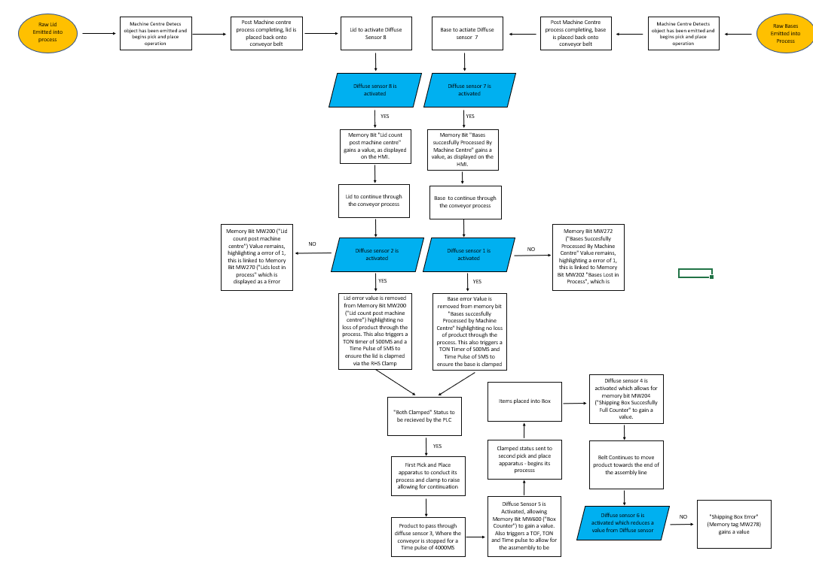
(Figure 1 – Flow Chart Of Factory IO Configuration
Reference – Microsoft Excel, 2022)

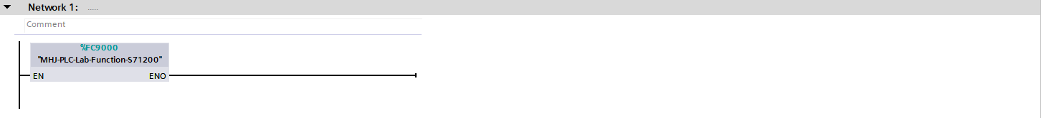
2.0 Ladder Logic Analysis
(Figure 2 – Network Line 1
Reference – TIA16, 2022)

Network line 1, as seen in figure 2, “MHJ-PLC-Lab-Function-S71200” denotes the interface between siemens TIA Portal and factory IO.
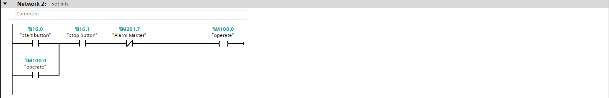
(Figure 3 – Network Line 2
Reference – TIA16, 2022)

Network Line 2, as seen in figure 3, is the function which dictates the functionality of the starting and stopping operations within the programming. The “start button” and “stop button” will both be linked to Buttons on the HMI, to both begin and stop the conveyor system. The operate tag is assigned to both the start button (where the value for on = 1) and the stop button (where the value for on = 0). This network utilizes a latch system which prevents the contacts closing when the start button is depressed, and contrarily closes the contacts when the stop button is pressed, cutting all power to the assembly line.

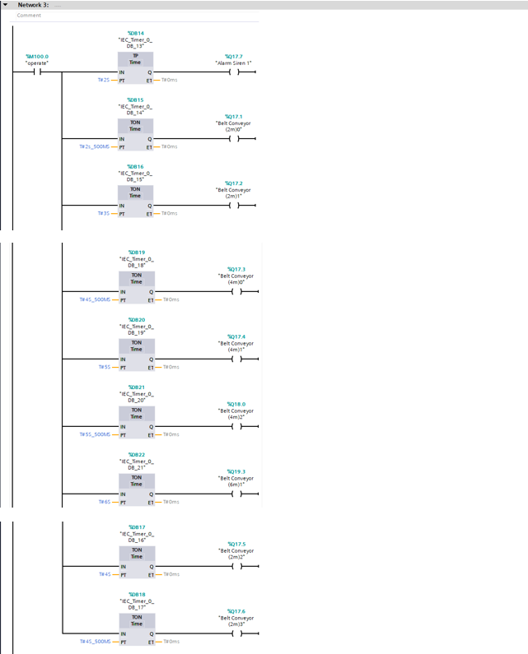
(Figure 4 – Network Line 3
Reference – TIA16, 2022)

Network 3, as seen in figure 4, provides the programme with logic to begin the conveyors within the factory. Initially the operate function, as introduced in network 2, triggers a warning signal to lineside personnel that the conveyor system is beginning to move. It is also important to note, to reduce potential stress placed on the electrical supply in the event of the production line being turned off and re-activated, a staggered activation has been implemented which will reduce potential stress placed on the system (which will prevent a potential power surge causing a power cut). This conveyors linked to both emitters are to begin first to feed the machine centers, these are then followed by the remainder of the conveyors over a 6 second period.

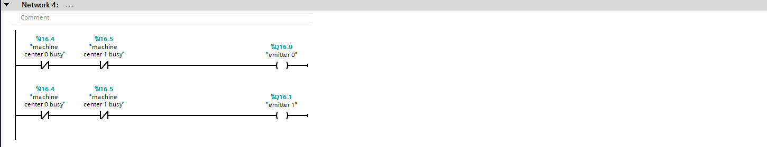
(Figure 5 – Network Line 4
Reference – TIA16, 2022)

As displayed in figure 5, network 4 enables both emitter 0 and emitter 1 to begin emitting both bases and lids into the production process, which are to be processed via the machine centers.
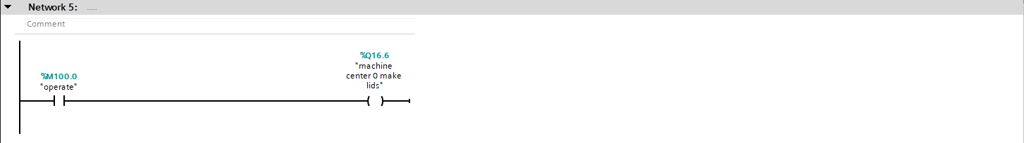
(Figure 6 – Network Line 5
Reference – TIA16, 2022)

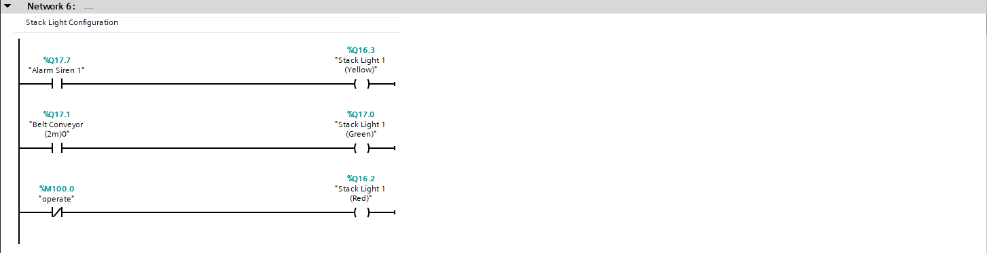
As seen in figure 6, this line of code denotes initializes the machine center to operate, which as a result begins the manufacturing of lids on the production line.
(Figure 7 – Network Line 6
Reference – TIA16, 2022)

As seen within the Factory IO configuration, the production line includes a siren and stack light to notify lineside personnel of the status of the assembly line. As seen in the first segment of network 6’s code, when the siren is activated, we see the yellow light is displayed on all stack lights across the assembly line. Similar to the above, when “belt conveyor 2m(0)” is activated (as seen during network 3) the green stack light aluminates, notifying the lineside technicians that the production line is now initializing start up. Contrary to the above, figure 7 states when the operation becomes a closed contact the red light is to be activated, indicating to lineside personnel that all conveyors have stopped.

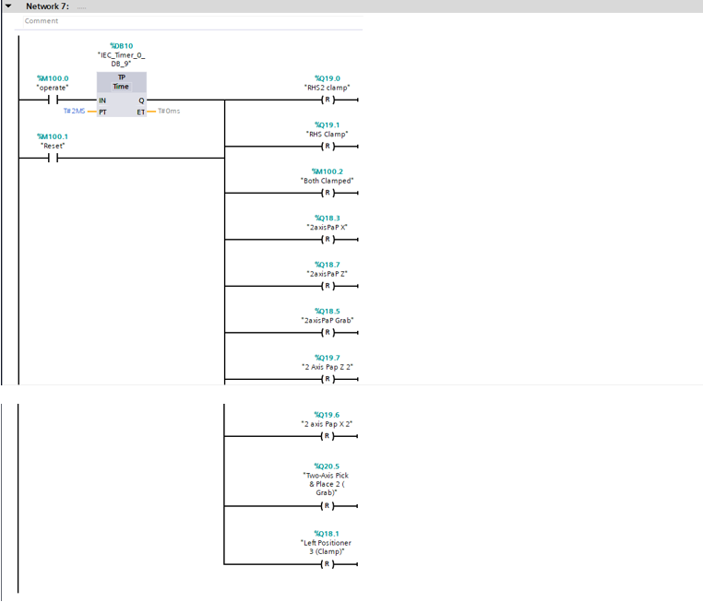
(Figure 8 – Network Line 7
Reference – TIA16, 2022)

As seen in figure 8, the operate function allows for the operation of all three clamps, and the functioning of both pick and place machinery’s operations. The reset tag included in the code also, when pressed is stored within the memory of the PLC. Then the line is restarted, a time pulse signal (which lasts 2 seconds) is sent to all apparatus and equipment (excluding both machine center process’, which are forced to operate via the factory IO tags).

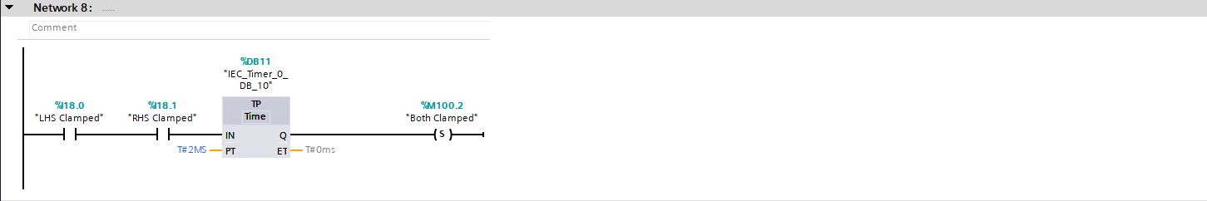
Figure 9 – Network Line 8
Reference – TIA16, 2022)

Figure 9 displays the output of “both clamped” as a memory bit, post both LHS Clamp and RHS clamp are within they’re clamped position. This memory bit is captured over a time pulse of 2 milliseconds.
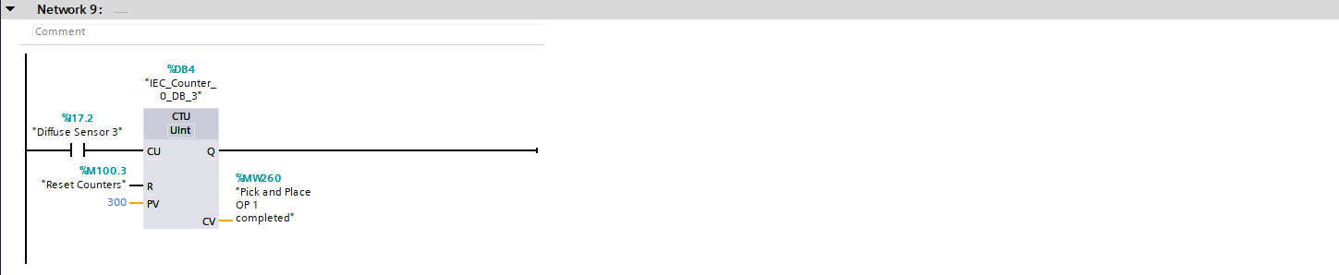
(Figure 10 – Network Line 9
Reference – TIA16, 2022)

Network 9, as denoted in figure 10, denotes a up-count to memory bit “MW260” (“Pick and place OP1 completed”) to gain a value post diffuse sensor 3 being activated. This metric is displayed on the root screen within the HMI.

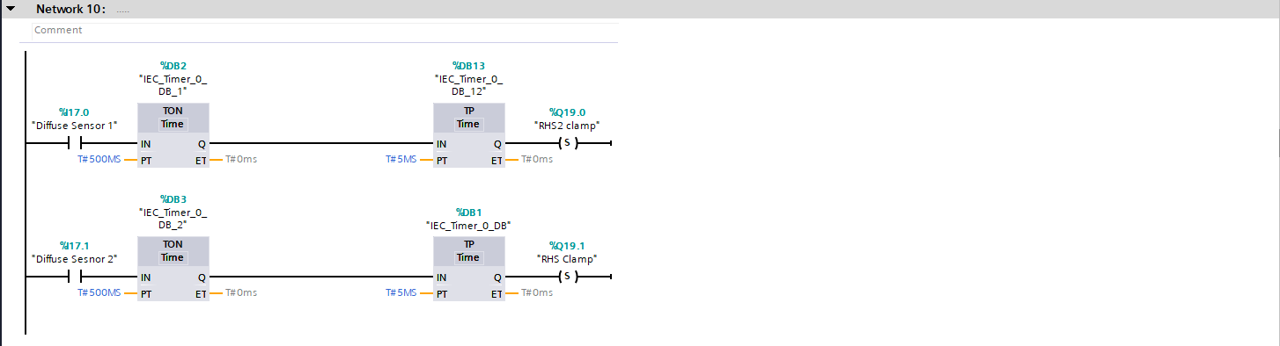
(Figure 11 – Network Line 10
Reference – TIA16, 2022)

Network 10 within the PLC configuration denotes the process of securing both the bases and lids within they’re clamps prior to the initial pick and place operation. During the first line of network 10, we see when diffuse sensor 1 is activated, a Ton timer of 500ms is activated, supported by a time pulse of 2’s to ensure perfect choreography of the base entering RHS2 Clamp, to ensure it is ready for the initial grabbing operation of the pick and place operator. This process is repeated for diffuse sensor 2 and the “RHS Clamp”. As discussed in figure 8, the clamping of both “RHS Clamp” and “RHS2 clamp” initializes the “both clamped” memory tag to operate, which will subsequently begin the operation of the pick and place apparatus.

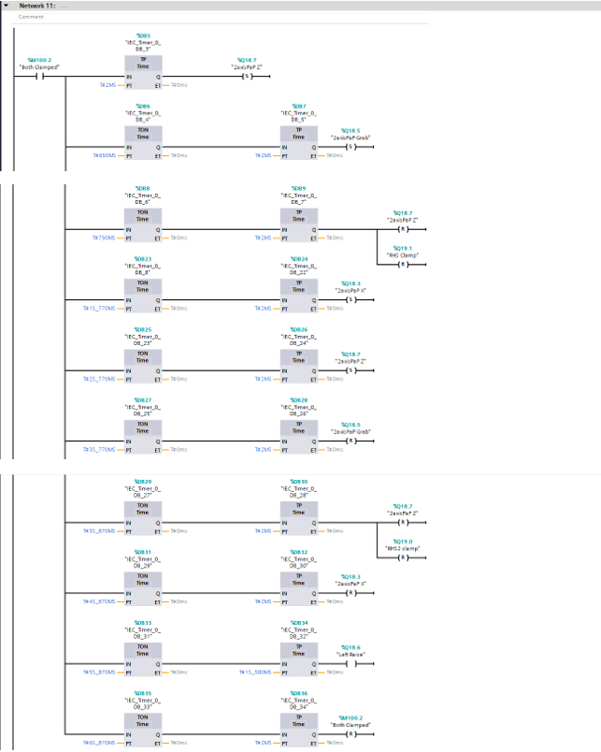
(Figure 12 – Network Line 11
Reference – TIA16, 2022)

Network 11, as seen in figure 12, demonstrates the sequence of operation for first pick and place apparatus. Post both clamps activating, the “both clamped” status is activated via the pick and place machine, which initializes the functionality of the apparatus, over a 6s_870ms period. The orchestration of both the “X” and “Z” operations conducted by the pick and place apparatus is pivotal to its primary function, as poorly timed operations can ultimately result in clashes with patterning equipment or a lack of function. The TON/TP timers used throughout the process are utilized to also control the resetting of both clamps. “RHS Clamp” is reset by utilizing the reset function, post the pick and place apparatus successfully completing its transition in the Z axis. Similar to this, post the RHS2 clamp being released (post the lids being delivered to the base’s production line), “left raise” is activated, which raises the LHS clamp which allows for the products to continue throughout the assembly process.
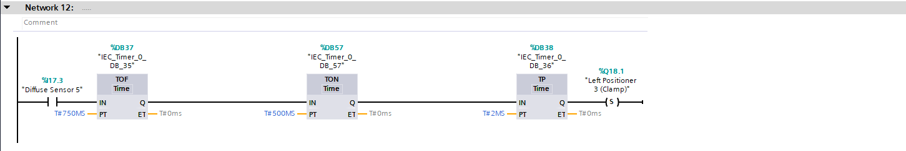
(Figure 13 – Network Line 12
Reference – TIA16, 2022)

Network 12 demonstrates the timing operations utilized to ensure the securing of the third clamping operation. Figure 12 demonstrates to the user that once diffuse sensor 5 is activated, a TOF, TON and TP timer activate the third clamp in the factory IO configuration, to allow for the second pick and place apparatus to conduct its process.
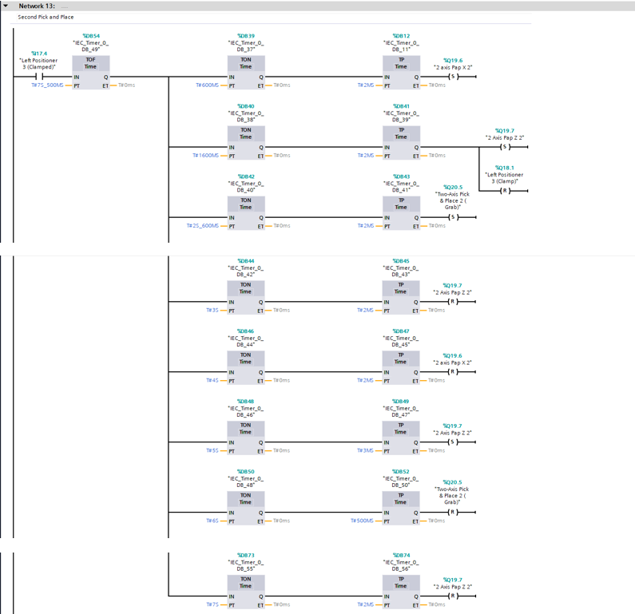
(Figure 14 – Network Line 13
Reference – TIA16, 2022)

Network 13, similarly to figure 6, demonstrates the operation sequence of the second pick and place machine. The “Left positioner (clamped) tag signals the apparatus to begin its operation. The choreography of all movements of the apparatus (in both X and Z) are choreographed over a 7.2 second period, through detailed choreography of both TON/TP timers. The correct sequence and timings of all X and Z movements Is pivotal in ensuring the apparatus is able to conduct its process efficiently.
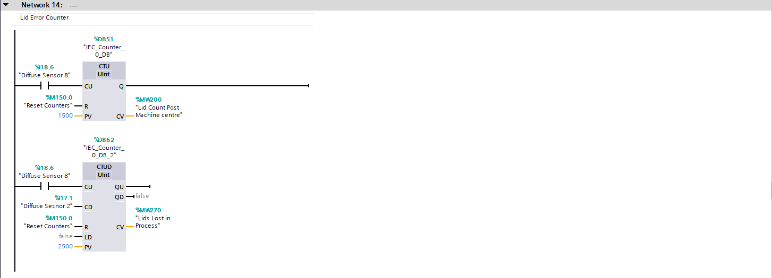
(Figure 15 – Network Line 14
Reference – TIA16, 2022)

Network 14 denotes the lid count and error, which is displayed within the HMI. The code denotes when Diffuse sensor 8 is activated (Sensor post machine center process), memory bit MW200 (Denoted as “lid count post machine center” within the PLC Tags) will gain a value. The second line of code within the network, through utilization of a Count up/down function, when diffuse sensor 2 is activated (Sensor prior to the clamping operation), this will retract a value from the initial value gained from memory bit MW200, resulting in the counter losing a value. In the event that diffuse sensor 8 is activated and diffuse sensor 2 is not, this would result in the +1 value remaining, through the memory tag MW202 “Base Lost in Process”, highlighting to the business there has been a lost product in the manufacturing process. The counter can also be reset when the reset counters button is selected on the HMI.

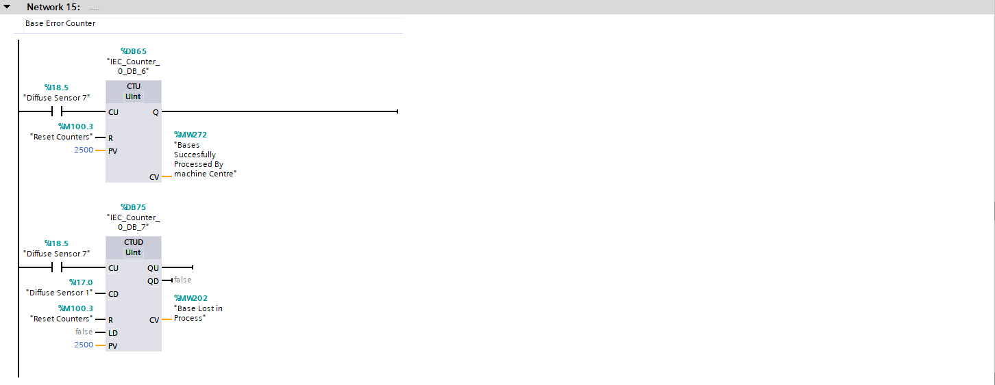
(Figure 16 – Network Line 15
Reference – TIA16, 2022)

Similarly to network 14, network 15 provided the user with visibility with regards to the bases lost during the manufacturing process. When diffuse sensor 7 is activated, a value is added to the counter through the utilization of memory bit MW272 “Bases successfully processed by machine center”. The second line of code within the network denotes that when diffuse sensor 1 is activated, to remove a value from diffuse sensor 7 (which will ultimately subtract a value from memory bit MW272). In the event that diffuse sensor 1 is not activated, a value will be added to memory bit MW202 “Base Lost in Process”, which will highlight that a loss of volume has occurred during the manufacturing process.

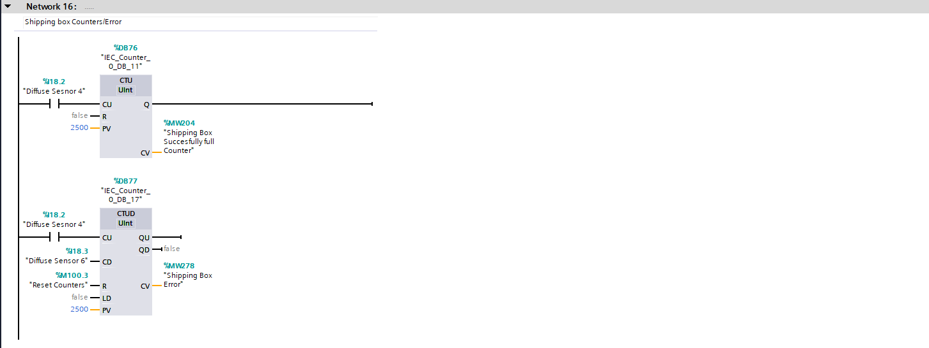
(Figure 17 – Network Line 16
Reference – TIA16, 2022)

Network 16 is utilized to count the quantity of shipping boxes which have been filled via the second pick and place apparatus. When diffuse sensor 4 is activated, memory bit MW204 “Shipping box successfully full counter” will gain a value. The second line of the code derives that when diffuse sensor 4 is activated (indicating that the product has progressed to the end of the assembly process), diffuse sensor 4 will lose a value. Therefore, a loss of product would be highlighted if diffuse sensor 4 was activated and diffuse sensor 6 was not, which would result in memory bit “shipping box error” gaining a value, which is displayed within the HMI.

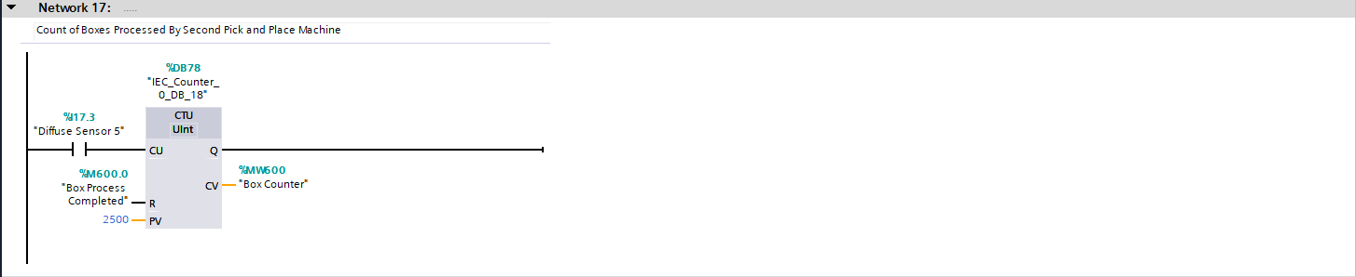
(Figure 18 – Network Line 17
Reference – TIA16, 2022)

Network 17 denotes the rung used to count the quantity of boxes which have been filled via the second pick and place apparatus. This is signaled through utilizing a count up operation, where when diffuse sensor 5 is activated, memory bit “box counter” gains a value.
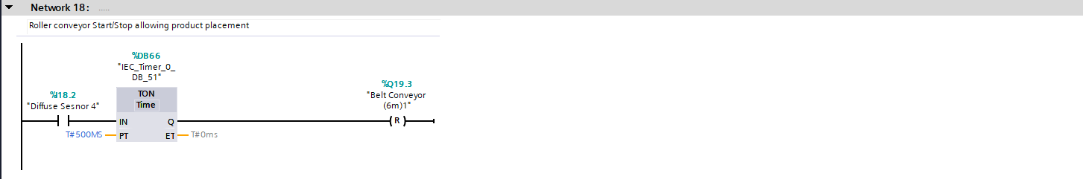
(Figure 19 – Network Line 18
Reference – TIA16, 2022)

As displayed in network 18, as seen in figure 19, demonstrates a time pulse, through utilization of a TON timer, to reset the 6m belt conveyor when diffuse sensor 4 is passed.
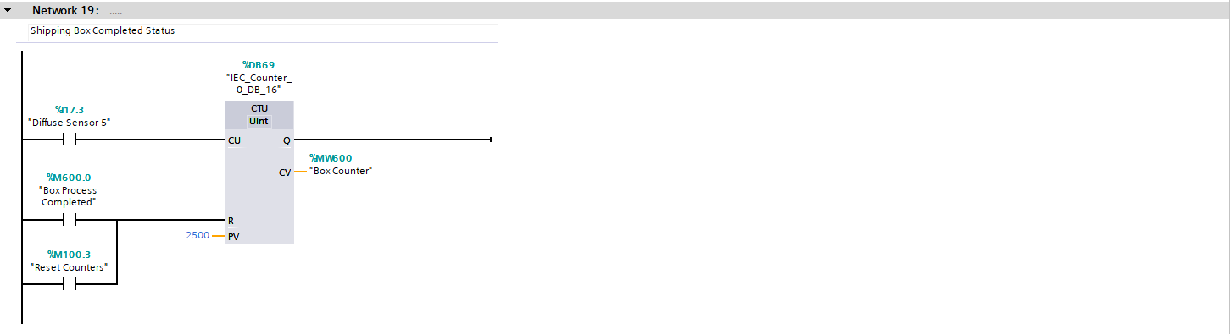
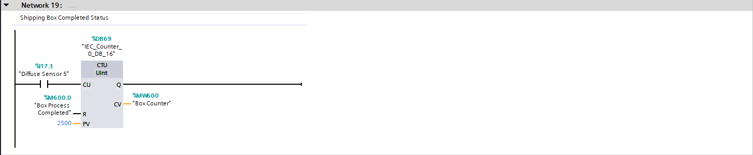
(Figure 20 – Network Line 19
Reference – TIA16, 2022) CHECK

Network line 19, as seen in figure 20, is utilized to provide a up-count when diffuse sensor 5 is passed, which indicates the quantity of boxes which have been processed via the second pick and place apparatus.

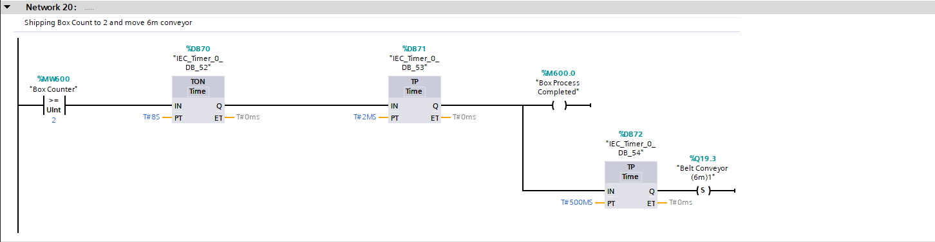
(Figure 21 – Network Line 20
Reference – TIA16, 2022)

Network 20 displays the relay function of how “Belt Conveyor 6m(1)” re activates post successfully receiving two boxes. When the memory tag “box counter” is equal or greater than two, this triggers the “Box process completed” memory tag. As a result of this, after a time pulse of 500ms, “Belt conveyor (6m)1” is once again set, resulting in the line moving and the completed product being emitted from the production process.

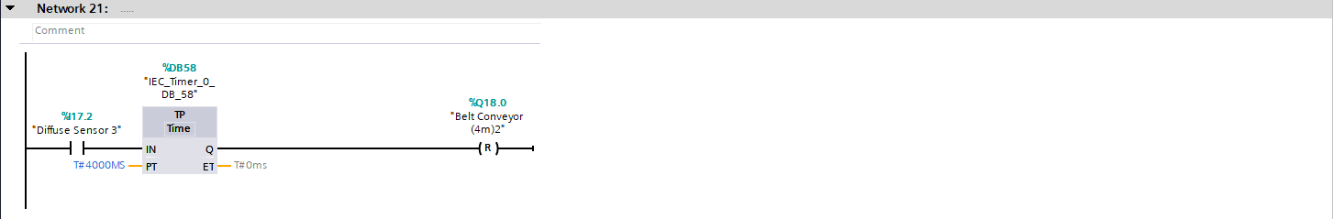
(Figure 22 – Network Line 21
Reference – TIA16, 2022)

Figure 21 is utilized to prevent a build up of material on the conveyor prior to the third clamping operation. The time pulse operator holds the line for 4000ms, prior to the line re-starting thus allowing product to flow into the clamp to allow for the second pick and place apparatus to complete its process.

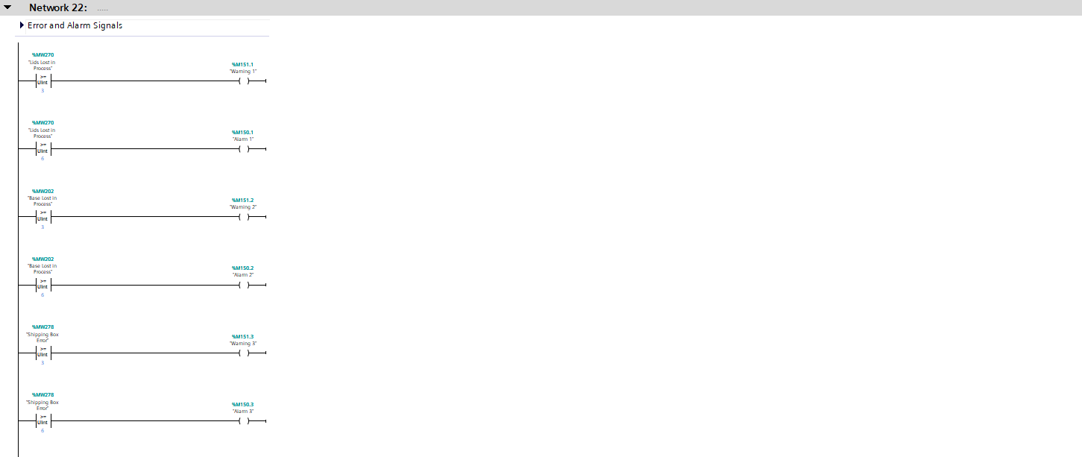
(Figure 23 – Network Line 22
Reference – TIA16, 2022) CHECK

Figure 22 displays the error alarms and signals inputted into the code, to prevent/notify lineside technicians of loss of product through the assembly process. As seen in network 22, the line will illuminate a warning message, as displayed on the root screen, for when lids/bases lost in the manufacturing process, as well as issues with the shipping boxes reaches a count of three to notify lineside technicians of the loss of volume. When this error count escalates to a count of six, regardless of where this error occurs, the code derives that the production facility will stop to prevent further loss of volume.

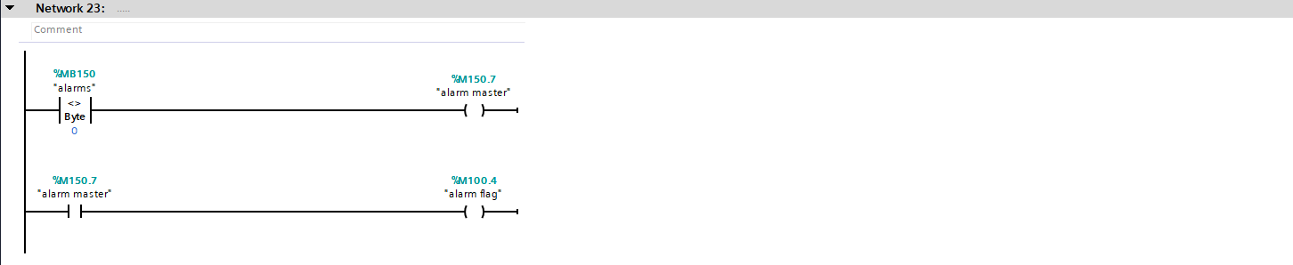
(Figure 24 – Network Line 23
Reference – TIA16, 2022)

Figure 24 denotes the code required to activate the alarm master. This code specifies if the value of Memory bit “Warnings” is greater or less than 0 the alarm master will activate, which also as a result activates the alarm flag tag.

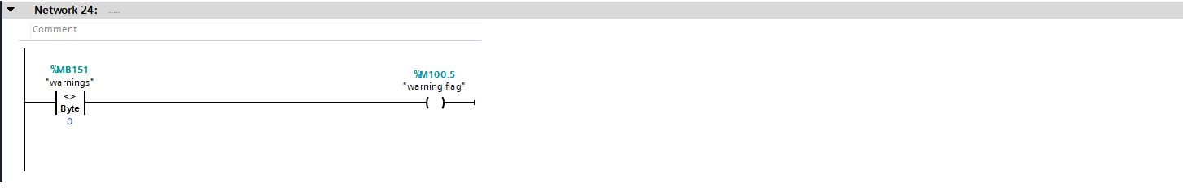
(Figure 25 – Network Line 24
Reference – TIA16, 2022)

Network line 24, as seen in figure 24, utilizes a comparator function which states when the warning memory bit is not 0 (which indicates it is a greater value), the warning flag tag is operated as a output.

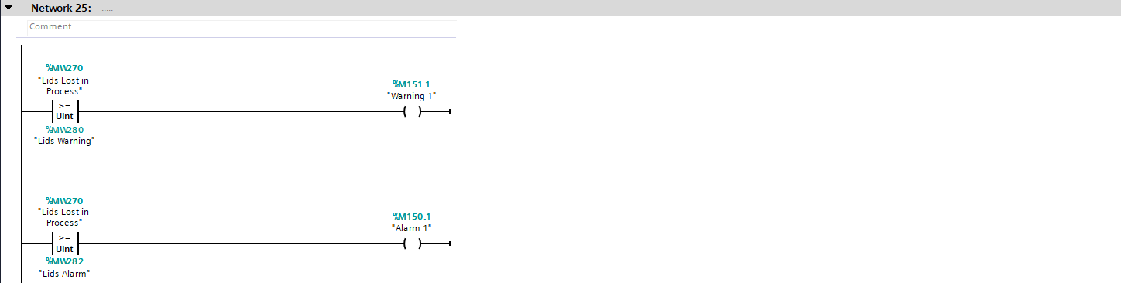
(Figure 26 – Network Line 25
Reference – TIA16, 2022)

Figure 26 denotes the tags which are connected to the engineering screen, which allow for manual entry of figures to denote when both the warnings/alarms signal for the loss of lids throughout the assembly process. The first line of the network denotes where the “lids lost in process” tag, is greater than equal too the “lids warning” tag, warning 1 will illuminate. The HMI, through utilization of a I/O field (connected to the lids warning tag) allows the user to pre set values to trigger the warning lights across the assembly line, as warning 1 is linked to the relevant pilot light on the HMI. Similarly to this, when the lids lost in process tag is greater or equal to that of the lids alarm tag, Alarm 1 will activate, of which is also tagged to a I/O field within the HMI and a correlating pilot light for visual confirmation.

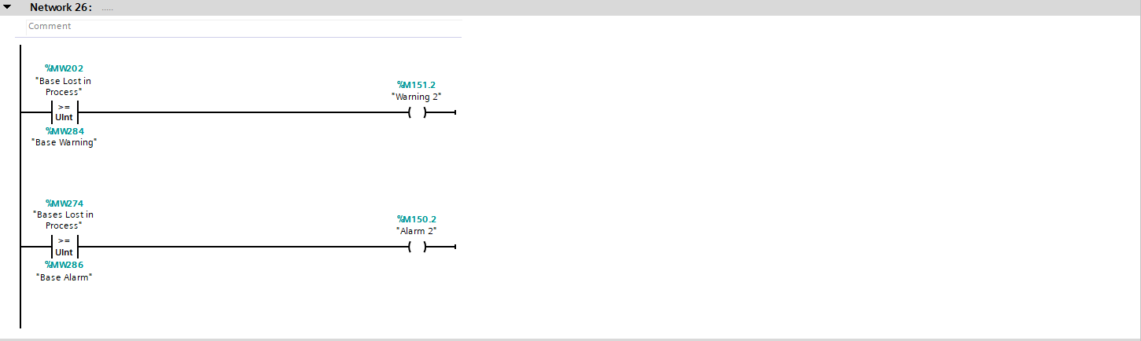
Figure 27– Network Line 26
Reference – TIA16, 2022)

Similar to figure 26, figure 27 also includes the code required to allow for manual entry (by utilization of I/O fields) for the figures of which activate the warnings/alarm signals but for the loss of Bases through the process. The first line of the code denotes where the “bases lost in process” tag is greater or equal too the “Base alarm” tag, warning 2 will aluminate on the HMI indicating a warning. Similarly to this, when the “Bases lost in process” tag is greater or equal to the “base alarm” tag, as entered by the user through the I/O fields on the HMI, alarm 2 will aluminate a pilot light on the HMI and stop the production process.
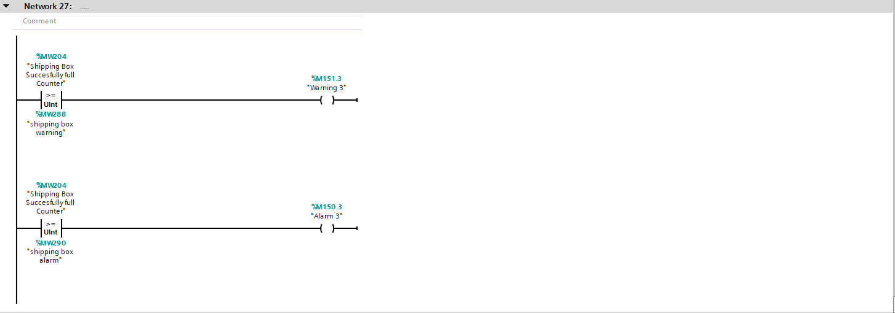
(Figure 28– Network Line 27
Reference – TIA16, 2022)

Figure 28 denotes the tags which are connected to the engineering screen, which allow for manual entry of figures to denote when both the warnings/alarms of shipping box errors occur. The first line in the code denotes where the “shipping box successfully full counter” is greater or equal to the “shipping box warnings” warning 3 will activate, thus activating a pilot light on the HMI. Similar to this, when the “shipping box successfully full counter” is greater or equal than the “shipping box alarm” tag, alarm 3 will activated, thus activating a pilot light on the engineering screen and stopping the assembly process.

3.0 HMI Integration

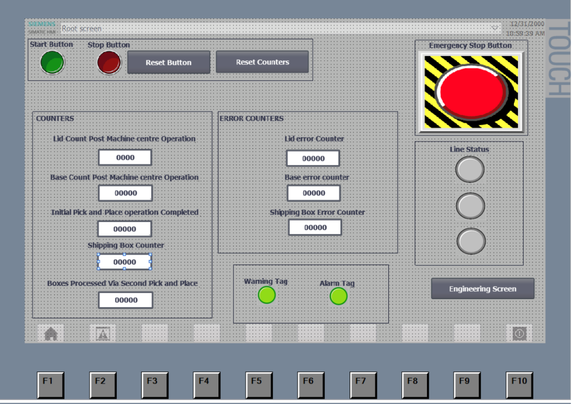

(Figure 29 – HMI Root Screen
Reference – TIA16, 2022)

The root screen within the HMI is the initial display an operative would be greeted with when using the HMI. As seen at the top of the screen, the operator is able to start/stop the production line at they’re own discretion through utilizing the start and stop buttons. This screen also displays all counters and error counters coded into the main TIA ladder logic, of which when reach set parameters specified in the ladder logic, illuminate the warning/alarm tag displayed on the warning screen. It is possible for both these errors and counters to be reset by depressing the “Reset counters” button within the HMI. The factory IO configuration also includes a stacked light to notify lineside personnel of the status of the line, this status is also replicated within the HMI in the line status area, where the relevant pilot light will becoming active dependant on the colour illuminated via the lineside stack lights. The HMI also includes a emergency stop button, where in the case of an emergency it is possible to stop all conveyors within the assembly process through the HMI.

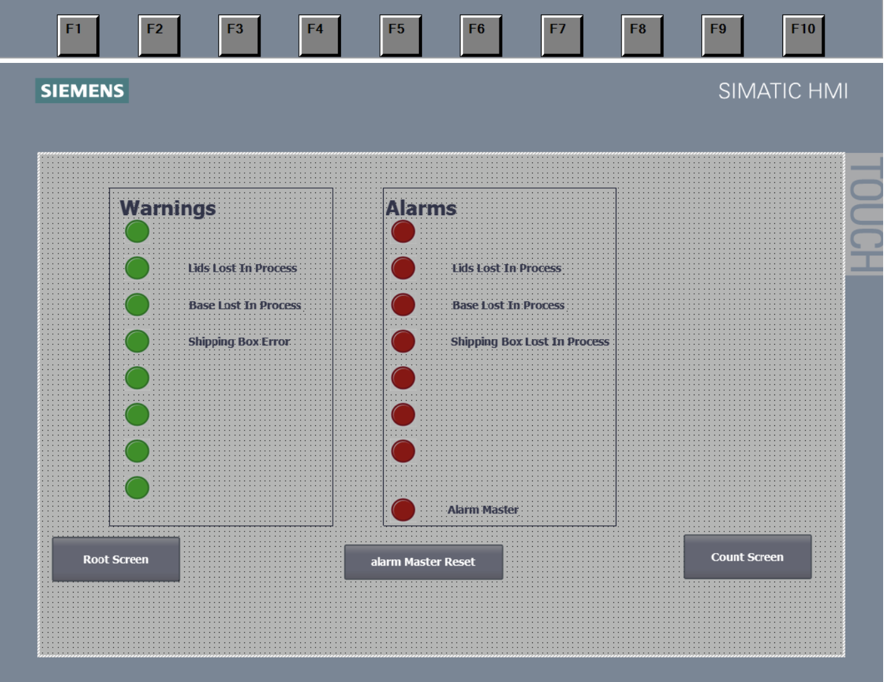

Figure 30 – HMI Warning Screen
Reference – TIA16, 2022)

The warning screen, as seen in Figure 30, displays the warnings and alarms highlighted due to the loss of production across the production line. The lids lost in the process warning is highlighted when the warning count reaches a value of three as the PLC tag “warning 1” is linked to the lid lost in process pilot light. Similarly, PLC tags “warning 2” and “warning 3” are highlighted when the bases lost in process/shipping error reaches a value of three. Similarly, as seen in figure 23, when the value of lost volume reaches six, the lid lost in process pilot light will illuminate as the “Alarm 1” PLC tag is connected to the pilot light. Similarly to this, “alarm 2” and “alarm 3” illuminate the pilot lights attached to the bases lost in process/shipping box lost in process, highlighting a loss of volume through the HMI. Upon these alarms raising, the alarm master will also illuminate, which can be reset through the alarm master reset button at the bottom of the HMI (which is utilized through a reset bit function when pressed – hence resetting the alarm master). The raising of these alarms will also stop the assembly process, and will require manual intervention to be re-activated. It is also possible to navigate through the other screens on the HMI by selecting the count screen and root screen buttons, which allow for navigation through the alternative screens on the HMI.

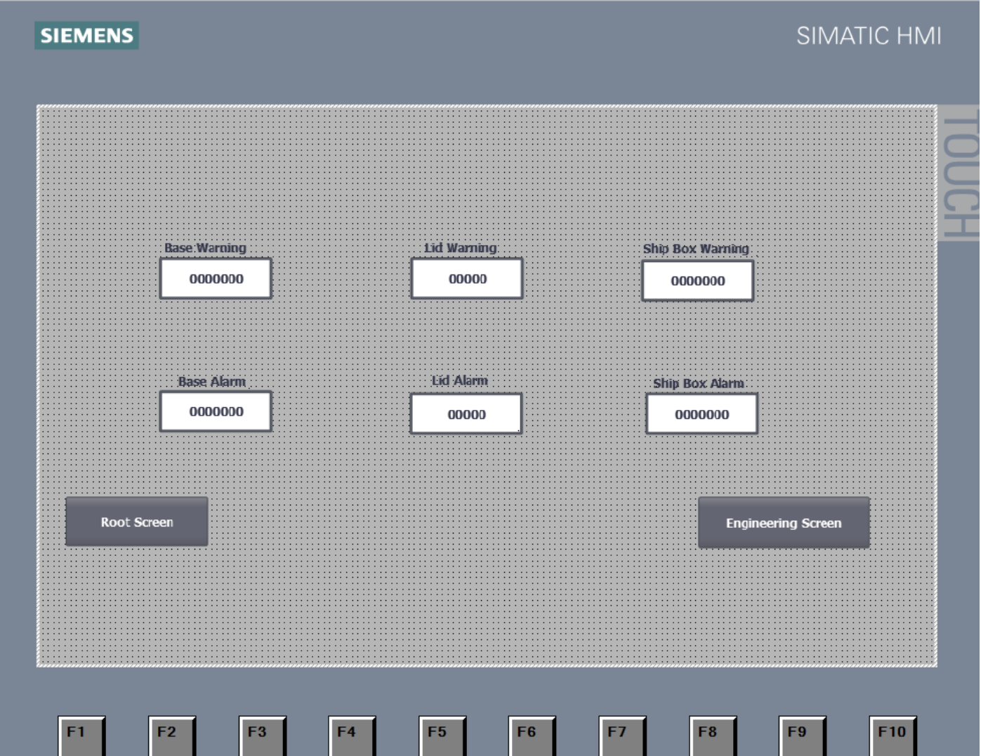

(Figure 31 – HMI Engineering Screen
Reference – TIA16, 2022)

The engineering screen is the final screen displayed to the user. This screen allows the user to pre set all warning/error counts manually, which will respectively trigger the warnings and errors displayed on both the root screen and count screen.

4.0 Conclusion
To conclude, the above technical report demonstrates how through efficient use of Siemens TIA, whilst using Factory IO as a factory interface, it is possible to simulate and choreograph the passing of multiple items and assembly these items, without subsequently causing any bottle necks within the assembly process. The report also generates how the user has created a HMI interface, to monitor any loss of volume throughout the manufacturing process.

