

Visions for the Future – Theoretical Perspectives on Management LCDB7006

Module Lecturer: Dr. Gladius Kulothungan
Student name: Md Zahirul Hoque
Student number: 1807936

Word Count (Excluding Topic, Abstract, Contents, References and Appendices): 7749 words

chosen topic (rework)

How has Human Resource Management (HRM) changed within the hospitality sector over the last ten years because of advanced technology?

Abstract
This essay is concerning the impact of advanced technology in Human resource management, especially in the Hospitality industry. The changing world noted the variation in technology which affects HR operations in an organisation and also supports the business to take a complicated decision. Theoretical framework designed for analysing the importance of IT in HRM. Organisational culture change with the advancement of technology in business and how it benefits organisations is evaluated in this paper. This essay deals with the changes brought by advanced technology in Human Resource Management (HRM) practices in the Hospitality sector. The essay is specifically on the hospitality industry. It contains an introduction to the hospitality industry and the importance of HR practices in the industry. Impact of technology will be assessed concerning HR practices. Undertaking essay is also emphasising over the evolution of Human Resource Management which includes the terms traditional human approach and personal management approach. Changes in the organisational structure in the field of HRM will be studied. This essay criticises HRM theories like organisation Theory and Contingency Theory. Then, essay involves the need for HRM approach. After that, the essay demonstrates Human Resource functions in the Hospitality sector by explaining traditional HR functions and Modern HR functions. Impact of modern technology and its future implication on HR have been reviewed in this essay. The modern HR function will have the impact of advanced technology like virtual team management; flexibility and creativity etc. with advantages such as reduce the amount of paperwork and manual record-keeping, retrieves information quickly and accurately and allows quick analysis of HR issues.

Contents
Abstract 3
1.0 Introduction 7
2.0 Human resource management and Technology 8
3.0 Conceptual framework 13
4.0 Theoretical Background 14
5.0 Trend in HR and technology in the Hospitality Industry 15
6.0 Advantage of advanced technology to HR in Hospitality 19
6.1. AI is making Recruitment Smarter 20
6.2. Compliance is more efficient and sophisticated 20
6.3. Analytics drive Better Performance Management 21
6.4. Better Analytics Boosts Diversity and Inclusion 21
6.5. Engaging Employees 21
6.6. Strengthening Culture 22
6.7. Managing Talent 22
7.0 Evolution of Human Resource Management 23
7.1 The Traditional Human Resource Approach 23
7.2 The Personnel Management Approach 23
7.3 Changes in the Structure of the organisation in the 21st century 24
8. 0 Modern HR functions in the 21st century 25
9.0. Theories of HRM 27
9.1 Organisation Theory 27
9.2 Contingency Theory 27
9.3 Resource-based theory 28
10.0. HRM and Evolution of Technology 29
10.1 HR Technology (2008-2010) 29
10.2 HR technology in the year (2011-2014) 29
10.3 Year (2015-2018) 30
10.3.1 Cloud remains in the projection 30
10.3.2 Going mobile 30
10.4 Future of HR technology (2019-future) 31
10.4.1 Virtual and augmented reality 32
10.4.2 Advanced Machine learning 32
10.4.3 Autonomous things and Agents 33
11. Conclusion 34
References 35
Appendix-1 HRIS implementation process 42
Appendix 2- Web-based self-service application and benefits 43

List of figures

Figure 1-Stages of HR technology ……………………………………………………………10
Figure 2-Conceptual framework for the impact of IT on HRM in the Hospitality Industry….13
Figure 3-Extended Lee model using job seeker prospective …………………………………16
Figure 4-Electronic HRM or E-HRM…………………………………………………………18
Figure 5-Role of HRM………………………………………………………………………...25
Figure 6-Key Functions of HRIS……………………………………………………………...26
Figure 7-Future HR conceptual framework…………………………………………………...31

1.0 Introduction
Technological penetration has been observed in the business environment, especially in the field of HR. Management allows new technology (Artificial Intelligence and Data Analytics) in HR to improve its efficiency, get better outcomes in human practices. In the current period, the majority of jobs became technical, and employee needs mobile access to information for better decision ability (Horwitz and Budhwar, 2015). With the use of machine learning, management improves the aspect of recruitment and general employee management through technology for smarter work practices. In the modern hospitality business, it has conventionally proved that Information and Communication Technology (ICT) includes internet, mobile communication, and social media have drastically changed the operation of HRM (Ehnert and Harry, 2011). Technology contributes to the fulfilment of the personnel policy of the organisation. Technological advancement enhances the value of human assets and support practices to explore the best talent from the labour market. Lin (2011) addressed that IT support Business to handle HR practices, introduced better recruitment tools and improve the efficiency of human capital through fast processing of information. The primary aim of this essay is to analyse the contribution of advanced technology to HRM in the hospitality industry. In this assignment, the last ten years of literature has been explored on IT and HRM in the hospitality industry and evaluated how to influence the functions of HRM (Rodriguez and Johnstone, 2015). Recruitment and selection, training and development and performance evaluation are some significant areas that enjoyed the core benefit of information technology in HRM.IT strategic plan has upgraded with exponential rate and offer the best tool to pool the gap of human resources in an organisation. The main objective of HRM is to recognise knowledgeable talent from the market, training them and putting at the right position to get maximum output. Human Resource comprises the strategic objective while framing its strategy for the organisation.
Ehnert and Harry (2011) pointed out that technology advancement in business increases its efficiency and integrates a diverse range of functions for fast accessing of information. However, Silberschatz, Korth and Sudarshan (2010) founded in study Information Technology had a significant impact on organisational functions to improve its efficiency and effectiveness of Human Resource practices. Database management, advance recruitment system, training and development and assessment of employees’ performance are some functions of HRM which utilised the advanced technology to improve business efficiency.

2.0 Human resource management and Technology
Kashyape (2019) stated that human resource department keeps some information about employees like employee personal information, emergency contacts, banking information, marital status and of course National Insurance Number. That is valuable information of employees, and the HR department is the custodian of employees’ data. This all information stores and process when required with different purposes with present technology but a change in technology allow the organisation to process this data in different aspect (Marler and Parry, 2016).
It is justified that changing time has changed the human operation and functions in various industries to hire, train and assess employees performance. In developed nations, the hospitality industry seeks to improve its performance with the support of technology to hire candidates, improving their skills and provide support at the workplace to replace traditional approaches with advance methods. Weeks (2013) addressed that it is not doubted; technology made faster ways to gather, stimulate and deliver information. Earlier organisation advertised in the newspaper and local magazines regarding the recruitment but now social media, email and other forms of print media used for attracting people towards company services. Social media advertisement has replaced the traditional model of recruitment and it is an easy and convenient way to make people informed at large geographical area. Organisational communication has improved due to advancement in technology which has faster communication and provides real-time messaging at the whole organisational level. Hence it is justified that technology advancement has changed the HR functions in the hospitality industry. Kaufman (2015) also committed that it improves organisational communication for the fast response. Technology minimised the administrative burden on the HR department and made more convenient access to meaningful information by managers, leaders and supervisor to take several decisions (Woollaston, 2014). Sometimes specific expertise needed to handle some special projects in the organisation, and it can easily access using HRIS to take effective HR-related decisions (Anderson, 2014). To learn the implementation process of HRIS in the organisation, see Appendix 1.

Marler and Parry (2016) admitted that company which potentially utilised the excellent way of technology for managing their HR functions would achieve competitive advantage over which does not have. However, Francis, Parkes and Reddington (2014) argued that all companies do not quickly adopt the latest and greatest technology, or it can say that all companies do not require advanced technology. However, companies perform better when it has open access to HR information to take quick decision. In current time, Hospitality industry adapted to cloud computing applications, which is supporting the business to spend less time in order to maintain talent management tools. Management has given more time to utilise best these tools for increasing workforce productivity (Musa, Ahmed and Bala, 2014). This shift in HR technology allows HR professionals to inject their energy into active supporting business activity rather than managing processes (Rodriguez and Johnstone, 2015).
Anderson (2014) argued that technology had brought incredible changes in the ways business used to be carried out in a competitive business environment. The traditional definition of business defined it as organised activities of people for manufacturing and selling goods with profit for fulfilling the needs of society (Lin, 2011). At present, the definition remains the same but includes the use of technology for gaining competitive advantage, remaining ahead in the competition, and expanding reach in the market and making money out of it (Rodriguez and Johnstone, 2015). Moreover, the companies which fail in developing and adopting the latest technology would soon find themselves out of the industry in the coming years (Palacios-Marqués and Devece-Carañana, 2013).
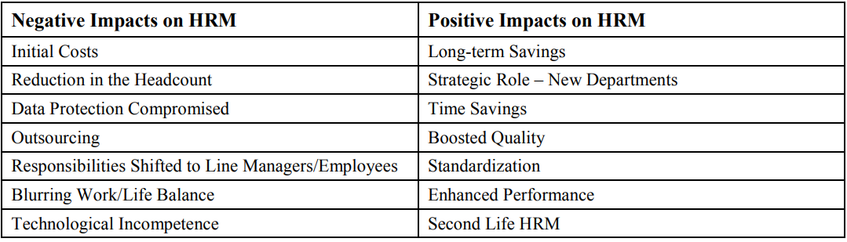
Source- (Looise, 2015)
Kogovsek and Kogovsek (2013) proposed that the involvement of technology in business does not only give benefit, but it also attached with some challenges and critical issues that may decline organisational profit. Above the table is showing the positive as well as the negative impact on technology on HR. Use of technology depends on the nature of business. For example, the small company used Microsoft Word or Microsoft Excel file to keep the necessary employee data. In contrast, the massive company manage data of managers, supervisor and employees with a diverse range of information (Nouri et al.,2019). This difference required the right technological tools to explore the information of employees for taking an HR decision. Level of sophistication has been examined in HR technology in different phases of time. There are four stages of development of HR technology recognised to handle employee information.
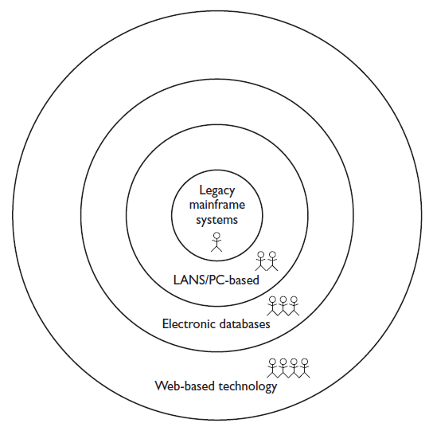

Figure 1- Stages of HR technology
Source- (Nouri et al., 2019)

Stage 1- Legacy mainframe system or paper-based systems
Initially, when a business has less engagement with technology in business, HR system was paper-based, and manual operation is done in the organisation (Kashyape, 2019). That system was independent and did not integrate with any other business-related operation. Information added as needed. Data was manually stored in mainframe computers, and it was a gradual process (Anderson, 2014). HR was the sole custodian of the data. Employees get their information directly from HR and resolve their problem by sharing with him.

Stage 2- Early personal computer (PC) technology (LAN, PCs)
In this stage, employees’ information migrated from paper to PCs and local area network (LAN) systems. Based on HR information, employee report was generated and listed “tombstone” data termed as necessary employee information. Advances observed in this system is payroll and some original versions of employee tracking. Hence, it can say that when paper-based technology moved to PC, only a few features were added to access information that was on a fundamental level (Martin and Cerdin, 2014). HR data stores in client-server and network architecture designed to allow access from every computer in the organisation. The server allows different users or HR professionals through specific user ID to access particular information over the server.
Stage3- Electronic databases System
Next stage in human resource technology observed as a relational database technology. A relational database enables management to access data from different files stored in different locations. The hospitality industry also utilised the benefit of the enterprise-wide system, which accesses cross-functional data as per requirement rather than a single department or group within the organisation (Taylor, Osland and Egri, 2012).
The famous enterprise-wide system was SAP because the use of the internet was increasing in business when this technology introduced in the market (Rashid, Hossain and Patrick, 2002). HR continued to improve its data but also evolve in a more integral part of the business. HR data became essential to generate report empowers HR function to provide a wide range of information for HR-related decision. For example, if a company wants to send mass mail for employees regarding the new product or organisational change, it will have to access data from the HR system. HR can quickly gather employee data electronically from the system using a relational database system.
Stage 4- Web-based technology
At present, the hospitality industry is enjoying the web-based technology in its HR functioning. Benefits of web-based technology allow HR to access the data from the different unit to take full HR decision. The organisation starts using interactive calls for better response and this IVR (Interactive Voice Response) based on telephonic technology in which a touch-tone phone used for accessing data from different integrated organisational units.
In the current period, Sturman, Corgel and Verma (2011) observed that the organisation is taking employee attendance through the coding machine and thumb impression work as a unique identity for employees. It also allows users to access information using the web-based application using a secure password-protected login page. For the most part, the HR department continues to work as a custodian of HR information. However, another department would also understand the value of employee information for taking such an important decision (Cole and Kelly, 2015). To analyse the benefit of this web-based technology, refer to Appendix 2.
Future stage- What is Next?
Musa, Ahmed and Bala (2014) proposed that continuous advancement in technology changes functions and feature but now the main theme of advancement in technology is the speed in information access. This new technology does not mean a reduction in HR staff but managing them effectively. This new system is mainly emphasising over translating information into knowledge so that many HR decision can be taken (Bondarouk, Harms and Lepak, 2017). In this technology, IT and HR both are working simultaneously to leverage this technology. It has been observed that high performing organisation spending 25% fewer people in the HR operation because of the technology (Cole and Kelly, 2015).
It is assumed that advanced technology will bring more features in HR technology and sharpen the skills of employees. That would also improve the functioning of HR, enhance management ability to judge the candidate, manage their performance records and offer a sustainable competitive business advantage.

3.0 Conceptual framework

HRM practices
Recruitment and selection
Training and development
Employee participation
Performance appraisal
Compensation and reward

Adoption of Human resource information system (HRIS)
Continuous advancement in HR technology
Improvement in HR operation
E-recruitment
Database management system
Instant decision making
Cost-effective benefits
Overall improvement in HR efficiency

Figure 2-Conceptual framework for the impact of IT on HRM in the Hospitality Industry
Above conceptual framework is presenting the changing role of HRM due to advancement in technology. Role of IT is increasing in HR practices and thus improving performance and reducing the cost of HR operations. Strategic management quickly gets relevant information using HRIS, which integrates information and quickly retrieve when required (Weeks, 2013). Ruël and Bondarouk (2014) pointed out that the traditional requirement and selection process changed into E-recruitment, data management using relational and web-based DBMS. However, Cole and Kelly (2015) presented that advance technology benefits HR to take advantage of fast information access, evaluation of training and employee performance.

4.0 Theoretical Background
As per significant research performed by CEO (Centre for Effective Organizations) and Human Resource Planning Society jointly, big companies required to concentrate on establishing sound relationships with the use of technology for enhancing profitability (Rodriguez and Johnstone, 2015). The research also highlighted that there is a low combination between the use of technology and HR functions because the majority of HR departments are underdeveloped and underperforming and hence required to be a part of overall strategies of the organisation along with the use of IT in HR activities (Palacios-Marqués and Devece-Carañana, 2013).
Hwang et al. (2014) studies that performed in assessing the effectiveness of technology in the hospitality sector have confirmed that technology has brought incredible changes in the manner of employees work does and manage the business. Introduction of systems like CRS (Computer Reservation Systems), GDS (Global Distribution Systems) and internet development has changed the strategies as well as operational practices in the Hospitality sector (Jackson, Schuler and Jiang, 2014). The changes have shifted the focus of players in the hospitality sector from physical assets to customer’s satisfaction. Advanced technology has a crucial role in sustaining and maintaining the customer focus (Musa, Ahmed and Bala, 2014). Further, because of the rising number of transactions and changing necessities, hotels require more integrative and powerful IT related tools which would help in gaining competitive advantage as well as provide support for survival. Although, there is no exact formula as to how IT provides a competitive advantage in the hospitality sector.

5.0 Trend in HR and technology in the Hospitality Industry
The hospitality sector is an enormous service industry which includes a wide range of services. It includes such as food and drinks services, lodging services, event management services, park services, cruise line services, transportation services, travel services and other areas related with the tourism industry (Sturman, Corgel and Verma, 2011).
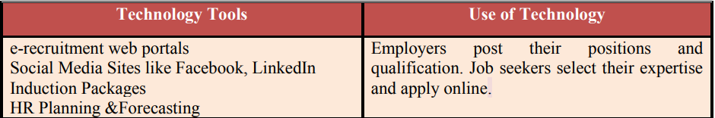
Source- (Nouri et Al., 2019)
Above the table is showing the tools used in HR procurement. Online recruitment through the e-recruitment web portal, social media like Facebook, LinkedIn, HR planning and forecasting. It has been observed that social media is playing a crucial role to attract job seekers from different areas. They can apply for the post as per their knowledge.
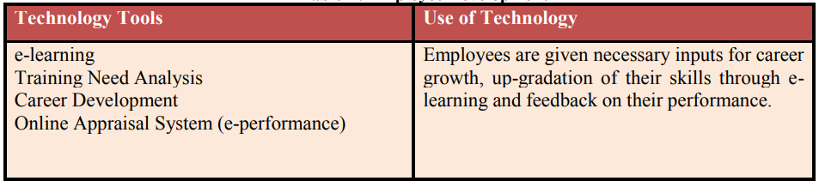Source- (Nouri et al., 2019)
E-learning, training need analysis tools are used to improve employees' skills and to give them feedback on their work. Online appraisal system helps managers to assess employee performance and taking corrective actions to improve their performance. The hospitality sector is that sector which relies on the amount of disposable income available and leisure time available with the customers (Sturman, Corgel and Verma, 2011). A unit of hospitality like hotel, restaurant or park involves various human resources like workers in the kitchen, housekeepers, servers, bartenders, marketing staff, HR staff, accountants etc. (Bottorff, 2013).
Marriot hotel is well known for keeping job title secret to avoid competitors for getting details of its initiatives. Stone et al. (2015) stated that most of the people recruited in the Marriot hotel do not know their position during the whole selection process. Looise (2015) also agreed that this improves challenges for employees and getting a new opportunity to improve their skills.
Over the years, Martin and Cerdin (2014) observed several changes in HR practices observed in the hospitality industry due to the rapid involvement of technology. The last ten years have brought extreme changes in HRM, especially in the Hospitality sector. The prime factor behind this is the development of ever upgradable advanced technologies which has helped in the automation of the majority of work of HR officials. The present-day HR department seems no busier as it was before. Apart from that software which has automated the payroll and smoothens onboarding procedure, there are many platforms which have helped in streamlining the process of recruitment, and the system of talent management has empowered organisations to quickly assess the requirement of training for their employees (Looise, 2015).
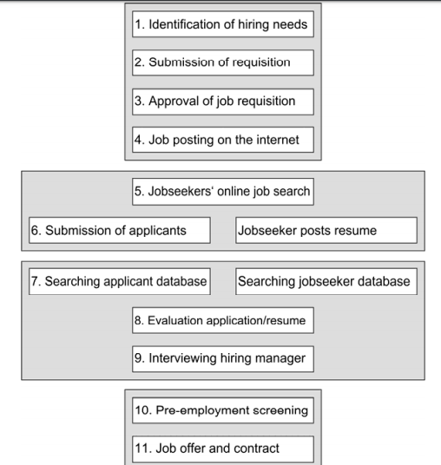
Figure 3-Extended Lee model using a job seeker perspective
Source- (Martin and Cerdin, 2014)

Above model has been extended by incorporating applicant’s perspective. Technology has changed recruitment to retirement process of employees. Employers identify the need for organisation, posting jobs on websites and attracting job seekers online. Candidate search jobs, post their resume and further process of shortlisting also demonstrate on the web portal. The employer made an online test for assessing primary abilities among candidate and complete the screening process. Selection of candidate also done online and offer letter and company contract send to candidates. These processes are done manually when technology was not extremely used at the business level. Today business relies on technology to perform its diverse range of functions (Looise, 2015).
The present-day HR department is no more engaged with personnel administration and management (because of automation). It is forward-looking, who spend their time and energy in strengthening organisational culture and managing the engagement of employees (Kaufman, 2015). They are also concerned with making the employees happy at the workplace and make them stay with the organisation for a foreseeable future.
However, Martin and Cerdin (2014) observed that although many evolution and progress happened in HR functions, still management practice are lacking in various areas. The prime reason behind this might be the fear of change, i.e. the HR managers might be reluctant to introduce new technologies because of fear of losing their job because of no requirement of them. On the other hand, Anderson (2014) also proposed that HR managers could invest in innovative HR platforms and technologies that would make the organisation more valuable and improve the morale of the team and increases the productivity of the organisation.

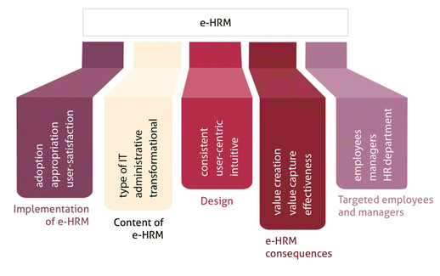
Figure 4-Electronic HRM or E-HRM
Source- (Cole and Kelly, 2015)
The integration between HRM and technology is termed as Electronic-HRM. Attempts to define e-HRM, various authors have presented their views from its inception, at around the time of the Beer. e-HRM is defined as ‘specialised information system for managing human capital and improving its efficiency.
The e-HRM in business is concerned with the integration of all mechanisms and HRM content which retrieve by different level of management/department or an individual. That makes HRM processes distinctive and consistent, increase the level of reliability and improve the long-term opportunity for targeted users (Bondarouk, Schilling and Ruël, 2016).

6.0 Advantage of advanced technology to HR in Hospitality
New technology brings changes in business culture and resolves various existing problems. A debate has been conducted between the changing roles of technology in human resource management, Divergence Vs. Convergence debate. This case has chosen the location of Slovakia and the United Kingdom.
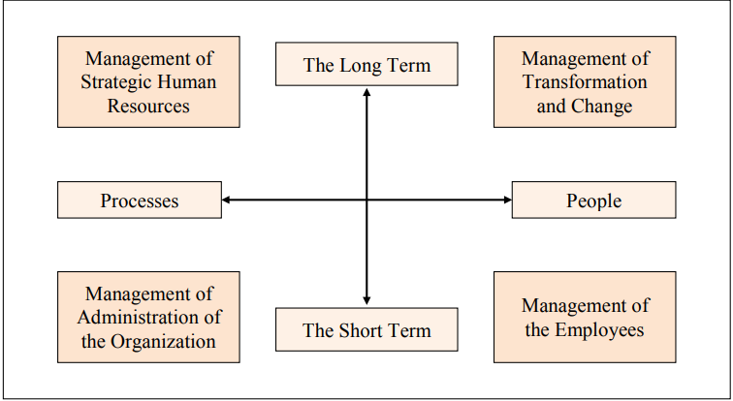
Source- (Ulrich, 1997)
A model has been presented by Ulrich, who observed that people and process of managing the resources are the prime concern of the successful business organisation. Ulrich is a famous author about the field of personal management and identified 4 Main HR roles those are personal admin expert, employee champion, change agent and strategic partner (Ulrich, 1997). However, Ruël and Bondarouk (2014) criticised that no one can explain what the roles of management that should involve in strategic management are. Although Ulrich proposed that to be a business partner individual has to perform all these four roles. Kashyape (2019) claimed that no evidence found that expressed positive relation between technology implementation in HR functions. Hippler, Brewster and Haslberger (2015) noted that human resource management as a business partner might not be considered as the fact that all organisation using advanced hardware and software. Kaufman (2015) proposed that some tough task of HR has been replaced with technology in the current business environment. Some organisations are fully automated, thus changes the HR policies and skills needed to manage HR functions. Kogovsek and Kogovsek (2013) stated that Apple, Google and other technology company employed effective techniques to assess human resource performance and managing them to improve productivity level. However, Rodriguez and Johnstone (2015) argued that competitive advantage is not sufficient, but the capacity to learn faster than competitors.

6.1. AI is making Recruitment Smarter
Recruiting new candidate is time-consuming and costly in a competitive business environment if the new application of technology was not available to support HR practices. Thanks to automation and AI (Artificial Intelligence), which made HR practices easier, and this enables easy recognition of skilled people who are potentially strong to manage business responsibility. AI made recruitment easy through automated resume screeners to robot interviewer, a wave of these tech solutions hit the market and getting access to talented and skilled candidates (Bondarouk, Harms and Lepak, 2017).
Jackson, Schuler and Jiang (2014) argued that AI is used to recognise the outperforming candidate in such areas to evaluate hard skills. AI also allows recruiters to focus on more narrow areas of skills which fit in organisation culture. Taylor, Osland and Egri (2012) stated that machine learning and AI had changed the way of recruitment, hires and onboard new employees. Taking the support of social media and intern application pool candidate gap and leverage the challenges of searching the right place to work made natural recruitment.

6.2. Compliance is more efficient and sophisticated
Staying compliant is one of the significant challenges for HR in an era of change. Laws and regulations are continuously changing and require heavy use of paperwork and information. Compliance dedicated to managing storage in the organisation, but cloud-based solutions have streamlined the process (Geffen, Ruël and Bondarouk, 2013). Technologies enable HR to evolve labour laws, to navigate the complex and sometimes politically charged compliance issues. Any businesses that embrace technology for compliance receive a higher position in the market due to more attractive recruiting and retention efforts and offer a better working condition to engage the employee in the long run.

6.3. Analytics drive Better Performance Management
Jackson, Schuler and Jiang (2014) proposed that performance management is an essential HR function to assess the work achievement of employees and giving rewards to motivate them. HR mainly emphasise the process of monitoring performance, collecting supervisory feedback and reviewing the employee performance regularly. Technology has eliminated various unnecessary steps, but adequate data-driven phases used to assess employee performance (Bondarouk, Harms and Lepak, 2017).
Martin and Cerdin (2014) found that HR is highly emphasising on the adoption of people analytics that allows managers and supervisor to take easy decision related to the workforce. The raw data used in analytical software and create actionable insights and give the right decision for promotions or compensation, development and succession planning (Jackson, Schuler and Jiang, 2014).

6.4. Better Analytics Boosts Diversity and Inclusion
Silberschatz, Korth and Sudarshan (2010) proposed that there is a positive relationship between the ethnically and gender-diverse leadership team, which directly improve profitability for the business. Candidate mainly looking over the companies offer a more diverse range of environment to learn new things which are impractically impossible in local work culture. In the case of HR functions, use of D&I (Diversity and Inclusion) is increasing and have pressure on HR software vendors to provide more features to handle HR function effectively.

6.5. Engaging Employees
A significant problem before HR managers is that most of the workers are not or less engaged in the workplace, which creates boredom and makes the employee reluctant to adopt new changes. Anderson (2014) found in his study that engaged employees are happier, and their productivity is also higher. On the other hand, in comparison to disengaged employees, it is less (Bondarouk, Harms and Lepak, 2017). When HRM concentrates on attracting the level of engagement of employees, it will improve their work quality. It would create a feeling of belongingness among employees resulting in helpful and positive moods in comparison to employees who are disengaged who might find it hard to smile (Horwitz and Budhwar, 2015). Technology plays a crucial role in identifying the level of engagement of each employee and assessing the training requirement of each employee. Use of advanced HR software would help in raising the level of engagement of employees in all sectors including hospitality sector thereby providing the organisation with the more motivated and competent employee (Hippler, Brewster and Haslberger, 2015).

6.6. Strengthening Culture
In last ten years use of advanced technology has made it easy for the hospitality industry to measure the happiness level of an employee with the culture of the organisation and confirming that everything is going as per plans (Butler, 2012). For instance, performing an online survey on the intranet would help in assessing whether after any new change employee are satisfied or feel stressed and overloaded (Silberschatz, Korth and Sudarshan, 2010).
Assessing such data, HR managers could decide as to whether to continue with the same program (if results are positive) or change the program (if results are negative).

6.7. Managing Talent
In the past ten years, HR has developed remarkably. Apart from applying technology in every function of HR, companies are utilising HRM for making the organisation stronger. In place of concentrating in management of records and fulfilling compliance-related matters, the modern-day HRM is hospitality sector spend the time on improving the engagement of employees, developing a more attractive and robust culture within the organisation and managing talent beginning from recruitment of employee till his exit (Grzinic and Saftic, 2012). Firms who have applied this modern HR approaches, which are technology-based have realised that their employee is happier and enjoy the honour of happier customers which improves its bottom line.

7.0 Evolution of Human Resource Management
For understanding the HRM (Human Resource Management) evolution process, it is required to know the ground on which has developed. In this section, the HR function evolves the technological aspect of functioning and how their values are discussed in detail.

7.1 The Traditional Human Resource Approach
The concluding decades of the 20th century have experienced various changes affecting the profession of personal managers. In light of the scientific management approach given by Taylor for improving productivity, it was noticed that primary motivation and productivity drivers were non-monetary (Cole and Kelly, 2015). A variety of innovative theories have evolved due to this change in behaviour. Some most popular theories which developed were Maslow’s need hierarchy theory in which it was explained how a person aspires for achieving next-level need (Kaufman, 2015). Even governments have established various laws for protecting the rights of the workers.

7.2 The Personnel Management Approach
The approach of personnel management, which succeeded in the twentieth century, has been more like managing (Anderson, 2012). Originating from the requirement for ensuring compliance of constitutional standards, it relates itself mainly with below areas, and afterwards, advanced technology has impacted it significantly. Rodriguez and Johnstone (2015) admitted that record keeping of employee and following policies through performing tasks like selection and recruitment, wage administration and training are an essential function of HRM. Initiating measures for the welfare of workers like vaccination facility, housing facility, medical care etc. (Den Hartog et al., 2013). Making efforts for improving efficiency by way of increment in wages, proper training and adherence to standards originating through work studies formulated through using scientific approaches proposed by Taylor or other. Negotiating with union leaders and deriving solutions for conflicts by suitable bargaining and related approaches under industrial relations (Beer, Boselie and Brewster, 2015).
The approaches used by Personnel Management aimed for the rousing interest of management for workers welfare and social obligation and making employees convinced with the organisational interest (Marler and Parry, 2016). Personnel managers hardly have a direct voice in the strategy of the organisation and are not directly involved in operational work.

7.3 Changes in the Structure of the organisation in the 21st century
Many large organisations till the end of the 1980s had a controlled and centralised organisational structure. This structure was compatible with a study and a stable business environment. Since the 1980s and in the 1990s the increased in competition, changes in technology and increased globalisation exposed the businesses to a more competitive and unstable operating environment. In this kind of environment, the centralised and administrative management structures were inflexible and ineffective (Bondarouk and Furtmueller-Ettinger, 2012). Another reason for the development of new management styles has been the de-industrialisation of the western economies and the emergence of the services sectors. Rodriguez and Johnstone (2015) stated that employees have to manage more accurately than before. They need to be developed, and the management has to invest in them in terms of development and training to ensure that they are motivated and perform at their levels (Bondarouk and Furtmueller-Ettinger, 2012). That has forced managers to develop their competitiveness and performance; thus this led to achieving the best results from the employees along with all other resources of the organisation (Bondarouk, Harms and Lepak, 2017). The decision-making process is much faster and involves less bureaucratic controls. As each department is working on its own, it can be much quicker to respond to consumer changes and changes in demand patterns (Bondarouk, Harms and Lepak, 2017). Research has proved that when employees are more involved and committed to their work, they are more motivated and remain involved in their jobs (Brewster, Brookes and Gollan, 2015). This development in new ways of managing employees has strongly been influenced by the Human Relations School that focused on employee development, motivation and leadership. New management techniques have identified other job-related factors, such as employee development and conditions at work, which can motivate and enhance employee performance (Marler and Parry, 2016). The increased competition which has resulted from globalisation has made it necessary for organisations to adopt a new management style. The top-down management is no longer suitable (Brynjolfsson and McAfee, 2014). The management is now focused on getting the best out of the employees. Thus, the organisational structures have changed as the new organisational culture favour a flatter structure which has a more responsive team structure. These teams are empowered to take action on their own, and there is not much focus on the classical command and control systems that were typical (Davilla and Elvira, 2012).

8. 0 Modern HR functions in the 21st century
Function and responsibility for HRM are increasing with increment with the technological revolution in the hospitality industry. The essential role of HR in the modern business world is presented below:
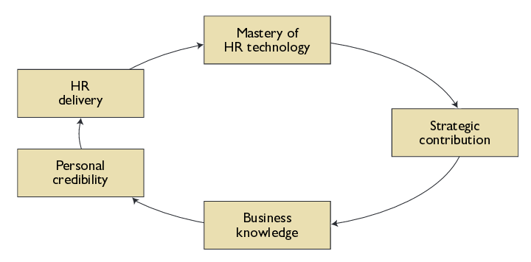
Figure 5-Role of HR
Source- (Bulmash, 2006)
- Virtual team management- Virtual teams are the group of people those intended to achieve a common goal but not located in the same place. Management of these teams is difficult in case of traditional HR practices, but now modern technology allows remote access of information through web-based technology. GPRS and social media allow communication with team-members worldwide (Jackson, Schuler and Jiang, 2014).
- Strong HR leadership- Leadership is an essential quality in management which all managers have to lead their employees. IT evaluation in HR improved the ability of a leader to take such an important decision related to human capital and resource planning.
- Flexibility and creativity- IT make the smooth flow of information worldwide, and this allows flexibility and creativity in HR practices to assess candidate quality and giving them the right treatment to achieve common organisational goal. Apart from these above function, job rotation, recruitment and selection, training and development and performance assessment some standard functions of HRM that featured with advanced technology and highly talented candidates are explored to get a sustainable competitive advantage (Marler and Parry, 2016).
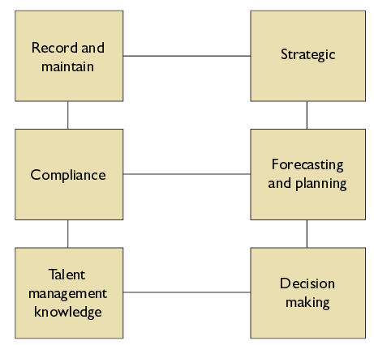
Figure 6-Key Functions of HRIS
Source- (Bondarouk, Harms and Lepak, 2017, pp-1336)

Human Resource Information System (HRIS) could help in lowering the use of paperwork, and manual work relates to record-keeping. It assists in retrieving data accurately and quickly. It permits a fast analysis of issues to relate to HR. Significant functions of HRIS has been presented in the above graph (Jackson, Schuler and Jiang, 2014). Primarily it records and maintains employees’ data. Talent management knowledge and compliance are some significant functions for HR while it supports strategic management to take decision and forecasting of human needs in the organisation.

9.0. Theories of HRM
Human resource management engaged with various theories to recruit, train and motivate employee for long-run profitability in business. Some critical theories have been discussed here.

9.1 Organisation Theory
Henry Mintzberg argues that the four definitions of managerial work laid down by Fayol: planning, organisation, coordination and control on the daily routine. Indeed, Mintzberg concluded in a significant finding, “the executives I was studying—all very competent by any standard—were fundamentally indistinguishable from their counterparts of 100 years ago, or a1000. The information they need differs, but they seek it in the same way-by word of mouth.” The classical theory of organisation suffers from superficiality and lack of realism (Bondarouk and Furtmueller-Ettinger, 2012). The academicians restricted themselves mainly to the areas of authority, which may be ideal or real but failed in covering remaining crucial elements having an impact on the organisational performance.

9.2 Contingency Theory
The contingency approach highlights that there is not a single best way to manage and therefore underscores the need for managerial approaches based on all relevant facts. It rejects the idea of one best form of structure.
Causal relationship: Critics have doubted the causal relationship between structure and performance, stating that there could be other factors such as the personal characteristics of management and staff that could influence performance. That structure could also be changed by management due to the feedback they get from the performance.
Organisational performance: The measurement of organisational performance has been inaccurate and challenging as such it is not possible to derive for the measurement of the organisational fit that is understood by the theory (Davilla and Elvira, 2012).
Independent variables: Critics raised about the supposed status of the independent variables as the ‘given’ and beyond the control of members of the organisation. What if the organisation is big enough and probably a monopoly and can have influence over its environment through lobbying and advertising? In such a case, any difference in eventuality factors is likely to have less consequence for survival and level of performance (Ehnert and Harry, 2011).
Planned change: Contingency models of organisation are criticised for their failure to give adequate attention to the unexpected consequences of planned change, for example, the effects of the introduction of new technology on the internal working of the organisation or the social interactions among groups of people engaged in certain activities (Martin and Cerdin, 2014).
Power factors: There are other factors beyond contingency conditions that significantly impact on the determination of organisational structure the ‘power’ factors. These could be pressures from the power needs shareholders, management and staff; government in case of public sector organisations; the culture of the organisation and the power of social norms.

9.3 Resource-based theory
The resource-based theory of HRM has given attention to the strategic value of the human capital and existed issues of learning. Rodriguez and Johnstone (2015) stated that the organisation is a collection of productive resources. Marler and Parry (2016) distinguish between physical and human resources and draws attention to the issues of learning, which comprise knowledge and experience of the team members.
Musa, Ahmed and Bala (2014) believes in the strategic capability of an organisation depends on the resources, specifically human resources. The human capital is highly utilised in the organisation and offer a more competitive advantage. Musa, Ahmed and Bala (2014) noted that competitive advantage means a situation of utilising the existing resource effectively in comparison to existing competitors for serving customers. The organisation is looking for a sustainable competitive advantage. However, Stone et al. (2015) presented that if any organisation develops extraordinary, reliable strategies, policies, norms and practices that enable the organisation to achieve sustainable competitive business advantage then its functioning is based on the resources-based approach. Wilby (2012) mentioned that the main principle of this theory is that resources of the organisation are the fundamental forces which should be applied with the knowledge to get optimum output. Resource-based theory implied that the organisation should improve the calibre of human resource by applying active learning and knowledge improvement tools for achieving both organisational and personal objectives (Musa, Ahmed and Bala, 2014).

10.0. HRM and Evolution of Technology
Human resource management is a critical part of an organisation which deals with managing, improving human efficiency for better outcomes. In this part, changes in HR technology in the last ten years and its impact on business, performance has been evaluated. Different kinds of data and information systems have been introduced to ease HR functions and improving Human capital efficiency.

10.1 HR Technology (2008-2010)
In the view of Bakia et al. (2012), from the year 2008, the landscape has begun to change aggressively in the field of HRM. As soon as trade and technology changed in the marketplace, it began to increase and lead to operations globally with the new HRM tool called talent management. On the other hand, Chakrabortty (2012) argued that the role of Human Resource is changed inside to provide to the requirement of strategic business like strengthening organisational structures, talent management and human resource planning. As per commented by Gordon (2012), concerning the technology advancement in the hospitality sector, in order to assist the HR process, Human resource management accepted new tools like online learning management applications, application tracking software and employee portals. These tools were either built internally or purchased from a seller. As per Wilby (2012), an organisation in the year 2008 to 2010 achieved more maturity than earlier via the adoption of software systems and tools; it developed a requirement for further divide the functions of the human resource into sub-functions and processes like Administration, Learning and Development, Recruitment and Payroll.

10.2 HR technology in the year (2011-2014)
In the view of Lynden (2011), at the end of the year 2010, technology advancements concerning data management made possible simplifications in the processes. It made human resource to concentrate on more essential as well as critical parts of the HRM like Succession Planning, Training and Retention as well. Woollaston (2014) argued at the beginning of 2011, in the field of Human Resource Development, Cloud Computing acted as a game shifting advanced technology, and it led to redefining the landscape of the businesses. Advancement in the technology made functions of human resource development easier such as access to information over the cloud through seamlessly made tasks relaxed for different departments and sub-departments in order to network and team up better (Musa, Ahmed and Bala, 2014). From these years, advanced technology eliminated the requirement of any supply to be served on-site.

10.3 Year (2015-2018)

10.3.1 Cloud remains in the projection
Moving of Human Resource Development to Cloud Computing was not just a new concept but much known in the middle of 2014. On the other hand, Galtung (2015) argued that in the field of Human Resource Development, Cloud Computing is still in its phase of adaptation. In the hospitality industry, HR managers were ready to get advantages of advanced technology such as solution via cloud computing (Sbarski, 2017). Cloud computing offers increased flexibility, reduced cost, faster updates, as well as innovation to the firms. In this way, Human Resource Managers could be in a relaxed mode, which was dealing with the expenditure of new system upgrading and in less time every year (Rodriguez and Johnstone, 2015). In order to gain these advantages, leading Human Resource Solution is included with SAP, ADP, Info, Oracle and Workday software on the cloud with the solutions because this software vendor can do all the solution automatically (Wilby, 2012).

10.3.2 Going mobile
Mobile apps were introduced earlier, but the use of mobile apps progressively and regularly started in this period. At the same time, Sbarski (2017) supported, with the increasing appearance of the SaaS approach and Cloud-based Apps, use of Mobile applications is rapidly raised. Mobile Apps and its use in the field of HRM reduced time and saved money. That led to making administrative load less. Galtung (2015) predicted that the mobile app technology in HRM would significantly develop the practice of self-service. In the field of HRM especially in the hospitality sector, people are genuinely involved in digital methods in order to apply for a job and get recruited via the assistance of mobile apps (Francis, Parkes and Reddington, 2014). Organisations use mobile app for offering requirements and valuable information through this app. On the other hand, Sbarski (2017) argued and opined about privacy issues and risks due to the mobile app.
In the view of Woollaston (2014), it is seen that necessary changes in HRM due to technology advancement are adapted from time to time. Human Resource management with modern technology will be beneficial, as well as less stressful (Martin and Cerdin, 2014). It helped and is still helping in the recruitment process and selecting talented employees for the organisations. By following trends of human resource management, a manager can help the firm in maintaining the organisation’s human resource activities successfully.

10.4 Future of HR technology (2019-future)

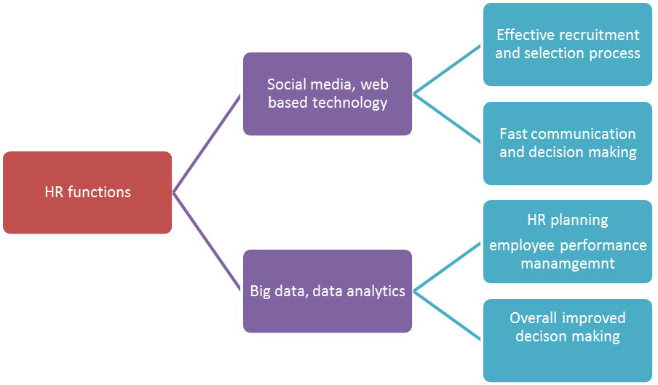
Figure 7-Future HR conceptual framework

Future of HR technology is internet-based and supported by various data analytical software. It is assumed that social media and web-based technology would evolve more in the recruitment and selection process because it has widened the area of HR core functions. It would also improve the assessment of employees making fast communication among management to take effective HR decisions (Kaufman, 2015). Big data and data analytical software would be used in future to assess employees’ performance and reward them for motivating and making them loyal for a more extended period. It is also believed that employee would prefer a more online approach to work and the concept of online or home- the based job would be increased that makes people more free for their personal life. HR functions are highly supported with technology and would also lead to a more favourable result in its performance in future.

10.4.1 Virtual and augmented reality
As per Nouri et al. (2019), it has been time to introduce augmented reality for a few years, but the application of virtual reality is hardly making progress in the market place. In this way, augmented and virtual reality is growing and maturing steadily and making its way to gain the working environment in the market (Sbarski, 2017). For instance: Microsoft (one of the most prominent organisations in the field of technology and innovation) is planning to introduce a headset “Hololens” that would be used by HR professionals shortly. This kind of innovations is mainly done with the objective for productivity as well as talent management. Wilby (2012) predicted the possibilities and future with virtual and augmented reality in firms’ training, development and learning where human resource uses the virtual reality for everything from corporate training to offsite assignments.
In addition to that, sectors which are targeting improved performance about the job, it would get normalise, since digitally available information is imposed expressively on the reality of the physical world. Training, as well as onboarding in organisational culture, could be changed through the addition of practical guidelines on the body of machines as well as tools, which will be used by the employees working with them (Bakia et al., 2012).

10.4.2 Advanced Machine learning
In the view of Lynden (2011), data analysis which is done automatically is called machine learning. Machine learning provides assessment via analytical models which are automatically created by algorithms. It is integrated not only for gathering the data but learn from that also in order to answer any situation (Looise, 2015). It identifies data sets from the business environment and learns for that. Advanced machine learning technology can enhance the efficacy of the analysis that human does; it also offers the human resource to look at broad scope and results and concentrates on the complex and challenging analysis (Wilby, 2012).
In the field of human resource management, the particular application focuses on recruitment processes, talent relationships and predictive analysis as well. One of the examples of this technology is “PhenomPeople.com” which does marketing data analysis and personalisation practices and uses the results in the process of recruitment. It also focuses on Employee Engagement. For example, KPMG recently developed a model for employee engagement, which is a machine learning process (KPMG, 2017).

10.4.3 Autonomous things and Agents
The technology of robotics is still growing about capacity and diversity of task along with autonomy. In this direction, one simplified example is a car which is autonomous driving enabled, however, the critical point about that which mostly remain unnoticed is that the state which is different from controlled environments and movement in open spaces. That indicates for the managers of Human resources departments, the requirement to build and train advanced skills to current employees (Cole and Kelly, 2015).
In the coming future, autonomous agents and machine learning would be similar to Hal provided by Space Odyssey (Nouri et al., 2019). Such agents have the capacity as well as capability to turn into nexus of private information by enhancing efficiency and improving the communication of company by providing access to correct and relevant data in right time (Mazilu, 2012). Its usage might be varied, such as recruitment to the engagement of employees or more.
Despite the rising usage of technology in the world of business, the human resource would be going to be the most complicated and vital asset for the company. The effective management of HR is vital for gaining competitive advantage. In the subsequent time, it is expected that technology has a significant role in assisting HR in assigning business strategies with the goals of individuals (Cole and Kelly, 2015). In nations like India in which there is a massive demand for a human resource, use of advanced technologies for linking workers with the employees is vital for attracting talent, retaining and engaging talent.

11. Conclusion
This essay described various stages of technology advancement in HRM. In this essay, technology evaluation of HR through Technology and various theories have been undertaken. The essay also presented the impact of advanced technology on organisational change in the hospitality sector and informs the technology of the future. Advancement in technology supports business operation effectively and offer more chances for an employee to improve their skills. Different theories of HRM suggested that human resources are fundamental in the business organisation, and their information is valuable for an organisation to take such important decisions. Future of HR technology would be more positive to support HR functions, but its implication and evaluation should be handed to the right person for improving overall organisational productivity.

References
Anderson, C. (2014) Makers: The new industrial revolution. New York, NY: Crown Business.
Bakia, M. et al. (2012) Understanding the Implications of Online Learning for Educational Productivity. U.S. Department of Education. Available at: https://www.sri.com/sites/default/files/publications/implications-online-learning.pdf [Accessed: 10 October, 2019].
Beer, M., Boselie, P. and Brewster, C. (2015) Back to the future: Implications for the field of HRM of the multi-stakeholder perspective proposed 30 years ago. Human Resource Management, Vol.54 (3), pp.427-438. Available at: https://web-a-ebscohost-com.ezproxy.uwtsd.ac.uk/ehost/pdfviewer/pdfviewer?vid=1&sid=c1311a6f-7cf9-410d-8e0e-365a3214193b%40sdc-v-sessmgr06 [Accessed: 10 October 2019].
Bondarouk, T., Harms, R. and Lepak, D. (2017) Does e-HRM lead to better HRM service? The International Journal of Human Resource Management, Vol. 28(9), pp.1332-1363.Available at: https://www-tandfonline-com.ezproxy.uwtsd.ac.uk/doi/pdf/10.1080/09585192.2015.1118139?needAccess=true [Accessed: 10 October, 2019].
Bondarouk, T., Schilling, D. and Ruël, H. (2016) eHRM adoption in emerging economies: The case of subsidiaries of multinational corporations in Indonesia. Canadian Journal of Administrative Sciences, Vol. 33(2), pp. 124–137.
Bondarouk, T. and Furtmueller-Ettinger, E. (2012) Electronic human resource management: Four decades of empirical evidence. Academy of Management Annual Meeting Proceedings, Vol. 2012(1), p1-1.
Bottorff, T. (2013) "Hospitality management: a guide to key reference works", Reference Services Review, Vol.41 (4), pp.605-622. Available at: https://search-proquest-com.ezproxy.uwtsd.ac.uk/docview/1445014998/fulltextPDF/7AABC24C36454EFAPQ/1?accountid=130472[Accessed: 10 October 2019].

Brewster, C., Brookes, M. and Gollan, P. J. (2015) The institutional antecedents of the assignment of HRM responsibilities to line managers. Human Resource Management, Vol. 54(4), pp.577–597.Available at: https://web-b-ebscohost-com.ezproxy.uwtsd.ac.uk/ehost/pdfviewer/pdfviewer?vid=1&sid=d8ae20ed-dc59-41d4-81fd-04a8594700fe%40pdc-v-sessmgr02[Accessed: 10 October, 2019].
Brynjolfsson, E. and McAfee, A. (2014) The second machine age. Work, progress, and prosperity in a time of brilliant technologies. W.W. Norton & Company.
Bulmash, J. (2006). Human resource management and technology. Chapter 3. Available at: https://catalogue.pearsoned.ca/assets/hip/us/hip_us_pearsonhighered/samplechapter/0132270870.pdf[Accessed: 10 October, 2019].
Butler, J. G. (2012) A History of Information Technology and Systems. The University of Arizona.
Chakrabortty, A. (2012) Innovation – who would dare oppose it? The Guardian, 1 October. Available at:https://www.theguardian.com/commentisfree/2012/oct/01/innovation-who-dare-oppose[Accessed: 10 October, 2019].
Cole, G.A. and Kelly, P. (2015) Management Theory and Practice, 8th ed. Hampshire: Cengage Learning EMEA.
Davilla, A. and Elvira, M. (2012) The Latin American HRM model. In Brewster, C. and Mayrhofer, W. (Eds.) Handbook of research on comparative HRM (pp. 478–493). Cheltenham: Edward Elgar.
Den Hartog, D.N. et al. (2013) HRM, communication, satisfaction, and perceived performance a cross-level test. Journal of Management, Vol. 39(6), pp.1637–1665.Available at: https://journals-sagepub-com.ezproxy.uwtsd.ac.uk/doi/pdf/10.1177/0149206312440118[Accessed: 10 October 2019]
Ehnert, I. and Harry, W. (2011) Recent developments and prospects on sustainable human resource management: Introduction to the special issue. Management Revue, Vol. 23(3), pp.221–238. Available at: https://search-proquest-com.ezproxy.uwtsd.ac.uk/docview/1080801967/fulltextPDF/5DF3269950624259PQ/1?accountid=130472 [Accessed: 14 October, 2019].
Francis, H., Parkes, C. and Reddington, M. (2014) E-HR and international HRM: A critical perspective on the discursive framing of e-HR. The International Journal of Human Resource Management, Vol. 25(10), pp.1327–1350.Available at: https://www-tandfonline-com.ezproxy.uwtsd.ac.uk/doi/pdf/10.1080/09585192.2013.870309?needAccess=true [Accessed: 12 October, 2019].
Galtung, J. (2015) "Prabhat Ranjan sarkar's social cycles, world unity and peace; Renaissance 2000 honouring Sarkar's 75th Anniversary, LA 1". Metafuture.org. Available at:http://www.metafuture.org/sarkar/prabhat.htm [Accessed: 21 April 2019].
Geffen, C., Ruël, H. J. M. and Bondarouk, T. (2013) E-HRM in MNCs: What can be learned from a review of the IS literature? European Journal of International Management, Vol. 7(4), pp. 373–393. Available at: https://www.researchgate.net/publication/239851558_E-HRM_in_MNC's_What_can_be_learned_from_a_review_of_the_IS_literature[Accessed: 10 October, 2019].
Gordon, R.J. (2012) ‘Is US economic growth over? Faltering innovation confronts the six headwinds’. Research Paper, 18315. Available at:https://www.nber.org/papers/w18315.pdf[Accessed: 23 April 2019].
Grzinic, J. and Saftic, D. (2012) Approach to the development of destination management in Croatian tourism. Management Journal of Contemporary Management, Vol.17 (1), pp. 59-75. Available at: https://web-a-ebscohost-com.ezproxy.uwtsd.ac.uk/ehost/pdfviewer/pdfviewer?vid=1&sid=6b0a33d0-20f5-4c89-936d-3dd21017c06c%40sdc-v-sessmgr03 [Accessed: 10 October, 2019].
Hippler, T., Brewster, C. and Haslberger, A. (2015) The elephant in the room: The role of time in expatriate adjustment. The International Journal of Human Resource Management, Vol. 26(15), pp.1920–1935.Available at: https://www-tandfonline-com.ezproxy.uwtsd.ac.uk/doi/pdf/10.1080/09585192.2015.1041762?needAccess=true[Accessed: 13 October, 2019].
Horwitz, F. and Budhwar, P. (2015) Handbook of human resource management in emerging markets. Cheltenham: Edward Elgar.
Hwang, J. et al. (2014) The Impact of Occupational Stress on Employee's Turnover Intention in the Luxury Hotel Segment. International Journal of Hospitality & Tourism Administration, Vol.15 (1), pp.60-77.Available at: https://web-a-ebscohost-com.ezproxy.uwtsd.ac.uk/ehost/pdfviewer/pdfviewer?vid=1&sid=487caa8c-f433-436b-aed8-5aa99a415dcd%40sessionmgr4010 [Accessed: 15 October, 2019].
Jackson, S. E., Schuler, R. S. and Jiang, K. (2014) An aspirational framework for strategic human resource management. The Academy of Management Annals, Vol. 8(1), pp.1–56. Available at: https://smlr.rutgers.edu/sites/default/files/documents/faculty_staff_docs/Aspirational%20Framework%20for%20Strategic%20HR%20Annals%202014%20%282%29.pdf[Accessed: 10 October, 2019].
Kashyape, A. (2019) How technology has changed the way the HR industry functions and what lies ahead. Yourstory, January 23. Available at: https://yourstory.com/2019/01/technology-changed-hr-industry-functions[Accessed: 15 October 2019].
Kaufman, B. E. (2015). Evolution of strategic HRM as seen through two founding books: A 30th anniversary perspective on the development of the field. Human Resource Management, Vol. 54(3), pp.389–407. Available at: https://web-a-ebscohost-com.ezproxy.uwtsd.ac.uk/ehost/pdfviewer/pdfviewer?vid=1&sid=71483531-291a-49f0-a990-8556d144b277%40sessionmgr4009[Accessed: 1 October, 2019].
Kogovsek, M. and Kogovsek, M. (2013) Innovation in Tourism: The potential for improving the sustainability of tourism Destination, in Contemporary trends in Tourism and Hospitality, A Collection of Papers, pp. 87-95.
KPMG (2017) Talent Development Programmes. Available at: https://assets.kpmg/content/dam/kpmg/mt/pdf/2017/10/mt-talent-development-programmes.pdf[Accessed: 13 October, 2019].

Lin, L. H. (2011) Electronic Human Resource Management and Organizational Innovation: The Roles of Information Technology and Virtual Organizational Structure, The International Journal of Human Resource Management, Vol. 22(2), pp.235–257.Available at: https://www-tandfonline-com.ezproxy.uwtsd.ac.uk/doi/pdf/10.1080/09585192.2011.540149?needAccess=true[Accessed: 14 October, 2019].
Looise, J. C. (2015) The role of government and regulation in HRM. A historical perspective. Proceedings of the 9th International Conference of the Dutch HRM Network, Utrecht. Available at: https://www.researchgate.net/publication/301232287_The_role_of_government_and_regulation_in_HRM_A_historical_perspective [Accessed: 10 October, 2019].
Lynden, B. (2011) Generation Y Heavily Dependent on Technology, Promotes Laziness. The Jambar, May 12. Available at: https://www.thejambar.com/generation-y-heavily-dependent-on-technology-promotes-laziness/[Accessed: 16 October, 2019].
Marler, J. H. and Parry, E. (2016) Human resource management, strategic involvement and e-HRM technology. The International Journal of Human Resource Management, Vol. 27(19), pp. 2233–2253. Available at: https://www-tandfonline-com.ezproxy.uwtsd.ac.uk/doi/pdf/10.1080/09585192.2015.1091980?needAccess=true[Accessed: 10 October, 2019].
Martin, G. and Cerdin, J. L. (2014) Employer branding and career theory: New directions for research. In Sparrow, P.R., Scullion, H. and Tarique, I. (Eds.), (2014) Strategic Talent Management: Contemporary Issues in International Context (pp. 151–176). Cambridge: Cambridge University Press.
Mazilu, M. (2012) Sustainable Tourism of Destination, Imperative Triangle Among Competitiveness, Effective Management and Proper Financing. Available at: https://www.researchgate.net/publication/221925572_Sustainable_Tourism_of_Destination_Imperative_Triangle_Among_Competitiveness_Effective_Management_and_Proper_Financing [Accessed: 10 October, 2019].

Musa, B., Ahmed, I. and Bala, A. (2014) Effect of Motivational Incentives on Staff Turnover in Hotel Industry in Gombe State. IOSR Journal of Business and Management, Vol.16 (3), pp.36-42. Available at: http://iosrjournals.org/iosr-jbm/papers/Vol16-issue3/Version-3/E016333642.pdf [Accessed: 10 October, 2019].
Nouri, S.M.R. et al. (2019) "Autonomic decentralised elasticity based on a reinforcement learning controller for cloud applications". Future Generation Computer Systems, Vol.94, pp.765-780. Available at: https://www-sciencedirect-com.ezproxy.uwtsd.ac.uk/science/article/pii/S0167739X18302826[Accessed: 11 October 2019].
Palacios-Marqués, D. and Devece-Carañana, C. A. (2013) Policies to support corporate social responsibility: The case of Telefónica. Human Resource Management, Vol. 52(1), pp.145–153. Available at: https://web-b-ebscohost-com.ezproxy.uwtsd.ac.uk/ehost/pdfviewer/pdfviewer?vid=1&sid=281cb3ef-7a36-431e-aa60-b6866a1e56d7%40sessionmgr101[Accessed: 10 October, 2019].
Rashid, M.A., Hossain, L. and Patrick, J.D. (2002) The Evolution of ERP Systems: A Historical Perspective. Chapter 1. Available at: https://faculty.biu.ac.il/~shnaidh/zooloo/nihul/evolution.pdf [Accessed: 10 October, 2019].
Rodriguez, J. K. and Johnstone, S. (2015) Regulation of work and employment: Advancing theory and research in international and comparative human resource management. The International Journal of Human Resource Management, Vol. 26(13), pp. 1782–1784.Available at: https://www.researchgate.net/publication/276173195_Special_issue_of_International_Journal_of_Human_Resource_Management_Regulation_of_work_and_employment_advancing_theory_and_research_in_international_and_comparative_human_resource_management[Accessed: 8 October, 2019].
Ruël, H. and Bondarouk, T. (2014) E-HRM research and practice: Facing the challenges ahead. In F. J. Martínez-López (Ed.), Handbook of strategic e-business management (pp. 633–653). Berlin: Springer-Verlag.
Sbarski, P. (2017) Serverless Architectures on AWS: With examples using AWS Lambda. Manning Publications.
Silberschatz, A., Korth, H.F. and Sudarshan, S. (2010) Database System Concepts, 6th ed. McGraw-Hill Higher Education. Available at: https://kakeboksen.td.org.uit.no/Database%20System%20Concepts%206th%20edition.pdf[Accessed: 10 October, 2019].
Stone, D. L. et al. (2015) The influence of technology on the future of human resource management. Human Resource Management Review, Vol. 25(2), pp. 216–231.Available at: https://www-sciencedirect-com.ezproxy.uwtsd.ac.uk/science/article/pii/S1053482215000030 [Accessed: 12 October, 2019].
Sturman, M.C., Corgel, J.B. and Verma, R. (2011) The Cornell School of Hotel Administration on Hospitality. Hoboken, N.J.: Wiley.
Taylor, S., Osland, J. and Egri, C. P. (2012) Guest editors’ introduction: Introduction to HRM’s role in sustainability: Systems, strategies, and practices. Human Resource Management, Vol. 51(6), pp. 789–798.Available at: https://web-a-ebscohost-com.ezproxy.uwtsd.ac.uk/ehost/pdfviewer/pdfviewer?vid=1&sid=576d3532-1593-44b9-a9fa-6553c657d36e%40sdc-v-sessmgr04 [Accessed: 10 October, 2019].
Ulrich, D. (1997). Human Resource Champions: The Next Agenda for Adding Value to HR Practices. Boston: Harvard Business School. ISBN 0-875-8471-96.
Weeks, K.O. (2013) An analysis of the Human Resource Information System Impact on Employees. Journal of Management Policy and Practice, Vol. 14(3), pp.35-49. Available at: http://digitalcommons.www.na-businesspress.com/JMPP/WeeksKO_Web14_3_.pdf[Accessed: 16 October, 2019].
Wilby, P. (2012) ‘Profit and PR are the real enemies of innovation’, The Guardian, August 10. Available at:https://www.theguardian.com/commentisfree/2012/aug/10/profit-pr-enemies-innovation[Accessed: 10 October, 2019].
Woollaston, V. (2014) Kids ARE growing up faster today - and it is all down to technology. Daily Mail, November 14. Available at: https://www.dailymail.co.uk/sciencetech/article-2834559/Kids-growing-faster-today-s-technology-Facebook-mobile-phones-causing-young-people-mature-quickly-poll-reveals.html [Accessed: 12 October, 2019]

Appendix-1 HRIS implementation process
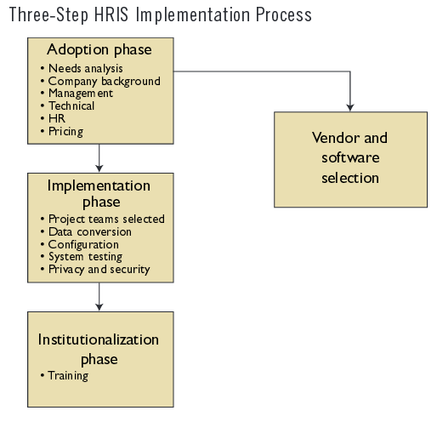
Source- (Bulmash, 2006, pp-61)

Appendix 2- Web-based self-service application and benefits
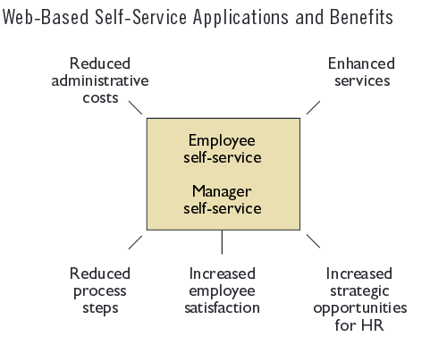
Source- (Bulmash, 2006, pp.66)

