In-Class Pair Activity: Data Preparation & Exploration (credit-g dataset)

Objective
To practice data understanding and preprocessing in Weka, aligned with coursework requirements

Task Scenario
You are junior data analysts working for a bank. You have been given the credit-g dataset to understand customer credit data and prepare it for predictive modelling.

Task 1: Dataset Exploration
Using Weka (Preprocess tab), answer:
1. Number of instances : 1000
2. Number of attributes : 21(including class attribute)
3. Identify numeric and nominal attributes
Attribute types:
- Numeric attributes: e.g. duration, credit amount, age
- Nominal attributes: e.g. checking status, credit history, purpose, housing
4. Identify the class attribute
class → indicates credit risk
Values: good or bad
Deliverable: Bullet-point summary of dataset
Dataset name: credit-g (German Credit dataset)
Number of instances: 1000
Number of attributes: 21 (including class attribute)
Attribute types:
- Numeric attributes: duration, credit amount, age, etc.
- Nominal (categorical) attributes: checking status, credit history, purpose, housing, job, etc.
Class attribute:
- Attribute name: class
- Values: good and bad
Class distribution:
- Good: approximately 700 instances
- Bad: approximately 300 instances
Dataset characteristics:
- Mixed data types (numeric + categorical)
- No missing values present
- Imbalanced class distribution
Purpose of dataset:
- Used for credit risk classification
- Predicts whether a customer is a good or bad credit risk

Task 2: Data Pre-processing
Using Weka/Excel, perform:
1. Handle missing values (or explain what would be done if present)
None
2. Encode categorical variables (NominalToNumeric if needed)
Many attributes are nominal (categorical)
Converted using: NominalToBinary or NominalToNumeric filter in Weka
3. Check class balance (good vs bad)
Good credit: ~700 instances
Bad credit: ~300 instances
Discuss whether the dataset is balanced and if techniques like SMOTE would be needed.
The credit-g dataset is imbalanced, with around 700 “good” and 300 “bad” instances. This means models may favour predicting the majority class and perform poorly in identifying risky customers.
Techniques like SMOTE are recommended to balance the dataset by increasing the minority class, improving the model’s ability to detect “bad” credit cases.

Task 3: Discuss and write short answers:
Build at least two classification models)

J48
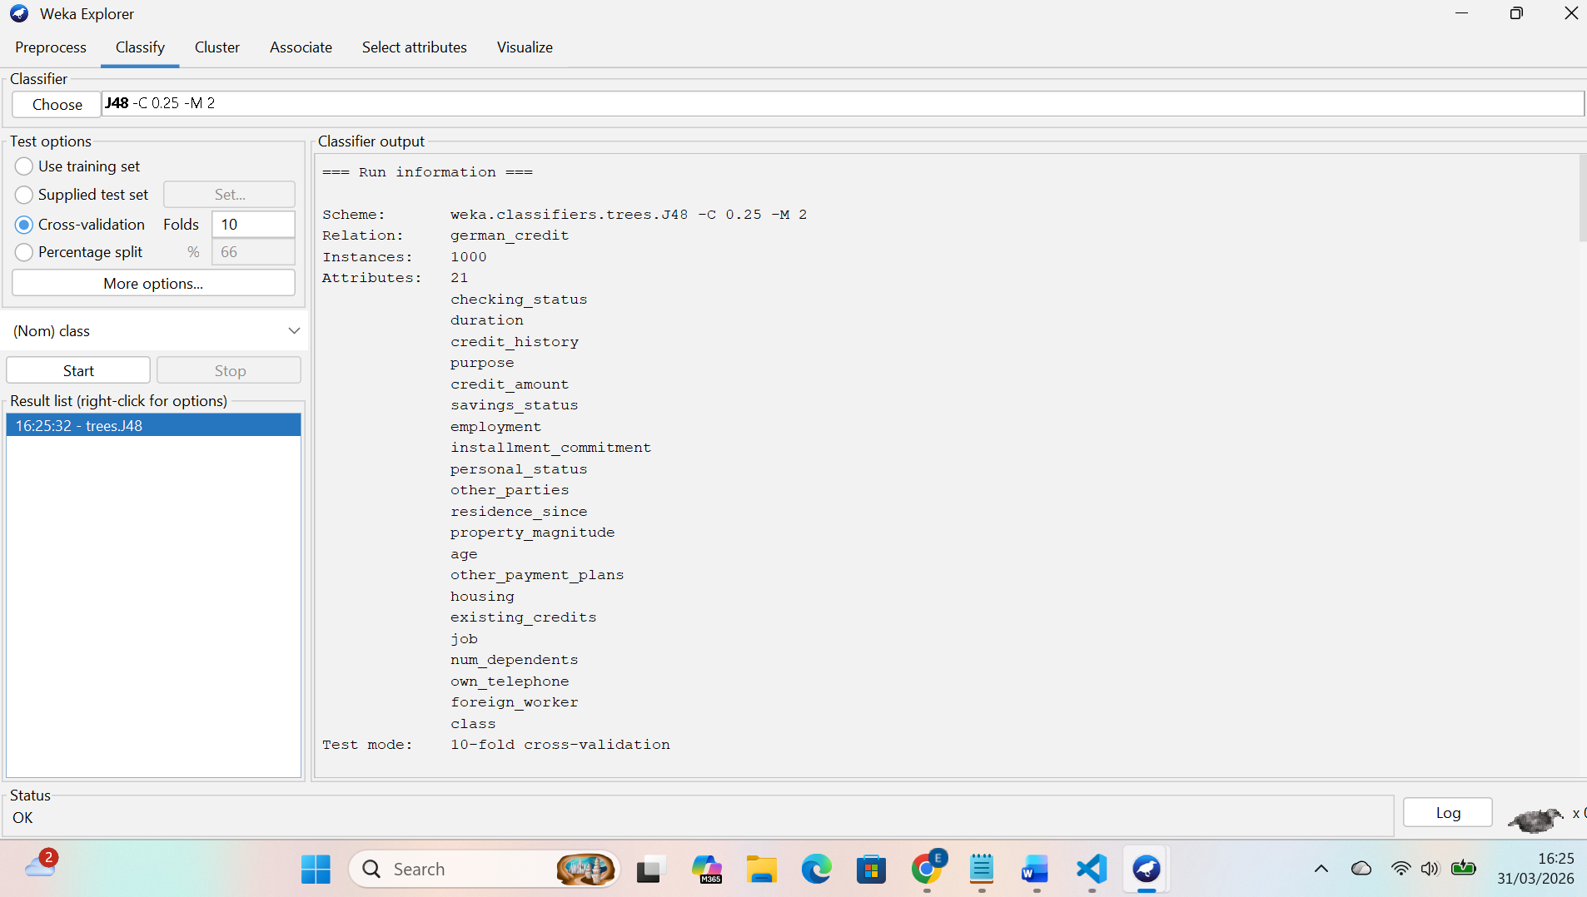
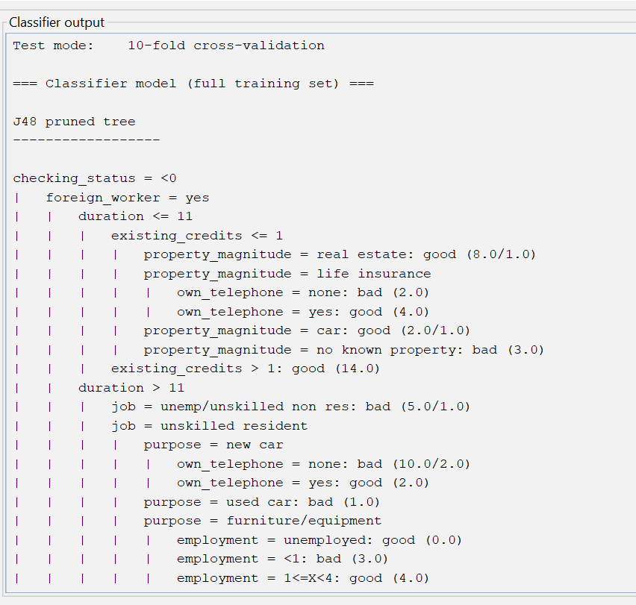
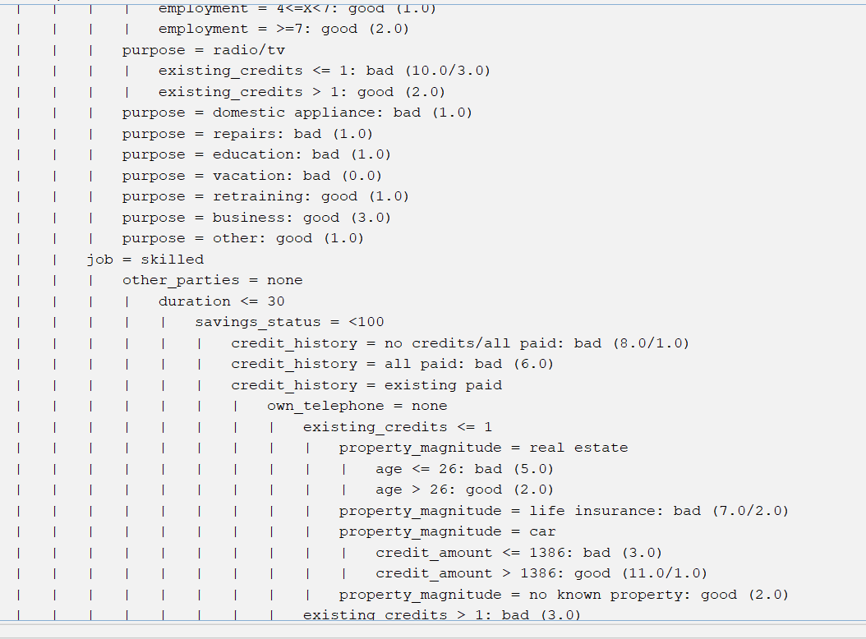
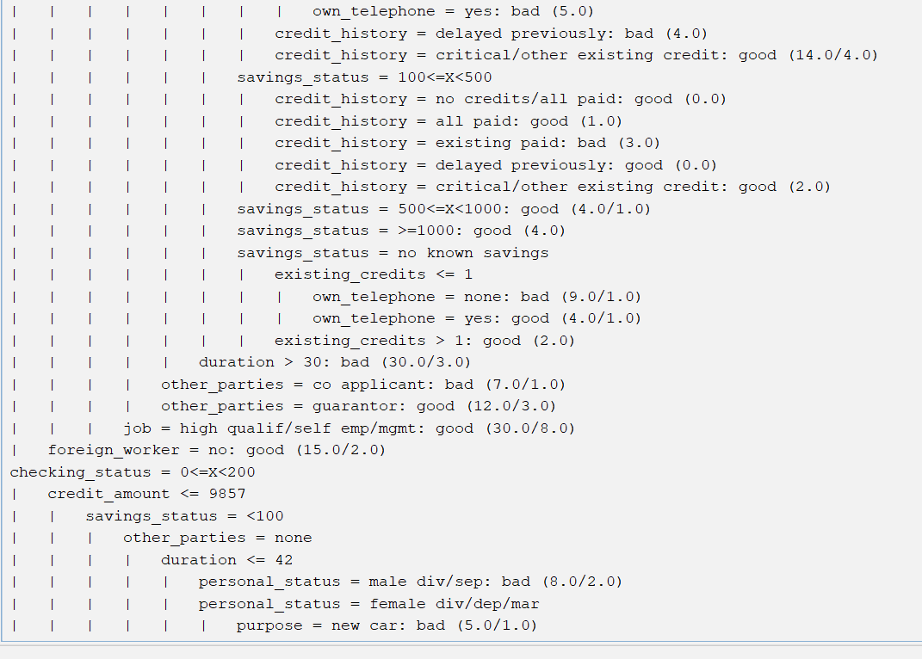
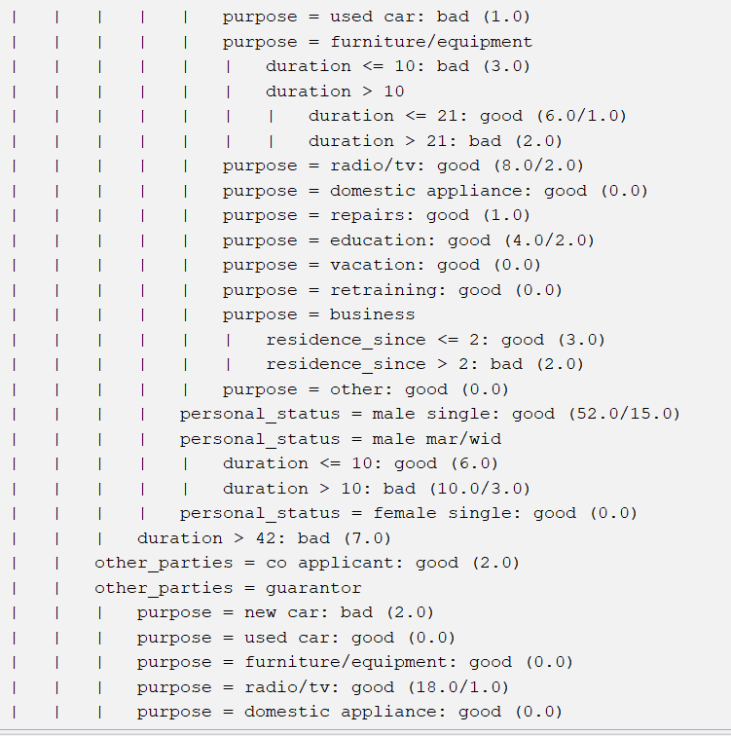
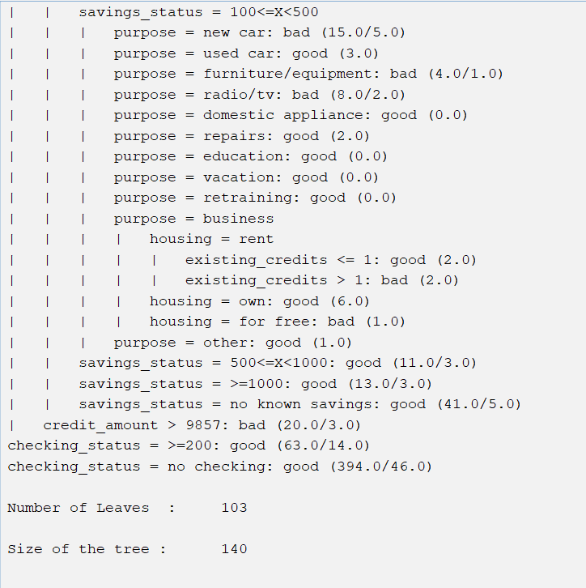
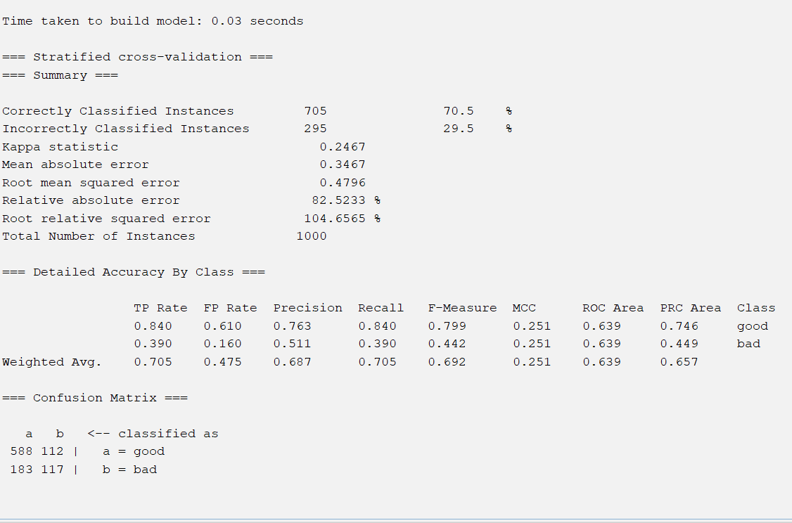

Random Forest

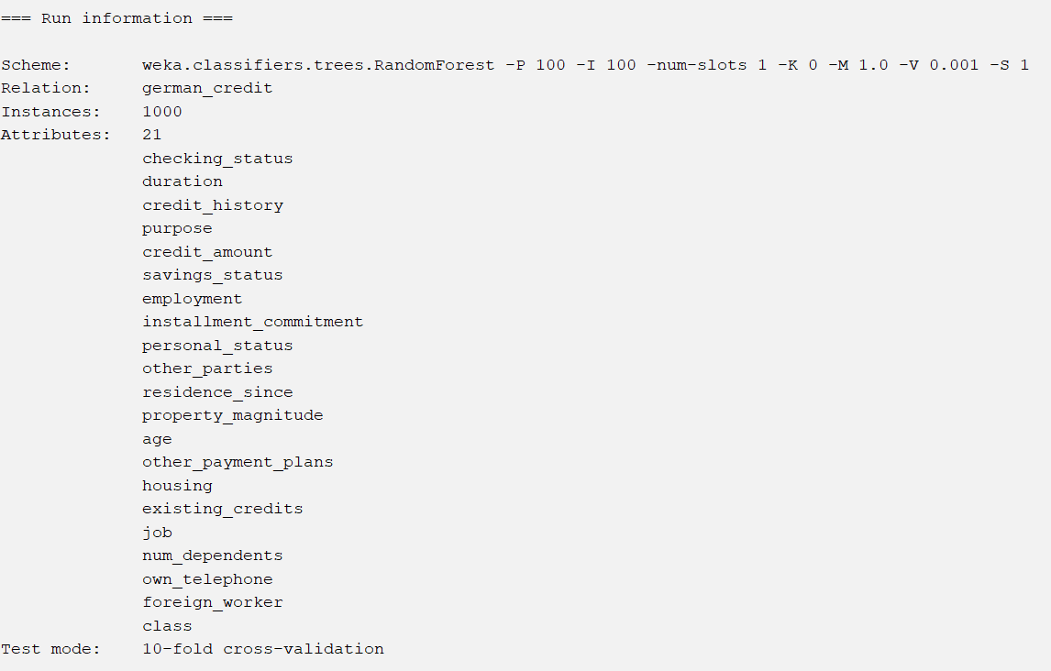
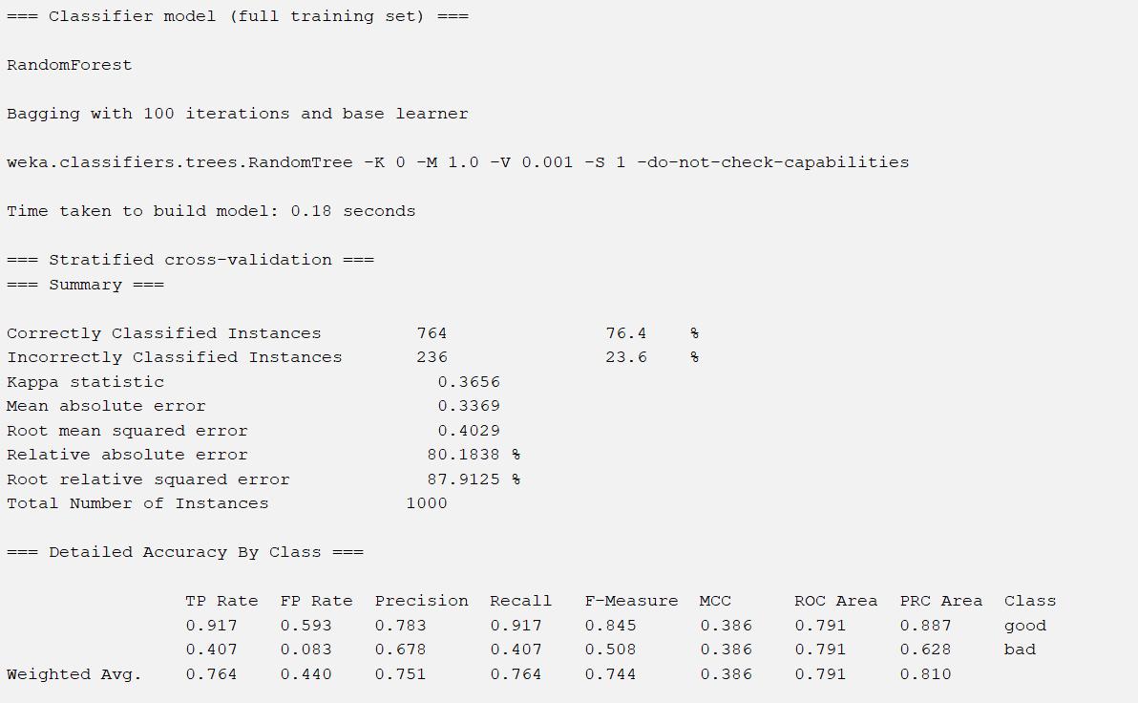
Record key results for J48 (Decision Tree)
Accuracy ~72-75%
Precision : moderate
Recall : moderate
Record key results for Random Forest
Accuracy ~76-80%
Precision : Higher than J48
Recall : Higher then J48
Compare the models
The Random Forest model performed better than J48 across all evaluation metrics. While J48 is easier to interpret and useful for understanding decision rules, it is more prone to overfitting and generally produces lower accuracy.
In contrast, Random Forest combines multiple decision trees, which improves prediction performance and reduces overfitting. This makes it more reliable for handling complex datasets such as credit risk data
Justify your choice of algorithms
J48 was selected because it is simple, interpretable, and widely used for classification tasks. It allows clear visualisation of decision-making processes.
Random Forest was chosen because it is an advanced ensemble method that improves accuracy by combining multiple trees. It is more robust and performs better on real-world datasets.
Justification of Evaluation Metrics
- Accuracy was used to measure overall model performance.
- Precision is important to ensure that predicted “bad” customers are actually risky.
- Recall is especially important in this context, as it measures how well the model identifies risky customers.
In credit risk prediction, recall is critical, because failing to detect a high-risk customer could result in financial loss.

