

BA (Hons) Business Management

LCBB4014: Introduction to Business

Members:
Name: Ion Paun / Student ID: 244188
Name: Ionut Marin / Student ID: 2512904
Name: Ilie Marin / Student ID: 2512903
Name: Amdad Hussain / Student ID: 2413131

Component 1: Practical Group Presentation

Table of Contents
Slide 1- Title Slide 3
Slide 2- Contents 3
Slide 3- Introduction 3
Slide 4- Company overview 3
Slide 5- SWOT: Strengths 4
Slide 6- SWOT: Weaknesses 4
Slide 7- SWOT: Opportunities 5
Slide 8: SWOT: Threats 5
Slide 9- PESTLE: Political 6
Slide 10- PESTLE: Economic 6
Slide 11- PESTLE: Social 7
Slide 12- PESTLE: Technological 8
Slide 13- Impact of globalisation 8
Slide 14- Influence on innovation 9
Slide 15- Recommendations 9
Slide 16- Conclusion 10
Slide 17- References 10

Slide 1- Title Slide


Slide 2- Contents
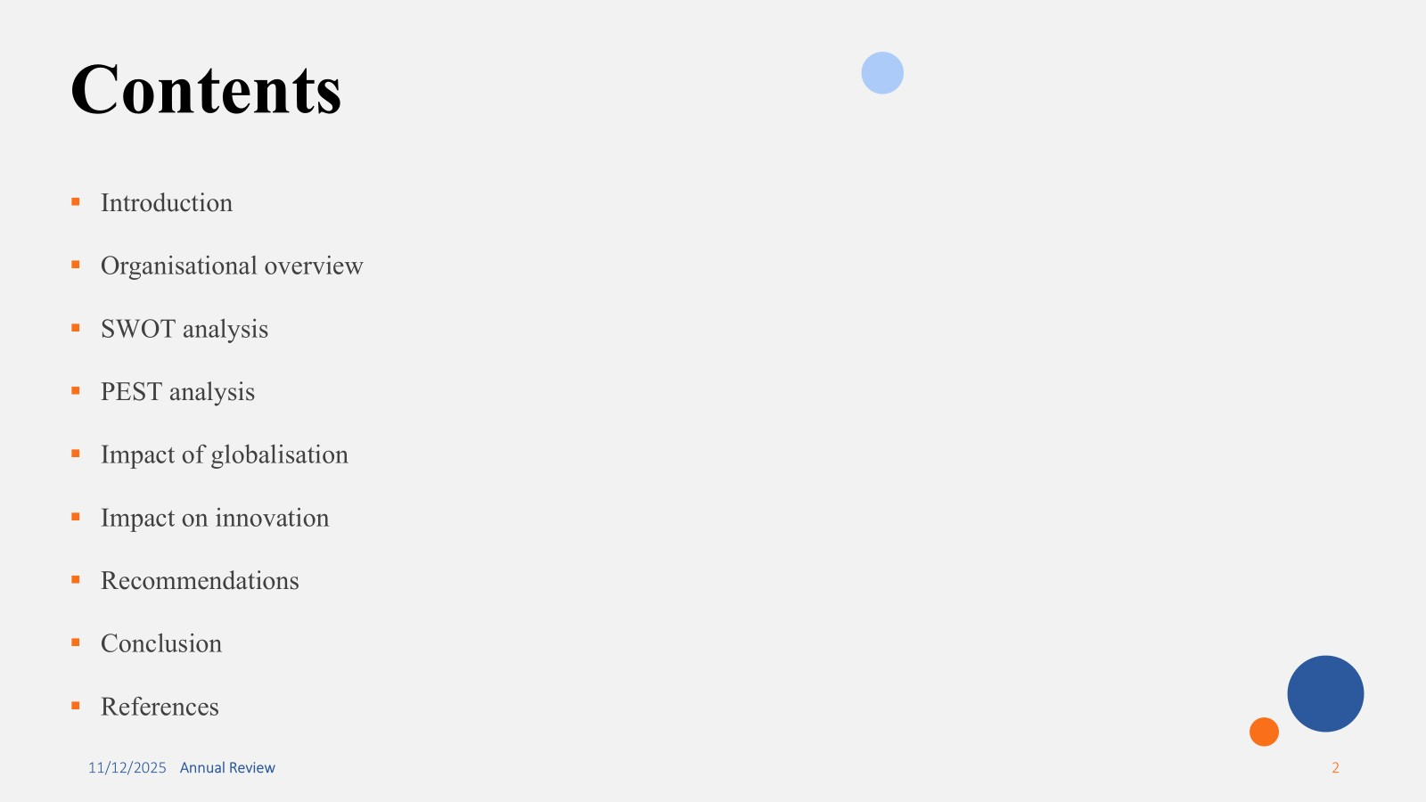

Slide 3- Introduction
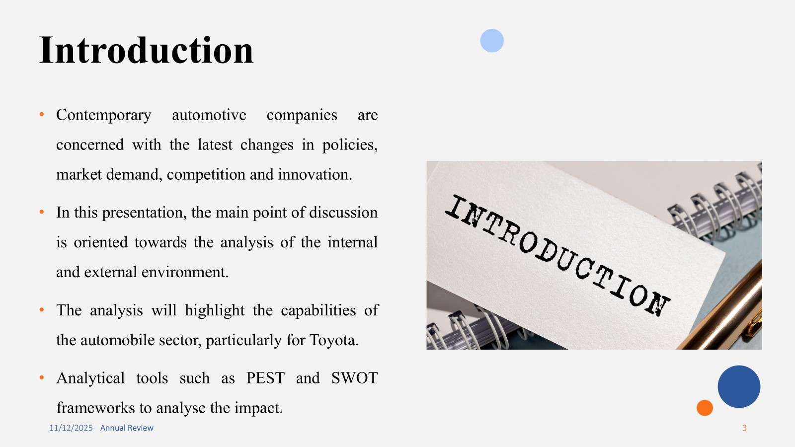
Contemporary automotive companies are concerned with the latest changes in policies, market demand, competition and the introduction of innovative solutions for the attraction of the customers. The impact of the internal and external environment on the performance of the automobile sector is apparent on the revenue generation and organisational growth. In this presentation, the main point of discussion is oriented towards the analysis of the internal and external environment to determine the influence of globalisation and changing trends in the automobile sector. The analysis will highlight the capabilities of the automobile sector, particularly for Toyota in growing amidst such industrial changes. To aid the discussion in the report, the application of analytical tools such as PEST and SWOT frameworks to analyse the impact on the operations and strategies.

Slide 4- Company overview
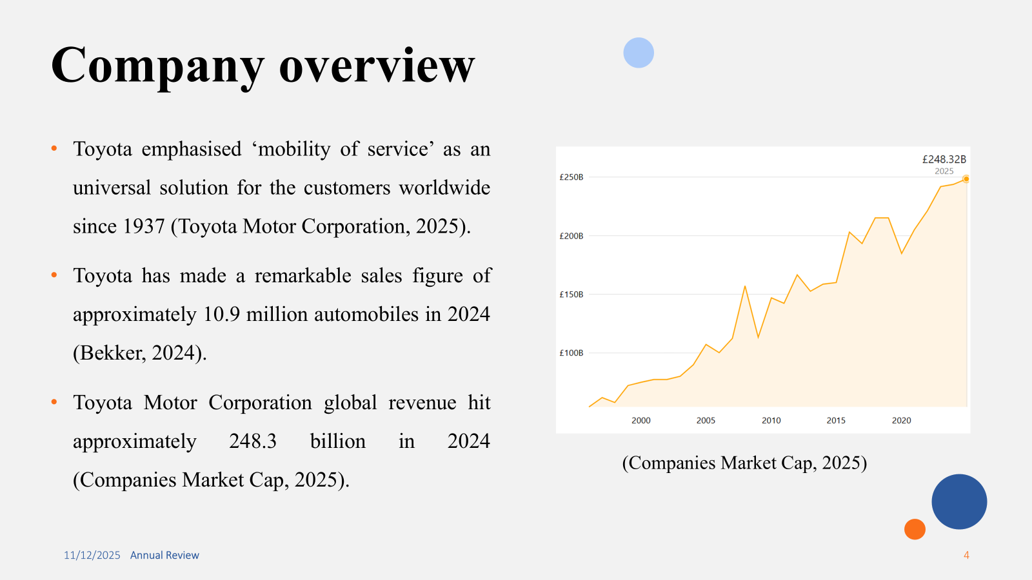
The automobile sector is strategically affected by the presence of Toyota as an automobile manufacturer since 1937. Its historical reign from Japan unveils that the automobile company has emphasised ‘mobility of service’ as an universal solution for the customers worldwide. The worldwide statistics show that Toyota has made a remarkable sales figure of approximately 10.9 million automobiles in 2024, which is a 3.7% fall as compared to 11.2 million units sold in 2023. The current market valuation of Toyota Motor Corporation is at around 202 billion and the global revenue hit approximately 248.3 billion in 2024. These figures show Toyota as a leading global automobile brand with high sales and revenue generation records. The brand has positioned itself competitively against EV, hybrids and carburetor engines.

Slide 5- SWOT: Strengths
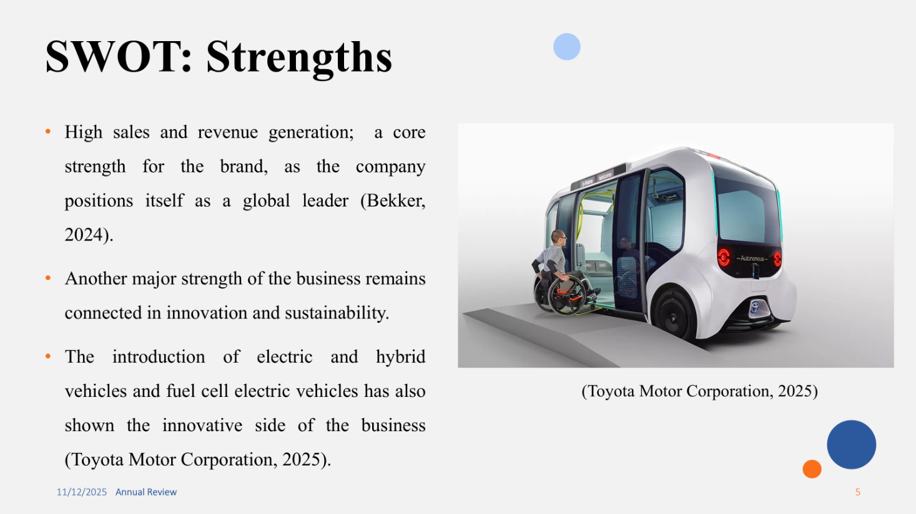
Toyota remains the most significant automobile manufacturer, considering its sales and revenue generation. With its 10.8 million car sales in 2024, Toyota has made a significant impact on the overall automobile sector. This has become a core strength for the brand, as the company positions itself as a global leader in revenue generation and units sold in the process. Another major strength of the business remains connected in innovation and sustainability in the market. Both of these concepts are maintained and addressed by CO2 reduction and the introduction of electric and hybrid vehicles. The introduction of fuel cell electric vehicles has also shown the innovative side of the business. In the global region, focusing on sustainability and innovation has minutely assisted the brand to acquire global leading position.

Slide 6- SWOT: Weaknesses
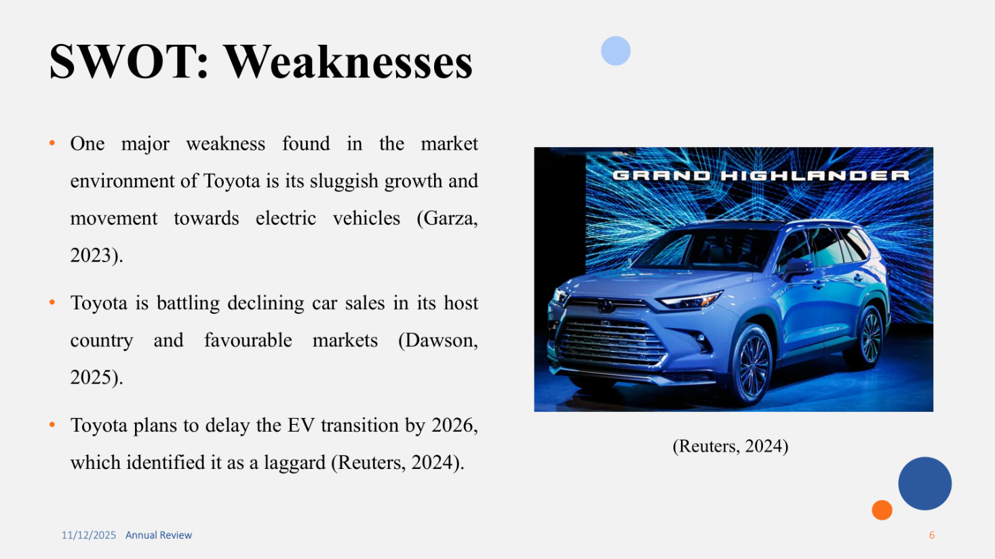
One major weakness found in the market environment of Toyota is its sluggish growth and movement towards electric vehicles in the portfolio. From various news sources, it is identified that Toyota has become a slow mover towards the EV market considering the rapid movement of the automobile market. It is also studied that a declining car sales in its host country and favourable markets has affected the growth and transition towards EV in the market. While underlining the sluggish transition, it is also clear that Toyota plans to delay the EV transition by 2026. This has provided a major ambiguity for the organisation while Toyota seeks to tackle the laggard in the market.

Slide 7- SWOT: Opportunities
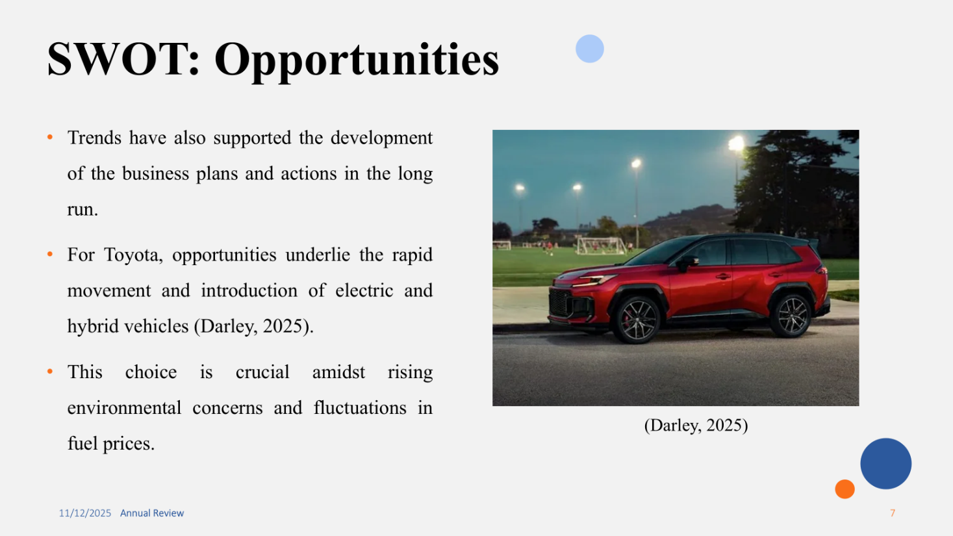
The automotive market for the respective brand remains influenced by industrial changes and trends. Trends have also supported the development of the business plans and actions in the long run. For Toyota, opportunities underlie the rapid movement and introduction of electric and hybrid vehicles. Although the brand has already shown significant planning and execution of electric and hybrid vehicles, there still remains stagnant business operations. Moreover, this choice is crucial amidst rising environmental concerns and fluctuations in fuel prices. This opportunity must be leveraged by the brand to exercise greater control over the leadership and impact on the key market position. A long-term vision is also perceived to be connected with the movement towards EV and hybrid segments in the market for the largest automobile company.

Slide 8: SWOT: Threats
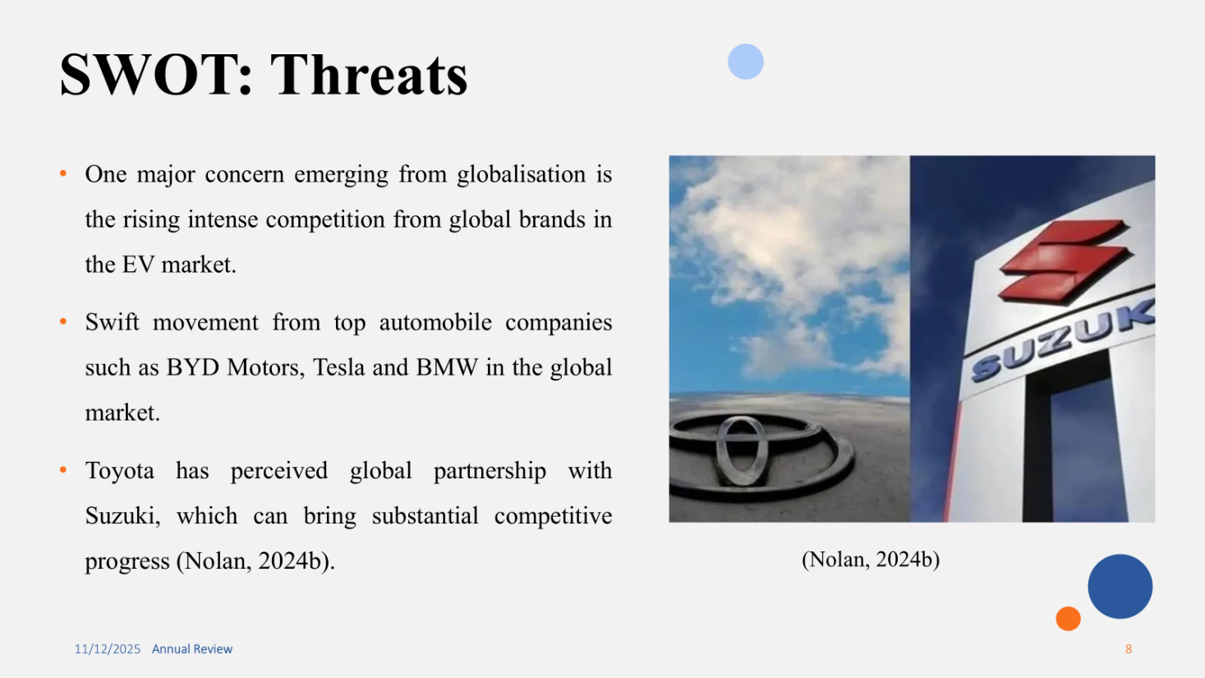
The market situation has introduced various challenges for the organisation. Among various challenges related to market changes and trends, one major concern emerged from globalisation is the rising intense competition from global brands in the EV market. With stagnant moves and actions from Toyota, the challenge deepens and intensified by the swift movement from top automobile companies such as BYD Motors, Tesla and BMW in the global market. To address this, Toyota has perceived global partnership with Suzuki, which can bring substantial competitive progress and vision in the market. This is also perceived as a major factor for the development of strategic vision and movement of the brand in addressing the needs of the market. Hence, the impact of the competitive landscape in terms of swift adoption of technology and faster movement is apparent on the sluggish sales of the brand.

Slide 9- PESTLE: Political
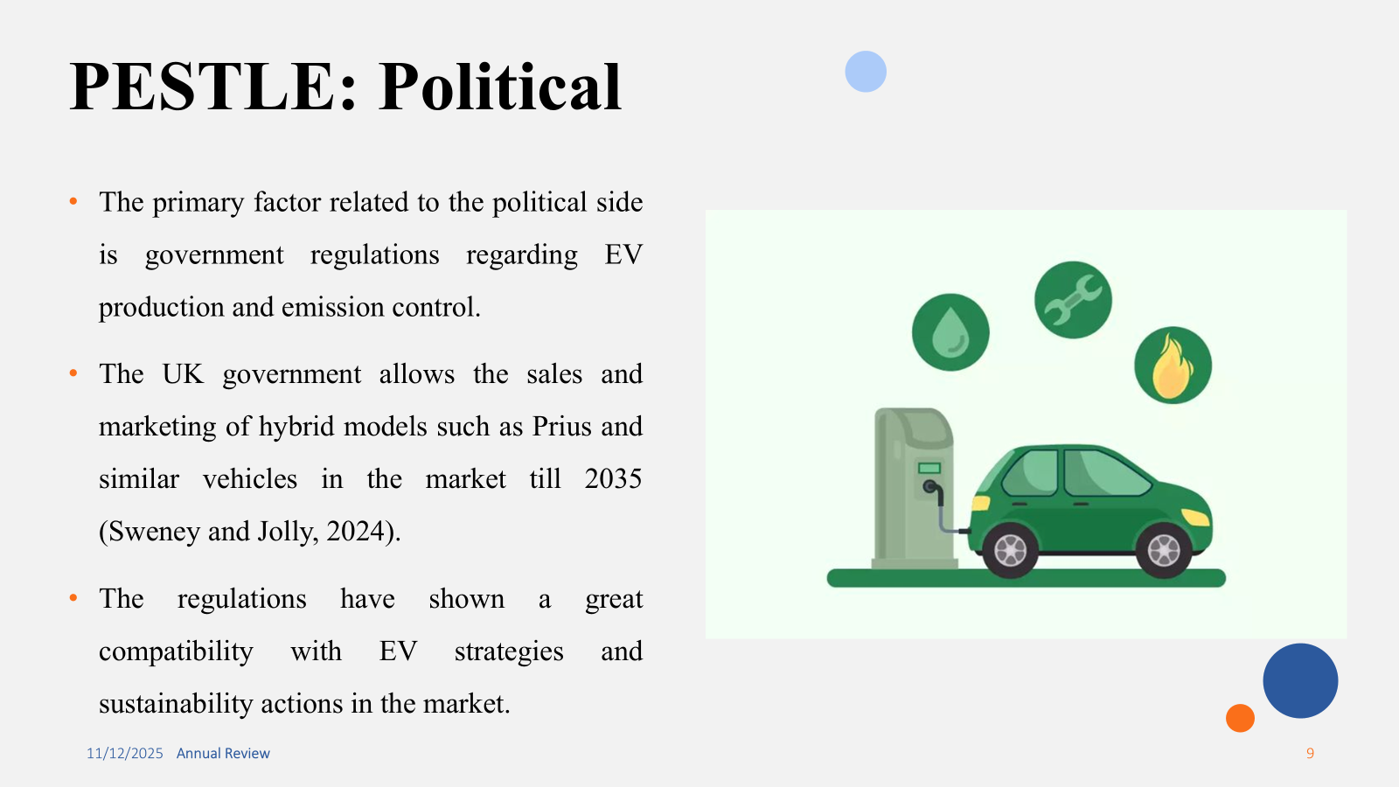
The primary factor related to the political side of the external environment for the automobile business is government regulations regarding EV production and emission control. One such instance can be excerpted from the UK government allowing the sales and marketing of hybrid models such as Prius and similar vehicles in the market till 2035. This decision of the UK government has pushed the discussion into a major political stance in support of the automobile sector in moving towards hybrids and mainly towards the eclectic vehicles in the market. The political stance towards the EV market and the influence of the regulations has shown a great compatibility with EV strategies and sustainability actions in the market. Thus, the market is politically affected by the latest decisions from the UK government and similar interests of the administration.

Slide 10- PESTLE: Economic
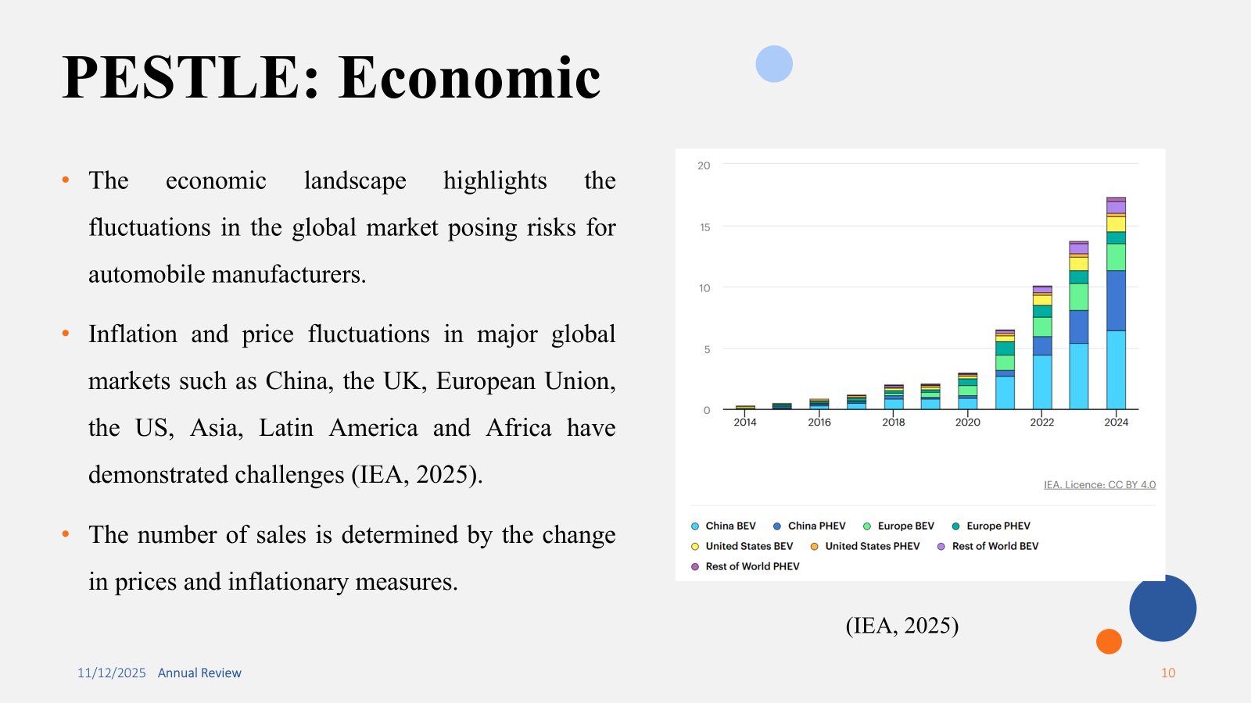
The economic landscape highlights the fluctuations in the global market posing risks for automobile manufacturers in the market. The impact of fluctuations on the strategic positioning and the sales of electric vehicles are critical in the market. Economic factors in terms of inflation and price fluctuations in major global markets such as China, the UK, European Union, the US, Asia, Latin America and Africa have demonstrated challenges for automobile companies. For Toyota, the significance of the overall economic fluctuations in the overall global market remains critical to maintain the performance. The number of sales is determined by the change in prices and inflationary measures for the customers seeking to buy EV vehicles in the global market. Therefore, the economic landscape will also be critical for Toyota to keep its sales and strategic vision connected.

Slide 11- PESTLE: Social
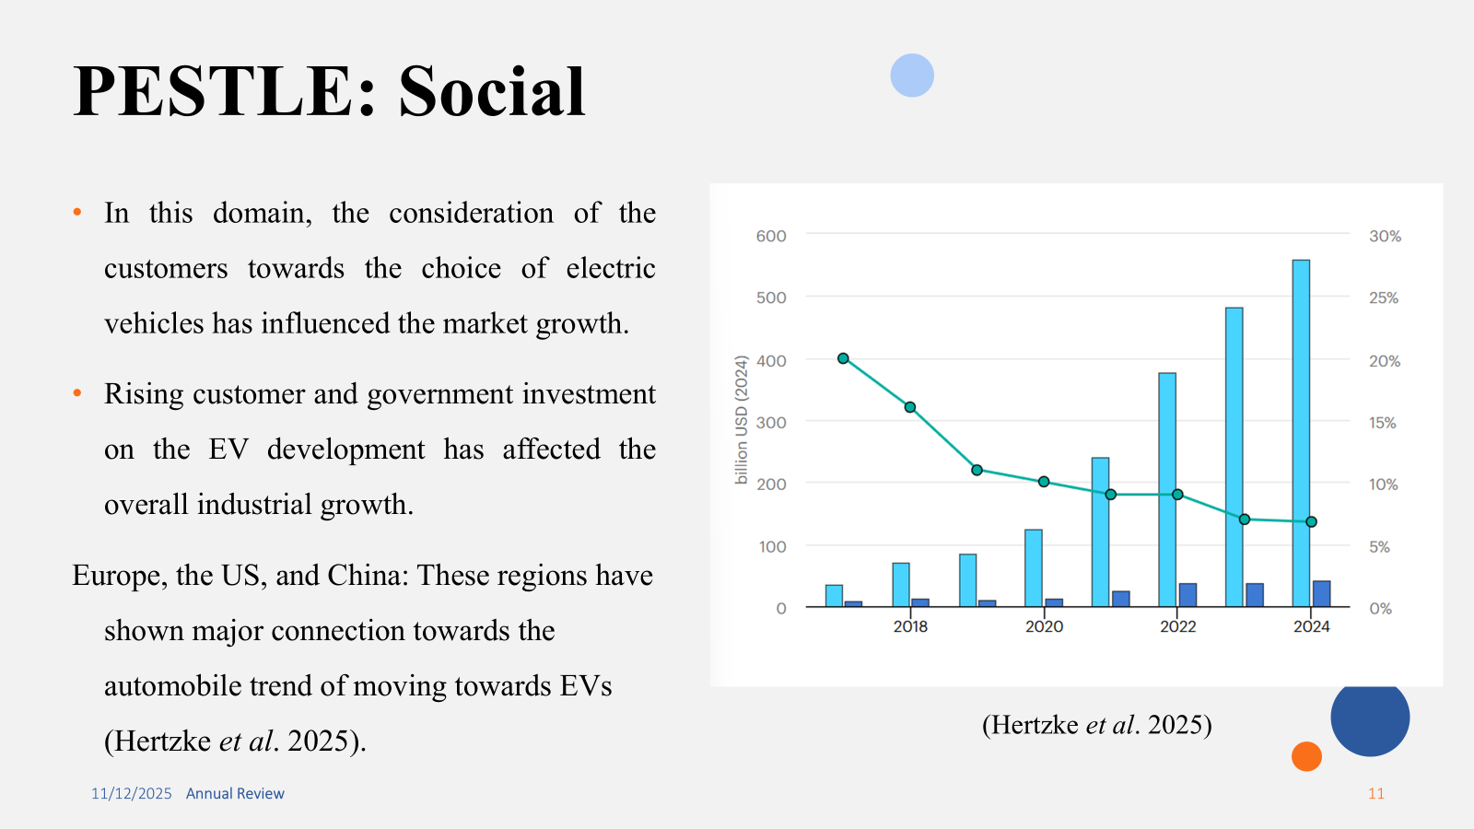
Socially, the automobile market has also shown a commendable impact on the performance of the organisations. In this domain, the consideration of the customers towards the choice of electric vehicles has influenced the market growth. Alongside this, rising customer and government investment on the EV development has affected the overall industrial growth. It is also studied that the regional markets in the international arena have highly affected the sales and projections. This is evident in the industrial report, as the major regions include Europe, the US, and China. These regions have shown major connection towards the automobile trend of moving towards EVs in the market. In terms of growing in the European market, consumer demands towards such vehicles have risen exponentially. The need for greater development of such factors have highly fostered the connection with the long-run strategic viewpoint.

Slide 12- PESTLE: Technological
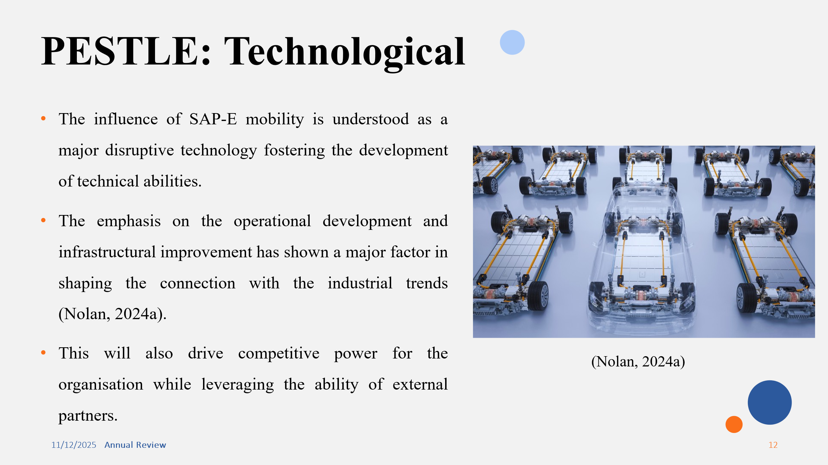
The development of the technological infrastructure and disruptive technologies have been perceived as integral for the functioning of organisations. It can be found that the influence of SAP-E mobility is understood as a major disruptive technology fostering the development of technical abilities for organisations to achieve operational efficiency. The emphasis on the operational development and infrastructural improvement has shown a major factor in shaping the connection with the industrial trends. The ability of automobile organisations, particularly for Toyota, will be aligned with the adoption of disruptive technologies through which it can work further on its EV transition. This will also drive competitive power for the organisation while leveraging the ability of external partners. A major perception towards achieving greater internal performance is achieved on the overall market.

Slide 13- Impact of globalisation
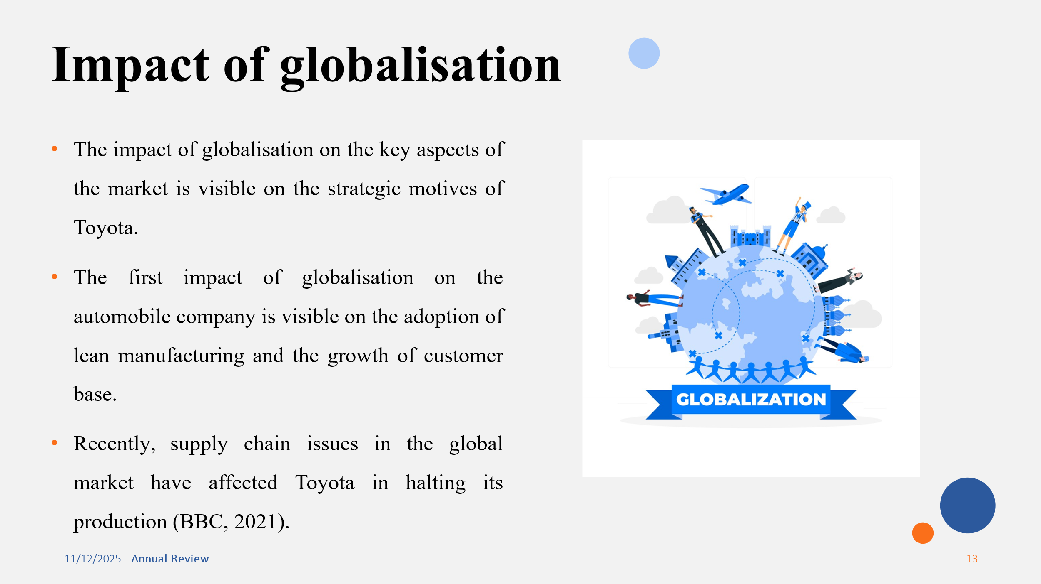
The impact of globalisation on the key aspects of the market is visible on the strategic motives of Toyota. The first impact of globalisation on the automobile company is visible on the adoption of lean manufacturing and the growth of customer base. The largest manufacturer has experienced a rapid growth of customer base. This has also affected the strategic positioning of the brand in the global market. Alongside this, the emphasis on the key supply chain network has also emerged as a concern for the organisation. Recently, supply chain issues in the global market have affected Toyota in halting its production to tackle the market challenges. Halting the production has become a major challenge in the supply chain, which is affected by the global issues and network problems.

Slide 14- Influence on innovation
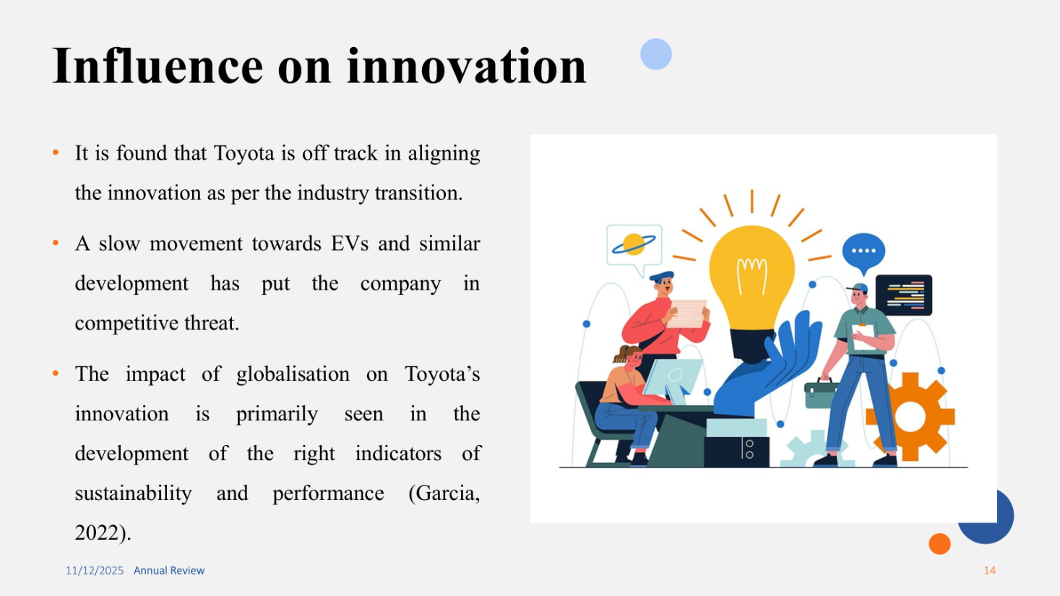
The influence of innovation is a major challenge on the procedures of competitive advantage and growth. It is found that Toyota is off track in aligning the innovation as per the industry transition. A slow movement towards EVs and similar development has put the company in competitive threat, since its rivals in the global arena have adopted the procedures effectively and to a large extent. The impact of globalisation on Toyota’s innovation is primarily seen on the development of the right indicators of sustainability and performance. However, a slow growth in sustainability is seen in the lack of EV lists in vehicles. It is measured that the lack of consideration towards this movement will dictate Toyota as a laggard in the automotive industry.

Slide 15- Recommendations
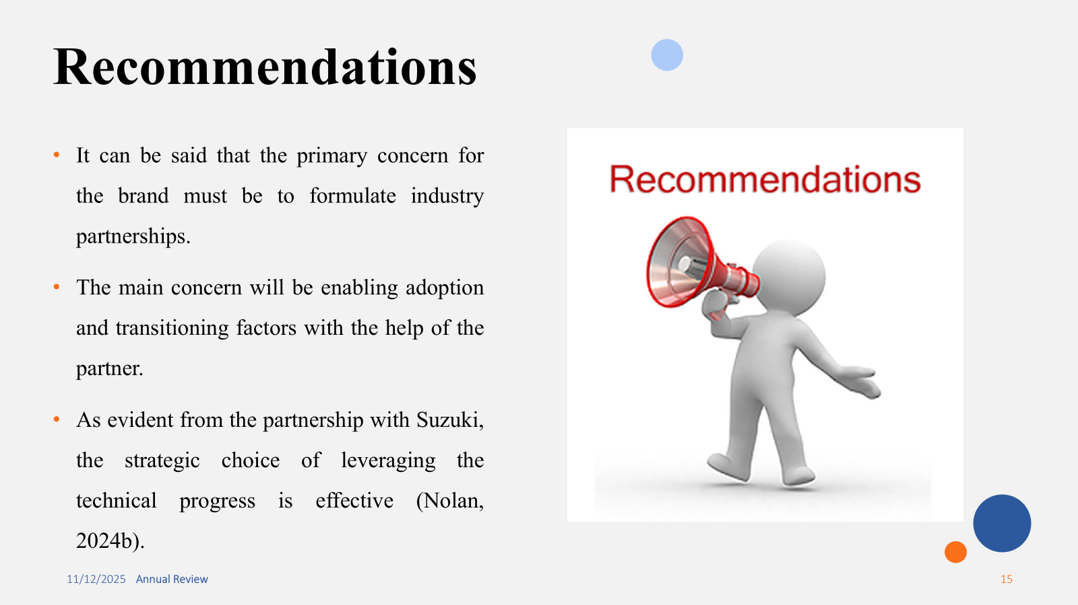
The emphasis on the internal and external environment pushes the discussion to determine the best suited advice for better performance and industry alignment for the automotive brand. It can be said that the primary concern for the brand must be to formulate industry partnerships in enabling adoption and transitioning factors with the help of the partner. As evident from the partnership with Suzuki, the strategic choice of leveraging the technical progress of the partner would result positively for the brand. The concern related to the overall adoption and transition period towards EV can be fostered with the help of a strategic partner. The essence of forming a strategic partnership remains a major consideration on the key perspectives of the market changes and the movement with industry trends.

Slide 16- Conclusion
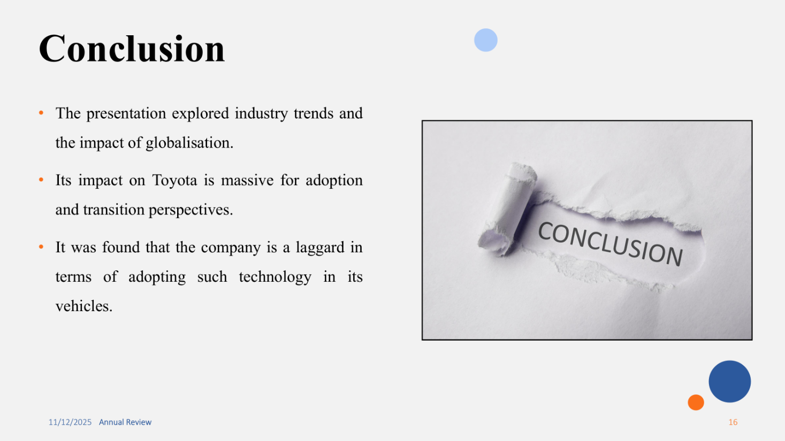
The presentation above has explored the market dynamics and the influence of industry trends such as the movement towards EV for Toyota. It was found that the company is a laggard in terms of adopting such technology in its vehicles. A major perception remains shared with the rise of EV trends among the global consumers. However, with market fluctuations and other concerns, Toyota has not been able to process the flow of this trend into its product portfolio. A slow growth has limited its exercise of global competitiveness, as compared to its rivals.

Slide 17- References


